# flink状态获取

## 1.本地Flink获取度量值：

语句：

总消费数量：并行度为三

curl localhost:8081/jobs/0e2598972acc7271c9e86ce43dcf23d5/vertices/7560815a613b217838f2c121f2495920/metrics?get=0.KeyedProcess.volans.consumeCount0

curl localhost:8081/jobs/0e2598972acc7271c9e86ce43dcf23d5/vertices/7560815a613b217838f2c121f2495920/metrics?get=1.KeyedProcess.volans.consumeCount1

curl localhost:8081/jobs/0e2598972acc7271c9e86ce43dcf23d5/vertices/7560815a613b217838f2c121f2495920/metrics?get=2.KeyedProcess.volans.consumeCount2

脏数据：

curl localhost:8081/jobs/0e2598972acc7271c9e86ce43dcf23d5/vertices/7560815a613b217838f2c121f2495920/metrics?get=0.KeyedProcess.volans.dirtyCount0

curl localhost:8081/jobs/0e2598972acc7271c9e86ce43dcf23d5/vertices/7560815a613b217838f2c121f2495920/metrics?get=1.KeyedProcess.volans.dirtyCount1

curl localhost:8081/jobs/0e2598972acc7271c9e86ce43dcf23d5/vertices/7560815a613b217838f2c121f2495920/metrics?get=2.KeyedProcess.volans.dirtyCount2

1.1本地先获取flink jobmanager 请求地址，默认端口为 8081

curl localhost:8081

1.2 通过jobs/jobID 获取对应作业的相信信息，以json类型返回数据

curl localhost:8081/jobs/963df8b04814c5840840ad5d85d57311

返回值：

{

"jid": "0e2598972acc7271c9e86ce43dcf23d5",

"name": "Flink Streaming Job",

"isStoppable": false,

"state": "RUNNING",

"start-time": 1605679735415,

"end-time": -1,

"duration": 260282,

"now": 1605679995697,

"timestamps": {

"FAILING": 0,

"FINISHED": 0,

"CANCELLING": 0,

"RECONCILING": 0,

"SUSPENDED": 0,

"RESTARTING": 0,

"CREATED": 1605679735415,

"FAILED": 0,

"CANCELED": 0,

"RUNNING": 1605679735421

},

"vertices": [{

"id": "bd9c186e89cc37a76d776844dfa8ccba",

"name": "Source: Custom Source -> Map",

"parallelism": 3,

"status": "RUNNING",

"start-time": 1605679735489,

"end-time": -1,

"duration": 260208,

"tasks": {

"CANCELING": 0,

"RECONCILING": 0,

"RUNNING": 3,

"CANCELED": 0,

"DEPLOYING": 0,

"CREATED": 0,

"FAILED": 0,

"SCHEDULED": 0,

"FINISHED": 0

},

"metrics": {

"read-bytes": 0,

"read-bytes-complete": true,

"write-bytes": 42,

"write-bytes-complete": true,

"read-records": 0,

"read-records-complete": true,

"write-records": 2,

"write-records-complete": true

}

}, {

"id": "7560815a613b217838f2c121f2495920",

"name": "KeyedProcess -> (Sink: Unnamed, Sink: Unnamed)",

"parallelism": 3,

"status": "RUNNING",

"start-time": 1605679735494,

"end-time": -1,

"duration": 260203,

"tasks": {

"CANCELING": 0,

"RECONCILING": 0,

"RUNNING": 3,

"CANCELED": 0,

"DEPLOYING": 0,

"CREATED": 0,

"FAILED": 0,

"SCHEDULED": 0,

"FINISHED": 0

},

"metrics": {

"read-bytes": 6252,

"read-bytes-complete": true,

"write-bytes": 0,

"write-bytes-complete": true,

"read-records": 2,

"read-records-complete": true,

"write-records": 0,

"write-records-complete": true

}

}],

"status-counts": {

"CANCELING": 0,

"RECONCILING": 0,

"RUNNING": 2,

"CANCELED": 0,

"DEPLOYING": 0,

"CREATED": 0,

"FAILED": 0,

"SCHEDULED": 0,

"FINISHED": 0

},

"plan": {

"jid": "0e2598972acc7271c9e86ce43dcf23d5",

"name": "Flink Streaming Job",

"nodes": [{

"id": "7560815a613b217838f2c121f2495920",

"parallelism": 3,

"operator": "",

"operator_strategy": "",

"description": "KeyedProcess -&gt; (Sink: Unnamed, Sink: Unnamed)",

"inputs": [{

"num": 0,

"id": "bd9c186e89cc37a76d776844dfa8ccba",

"ship_strategy": "HASH",

"exchange": "pipelined_bounded"

}],

"optimizer_properties": {}

}, {

"id": "bd9c186e89cc37a76d776844dfa8ccba",

"parallelism": 3,

"operator": "",

"operator_strategy": "",

"description": "Source: Custom Source -&gt; Map",

"optimizer_properties": {}

}]

}

}

返回的json中vertices数组字段中包含所有算子的算子ID

通过返回值，获取name以KeyedProcess开头的算子ID，例如：

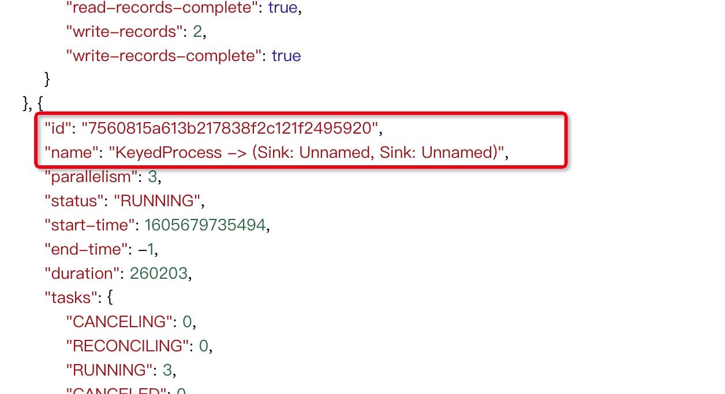

1.3 通过 jobs/jobid/vertices/算子id/metrics?get=度量ID 度量值

因为作业是并行执行，所以会有多个分区, 例如：

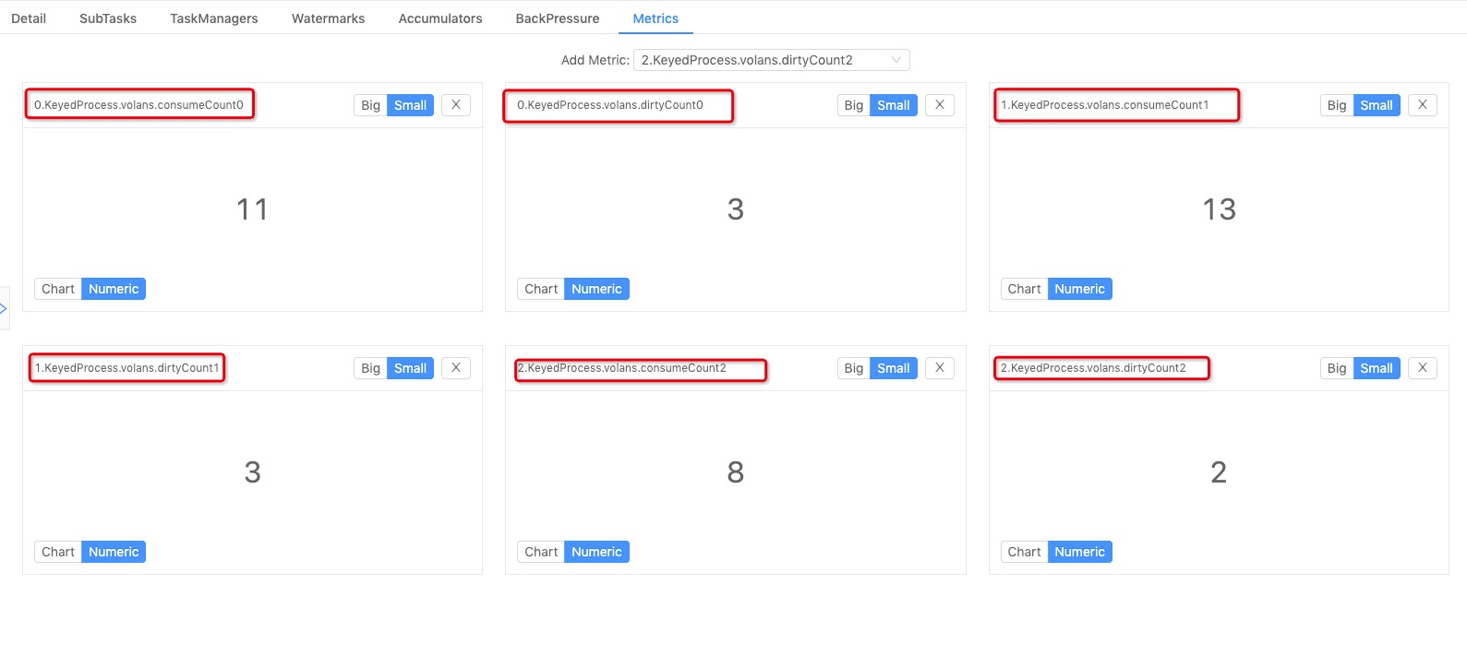

需要获取的度量有六个：

消费统计：

0.KeyedProcess.volans.consumeCount0 = 2

1.KeyedProcess.volans.consumeCount1 = 2

1. KeyedProcess.volans.consumeCount2 = 1

所以要想获取此程序中总消费个数，需要将三者相加： 2+2+1 = 5

同理，脏数据应为：以下三者数值相加的和

0.KeyedProcess.volans.dirtyCount0

1.KeyedProcess.volans.dirtyCount1

2.KeyedProcess.volans.dirtyCount2

综上请求应为：

总消费数量：并行度为三

curl localhost:8081/jobs/0e2598972acc7271c9e86ce43dcf23d5/vertices/7560815a613b217838f2c121f2495920/metrics?get=0.KeyedProcess.volans.consumeCount0

curl localhost:8081/jobs/0e2598972acc7271c9e86ce43dcf23d5/vertices/7560815a613b217838f2c121f2495920/metrics?get=1.KeyedProcess.volans.consumeCount1

curl localhost:8081/jobs/0e2598972acc7271c9e86ce43dcf23d5/vertices/7560815a613b217838f2c121f2495920/metrics?get=2.KeyedProcess.volans.consumeCount2

脏数据：

curl localhost:8081/jobs/0e2598972acc7271c9e86ce43dcf23d5/vertices/7560815a613b217838f2c121f2495920/metrics?get=0.KeyedProcess.volans.dirtyCount0

curl localhost:8081/jobs/0e2598972acc7271c9e86ce43dcf23d5/vertices/7560815a613b217838f2c121f2495920/metrics?get=1.KeyedProcess.volans.dirtyCount1

curl localhost:8081/jobs/0e2598972acc7271c9e86ce43dcf23d5/vertices/7560815a613b217838f2c121f2495920/metrics?get=2.KeyedProcess.volans.dirtyCount2

## 2.Flink on Yarn 模式：

2.1 先要获取yarn中applicationMaster 地址

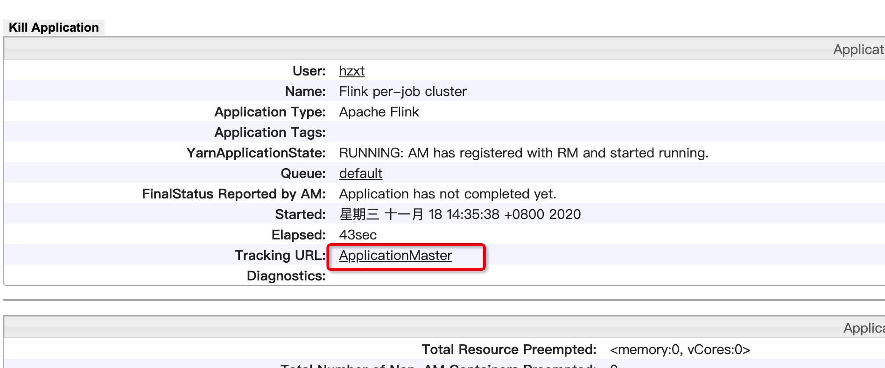

2.2 获取jobid

curl http://hzxtdemacbook-pro.local:8088/proxy/application_1605671767966_0004/jobs

返回值：

{"jobs":[{"id":"4863da5fcb2ab878777de460eb02a2d7","status":"RUNNING"}]}

2.3 通过jobid获取算子ID

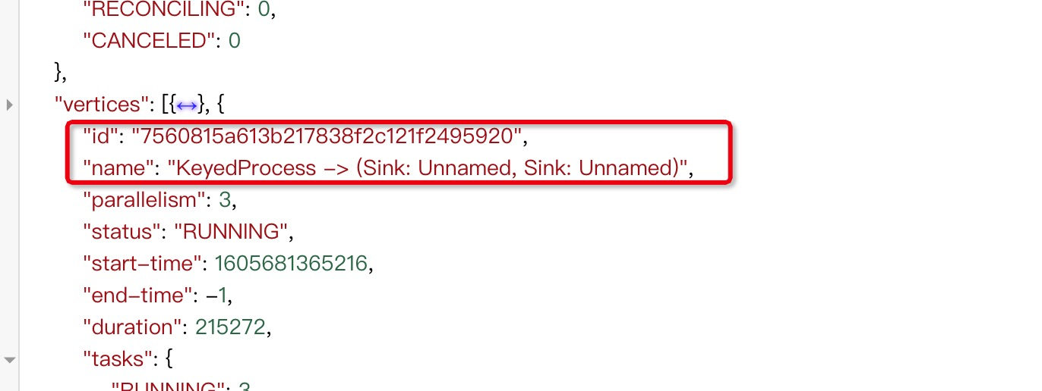

2.4 通过 jobs/jobid/vertices/算子id/metrics?get=度量ID 度量值

和本地模式一样获取不同并行度的度量值

同理如上：



请求：

curl http://hzxtdemacbook-pro.local:8088/proxy/application_1605671767966_0004/jobs/4863da5fcb2ab878777de460eb02a2d7/vertices/7560815a613b217838f2c121f2495920/metrics?get=0.KeyedProcess.volans.consumeCount0

curl [http://hzxtdemacbook-pro.local:8088/proxy/application_1605671767966_0004/jobs/4863da5fcb2ab878777de460eb02a2d7/vertices/7560815a613b217838f2c121f2495920/metrics?get=1.KeyedProcess.volans.consumeCount1](http://hzxtdemacbook-pro.local:8088/proxy/application_1605671767966_0004/jobs/4863da5fcb2ab878777de460eb02a2d7/vertices/7560815a613b217838f2c121f2495920/metrics?get=2.KeyedProcess.volans.counter-consumeCount1)

curl [http://hzxtdemacbook-pro.local:8088/proxy/application_1605671767966_0004/jobs/4863da5fcb2ab878777de460eb02a2d7/vertices/7560815a613b217838f2c121f2495920/metrics?get=2.KeyedProcess.volans.consumeCount2](http://hzxtdemacbook-pro.local:8088/proxy/application_1605671767966_0004/jobs/4863da5fcb2ab878777de460eb02a2d7/vertices/7560815a613b217838f2c121f2495920/metrics?get=2.KeyedProcess.volans.counter-consumeCount2)

脏数据：

curl http://hzxtdemacbook-pro.local:8088/proxy/application_1605671767966_0004/jobs/4863da5fcb2ab878777de460eb02a2d7/vertices/7560815a613b217838f2c121f2495920/metrics?get=0.KeyedProcess.volans.dirtyCount0

curl [http://hzxtdemacbook-pro.local:8088/proxy/application_1605671767966_0004/jobs/4863da5fcb2ab878777de460eb02a2d7/vertices/7560815a613b217838f2c121f2495920/metrics?get=1.KeyedProcess.volans.dirtyCount1](http://hzxtdemacbook-pro.local:8088/proxy/application_1605671767966_0004/jobs/4863da5fcb2ab878777de460eb02a2d7/vertices/7560815a613b217838f2c121f2495920/metrics?get=2.KeyedProcess.volans.counter-dirtyCount1)

curl http://hzxtdemacbook-pro.local:8088/proxy/application_1605671767966_0004/jobs/4863da5fcb2ab878777de460eb02a2d7/vertices/7560815a613b217838f2c121f2495920/metrics?get=2.KeyedProcess.volans.dirtyCount2