МДК 01.03 «Разработка мобильных приложений»

Практическая работа №1

Учебная группа 32.1ИСД

Студент Данилин Николай Юрьевич

|  |
| --- |
| using System;  using System.Collections.Generic;  using System.ComponentModel;  using System.Linq;  using System.Runtime.CompilerServices;  using System.Text;  using System.Threading.Tasks;  using System.Windows.Media;  using System.Windows.Input;  using Данилин_Пр1.Models;  using System.Windows;  using System.Runtime.InteropServices;    namespace Данилин_Пр1.ViewModels  {  public class MainViewModel : INotifyPropertyChanged  {  public event PropertyChangedEventHandler PropertyChanged;  public void OnPropertyChanged([CallerMemberName] string name = "")  {  PropertyChanged?.Invoke(this, new PropertyChangedEventArgs(name));  }  private byte _r;  public byte R  {  get  {  return _r;  }  set  {  _r = value;  OnPropertyChanged();  UpdateColor();  }  }    private byte _g;  public byte G  {  get  {  return _g;  }  set  {  _g = value;  OnPropertyChanged();  UpdateColor();  }  }    private byte _b;  public byte B  {  get  {  return _b;  }  set  {  _b = value;  OnPropertyChanged();  UpdateColor();  }  }    private byte _a = 255;  public byte A  {  get  {  return _a;  }  set  {  _a = value;  OnPropertyChanged();  UpdateColor();  }  }    private Brush _brush;  public Brush Brush  {  get  {  return _brush;  }  set  {  _brush = value;  OnPropertyChanged();  }  }    public void UpdateColor()  {  Brush = new SolidColorBrush(Color.FromArgb(_a, _r, _g, _b));  }    public DelegateCommand updateClipboardCommand  {  get  {  return new DelegateCommand(obj => { UpdateClipboard(); });  }  }    private void UpdateClipboard()  {  MessageBox.Show  (  $"Цвет скопирован. \n" +  $"Ваш цвет в hex: {Color.FromRgb(_r, _g, _b)}\n" +  $"Ваш цвет в rgb: R:{_r} G:{_g} B:{_b}\n" +  $"Прозрачность (Alpha): {_a}"  );  Clipboard.SetText  (  $"Hex: {Color.FromRgb(_r, _g, _b)}\n" +  $"Rgb: {_r} {_g} {_b}\n" +  $"Alpha: {_a}"  );  }  }  }  <Window x:Class="Данилин_Пр1.MainWindow"  xmlns="http://schemas.microsoft.com/winfx/2006/xaml/presentation"  xmlns:x="http://schemas.microsoft.com/winfx/2006/xaml"  xmlns:d="http://schemas.microsoft.com/expression/blend/2008"  xmlns:mc="http://schemas.openxmlformats.org/markup-compatibility/2006"  xmlns:local="clr-namespace:Данилин_Пр1"  xmlns:vm="clr-namespace:Данилин_Пр1.ViewModels"  mc:Ignorable="d"  Title="MainWindow" Height="450" Width="800">  <Window.DataContext>  <vm:MainViewModel></vm:MainViewModel>  </Window.DataContext>  <Grid Background="White">  <Grid.ColumnDefinitions>  <ColumnDefinition/>  <ColumnDefinition/>  </Grid.ColumnDefinitions>  <StackPanel Grid.Column="1">  <Label Grid.ColumnSpan="2">R</Label>  <Label Content="{Binding R}" Grid.ColumnSpan="2"></Label>  <Slider x:Name="mainSlider" Value="{Binding R}" Maximum="255" Grid.ColumnSpan="2" TickPlacement="TopLeft"></Slider>  <Label Grid.ColumnSpan="2">G</Label>  <Label Content="{Binding G}" Grid.ColumnSpan="2"></Label>  <Slider Value="{Binding G}" Maximum="255" Grid.ColumnSpan="2" TickPlacement="TopLeft"></Slider>  <Label Grid.ColumnSpan="2">B</Label>  <Label Content="{Binding B}" Grid.ColumnSpan="2"></Label>  <Slider Value="{Binding B}" Maximum="255" Grid.ColumnSpan="2" TickPlacement="TopLeft"></Slider>  <Label Grid.ColumnSpan="2">А</Label>  <Label Content="{Binding A}" Grid.ColumnSpan="2"></Label>  <Slider Value="{Binding A}" Maximum="255" Grid.ColumnSpan="2" TickPlacement="TopLeft"/>  <Button Content="Скопировать цвет" Command="{Binding updateClipboardCommand}" Width="250" Height="100"/>  </StackPanel>  <Label Background="{Binding Brush}" Width="250" Height="250"/>      </Grid>  </Window> |

# Демонстрация работы приложения

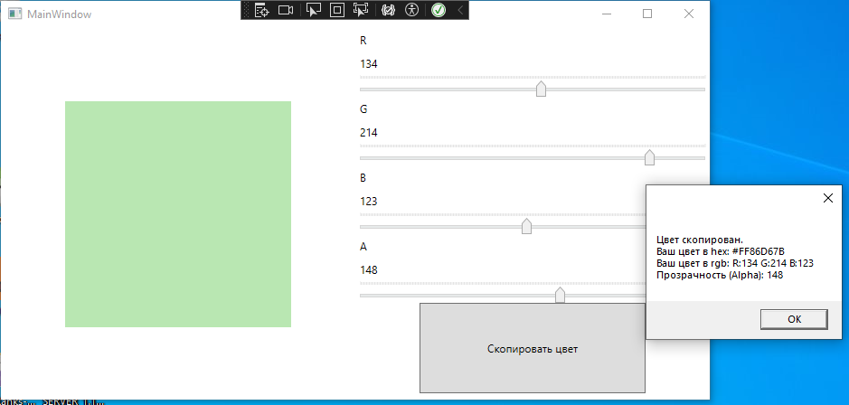

Рисунок 1. Раскрашивание и копирование цвета.