TEST YOUR KNOWLEDGE - CALCULATOR

Last updated: [9 July, 2021]

You may not use or facilitate the use of this document in connection with any infringement or other legal analysis concerning Intel products described herein.

No license (express or implied, by estoppel or otherwise) to any intellectual property rights is granted by this document.

All information provided here is subject to change without notice. Contact your Intel representative to obtain the latest Intel product specifications and roadmaps.

The products described may contain design defects or errors known as errata which may cause the product to deviate from published specifications. Current characterized errata are available on request.

Intel Corporation. All rights reserved. Intel, the Intel logo, and other Intel marks are trademarks of Intel Corporation or its subsidiaries. Intel warrants performance of its FPGA and semiconductor products to current specifications in accordance with Intel's standard warranty, but reserves the right to make changes to any products and services at any time without notice. Intel assumes no responsibility or liability arising out of the application or use of any information, product, or service described herein except as expressly agreed to in writing by Intel. Intel customers are advised to obtain the latest version of device specifications before relying on any published information and before placing orders for products or services.

*Other names and brands may be claimed as the property of others.

Copyright © 2021, Intel Corporation. All rights reserved.

Contents

1.0 Introduction 3

1.1 Prerequisites 3

1.2 Reference Documents 3

2.0 Top Level Schematic 4

3.0 Modules Provided 6

3.1 Ctr 0-98 *change to 0-99 (built from IP catalog) 6

3.2 Clock divider 50 MHz to 2 Hz 6

3.3 Eight bit binary to decimal 7

3.4 Seven segment 7

4.0 Document Revisions 8

# Introduction

**This is a short lab to test your knowledge in assembling a small FPGA project on the DE10-Lite development kit. The circuit adds the values of two counters (0-98) that are enabled with push button switches. The two addends and the sum are displayed on the seven segment displays. Since the sum can overflow to a 3rd hundreds place digit and there are only 6 seven segment displays, the hundreds position should be represented by lighting up all 10 LEDs simultaneously.**

## Prerequisites

* Introduction to Intel FPGAs and Quartus Software course
  + Link to self-guided course: [OUWINTRO](https://www.intel.com/content/www/us/en/programmable/support/training/course/ouwintro.html)
* Basic knowledge of Verilog and digital design
* Intel FPGA Board with (at least) the following features:
  + 2 pushbuttons
  + 1 LED
  + 6 Seven segment displays

## Reference Documents

Table 1‑1. Reference Documents

|  |  |
| --- | --- |
| Document | Document No./Location |
| QAR file for calculator | [addit.qar](https://github.com/intel/FPGA-Devcloud/blob/master/main/QuickStartGuides/TestYourKnowledge/TestYourKnowledge_Calculator/addit.qar) |

# Top Level Schematic

1. Set up a project and pin assignments for the following pins:
   1. Clock
   2. 2 pushbuttons
   3. 6 seven segment displays
2. Create top module based on provided wrapper. This requires editing the Verilog file and wiring up the blocks.
3. Compile and program on board
4. Change ctr to count to 99
5. Now make the hundreds position light up 10 LEDs. Add LEDs to top level and check pin assignments
6. Bonus section (Go for it!) : Make ctr count up or down, by controlling its direction with switch 0.

# Modules Provided

## Ctr 0-98 *change to 0-99 (built from IP catalog)

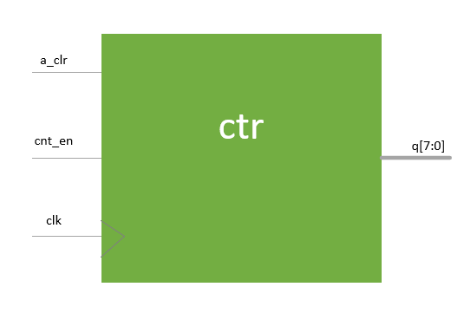Note that the counter is a parametrized IP. To edit the counter: Project Navigator Change to IP Components. Right click on LPM COUNTER and change to include updown input port. You will need to add the updown port to the top level and connect to appropriate SW[0] signal which is preassigned in the assignment editor.

* Input a_clr
* Input cnt_en
* Input clk
* Output q

Counter counts up while cnt_en is active at the rising edge of clk. A_clr is used to reset the count which is output by q.

## Clock divider 50 MHz to 2 Hz

* 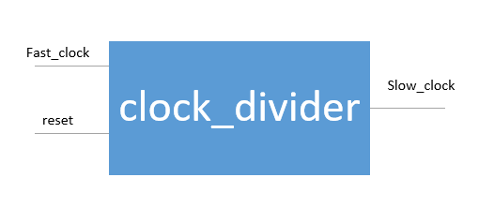Input fast_clock
* Input reset
* Output slow_clock

The clock divider takes the 50 MHz clock generated by the FPGA and outputs a slower clock signal which has a frequency dependent on the value of the size of the internal counter.

## Eight bit binary to decimal

* Input [7:0] binary
* Output [3:0] decimal_hundreds
* Output [3:0] decimal_tens
* 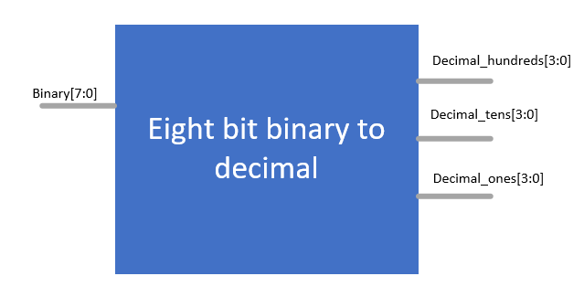Output [3:0] decimal_ones

Converts the binary output of the counter into values that represent ones, tens, and hundreds places in the decimal system.

## Seven segment

* Input [3:0] led_bcd
* Output reg [6:0] led_out

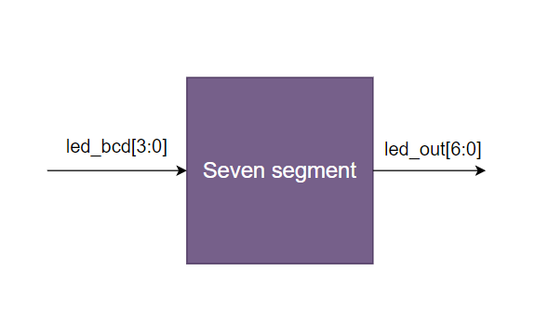

Converts the value 0-9 from binary coded decimal to the decoded value needed to properly light up the 7-segment LED.

# Document Revisions

|  |  |  |
| --- | --- | --- |
| Date | Author | Comments |
| 6/25/2021 | RK | Transferred TYK1 guide to common Word template and included diagrams for modules provided. |