Settings: Setting Default Ledger and Period
The default ledger, year, and period can be set on an individual basis. By default, it is set at the current period. There are times it can be helpful to change the default. For example, if the new year and new period have already been opened but you are still entering receipts in the old year/period, you can manually select the correct year/period for each new batch or you can temporarily change your default year/period to the old year.
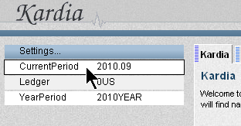
- In the Settings box on the upper left, click on one of the current settings. (It doesn't matter which one you click on.)

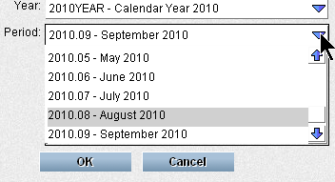
- Click on the drop down arrows to change the ledger, year, or period and select the settings you want as the default.

- Click OK

Back at the main screen, the settings box should display the new defaults.

- This only affects the computer/user that the settings were changed for. This does not affect anyone else.
- Some areas of this are still being implemented. If you stumble across this documentation too early, please realize that some of the modules are set up to go to “most recent period” instead of going to the default period. This will eventually be adjusted.

