Kardia Basics: Setting Enter Key Preferences
The Enter key on the keyboard can be set to be used in different ways. See notes at the bottom on the three options and what each option might be useful for.

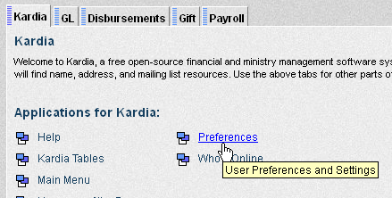
- On the Kardia tab, click Preferences

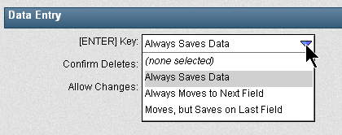
- In the Data Entry section, click the drop down arrow to see the list of options for the [ENTER] Key setting.
- Click on the option desired.
- Click Save to save the change.

Available Options:
Option 1 – Always Saves Data: This option is often used if the tab button or mouse are used to move from field to field within a page. Pressing the [ENTER] key will attempt to save the page/data entered.

Option 2 – Always Moves to Next Field: Generally not recommended. This option requires the mouse to be used to save a form or any changes. Instructions for some Kardia documentation will not work if this setting is used.

Option 3 – Moves, but Saves on Last Field: This option is often used when the 10 key pad is being heavily utilized. This will allow pressing the ENTER key to move from field to field and then save when the end of the form/page is reached. Since there is an ENTER key, but not a TAB key on the 10 key pad, using this setting can greatly aid efficiency when using a 10 key as the main point of entry.

