Gift Reports: Running the Mailings for Gifts Report
The Mailings for Gifts report is used to manually look through the list of donors for a particular month and overview the mailing lists of which they are a part. This report takes lots of “computer thinking,” so you may want to avoid running this report when other major entry (such as gift entry or payroll) is happening.
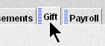
- In Kardia, click on the Gift tab
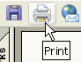
- Click on Mailings for Gifts
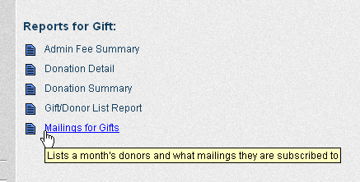
- Using the Period drop down arrow, click on the period needed for the report. If you're wanting the March report, choose the March period.
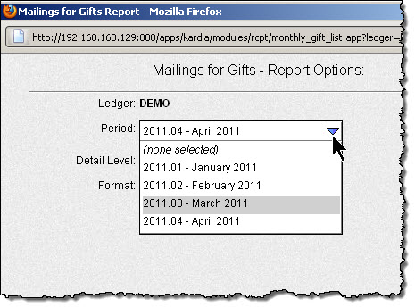
- Click Print. Wait for the report.
Note: This report may take 45-90 seconds to run after you click the Print button. If you haven't seen it in 5 minutes, email LightSys.

