Gift Receipting in Kardia
Basic instructions for doing gift receipting in Kardia. While this document cannot provide all answers, it is designed to help in most common situations. If you need instructions for accessing Kardia, please see Basics-GettingLoggedIn.pdf.

- In the Gift tab, click Receipts Batches
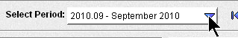
- Make sure Select Period displays the correct month.

Creating a New Receipts Batch

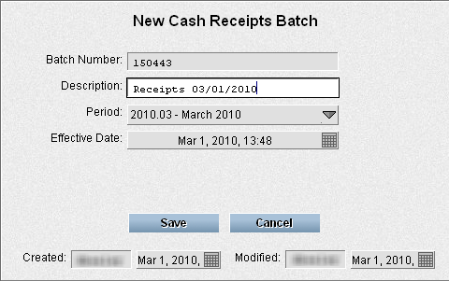
- Click the New Batch button

- Enter Receipts mm/dd/yyyy in the Description box.. You can enter whatever description fits that batch – Capital Dynamics mm/dd/yyyy, Web Gifts mm/dd/yyyy, or other...
- Click Save

If you later need to edit the Description or other batch details, select the batch and click the Edit Batch Details button. This will display the same options as above. Make any needed changes and click Save.

Enter Receipts in an Existing Batch

- Click on the batch in which you want to add/edit receipts
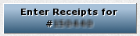
- Click Enter Receipts for #

Starting a New Receipt

- Click New Receipt

In the Donor section (use tab to go from field to field – press Enter to jump to Designation)
- Enter the partner ID
Different ways you can do this:
    - Type in the partner ID and press Tab or
    - Type in any part of the donor name (Bergen Jo) and press F3. Use the keyboard arrows to find the correct donor name and press Tab or
    - Type in zip code and part of the donor name (30277 Bergen or 30277 Joe) and press F3. Use the keyboard arrows to find the correct donor name and press Tab

Tip: Think about the most unique part of their name or zip. If their name is Danica Smith, try searching for Danica. There will probably be fewer of those in the database.
Caution: First names can be tricky. The account can be under the spouse's name or under Bill instead of William. Search several ways before adding a new donor.

- If the search returned multiple entries and you're not sure which is right, click on the one that might be correct and look at the address/giving history in the donor window.
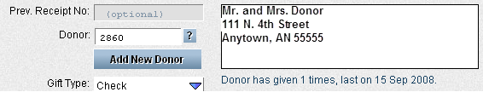
- If the donor is not the one you are wanting, click in the Donor number field and search again.

Caution: Uncertain about a donor or address? Set it aside and check into it more thoroughly later. Getting receipts right is important.
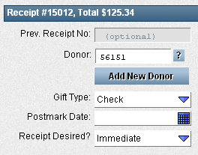
- Use tab to go to the next fields OR use Enter to jump to the designation if everything is correct.
  - Gift Type: Click arrow to chose from list if this needs changed
  - Postmark Date: Okay to leave blank. If you are entering end of year gifts, you can fill in this box by simply typing the date mm/dd or by clicking on the calendar and selecting the date
  - Receipt Desired: If the donor requests to receive only an annual receipt, click the arrow to choose “Annual” from the list
  - Goods Provided: If the gift was in payment for books or other materials, enter the value of the goods provided here. Otherwise leave at the default – 0.

In the Designation section (Use tab to go from field to field.)
- Check number: Type in check number or leave blank if N/A.
- Amount: Type in amount. (You don't need to put the “.00” – it will fill it in)
- Personal gift: Check box if gift is a personal gift to a missionary
- Anonymous gift: Check box if donor wants gift to be anonymous. They will still get a receipt printed and mailed to them, but they will be shown as Anonymous in the donation reports.
- Designation: Type in designation number or type part of the designation description and then press F3 to search for it in the list. Click on the designation or use the down arrows to select the correct designation and press tab.
- Admin Fee Type: This is automatically set. If it needs changed for some reason, use the drop down arrow to choose from the list
- Comments – enter any needed comments
- Press Enter to finish and save the designation
or
Press Enter twice to save the designation and begin a new receipt.

Another designation for the same receipt?: The cursor should be back in the check number box and you can immediately start entering the next designation for that receipt. Repeat steps 8-15.
Tip: Use the ⬆ key on your keyboard to recall the last value entered in a field. (Example: use ⬆ in the check number field to use the same check number.)

Ready for the next receipt? Click New Receipt or use the “press enter twice” tool mentioned in #15.

Not wanting to start a new receipt or a new designation? Press Esc after saving the last designation.

Editing Receipts or Designations (that are saved, but not yet posted)
- Click on the line item that needs to be edited.
- Make any changes
- Click Save (or click Cancel to discard changes)

If Message Says: Data Save Failed
If you click Save to save a receipt or designation and you get a message saying Data Save Failed, follow these steps.
- Click OK to the Data Save Failed message
- Check the designation for empty amount field or designation field
- Check for invalid designation
- Try to fix the field that had the empty or incorrect information.
- If you continue to receive the Data Save Failed error on that receipt, close out of the batch (using the X) and then go back into it and continue with changes.

Random Tips
- Use the F3 button to search anytime you have a field with a question mark box at the end. You can use the arrow keys on your keyboard or your mouse to browse the list.
- Use the ⬆ key on your keyboard to repeat the last value entered on a field. For example, instead of retyping the check number for the second designation, press the ⬆ key and the last check number will show in the field.
- Designation letters are case insensitive. The program will automatically change 40006.b into 40006.B. However, if there is a “.” in the designation, the “.” is required!
- When you finish a designation, press Enter once to enter another designation for the new receipt or press Enter twice to start entering a new donor/receipt. If you don't want to start either a new designation or a new receipt, press Enter once to save the designation just entered and then press Esc to close out of entry mode.
- The documentation is set up assuming the Kardia preferences ENTER key settings at “Always Saves Data.” If yours is set up otherwise, results will be slightly different. Example if key settings are “Moves, but Saves on Last Field”: Pressing ENTER after typing in the Partner ID will simply move you to the next field, not jump you to the designation. Setting the ENTER to “Always Moves to Next Field” is not recommended since it does not work with many of the above instructions. To see instructions for changing Kardia ENTER key settings, see Basics-SettingEnterKey.pdf.

