Gift Receipting: Running a Donation Detail Report
The Donation Detail Report can be used to look at gift information in a specific batch or a time period. The report will “print” to the computer screen where it can be reviewed electronically or printed to paper.

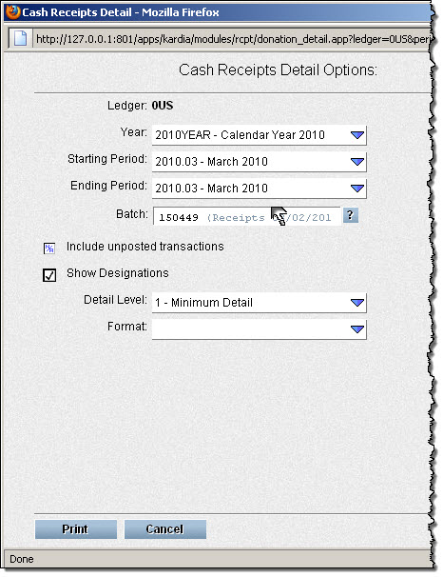
- On the Gift tab, click Donation Detail

- Year, Starting Period, Ending Period: These fields are required. Use the drop down list to select the correct period.
- Batch: Leave this field blank if reporting on a time period. For a specific batch, type in the Batch number (easiest) or click on the ? to choose from the pick list.

- Include Unposted Transactions: Generally leave this as N/A. If you want to include unposted transactions from the batch or time period, click on the check box until the check mark displays.

- Show Designations: Click twice on the check box to make the check mark display. If you do not want the designation lines to be included, leave the check box empty or N/A.

- Detail Level: Use the drop down list to select the amount of detail in the report. If left blank, it will default to “1 – Minimum Detail.”

- Format: Defaults to PDF when left blank. This should be correct for most situations. If a different format is desired, use the drop down list to select the format.
- Click Print and the report will be “printed” on the screen. To print the report on paper, use the print options from the displayed report.

