Gift Receipting in Kardia – Gifts that Need Looking Up

- Start Kardia from the icon on the desktop
- Enter your user name and password in the Authentication box. Click OK.
- Click on the Gift tab
- Click on Receipts Batches

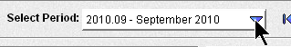
- Make sure Select Period displays the correct month.

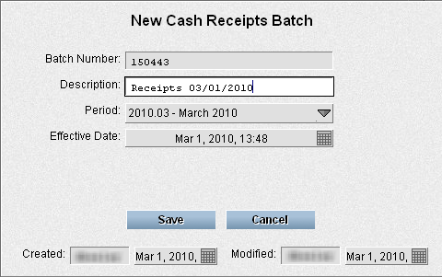
- Click the New Batch button

- Enter Receipts mm/dd/yyyy in the Description box.
- Click Save

Enter Receipts

- Click Enter Receipts for #

- Click New Receipt

- Search to see if the donor is in the system
Different ways you can do this:
    - Type in the partner ID and press Tab or
    - Type in any part of the donor name (Bergen Jo) and press F3. Use the keyboard arrows to find the correct donor name and press Tab or
    - Type in zip code and part of the donor name (30277 Bergen or 30277 Joe) and press F3. Use the keyboard arrows to find the correct donor name and press Tab

Tip: Think about the most unique part of their name or zip. If the person is name Danica Smith, search for Danica, not Smith. There will probably be fewer of those in the database.

- If the search returned multiple entries and you're not sure which is right, click on the one that might be correct and look at the address/giving history in the donor window.
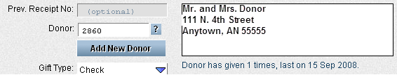
- If the donor is not the one you are wanting, click in the Donor number field and search again.
If a donor is not found in Kardia or if there is an address change needed, set the gift aside to search for/enter later in FilePro and move on to the next gift.

- If the right Donor is selected, use Enter to jump to the designation.

In the Designation section
- Type in check number Press Tab
- Type in amount Press Tab
- Press Tab two more times to get past Personal Gift and Anonymous Gift
- Designation code: Type in the Designation code OR search for it
Searching for designation code:
  - Type part of the designation description in the designation field. Part of the description might include missionary last name or part of the project name.
  - Use the arrow keys to highlight the correct designation.
  - Press tab and glance at Designation code description to make sure it's right.
- Press Enter if no comments
or if there are comments, press tab to get to comments, enter the comments, and press Enter
- Write the receipt number on the envelope

Another designation for the same receipt?: The cursor should be back in the check number box and you can immediately start entering the next designation for that receipt. Repeat steps 15-19.

Ready for the next receipt? Click New Receipt or press Enter again.

Not wanting to start a new receipt or a new designation? Press Esc after saving the last designation.

