Gift Receipting in Kardia – Gifts with Return Receipts
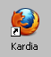
- Start Kardia from the icon on the desktop
- Enter your user name and password in the Authentication box. Click OK.
- Click on the Gift tab
- Click on Receipts Batches
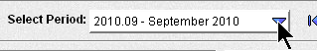
- Make sure Select Period displays the correct month.

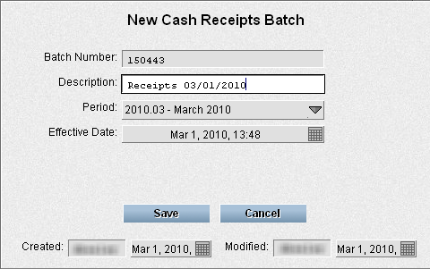
- Click the New Batch button

- Enter Receipts mm/dd/yyyy in the Description box.

- Click Save
Enter Receipts
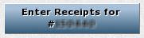
- Click Enter Receipts for #

- Click New Receipt
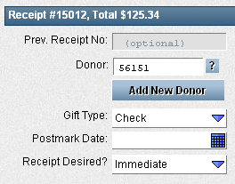
- Enter the Donor number
- Press Tab
- Donor right? Press Enter to jump to designation

In the Designation section
- Type in check number Press Tab
- Type in amount Press Tab
- Press Tab two more times to get past Personal Gift and Anonymous Gift (but remember to check these boxes if the gift is a personal gift or anonymous gift!)
- Type in the Designation code.
- Press tab and glance at Designation code description to make sure it's right.
- Press Enter if no comments
or if there are comments, press tab to get to comments, enter the comments, and press Enter
- Write the receipt number on the envelope

Another designation for the same receipt?: The cursor should be back in the check number box and you can immediately start entering the next designation for that receipt. Repeat steps 14-19.

Ready for the next receipt? Click New Receipt or press Enter again.

Not wanting to start a new receipt or a new designation? Press Esc after saving the last designation.

