GL: Creating a New Monthly Accounting Period
Instructions on how to create a new monthly accounting period. Consider doing this immediately before the start of the new period. Creating it too far in advance can cause others working in Kardia to inadvertently choose the wrong financial period.

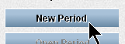
- In the GL tab, click GL Period Maintenance
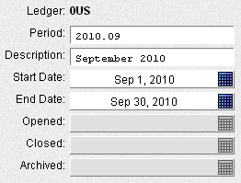
- Click “New Period”
- Period: Enter yyyy.mm with mm being the new month.

- Description: Enter the new Month and yyyy
(e.g. September 2010)

- Start Date: Click on the calendar and choose the first day of the new period from the drop down.

- End Date: Click on the calendar and choose the last day of the new period from the drop down.
You can also type the dates in the Start/End Date boxes (i.e. 9/1 and 9/31), but using the calendar ensures that the month has the correct number of days included.

- Click Save

- When it is finished saving, click Open Period.
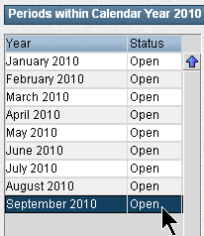
When finished, the new period should be listed at the left side with the other calendar year periods and the status should be “Open.”

