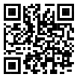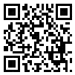PPI-1 : PPN-1 :

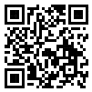

PPI-2 : PPN-2 :

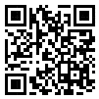

PPI-3 : PPN-3 :

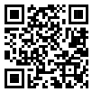

PPI-4 : PPN-4 :

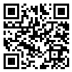

PPI-5 : PPN-5 :

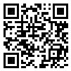

PPI-6 : PPN-6 :

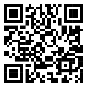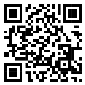

PPI-7 : PPN-7 :

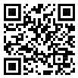

PPI-8 : PPN-8 :

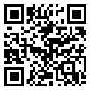

PPI-9 : PPN-9 :

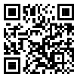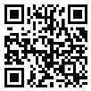

PPI-10 : PPN-10 :

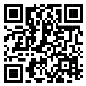

PPI-11 : PPN-11 :

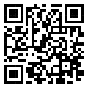

PPI-12 : PPN-12 :

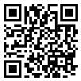

PPI-13 : PPN-13 :

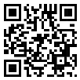

PPI-14 : PPN-14 :

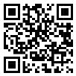

PPI-15 : PPN-15 :