gIntroduction to Spring Boot | What is Spring Boot | Spring Boot Tutorial in

Introduction to Spring Boot
Spring Boot is a framework built on top of the Spring Framework, designed to simplify the development of Java-based enterprise applications. It eliminates the need for extensive configuration and provides pre-configured defaults to help developers create production-ready applications quickly.

Key Features of Spring Boot
- Auto-Configuration:
  - Automatically configures the Spring application based on the libraries available on the classpath.
  - Removes the need for explicit XML or Java-based configuration.
- Standalone Applications:
  - Spring Boot enables the creation of standalone applications that can run with an embedded server (e.g., Tomcat, Jetty).
- Embedded Servers:
  - No need to deploy WAR files; instead, applications run as JAR files with embedded servers like Tomcat, Jetty, or Undertow.
- Production-Ready:
  - Provides features like health checks, monitoring (via Actuator), and metrics out of the box.
- Spring Boot Starter Dependencies:
  - Bundles commonly used dependencies into “starters,” simplifying dependency management (e.g., spring-boot-starter-web, spring-boot-starter-data-jpa).
- Command Line Interface (CLI):
  - Allows running Spring applications from the command line with minimal setup.
- Spring Boot Actuator:
  - Provides tools for application monitoring, gathering metrics, and operational insights.

Advantages of Spring Boot
- Rapid Development: Faster time to market due to auto-configuration and pre-built features.
- Microservices-Friendly: Ideal for building lightweight, standalone microservices.
- Reduced Complexity: Removes boilerplate code and configuration.
- Wide Integration: Works seamlessly with various databases, messaging systems, and cloud platforms.

Why Use Spring Boot?
Spring Boot is designed to:
- Simplify Spring-based application development.
- Provide a faster way to build production-ready applications.
- Reduce boilerplate code and manual configuration.

Practical Example
A simple Spring Boot application can be created with minimal setup:
java
Copy code
@SpringBootApplication
public class MySpringBootApplication {
public static void main(String[] args) {
SpringApplication.run(MySpringBootApplication.class, args);
}
}

Summary
Spring Boot is a powerful framework that simplifies application development, enabling developers to focus on business logic while handling the configuration and setup automatically. It’s particularly suited for building REST APIs, web applications, and microservices.

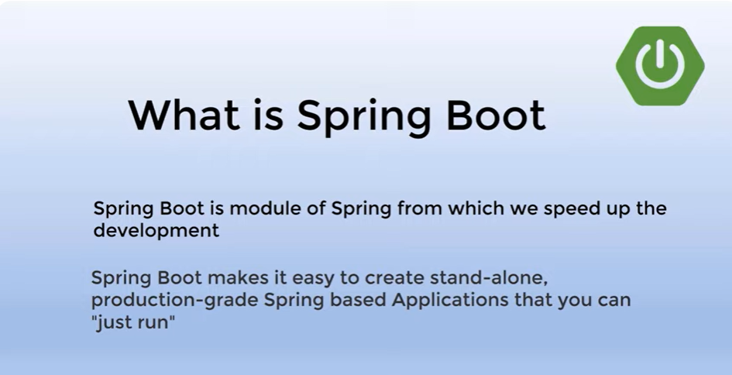
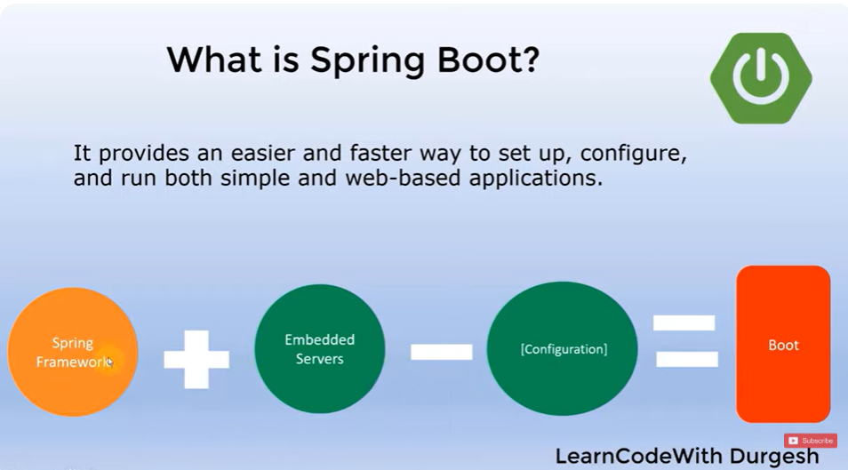
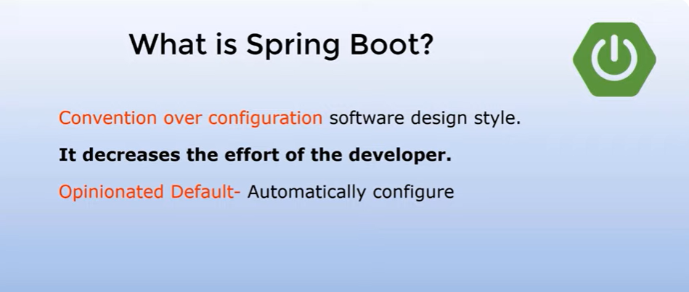
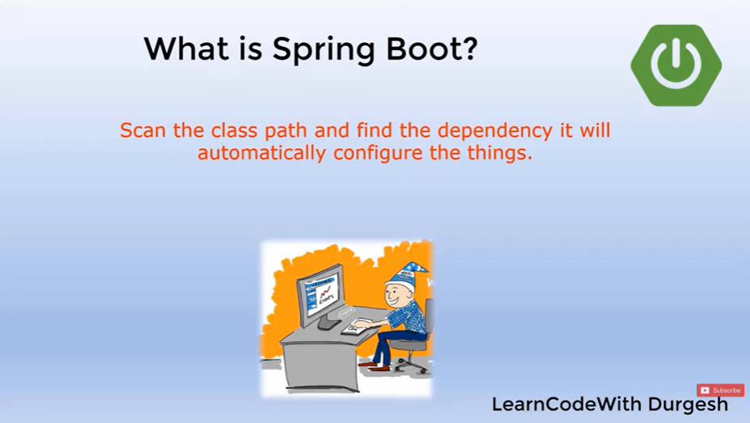
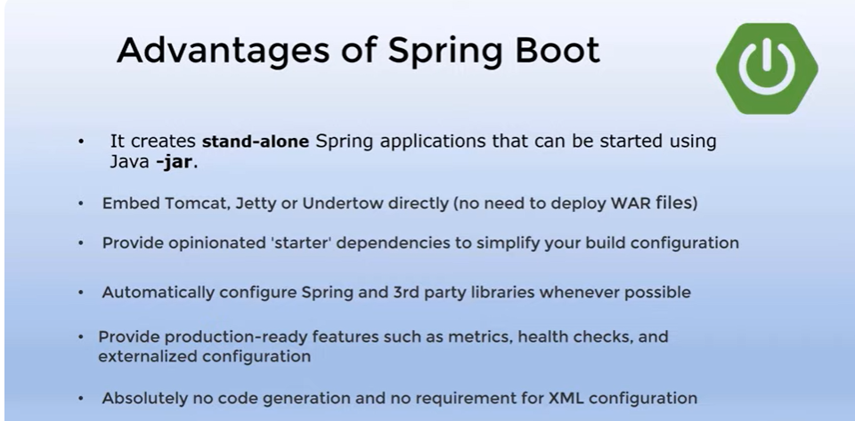
How Spring Boot Auto Configuration Magic works | Spring boot Tutorial

How Spring Boot Auto-Configuration Works
Spring Boot’s auto-configuration is one of its most powerful features. It simplifies the development process by automatically configuring your application based on the dependencies and properties defined. Here’s a breakdown of how the "magic" of auto-configuration works:

Key Components of Auto-Configuration
- Spring Boot Starters:
  - Starter dependencies (like spring-boot-starter-web or spring-boot-starter-data-jpa) pull in the necessary libraries and frameworks for your application.
  - For example:
xml
Copy code
<dependency>
<groupId>org.springframework.boot</groupId>
<artifactId>spring-boot-starter-web</artifactId>
</dependency>
This brings in libraries like Spring MVC, Jackson for JSON processing, and an embedded Tomcat server.
- @EnableAutoConfiguration Annotation:
  - Included in the @SpringBootApplication annotation:
java
Copy code
@SpringBootApplication
public class MyApplication {
public static void main(String[] args) {
SpringApplication.run(MyApplication.class, args);
}
}
  - It triggers the auto-configuration mechanism by scanning the classpath and configuring beans automatically.
- META-INF/spring.factories:
  - Spring Boot uses the spring.factories file located in META-INF to define which auto-configuration classes should be loaded.
  - Example entry in spring.factories:
Copy code
org.springframework.boot.autoconfigure.EnableAutoConfiguration=\
org.springframework.boot.autoconfigure.web.servlet.WebMvcAutoConfiguration,\
org.springframework.boot.autoconfigure.orm.jpa.HibernateJpaAutoConfiguration
- Conditional Annotations:
  - Auto-configuration classes use conditional annotations to determine if certain configurations should be applied:
    - @ConditionalOnClass: Checks if a specific class is on the classpath.
    - @ConditionalOnMissingBean: Checks if a bean is not already defined by the user.
    - @ConditionalOnProperty: Checks if a specific property is set in application.properties.
Example:
java
Copy code
@Configuration
@ConditionalOnClass(DataSource.class)
public class DataSourceAutoConfiguration {
@Bean
public DataSource dataSource() {
return new HikariDataSource(); // Default DataSource
}
}

How It Works Step-by-Step
- Dependency Inclusion:
  - When you add a Spring Boot starter dependency, it pulls in the related libraries.
- Classpath Scanning:
  - Spring Boot scans your classpath to detect the included libraries and frameworks.
- Auto-Configuration Classes:
  - Based on the detected libraries, Spring Boot loads the corresponding auto-configuration classes listed in spring.factories.
- Conditional Logic:
  - Each auto-configuration class checks if the required conditions (classes, beans, or properties) are met.
- Bean Creation:
  - If the conditions are satisfied, Spring Boot creates and configures the necessary beans automatically.

Example: Web Application
When you include spring-boot-starter-web:
- Spring Boot detects that spring-web is on the classpath.
- Loads WebMvcAutoConfiguration.
- Configures a default DispatcherServlet, ViewResolver, and other web-related beans.

Disabling Auto-Configuration
If you want to exclude specific auto-configuration classes, you can do so using the exclude attribute:
java
Copy code
@SpringBootApplication(exclude = {DataSourceAutoConfiguration.class})
public class MyApplication {
public static void main(String[] args) {
SpringApplication.run(MyApplication.class, args);
}
}
Or in application.properties:
properties
Copy code
spring.autoconfigure.exclude=org.springframework.boot.autoconfigure.jdbc.DataSourceAutoConfiguration

Benefits of Auto-Configuration
- Reduces boilerplate code.
- Simplifies configuration for common use cases.
- Provides sensible defaults while allowing customization.

Summary
Spring Boot’s auto-configuration works by detecting the presence of certain libraries and properties and then applying configuration using conditional logic. The combination of @EnableAutoConfiguration, spring.factories, and conditional annotations is the "magic" behind it. This allows developers to focus on writing business logic while Spring Boot takes care of the setup.
Spring Boot uses conditional annotations to determine whether specific beans or configurations should be loaded. Here’s a detailed explanation of the key annotations involved in its auto-configuration process:

1. @ConditionalOnClass
- Purpose: The configuration is applied only if a specific class is present in the application’s classpath.
- Use Case: Used to ensure that the auto-configuration activates only when certain dependencies are available.
Example:
java
Copy code
@Configuration
@ConditionalOnClass(name = "javax.sql.DataSource")
public class DataSourceAutoConfiguration {
@Bean
public DataSource dataSource() {
return new HikariDataSource(); // Provides a default DataSource
}
}
How it works:
- Checks for the presence of the javax.sql.DataSource class.
- If the class is available, the dataSource bean is created.

2. @ConditionalOnMissingBean
- Purpose: The configuration is applied only if a specific bean is not already defined in the application context.
- Use Case: Prevents overriding custom user-defined beans.
Example:
java
Copy code
@Bean
@ConditionalOnMissingBean(DataSource.class)
public DataSource defaultDataSource() {
return new HikariDataSource();
}
How it works:
- If a DataSource bean is already defined in the application, this configuration will be skipped.
- If no DataSource is defined, it creates and registers the defaultDataSource bean.

3. @ConditionalOnProperty
- Purpose: The configuration is applied based on the presence or value of a property in application.properties or application.yml.
- Use Case: Allows toggling features or settings through configuration.
Example:
java
Copy code
@Configuration
@ConditionalOnProperty(name = "feature.x.enabled", havingValue = "true", matchIfMissing = false)
public class FeatureXConfiguration {
@Bean
public FeatureX featureX() {
return new FeatureX();
}
}
How it works:
- If feature.x.enabled=true is set in application.properties, the FeatureX bean is registered.
- If the property is missing or set to false, the configuration is skipped.
Attributes:
- name: The name of the property to check.
- havingValue: The value that the property must have for the condition to match.
- matchIfMissing: Defaults to false. If set to true, the condition matches even if the property is not defined.

4. @ConditionalOnBean
- Purpose: The configuration is applied only if a specific bean is already present in the application context.
- Use Case: Used to create configurations that depend on existing beans.
Example:
java
Copy code
@Configuration
@ConditionalOnBean(DataSource.class)
public class JpaConfiguration {
@Bean
public EntityManagerFactory entityManagerFactory() {
// Configures EntityManagerFactory based on the existing DataSource
return new EntityManagerFactory();
}
}
How it works:
- Checks if a DataSource bean exists.
- If it does, the entityManagerFactory bean is created.

5. @ConditionalOnWebApplication
- Purpose: The configuration is applied only if the application is a web application.
- Use Case: Ensures that web-specific configurations are applied only in web applications.
Example:
java
Copy code
@Configuration
@ConditionalOnWebApplication
public class WebMvcAutoConfiguration {
@Bean
public DispatcherServlet dispatcherServlet() {
return new DispatcherServlet();
}
}
How it works:
- Checks if the application is running as a web application (e.g., with an embedded web server like Tomcat or Jetty).
- If true, registers the dispatcherServlet bean.

6. @ConditionalOnNotWebApplication
- Purpose: The configuration is applied only if the application is not a web application.
- Use Case: Useful for non-web-based (CLI or batch) applications.
Example:
java
Copy code
@Configuration
@ConditionalOnNotWebApplication
public class NonWebAppConfiguration {
@Bean
public CommandLineRunner commandLineRunner() {
return args -> System.out.println("Running in non-web mode!");
}
}

7. @ConditionalOnResource
- Purpose: The configuration is applied only if a specific resource (e.g., a file) is available.
- Use Case: Used to conditionally load configurations based on resource presence.
Example:
java
Copy code
@Configuration
@ConditionalOnResource(resources = "classpath:application.properties")
public class ResourceBasedConfiguration {
@Bean
public MyResourceDependentBean myBean() {
return new MyResourceDependentBean();
}
}
How it works:
- Checks if application.properties exists in the classpath.
- If it does, the configuration is applied.

8. @Conditional
- Purpose: A generic condition annotation that allows custom logic to determine whether a configuration should be applied.
- Use Case: Implement complex or custom conditional logic.
Example:
java
Copy code
@Configuration
@Conditional(MyCustomCondition.class)
public class CustomConfiguration {
@Bean
public MyCustomBean customBean() {
return new MyCustomBean();
}
}
Custom Condition:
java
Copy code
public class MyCustomCondition implements Condition {
@Override
public boolean matches(ConditionContext context, AnnotatedTypeMetadata metadata) {
// Custom logic for matching
return context.getEnvironment().containsProperty("my.custom.property");
}
}

Summary Table of Conditional Annotations
Annotation | Applies When
@ConditionalOnClass | A specific class is on the classpath.
@ConditionalOnMissingBean | A specific bean is not already defined.
@ConditionalOnProperty | A property exists and has a specific value.
@ConditionalOnBean | A specific bean is already defined.
@ConditionalOnWebApplication | The application is a web application.
@ConditionalOnNotWebApplication | The application is not a web application.
@ConditionalOnResource | A specific resource exists.
@Conditional | A custom condition is met.

Summary
Spring Boot’s conditional annotations allow it to decide which configurations to apply dynamically, based on the application’s environment, classpath, properties, or custom logic. This flexibility enables Spring Boot to provide a wide range of defaults while remaining customizable.

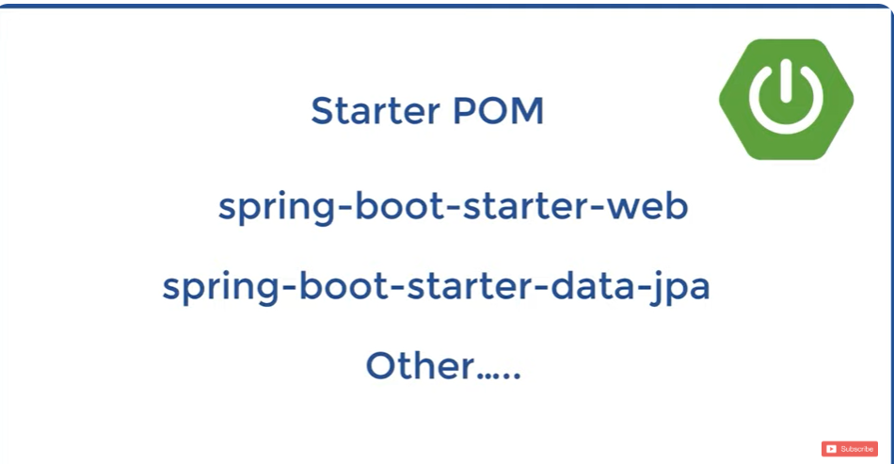
Maven dependency
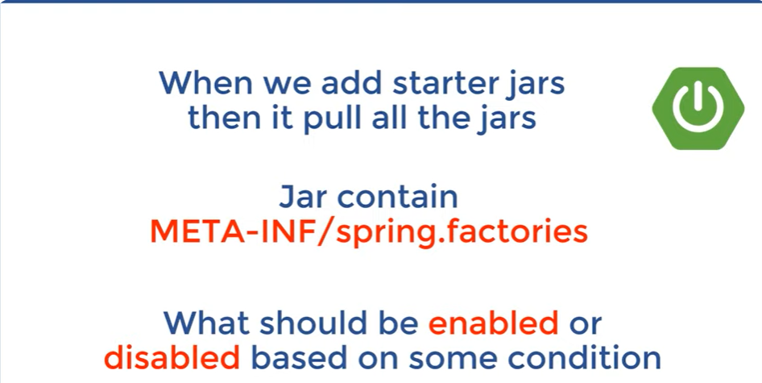
Auto configurations are present in spring.factories
Enabling and disabling are based on conditional annotations on bean
How to start with spring boot project | Ways to create spring boot project
Spring Boot makes it simple to start a project with minimal configuration. Here are the main ways to create and initialize a Spring Boot project:

1. Using Spring Initializr (Recommended for Beginners)
Steps:
- Visit Spring Initializr:
  - Go to https://start.spring.io.
- Configure the Project:
  - Project: Choose Maven or Gradle.
  - Language: Select Java.
  - Spring Boot Version: Choose the latest stable version.
  - Project Metadata: Fill in:
    - Group: e.g., com.example.
    - Artifact: e.g., demo.
  - Dependencies: Add dependencies like:
    - Spring Web (for web applications),
    - Spring Data JPA (for database access),
    - H2 Database (optional, for in-memory DB).
- Generate the Project:
  - Click "Generate" to download the project as a .zip file.
  - Extract it to your desired location.
- Import into IDE:
  - Open the project in an IDE like IntelliJ IDEA, Eclipse, or VS Code.
- Run the Application:
  - Locate the main class (annotated with @SpringBootApplication) and run it.
java
Copy code
@SpringBootApplication
public class DemoApplication {
public static void main(String[] args) {
SpringApplication.run(DemoApplication.class, args);
}
}

2. Using an IDE (Eclipse or IntelliJ IDEA)
Eclipse:
- Open Eclipse and ensure the Spring Tools 4 plugin is installed.
- Go to File → New → Spring Starter Project.
- Fill in the project metadata (Group, Artifact, Name, etc.).
- Select dependencies (e.g., Spring Web, Spring Boot DevTools, etc.).
- Click Finish to generate the project.
- Run the application by right-clicking the main class and selecting Run As → Spring Boot App.
IntelliJ IDEA:
- Open IntelliJ IDEA and go to File → New → Project.
- Select Spring Initializr and click Next.
- Configure the project metadata and select dependencies.
- Click Finish to create the project.
- Run the application from the main class.

3. Using Spring Boot CLI
The Spring Boot Command Line Interface (CLI) is a tool that allows you to quickly bootstrap a Spring Boot application.
Steps:
- Install Spring Boot CLI:
  - Download it from the official Spring Boot CLI site.
  - Add it to your system's PATH.
- Create a new project:
bash
Copy code
spring init --dependencies=web,data-jpa,h2 my-project
  - This creates a project with the specified dependencies.
- Navigate to the project directory:
bash
Copy code
cd my-project
- Build and run the application:
bash
Copy code
./mvnw spring-boot:run

4. Manually Setting Up a Maven Project
If you prefer manual control, you can create a Maven project and configure Spring Boot.
Steps:
- Create a Maven project in your IDE.
- Add the Spring Boot dependencies to your pom.xml:
xml
Copy code
<dependencies>
<dependency>
<groupId>org.springframework.boot</groupId>
<artifactId>spring-boot-starter-web</artifactId>
</dependency>
<dependency>
<groupId>org.springframework.boot</groupId>
<artifactId>spring-boot-starter-data-jpa</artifactId>
</dependency>
<dependency>
<groupId>com.h2database</groupId>
<artifactId>h2</artifactId>
</dependency>
</dependencies>
- Add the Spring Boot plugin for running the application:
xml
Copy code
<build>
<plugins>
<plugin>
<groupId>org.springframework.boot</groupId>
<artifactId>spring-boot-maven-plugin</artifactId>
</plugin>
</plugins>
</build>
- Create a main class with the @SpringBootApplication annotation and run it.

5. Using a Gradle Project
If you prefer Gradle over Maven, you can create a Gradle project and configure Spring Boot.
Steps:
- Create a Gradle project in your IDE or manually.
- Add Spring Boot dependencies to the build.gradle file:
groovy
Copy code
dependencies {
implementation 'org.springframework.boot:spring-boot-starter-web'
implementation 'org.springframework.boot:spring-boot-starter-data-jpa'
runtimeOnly 'com.h2database:h2'
}
- Add the Spring Boot plugin:
groovy
Copy code
plugins {
id 'org.springframework.boot' version '3.1.4'
}
- Build and run the application:
bash
Copy code
./gradlew bootRun

6. Using Online IDEs
For quick prototyping, you can use online platforms like:
- Spring Boot Initializr (with in-browser IDE options).
- Gitpod.
- Replit.

Summary Table
Method | Best For
Spring Initializr | Beginners and those wanting quick project setup.
IDE (Eclipse/IntelliJ) | Developers already working in these IDEs.
Spring Boot CLI | Command-line enthusiasts for rapid prototyping.
Manual Maven Setup | Developers needing fine-grained control.
Manual Gradle Setup | Those who prefer Gradle over Maven.
Online IDEs | Quick prototyping or working without installing local tools.

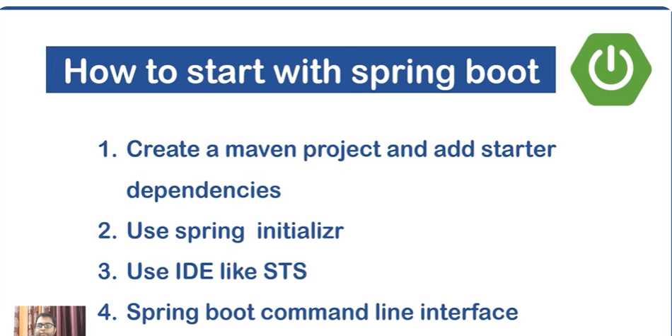
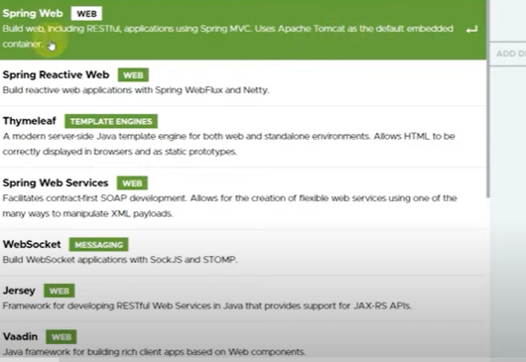
The @SpringBootApplication annotation is a central feature in Spring Boot that simplifies the configuration of your application. It combines three essential annotations:
- @Configuration: Indicates that the class can be used by the Spring IoC container as a source of bean definitions.
- @EnableAutoConfiguration: Instructs Spring Boot to automatically configure your application based on the dependencies present in the classpath.
- @ComponentScan: Enables scanning for Spring components, configurations, and services in the package where the application is located, allowing Spring to detect and register beans.
By using @SpringBootApplication, you streamline your application's setup, reducing the need for manual configuration. This annotation is typically placed on the main class of your Spring Boot application, as shown below:
java
Copy code
package com.example.demo;

import org.springframework.boot.SpringApplication;
import org.springframework.boot.autoconfigure.SpringBootApplication;

@SpringBootApplication
public class DemoApplication {
public static void main(String[] args) {
SpringApplication.run(DemoApplication.class, args);
}
}
In this example, DemoApplication is marked with @SpringBootApplication, indicating it's the primary Spring configuration class. The main method uses SpringApplication.run() to launch the application.
It's important to note that while @SpringBootApplication provides a convenient way to enable these features with their default attributes, you can customize its behavior. For instance, if you prefer not to use component scanning or auto-configuration, you can replace @SpringBootApplication with the specific annotations that suit your needs. This flexibility allows you to tailor the configuration to your application's requirements.
The @SpringBootApplication annotation is a core annotation in Spring Boot. It is a convenience annotation that combines several annotations into one. It simplifies the configuration and setup of a Spring Boot application by enabling essential functionalities with minimal code.

Breakdown of @SpringBootApplication
The annotation combines the following three annotations:
- @Configuration
  - Marks the class as a source of Spring configuration.
  - It is used to define beans using Java-based configuration instead of XML.
  - Example:
java
Copy code
@Configuration
public class AppConfig {
@Bean
public MyService myService() {
return new MyService();
}
}
- @EnableAutoConfiguration
  - Enables Spring Boot's auto-configuration mechanism.
  - Automatically configures the application based on the dependencies present in the classpath.
For example:
    - If spring-boot-starter-web is included, it configures a web application.
    - If spring-boot-starter-data-jpa is included, it configures a JPA environment.
  - You can exclude specific auto-configurations if needed:
java
Copy code
@SpringBootApplication(exclude = {DataSourceAutoConfiguration.class})
- @ComponentScan
  - Scans the package where the class is located (and sub-packages) for components, configurations, and services to register them as Spring beans.
  - It eliminates the need for explicitly specifying @ComponentScan unless you want to customize the scanning process.

Use Case
You place @SpringBootApplication on the main application class, which serves as the entry point for your Spring Boot application.

Example of @SpringBootApplication

Application Entry Point
java
Copy code
package com.example.demo;

import org.springframework.boot.SpringApplication;
import org.springframework.boot.autoconfigure.SpringBootApplication;

@SpringBootApplication
public class DemoApplication {

public static void main(String[] args) {
SpringApplication.run(DemoApplication.class, args);
}
}

What Happens:
- @Configuration: Marks the DemoApplication class as a configuration class.
- @EnableAutoConfiguration: Automatically configures the application based on dependencies in pom.xml or build.gradle.
- @ComponentScan: Scans the com.example.demo package and its sub-packages for Spring components.

Additional Features with @SpringBootApplication
- Customizing Auto-Configuration:
  - Disable specific configurations:
java
Copy code
@SpringBootApplication(exclude = {HibernateJpaAutoConfiguration.class})
- Specifying Base Packages for Scanning:
  - If your components are outside the default package:
java
Copy code
@SpringBootApplication(scanBasePackages = {"com.example.other", "com.example.another"})
- Adding CommandLineRunner:
  - You can define a CommandLineRunner bean to execute code at application startup:
java
Copy code
@SpringBootApplication
public class DemoApplication {

public static void main(String[] args) {
SpringApplication.run(DemoApplication.class, args);
}

@Bean
public CommandLineRunner commandLineRunner() {
return args -> System.out.println("Application started!");
}
}

Key Benefits of @SpringBootApplication
- Convenience: Reduces boilerplate code by combining multiple annotations into one.
- Auto-Configuration: Automatically configures commonly used components and dependencies.
- Default Component Scanning: Simplifies Spring component scanning within the package structure.

Behind the Scenes
When you use @SpringBootApplication:
- Spring Boot creates a SpringApplication object and starts the application context.
- It triggers auto-configuration, initializes beans, and configures your application.
- If you're using embedded servers (like Tomcat or Jetty), it starts them automatically.

Example Project Structure
plaintext
Copy code
src/main/java
└── com.example.demo
├── DemoApplication.java // Main application class
├── controller
│ └── HelloController.java // RestController
├── service
│ └── HelloService.java // Service class
└── model
└── Hello.java // Model class

Example: Complete Spring Boot App

HelloController.java
java
Copy code
package com.example.demo.controller;

import org.springframework.web.bind.annotation.GetMapping;
import org.springframework.web.bind.annotation.RestController;

@RestController
public class HelloController {

@GetMapping("/hello")
public String sayHello() {
return "Hello, Spring Boot!";
}
}

DemoApplication.java
java
Copy code
package com.example.demo;

import org.springframework.boot.SpringApplication;
import org.springframework.boot.autoconfigure.SpringBootApplication;

@SpringBootApplication
public class DemoApplication {

public static void main(String[] args) {
SpringApplication.run(DemoApplication.class, args);
}
}

Summary
- @SpringBootApplication is a meta-annotation that combines @Configuration, @EnableAutoConfiguration, and @ComponentScan.
- It simplifies the setup and configuration of Spring Boot applications.
- Use it on your main class to mark the starting point of your application.
4o

We can change port of server like this in application.properties
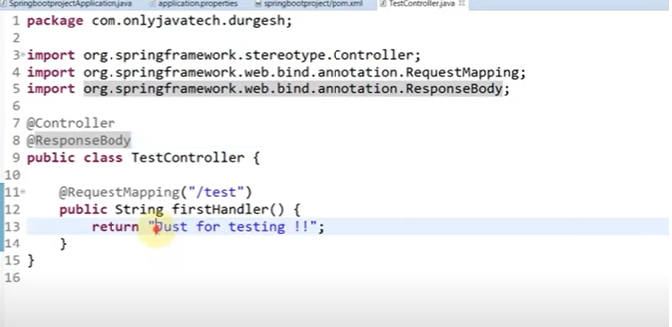
In Spring MVC, the @Controller and @ResponseBody annotations play pivotal roles in defining how web requests are handled and how responses are constructed.
@Controller Annotation:
- Purpose: Marks a Java class as a Spring MVC controller, designating it as a component that can handle web requests.
- Functionality: Within a class annotated with @Controller, methods can be defined to handle specific HTTP requests (e.g., GET, POST). These methods typically return view names, which are resolved to actual views (like JSPs or Thymeleaf templates) that render the response.
- Example:
java
Copy code
import org.springframework.stereotype.Controller;
import org.springframework.web.bind.annotation.GetMapping;

@Controller
public class MyController {

@GetMapping("/greeting")
public String greeting() {
return "greetingView"; // Refers to a view named 'greetingView'
}
}
@ResponseBody Annotation:
- Purpose: Indicates that the return value of a method should be written directly to the HTTP response body, rather than being interpreted as a view name.
- Functionality: When a method is annotated with @ResponseBody, Spring converts the method's return value into the appropriate format (e.g., JSON or XML) using HttpMessageConverters. This is particularly useful for building RESTful web services where responses are typically in JSON or XML format.
- Example:
java
Copy code
import org.springframework.stereotype.Controller;
import org.springframework.web.bind.annotation.GetMapping;
import org.springframework.web.bind.annotation.ResponseBody;

@Controller
public class MyController {

@GetMapping("/user")
@ResponseBody
public User getUser() {
return new User("John", "Doe"); // Serialized to JSON or XML
}
}
In this example, the getUser() method returns a User object, which Spring automatically serializes into JSON (assuming Jackson is on the classpath) and writes to the HTTP response body.
Combining @Controller and @ResponseBody:
- Purpose: To simplify the creation of RESTful controllers, Spring provides the @RestController annotation, which combines @Controller and @ResponseBody.
- Functionality: When a class is annotated with @RestController, all methods within the class inherit the behavior of @ResponseBody, eliminating the need to annotate each method individually.
- Example:
java
Copy code
import org.springframework.web.bind.annotation.GetMapping;
import org.springframework.web.bind.annotation.RestController;

@RestController
public class MyRestController {

@GetMapping("/user")
public User getUser() {
return new User("John", "Doe"); // Serialized to JSON or XML
}
}
In this setup, the MyRestController class is ready to handle web requests, and all its methods return data directly written to the HTTP response body in the appropriate format.
JSP View in Spring Boot

Integrating JavaServer Pages (JSP) as the view layer in a Spring Boot application requires specific configurations. Here's a step-by-step guide to setting up JSP views in your Spring Boot project:
1. Project Structure:
Organize your project to accommodate JSP files. A typical structure is:
css
Copy code
src
├── main
│ ├── java
│ │ └── com.example.demo
│ │ └── DemoApplication.java
│ ├── resources
│ │ └── application.properties
│ └── webapp
│ └── WEB-INF
│ └── jsp
│ └── yourpage.jsp
Place your JSP files in the src/main/webapp/WEB-INF/jsp/ directory to ensure they're not directly accessible via URL, enhancing security.
2. Maven Dependencies:
Include the following dependencies in your pom.xml to enable JSP support:
xml
Copy code
<dependencies>
<!-- Spring Boot Starter Web -->
<dependency>
<groupId>org.springframework.boot</groupId>
<artifactId>spring-boot-starter-web</artifactId>
</dependency>
<!-- JSP Support -->
<dependency>
<groupId>org.apache.tomcat.embed</groupId>
<artifactId>tomcat-embed-jasper</artifactId>
<scope>provided</scope>
</dependency>
<!-- JSTL Support -->
<dependency>
<groupId>jakarta.servlet.jsp.jstl</groupId>
<artifactId>jakarta.servlet.jsp.jstl-api</artifactId>
<version>3.0.0</version>
</dependency>
<dependency>
<groupId>org.glassfish.web</groupId>
<artifactId>jakarta.servlet.jsp.jstl</artifactId>
<version>3.0.1</version>
</dependency>
</dependencies>
These dependencies provide the necessary support for JSP and JSTL in your Spring Boot application.
3. Application Properties:
Configure the view resolver in your application.properties file:
properties
Copy code
spring.mvc.view.prefix=/WEB-INF/jsp/
spring.mvc.view.suffix=.jsp
This configuration tells Spring Boot where to find your JSP files.
4. Controller Setup:
Create a controller to handle web requests and return the appropriate JSP view:
java
Copy code
package com.example.demo;

import org.springframework.stereotype.Controller;
import org.springframework.web.bind.annotation.GetMapping;

@Controller
public class MyController {

@GetMapping("/welcome")
public String welcome() {
return "welcome"; // Corresponds to /WEB-INF/jsp/welcome.jsp
}
}
When a user accesses /welcome, the welcome.jsp page will be rendered.
5. Packaging Considerations:
Spring Boot applications using JSP should be packaged as WAR files, not JARs.
In your pom.xml, set the packaging to WAR:
xml
Copy code
<packaging>war</packaging>
Additionally, modify your main application class to extend SpringBootServletInitializer:
java
Copy code
package com.example.demo;

import org.springframework.boot.SpringApplication;
import org.springframework.boot.autoconfigure.SpringBootApplication;
import org.springframework.boot.web.servlet.support.SpringBootServletInitializer;

@SpringBootApplication
public class DemoApplication extends SpringBootServletInitializer {

public static void main(String[] args) {
SpringApplication.run(DemoApplication.class, args);
}
}
This setup ensures compatibility with JSP, as JSPs require a servlet container like Tomcat, which is better supported with WAR packaging.
6. Limitations and Alternatives:
While JSP can be used with Spring Boot, it has limitations, especially regarding compatibility with embedded servlet containers and modern development practices.
Consider using alternative templating engines like Thymeleaf or FreeMarker, which offer better integration with Spring Boot and more features.

We can store key value pairs in application.properties
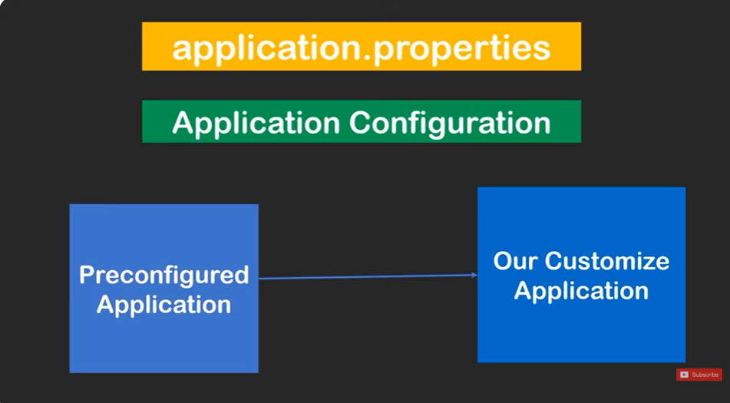
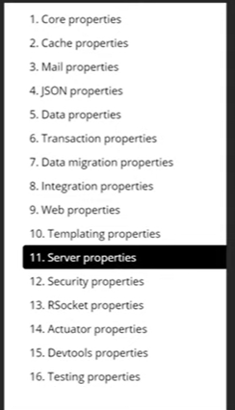

JPA with Spring Boot Complete Explanation
Java Persistence API (JPA) is a specification that facilitates the management of relational data in Java applications by providing a standardized approach to Object-Relational Mapping (ORM). In Spring Boot, JPA is commonly used in conjunction with Spring Data JPA, which offers a higher-level abstraction for data access, streamlining database interactions.
Key Components of JPA in Spring Boot:
- Entity Classes: These are simple Java classes (POJOs) annotated with @Entity, representing database tables. Each instance corresponds to a row in the table.
- Repositories: Spring Data JPA provides repository interfaces, such as CrudRepository and JpaRepository, which offer CRUD operations without the need for boilerplate code. By extending these interfaces, you can define custom query methods based on naming conventions.
- EntityManager: This is the primary JPA interface used to interact with the persistence context. In Spring Boot, the EntityManager is typically managed by the Spring container, allowing for seamless integration and transaction management.
Setting Up JPA in a Spring Boot Application:
- Add Dependencies: Include the spring-boot-starter-data-jpa starter in your pom.xml (for Maven) or build.gradle (for Gradle) to bring in the necessary libraries.
- Configure Data Source: Specify database connection properties in the application.properties or application.yml file, including URL, username, password, and driver class name.
- Define Entity Classes: Create Java classes representing your database tables, annotating them with @Entity and defining primary keys using @Id.
- Create Repository Interfaces: Define interfaces that extend JpaRepository or CrudRepository for your entities to enable CRUD operations and custom queries.
- Service Layer (Optional): Implement a service layer to encapsulate business logic and interact with repositories, promoting a clean architecture.
- Transaction Management: Spring Boot manages transactions automatically. However, for finer control, you can use the @Transactional annotation on service methods to define transaction boundaries.
Example:
Here's a simple example demonstrating the integration of JPA in a Spring Boot application:
- Entity Class:
java
Copy code
import jakarta.persistence.Entity;
import jakarta.persistence.GeneratedValue;
import jakarta.persistence.GenerationType;
import jakarta.persistence.Id;

@Entity
public class Customer {

@Id
@GeneratedValue(strategy = GenerationType.IDENTITY)
private Long id;

private String firstName;
private String lastName;

// Constructors, getters, and setters
}
- Repository Interface:
java
Copy code
import org.springframework.data.jpa.repository.JpaRepository;

public interface CustomerRepository extends JpaRepository<Customer, Long> {
List<Customer> findByLastName(String lastName);
}
- Service Layer:
java
Copy code
import org.springframework.beans.factory.annotation.Autowired;
import org.springframework.stereotype.Service;
import org.springframework.transaction.annotation.Transactional;

@Service
public class CustomerService {

@Autowired
private CustomerRepository repository;

@Transactional
public Customer saveCustomer(Customer customer) {
return repository.save(customer);
}

public List<Customer> getCustomersByLastName(String lastName) {
return repository.findByLastName(lastName);
}
}
- Application Properties:
arduino
Copy code
spring.datasource.url=jdbc:mysql://localhost:3306/mydb
spring.datasource.username=root
spring.datasource.password=secret
spring.jpa.hibernate.ddl-auto=update
This setup allows you to perform CRUD operations on the Custoimer entity seamlessly.
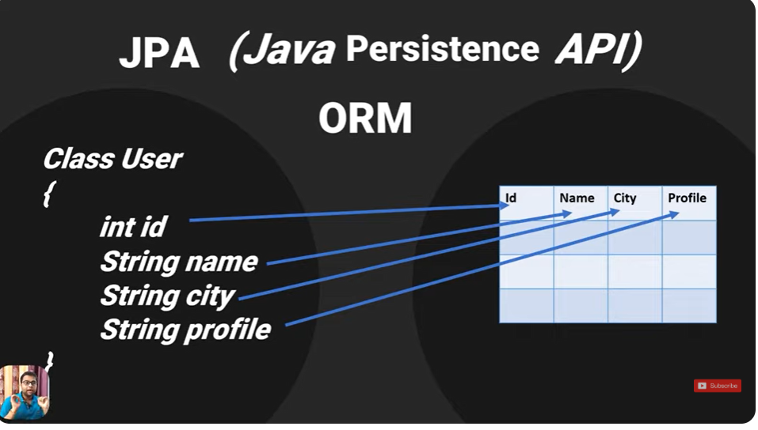
EntityManagerFactory and EntityManager
In Java Persistence API (JPA), the EntityManagerFactory and EntityManager are fundamental components for managing the lifecycle of entities and interacting with the database.
EntityManagerFactory:
The EntityManagerFactory is a factory class responsible for creating EntityManager instances. It is typically created once per application and is thread-safe, allowing multiple threads to share a single instance. The factory is configured based on the persistence unit defined in the persistence.xml file or through annotations.
EntityManager:
The EntityManager is the primary interface for interacting with the persistence context. It is used to create, read, update, and delete entities. Unlike EntityManagerFactory, EntityManager instances are not thread-safe and should be used within the scope of a single transaction or request.
Usage in Spring Boot:
In a Spring Boot application, the EntityManager is typically injected into service classes using the @PersistenceContext annotation. Spring Boot manages the lifecycle of the EntityManager and EntityManagerFactory, ensuring that they are properly initialized and closed.
Example:
java
Copy code
import org.springframework.beans.factory.annotation.Autowired;
import org.springframework.stereotype.Service;
import org.springframework.transaction.annotation.Transactional;

import javax.persistence.EntityManager;
import javax.persistence.PersistenceContext;

@Service
public class CustomerService {

@PersistenceContext
private EntityManager entityManager;

@Transactional
public void saveCustomer(Customer customer) {
entityManager.persist(customer);
}
}
In this example, the CustomerService class has an EntityManager injected via the @PersistenceContext annotation. The saveCustomer method uses the EntityManager to persist a Customer entity within a transaction.
Key Points:
- EntityManagerFactory is used to create EntityManager instances and is typically shared across the application.
- EntityManager is used to interact with the database and should be used within the scope of a single transaction or request.
- In Spring Boot, the EntityManager is managed by the framework and can be injected into service classes using the @PersistenceContext annotation.
Understanding the roles of EntityManagerFactory and EntityManager is crucial for effectively managing database interactions in a JPA-based application.
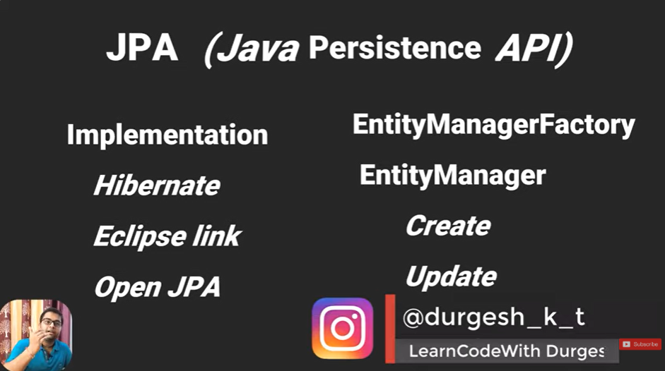
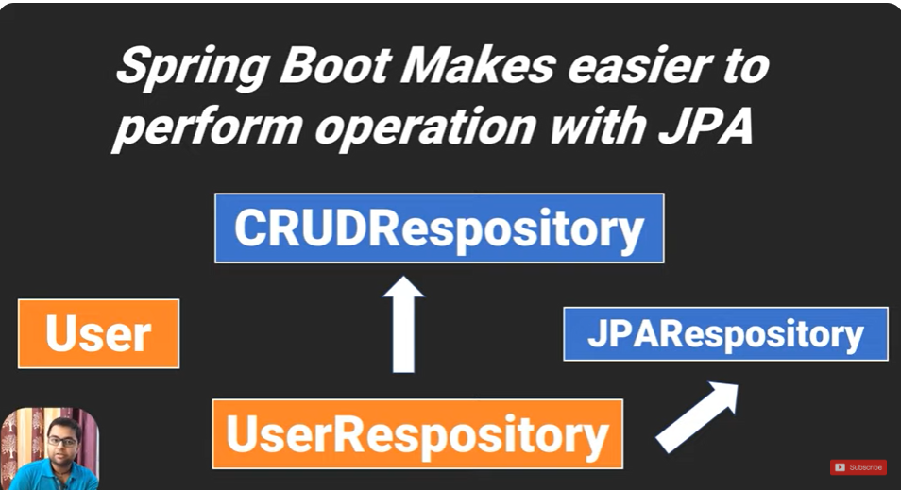
In Spring Data JPA, the CrudRepository and JpaRepository interfaces are part of the repository abstraction layer, providing methods for performing CRUD (Create, Read, Update, Delete) operations on entities.
CrudRepository Interface:
The CrudRepository interface is the most basic of the repository interfaces provided by Spring Data JPA. It defines a collection of methods for CRUD operations:
- save(S entity): Saves a given entity.
- findById(ID id): Retrieves an entity by its id.
- findAll(): Retrieves all entities.
- count(): Returns the number of entities.
- deleteById(ID id): Deletes the entity with the given id.
- delete(T entity): Deletes a given entity.
- existsById(ID id): Checks if an entity exists by its id.
These methods cover the fundamental operations needed for basic data access.
GeeksforGeeks
JpaRepository Interface:
The JpaRepository interface extends CrudRepository and adds additional JPA-specific methods:
- flush(): Flushes all pending changes to the database.
- saveAndFlush(S entity): Saves an entity and flushes changes immediately.
- deleteInBatch(Iterable<T> entities): Deletes entities in a batch.
- deleteAllInBatch(): Deletes all entities in a batch.
- getOne(ID id): Retrieves a reference to an entity by its id.
These additional methods provide more control over the persistence context and batch operations.
Baeldung
Choosing Between CrudRepository and JpaRepository:
- Use CrudRepository when you need basic CRUD operations without the need for advanced JPA features.
- Use JpaRepository when you require additional JPA-specific functionalities, such as flushing the persistence context or batch operations.
By extending these interfaces, Spring Data JPA automatically provides implementations for the defined methods, reducing boilerplate code and simplifying data access.
Example:
java
Copy code
import org.springframework.data.jpa.repository.JpaRepository;

public interface UserRepository extends JpaRepository<User, Long> {
// Custom query methods can be defined here
}
In this example, UserRepository extends JpaRepository, allowing it to inherit all CRUD operations and JPA-specific methods for the User entity.

Db configuration in application.properies file | JPA with Spring Boot

In a Spring Boot application, the application.properties file is used to configure the database connection when using JPA. Below is a sample configuration:

Example Configuration
properties
Copy code
# DataSource Configuration
spring.datasource.url=jdbc:mysql://localhost:3306/StudentDB
spring.datasource.username=root
spring.datasource.password=password

# Hibernate JPA Configuration
spring.jpa.hibernate.ddl-auto=update
spring.jpa.show-sql=true
spring.jpa.properties.hibernate.dialect=org.hibernate.dialect.MySQL8Dialect

# Optional: Set the SQL logging format for better readability
spring.jpa.properties.hibernate.format_sql=true

Explanation:
- spring.datasource.url: Specifies the JDBC URL of your database.
  - Replace localhost with your database server IP or hostname.
  - Replace StudentDB with the name of your database.
- spring.datasource.username and spring.datasource.password: Your database credentials.
- spring.jpa.hibernate.ddl-auto: Specifies the database schema update strategy:
  - create: Creates the schema, destroying existing data.
  - create-drop: Same as create but drops the schema when the session ends.
  - update: Updates the schema without destroying data.
  - validate: Validates the schema against the entities but does not modify the database.
  - none: No action.
- spring.jpa.show-sql: Enables logging of SQL queries generated by Hibernate.
- spring.jpa.properties.hibernate.dialect: Specifies the Hibernate dialect for your database (e.g., MySQL, PostgreSQL).
- spring.jpa.properties.hibernate.format_sql: (Optional) Formats the SQL output in logs for readability.

he Hibernate dialect is a configuration that tells Hibernate how to generate SQL statements specific to the database type you are using. It optimizes the SQL commands for the database's syntax and features. Below is a list of commonly used dialects for different databases in Spring Boot:

Common Hibernate Dialects

MySQL
- MySQL 5:
properties
Copy code
spring.jpa.properties.hibernate.dialect=org.hibernate.dialect.MySQL5Dialect
- MySQL 8:
properties
Copy code
spring.jpa.properties.hibernate.dialect=org.hibernate.dialect.MySQL8Dialect

PostgreSQL
properties
Copy code
spring.jpa.properties.hibernate.dialect=org.hibernate.dialect.PostgreSQLDialect

Oracle
- Oracle 10g:
properties
Copy code
spring.jpa.properties.hibernate.dialect=org.hibernate.dialect.Oracle10gDialect
- Oracle 12c:
properties
Copy code
spring.jpa.properties.hibernate.dialect=org.hibernate.dialect.Oracle12cDialect

SQL Server
- SQL Server 2008:
properties
Copy code
spring.jpa.properties.hibernate.dialect=org.hibernate.dialect.SQLServer2008Dialect
- SQL Server 2012:
properties
Copy code
spring.jpa.properties.hibernate.dialect=org.hibernate.dialect.SQLServer2012Dialect

H2 (In-memory Database)
properties
Copy code
spring.jpa.properties.hibernate.dialect=org.hibernate.dialect.H2Dialect

MariaDB
- MariaDB 10.2 and later:
properties
Copy code
spring.jpa.properties.hibernate.dialect=org.hibernate.dialect.MariaDBDialect

SQLite
properties
Copy code
spring.jpa.properties.hibernate.dialect=org.hibernate.dialect.SQLiteDialect

What Happens Without Dialect?
- Hibernate tries to detect the database type based on the JDBC driver and assigns a default dialect.
- Explicitly setting the dialect ensures optimal performance and compatibility with your database.

Our Codes for Insert and Springboot ORM DATABASE CONFIG ARE
User.java(An Entity Class)
package com.jpa.test.entities;

import jakarta.persistence.Entity;
import jakarta.persistence.GeneratedValue;
import jakarta.persistence.GenerationType;
import jakarta.persistence.Id;
import jakarta.persistence.Table;

@Entity
@Table(name = "users")
public class User {
@Id
@GeneratedValue(strategy = GenerationType.AUTO)
private int id;
private String name;
private String status;
@Override
public String toString() {
return "User [id=" + id + ", name=" + name + ", status=" + status + ", getId()=" + getId() + ", getName()="
+ getName() + ", getStatus()=" + getStatus() + ", getClass()=" + getClass() + ", hashCode()=" + hashCode()
+ ", toString()=" + super.toString() + "]";
}
public User() {
super();
// TODO Auto-generated constructor stub
}
public User(int id, String name, String status) {
super();
this.id = id;
this.name = name;
this.status = status;
}
public int getId() {
return id;
}
public void setId(int id) {
this.id = id;
}
public String getName() {
return name;
}
public void setName(String name) {
this.name = name;
}
public String getStatus() {
return status;
}
public void setStatus(String status) {
this.status = status;
}
}

UserRepository.java
package com.jpa.test.dao;

import org.springframework.data.repository.CrudRepository;

import com.jpa.test.entities.User;

public interface UserRepository extends CrudRepository<User, Integer>{

}

In your Spring Boot application, the UserRepository interface extends CrudRepository<User, Integer>, enabling CRUD operations for the User entity without the need for boilerplate code.
Key Points:
- CrudRepository Interface: This is a Spring Data interface that provides generic CRUD operations for a specific type. By extending CrudRepository, UserRepository inherits methods such as save(), findById(), findAll(), deleteById(), and others, facilitating standard database operations.
Spring Documentation
- Type Parameters: The generic parameters <User, Integer> specify that the repository manages User entities with Integer as the type of their primary key.
Benefits:
- Simplified Data Access: Leveraging CrudRepository reduces the need to write common data access code, allowing you to focus on business logic.
- Consistency: Utilizing a standardized repository interface promotes consistent data access patterns across your application.
Example Usage:
java
Copy code
import org.springframework.beans.factory.annotation.Autowired;
import org.springframework.stereotype.Service;

@Service
public class UserService {

@Autowired
private UserRepository userRepository;

public User createUser(User user) {
return userRepository.save(user);
}

public Iterable<User> getAllUsers() {
return userRepository.findAll();
}

public void deleteUserById(Integer id) {
userRepository.deleteById(id);
}
}
In this example, UserService uses UserRepository to perform CRUD operations on User entities.
Considerations:
- Advanced Functionality: If you require additional JPA-specific features, such as batch operations or flushing the persistence context, consider extending JpaRepository instead of CrudRepository.
Stack Overflow
- Custom Queries: For complex queries beyond standard CRUD operations, you can define custom query methods within UserRepository using Spring Data JPA's query derivation mechanism.
By extending CrudRepository, your UserRepository interface gains a comprehensive set of CRUD functionalities, streamlining data management for the User entity in your Spring Boot application.

SpringBootApplication.java
package com.jpa.test;

import org.springframework.boot.SpringApplication;
import org.springframework.boot.autoconfigure.SpringBootApplication;
import org.springframework.context.ApplicationContext;

import com.jpa.test.dao.UserRepository;
import com.jpa.test.entities.User;

@SpringBootApplication
public class BootjpaexampleApplication {

public static void main(String[] args) {
ApplicationContext context=SpringApplication.run(BootjpaexampleApplication.class, args);
UserRepository userRepository = context.getBean(UserRepository.class);

User user = new User();
user.setName("Light Yash");

user.setStatus("I am a Java programmer");

User u = userRepository.save(user);

System.out.println(u);
}

}

Application.properties
spring.application.name=bootjpaexample
server.port=9091
spring.datasource.url=jdbc:postgresql://localhost:5432/test
spring.datasource.password=light
spring.datasource.username=postgres
spring.datasource.driver-class-name=org.postgresql.Driver
spring.jpa.properties.hibernate.dialect=org.hibernate.dialect.PostgreSQLDialect
spring.jpa.hibernate.ddl-auto=update
spring.jpa.show-sql=true
spring.jpa.properties.hibernate.format_sql=true

CRUD Operation using JPA and Spring Boot | CREATE | READ | UPDATE | DELETE
n a Spring Boot application, performing CRUD (Create, Read, Update, Delete) operations using JPA (Java Persistence API) is streamlined through the use of Spring Data JPA. This approach reduces boilerplate code and enhances productivity. Here's a step-by-step guide to implementing these operations:
1. Set Up Your Spring Boot Application
- Dependencies: Include the necessary dependencies in your pom.xml file:
xml
Copy code
<dependencies>
<dependency>
<groupId>org.springframework.boot</groupId>
<artifactId>spring-boot-starter-data-jpa</artifactId>
</dependency>
<dependency>
<groupId>org.springframework.boot</groupId>
<artifactId>spring-boot-starter-web</artifactId>
</dependency>
<!-- For H2 Database -->
<dependency>
<groupId>com.h2database</groupId>
<artifactId>h2</artifactId>
<scope>runtime</scope>
</dependency>
<!-- For MySQL Database -->
<!--
<dependency>
<groupId>mysql</groupId>
<artifactId>mysql-connector-java</artifactId>
<scope>runtime</scope>
</dependency>
-->
</dependencies>
- Configuration: Configure your database connection in the application.properties file. For H2:
properties
Copy code
spring.datasource.url=jdbc:h2:mem:testdb
spring.datasource.driverClassName=org.h2.Driver
spring.datasource.username=sa
spring.datasource.password=
spring.jpa.database-platform=org.hibernate.dialect.H2Dialect
spring.h2.console.enabled=true
For MySQL:
properties
Copy code
spring.datasource.url=jdbc:mysql://localhost:3306/your_db_name
spring.datasource.username=your_username
spring.datasource.password=your_password
spring.jpa.hibernate.ddl-auto=update
spring.jpa.show-sql=true
2. Define the Entity Model
Create an entity class that maps to a database table. For example, a User entity:
java
Copy code
import javax.persistence.Entity;
import javax.persistence.GeneratedValue;
import javax.persistence.GenerationType;
import javax.persistence.Id;

@Entity
public class User {

@Id
@GeneratedValue(strategy = GenerationType.IDENTITY)
private Long id;

private String name;
private String email;

// Constructors, getters, and setters
}
3. Create the Repository Interface
Define a repository interface for the User entity by extending JpaRepository.
java
Copy code
import org.springframework.data.jpa.repository.JpaRepository;

public interface UserRepository extends JpaRepository<User, Long> {
// Custom query methods (if any)
}
4. Implement CRUD Operations in the Service Layer
Create a service class to handle business logic and interact with the repository.
java
Copy code
import org.springframework.beans.factory.annotation.Autowired;
import org.springframework.stereotype.Service;

import java.util.List;
import java.util.Optional;

@Service
public class UserService {

@Autowired
private UserRepository userRepository;

// Create
public User createUser(User user) {
return userRepository.save(user);
}

// Read
public List<User> getAllUsers() {
return userRepository.findAll();
}

public Optional<User> getUserById(Long id) {
return userRepository.findById(id);
}

// Update
public User updateUser(Long id, User userDetails) {
User user = userRepository.findById(id)
.orElseThrow(() -> new ResourceNotFoundException("User not found with id " + id));
user.setName(userDetails.getName());
user.setEmail(userDetails.getEmail());
return userRepository.save(user);
}

// Delete
public void deleteUser(Long id) {
User user = userRepository.findById(id)
.orElseThrow(() -> new ResourceNotFoundException("User not found with id " + id));
userRepository.delete(user);
}
}
5. Expose CRUD Operations via RESTful Endpoints
Create a controller to map HTTP requests to the service methods.
java
Copy code
import org.springframework.beans.factory.annotation.Autowired;
import org.springframework.http.ResponseEntity;
import org.springframework.web.bind.annotation.*;

import java.util.List;

@RestController
@RequestMapping("/api/users")
public class UserController {

@Autowired
private UserService userService;

// Create
@PostMapping
public User createUser(@RequestBody User user) {
return userService.createUser(user);
}

// Read All
@GetMapping
public List<User> getAllUsers() {
return userService.getAllUsers();
}

// Read by ID
@GetMapping("/{id}")
public ResponseEntity<User> getUserById(@PathVariable Long id) {
return userService.getUserById(id)
.map(ResponseEntity::ok)
.orElse(ResponseEntity.notFound().build());
}

// Update
@PutMapping("/{id}")
public ResponseEntity<User> updateUser(@PathVariable Long id, @RequestBody User userDetails) {
return ResponseEntity.ok(userService.updateUser(id, userDetails));
}

// Delete
@DeleteMapping("/{id}")
public ResponseEntity<Void> deleteUser(@PathVariable Long id) {
userService.deleteUser(id);
return ResponseEntity.noContent().build();
}
}
6. Testing the Application
You can test the CRUD operations using tools like Postman or curl by sending HTTP requests to the defined endpoints.
For example, to create a new user:
bash
Copy code
POST /api/users
Content-Type: application/json

{
"name": "John Doe",
"email": "john.doe@example.com"
}
This setup provides a robust foundation for performing CRUD operations in a Spring Boot application using Spring Data JPA.
For a more detailed walkthrough, you can refer to this comprehensive guide: Spring Boot - CRUD Operations.

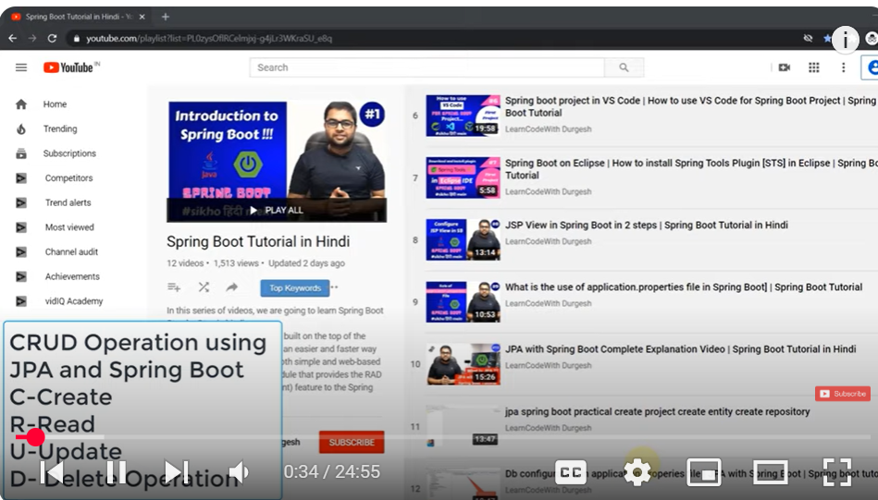
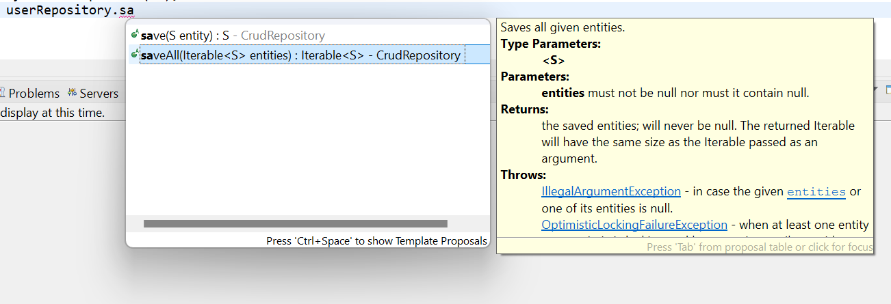
Creaing
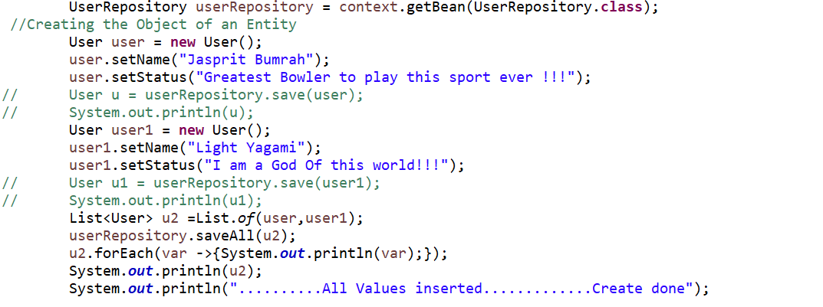
We can use saveall as well if we have multiple

Updating
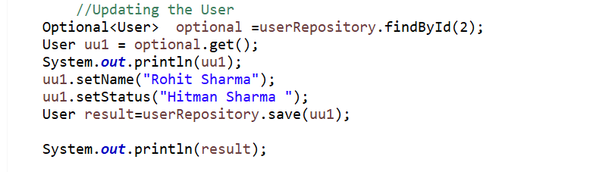
Read Data
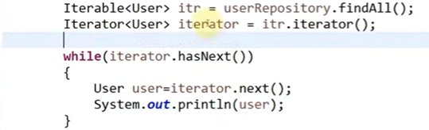
The above is used to get all data for the single one we already did in update
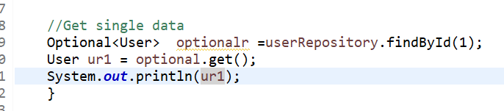
In Java, the Optional class is a container object introduced in Java 8 to represent the presence or absence of a value. It is part of the java.util package and is designed to prevent NullPointerException by providing a more expressive way to handle optional values.
Key Features of Optional:
- Avoiding Null Checks: Optional allows you to express the possibility of a value being absent without using null, thereby reducing the need for explicit null checks.
- Functional Operations: It supports functional programming operations like map, flatMap, filter, and ifPresent, enabling more readable and concise code.
Common Methods in Optional:
- of(T value): Returns an Optional containing the specified non-null value.
- ofNullable(T value): Returns an Optional containing the specified value if it's non-null, otherwise returns an empty Optional.
- isPresent(): Returns true if the Optional contains a value, otherwise false.
- ifPresent(Consumer<? super T> action): If a value is present, it performs the given action with the value, otherwise does nothing.
- orElse(T other): Returns the value if present, otherwise returns other.
- orElseGet(Supplier<? extends T> other): Returns the value if present, otherwise invokes other and returns the result of that invocation.
- orElseThrow(Supplier<? extends X> exceptionSupplier): Returns the value if present, otherwise throws an exception produced by the provided supplier.
Example Usage:
java
Copy code
import java.util.Optional;

public class OptionalExample {

public static void main(String[] args) {
String value = "Hello, World!";
Optional<String> optionalValue = Optional.ofNullable(value);

// Check if value is present
if (optionalValue.isPresent()) {
System.out.println("Value is present: " + optionalValue.get());
} else {
System.out.println("Value is not present.");
}

// Using ifPresent
optionalValue.ifPresent(val -> System.out.println("Value is: " + val));

// Using orElse
String defaultValue = optionalValue.orElse("Default Value");
System.out.println("Value: " + defaultValue);

// Using orElseGet
String valueFromSupplier = optionalValue.orElseGet(() -> "Value from Supplier");
System.out.println("Value: " + valueFromSupplier);

// Using orElseThrow
String valueOrException = optionalValue.orElseThrow(() -> new IllegalArgumentException("Value is missing"));
System.out.println("Value: " + valueOrException);
}
}
When to Use Optional:
- Return Types: Use Optional as a return type to indicate that a method may not return a value.
- Avoiding Null Checks: Use Optional to avoid explicit null checks and to make the code more readable.
Caution:
While Optional is a powerful tool, it should not be used as a field type in entities or as method parameters. Its primary purpose is to be used as a return type to indicate the possibility of absence.
In Java, the Consumer interface is a functional interface introduced in Java 8, located in the java.util.function package. It represents an operation that accepts a single input argument and returns no result. This is a general-purpose interface intended for operations that take an input and perform some action without returning a value.
Key Characteristics:
- Functional Interface: Consumer is a functional interface, meaning it can be implemented using lambda expressions or method references.
- Single Abstract Method: It has a single abstract method:
java
Copy code
void accept(T t);
This method takes an input of type T and performs an operation on it.
Commonly Used Methods:
- andThen: Returns a composed Consumer that first applies the original Consumer to the input and then applies the after Consumer to the result.
java
Copy code
default Consumer<T> andThen(Consumer<? super T> after) {
Objects.requireNonNull(after);
return (T t) -> { accept(t); after.accept(t); };
}
This is useful for chaining multiple operations.
Example Usage:
Here's an example of how to use Consumer with a lambda expression:
java
Copy code
import java.util.function.Consumer;

public class ConsumerExample {
public static void main(String[] args) {
Consumer<String> printConsumer = (String s) -> System.out.println(s);
printConsumer.accept("Hello, World!");
}
}
In this example, printConsumer is a Consumer that prints the provided string to the console.
Using Consumer with Collections:
The forEach method in the Iterable interface accepts a Consumer to perform an action on each element:
java
Copy code
import java.util.Arrays;
import java.util.List;

public class ConsumerForEachExample {
public static void main(String[] args) {
List<String> names = Arrays.asList("Alice", "Bob", "Charlie");
names.forEach(name -> System.out.println(name));
}
}
This will output:
Copy code
Alice
Bob
Charlie
Combining Consumers:
You can combine multiple Consumer instances using the andThen method:
java
Copy code
import java.util.function.Consumer;

public class CombinedConsumerExample {
public static void main(String[] args) {
Consumer<String> greetConsumer = (String s) -> System.out.print("Hello, ");
Consumer<String> nameConsumer = (String s) -> System.out.println(s);

greetConsumer.andThen(nameConsumer).accept("Alice");
}
}
This will output:
Copy code
Hello, Alice
In this example, greetConsumer and nameConsumer are combined so that "Hello, " is printed first, followed by the name.
When to Use Consumer:
- Performing Actions: Use Consumer when you need to perform an action on an object without returning a result.
- Functional Programming: It's particularly useful in functional programming paradigms where functions are passed as arguments.

Delete Data
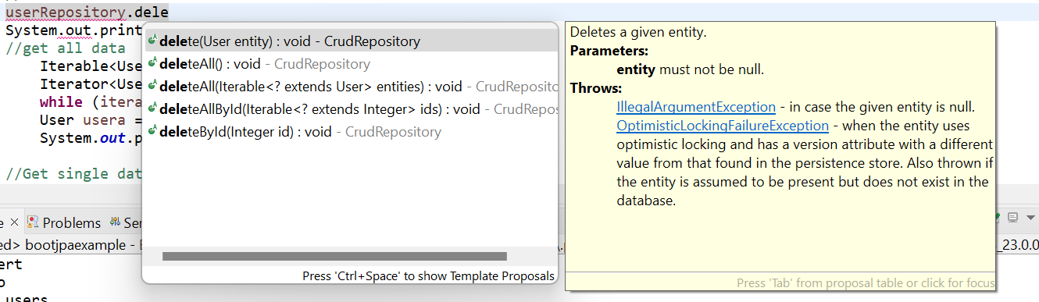

Our code Containing CRUD Operation are
Application.java
package com.jpa.test;

import java.util.Iterator;
import java.util.List;
import java.util.Optional;

import org.springframework.boot.SpringApplication;
import org.springframework.boot.autoconfigure.SpringBootApplication;
import org.springframework.context.ApplicationContext;

import com.jpa.test.dao.UserRepository;
import com.jpa.test.entities.User;

@SpringBootApplication
public class BootjpaexampleApplication {

public static void main(String[] args) {
ApplicationContext context=SpringApplication.run(BootjpaexampleApplication.class, args);
UserRepository userRepository = context.getBean(UserRepository.class);
//Creating the Object of an Entity
User user = new User();
user.setName("Jasprit Bumrah");
user.setStatus("Greatest Bowler to play this sport ever !!!");
// User u = userRepository.save(user);
// System.out.println(u);
User user1 = new User();
user1.setName("Light Yagami");
user1.setStatus("I am a God Of this world!!!");
// User u1 = userRepository.save(user1);
// System.out.println(u1);
List<User> u2 =List.of(user,user1);
userRepository.saveAll(u2);
u2.forEach(var ->{System.out.println(var);});
System.out.println(u2);
System.out.println("..........All Values inserted.............Create done");

//Updating the User
Optional<User> optional =userRepository.findById(2);
User uu1 = optional.get();
System.out.println(uu1);
uu1.setName("Rohit Sharma");
uu1.setStatus("Hitman Sharma ");
User result=userRepository.save(uu1);
System.out.println(result);

//Delete Data
userRepository.deleteById(3);
System.out.println("Deleted");

//Delete all data
Iterable<User> allusers = userRepository.findAll();
allusers.forEach(userd -> System.out.println(userd));
userRepository.deleteAll(allusers);

//get all data
Iterable<User> itr = userRepository.findAll();
Iterator<User> iterator = itr.iterator();
while (iterator.hasNext()) {
User usera = iterator.next();
System.out.println(user);

//Get single data
Optional<User> optionalr =userRepository.findById(1);
User ur1 = optional.get();
System.out.println(ur1);
}

}
}

User.java(An Entity Class)
package com.jpa.test.entities;

import jakarta.persistence.Entity;
import jakarta.persistence.GeneratedValue;
import jakarta.persistence.GenerationType;
import jakarta.persistence.Id;
import jakarta.persistence.Table;

@Entity
@Table(name = "users")
public class User {
@Id
@GeneratedValue(strategy = GenerationType.AUTO)
private int id;
private String name;
private String status;
@Override
public String toString() {
return "User [id=" + id + ", name=" + name + ", status=" + status + ", getId()=" + getId() + ", getName()="
+ getName() + ", getStatus()=" + getStatus() + ", getClass()=" + getClass() + ", hashCode()=" + hashCode()
+ ", toString()=" + super.toString() + "]";
}
public User() {
super();
// TODO Auto-generated constructor stub
}
public User(int id, String name, String status) {
super();
this.id = id;
this.name = name;
this.status = status;
}
public int getId() {
return id;
}
public void setId(int id) {
this.id = id;
}
public String getName() {
return name;
}
public void setName(String name) {
this.name = name;
}
public String getStatus() {
return status;
}
public void setStatus(String status) {
this.status = status;
}
}

UserRepository.java
package com.jpa.test.dao;

import org.springframework.data.repository.CrudRepository;

import com.jpa.test.entities.User;

public interface UserRepository extends CrudRepository<User, Integer>{

}

Application.properties
spring.application.name=bootjpaexample

spring.datasource.url=jdbc:postgresql://localhost:5432/test
spring.datasource.password=light
spring.datasource.username=postgres
spring.datasource.driver-class-name=org.postgresql.Driver
spring.jpa.properties.hibernate.dialect=org.hibernate.dialect.PostgreSQLDialect
spring.jpa.hibernate.ddl-auto=update
spring.jpa.show-sql=true
spring.jpa.properties.hibernate.format_sql=true

Custom Finder methods | Derived Query methods in Spring data JPA

Custom Finder Methods and Derived Query Methods in Spring Data JPA
Spring Data JPA simplifies the development of JPA-based data access layers by providing features like Custom Finder Methods and Derived Query Methods. These allow you to query your database without writing actual SQL or JPQL code.

1. Derived Query Methods87
Derived Query Methods in Spring Data JPA allow you to define query methods based on the method names. Spring Data JPA analyzes the method name and automatically generates the appropriate query.

Syntax and Working
You can define methods in the repository interface using the naming convention. Spring Data JPA will parse the method name and construct the query.
For example, if you have an entity Person with fields name and age, you can write a method like this:
java
Copy code
public interface PersonRepository extends JpaRepository<Person, Long> {
List<Person> findByName(String name);
List<Person> findByAgeGreaterThanEqual(int age);
List<Person> findByNameAndAge(String name, int age);
}
How it works:
- findByName(String name) generates a query like SELECT p FROM Person p WHERE p.name = :name
- findByAgeGreaterThanEqual(int age) generates a query like SELECT p FROM Person p WHERE p.age >= :age
- findByNameAndAge(String name, int age) generates a query like SELECT p FROM Person p WHERE p.name = :name AND p.age = :age

Supported keywords:
- findBy - basic search by field.
- And, Or - combining conditions.
- GreaterThan, LessThan, GreaterThanEqual, LessThanEqual - comparison operators.
- Between, IsNull, IsNotNull - special operations.
- OrderBy - sorting results.

Example:
Consider the following Person entity:
java
Copy code
@Entity
public class Person {
@Id
@GeneratedValue(strategy = GenerationType.IDENTITY)
private Long id;

private String name;
private int age;

// Getters and setters
}
The corresponding repository:
java
Copy code
public interface PersonRepository extends JpaRepository<Person, Long> {
List<Person> findByName(String name);
List<Person> findByAgeGreaterThanEqual(int age);
List<Person> findByNameAndAge(String name, int age);
}
Usage in a service class:
java
Copy code
@Service
public class PersonService {
@Autowired
private PersonRepository personRepository;

public List<Person> getPeopleByName(String name) {
return personRepository.findByName(name);
}

public List<Person> getPeopleAboveAge(int age) {
return personRepository.findByAgeGreaterThanEqual(age);
}

public List<Person> getPeopleByNameAndAge(String name, int age) {
return personRepository.findByNameAndAge(name, age);
}
}

2. Custom Finder Methods
Custom Finder Methods allow you to define more complex queries by creating methods with the @Query annotation. This is useful when derived query methods do not meet your needs.

Syntax and Working
You can use @Query to define a custom JPQL or SQL query. You can also use named parameters with @Param to bind method parameters to query parameters.
Example:
java
Copy code
public interface PersonRepository extends JpaRepository<Person, Long> {

@Query("SELECT p FROM Person p WHERE p.name = :name")
List<Person> findByName(@Param("name") String name);

@Query("SELECT p FROM Person p WHERE p.age >= :age ORDER BY p.name")
List<Person> findPeopleAboveAgeOrdered(@Param("age") int age);
}
This repository interface defines two custom queries:
- findByName will return all Person entities with the given name.
- findPeopleAboveAgeOrdered will return people older than or equal to the specified age, ordered by their name.

Example of using @Query for native SQL queries:
java
Copy code
public interface PersonRepository extends JpaRepository<Person, Long> {

@Query(value = "SELECT * FROM Person p WHERE p.age >= ?1", nativeQuery = true)
List<Person> findPeopleAboveAgeNative(int age);
}
In this case, the query is written in native SQL (as opposed to JPQL), and nativeQuery = true tells Spring Data JPA to treat the query as a native SQL query.

Code Example with Service
java
Copy code
@Service
public class PersonService {
@Autowired
private PersonRepository personRepository;

// Using derived query method
public List<Person> getPeopleByName(String name) {
return personRepository.findByName(name);
}

// Using custom JPQL query
public List<Person> getPeopleAboveAge(int age) {
return personRepository.findPeopleAboveAgeOrdered(age);
}

// Using custom native SQL query
public List<Person> getPeopleAboveAgeNative(int age) {
return personRepository.findPeopleAboveAgeNative(age);
}
}

Advantages of Derived Query Methods:
- No need to write JPQL or SQL: It's easy and clean to use method names to create queries.
- Automatic query generation: Spring Data JPA handles the query generation automatically, which reduces boilerplate code.

When to use Custom Finder Methods:
- Complex queries: If you need to perform joins, groupings, or advanced filtering, custom queries via @Query are useful.
- Native SQL: For performance reasons, sometimes you might want to write queries using native SQL (which Spring Data JPA allows).

Key Takeaways:
- Derived Query Methods are automatically generated based on method names, reducing boilerplate code.
- Custom Finder Methods are used when you need more complex or specific queries and can be written using JPQL or native SQL.
4o mini

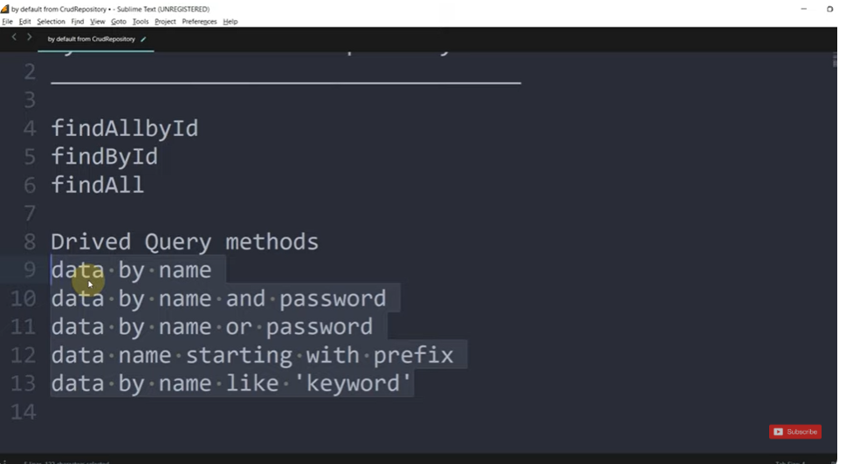
Default methods are provided but what if we want to retrieve data using other conditions or combined conditions
In that case we can create our custom finder method or derived query method

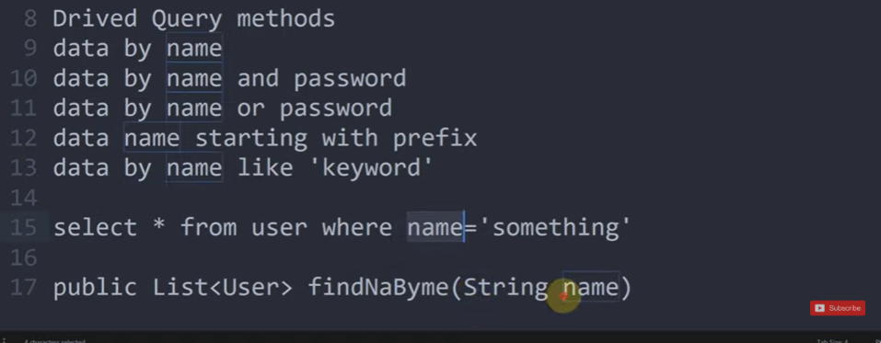
Method name is imp here
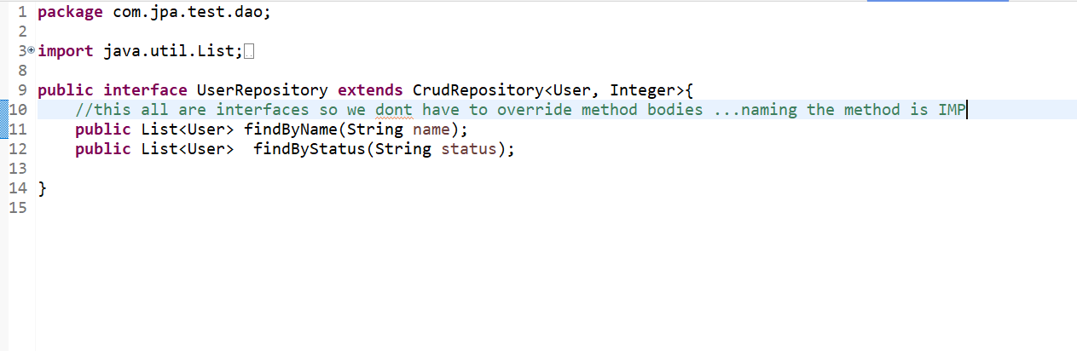
In our Application.java

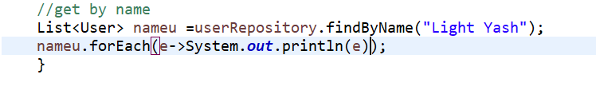

Spring Data Supported Keywords
Spring Data JPA supports a variety of keywords for Derived Query Methods that allow you to construct queries without explicitly writing JPQL or SQL. These keywords are used in the method names, and Spring Data JPA interprets them to generate the corresponding queries.
Here’s a list of commonly supported keywords in Spring Data JPA:

1. Basic Keywords
- findBy: Used to fetch data based on the field name(s).
  - Example: findByName(String name) generates SELECT p FROM Person p WHERE p.name = :name
- countBy: Used to count entities based on a field.
  - Example: countByAge(int age) generates SELECT COUNT(p) FROM Person p WHERE p.age = :age
- existsBy: Used to check if an entity exists with the given field.
  - Example: existsByName(String name) generates SELECT COUNT(p) > 0 FROM Person p WHERE p.name = :name
- deleteBy: Used to delete entities based on a field.
  - Example: deleteByAgeGreaterThanEqual(int age) generates DELETE FROM Person p WHERE p.age >= :age
- findOneBy: Finds a single entity by a field.
  - Example: findOneByName(String name) generates SELECT p FROM Person p WHERE p.name = :name

2. Logical Operators
- And: Combines multiple conditions with an AND operator.
  - Example: findByNameAndAge(String name, int age) generates SELECT p FROM Person p WHERE p.name = :name AND p.age = :age
- Or: Combines multiple conditions with an OR operator.
  - Example: findByNameOrAge(String name, int age) generates SELECT p FROM Person p WHERE p.name = :name OR p.age = :age

3. Comparison Operators
- GreaterThan, GreaterThanEqual: For comparing a value to be greater than or greater than or equal to a field.
  - Example: findByAgeGreaterThan(int age) generates SELECT p FROM Person p WHERE p.age > :age
- LessThan, LessThanEqual: For comparing a value to be less than or less than or equal to a field.
  - Example: findByAgeLessThanEqual(int age) generates SELECT p FROM Person p WHERE p.age <= :age
- Between: For checking if a value is between two values.
  - Example: findByAgeBetween(int start, int end) generates SELECT p FROM Person p WHERE p.age BETWEEN :start AND :end
- IsNull, IsNotNull: Checks if a field is null or not null.
  - Example: findByNameIsNull() generates SELECT p FROM Person p WHERE p.name IS NULL

4. String Matching
- Like: For partial matching using LIKE.
  - Example: findByNameLike(String name) generates SELECT p FROM Person p WHERE p.name LIKE :name
- StartingWith: For matching values that start with a given string.
  - Example: findByNameStartingWith(String prefix) generates SELECT p FROM Person p WHERE p.name LIKE :prefix%
- EndingWith: For matching values that end with a given string.
  - Example: findByNameEndingWith(String suffix) generates SELECT p FROM Person p WHERE p.name LIKE %:suffix
- Containing: For matching values that contain a given substring.
  - Example: findByNameContaining(String substring) generates SELECT p FROM Person p WHERE p.name LIKE %:substring%

5. Sorting
- OrderBy: For sorting the results.
  - Example: findByAgeOrderByNameDesc(int age) generates SELECT p FROM Person p WHERE p.age = :age ORDER BY p.name DESC

6. Paging and Sorting
- Spring Data JPA also supports paging and sorting directly in method signatures.
  - Example: findByAge(int age, Pageable pageable) generates a query that includes pagination, e.g., SELECT p FROM Person p WHERE p.age = :age

7. Null and Non-Null Matching
- IsNull: Matches null values.
  - Example: findByNameIsNull() generates SELECT p FROM Person p WHERE p.name IS NULL
- IsNotNull: Matches non-null values.
  - Example: findByNameIsNotNull() generates SELECT p FROM Person p WHERE p.name IS NOT NULL

8. In/NotIn
- In: For checking if a field is in a set of values.
  - Example: findByNameIn(List<String> names) generates SELECT p FROM Person p WHERE p.name IN :names
- NotIn: For checking if a field is not in a set of values.
  - Example: findByNameNotIn(List<String> names) generates SELECT p FROM Person p WHERE p.name NOT IN :names

9. Distinct
- Distinct: For returning distinct results.
  - Example: findDistinctByAge(int age) generates SELECT DISTINCT p FROM Person p WHERE p.age = :age

10. Custom Methods with @Query
If the derived query method syntax doesn't fit your needs, you can always use the @Query annotation to define custom queries in JPQL or native SQL.
java
Copy code
@Query("SELECT p FROM Person p WHERE p.name LIKE %:name%")
List<Person> findByNameContaining(@Param("name") String name);

Summary of Keywords:
- Basic: findBy, countBy, existsBy, deleteBy
- Logical: And, Or
- Comparison: GreaterThan, LessThan, Between, IsNull, IsNotNull
- String Matching: Like, StartingWith, EndingWith, Containing
- Sorting: OrderBy
- Paging: Pageable in method signatures
- In/NotIn: In, NotIn
- Distinct: Distinct
These keywords allow you to build complex queries just by naming your methods appropriately. Spring Data JPA will handle the rest.
4o mini
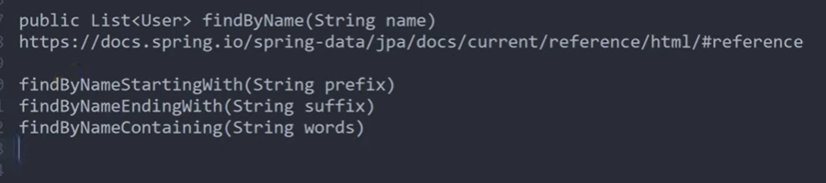
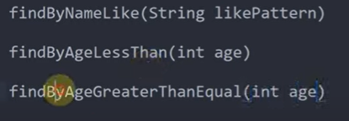

Annotation in Spring Data JPA
n Spring Data JPA, annotations are used to define and customize the behavior of queries, entities, and repository methods. Here are the key annotations commonly used in Spring Data JPA with examples and explanations:

1. @Entity
- Purpose: Marks a class as a JPA entity, which means that it will be mapped to a database table.
- Usage: Applied at the class level.
java
Copy code
@Entity
public class Person {
@Id
private Long id;
private String name;
private int age;
private String city;
}

2. @Table
- Purpose: Specifies the name of the database table to which an entity is mapped.
- Usage: Applied at the class level (optional, as JPA defaults to the entity class name).
java
Copy code
@Entity
@Table(name = "person")
public class Person {
// Entity mapping
}

3. @Id
- Purpose: Marks a field as the primary key of the entity.
- Usage: Applied at the field level.
java
Copy code
@Entity
public class Person {
@Id
private Long id; // Primary Key
private String name;
private int age;
}

4. @GeneratedValue
- Purpose: Specifies the strategy for generating primary key values.
- Usage: Applied at the field level (in combination with @Id).
java
Copy code
@Id
@GeneratedValue(strategy = GenerationType.IDENTITY) // AUTO_INCREMENT in DB
private Long id;

5. @Column
- Purpose: Specifies the column name in the database for a given field. If not provided, the default is the field's name.
- Usage: Applied at the field level.
java
Copy code
@Column(name = "full_name")
private String name;

6. @Query
- Purpose: Defines a custom query using JPQL (Java Persistence Query Language) or SQL (native query).
- Usage: Applied at the repository method level.
java
Copy code
@Query("SELECT p FROM Person p WHERE p.age > :age")
List<Person> findByAgeGreaterThan(@Param("age") int age);
- For native SQL queries:
java
Copy code
@Query(value = "SELECT * FROM person WHERE city = :city", nativeQuery = true)
List<Person> findByCity(@Param("city") String city);

7. @Param
- Purpose: Used to bind method parameters to named query parameters.
- Usage: Applied to method parameters that correspond to the named parameters in the @Query.
java
Copy code
@Query("SELECT p FROM Person p WHERE p.name = :name")
List<Person> findByName(@Param("name") String name);

8. @Modifying
- Purpose: Used with @Query to indicate that the query is a modifying operation (e.g., UPDATE, DELETE).
- Usage: Applied at the method level when performing update, delete, or insert operations.
java
Copy code
@Modifying
@Query("UPDATE Person p SET p.city = :city WHERE p.age > :age")
int updateCity(@Param("city") String city, @Param("age") int age);

9. @Transactional
- Purpose: Specifies that a method or class should be executed within a transactional context.
- Usage: Applied at the class or method level to manage transaction boundaries.
java
Copy code
@Transactional
@Modifying
@Query("DELETE FROM Person p WHERE p.age < :age")
void deleteByAgeLessThan(@Param("age") int age);

10. @EntityListeners
- Purpose: Specifies a listener class that is invoked during the entity lifecycle (e.g., @PrePersist, @PreUpdate).
- Usage: Applied at the class level to register listeners.
java
Copy code
@Entity
@EntityListeners(AuditingEntityListener.class)
public class Person {
@Id
private Long id;
private String name;
private int age;
}

11. @IdClass
- Purpose: Specifies a composite primary key class, used when the primary key consists of multiple fields.
- Usage: Applied at the class level.
java
Copy code
@IdClass(PersonId.class)
@Entity
public class Person {
@Id
private Long id;
@Id
private String name;
}

12. @EmbeddedId
- Purpose: Marks a field as a composite primary key using an embeddable class.
- Usage: Applied to a field that is an instance of an embeddable class containing multiple fields that form the primary key.
java
Copy code
@Entity
public class Person {
@EmbeddedId
private PersonId id; // Composite Key0
}

13. @Embeddable
- Purpose: Marks a class as embeddable (a class that can be embedded into an entity as part of the primary key or other fields).
- Usage: Applied at the class level for classes that are embedded as part of the entity.
java
Copy code
@Embeddable
public class PersonId implements Serializable {
private Long id;
private String name;
}

14. @Enumerated
- Purpose: Specifies how an enum should be stored in the database (as ORDINAL or STRING).
- Usage: Applied to an enum field.
java
Copy code
@Enumerated(EnumType.STRING)
private Status status; // Stored as a string in DB

15. @Lob
- Purpose: Used to specify that a field should be treated as a large object (e.g., BLOB or CLOB in the database).
- Usage: Applied to fields storing large data (e.g., byte[] for binary data or String for large text).
java
Copy code
@Lob
private String description;

16. @Transient
- Purpose: Marks a field that should not be persisted in the database.
- Usage: Applied to fields that should not be saved or retrieved from the database.
java
Copy code
@Transient
private int tempValue; // Not stored in DB

17. @Version
- Purpose: Marks a field for optimistic locking, used to prevent conflicting updates.
- Usage: Applied to a field that tracks the version of the entity (usually a Long or int field).
java
Copy code
@Version
private Long version;

18. @QueryHints
- Purpose: Specifies query hints, like locking hints, for the query.
- Usage: Applied at the method level.
java
Copy code
@Query("SELECT p FROM Person p WHERE p.age > :age")
@QueryHints({@QueryHint(name = "javax.persistence.lock.timeout", value = "1000")})
List<Person> findByAgeWithLock(@Param("age") int age);

Summary of Common Annotations in Spring Data JPA
- @Entity: Marks the class as an entity.
- @Table: Specifies the table name.
- @Id: Marks a field as the primary key.
- @GeneratedValue: Specifies the strategy for generating primary key values.
- @Column: Specifies the column name in the database.
- @Query: Defines custom JPQL or native SQL queries.
- @Param: Binds method parameters to query parameters.
- @Modifying: Marks a query as a modifying operation (update, delete, insert).
- @Transactional: Specifies that a method should be executed in a transaction.
- @EntityListeners: Registers entity listeners for lifecycle events.
- @IdClass: Specifies a composite primary key.
- @EmbeddedId: Specifies a composite key embedded in another class.
- @Embeddable: Defines a class to be embedded as part of an entity.
- @Enumerated: Specifies how an enum is stored.
- @Lob: Marks a field as a large object.
- @Transient: Marks a field to be ignored by JPA.
- @Version: Defines a field for optimistic locking.
- @QueryHints: Specifies query hints for query optimization.
These annotations form the foundation of working with JPA in Spring Data, enabling you to define how your entities are persisted, how queries are executed, and how transactional operations are handled.

Let's go through an example using Spring Data JPA with various derived query keywords.

Example Entity: Person
Consider the Person entity with fields id, name, age, and city.
java
Copy code
@Entity
public class Person {
@Id
@GeneratedValue(strategy = GenerationType.IDENTITY)
private Long id;

private String name;
private int age;
private String city;

// Getters and setters
}

PersonRepository Interface
In the repository interface, you can use Spring Data JPA's derived query methods by leveraging the supported keywords.
java
Copy code
public interface PersonRepository extends JpaRepository<Person, Long> {

// Basic Query - findBy
List<Person> findByName(String name);

// Comparison Operators
List<Person> findByAgeGreaterThan(int age); // age > ?
List<Person> findByAgeGreaterThanEqual(int age); // age >= ?
List<Person> findByAgeLessThan(int age); // age < ?
List<Person> findByAgeBetween(int start, int end); // age BETWEEN ?1 AND ?2

// Logical Operators
List<Person> findByNameAndCity(String name, String city); // name = ? AND city = ?
List<Person> findByAgeGreaterThanAndCity(int age, String city); // age > ? AND city = ?

// String Matching
List<Person> findByNameLike(String namePattern); // name LIKE ?
List<Person> findByNameStartingWith(String prefix); // name LIKE ?
List<Person> findByCityEndingWith(String suffix); // city LIKE ?
List<Person> findByCityContaining(String substring); // city LIKE ?

// Sorting Results
List<Person> findByAgeOrderByNameAsc(int age); // age = ? ORDER BY name ASC
List<Person> findByCityOrderByAgeDesc(String city); // city = ? ORDER BY age DESC

// Paging
Page<Person> findByCity(String city, Pageable pageable); // page results by city

// In and NotIn
List<Person> findByCityIn(List<String> cities); // city IN ?
List<Person> findByCityNotIn(List<String> cities); // city NOT IN ?

// Distinct Results
List<Person> findDistinctByAge(int age); // DISTINCT age = ?
}

Example Usage in a Service Class
Now, let's see how you can use these derived query methods in your service.
java
Copy code
@Service
public class PersonService {

@Autowired
private PersonRepository personRepository;

// Get all people by name
public List<Person> getPeopleByName(String name) {
return personRepository.findByName(name);
}

// Get all people older than a certain age
public List<Person> getPeopleAboveAge(int age) {
return personRepository.findByAgeGreaterThan(age);
}

// Get people whose age is between two values
public List<Person> getPeopleBetweenAges(int startAge, int endAge) {
return personRepository.findByAgeBetween(startAge, endAge);
}

// Get people who live in a specific city
public List<Person> getPeopleByCity(String city) {
return personRepository.findByCity(city);
}

// Get people whose name starts with a specific prefix
public List<Person> getPeopleByNamePrefix(String prefix) {
return personRepository.findByNameStartingWith(prefix);
}

// Get people from a set of cities
public List<Person> getPeopleFromCities(List<String> cities) {
return personRepository.findByCityIn(cities);
}

// Get people older than a specific age and living in a specific city
public List<Person> getPeopleAboveAgeInCity(int age, String city) {
return personRepository.findByAgeGreaterThanAndCity(age, city);
}

// Get a page of people from a specific city (pagination)
public Page<Person> getPeopleByCityWithPaging(String city, Pageable pageable) {
return personRepository.findByCity(city, pageable);
}

// Get distinct people by age
public List<Person> getDistinctPeopleByAge(int age) {
return personRepository.findDistinctByAge(age);
}
}

Example Queries
Let's break down how each query works:
- Find by Name:
java
Copy code
List<Person> people = personRepository.findByName("John");
This generates a query: SELECT p FROM Person p WHERE p.name = :name.
- Find by Age Greater Than:
java
Copy code
List<Person> people = personRepository.findByAgeGreaterThan(30);
This generates a query: SELECT p FROM Person p WHERE p.age > :age.
- Find by Name and City:
java
Copy code
List<Person> people = personRepository.findByNameAndCity("John", "New York");
This generates a query: SELECT p FROM Person p WHERE p.name = :name AND p.city = :city.
- Find by Name Starting With:
java
Copy code
List<Person> people = personRepository.findByNameStartingWith("Jo");
This generates a query: SELECT p FROM Person p WHERE p.name LIKE :prefix%.
- Find by Age and Sort by Name:
java
Copy code
List<Person> people = personRepository.findByAgeOrderByNameAsc(25);
This generates a query: SELECT p FROM Person p WHERE p.age = :age ORDER BY p.name ASC.
- Find by City with Pagination:
java
Copy code
PageRequest pageRequest = PageRequest.of(0, 10, Sort.by("name"));
Page<Person> people = personRepository.findByCity("New York", pageRequest);
This generates a paginated query: SELECT p FROM Person p WHERE p.city = :city.
- Find by Cities in List:
java
Copy code
List<String> cities = Arrays.asList("New York", "Los Angeles");
List<Person> people = personRepository.findByCityIn(cities);
This generates a query: SELECT p FROM Person p WHERE p.city IN :cities.
- Find Distinct People by Age:
java
Copy code
List<Person> people = personRepository.findDistinctByAge(30);
This generates a query: SELECT DISTINCT p FROM Person p WHERE p.age = :age.

Summary
In this example, we used various derived query methods, including:
- Basic searches: findByName(), findByAgeGreaterThan()
- Logical operators: findByNameAndCity()
- Comparison operators: findByAgeBetween()
- String matching: findByNameStartingWith(), findByCityContaining()
- Sorting: findByAgeOrderByNameAsc()
- Paging: findByCity(Pageable pageable)
- In/NotIn: findByCityIn()
- Distinct results: findDistinctByAge()
This demonstrates how to leverage Spring Data JPA's derived query methods to handle most of your database query needs with minimal code.
4o mini

Executing JPQL and Native Queries with Spring Data JPA | @Query @Param Annotations | Spring boot

In Spring Data JPA, you can execute custom queries using JPQL (Java Persistence Query Language) or Native SQL by utilizing the @Query annotation. Additionally, you can pass parameters to these queries using the @Param annotation to make your queries more dynamic and reusable.

1. JPQL (Java Persistence Query Language)
JPQL is similar to SQL but operates on entities and their properties rather than database tables and columns. With Spring Data JPA, you can use the @Query annotation to define a custom JPQL query.

Example: JPQL Query
Consider the same Person entity, where we want to get a list of people based on their age and city.
java
Copy code
public interface PersonRepository extends JpaRepository<Person, Long> {

// JPQL Query using @Query annotation
@Query("SELECT p FROM Person p WHERE p.age > :age AND p.city = :city")
List<Person> findByAgeGreaterThanAndCity(@Param("age") int age, @Param("city") String city);
}
In this example:
- The query is written in JPQL, where Person is the entity and age, city are the attributes of the Person entity.
- The @Param annotation binds the method parameters (age and city) to the named parameters in the JPQL query.

Example Usage in a Service Class
java
Copy code
@Service
public class PersonService {

@Autowired
private PersonRepository personRepository;

public List<Person> getPeopleAboveAgeAndInCity(int age, String city) {
return personRepository.findByAgeGreaterThanAndCity(age, city);
}
}

2. Native SQL Queries
Sometimes you might need to execute queries that are specific to the underlying database. You can use native SQL queries (queries directly written in SQL) via the @Query annotation by setting the nativeQuery attribute to true.

Example: Native SQL Query
java
Copy code
public interface PersonRepository extends JpaRepository<Person, Long> {

// Native SQL Query using @Query annotation
@Query(value = "SELECT * FROM person p WHERE p.age > :age AND p.city = :city", nativeQuery = true)
List<Person> findByAgeGreaterThanAndCityNative(@Param("age") int age, @Param("city") String city);
}
In this example:
- The query is a native SQL query, so SELECT * FROM person is used instead of JPQL.
- The nativeQuery = true attribute is set to tell Spring Data JPA that this is a native SQL query.
- The @Param annotation is used to bind the method parameters to the query.

Example Usage in a Service Class
java
Copy code
@Service
public class PersonService {

@Autowired
private PersonRepository personRepository;

public List<Person> getPeopleAboveAgeAndInCityUsingNativeQuery(int age, String city) {
return personRepository.findByAgeGreaterThanAndCityNative(age, city);
}
}

3. Using @Query with Pagination
You can also use @Query with pagination by passing a Pageable parameter to the method.
java
Copy code
public interface PersonRepository extends JpaRepository<Person, Long> {

@Query("SELECT p FROM Person p WHERE p.city = :city")
Page<Person> findByCityWithPaging(@Param("city") String city, Pageable pageable);
}

Example Usage in a Service Class (with Pagination)
java
Copy code
@Service
public class PersonService {

@Autowired
private PersonRepository personRepository;

public Page<Person> getPeopleByCityWithPaging(String city, Pageable pageable) {
return personRepository.findByCityWithPaging(city, pageable);
}
}

4. Using @Query with Multiple Parameters
You can also define a query with multiple parameters, which can be passed using the @Param annotation.
java
Copy code
public interface PersonRepository extends JpaRepository<Person, Long> {

// JPQL query with multiple parameters
@Query("SELECT p FROM Person p WHERE p.name = :name AND p.city = :city")
List<Person> findByNameAndCity(@Param("name") String name, @Param("city") String city);
}

Example Usage in a Service Class
java
Copy code
@Service
public class PersonService {

@Autowired
private PersonRepository personRepository;

public List<Person> getPeopleByNameAndCity(String name, String city) {
return personRepository.findByNameAndCity(name, city);
}
}

5. Using Aggregation Functions with @Query
You can use aggregation functions like COUNT(), SUM(), AVG(), etc., in your custom queries.
java
Copy code
public interface PersonRepository extends JpaRepository<Person, Long> {

// Using COUNT() to count people above a certain age
@Query("SELECT COUNT(p) FROM Person p WHERE p.age > :age")
long countPeopleAboveAge(@Param("age") int age);
}

Example Usage in a Service Class
java
Copy code
@Service
public class PersonService {

@Autowired
private PersonRepository personRepository;

public long countPeopleAboveAge(int age) {
return personRepository.countPeopleAboveAge(age);
}
}

6. Using @Modifying for Update/Delete Operations
The @Modifying annotation is used for update, delete, or insert operations in Spring Data JPA. It must be used with the @Query annotation for these operations.

Example: Update with @Modifying
java
Copy code
public interface PersonRepository extends JpaRepository<Person, Long> {

// Update operation using @Modifying
@Modifying
@Query("UPDATE Person p SET p.city = :city WHERE p.age > :age")
int updateCityForPeopleAboveAge(@Param("city") String city, @Param("age") int age);
}

Example Usage in a Service Class
java
Copy code
@Service
public class PersonService {

@Autowired
private PersonRepository personRepository;

public int updateCityForPeopleAboveAge(int age, String city) {
return personRepository.updateCityForPeopleAboveAge(city, age);
}
}

7. Using @Query with Custom Native Queries for Insertion or Deletion
Spring Data JPA can also handle native SQL queries for insertion or deletion.
java
Copy code
public interface PersonRepository extends JpaRepository<Person, Long> {

@Modifying
@Query(value = "DELETE FROM person WHERE city = :city", nativeQuery = true)
void deleteByCity(@Param("city") String city);
}

Example Usage in a Service Class (Delete Operation)
java
Copy code
@Service
public class PersonService {

@Autowired
private PersonRepository personRepository;

public void deleteByCity(String city) {
personRepository.deleteByCity(city);
}
}

Summary
- JPQL Query: Written in JPQL and maps to entities and their attributes.
- Native SQL Query: Directly written in SQL, mapped to the underlying database.
- @Query Annotation: Used to define custom JPQL or SQL queries.
- @Param Annotation: Used to bind method parameters to query parameters.
- @Modifying: Used for modifying operations like update, delete, or insert.
- Pagination and Sorting: Supported by passing Pageable or Sort parameters.
These annotations allow you to leverage the power of custom queries while still using Spring Data JPA's abstraction and repository pattern.
4o mini

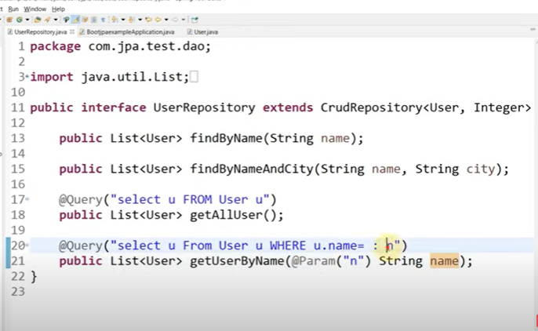

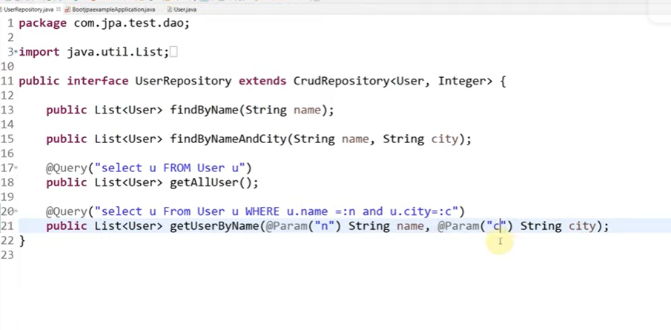

Introduction to API/WEB SERVICES | What is REST API | Understand REST API with Example |Spring Boot

Introduction to API / Web Services
In software development, APIs (Application Programming Interfaces) are mechanisms that allow different systems or software components to communicate with each other. Web services are a type of API that allows systems to communicate over the internet using standard protocols like HTTP. The most common type of web service today is the REST API (Representational State Transfer API).

What is a REST API?
A REST API is an API that adheres to the principles of REST (Representational State Transfer). REST is an architectural style for distributed systems, and it's commonly used in web services to enable communication between a client and a server.
REST APIs typically use HTTP methods like GET, POST, PUT, DELETE, etc., and communicate using standard data formats like JSON or XML.

Key Principles of REST:
- Stateless: Each request from the client to the server must contain all the information needed to understand and process the request. The server does not store any client context between requests.
- Client-Server Architecture: The client and server are separate entities. The client interacts with the server through requests, and the server processes these requests and sends responses back.
- Uniform Interface: REST APIs follow a uniform set of conventions for resource URLs (Uniform Resource Identifiers) and standard HTTP methods (GET, POST, PUT, DELETE).
- Cacheable: Responses must explicitly indicate whether they are cacheable. This helps in improving performance by reducing the need for repeated requests.
- Layered System: A client can interact with the server through intermediary servers (like proxies or load balancers), which handle requests without needing to know about the client’s internal structure.
- Code on Demand (optional): The server can provide executable code to the client (e.g., JavaScript), allowing the client to dynamically extend its functionality.

REST API Methods
- GET: Retrieves data from the server (e.g., fetch a list of items).
- POST: Sends data to the server to create a new resource (e.g., create a new item).
- PUT: Updates an existing resource on the server (e.g., modify an item).
- DELETE: Deletes a resource on the server (e.g., remove an item).

Understanding REST API with Example
Imagine you're building a Book Store API, where you manage a collection of books. Each book has properties like id, title, author, and price.

Example: CRUD Operations on Books
- GET /api/books: Retrieve all books.
- GET /api/books/{id}: Retrieve a single book by its id.
- POST /api/books: Create a new book.
- PUT /api/books/{id}: Update an existing book.
- DELETE /api/books/{id}: Delete a book.
Let's now look at how to implement a simple REST API in Spring Boot to manage a list of books.

Building a REST API with Spring Boot
Spring Boot simplifies the process of building production-ready applications with Spring. It provides a set of tools and default configurations to set up a web application and expose REST APIs with minimal configuration.

1. Setting Up Spring Boot Project
To create a REST API using Spring Boot, you'll need:
- Spring Web: This will allow you to build web applications, including RESTful web services.
- Spring Data JPA (optional): If you need database interaction, you can use Spring Data JPA to work with relational databases.
You can create the project using Spring Initializr: https://start.spring.io/

2. Create the Model Class (Book)
java
Copy code
package com.example.bookstore.model;

public class Book {

private Long id;
private String title;
private String author;
private double price;

// Constructors, getters, setters
public Book(Long id, String title, String author, double price) {
this.id = id;
this.title = title;
this.author = author;
this.price = price;
}

// Getters and Setters
}

3. Create the Controller Class
This is where we define the RESTful endpoints (URLs) for our API.
java
Copy code
package com.example.bookstore.controller;

import com.example.bookstore.model.Book;
import org.springframework.web.bind.annotation.*;

import java.util.ArrayList;
import java.util.List;

@RestController
@RequestMapping("/api/books")
public class BookController {

private List<Book> books = new ArrayList<>();

public BookController() {
// Initializing some books
books.add(new Book(1L, "Spring in Action", "Craig Walls", 39.99));
books.add(new Book(2L, "Java Programming", "Herbert Schildt", 29.99));
}

// GET all books
@GetMapping
public List<Book> getAllBooks() {
return books;
}

// GET book by ID
@GetMapping("/{id}")
public Book getBookById(@PathVariable Long id) {
return books.stream()
.filter(book -> book.getId().equals(id))
.findFirst()
.orElse(null); // Return null if no book is found
}

// POST a new book
@PostMapping
public void createBook(@RequestBody Book book) {
books.add(book);
}

// PUT to update a book
@PutMapping("/{id}")
public void updateBook(@PathVariable Long id, @RequestBody Book updatedBook) {
books.forEach(book -> {
if (book.getId().equals(id)) {
book.setTitle(updatedBook.getTitle());
book.setAuthor(updatedBook.getAuthor());
book.setPrice(updatedBook.getPrice());
}
});
}

// DELETE a book by ID
@DeleteMapping("/{id}")
public void deleteBook(@PathVariable Long id) {
books.removeIf(book -> book.getId().equals(id));
}
}

Explanation of the Controller:
- @RestController: Marks this class as a REST controller, meaning that the return values of the methods will be serialized directly into HTTP responses (typically as JSON).
- @RequestMapping("/api/books"): Specifies that all methods in this class will handle requests starting with /api/books.
- @GetMapping, @PostMapping, @PutMapping, @DeleteMapping: These are shorthand annotations for the HTTP methods GET, POST, PUT, and DELETE, respectively.
- @PathVariable: Binds a method parameter to a path variable (e.g., {id}).
- @RequestBody: Binds a method parameter to the body of the request (e.g., for POST and PUT requests).

4. Running the Spring Boot Application
Once you have the application set up, you can run it by executing:
bash
Copy code
mvn spring-boot:run
This will start the Spring Boot application on http://localhost:8080.

5. Testing the API
You can test the API using tools like Postman or curl.
- GET all books:
bash
Copy code
curl -X GET http://localhost:8080/api/books
- GET book by ID:
bash
Copy code
curl -X GET http://localhost:8080/api/books/1
- POST a new book:
bash
Copy code
curl -X POST http://localhost:8080/api/books -H "Content-Type: application/json" -d '{"id": 3, "title": "Java Concurrency", "author": "Brian Goetz", "price": 49.99}'
- PUT update book:
bash
Copy code
curl -X PUT http://localhost:8080/api/books/1 -H "Content-Type: application/json" -d '{"title": "Spring in Action - Updated", "author": "Craig Walls", "price": 45.00}'
- DELETE a book:
bash
Copy code
curl -X DELETE http://localhost:8080/api/books/1

Conclusion
A REST API provides a simple, lightweight, and scalable way for systems to communicate over the web. In Spring Boot, creating RESTful web services is straightforward thanks to annotations like @RestController, @GetMapping, @PostMapping, and @RequestMapping. By following REST principles, you can design an API that is easy to understand and consume.
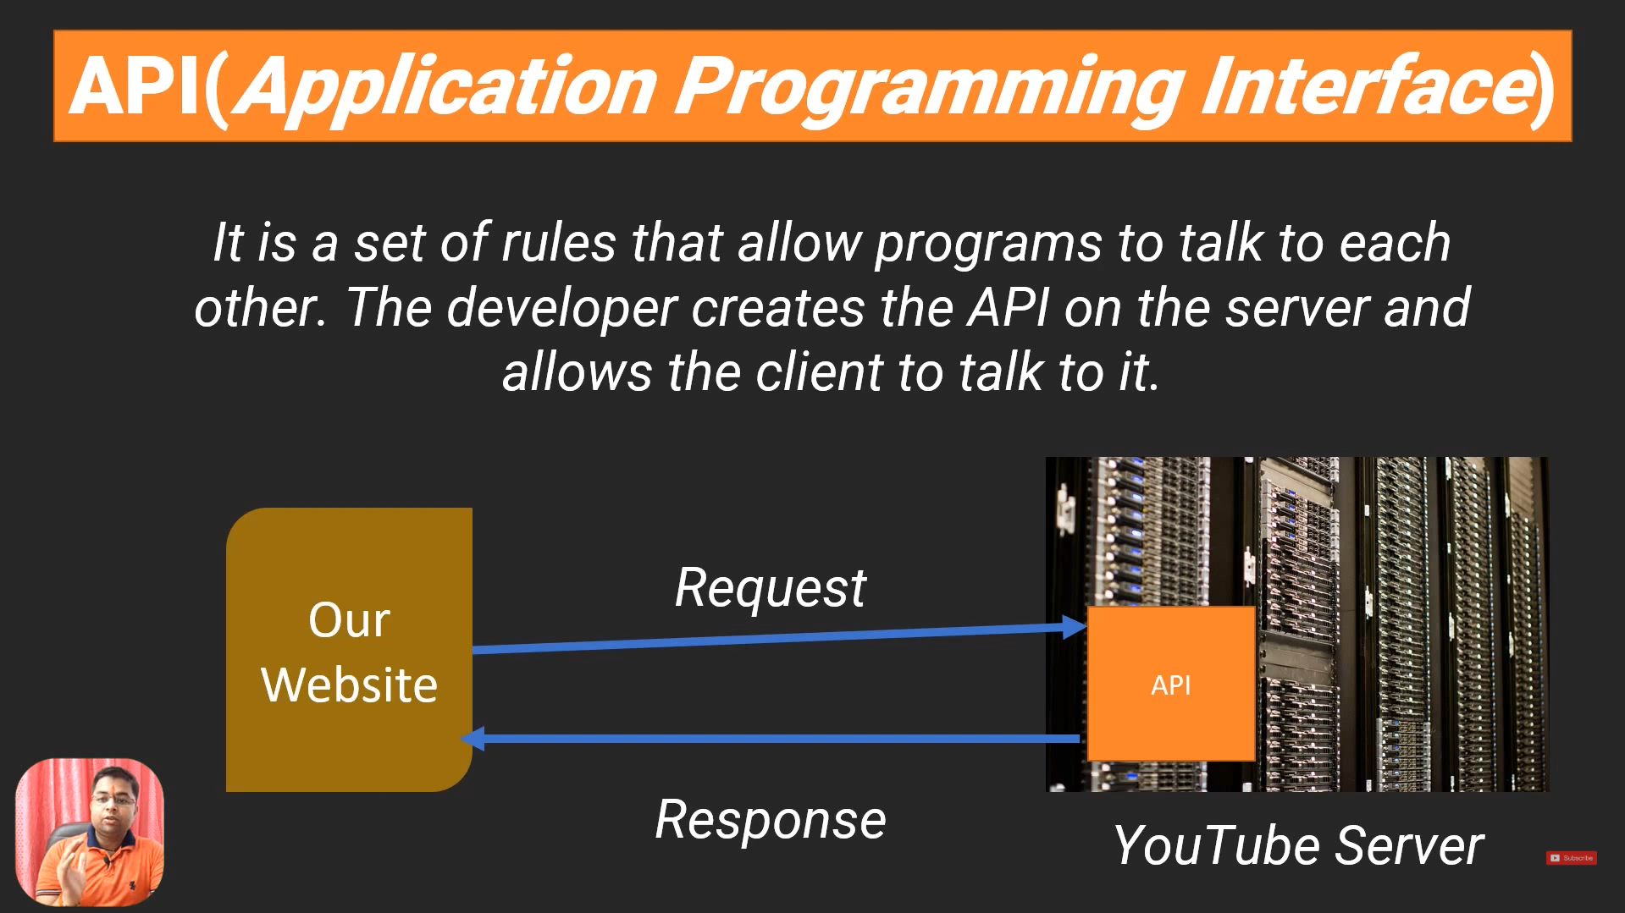
Response will be either in xml format or json format
Mostly Json

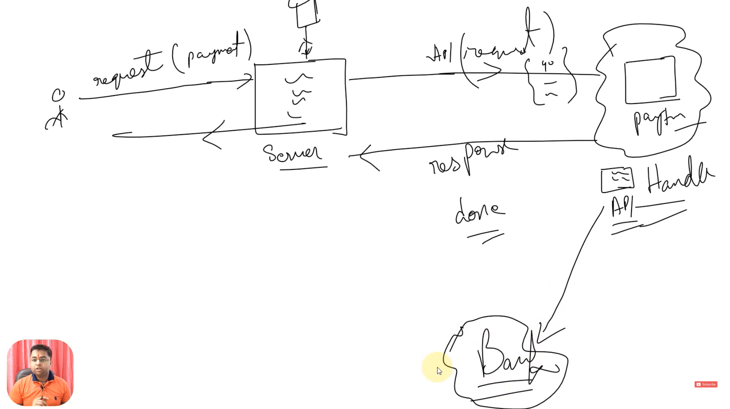
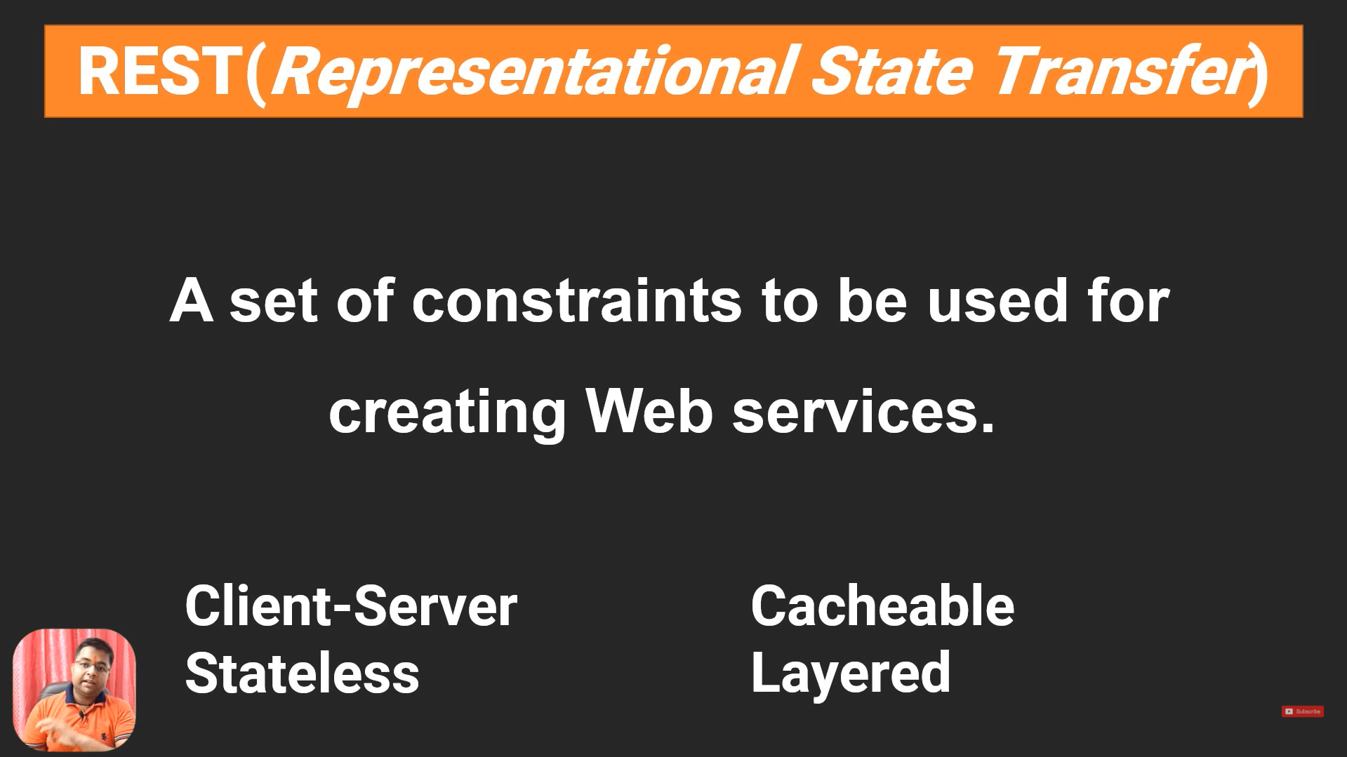

Cacheable Meaning in REST APIs
In the context of REST APIs, cacheable means that the responses returned by the server can be stored temporarily (cached) by intermediate systems like browsers, proxy servers, or content delivery networks (CDNs). These cached responses can then be reused for subsequent requests to improve performance, reduce latency, and decrease the load on the server.

Why is Cacheability Important?
- Improved Performance: Cached responses can be served quickly without re-processing the request on the server.
- Reduced Latency: Since cached data is closer to the client (e.g., in the browser or proxy), retrieval time is much faster.
- Less Server Load: Fewer requests reach the server, reducing processing overhead.
- Bandwidth Savings: Cached data avoids redundant data transmission, saving bandwidth.

How Cacheability Works
When a REST API server sends a response, it includes cache-control metadata in the HTTP headers. These headers instruct the client or intermediate systems whether and for how long the response can be cached.

Common HTTP Headers for Cache Control
- Cache-Control: The most important header for controlling caching behavior.
  - Example values:
    - Cache-Control: no-cache: Forces the client to validate the cached response with the server before using it.
    - Cache-Control: no-store: Prevents caching entirely.
    - Cache-Control: max-age=3600: Specifies that the response can be cached for 3600 seconds (1 hour).
- ETag (Entity Tag): Provides a unique identifier for a specific version of a resource. The client can check this tag to determine if the cached resource is still valid.
  - Example: ETag: "abc123"
- Expires: Specifies the date and time when the cached response is no longer valid.
  - Example: Expires: Wed, 02 Jan 2025 15:00:00 GMT
- Last-Modified: Indicates when the resource was last updated. Clients can use this information to make conditional requests.
  - Example: Last-Modified: Wed, 01 Jan 2025 12:00:00 GMT

Cacheable Example in REST APIs

Scenario: API for Product Details
Imagine an API endpoint /api/products/{id} that returns details about a product. Since product details don’t change frequently, the response can be cached.

Controller Example in Spring Boot
java
Copy code
package com.example.api.controller;

import org.springframework.http.ResponseEntity;
import org.springframework.web.bind.annotation.GetMapping;
import org.springframework.web.bind.annotation.PathVariable;
import org.springframework.web.bind.annotation.RestController;

import java.time.LocalDateTime;

@RestController
@RequestMapping("/api/products")
public class ProductController {

@GetMapping("/{id}")
public ResponseEntity<Product> getProductById(@PathVariable Long id) {
Product product = new Product(id, "Laptop", "Electronics", 1200.00, LocalDateTime.now());

return ResponseEntity.ok()
.header("Cache-Control", "max-age=3600") // Cache for 1 hour
.header("ETag", "\"product-" + id + "\"") // Unique ETag for this resource
.body(product);
}
}

Product Model
java
Copy code
package com.example.api.model;

import java.time.LocalDateTime;

public class Product {
private Long id;
private String name;
private String category;
private double price;
private LocalDateTime lastUpdated;

// Constructor, Getters, and Setters
public Product(Long id, String name, String category, double price, LocalDateTime lastUpdated) {
this.id = id;
this.name = name;
this.category = category;
this.price = price;
this.lastUpdated = lastUpdated;
}

// Getters and Setters
}

How the Cache Works for This Example
- First Request:
  - The client sends a GET request for /api/products/1.
  - The server responds with the product details and includes the Cache-Control and ETag headers.
- Subsequent Requests:
  - The client checks if the cached response is still valid using the ETag.
  - If the response is still valid, it can be reused without contacting the server.
  - If the resource has changed (e.g., price updated), the server returns a new version with an updated ETag.

Key Notes:
- Cacheability is Resource-Specific: Some resources (like product details) are ideal for caching, while others (like user account information) are not.
- Avoid Caching Sensitive Data: Responses containing private or sensitive information should use Cache-Control: no-store to prevent caching.
- Performance Gains: Proper use of caching can significantly enhance application performance, especially for high-traffic APIs.
4o
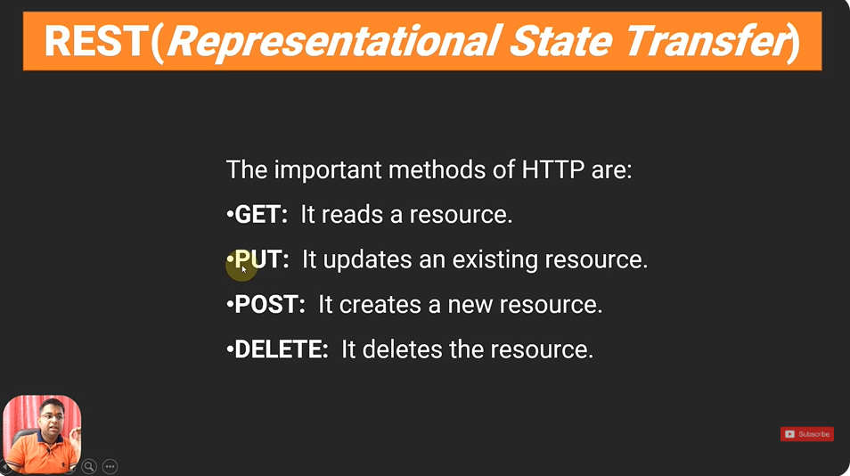
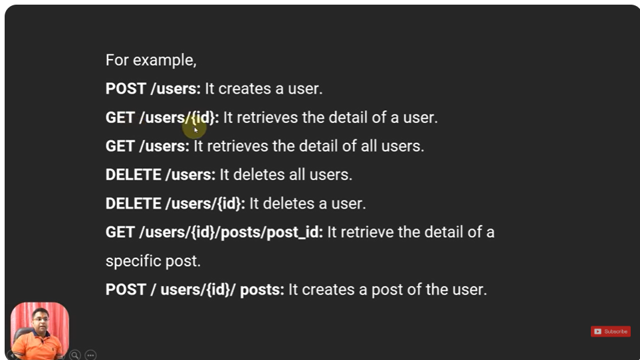
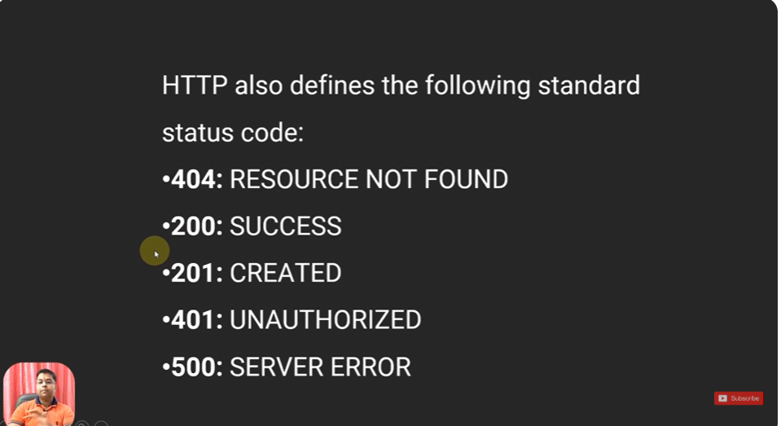

Magic of Spring Boot DevTools

Spring Boot DevTools is a development-time tool designed to improve productivity during application development. It enables features like automatic restarts, live reloading, and debugging aids, making the development process faster and more seamless.

Key Features of Spring Boot DevTools
- Automatic Restart
  - What it does: Automatically restarts the application whenever files in the classpath are modified.
  - How it helps: You don’t need to stop and restart the application manually after making code changes.
  - How it works: DevTools watches for changes in the src/main/java and src/main/resources directories. When it detects a change, it restarts the application context.
- LiveReload
  - What it does: Automatically reloads the browser when static resources like HTML, CSS, or JavaScript files are modified.
  - How it helps: Simplifies frontend development by removing the need to refresh the browser manually.
  - How it works: It integrates with the LiveReload browser plugin, which listens for changes and triggers a reload.
- Property Defaults
  - DevTools changes certain default behaviors of Spring Boot during development:
    - Caching is disabled for templates like Thymeleaf, FreeMarker, or Groovy templates to allow real-time changes.
    - Enables additional development-friendly configurations.
- Remote Debugging
  - What it does: Allows you to connect to a running application remotely for debugging purposes.
  - How it helps: Simplifies debugging for cloud-based or containerized applications during development.
  - How it works: You can enable remote debugging by setting up DevTools on a remote server.
- Restart Exclusions
  - What it does: Prevents specific files or directories from triggering an application restart.
  - How it helps: Avoids unnecessary restarts for files that don’t affect the application (e.g., logs, temporary files).
  - How it works: Configure excluded resources in the spring.devtools.restart.exclude property.
- Customizable Restarts
  - You can customize which directories are monitored for changes using the spring.devtools.restart.additional-paths property.
- Disable Restarts
  - Why needed: For performance reasons or specific workflows, you may want to disable automatic restarts.
  - How to disable: Set spring.devtools.restart.enabled=false in the application.properties file.

How to Add DevTools to Your Project
To use Spring Boot DevTools, include the following dependency in your pom.xml:
xml
Copy code
<dependency>
<groupId>org.springframework.boot</groupId>
<artifactId>spring-boot-devtools</artifactId>
<scope>runtime</scope>
<optional>true</optional>
</dependency>

Example: Testing DevTools Magic

Step 1: Create a Simple Spring Boot Application
Create a REST controller to display a simple message.
java
Copy code
package com.example.demo.controller;

import org.springframework.web.bind.annotation.GetMapping;
import org.springframework.web.bind.annotation.RestController;

@RestController
public class HelloController {

@GetMapping("/hello")
public String sayHello() {
return "Hello, Spring Boot DevTools!";
}
}

Step 2: Run the Application
Start your application using your IDE or mvn spring-boot:run. Access the endpoint at http://localhost:8080/hello.

Step 3: Modify the Code
Change the return value of the sayHello method:
java
Copy code
@GetMapping("/hello")
public String sayHello() {
return "DevTools Magic at Work!";
}

Step 4: Observe Automatic Restart
After saving the changes, Spring Boot DevTools will automatically restart the application. Refresh the browser, and you’ll see the updated message without restarting the application manually.

LiveReload Example for Static Resources
- Add an HTML file under src/main/resources/static/index.html.
html
Copy code
<!DOCTYPE html>
<html lang="en">
<head>
<meta charset="UTF-8">
<title>Welcome</title>
</head>
<body>
<h1>Hello, Spring Boot!</h1>
</body>
</html>
- Access it at http://localhost:8080/index.html.
- Modify the content of the HTML file:
html
Copy code
<h1>Welcome to DevTools LiveReload!</h1>
- Save the changes, and the browser will refresh automatically (if the LiveReload plugin is enabled).

Common Configuration Options
You can control DevTools behavior through the application.properties file:
- Disable restart:
properties
Copy code
spring.devtools.restart.enabled=false
- Exclude files from restart:
properties
Copy code
spring.devtools.restart.exclude=static/**,public/**
- Include additional paths for monitoring:
properties
Copy code
spring.devtools.restart.additional-paths=some/external/directory
- Enable remote debugging:
properties
Copy code
spring.devtools.remote.secret=some-secret
spring.devtools.remote.context-path=/remote

Pros and Cons of DevTools

Pros:
- Saves time by eliminating manual restarts.
- Improves frontend and backend development efficiency.
- Makes debugging easier with remote features.

Cons:
- Extra memory consumption due to background monitoring.
- Can cause slowdowns for large projects if not configured properly.

Conclusion
Spring Boot DevTools is an essential tool for developers seeking faster feedback loops during application development. Its ability to restart applications automatically, reload static resources, and disable caching simplifies the development process, allowing you to focus on writing code rather than managing restarts.

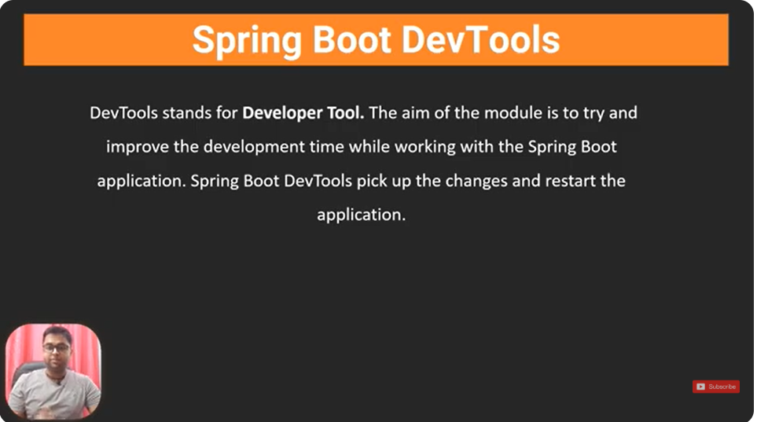
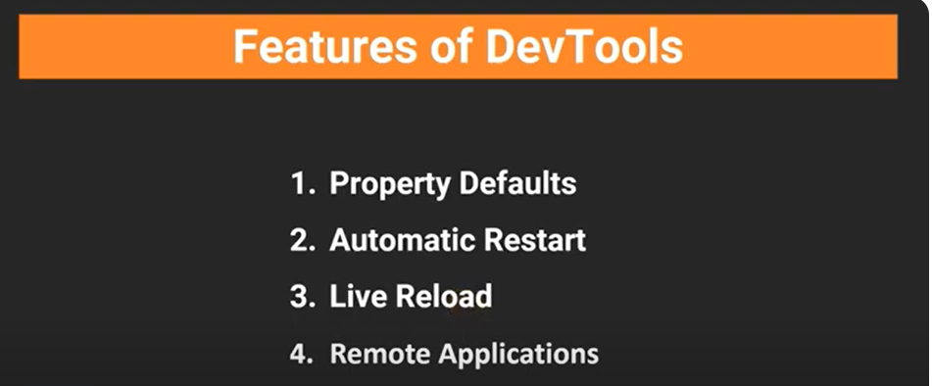

Springboot dev tools dependency we need to add

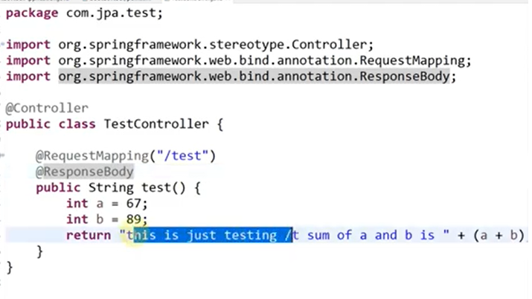
If we don’t use @ResponseBody than that string indicates a name of view.

Creating REST API using Spring Boot | Creating GET functionality

A REST API (Representational State Transfer API) allows communication between client and server using HTTP methods such as GET, POST, PUT, DELETE, etc. In this explanation, we will focus on creating a simple REST API with GET functionality using Spring Boot.

1. Steps to Create a GET API in Spring Boot
- Create a Spring Boot project
- Add required dependencies
- Create a REST Controller
- Define a GET endpoint
- Run and test the API

2. Step-by-Step Implementation

Step 1: Create a Spring Boot Project
You can create a Spring Boot project using Spring Initializr.
- Project Type: Maven
- Spring Boot Version: 2.7.x or 3.x
- Dependencies:
  - Spring Web (for REST API)
  - Spring Boot DevTools (for fast development)
  - Lombok (optional, for reducing boilerplate code)

Maven Dependency (pom.xml)
xml
Copy code
<dependencies>
<!-- Spring Boot Web Starter for REST API -->
<dependency>
<groupId>org.springframework.boot</groupId>
<artifactId>spring-boot-starter-web</artifactId>
</dependency>

<!-- Spring Boot DevTools (Optional for hot reload) -->
<dependency>
<groupId>org.springframework.boot</groupId>
<artifactId>spring-boot-devtools</artifactId>
<scope>runtime</scope>
<optional>true</optional>
</dependency>

<!-- Lombok (Optional for reducing boilerplate code) -->
<dependency>
<groupId>org.projectlombok</groupId>
<artifactId>lombok</artifactId>
<scope>provided</scope>
</dependency>
</dependencies>

Step 2: Create the Main Application Class

DemoApplication.java
java
Copy code
package com.example.demo;

import org.springframework.boot.SpringApplication;
import org.springframework.boot.autoconfigure.SpringBootApplication;

@SpringBootApplication
public class DemoApplication {
public static void main(String[] args) {
SpringApplication.run(DemoApplication.class, args);
}
}
This main class is the entry point of our Spring Boot application.

Step 3: Create a Model Class
A Model represents the data structure used in the API.

Student.java
java
Copy code
package com.example.demo.model;

public class Student {
private int id;
private String name;
private int age;

// Constructor
public Student(int id, String name, int age) {
this.id = id;
this.name = name;
this.age = age;
}

// Getters
public int getId() { return id; }
public String getName() { return name; }
public int getAge() { return age; }
}

Step 4: Create a Service Class
The Service Layer contains the business logic.

StudentService.java
java
Copy code
package com.example.demo.service;

import com.example.demo.model.Student;
import org.springframework.stereotype.Service;
import java.util.Arrays;
import java.util.List;

@Service
public class StudentService {

// Hardcoded list of students
private final List<Student> students = Arrays.asList(
new Student(1, "Alice", 22),
new Student(2, "Bob", 24),
new Student(3, "Charlie", 21)
);

// Fetch all students
public List<Student> getAllStudents() {
return students;
}

// Fetch student by ID
public Student getStudentById(int id) {
return students.stream().filter(s -> s.getId() == id).findFirst().orElse(null);
}
}

Step 5: Create a REST Controller
A Controller handles API requests.

StudentController.java
java
Copy code
package com.example.demo.controller;

import com.example.demo.model.Student;
import com.example.demo.service.StudentService;
import org.springframework.web.bind.annotation.*;

import java.util.List;

@RestController
@RequestMapping("/api/students") // Base URL for all endpoints in this controller
public class StudentController {

private final StudentService studentService;

// Constructor Injection (Best practice)
public StudentController(StudentService studentService) {
this.studentService = studentService;
}

// 1. GET Request - Fetch all students
@GetMapping
public List<Student> getAllStudents() {
return studentService.getAllStudents();
}

// 2. GET Request - Fetch student by ID
@GetMapping("/{id}")
public Student getStudentById(@PathVariable int id) {
return studentService.getStudentById(id);
}
}

3. Explanation of Key Annotations
Annotation | Description
@RestController | Marks this class as a REST API Controller
@RequestMapping("/api/students") | Sets the base path for all APIs in this controller
@GetMapping | Maps HTTP GET requests to a method
@PathVariable | Extracts values from the URL path

4. Running and Testing the API

Start the Spring Boot Application
Run the project from your IDE or use the command:
sh
Copy code
mvn spring-boot:run

Testing with Browser or Postman
- Fetch All Students
  - URL: http://localhost:8080/api/students
  - Method: GET
  - Response (JSON):
json
Copy code
[
{ "id": 1, "name": "Alice", "age": 22 },
{ "id": 2, "name": "Bob", "age": 24 },
{ "id": 3, "name": "Charlie", "age": 21 }
]
- Fetch Student by ID
  - URL: http://localhost:8080/api/students/1
  - Method: GET
  - Response (JSON):
json
Copy code
{ "id": 1, "name": "Alice", "age": 22 }

5. Summary
- Created a REST API in Spring Boot.
- Implemented GET functionality to retrieve data.
- Tested using browser/Postman.

6. Next Steps
- Implement POST (Create Student) functionality.
- Implement PUT (Update Student) functionality.
- Implement DELETE (Delete Student) functionality.

Spring Boot REST API – Implementing CRUD Operations (POST, PUT, DELETE)
Now that we have implemented the GET functionality, let's continue with the POST (Create), PUT (Update), and DELETE (Remove) operations.

1. Updated StudentService.java (Service Layer)
We will modify the StudentService class to allow adding, updating, and deleting students dynamically.
java
Copy code
package com.example.demo.service;

import com.example.demo.model.Student;
import org.springframework.stereotype.Service;

import java.util.ArrayList;
import java.util.List;
import java.util.Optional;

@Service
public class StudentService {

private final List<Student> students = new ArrayList<>();

// Constructor: Adding some initial students
public StudentService() {
students.add(new Student(1, "Alice", 22));
students.add(new Student(2, "Bob", 24));
students.add(new Student(3, "Charlie", 21));
}

// Fetch all students
public List<Student> getAllStudents() {
return students;
}

// Fetch student by ID
public Student getStudentById(int id) {
return students.stream().filter(s -> s.getId() == id).findFirst().orElse(null);
}

// Add new student (POST)
public Student addStudent(Student student) {
students.add(student);
return student;
}

// Update student (PUT)
public Student updateStudent(int id, Student updatedStudent) {
for (int i = 0; i < students.size(); i++) {
if (students.get(i).getId() == id) {
students.set(i, updatedStudent);
return updatedStudent;
}
}
return null;
}

// Delete student (DELETE)
public boolean deleteStudent(int id) {
return students.removeIf(s -> s.getId() == id);
}
}

2. Updated StudentController.java (Controller Layer)
Now, let's modify our controller to handle POST, PUT, and DELETE operations.
java
Copy code
package com.example.demo.controller;

import com.example.demo.model.Student;
import com.example.demo.service.StudentService;
import org.springframework.http.HttpStatus;
import org.springframework.http.ResponseEntity;
import org.springframework.web.bind.annotation.*;

import java.util.List;

@RestController
@RequestMapping("/api/students")
public class StudentController {

private final StudentService studentService;

// Constructor Injection (Best practice)
public StudentController(StudentService studentService) {
this.studentService = studentService;
}

// 1. GET Request - Fetch all students
@GetMapping
public List<Student> getAllStudents() {
return studentService.getAllStudents();
}

// 2. GET Request - Fetch student by ID
@GetMapping("/{id}")
public ResponseEntity<Student> getStudentById(@PathVariable int id) {
Student student = studentService.getStudentById(id);
return student != null ? ResponseEntity.ok(student) : ResponseEntity.notFound().build();
}

// 3. POST Request - Add a new student
@PostMapping
public ResponseEntity<Student> addStudent(@RequestBody Student student) {
Student newStudent = studentService.addStudent(student);
return ResponseEntity.status(HttpStatus.CREATED).body(newStudent);
}

// 4. PUT Request - Update a student
@PutMapping("/{id}")
public ResponseEntity<Student> updateStudent(@PathVariable int id, @RequestBody Student updatedStudent) {
Student student = studentService.updateStudent(id, updatedStudent);
return student != null ? ResponseEntity.ok(student) : ResponseEntity.notFound().build();
}

// 5. DELETE Request - Delete a student
@DeleteMapping("/{id}")
public ResponseEntity<Void> deleteStudent(@PathVariable int id) {
boolean deleted = studentService.deleteStudent(id);
return deleted ? ResponseEntity.noContent().build() : ResponseEntity.notFound().build();
}
}

3. Explanation of HTTP Methods
HTTP Method | Description | Endpoint
GET | Fetch all students | GET /api/students
GET | Fetch a student by ID | GET /api/students/{id}
POST | Add a new student | POST /api/students
PUT | Update an existing student | PUT /api/students/{id}
DELETE | Delete a student by ID | DELETE /api/students/{id}

4. Testing the API using Postman / cURL

1️⃣ GET – Fetch All Students
- URL: http://localhost:8080/api/students
- Method: GET
- Response:
json
Copy code
[
{ "id": 1, "name": "Alice", "age": 22 },
{ "id": 2, "name": "Bob", "age": 24 },
{ "id": 3, "name": "Charlie", "age": 21 }
]

2️⃣ GET – Fetch Student by ID
- URL: http://localhost:8080/api/students/1
- Method: GET
- Response:
json
Copy code
{ "id": 1, "name": "Alice", "age": 22 }

3️⃣ POST – Add a New Student
- URL: http://localhost:8080/api/students
- Method: POST
- Body (JSON):
json
Copy code
{ "id": 4, "name": "David", "age": 23 }
- Response (201 Created):
json
Copy code
{ "id": 4, "name": "David", "age": 23 }

4️⃣ PUT – Update a Student
- URL: http://localhost:8080/api/students/2
- Method: PUT
- Body (JSON):
json
Copy code
{ "id": 2, "name": "Bob Marley", "age": 25 }
- Response (200 OK):
json
Copy code
{ "id": 2, "name": "Bob Marley", "age": 25 }

5️⃣ DELETE – Remove a Student
- URL: http://localhost:8080/api/students/3
- Method: DELETE
- Response (204 No Content)

5. Summary
✔ Implemented full CRUD operations using Spring Boot
✔ Used @RestController, @GetMapping, @PostMapping, @PutMapping, and @DeleteMapping
✔ Tested using Postman and cURL

Integrating PostgreSQL with Spring Boot for REST API CRUD Operations
Now, we'll integrate PostgreSQL with our Spring Boot application. This involves:
- Setting up PostgreSQL database
- Configuring Spring Boot to use PostgreSQL
- Using JPA (Hibernate) for database operations
- Implementing CRUD operations with PostgreSQL

1. Setting Up PostgreSQL Database
Before we proceed, make sure PostgreSQL is installed and running.

Create a Database and Table
Open psql (PostgreSQL Shell) or use pgAdmin and run:
sql
Copy code
CREATE DATABASE studentdb;

2. Add PostgreSQL Dependency to pom.xml
Modify pom.xml to include the PostgreSQL driver and Spring Data JPA:
xml
Copy code
<dependencies>
<!-- Spring Boot Web Starter -->
<dependency>
<groupId>org.springframework.boot</groupId>
<artifactId>spring-boot-starter-web</artifactId>
</dependency>

<!-- Spring Boot JPA Starter -->
<dependency>
<groupId>org.springframework.boot</groupId>
<artifactId>spring-boot-starter-data-jpa</artifactId>
</dependency>

<!-- PostgreSQL Driver -->
<dependency>
<groupId>org.postgresql</groupId>
<artifactId>postgresql</artifactId>
<scope>runtime</scope>
</dependency>

<!-- Lombok (Optional) -->
<dependency>
<groupId>org.projectlombok</groupId>
<artifactId>lombok</artifactId>
<scope>provided</scope>
</dependency>
</dependencies>

3. Configure application.properties
Tell Spring Boot to connect to PostgreSQL.
Modify src/main/resources/application.properties:
properties
Copy code
# PostgreSQL Database Configuration
spring.datasource.url=jdbc:postgresql://localhost:5432/studentdb
spring.datasource.username=postgres
spring.datasource.password=your_password
spring.datasource.driver-class-name=org.postgresql.Driver

# JPA (Hibernate) Configuration
spring.jpa.database-platform=org.hibernate.dialect.PostgreSQLDialect
spring.jpa.hibernate.ddl-auto=update
spring.jpa.show-sql=true
Replace your_password with your actual PostgreSQL password.

4. Create Student Entity
Modify the Student class to be a JPA entity.
java
Copy code
package com.example.demo.model;

import jakarta.persistence.*;

@Entity
@Table(name = "students")
public class Student {
@Id
@GeneratedValue(strategy = GenerationType.IDENTITY)
private int id;

private String name;
private int age;

public Student() {}

public Student(String name, int age) {
this.name = name;
this.age = age;
}

public int getId() { return id; }
public String getName() { return name; }
public int getAge() { return age; }

public void setId(int id) { this.id = id; }
public void setName(String name) { this.name = name; }
public void setAge(int age) { this.age = age; }
}
- @Entity → Marks the class as a database table.
- @Table(name = "students") → Maps the class to a table named students.
- @Id & @GeneratedValue(strategy = GenerationType.IDENTITY) → Defines id as the primary key with auto-increment.

5. Create StudentRepository (JPA Repository)
java
Copy code
package com.example.demo.repository;

import com.example.demo.model.Student;
import org.springframework.data.jpa.repository.JpaRepository;
import org.springframework.stereotype.Repository;

@Repository
public interface StudentRepository extends JpaRepository<Student, Integer> {
}
- JpaRepository<Student, Integer> → Provides built-in CRUD methods.

6. Modify StudentService to Use JPA
java
Copy code
package com.example.demo.service;

import com.example.demo.model.Student;
import com.example.demo.repository.StudentRepository;
import org.springframework.stereotype.Service;

import java.util.List;
import java.util.Optional;

@Service
public class StudentService {

private final StudentRepository studentRepository;

public StudentService(StudentRepository studentRepository) {
this.studentRepository = studentRepository;
}

// Fetch all students
public List<Student> getAllStudents() {
return studentRepository.findAll();
}

// Fetch student by ID
public Student getStudentById(int id) {
return studentRepository.findById(id).orElse(null);
}

// Add new student (POST)
public Student addStudent(Student student) {
return studentRepository.save(student);
}

// Update student (PUT)
public Student updateStudent(int id, Student updatedStudent) {
if (studentRepository.existsById(id)) {
updatedStudent.setId(id); // Ensure the same ID
return studentRepository.save(updatedStudent);
}
return null;
}

// Delete student (DELETE)
public boolean deleteStudent(int id) {
if (studentRepository.existsById(id)) {
studentRepository.deleteById(id);
return true;
}
return false;
}
}

7. Modify StudentController
java
Copy code
package com.example.demo.controller;

import com.example.demo.model.Student;
import com.example.demo.service.StudentService;
import org.springframework.http.HttpStatus;
import org.springframework.http.ResponseEntity;
import org.springframework.web.bind.annotation.*;

import java.util.List;

@RestController
@RequestMapping("/api/students")
public class StudentController {

private final StudentService studentService;

public StudentController(StudentService studentService) {
this.studentService = studentService;
}

// 1. GET - Fetch all students
@GetMapping
public List<Student> getAllStudents() {
return studentService.getAllStudents();
}

// 2. GET - Fetch student by ID
@GetMapping("/{id}")
public ResponseEntity<Student> getStudentById(@PathVariable int id) {
Student student = studentService.getStudentById(id);
return student != null ? ResponseEntity.ok(student) : ResponseEntity.notFound().build();
}

// 3. POST - Add new student
@PostMapping
public ResponseEntity<Student> addStudent(@RequestBody Student student) {
return ResponseEntity.status(HttpStatus.CREATED).body(studentService.addStudent(student));
}

// 4. PUT - Update student
@PutMapping("/{id}")
public ResponseEntity<Student> updateStudent(@PathVariable int id, @RequestBody Student updatedStudent) {
Student student = studentService.updateStudent(id, updatedStudent);
return student != null ? ResponseEntity.ok(student) : ResponseEntity.notFound().build();
}

// 5. DELETE - Delete student
@DeleteMapping("/{id}")
public ResponseEntity<Void> deleteStudent(@PathVariable int id) {
return studentService.deleteStudent(id) ? ResponseEntity.noContent().build() : ResponseEntity.notFound().build();
}
}

8. Running the Application
- Start PostgreSQL
- Run Spring Boot Application
sh
Copy code
mvn spring-boot:run
- Test API Using Postman or CURL
✔ GET ALL STUDENTS → GET http://localhost:8080/api/students
✔ GET STUDENT BY ID → GET http://localhost:8080/api/students/1
✔ ADD STUDENT → POST http://localhost:8080/api/students
json
Copy code
{ "name": "John", "age": 25 }
✔ UPDATE STUDENT → PUT http://localhost:8080/api/students/1
json
Copy code
{ "id": 1, "name": "John Doe", "age": 26 }
✔ DELETE STUDENT → DELETE http://localhost:8080/api/students/1

9. Summary
✔ Integrated PostgreSQL with Spring Boot
✔ Used Spring Data JPA for CRUD operations
✔ Tested API using Postman and cURL

How to call API | Postman

How to Call API Using Postman
Postman is a popular tool for testing REST APIs. You can send various types of HTTP requests (GET, POST, PUT, DELETE) and analyze the responses. Below are the steps to call an API using Postman.

1. Install and Open Postman
- Download and install Postman from Postman’s official site.
- Open Postman after installation.

2. Calling a REST API in Postman

GET Request (Fetching Data)

Example: Get All Students
- Open Postman.
- Select GET from the dropdown.
- Enter the URL:
bash
Copy code
http://localhost:8080/api/students
- Click Send.
- Response appears in the Body section.

Example: Get Student by ID
- URL:
bash
Copy code
http://localhost:8080/api/students/1
- This fetches the student with ID 1.

POST Request (Creating Data)

Example: Add a New Student
- Select POST.
- Enter the URL:
bash
Copy code
http://localhost:8080/api/students
- Click Body → raw → JSON.
- Enter the JSON data:
json
Copy code
{
"name": "John Doe",
"age": 22,
"department": "Computer Science"
}
- Click Send.
- A new student is created.

PUT Request (Updating Data)

Example: Update Student Information
- Select PUT.
- Enter the URL:
bash
Copy code
http://localhost:8080/api/students/1
- Click Body → raw → JSON.
- Enter the updated JSON:
json
Copy code
{
"name": "John Updated",
"age": 23,
"department": "IT"
}
- Click Send.
- The student’s information is updated.

DELETE Request (Deleting Data)

Example: Delete a Student
- Select DELETE.
- Enter the URL:
bash
Copy code
http://localhost:8080/api/students/1
- Click Send.
- The student with ID 1 is deleted.

3. Adding Query Parameters
For pagination and sorting:
bash
Copy code
http://localhost:8080/api/students/paged?page=0&size=5&sortBy=name&sortDirection=asc
- page=0 → Fetch first page.
- size=5 → Fetch 5 records per page.
- sortBy=name → Sort by student name.
- sortDirection=asc → Sort in ascending order.

4. Using Headers
For APIs requiring headers:
- Go to the Headers tab.
- Add:
yaml
Copy code
Key: Content-Type, Value: application/json
If authentication is needed, you might add:
yaml
Copy code
Key: Authorization, Value: Bearer <your_token>

5. Saving Requests for Future Use
- Click Save in Postman after making a request.
- You can organize them into collections for later use.

6. Viewing API Response
- 200 OK → Successful request.
- 201 Created → Data successfully created (for POST).
- 400 Bad Request → Invalid input.
- 404 Not Found → Requested resource not found.
- 500 Internal Server Error → Issue on the server-side.

Summary
✔ GET → Fetch data.
✔ POST → Create new data.
✔ PUT → Update existing data.
✔ DELETE → Remove data.
✔ Query Params & Headers → For advanced requests.
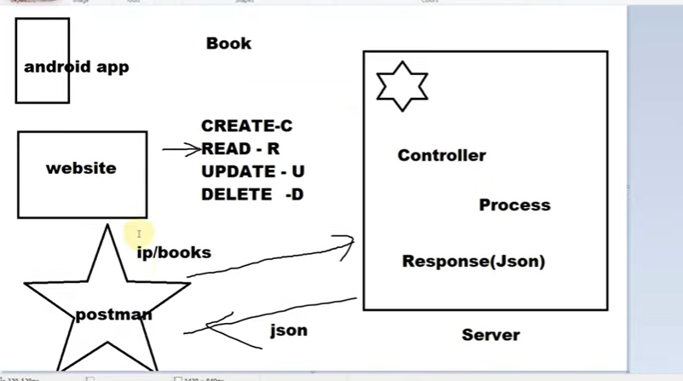

Annotation | Description
@RestController | Marks this class as a RESTful controller.
@RequestMapping("/api/books") | Sets the base URL for API endpoints.
@GetMapping | Handles HTTP GET requests.
@PathVariable("id") | Extracts {id} from the URL.
@Service | Marks this class as a service component.
@Autowired | Injects dependencies automatically.
@Entity | Marks the class as a JPA entity.
@Id | Specifies the primary key.
@GeneratedValue(strategy = GenerationType.IDENTITY) | Enables auto-increment for the primary key.

5. Summary
- @GetMapping is used to handle GET requests.
- Fetching all books: GET /api/books
- Fetching a book by ID: GET /api/books/{id}
- Uses @PathVariable to extract the ID from the URL.
- Service layer handles the business logic.
- Data is retrieved from the database using JPA.

Our Codes Implementing Functionality using SpringBoot and PostMan

At this stage we have not Included JPA Database so will use a fake service class for Data

BookController.java

package com.api.book.controllers;

import java.util.List;

import org.springframework.beans.factory.annotation.Autowired;
import org.springframework.stereotype.Controller;
import org.springframework.web.bind.annotation.GetMapping;
import org.springframework.web.bind.annotation.PathVariable;
import org.springframework.web.bind.annotation.RequestMapping;
import org.springframework.web.bind.annotation.RequestMethod;
import org.springframework.web.bind.annotation.ResponseBody;
import org.springframework.web.bind.annotation.RestController;

import com.api.book.entities.Book;
import com.api.book.services.BookService;
//This annotation is used to make it RESTAPI Based Controller
@RestController
public class BookController {
@Autowired
private BookService bookservice;
//This Annotation avoids explicit mentioning of method request type
@GetMapping("/books")
public List<Book> getBook(){
//commented code was used to hard code raw values to understand GET
/*
* Book book = new Book(); book.setId(12);
* book.setName("Complete Java Development"); book.setAuthor("Light");
*/
//here we are calling getAllBooks method from fake service class
return this.bookservice.getAllBooks();
}
//This controller is for getting request on ID basis we have to fir this after URL
@GetMapping("/books/{id}")
public Book getBook(@PathVariable("id") int id) {
return bookservice.getBookById(id);
}

}

Book.java an Entity Class

package com.api.book.entities;

public class Book {

private int id;
private String name;
private String author;
public int getId() {
return id;
}
public void setId(int id) {
this.id = id;
}
public String getName() {
return name;
}
public void setName(String name) {
this.name = name;
}
public String getAuthor() {
return author;
}
public void setAuthor(String author) {
this.author = author;
}
@Override
public String toString() {
return "Book [id=" + id + ", name=" + name + ", author=" + author + ", getId()=" + getId() + ", getName()="
+ getName() + ", getAuthor()=" + getAuthor() + ", getClass()=" + getClass() + ", hashCode()="
+ hashCode() + ", toString()=" + super.toString() + "]";
}
public Book() {
super();
// TODO Auto-generated constructor stub
}
public Book(int id, String name, String author) {
super();
this.id = id;
this.name = name;
this.author = author;
}

}

BookService.java fake service class

package com.api.book.services;

import java.util.ArrayList;
import java.util.List;

import org.springframework.stereotype.Component;

import com.api.book.entities.Book;
@Component
public class BookService {
//creating a static list of books
private static List<Book> list = new ArrayList<>();
static
{
list.add(new Book(12,"Complete Java Development","light"));
list.add(new Book(17,"Complete Python Development","Yash"));
list.add(new Book(12,"Complete Web Development","Levi"));
}
//get all books
public List<Book>getAllBooks(){

return list;
}
//get single book
public Book getBookById(int id) {
Book book1 = null;
book1 = list.stream()
.filter(e -> e.getId() == id) // Corrected lambda expression
.findFirst()
.orElse(null); // Avoids NoSuchElementException if no match is found
return book1;
}

}

@PostMapping | Creating Resource REST API | REST API using Spring Boot

@PostMapping | Creating a Resource in REST API Using Spring Boot

1. What is @PostMapping?
- @PostMapping is used in Spring Boot to handle HTTP POST requests.
- It is typically used to create a new resource in a REST API.
- The data is sent in the request body in JSON format.

2. Example: Creating a Book Resource

2.1 Book Entity (Book.java)
This is a simple Book entity with properties like id, title, and author.
java
Copy code
import jakarta.persistence.*;

@Entity
public class Book {

@Id
@GeneratedValue(strategy = GenerationType.IDENTITY)
private int id;
private String title;
private String author;

// Constructors
public Book() {}

public Book(int id, String title, String author) {
this.id = id;
this.title = title;
this.author = author;
}

// Getters and Setters
public int getId() { return id; }
public void setId(int id) { this.id = id; }

public String getTitle() { return title; }
public void setTitle(String title) { this.title = title; }

public String getAuthor() { return author; }
public void setAuthor(String author) { this.author = author; }
}

2.2 Repository Layer (BookRepository.java)
This interface allows database operations.
java
Copy code
import org.springframework.data.jpa.repository.JpaRepository;

public interface BookRepository extends JpaRepository<Book, Integer> {
}

2.3 Service Layer (BookService.java)
This class contains the business logic for adding books.
java
Copy code
import org.springframework.beans.factory.annotation.Autowired;
import org.springframework.stereotype.Service;
import java.util.List;

@Service
public class BookService {

@Autowired
private BookRepository bookRepository;

public Book addBook(Book book) {
return bookRepository.save(book);
}
}

2.4 Controller Layer (BookController.java)
This controller handles HTTP POST requests.
java
Copy code
import org.springframework.beans.factory.annotation.Autowired;
import org.springframework.web.bind.annotation.*;

@RestController
@RequestMapping("/api/books")
public class BookController {

@Autowired
private BookService bookService;

// Create a new book
@PostMapping
public Book addBook(@RequestBody Book book) {
return bookService.addBook(book);
}
}

3. Testing the API in Postman

3.1 URL
bash
Copy code
POST http://localhost:8080/api/books

3.2 Request Headers
bash
Copy code
Content-Type: application/json

3.3 Request Body (JSON)
json
Copy code
{
"title": "Spring Boot Guide",
"author": "John Doe"
}

3.4 Expected Response
json
Copy code
{
"id": 1,
"title": "Spring Boot Guide",
"author": "John Doe"
}

4. Explanation of Annotations
Annotation | Description
@RestController | Marks this class as a RESTful controller.
@RequestMapping("/api/books") | Sets the base URL for API endpoints.
@PostMapping | Handles HTTP POST requests.
@RequestBody | Maps request body (JSON) to a Java object.
@Service | Marks this class as a service component.
@Autowired | Injects dependencies automatically.
@Entity | Marks the class as a JPA entity.
@Id | Specifies the primary key.
@GeneratedValue(strategy = GenerationType.IDENTITY) | Enables auto-increment for the primary key.

5. Summary
- @PostMapping is used to handle POST requests.
- Data is sent as JSON in the request body.
- @RequestBody converts JSON into a Java object.
- Data is saved in the database using JpaRepository.

Just add a addBook method in service layer

- 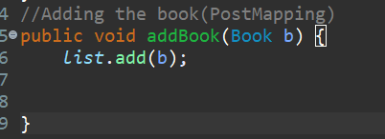

And call that service layer

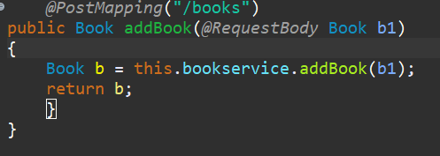
@DeleteMapping | Deleting Resource REST API | REST API using Spring Boot

1. What is @DeleteMapping?
- @DeleteMapping is used to handle HTTP DELETE requests in Spring Boot.
- It is typically used to delete a resource from the database.
- The request URL usually contains the resource ID to identify what needs to be deleted.

4. Explanation of Annotations
Annotation | Description
@RestController | Marks this class as a RESTful controller.
@RequestMapping("/api/books") | Sets the base URL for API endpoints.
@DeleteMapping("/{id}") | Handles HTTP DELETE requests for a specific ID.
@PathVariable("id") | Extracts {id} from the URL.
@Service | Marks this class as a service component.
@Autowired | Injects dependencies automatically.
@Entity | Marks the class as a JPA entity.
@Id | Specifies the primary key.
@GeneratedValue(strategy = GenerationType.IDENTITY) | Enables auto-increment for the primary key.

5. Summary
- @DeleteMapping("/{id}") is used to handle DELETE requests.
- The book ID is extracted from the URL using @PathVariable.
- The service layer calls deleteById(id) to remove the book from the database.
- Postman or any API client can be used to test the API.

@DeleteMapping | Deleting Resource REST API | REST API using Spring Boot

• @DeleteMapping is an annotation in Spring Boot used to handle HTTP DELETE requests.
• It is typically used for deleting a resource from the database.
• The request URL usually contains the resource ID to identify what needs to be deleted.

Annotation | Description
@RestController | Marks this class as a RESTful controller.
@RequestMapping("/api/books") | Sets the base URL for API endpoints.
@DeleteMapping("/{id}") | Handles HTTP DELETE requests for a specific ID.
@PathVariable("id") | Extracts {id} from the URL.
@Service | Marks this class as a service component.
@Autowired | Injects dependencies automatically.
@Entity | Marks the class as a JPA entity.
@Id | Specifies the primary key.
@GeneratedValue(strategy = GenerationType.IDENTITY) | Enables auto-increment for the primary key.
ResponseEntity<String> | Used to return an HTTP response with status codes.

5. Summary
- @DeleteMapping("/{id}") is used to handle DELETE requests.
- The book ID is extracted from the URL using @PathVariable.
- The service layer first checks if the book exists using existsById(id).
- If found, the book is deleted; otherwise, a 404 Not Found response is returned.
- Postman or any API client can be used to test the API.
Our Controller Method
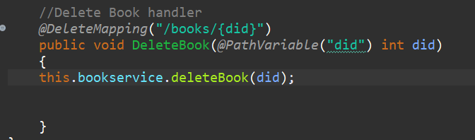
Our service Method
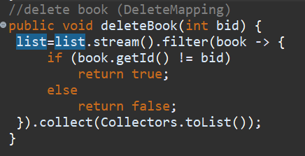

Stream API Processing
java
Copy code
list.stream().filter(book -> {
- list.stream() → Converts the list (assumed to be a collection of books) into a Stream, enabling functional-style processing.
- .filter(book -> { ... }) → This is a lambda expression, used to filter elements from the stream. It processes each book in the list and decides whether to keep it or remove it based on the given condition.

3. Filtering Condition
java
Copy code
if (book.getId() != bid)
return true;
else
return false;
- book.getId() != bid → Checks if the book's ID is not equal to bid (i.e., the ID of the book to be deleted).
- If true → The book is kept in the list.
- If false → The book is removed.
This code can be simplified to:
java
Copy code
.filter(book -> book.getId() != bid)
Since the filter method already expects a boolean return value, the if-else statement is unnecessary.

4. Collecting the Filtered List
java
Copy code
}).collect(Collectors.toList());
- .collect(Collectors.toList()) → Converts the filtered stream back into a List.

@PutMapping | Updating the Resource creating api using spring boot
In Spring Boot, the @PutMapping annotation is used to update an existing resource in a REST API. It is part of Spring Web and is commonly used in RESTful APIs to handle HTTP PUT requests.

1. When to Use @PutMapping?
- Use @PutMapping when updating an existing resource.
- Use @PostMapping when creating a new resource.
- If the resource does not exist, @PutMapping may create it (depending on implementation), but usually, it's better to return a 404 Not Found.

7. PUT vs POST
Feature | PUT (Update) | POST (Create)
Purpose | Update an existing resource | Create a new resource
Idempotency | Yes (Repeated requests have the same effect) | No (Each request creates a new resource)
Body | Contains full updated object | Contains new object data
URL Structure | /resource/{id} | /resource

8. Summary
- @PutMapping is used for updating resources in REST APIs.
- The @PathVariable extracts the resource ID from the URL.
- The @RequestBody contains the updated data.
- Use ResponseEntity for better API responses.
- Always check if the resource exists before updating.
Our Service Method
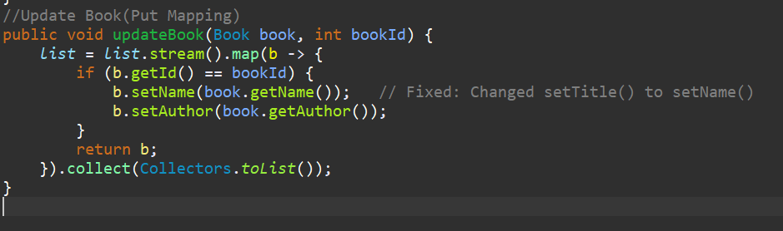
Our handler method
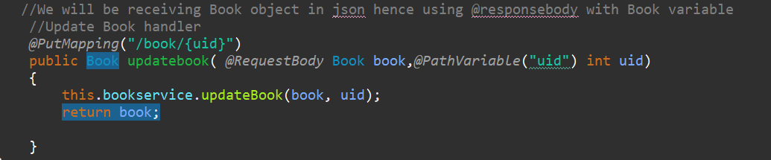

ResponseEntity | Handling HttpStatus while creating REST API using Spring Boot

1. What is ResponseEntity?
- ResponseEntity<T> represents an HTTP response including status code, headers, and body.
- It is used in Spring Boot REST APIs to return more control over the response.
- Commonly used to handle errors, success messages, and custom responses.

2. Example: Handling HttpStatus in a REST API
We will build a Book REST API with proper HTTP status codes using ResponseEntity.

3. Explanation of ResponseEntity Usage
Method | Return Type | ResponseEntity Status | Description
getAllBooks() | ResponseEntity<List<Book>> | 200 OK if books exist, 204 NO CONTENT if empty | Returns a list of books.
getBookById(id) | ResponseEntity<?> | 200 OK if found, 404 NOT FOUND if missing | Returns a single book or an error message.
addBook(book) | ResponseEntity<Book> | 201 CREATED | Saves a new book in the database.
deleteBookById(id) | ResponseEntity<String> | 200 OK if deleted, 404 NOT FOUND if missing | Deletes a book and returns a response message.

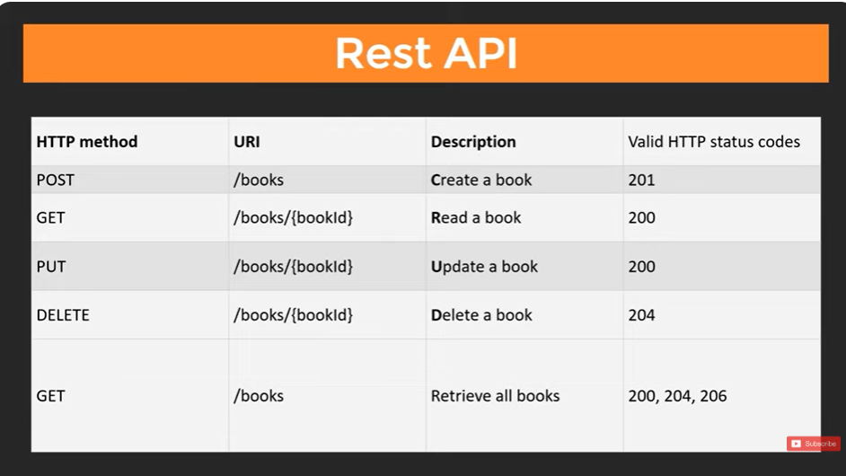
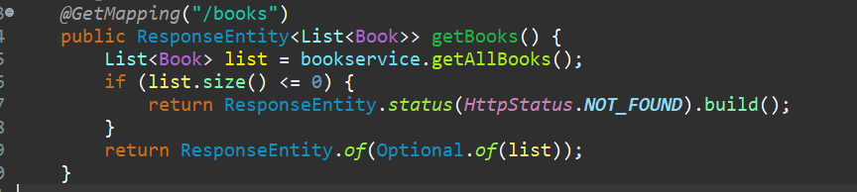
Our COMPLETE CODES FOR REST API ARE

BOOKCONTROLLER.JAVA
package com.api.book.controllers;

import java.util.List;
import java.util.Optional;

import org.springframework.beans.factory.annotation.Autowired;
import org.springframework.http.HttpStatus;
import org.springframework.http.ResponseEntity;
import org.springframework.stereotype.Controller;
import org.springframework.web.bind.annotation.DeleteMapping;
import org.springframework.web.bind.annotation.GetMapping;
import org.springframework.web.bind.annotation.PathVariable;
import org.springframework.web.bind.annotation.PostMapping;
import org.springframework.web.bind.annotation.PutMapping;
import org.springframework.web.bind.annotation.RequestBody;
import org.springframework.web.bind.annotation.RequestMapping;
import org.springframework.web.bind.annotation.RequestMethod;
import org.springframework.web.bind.annotation.ResponseBody;
import org.springframework.web.bind.annotation.RestController;

import com.api.book.entities.Book;
import com.api.book.services.BookService;

//This annotation is used to make it RESTAPI Based Controller
@RestController
public class BookController {
@Autowired
private BookService bookservice;

//This Annotation avoids explicit mentioning of method request type
// Get All Books Handler
/*
* @GetMapping("/books") public List<Book> getBook(){ //commented code was used
* to hard code raw values to understand GET
*
* Book book = new Book(); book.setId(12);
* book.setName("Complete Java Development"); book.setAuthor("Light");
*
* //here we are calling getAllBooks method from fake service class return
* this.bookservice.getAllBooks(); }
*/
// get all books handler
@GetMapping("/books")
public ResponseEntity<List<Book>> getBooks() {
List<Book> list = bookservice.getAllBooks();
if (list.size() <= 0) {
return ResponseEntity.status(HttpStatus.NOT_FOUND).build();
}
return ResponseEntity.of(Optional.of(list));
}

// This controller is for getting request on ID basis we have to fir this after
// URL
// Get a particular book using ID handler
@GetMapping("/books/{id}")
public ResponseEntity<Book> getBook(@PathVariable("id") int id) {
Book book = bookservice.getBookById(id);
if (book == null) {
return ResponseEntity.status(HttpStatus.NOT_FOUND).build();
}
return ResponseEntity.of(Optional.of(book));
}

// Add Book handler
@PostMapping("/books")
public Book addBook(@RequestBody Book b1) {
Book b = this.bookservice.addBook(b1);
return b;
}

// Delete Book handler
@DeleteMapping("/books/{did}")
public void DeleteBook(@PathVariable("did") int did) {
this.bookservice.deleteBook(did);

}

// We will be receiving Book object in json hence using @responsebody with Book
// variable
// Update Book handler
@PutMapping("/books/{uid}")
public Book updatebook(@RequestBody Book book, @PathVariable("uid") int uid) {
this.bookservice.updateBook(book, uid);
return book;

}
}

SERVICE.JAVA
package com.api.book.services;

import java.util.ArrayList;
import java.util.List;
import java.util.stream.Collectors;

import org.springframework.stereotype.Component;

import com.api.book.entities.Book;
@Component
public class BookService {

//creating a static list of books
private static List<Book> list = new ArrayList<>();
static
{
list.add(new Book(12,"Complete Java Development","light"));
list.add(new Book(17,"Complete Python Development","Yash"));
list.add(new Book(12,"Complete Web Development","Levi"));
}
//get all books
public List<Book>getAllBooks(){

return list;
}
//get single book
public Book getBookById(int id) {
Book book1 = null;
book1 = list.stream()
.filter(e -> e.getId() == id) // Corrected lambda expression
.findFirst()
.orElse(null); // Avoids NoSuchElementException if no match is found
return book1;
}
//Adding the book(PostMapping)
public Book addBook(Book b) {
list.add(b);
return b;

}
//delete book (DeleteMapping)
public void deleteBook(int bid) {
list=list.stream().filter(book -> {
if (book.getId() != bid)
return true;
else
return false;
}).collect(Collectors.toList());
}
//Update Book(Put Mapping)
public void updateBook(Book book, int bookId) {
list = list.stream().map(b -> {
if (b.getId() == bookId) {
b.setName(book.getName()); // Fixed: Changed setTitle() to setName()
b.setAuthor(book.getAuthor());
}
return b;
}).collect(Collectors.toList());
}

}

Now will do Rest API with database JPA

Connecting with Database using JPA | Spring Boot Rest API

Book.java An Entity Class
package com.api.book.entities;

import jakarta.persistence.Column;
import jakarta.persistence.Entity;
import jakarta.persistence.GeneratedValue;
import jakarta.persistence.GenerationType;
import jakarta.persistence.Id;
import jakarta.persistence.Table;

@Entity
@Table(name="MyBookShelf")
public class Book {

@Id
@GeneratedValue(strategy = GenerationType.AUTO)
@Column(name="Book_ID")
private int id;
@Column(name="Book_Name")
private String name;
@Column(name="Book_Author")
private String author;
public int getId() {
return id;
}
public void setId(int id) {
this.id = id;
}
public String getName() {
return name;
}
public void setName(String name) {
this.name = name;
}
public String getAuthor() {
return author;
}
public void setAuthor(String author) {
this.author = author;
}
@Override
public String toString() {
return "Book [id=" + id + ", name=" + name + ", author=" + author + ", getId()=" + getId() + ", getName()="
+ getName() + ", getAuthor()=" + getAuthor() + ", getClass()=" + getClass() + ", hashCode()="
+ hashCode() + ", toString()=" + super.toString() + "]";
}
public Book() {
super();
// TODO Auto-generated constructor stub
}
public Book(int id, String name, String author) {
super();
this.id = id;
this.name = name;
this.author = author;
}

}

BookRepository.java
package com.api.book.dao;

import org.springframework.data.repository.CrudRepository;
import com.api.book.entities.Book;

public interface BookRepository extends CrudRepository<Book, Integer> {

// method name to follow Spring Data JPA conventions
public Book findById(int id);
}

BookService.java
package com.api.book.services;

import java.util.ArrayList;
import java.util.List;
import java.util.stream.Collectors;

import org.springframework.beans.factory.annotation.Autowired;
import org.springframework.stereotype.Component;

import com.api.book.dao.BookRepository;
import com.api.book.entities.Book;
@Component
public class BookService {
@Autowired
private BookRepository bookrepository;

/*
* //creating a static list of books private static List<Book> list = new
* ArrayList<>(); static { list.add(new
* Book(12,"Complete Java Development","light")); list.add(new
* Book(17,"Complete Python Development","Yash")); list.add(new
* Book(12,"Complete Web Development","Levi")); }
*/
//get all books
public List<Book>getAllBooks(){
List<Book> getall =(List<Book>)this.bookrepository.findAll();

return getall;
}
//get single book
public Book getBookById(int id) {
Book book1 = null;
book1 = this.bookrepository.findById(id);
/*
* book1 = list.stream() .filter(e -> e.getId() == id) // Corrected lambda
* expression .findFirst() .orElse(null); // Avoids NoSuchElementException if no
* match is found
*/ return book1;
}
//Adding the book(PostMapping)
public Book addBook(Book b) {
// list.add(b);
Book result =bookrepository.save(b);
return result;

}
//delete book (DeleteMapping)
public void deleteBook(int bid) {
bookrepository.deleteById(bid);
}

/*
* list=list.stream().filter(book -> { if (book.getId() != bid) return true;
* else return false; }).collect(Collectors.toList()); }
*/
//Update Book(Put Mapping)
public void updateBook(Book book, int bookId) {
book.setId(bookId);
bookrepository.save(book);
/*
* list = list.stream().map(b -> { if (b.getId() == bookId) {
* b.setName(book.getName()); // Fixed: Changed setTitle() to setName()
* b.setAuthor(book.getAuthor()); } return b; }).collect(Collectors.toList());
*/
}

}

BookController.java

package com.api.book.controllers;

import java.util.List;
import java.util.Optional;

import org.springframework.beans.factory.annotation.Autowired;
import org.springframework.http.HttpStatus;
import org.springframework.http.ResponseEntity;
import org.springframework.stereotype.Controller;
import org.springframework.web.bind.annotation.DeleteMapping;
import org.springframework.web.bind.annotation.GetMapping;
import org.springframework.web.bind.annotation.PathVariable;
import org.springframework.web.bind.annotation.PostMapping;
import org.springframework.web.bind.annotation.PutMapping;
import org.springframework.web.bind.annotation.RequestBody;
import org.springframework.web.bind.annotation.RequestMapping;
import org.springframework.web.bind.annotation.RequestMethod;
import org.springframework.web.bind.annotation.ResponseBody;
import org.springframework.web.bind.annotation.RestController;

import com.api.book.entities.Book;
import com.api.book.services.BookService;

//This annotation is used to make it RESTAPI Based Controller
@RestController
public class BookController {
@Autowired
private BookService bookservice;

//This Annotation avoids explicit mentioning of method request type
// Get All Books Handler
/*
* @GetMapping("/books") public List<Book> getBook(){ //commented code was used
* to hard code raw values to understand GET
*
* Book book = new Book(); book.setId(12);
* book.setName("Complete Java Development"); book.setAuthor("Light");
*
* //here we are calling getAllBooks method from fake service class return
* this.bookservice.getAllBooks(); }
*/
// get all books handler
@GetMapping("/books")
public ResponseEntity<List<Book>> getBooks() {
List<Book> list = bookservice.getAllBooks();
if (list.size() <= 0) {
return ResponseEntity.status(HttpStatus.NOT_FOUND).build();
}
return ResponseEntity.status(HttpStatus.CREATED).body(list);
}

// This controller is for getting request on ID basis we have to fir this after
// URL
// Get a particular book using ID handler
@GetMapping("/books/{id}")
public ResponseEntity<Book> getBook(@PathVariable("id") int id) {
Book book = bookservice.getBookById(id);
if (book == null) {
return ResponseEntity.status(HttpStatus.NOT_FOUND).build();
}
return ResponseEntity.of(Optional.of(book));
}

// Add Book handler
@PostMapping("/books")
public ResponseEntity<Book> addBook(@RequestBody Book b1) {
Book b= null;
try {
b = this.bookservice.addBook(b1);
System.out.println(b1);
return ResponseEntity.status(HttpStatus.CREATED).build();
} catch (Exception e) {
return ResponseEntity.status(HttpStatus.INTERNAL_SERVER_ERROR).build();
}
}

// Delete Book handler
@DeleteMapping("/books/{did}")
public void DeleteBook(@PathVariable("did") int did) {
this.bookservice.deleteBook(did);

}

// We will be receiving Book object in json hence using @responsebody with Book
// variable
// Update Book handler
@PutMapping("/books/{uid}")
public Book updatebook(@RequestBody Book book, @PathVariable("uid") int uid) {
this.bookservice.updateBook(book, uid);
return book;

}
}

Application.properties

spring.application.name=demo
server.port=8090
spring.datasource.name=d1
spring.datasource.url=jdbc:postgresql://localhost:5432/test
spring.datasource.password=light
spring.datasource.username=postgres
spring.datasource.driver-class-name=org.postgresql.Driver
spring.jpa.properties.hibernate.dialect=org.hibernate.dialect.PostgreSQLDialect
spring.jpa.hibernate.ddl-auto=update
spring.jpa.show-sql=true
spring.jpa.properties.hibernate.format_sql=true

Notes-
ResponseEntity is a part of the org.springframework.http package and is a generic class used to represent an HTTP response in a Spring web application. It allows for flexibility in setting HTTP status codes, headers, and the response body.
In the context of the provided code, ResponseEntity<List<Book>> is used to indicate that the response body will contain a list of books.

Constructing a ResponseEntity:
- ResponseEntity.status(HttpStatus):
  - This method sets the HTTP status of the response.
  - HttpStatus is an enum in the Spring framework that contains HTTP status codes (e.g., 200 OK, 404 NOT_FOUND, 201 CREATED, etc.).
  - Usage: ResponseEntity.status(HttpStatus.NOT_FOUND) or ResponseEntity.status(HttpStatus.CREATED). This sets the status code for the response.
Example:
java
Copy code
return ResponseEntity.status(HttpStatus.NOT_FOUND).build();
In this case, the response will have a 404 NOT_FOUND status, indicating that the requested resource was not found.
- .body(T body):
  - This method is used to set the body of the response, where T is the type of the body. In your example, the body is a list of Book objects (List<Book>).
  - Usage: ResponseEntity.status(HttpStatus.CREATED).body(list).
  - This attaches the data (in this case, the list of books) to the HTTP response body, which will be sent back to the client.
Example:
java
Copy code
return ResponseEntity.status(HttpStatus.CREATED).body(list);
This means that the response will have the status 201 CREATED and include the list of books as the body of the response.
- build():
  - The build() method creates and returns a ResponseEntity instance based on the previously set status and headers.
  - Usage: ResponseEntity.status(HttpStatus.NOT_FOUND).build().
  - When build() is called, it finalizes the creation of the response, without setting a body (i.e., an empty response body is returned, but the HTTP status is set).
Example:
java
Copy code
return ResponseEntity.status(HttpStatus.NOT_FOUND).build();
In this case, the response will have no content in the body, but it will have a 404 NOT_FOUND status.

Putting It All Together:
java
Copy code
@GetMapping("/books")
public ResponseEntity<List<Book>> getBooks() {
List<Book> list = bookservice.getAllBooks();
if (list.size() <= 0) {
return ResponseEntity.status(HttpStatus.NOT_FOUND).build();
}
return ResponseEntity.status(HttpStatus.CREATED).body(list);
}
- ResponseEntity.status(HttpStatus.NOT_FOUND).build():
  - If the list of books is empty (i.e., list.size() <= 0), the method returns a response with the 404 NOT_FOUND status.
  - The build() method is used here because no body is needed in this case; the response simply signals that no books were found.
- ResponseEntity.status(HttpStatus.CREATED).body(list):
  - If books are found, the method returns a response with a 201 CREATED status.
  - The body(list) method is used to send the list of books as the response body. This means the client will receive the list of books in the response body along with the 201 CREATED status.

HTTP Status Codes (HttpStatus):
Here’s a breakdown of the HTTP statuses used:
- HttpStatus.NOT_FOUND (404):
  - Indicates that the resource the client is requesting (the list of books) is not found. It's appropriate for scenarios where the client asks for a resource that doesn't exist or is unavailable.
- HttpStatus.CREATED (201):
  - Generally used for POST requests when a new resource is successfully created. However, in this example, it’s used for GET to indicate successful retrieval of resources (although 200 OK would be more conventional for a successful GET request).

Key Points About ResponseEntity:
- Status: The status code indicates the outcome of the HTTP request (success, failure, etc.).
- Body: This contains the actual data being returned to the client (e.g., a list of books, error messages, etc.).
- Headers: Optional HTTP headers can be added to the ResponseEntity to provide additional information (e.g., content type, caching directives, etc.).
- Flexibility: ResponseEntity allows you to control the response in detail, ensuring the client receives the appropriate status, body, and headers.

Summary:
ResponseEntity is a crucial class in Spring for constructing HTTP responses. It provides flexibility in setting status codes, response bodies, and headers. The combination of methods like status(), body(), and build() allows developers to precisely control how the response is returned to the client.

Non Important Notes

Class and Annotations:
- @RestController: This annotation is a specialized version of @Controller in Spring. It is used to define a controller that returns JSON or XML responses, eliminating the need for @ResponseBody on individual methods. In this case, the BookController class is a RESTful controller that handles HTTP requests related to books.
- @Autowired: This annotation is used to inject the BookService bean into the controller, allowing the controller to use the methods from BookService for handling book-related operations.

HTTP Request Mapping:
- @GetMapping("/books"):
  - Purpose: Handles GET requests to fetch all books.
  - Response:
    - The response type is ResponseEntity<List<Book>>, which means a response that contains a list of books. It allows setting various HTTP status codes and the body of the response.
    - If the list of books is empty, the method returns an HTTP status 404 NOT_FOUND using ResponseEntity.status(HttpStatus.NOT_FOUND).build(). This indicates that no books were found in the database.
    - If books are found, it returns a 201 CREATED status, which may seem unusual for a GET request (which is typically associated with a 200 OK status). A more conventional status for a GET request would be 200 OK. However, 201 CREATED is used here as a design choice.
    - Theory: HTTP status codes are part of the response sent to the client. They convey information about the result of the request:
      - 200 OK: The request was successful.
      - 404 NOT_FOUND: The requested resource was not found.
      - 201 CREATED: A new resource was created (usually for POST requests, but used here to indicate successful retrieval of resources).
- @GetMapping("/books/{id}"):
  - Purpose: Handles GET requests to fetch a particular book by its ID.
  - Response:
    - If the book with the specified id is found, the method returns the book wrapped inside a ResponseEntity.of(Optional.of(book)). This returns a 200 OK status with the book data in the body.
    - If the book is not found (book == null), the method returns a 404 NOT_FOUND status with ResponseEntity.status(HttpStatus.NOT_FOUND).build().
    - Theory: A GET request is used to retrieve data. Returning a 404 status when the resource isn't found helps the client understand that the requested resource doesn't exist.
- @PostMapping("/books"):
  - Purpose: Handles POST requests to add a new book.
  - Request Body: The @RequestBody Book b1 annotation tells Spring to deserialize the request body (in JSON format) into a Book object.
  - Response:
    - If the book is added successfully, the method returns a 201 CREATED status using ResponseEntity.status(HttpStatus.CREATED).build(). This indicates that the new book was successfully created.
    - If an exception occurs while adding the book, it returns an 500 INTERNAL_SERVER_ERROR status, indicating that something went wrong on the server side.
    - Theory: The POST method is used to create new resources. Returning 201 signifies that the resource has been successfully created.
- @DeleteMapping("/books/{did}"):
  - Purpose: Handles DELETE requests to remove a book by its ID.
  - Response: The method doesn't return anything (void), but it triggers the deletion of a book by calling the bookservice.deleteBook(did) method. HTTP status code 200 OK or 204 NO CONTENT is typically used for successful deletions, though it's not explicitly returned here.
  - Theory: A DELETE request removes a resource. It's common to return a 204 NO CONTENT status to indicate that the resource was deleted successfully, but no additional content is included in the response.
- @PutMapping("/books/{uid}"):
  - Purpose: Handles PUT requests to update an existing book.
  - Request Body: The @RequestBody Book book annotation tells Spring to deserialize the request body (in JSON format) into a Book object.
  - Response: After updating the book, it returns the updated book object in the response.
  - Theory: A PUT request is used to update a resource. Typically, it returns the updated resource, and the response status code is 200 OK.

HTTP Status Codes in REST API:
- 200 OK: The request was successful, and the server returned the requested data (for GET requests) or the modified resource (for PUT requests).
- 201 CREATED: The resource was successfully created (usually for POST requests).
- 204 NO CONTENT: The resource was successfully deleted, but no content is returned (usually for DELETE requests).
- 400 BAD REQUEST: The request was malformed or invalid.
- 404 NOT FOUND: The requested resource was not found.
- 500 INTERNAL SERVER ERROR: A server-side error occurred while processing the request.

Summary:
The BookController defines methods for handling CRUD operations (Create, Read, Update, Delete) related to books in the system. Each method responds with a relevant HTTP status code, which informs the client about the success or failure of the request. The use of ResponseEntity allows for better control over the response status and body, ensuring a more informative and standardized API.

Nesting Custom Type in spring Boot Rest Api | Using ONE TO ONE Mapping with Spring Boot Rest API
n this lesson, we'll cover how to use One-to-One (1:1) relationships with custom types in a Spring Boot REST API. We'll walk through creating a Spring Boot application that demonstrates One-to-One mapping between two entities.

1. Define the Custom Types (Entities)
In a One-to-One relationship, each entity in the relationship is linked to exactly one entity from the other side. Let's assume you're building an application where a User has a Profile.

Step 1: Create the User Entity
java
Copy code
import javax.persistence.*;

@Entity
public class User {
@Id
@GeneratedValue(strategy = GenerationType.IDENTITY)
private Long id;
private String username;
private String email;

@OneToOne(mappedBy = "user", cascade = CascadeType.ALL)
private UserProfile userProfile;

// Getters and setters
}

Step 2: Create the UserProfile Entity
java
Copy code
import javax.persistence.*;

@Entity
public class UserProfile {
@Id
@GeneratedValue(strategy = GenerationType.IDENTITY)
private Long id;
private String address;
private String phoneNumber;

@OneToOne
@JoinColumn(name = "user_id")
private User user;

// Getters and setters
}

2. Create the Repository Layer
Spring Data JPA repositories are used to perform CRUD operations on entities.

Step 1: Create a User Repository
java
Copy code
import org.springframework.data.jpa.repository.JpaRepository;

public interface UserRepository extends JpaRepository<User, Long> {
}

Step 2: Create a UserProfile Repository
java
Copy code
import org.springframework.data.jpa.repository.JpaRepository;

public interface UserProfileRepository extends JpaRepository<UserProfile, Long> {
}

3. Create the Service Layer
The service layer is where business logic is typically handled.

Step 1: Create the UserService
java
Copy code
import org.springframework.beans.factory.annotation.Autowired;
import org.springframework.stereotype.Service;

@Service
public class UserService {
@Autowired
private UserRepository userRepository;
@Autowired
private UserProfileRepository userProfileRepository;

public User createUserWithProfile(User user, UserProfile userProfile) {
userProfile.setUser(user); // Linking the profile to the user
user.setUserProfile(userProfile); // Linking the user to the profile
userRepository.save(user);
return user;
}
}

4. Create the Controller Layer
This is where we expose the REST API endpoints to interact with the entities.

Step 1: Create the UserController
java
Copy code
import org.springframework.beans.factory.annotation.Autowired;
import org.springframework.web.bind.annotation.*;

@RestController
@RequestMapping("/users")
public class UserController {
@Autowired
private UserService userService;

@PostMapping
public User createUser(@RequestBody UserDto userDto) {
User user = new User();
user.setUsername(userDto.getUsername());
user.setEmail(userDto.getEmail());

UserProfile userProfile = new UserProfile();
userProfile.setAddress(userDto.getAddress());
userProfile.setPhoneNumber(userDto.getPhoneNumber());

return userService.createUserWithProfile(user, userProfile);
}
}

Step 2: Create the UserDto
The UserDto is a simple data transfer object that will hold the data to be received in the POST request.
java
Copy code
public class UserDto {
private String username;
private String email;
private String address;
private String phoneNumber;

// Getters and setters
}

5. Test the Application
After you've implemented the above code, run your application and test it using an API client like Postman. Here's an example of a POST request you can send:

Request Body (JSON)
json
Copy code
{
"username": "john_doe",
"email": "john@example.com",
"address": "123 Main St",
"phoneNumber": "123-456-7890"
}

Expected Response (JSON)
json
Copy code
{
"id": 1,
"username": "john_doe",
"email": "john@example.com",
"userProfile": {
"id": 1,
"address": "123 Main St",
"phoneNumber": "123-456-7890"
}
}

6. Explanation of Key Annotations and Concepts
- @OneToOne: This is the JPA annotation used to define the one-to-one relationship between two entities.
- mappedBy: This attribute is used in the User entity to specify the inverse side of the relationship, meaning that the UserProfile owns the relationship.
- @JoinColumn: This is used in the UserProfile entity to specify the foreign key column (user_id) that will link back to the User entity.
- CascadeType.ALL: This allows all operations (like persist, merge, delete) to cascade from User to UserProfile.

Conclusion
This example demonstrates how to handle a One-to-One relationship between custom entities in Spring Boot, how to use repositories for persistence, and how to expose an endpoint for creating entities with related data.
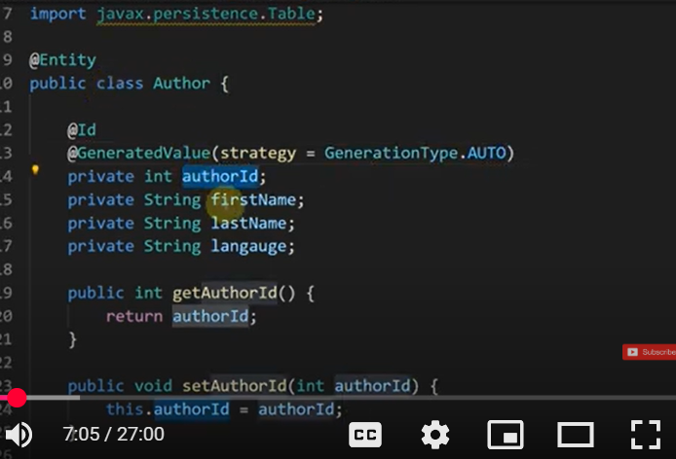
Author in our Last REST API will be injected as an Object now
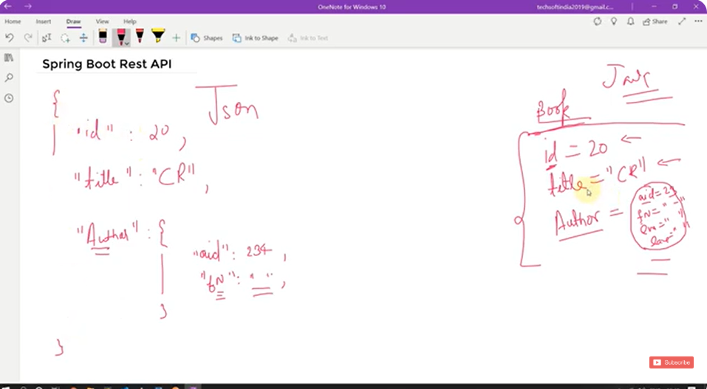
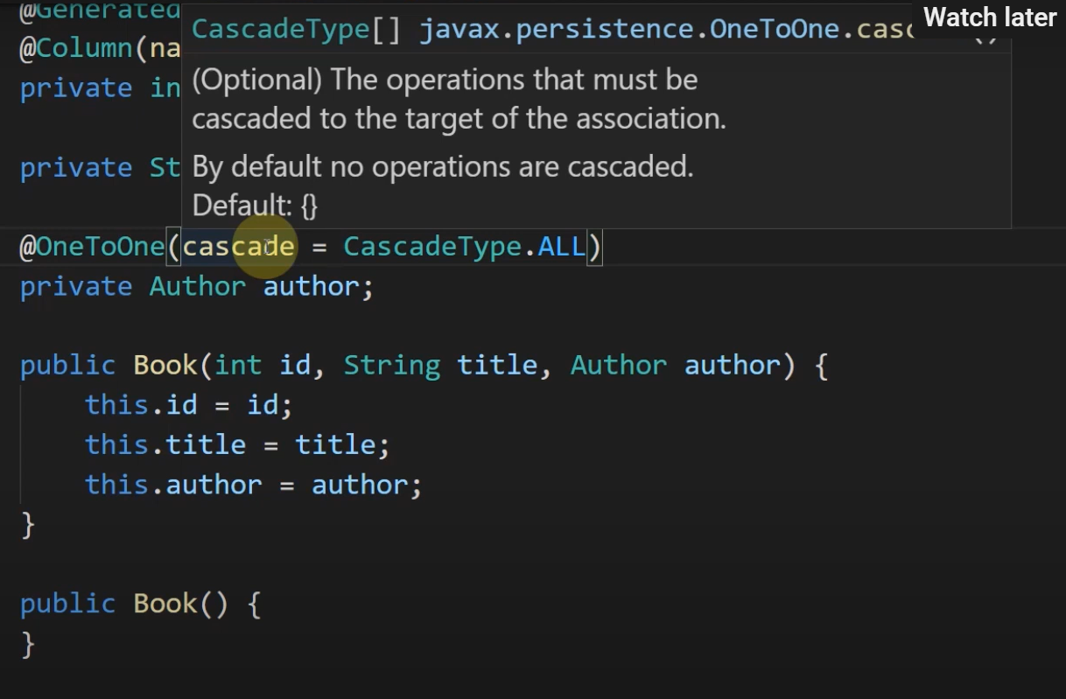

1. Define the Entities
Each Book will have one Author. We'll use @OneToOne with Cascade operations to maintain this relationship.

Book Entity
java
Copy code
import javax.persistence.*;

@Entity
public class Book {
@Id
@GeneratedValue(strategy = GenerationType.IDENTITY)
private Long id;
private String name;

@OneToOne(cascade = CascadeType.ALL)
@JoinColumn(name = "author_id")
private Author author;

// Getters and setters
public Long getId() {
return id;
}

public void setId(Long id) {
this.id = id;
}

public String getName() {
return name;
}

public void setName(String name) {
this.name = name;
}

public Author getAuthor() {
return author;
}

public void setAuthor(Author author) {
this.author = author;
}
}

Author Entity
java
Copy code
import javax.persistence.*;

@Entity
public class Author {
@Id
@GeneratedValue(strategy = GenerationType.IDENTITY)
private Long id;
private String name;

@OneToOne(mappedBy = "author")
private Book book;

// Getters and setters
public Long getId() {
return id;
}

public void setId(Long id) {
this.id = id;
}

public String getName() {
return name;
}

public void setName(String name) {
this.name = name;
}

public Book getBook() {
return book;
}

public void setBook(Book book) {
this.book = book;
}
}

2. Create the Repository Layer
Spring Data JPA will manage database interactions for us.

Book Repository
java
Copy code
import org.springframework.data.jpa.repository.JpaRepository;

public interface BookRepository extends JpaRepository<Book, Long> {
}

Author Repository
java
Copy code
import org.springframework.data.jpa.repository.JpaRepository;

public interface AuthorRepository extends JpaRepository<Author, Long> {
}

3. Create the Service Layer
This layer handles the business logic.
java
Copy code
import org.springframework.beans.factory.annotation.Autowired;
import org.springframework.stereotype.Service;

@Service
public class BookService {
@Autowired
private BookRepository bookRepository;

public Book createBookWithAuthor(Book book, Author author) {
book.setAuthor(author); // Associate Author with Book
return bookRepository.save(book); // Save both due to CascadeType.ALL
}
}

4. Create the Controller Layer
The controller will expose REST API endpoints.
java
Copy code
import org.springframework.beans.factory.annotation.Autowired;
import org.springframework.web.bind.annotation.*;

@RestController
@RequestMapping("/books")
public class BookController {
@Autowired
private BookService bookService;

@PostMapping
public Book createBook(@RequestBody BookDto bookDto) {
Book book = new Book();
book.setName(bookDto.getBookName());

Author author = new Author();
author.setName(bookDto.getAuthorName());

return bookService.createBookWithAuthor(book, author);
}
}

5. Create a DTO for Input Handling
This Data Transfer Object (DTO) will be used in API requests.
java
Copy code
public class BookDto {
private String bookName;
private String authorName;

// Getters and setters
public String getBookName() {
return bookName;
}

public void setBookName(String bookName) {
this.bookName = bookName;
}

public String getAuthorName() {
return authorName;
}

public void setAuthorName(String authorName) {
this.authorName = authorName;
}
}

6. Testing the API
Run the application and use Postman or a similar tool to send a POST request.

API Endpoint
bash
Copy code
POST http://localhost:8080/books

Request Body (JSON)
json
Copy code
{
"bookName": "Spring Boot Essentials",
"authorName": "John Doe"
}

Expected Response
json
Copy code
{
"id": 1,
"name": "Spring Boot Essentials",
"author": {
"id": 1,
"name": "John Doe"
}
}

7. Key Concepts Used
- @OneToOne: Defines a one-to-one relationship.
- @JoinColumn(name = "author_id"): Specifies the foreign key in Book.
- cascade = CascadeType.ALL: Ensures that saving a Book also saves the related Author.
- DTO (Data Transfer Object): Prevents exposing entity structure in API.

Conclusion
You have successfully implemented a One-to-One relationship between Book and Author in Spring Boot using JPA, REST API, and DTOs.

Jackson – Bidirectional Relationships | @JsonManagedReference, @JsonBackReference | Spring Boot

Now will add Book as an entity object in Author class
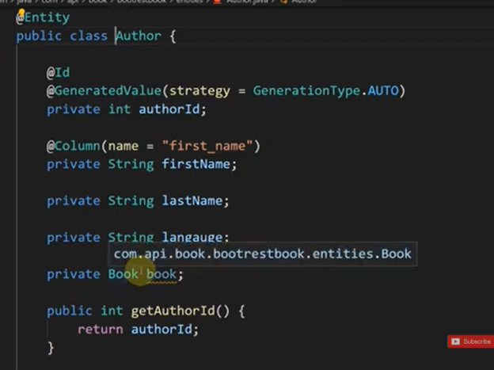

Handling Infinite Recursion with @JsonManagedReference and @JsonBackReference

1. Problem: Infinite Recursion in Bidirectional Relationships
- When using bidirectional relationships in JPA, serialization with Jackson (used by Spring Boot) can cause an infinite recursion issue.
- Example: If Book has an Author, and Author has a list of Books, Jackson will keep serializing back and forth, causing a StackOverflowError.

Example of Infinite Recursion Issue
java
Copy code
@Entity
public class Book {
@Id
@GeneratedValue(strategy = GenerationType.IDENTITY)
private int id;
private String title;

@OneToOne(mappedBy = "book", cascade = CascadeType.ALL)
private Author author;
}
java
Copy code
@Entity
public class Author {
@Id
@GeneratedValue(strategy = GenerationType.IDENTITY)
private int id;
private String name;

@OneToOne
@JoinColumn(name = "book_id")
private Book book;
}

Problem: Infinite Recursion
When returning Book as JSON, Jackson will serialize Author, which in turn serializes Book again → infinite loop.

2. Solution: Using @JsonManagedReference and @JsonBackReference
- @JsonManagedReference (Parent Side) → Indicates the forward relationship.
- @JsonBackReference (Child Side) → Indicates the back reference to prevent infinite recursion.

2.1 Updated Code with Annotations
java
Copy code
import com.fasterxml.jackson.annotation.JsonManagedReference;
import jakarta.persistence.*;

@Entity
public class Book {
@Id
@GeneratedValue(strategy = GenerationType.IDENTITY)
private int id;
private String title;

@OneToOne(mappedBy = "book", cascade = CascadeType.ALL)
@JsonManagedReference // Prevents infinite loop
private Author author;

// Getters and Setters
}
java
Copy code
import com.fasterxml.jackson.annotation.JsonBackReference;
import jakarta.persistence.*;

@Entity
public class Author {
@Id
@GeneratedValue(strategy = GenerationType.IDENTITY)
private int id;
private String name;

@OneToOne
@JoinColumn(name = "book_id")
@JsonBackReference // Prevents infinite loop
private Book book;

// Getters and Setters
}

3. Explanation of Annotations
Annotation | Description
@JsonManagedReference | Used on the parent side to manage serialization.
@JsonBackReference | Used on the child side to prevent infinite recursion.

4. Testing the API

Controller to Get Book Details
java
Copy code
import org.springframework.beans.factory.annotation.Autowired;
import org.springframework.web.bind.annotation.*;

import java.util.List;

@RestController
@RequestMapping("/api/books")
public class BookController {

@Autowired
private BookRepository bookRepository;

@GetMapping("/{id}")
public Book getBookById(@PathVariable int id) {
return bookRepository.findById(id).orElse(null);
}
}

Expected JSON Response
json
Copy code
{
"id": 1,
"title": "Spring Boot Guide",
"author": {
"id": 10,
"name": "John Doe"
}
}

Without @JsonManagedReference and @JsonBackReference → StackOverflowError

With @JsonManagedReference and @JsonBackReference → Works Correctly 🎯

5. Alternative: Using @JsonIgnore
Another simple approach is to use @JsonIgnore on one side of the relationship:
java
Copy code
@OneToOne(mappedBy = "book", cascade = CascadeType.ALL)
@JsonIgnore
private Author author;
- This prevents serialization of author, but the relationship is still maintained in the database.

6. Summary
- Bidirectional relationships cause infinite recursion in JSON serialization.
- Use @JsonManagedReference on the parent and @JsonBackReference on the child to prevent this.
- Alternative: @JsonIgnore can also be used if the field does not need to be serialized.
- This ensures that Spring Boot REST APIs work efficiently without errors.

File Uploading in very simple steps | Spring boot REST API

. Overview
Spring Boot makes file uploading easy using MultipartFile. In this guide, we'll create a simple REST API that allows users to upload files.

2. Add Required Dependency (Maven)
Ensure you have spring-boot-starter-web in your pom.xml:
xml
Copy code
<dependencies>
<!-- Spring Boot Starter Web -->
<dependency>
<groupId>org.springframework.boot</groupId>
<artifactId>spring-boot-starter-web</artifactId>
</dependency>
</dependencies>

3. Create a Simple File Upload Controller
Spring Boot provides the MultipartFile interface, which represents an uploaded file.

3.1 File Upload API (FileUploadController.java)
java
Copy code
import org.springframework.web.bind.annotation.*;
import org.springframework.web.multipart.MultipartFile;
import org.springframework.http.ResponseEntity;
import org.springframework.http.HttpStatus;

import java.io.File;
import java.io.IOException;

@RestController
@RequestMapping("/api/files")
public class FileUploadController {

private static final String UPLOAD_DIR = "C:/uploads/"; // Change path as needed

@PostMapping("/upload")
public ResponseEntity<String> uploadFile(@RequestParam("file") MultipartFile file) {
if (file.isEmpty()) {
return ResponseEntity.status(HttpStatus.BAD_REQUEST).body("File is empty");
}

try {
// Save the file to the specified directory
File destinationFile = new File(UPLOAD_DIR + file.getOriginalFilename());
file.transferTo(destinationFile);

return ResponseEntity.ok("File uploaded successfully: " + file.getOriginalFilename());
} catch (IOException e) {
return ResponseEntity.status(HttpStatus.INTERNAL_SERVER_ERROR).body("File upload failed");
}
}
}

4. Explanation
Component | Description
@RestController | Marks this class as a REST API controller.
@RequestMapping("/api/files") | Base URL for all endpoints in this controller.
@PostMapping("/upload") | Handles file uploads via POST /api/files/upload.
@RequestParam("file") MultipartFile file | Extracts the uploaded file from the request.
file.transferTo(destinationFile) | Saves the file to the specified directory.
ResponseEntity<String> | Returns an HTTP response message.

5. Testing the API in Postman
- Open Postman.
- Select POST method.
- Enter http://localhost:8080/api/files/upload.
- Go to Body → form-data.
- Add a key "file" and select a file to upload.
- Click Send → Response: "File uploaded successfully: filename.txt"

6. Notes
- The upload directory (C:/uploads/) must exist before running the code.
- To store files in a database instead of disk, convert MultipartFile to byte[] and store in BLOB.
- Multipart uploads must be enabled in application.properties (optional):
properties
Copy code
spring.servlet.multipart.enabled=true
spring.servlet.multipart.max-file-size=10MB
spring.servlet.multipart.max-request-size=20MB

7. Summary
- Uses MultipartFile for file upload.
- Saves file to a specified directory.
- Handles empty files and errors gracefully.
- Easily testable with Postman.

Our Image Upload Code

FileUploadHelper.java
package com.api.book.helper;

import java.io.FileOutputStream;
import java.io.InputStream;

import org.springframework.stereotype.Component;
import org.springframework.web.multipart.MultipartFile;

@Component
public class FileUploadHelper {
public final String UPLOAD_DIR = "C:\\Users\\YABHOSAL\\SpringPractise\\demo\\src\\main\\resources\\static";
public boolean uploadfile(MultipartFile file) {

boolean f = false;

try {

InputStream is = file.getInputStream();
byte data[] = new byte[is.available()];
is.read(data);

FileOutputStream fs = new FileOutputStream(UPLOAD_DIR+"\\"+file.getOriginalFilename());
fs.write(data);
fs.flush();
fs.close();
f=true;
} catch (Exception e) {
// TODO: handle exception
}
return f;

}
}

FileUploadController.java
package com.api.book.controllers;

import org.springframework.beans.factory.annotation.Autowired;
import org.springframework.http.HttpStatus;
import org.springframework.http.ResponseEntity;
import org.springframework.web.bind.annotation.PostMapping;
import org.springframework.web.bind.annotation.RequestParam;
import org.springframework.web.bind.annotation.RestController;
import org.springframework.web.multipart.MultipartFile;

import com.api.book.helper.FileUploadHelper;

@RestController
public class FileUploadController {
@Autowired
private FileUploadHelper fileuploadhelper;
@PostMapping("/upload-file")
public ResponseEntity<String> uploadfile(@RequestParam("file") MultipartFile file)
{System.out.println(file.getOriginalFilename());
System.out.println(file.getSize());
System.out.println(file.getContentType());
System.out.println(file.getName());
if (file.isEmpty()) {
return ResponseEntity.status(HttpStatus.INTERNAL_SERVER_ERROR)
.body("Request is empty it must contain a file");
}
//file upload code
boolean f =fileuploadhelper.uploadfile(file);
if (f) {
return ResponseEntity.ok("File is Successfully Uploaded..........");
}

return ResponseEntity.status(HttpStatus.INTERNAL_SERVER_ERROR).body("SomeThing Went Wrong Try again>>>>>!");
}

}

Application.properties
#MultiPart Configuration
spring.servlet.multipart.enabled=true
#max file size
spring.servlet.multipart.max-file-size=300MB
#Threshhold after which files are written in database
spring.servlet.multipart.file-size-threshold=1KB

For Dynamic Path
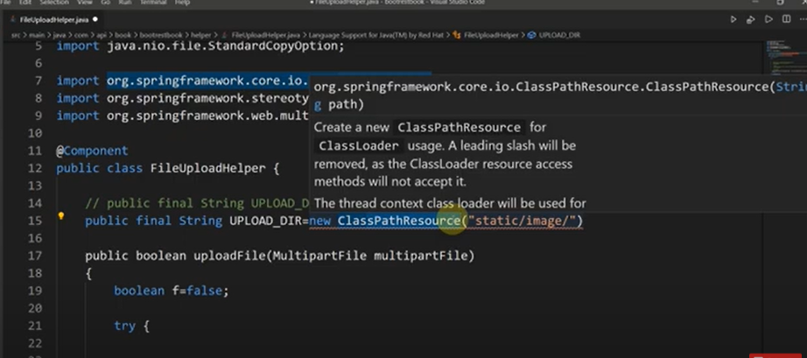
And add an IO Exception
