Build REST APIs using Spring Boot, Spring Security 6, JWT, Spring Data JPA, Hibernate, MySQL, Docker & Deploy on AWS
REST Introduction and REST Architecture
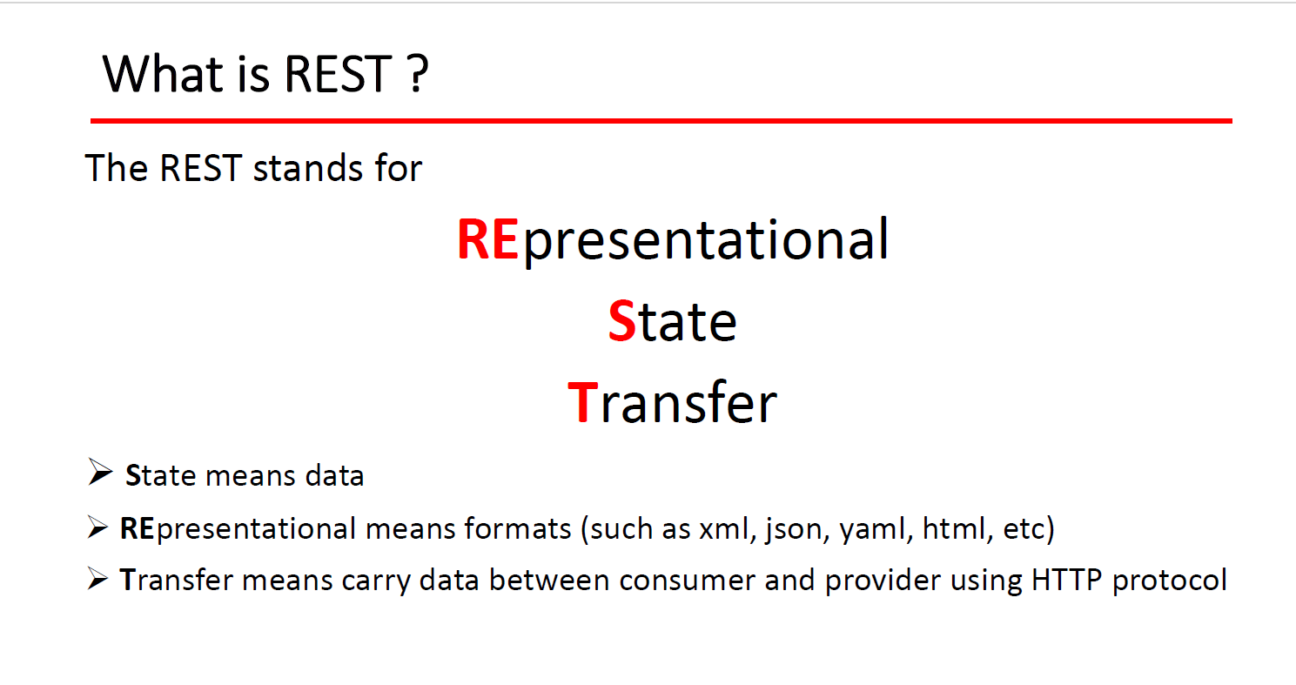
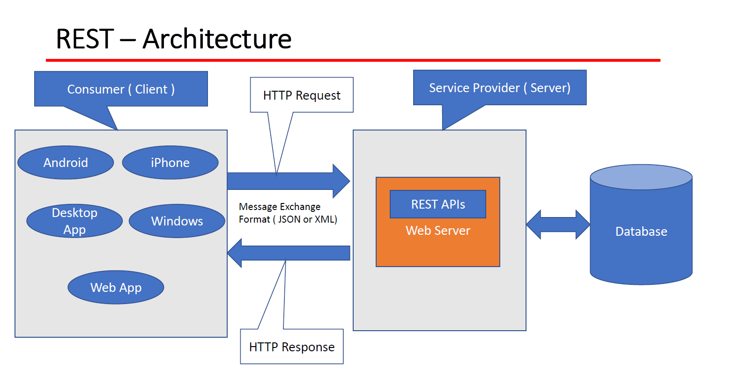
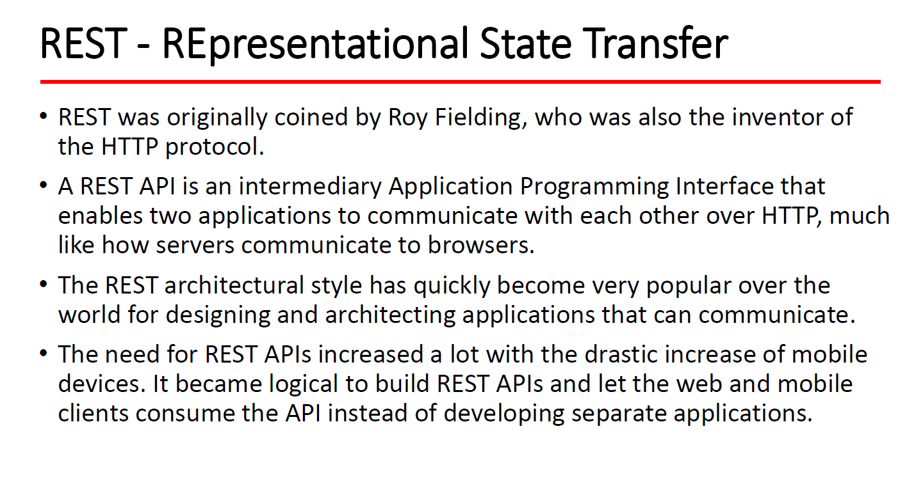
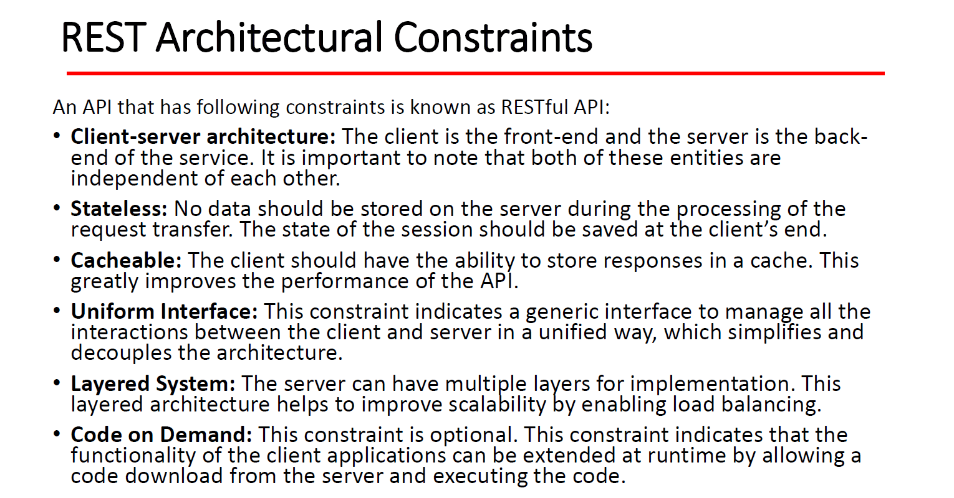
REST Key Concepts - Resource, URI and Sub-resource
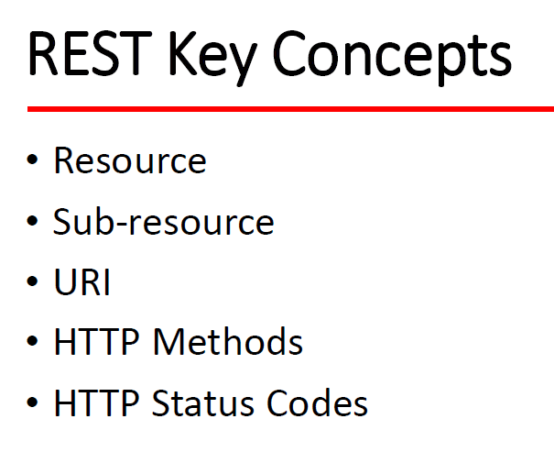
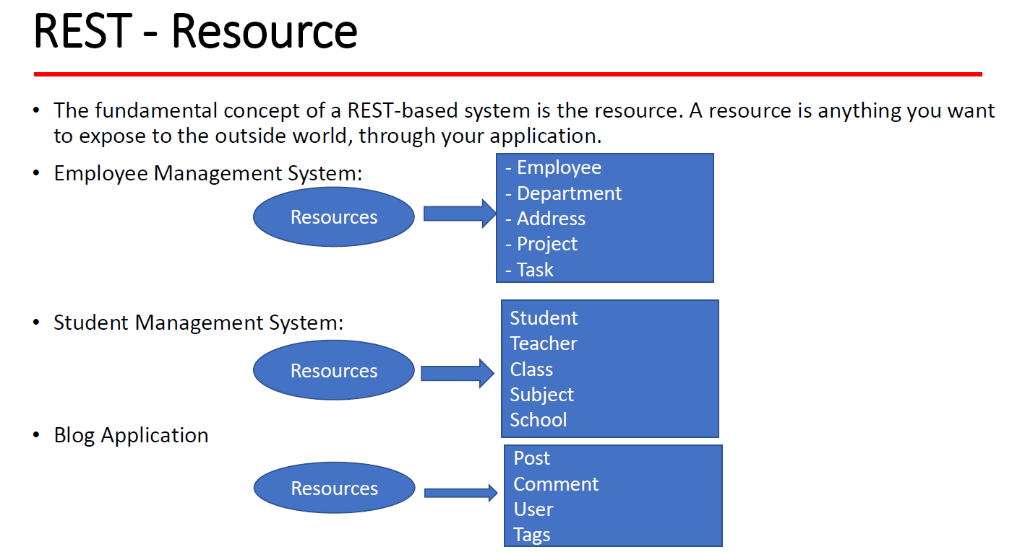
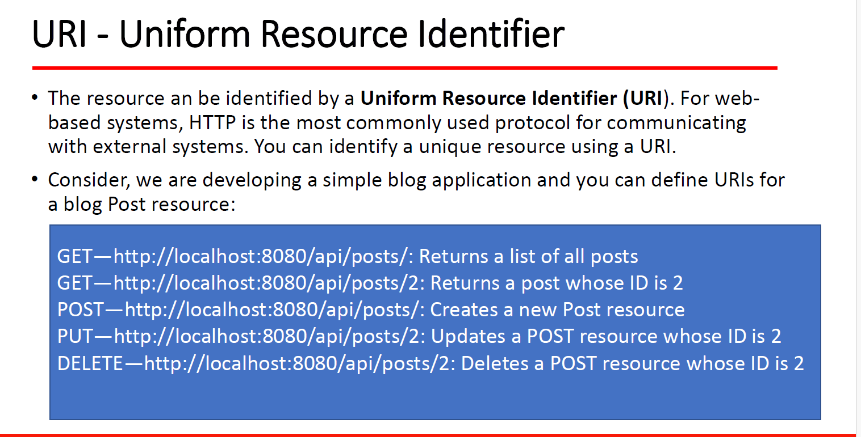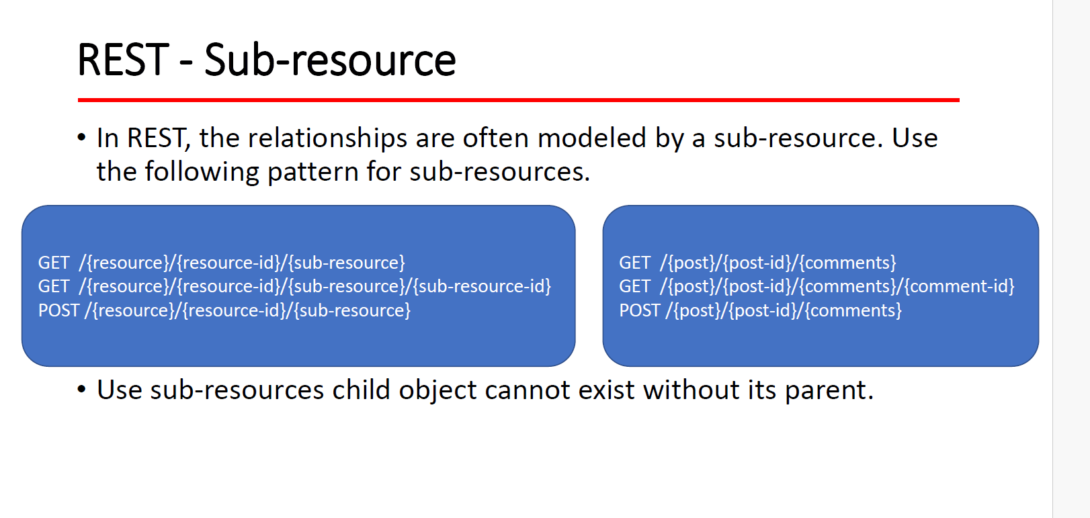
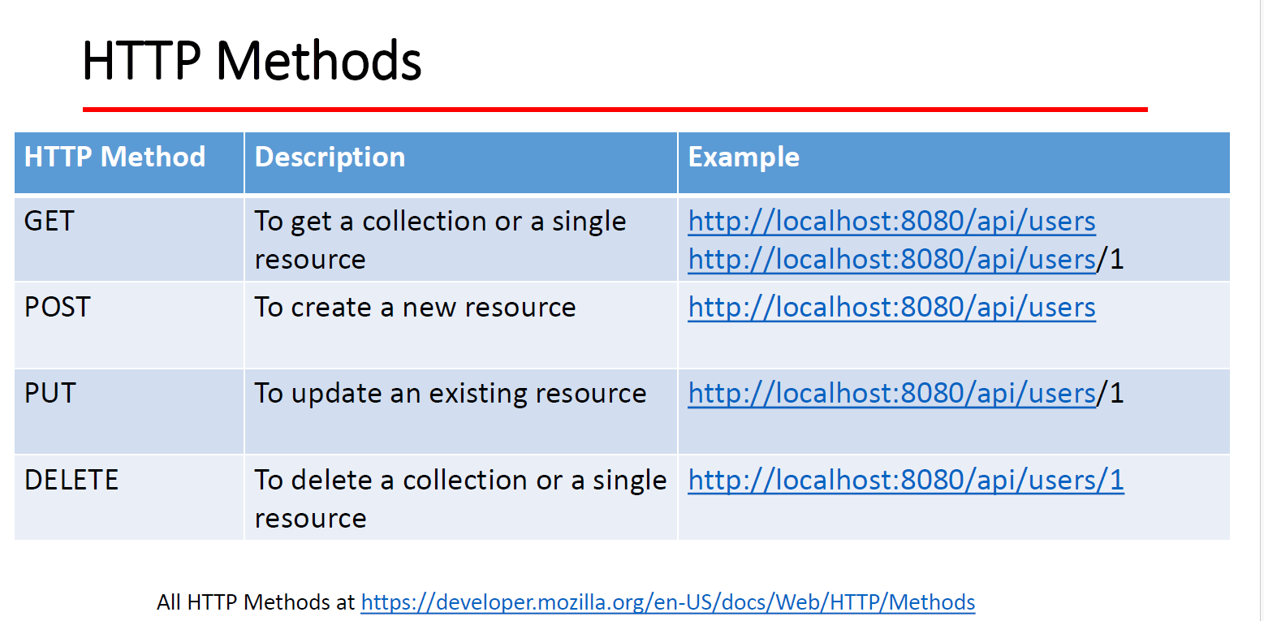
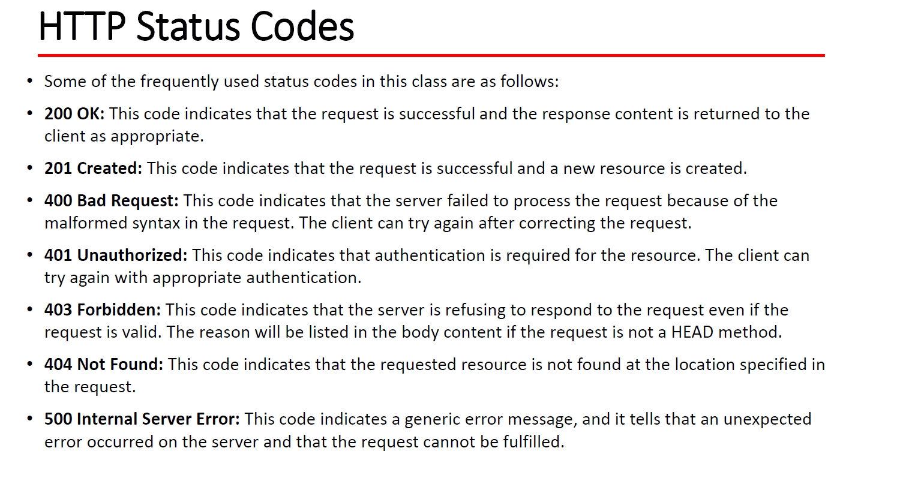

Section 5: Spring Boot REST API Development Basics (Covered Important Annotations)
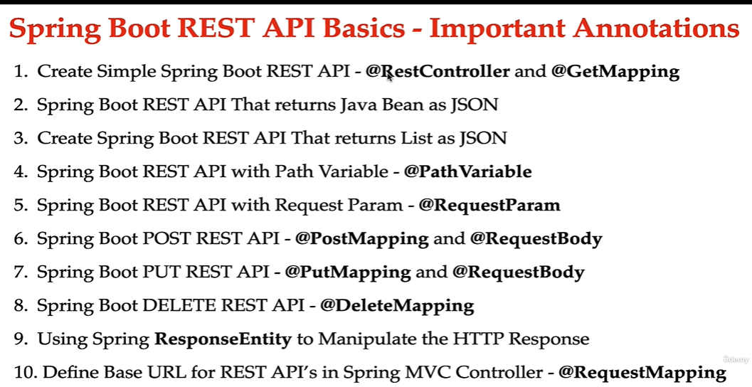

Create Simple Spring Boot REST API - @GetMapping
@Controller @ ResponseBody @RestController

1. @Controller

Definition:
- The @Controller annotation is used in Spring MVC to mark a class as a web controller that handles HTTP requests.
- It is part of the spring-web module and works with @RequestMapping to map HTTP requests to handler methods.
- It is mainly used for rendering view-based web applications (such as those using Thymeleaf, JSP, etc.).

Example:
java
CopyEdit
@Controller
public class HomeController {

@RequestMapping("/home")
public String homePage() {
return "home"; // Returns the view name (e.g., home.html in Thymeleaf)
}
}
- The method returns a view name (not a response body), and the view resolver maps it to an actual HTML file.

Key Points:
✅ Used for MVC-based applications (not REST APIs).
✅ Works with view resolvers to return HTML/JSP pages.
✅ Requires a separate ViewResolver configuration to map view names to actual templates.
✅ If you need to return JSON/XML instead of a view, you need to use @ResponseBody.

2. @ResponseBody

Definition:
- The @ResponseBody annotation is used at the method level or class level to indicate that the return value of the method should be written directly to the HTTP response body.
- It tells Spring not to use a view resolver but instead return the actual response (JSON, XML, String, etc.).
- It is commonly used for REST APIs that return structured data like JSON.

Example:
java
CopyEdit
@Controller
public class ApiController {

@RequestMapping("/data")
@ResponseBody
public String getData() {
return "Hello, this is a raw response!";
}
}
- The response will be Hello, this is a raw response! instead of rendering a view.

Example with JSON Response:
java
CopyEdit
@Controller
public class UserController {

@RequestMapping("/user")
@ResponseBody
public User getUser() {
return new User(1, "John Doe", "john@example.com"); // Will be converted to JSON
}
}
- If User is a Java object, Spring automatically serializes it into JSON if Jackson (or any JSON library) is present.

Key Points:
✅ Used when returning data instead of views.
✅ Can be applied at the method level inside @Controller.
✅ Works well for AJAX calls and APIs.
✅ Eliminates the need for a separate ViewResolver.

3. @RestController

Definition:
- @RestController is a specialized version of @Controller that combines @Controller and @ResponseBody.
- Any method inside a @RestController returns data (JSON/XML) by default, eliminating the need for @ResponseBody on each method.
- It is used for RESTful web services.

Example:
java
CopyEdit
@RestController
public class RestApiController {

@GetMapping("/hello")
public String sayHello() {
return "Hello from REST API!";
}
}
- The response will be "Hello from REST API!" as plain text instead of rendering a view.

Example Returning JSON:
java
CopyEdit
@RestController
public class UserRestController {

@GetMapping("/user")
public User getUser() {
return new User(1, "John Doe", "john@example.com"); // Automatically converted to JSON
}
}
- If the User class is defined as:
java
CopyEdit
public class User {
private int id;
private String name;
private String email;

public User(int id, String name, String email) {
this.id = id;
this.name = name;
this.email = email;
}

// Getters and Setters
}
- The response will be:
json
CopyEdit
{
"id": 1,
"name": "John Doe",
"email": "john@example.com"
}
(Spring Boot automatically converts Java objects to JSON using Jackson.)

Key Points:
✅ Eliminates the need for @ResponseBody on each method.
✅ Used for creating RESTful APIs.
✅ Returns JSON/XML responses directly.
✅ Preferred for building microservices and REST APIs.

🔥 Comparison Table
Feature | @Controller | @ResponseBody | @RestController
Used for | Web applications (MVC) | REST APIs | REST APIs
Returns | View (HTML/JSP) | JSON/XML/Text | JSON/XML/Text
Requires View Resolver | ✅ Yes | ❌ No | ❌ No
Auto-converts Java objects to JSON | ❌ No | ✅ Yes | ✅ Yes
Needs @ResponseBody for JSON? | ✅ Yes | ❌ No (it is @ResponseBody) | ❌ No (it's implicit)
Best Use Case | Websites | Data responses in controllers | RESTful web services

🔹 When to Use What?
- Use @Controller when building traditional web applications with Thymeleaf, JSP, or Freemarker templates.
- Use @ResponseBody when you need to return JSON/XML in a @Controller method without changing the whole class.
- Use @RestController when building RESTful APIs, as it combines @Controller + @ResponseBody and simplifies API development.

🎯 Conclusion
- @Controller is used for traditional MVC applications where the response is a view (HTML, JSP).
- @ResponseBody is used when you want to return data (JSON/XML) instead of a view inside a @Controller.
- @RestController is a shortcut for @Controller + @ResponseBody, designed specifically for RESTful APIs.

@GetMapping

@GetMapping in Spring Boot

Definition:
@GetMapping is a Spring annotation used to map HTTP GET requests to a specific method in a controller. It is part of Spring MVC and is commonly used in RESTful APIs.
- It is a shortcut for @RequestMapping(method = RequestMethod.GET).
- It simplifies the definition of GET request handlers.

1️⃣ Basic Example
java
CopyEdit
@RestController
public class HelloController {

@GetMapping("/hello")
public String sayHello() {
return "Hello, World!";
}
}
📌 Explanation:
- The method sayHello() handles GET /hello.
- It returns plain text (Hello, World!).
📌 Output (on calling GET /hello in a browser or Postman):
CopyEdit
Hello, World!

2️⃣ Returning JSON Response
If we return a Java object, Spring Boot automatically converts it into JSON using Jackson.
java
CopyEdit
@RestController
public class UserController {

@GetMapping("/user")
public User getUser() {
return new User(1, "John Doe", "john@example.com");
}
}

User.java
java
CopyEdit
public class User {
private int id;
private String name;
private String email;

public User(int id, String name, String email) {
this.id = id;
this.name = name;
this.email = email;
}

// Getters and Setters
}
📌 Output (on calling GET /user):
json
CopyEdit
{
"id": 1,
"name": "John Doe",
"email": "john@example.com"
}

3️⃣ Using Path Variables (@PathVariable)
- We can extract values from the URL using @PathVariable.
java
CopyEdit
@RestController
public class ProductController {

@GetMapping("/product/{id}")
public String getProduct(@PathVariable int id) {
return "Product ID: " + id;
}
}

Example Requests & Responses
Request | Response
GET /product/5 | Product ID: 5
GET /product/10 | Product ID: 10

4️⃣ Using Query Parameters (@RequestParam)
- Query parameters are passed after ? in the URL.
java
CopyEdit
@RestController
public class SearchController {

@GetMapping("/search")
public String search(@RequestParam String query) {
return "Searching for: " + query;
}
}

Example Requests & Responses
Request | Response
GET /search?query=laptop | Searching for: laptop
GET /search?query=phone | Searching for: phone
- You can also provide default values:
java
CopyEdit
@GetMapping("/search")
public String search(@RequestParam(defaultValue = "default") String query) {
return "Searching for: " + query;
}
- GET /search (without query) → Response: Searching for: default

5️⃣ Multiple Query Parameters
java
CopyEdit
@RestController
public class OrderController {

@GetMapping("/order")
public String getOrder(@RequestParam int id, @RequestParam String status) {
return "Order ID: " + id + ", Status: " + status;
}
}

Example Requests & Responses
Request | Response
GET /order?id=101&status=shipped | Order ID: 101, Status: shipped
GET /order?id=202&status=pending | Order ID: 202, Status: pending

6️⃣ Mapping Multiple URLs to the Same Method
java
CopyEdit
@RestController
public class MultiMappingController {

@GetMapping({"/home", "/index", "/welcome"})
public String home() {
return "Welcome!";
}
}
- The method handles multiple URLs:
  - GET /home
  - GET /index
  - GET /welcome
- Response: "Welcome!"

7️⃣ Using Headers in @GetMapping
- We can restrict @GetMapping to only accept requests with specific headers.
java
CopyEdit
@RestController
public class HeaderController {

@GetMapping(value = "/api/data", headers = "X-API-KEY=12345")
public String getData() {
return "Authorized request!";
}
}
- The request must include:
X-API-KEY: 12345

8️⃣ Customizing Response with ResponseEntity
- ResponseEntity allows custom HTTP status codes, headers, and response bodies.
java
CopyEdit
@RestController
public class ResponseEntityExample {

@GetMapping("/response")
public ResponseEntity<String> getResponse() {
return ResponseEntity.status(HttpStatus.OK)
.header("Custom-Header", "CustomValue")
.body("Hello with custom response!");
}
}
📌 Output (on GET /response):
vbnet
CopyEdit
HTTP 200 OK
Custom-Header: CustomValue
Body: "Hello with custom response!"

9️⃣ Returning a List of Objects
- We can return multiple items in JSON format.
java
CopyEdit
@RestController
public class UserListController {

@GetMapping("/users")
public List<User> getUsers() {
return List.of(
new User(1, "Alice", "alice@example.com"),
new User(2, "Bob", "bob@example.com")
);
}
}
📌 Output (on GET /users):
json
CopyEdit
[
{
"id": 1,
"name": "Alice",
"email": "alice@example.com"
},
{
"id": 2,
"name": "Bob",
"email": "bob@example.com"
}
]

🔍 Key Points
✅ @GetMapping is used for handling GET requests.
✅ It simplifies @RequestMapping(method = RequestMethod.GET).
✅ Supports path variables (@PathVariable) and query parameters (@RequestParam).
✅ Returns JSON responses automatically in @RestController.
✅ Can handle multiple URLs and custom headers.
✅ Works well with ResponseEntity for full control over responses.
🚀 For REST APIs, always prefer @RestController with @GetMapping!
Spring Boot REST API That Returns Java Bean as JSON

Spring Boot REST API That Returns a Java Bean as JSON
In a Spring Boot REST API, we can return a Java object (Bean) as a JSON response automatically. This is done using Spring MVC and Jackson (JSON Processor).

1️⃣ Creating a Simple REST API That Returns a Java Bean

📌 Step 1: Create a Java Bean (Model Class)
java
CopyEdit
public class User {
private int id;
private String name;
private String email;

public User(int id, String name, String email) {
this.id = id;
this.name = name;
this.email = email;
}

// Getters and Setters
public int getId() { return id; }
public void setId(int id) { this.id = id; }

public String getName() { return name; }
public void setName(String name) { this.name = name; }

public String getEmail() { return email; }
public void setEmail(String email) { this.email = email; }
}
- This Java Bean (POJO) represents a User entity.
- No need for @Component or @Entity because it's a simple DTO (Data Transfer Object).

📌 Step 2: Create a REST Controller
java
CopyEdit
import org.springframework.web.bind.annotation.GetMapping;
import org.springframework.web.bind.annotation.RequestMapping;
import org.springframework.web.bind.annotation.RestController;

@RestController
@RequestMapping("/api")
public class UserController {

@GetMapping("/user")
public User getUser() {
return new User(1, "John Doe", "john@example.com");
}
}
- @RestController: Marks this class as a Spring REST API.
- @RequestMapping("/api"): Sets a base path (/api).
- @GetMapping("/user"): Maps GET /api/user to getUser().

📌 Step 3: Run the Application
Start your Spring Boot application.

📌 Step 4: Test the API (Using Postman or Browser)
Call:
bash
CopyEdit
GET http://localhost:8080/api/user
✅ Response (JSON)
json
CopyEdit
{
"id": 1,
"name": "John Doe",
"email": "john@example.com"
}
🚀 Spring Boot automatically converts the User object into JSON using Jackson.

2️⃣ Returning a List of Java Beans as JSON
If we need to return multiple objects, we use a List.

Modify UserController to Return a List of Users
java
CopyEdit
import java.util.List;

@RestController
@RequestMapping("/api")
public class UserController {

@GetMapping("/users")
public List<User> getUsers() {
return List.of(
new User(1, "John Doe", "john@example.com"),
new User(2, "Alice Smith", "alice@example.com"),
new User(3, "Bob Johnson", "bob@example.com")
);
}
}

📌 Test the API
Call:
bash
CopyEdit
GET http://localhost:8080/api/users
✅ Response (JSON)
json
CopyEdit
[
{
"id": 1,
"name": "John Doe",
"email": "john@example.com"
},
{
"id": 2,
"name": "Alice Smith",
"email": "alice@example.com"
},
{
"id": 3,
"name": "Bob Johnson",
"email": "bob@example.com"
}
]
🚀 Spring Boot automatically converts the list of User objects into JSON!

3️⃣ Returning a Response with ResponseEntity
Sometimes, we need to return a custom status code or headers.
java
CopyEdit
import org.springframework.http.ResponseEntity;
import org.springframework.http.HttpStatus;
import java.util.List;

@RestController
@RequestMapping("/api")
public class UserController {

@GetMapping("/users")
public ResponseEntity<List<User>> getUsers() {
List<User> users = List.of(
new User(1, "John Doe", "john@example.com"),
new User(2, "Alice Smith", "alice@example.com")
);

return ResponseEntity.status(HttpStatus.OK).body(users);
}
}
✅ This returns 200 OK with JSON data.

🔍 Key Takeaways
✔ @RestController ensures JSON response automatically.
✔ @GetMapping maps HTTP GET requests to a method.
✔ Spring Boot uses Jackson to serialize Java objects into JSON.
✔ Returning a List automatically converts it into a JSON array.
✔ ResponseEntity helps customize status codes & headers.
🚀 This is how we return Java Beans as JSON in Spring Boot REST APIs! 🚀

Create Spring Boot REST API That Returns List as JSON

Spring Boot REST API That Returns a List as JSON
In Spring Boot, you can create a REST API that returns a List of Java Objects as JSON. Spring Boot uses Jackson for automatic conversion.

1️⃣ Create a Spring Boot REST API That Returns a List

📌 Step 1: Create a Java Bean (Model Class)
java
CopyEdit
public class Product {
private int id;
private String name;
private double price;

public Product(int id, String name, double price) {
this.id = id;
this.name = name;
this.price = price;
}

// Getters and Setters
public int getId() { return id; }
public void setId(int id) { this.id = id; }

public String getName() { return name; }
public void setName(String name) { this.name = name; }

public double getPrice() { return price; }
public void setPrice(double price) { this.price = price; }
}
- This Java Bean (POJO) represents a Product entity.
- No need for @Entity since we are not using a database.

📌 Step 2: Create a REST Controller
java
CopyEdit
import org.springframework.web.bind.annotation.GetMapping;
import org.springframework.web.bind.annotation.RequestMapping;
import org.springframework.web.bind.annotation.RestController;
import java.util.List;

@RestController
@RequestMapping("/api")
public class ProductController {

@GetMapping("/products")
public List<Product> getAllProducts() {
return List.of(
new Product(1, "Laptop", 1200.50),
new Product(2, "Smartphone", 699.99),
new Product(3, "Tablet", 450.00)
);
}
}
✅ Explanation:
- @RestController → Marks this class as a REST API.
- @RequestMapping("/api") → Defines base path (/api).
- @GetMapping("/products") → Maps GET /api/products to getAllProducts().
- List.of() creates a list of Product objects and returns it.

📌 Step 3: Run the Application
Start your Spring Boot application.

📌 Step 4: Test the API
Call:
bash
CopyEdit
GET http://localhost:8080/api/products
✅ Response (JSON)
json
CopyEdit
[
{
"id": 1,
"name": "Laptop",
"price": 1200.50
},
{
"id": 2,
"name": "Smartphone",
"price": 699.99
},
{
"id": 3,
"name": "Tablet",
"price": 450.00
}
]
🚀 Spring Boot automatically converts the list of Product objects into JSON using Jackson.

2️⃣ Using ResponseEntity for More Control
If you want to customize the response status codes or headers, use ResponseEntity.
java
CopyEdit
import org.springframework.http.ResponseEntity;
import org.springframework.http.HttpStatus;
import java.util.List;

@RestController
@RequestMapping("/api")
public class ProductController {

@GetMapping("/products")
public ResponseEntity<List<Product>> getAllProducts() {
List<Product> products = List.of(
new Product(1, "Laptop", 1200.50),
new Product(2, "Smartphone", 699.99),
new Product(3, "Tablet", 450.00)
);

return ResponseEntity.status(HttpStatus.OK).body(products);
}
}
✅ This returns 200 OK with JSON data.

🔍 Key Takeaways
✔ @RestController ensures JSON response.
✔ @GetMapping maps HTTP GET requests to methods.
✔ Spring Boot uses Jackson to convert Java objects into JSON.
✔ Returning a List automatically converts it into a JSON array.
✔ ResponseEntity helps customize status codes & headers.
🚀 This is how you return a list as JSON in Spring Boot REST APIs! 🚀
Spring Boot REST API with Path Variable - @PathVariable
In Spring Boot, the @PathVariable annotation is used to extract values from the URI path in a REST API request. It helps in building dynamic URLs where parts of the URL act as parameters.

1️⃣ How @PathVariable Works
@PathVariable binds a URI template variable to a method parameter.

Example: Dynamic URL
bash
CopyEdit
GET http://localhost:8080/api/products/1
- 1 is a path variable representing a product ID.
- The controller extracts this value and processes the request accordingly.

2️⃣ Create a Spring Boot REST API with @PathVariable

📌 Step 1: Create a Java Bean (Model Class)
java
CopyEdit
public class Product {
private int id;
private String name;
private double price;

public Product(int id, String name, double price) {
this.id = id;
this.name = name;
this.price = price;
}

// Getters and Setters
public int getId() { return id; }
public void setId(int id) { this.id = id; }

public String getName() { return name; }
public void setName(String name) { this.name = name; }

public double getPrice() { return price; }
public void setPrice(double price) { this.price = price; }
}

📌 Step 2: Create a REST Controller with @PathVariable
java
CopyEdit
import org.springframework.web.bind.annotation.GetMapping;
import org.springframework.web.bind.annotation.PathVariable;
import org.springframework.web.bind.annotation.RequestMapping;
import org.springframework.web.bind.annotation.RestController;
import java.util.List;

@RestController
@RequestMapping("/api")
public class ProductController {

private List<Product> productList = List.of(
new Product(1, "Laptop", 1200.50),
new Product(2, "Smartphone", 699.99),
new Product(3, "Tablet", 450.00)
);

@GetMapping("/products/{id}")
public Product getProductById(@PathVariable int id) {
return productList.stream()
.filter(product -> product.getId() == id)
.findFirst()
.orElse(null); // Returns null if no product found
}
}
✅ Explanation:
- @GetMapping("/products/{id}"):
  - Maps requests like /products/1, /products/2, etc.
  - {id} is a path variable.
- @PathVariable int id: Extracts id from the URL.
- Searches for the product with the given ID using Java Streams.
- Returns null if the product is not found.

📌 Step 3: Run the Application
Start your Spring Boot application.

📌 Step 4: Test the API
Call:
bash
CopyEdit
GET http://localhost:8080/api/products/2
✅ Response (JSON)
json
CopyEdit
{
"id": 2,
"name": "Smartphone",
"price": 699.99
}
If you request an invalid product ID, the response will be null.

3️⃣ Handling Product Not Found with ResponseEntity
Instead of returning null, we can return an error message when the product is not found.

Updated Controller with ResponseEntity
java
CopyEdit
import org.springframework.http.HttpStatus;
import org.springframework.http.ResponseEntity;

@RestController
@RequestMapping("/api")
public class ProductController {

private List<Product> productList = List.of(
new Product(1, "Laptop", 1200.50),
new Product(2, "Smartphone", 699.99),
new Product(3, "Tablet", 450.00)
);

@GetMapping("/products/{id}")
public ResponseEntity<?> getProductById(@PathVariable int id) {
return productList.stream()
.filter(product -> product.getId() == id)
.findFirst()
.map(product -> ResponseEntity.ok().body(product))
.orElseGet(() -> ResponseEntity.status(HttpStatus.NOT_FOUND)
.body("Product not found with ID: " + id));
}
}
✅ Improvements:
- Returns 200 OK if product exists.
- Returns 404 NOT FOUND if product doesn't exist.
- Returns a custom error message.

📌 Step 5: Test the Improved API

✅ Valid Request
bash
CopyEdit
GET http://localhost:8080/api/products/2
🔹 Response (200 OK)
json
CopyEdit
{
"id": 2,
"name": "Smartphone",
"price": 699.99
}

❌ Invalid Request
bash
CopyEdit
GET http://localhost:8080/api/products/10
🔹 Response (404 NOT FOUND)
json
CopyEdit
"Product not found with ID: 10"

4️⃣ Using Multiple @PathVariable Parameters
We can pass multiple path variables in the URL.

Example: Find a product by ID and name
java
CopyEdit
@GetMapping("/products/{id}/{name}")
public String getProductByIdAndName(@PathVariable int id, @PathVariable String name) {
return "Product ID: " + id + ", Name: " + name;
}
Test URL:
bash
CopyEdit
GET http://localhost:8080/api/products/1/Laptop
✅ Response
yaml
CopyEdit
Product ID: 1, Name: Laptop

🔍 Key Takeaways
✔ @PathVariable extracts values from the URL path.
✔ Supports single or multiple path variables.
✔ Can return null, JSON, or a custom error response.
✔ Use ResponseEntity for better status handling.
Spring Boot REST API with Request Param - @RequestParam

Overview of @RequestParam
- Purpose:
@RequestParam is used to extract query parameters from the URL. Query parameters are the key-value pairs appended to the URL after the ?.
- Usage:
You annotate a method parameter with @RequestParam to bind a query parameter directly to that parameter. It works well with REST endpoints where the client sends data as part of the query string.
- Default Values & Required Flag:
You can specify if a parameter is required (required = true/false) and also provide a default value using the defaultValue attribute.

1️⃣ Simple Example: Extracting a Single Query Parameter
Imagine an endpoint that searches for products by name. The client might call:
bash
CopyEdit
GET http://localhost:8080/api/search?query=laptop

Example Code:
java
CopyEdit
import org.springframework.web.bind.annotation.GetMapping;
import org.springframework.web.bind.annotation.RequestParam;
import org.springframework.web.bind.annotation.RestController;

@RestController
public class SearchController {

@GetMapping("/api/search")
public String searchProducts(@RequestParam String query) {
return "Searching for: " + query;
}
}
Explanation:
- @RequestParam String query: Binds the query parameter query from the URL to the method parameter.
- When the endpoint is called, it returns a simple text response with the search query.

2️⃣ Example with Default Value and Optional Parameter
Sometimes, a parameter may not always be provided by the client. You can set a default value or mark the parameter as optional.

Example Code:
java
CopyEdit
import org.springframework.web.bind.annotation.GetMapping;
import org.springframework.web.bind.annotation.RequestParam;
import org.springframework.web.bind.annotation.RestController;

@RestController
public class SearchController {

@GetMapping("/api/search")
public String searchProducts(
@RequestParam(name = "query", defaultValue = "all", required = false) String query) {
return "Searching for: " + query;
}
}
Explanation:
- defaultValue = "all": If the client does not provide a query parameter, it defaults to "all".
- required = false: Indicates that the parameter is optional.

3️⃣ Returning a List of Filtered Results
Let’s consider a more practical example. Assume you have a list of products, and you want to filter them based on a category provided as a query parameter.

Example Java Bean: Product
java
CopyEdit
public class Product {
private int id;
private String name;
private String category;

public Product(int id, String name, String category) {
this.id = id;
this.name = name;
this.category = category;
}

// Getters and Setters
public int getId() { return id; }
public void setId(int id) { this.id = id; }

public String getName() { return name; }
public void setName(String name) { this.name = name; }

public String getCategory() { return category; }
public void setCategory(String category) { this.category = category; }
}

Example REST Controller:
java
CopyEdit
import org.springframework.web.bind.annotation.GetMapping;
import org.springframework.web.bind.annotation.RequestParam;
import org.springframework.web.bind.annotation.RestController;
import java.util.List;
import java.util.stream.Collectors;

@RestController
public class ProductController {

// Simulated list of products
private List<Product> products = List.of(
new Product(1, "Laptop Pro", "electronics"),
new Product(2, "Smartphone X", "electronics"),
new Product(3, "Coffee Maker", "home"),
new Product(4, "Desk Lamp", "home")
);

@GetMapping("/api/products")
public List<Product> getProductsByCategory(@RequestParam(name = "category", defaultValue = "") String category) {
// If no category is provided, return all products
if (category.isBlank()) {
return products;
}
// Filter products by category (case-insensitive)
return products.stream()
.filter(product -> product.getCategory().equalsIgnoreCase(category))
.collect(Collectors.toList());
}
}
Explanation:
- The method getProductsByCategory handles GET /api/products?category=....
- If the category query parameter is not provided (or is blank), the API returns the full list.
- Otherwise, it filters the products by the provided category (ignoring case).

4️⃣ Using ResponseEntity for Enhanced Control
You might want to return custom status codes or headers along with your JSON response. In such cases, wrap your response using ResponseEntity.

Example Code:
java
CopyEdit
import org.springframework.http.HttpStatus;
import org.springframework.http.ResponseEntity;
import org.springframework.web.bind.annotation.GetMapping;
import org.springframework.web.bind.annotation.RequestParam;
import org.springframework.web.bind.annotation.RestController;
import java.util.List;
import java.util.stream.Collectors;

@RestController
public class ProductController {

private List<Product> products = List.of(
new Product(1, "Laptop Pro", "electronics"),
new Product(2, "Smartphone X", "electronics"),
new Product(3, "Coffee Maker", "home"),
new Product(4, "Desk Lamp", "home")
);

@GetMapping("/api/products")
public ResponseEntity<List<Product>> getProductsByCategory(
@RequestParam(name = "category", defaultValue = "") String category) {
List<Product> filteredProducts;
if (category.isBlank()) {
filteredProducts = products;
} else {
filteredProducts = products.stream()
.filter(product -> product.getCategory().equalsIgnoreCase(category))
.collect(Collectors.toList());
}

if (filteredProducts.isEmpty()) {
return ResponseEntity.status(HttpStatus.NOT_FOUND).body(filteredProducts);
}

return ResponseEntity.ok(filteredProducts);
}
}
Explanation:
- The endpoint now returns a ResponseEntity which allows for custom HTTP status codes.
- If the filtered list is empty, it returns 404 NOT FOUND; otherwise, it returns 200 OK along with the filtered products.

🔍 Key Points Recap
- @RequestParam binds query parameters from the URL to method parameters.
- You can specify if a parameter is required and assign a default value.
- It is ideal for scenarios like search, filtering, or sorting.
- Combine it with ResponseEntity for enhanced response control.

With these examples, you now have a detailed understanding of how to use @RequestParam in your Spring Boot REST API to extract query parameters and return responses in JSON format.
Spring Boot POST REST API - @PostMapping and @RequestBody

Overview
- @PostMapping:
This annotation maps HTTP POST requests onto a specific handler method. It’s a shorthand for @RequestMapping(method = RequestMethod.POST).
- @RequestBody:
This annotation binds the HTTP request body to a Java object. Spring Boot uses Jackson (or another JSON processor) to automatically deserialize JSON data into the specified Java bean.

Step-by-Step Guide

1. Create a Java Bean
The Java bean represents the data structure of the request payload. For example, let’s create a User class:
java
CopyEdit
public class User {
private int id;
private String name;
private String email;

// Default constructor is required for JSON deserialization
public User() {}

public User(int id, String name, String email) {
this.id = id;
this.name = name;
this.email = email;
}

// Getters and Setters
public int getId() { return id; }
public void setId(int id) { this.id = id; }

public String getName() { return name; }
public void setName(String name) { this.name = name; }

public String getEmail() { return email; }
public void setEmail(String email) { this.email = email; }
}
Note: A default (no-argument) constructor is essential for the deserialization process.

2. Create the REST Controller
Now, create a controller that uses @PostMapping and @RequestBody:
java
CopyEdit
import org.springframework.http.HttpStatus;
import org.springframework.http.ResponseEntity;
import org.springframework.web.bind.annotation.PostMapping;
import org.springframework.web.bind.annotation.RequestBody;
import org.springframework.web.bind.annotation.RequestMapping;
import org.springframework.web.bind.annotation.RestController;

@RestController
@RequestMapping("/api")
public class UserController {

@PostMapping("/users")
public ResponseEntity<User> createUser(@RequestBody User user) {
// Here you can add business logic, e.g., saving the user to a database.
// For demonstration, we simply echo the user back.

// Return HTTP status 201 (Created) along with the user data.
return new ResponseEntity<>(user, HttpStatus.CREATED);
}
}
Explanation:
- @RestController:
Marks the class as a RESTful controller that automatically converts return objects to JSON.
- @RequestMapping("/api"):
Sets the base URL path for all endpoints in the controller.
- @PostMapping("/users"):
Maps POST requests sent to /api/users to the createUser method.
- @RequestBody User user:
Binds the incoming JSON payload to a User object. For example, if the client sends:
json
CopyEdit
{
"id": 1,
"name": "John Doe",
"email": "john@example.com"
}
Spring Boot (using Jackson) will deserialize this JSON into a User instance.
- ResponseEntity<User>:
Allows you to customize the HTTP response, including setting status codes. Here, we return 201 CREATED indicating that a new resource was created.

3. Testing the API
To test the endpoint, you can use tools like Postman or cURL. For example:
- cURL Example:
bash
CopyEdit
curl -X POST "http://localhost:8080/api/users" \
-H "Content-Type: application/json" \
-d '{"id":1,"name":"John Doe","email":"john@example.com"}'
- Expected JSON Response:
json
CopyEdit
{
"id": 1,
"name": "John Doe",
"email": "john@example.com"
}
This response echoes back the data sent, along with the HTTP status 201 CREATED.

Key Takeaways
- Automatic JSON Mapping:
With @RequestBody, Spring Boot seamlessly converts JSON request data into a Java object.
- POST Mapping Simplified:
@PostMapping makes it easy to define endpoints that create resources.
- Customization with ResponseEntity:
Use ResponseEntity to include HTTP status codes and headers in your responses.
- Practical Application:
This pattern is widely used in RESTful APIs to handle data creation operations (e.g., user registration, order placement).

By following this guide, you’ll be able to create a robust Spring Boot POST REST API that accepts JSON data, maps it to a Java bean using @RequestBody, and processes the data efficiently. This approach is a cornerstone of modern REST API development in Spring Boot.
Spring Boot PUT REST API - @PutMapping and @RequestBody

Overview
- @PutMapping:
This annotation maps HTTP PUT requests to a specific handler method. PUT is typically used for updating an existing resource.
- @RequestBody:
Binds the HTTP request body (usually in JSON format) to a Java object. Spring Boot uses Jackson to automatically deserialize the JSON data into the specified Java bean.

Step-by-Step Implementation

1️⃣ Define a Java Bean (Model Class)
For example, let’s use a Product class as our model:
java
CopyEdit
public class Product {
private int id;
private String name;
private double price;

// Default constructor for JSON deserialization
public Product() {}

public Product(int id, String name, double price) {
this.id = id;
this.name = name;
this.price = price;
}

// Getters and Setters
public int getId() { return id; }
public void setId(int id) { this.id = id; }

public String getName() { return name; }
public void setName(String name) { this.name = name; }

public double getPrice() { return price; }
public void setPrice(double price) { this.price = price; }
}

2️⃣ Create the REST Controller with @PutMapping
In this example, we simulate an update operation on a list of products. The endpoint accepts an updated Product object in the request body and the product ID as a path variable.
java
CopyEdit
import org.springframework.http.HttpStatus;
import org.springframework.http.ResponseEntity;
import org.springframework.web.bind.annotation.PutMapping;
import org.springframework.web.bind.annotation.PathVariable;
import org.springframework.web.bind.annotation.RequestBody;
import org.springframework.web.bind.annotation.RequestMapping;
import org.springframework.web.bind.annotation.RestController;
import java.util.ArrayList;
import java.util.List;
import java.util.Optional;

@RestController
@RequestMapping("/api")
public class ProductController {

// Simulated in-memory list of products
private List<Product> products = new ArrayList<>(List.of(
new Product(1, "Laptop", 1200.50),
new Product(2, "Smartphone", 699.99),
new Product(3, "Tablet", 450.00)
));

@PutMapping("/products/{id}")
public ResponseEntity<?> updateProduct(@PathVariable int id, @RequestBody Product updatedProduct) {
// Find product by id
Optional<Product> productOptional = products.stream()
.filter(product -> product.getId() == id)
.findFirst();

if (productOptional.isPresent()) {
Product existingProduct = productOptional.get();

// Update product details
existingProduct.setName(updatedProduct.getName());
existingProduct.setPrice(updatedProduct.getPrice());

// In a real application, you would save changes to the database.
return ResponseEntity.ok(existingProduct);
} else {
// Return 404 Not Found if product does not exist
return ResponseEntity.status(HttpStatus.NOT_FOUND)
.body("Product not found with ID: " + id);
}
}
}
Explanation:
- Endpoint Mapping:
@PutMapping("/products/{id}") maps PUT requests (e.g., PUT /api/products/1) to the updateProduct method. The {id} in the URL is extracted as a path variable.
- Binding Request Body:
@RequestBody Product updatedProduct tells Spring to deserialize the incoming JSON into a Product instance.
- Update Logic:
The code searches for an existing product by its ID. If found, it updates the product's name and price. If not, it returns a 404 NOT FOUND status.
- Response:
A successful update returns the updated product with HTTP status 200 OK. If no product is found, a message with HTTP status 404 NOT FOUND is returned.

3️⃣ Testing the PUT API
Use Postman, cURL, or any HTTP client to test the API. For example, using cURL:
bash
CopyEdit
curl -X PUT "http://localhost:8080/api/products/1" \
-H "Content-Type: application/json" \
-d '{"name": "Gaming Laptop", "price": 1500.00}'
Expected Response:
If the product with ID 1 exists, you should receive a JSON response like:
json
CopyEdit
{
"id": 1,
"name": "Gaming Laptop",
"price": 1500.00
}
If the product is not found, the response will indicate the error with a 404 NOT FOUND status.

Key Takeaways
- @PutMapping:
Ideal for handling resource updates with HTTP PUT requests.
- @RequestBody:
Automatically converts JSON payloads to Java objects using Jackson.
- Combining Path Variables:
Use @PathVariable to identify the resource (e.g., product ID) that needs to be updated.
- Response Handling:
Utilize ResponseEntity for flexible HTTP response management, including custom status codes.
This setup forms the backbone of a typical RESTful update operation in a Spring Boot application. It demonstrates best practices for handling data updates in your API.
Spring Boot DELETE REST API - @DeleteMapping

Overview
- @DeleteMapping:
This annotation maps HTTP DELETE requests to a specific handler method in your controller. It's used when you need to delete a resource.
- Common Use Case:
Deleting an entity (like a product, user, or order) from your data store. In our example, we simulate this with an in-memory list.

Step-by-Step Implementation

1️⃣ Define a Java Bean (Model Class)
For demonstration purposes, let’s create a Product class:
java
CopyEdit
public class Product {
private int id;
private String name;
private double price;

// Default constructor required for JSON deserialization
public Product() {}

public Product(int id, String name, double price) {
this.id = id;
this.name = name;
this.price = price;
}

// Getters and Setters
public int getId() { return id; }
public void setId(int id) { this.id = id; }

public String getName() { return name; }
public void setName(String name) { this.name = name; }

public double getPrice() { return price; }
public void setPrice(double price) { this.price = price; }
}

2️⃣ Create the REST Controller with @DeleteMapping
In this example, the controller maintains an in-memory list of products. The DELETE endpoint removes a product by its ID.
java
CopyEdit
import org.springframework.http.HttpStatus;
import org.springframework.http.ResponseEntity;
import org.springframework.web.bind.annotation.DeleteMapping;
import org.springframework.web.bind.annotation.PathVariable;
import org.springframework.web.bind.annotation.RequestMapping;
import org.springframework.web.bind.annotation.RestController;
import java.util.ArrayList;
import java.util.List;

@RestController
@RequestMapping("/api")
public class ProductController {

// Simulated in-memory product list
private List<Product> products = new ArrayList<>(List.of(
new Product(1, "Laptop", 1200.50),
new Product(2, "Smartphone", 699.99),
new Product(3, "Tablet", 450.00)
));

@DeleteMapping("/products/{id}")
public ResponseEntity<?> deleteProduct(@PathVariable int id) {
// Attempt to remove the product with the specified id
boolean removed = products.removeIf(product -> product.getId() == id);

if (removed) {
// If deletion is successful, return 200 OK with a success message.
return ResponseEntity.ok("Product deleted successfully");
} else {
// If product is not found, return 404 NOT FOUND with an error message.
return ResponseEntity.status(HttpStatus.NOT_FOUND)
.body("Product not found with ID: " + id);
}
}
}
Explanation:
- Endpoint Mapping:
The annotation @DeleteMapping("/products/{id}") maps HTTP DELETE requests (e.g., DELETE /api/products/2) to the deleteProduct method.
The {id} in the URL is captured as a path variable via @PathVariable.
- Logic:
The method uses removeIf on the product list to remove the product matching the given ID.
  - If a product is removed, the method returns a 200 OK response with a success message.
  - If no product with the provided ID is found, it returns a 404 NOT FOUND response with an error message.
- ResponseEntity:
Using ResponseEntity allows for flexible HTTP response management by setting both the response body and the status code.

3️⃣ Testing the DELETE API
You can test the API using tools like Postman or cURL. For example:
- cURL Command:
bash
CopyEdit
curl -X DELETE "http://localhost:8080/api/products/2"
- Expected Responses:
  - Success (if the product exists):
json
CopyEdit
"Product deleted successfully"
with HTTP status code 200 OK.
  - Error (if the product does not exist):
json
CopyEdit
"Product not found with ID: 2"
with HTTP status code 404 NOT FOUND.

Key Takeaways
- @DeleteMapping:
Simplifies handling DELETE requests in your REST API.
- Path Variables:
Use @PathVariable to capture dynamic values (like product IDs) from the URL.
- Response Handling:
ResponseEntity provides the flexibility to set HTTP status codes and custom response bodies.
- Real-World Application:
This pattern is commonly used for RESTful APIs where resource deletion is a key operation (e.g., removing a user, deleting an order, etc.).

By following these steps, you can create a robust DELETE endpoint in your Spring Boot application. This endpoint will efficiently handle deletion requests and return appropriate HTTP responses based on the outcome.
Using Spring ResponseEntity to Manipulate the HTTP Response – ResponseEntity

What is ResponseEntity?
ResponseEntity<T> is a generic wrapper in Spring MVC and Spring Boot that represents the entire HTTP response. It provides full control over:
- HTTP Status Code: Set the appropriate status (e.g., 200 OK, 201 Created, 404 Not Found, etc.).
- HTTP Headers: Add custom headers to the response.
- Response Body: Include the data or message you want to send back to the client.

Basic Usage
A common usage pattern is to return a ResponseEntity directly from your controller method. For example:
java
CopyEdit
import org.springframework.http.HttpStatus;
import org.springframework.http.ResponseEntity;
import org.springframework.web.bind.annotation.GetMapping;
import org.springframework.web.bind.annotation.RestController;

@RestController
public class SampleController {

@GetMapping("/hello")
public ResponseEntity<String> hello() {
String responseBody = "Hello, World!";
return new ResponseEntity<>(responseBody, HttpStatus.OK);
}
}
- Explanation:
The above code returns "Hello, World!" with an HTTP status of 200 OK.

Adding Custom Headers
You can also add custom HTTP headers by creating an instance of HttpHeaders and passing it to the ResponseEntity.
java
CopyEdit
import org.springframework.http.HttpHeaders;
import org.springframework.http.HttpStatus;
import org.springframework.http.ResponseEntity;
import org.springframework.web.bind.annotation.GetMapping;
import org.springframework.web.bind.annotation.RestController;

@RestController
public class HeaderController {

@GetMapping("/custom-header")
public ResponseEntity<String> customHeader() {
HttpHeaders headers = new HttpHeaders();
headers.add("Custom-Header", "CustomValue");
String body = "Response with custom header";

return new ResponseEntity<>(body, headers, HttpStatus.OK);
}
}
- Explanation:
In this example, the response includes a header named Custom-Header with the value CustomValue.

Returning Different Status Codes
ResponseEntity allows you to dynamically set status codes based on your application logic.

Example: Conditional Response
java
CopyEdit
import org.springframework.http.HttpStatus;
import org.springframework.http.ResponseEntity;
import org.springframework.web.bind.annotation.GetMapping;
import org.springframework.web.bind.annotation.PathVariable;
import org.springframework.web.bind.annotation.RestController;

@RestController
public class ConditionalController {

@GetMapping("/resource/{id}")
public ResponseEntity<?> getResource(@PathVariable int id) {
// Simulated resource retrieval logic
if (id <= 0) {
return new ResponseEntity<>("Invalid resource ID", HttpStatus.BAD_REQUEST);
}
// Simulated resource found
String resource = "Resource with ID: " + id;
return new ResponseEntity<>(resource, HttpStatus.OK);
}
}
- Explanation:
The method returns:
  - 400 BAD REQUEST if the id is not valid.
  - 200 OK along with the resource if the id is valid.

Using Builder Pattern with ResponseEntity
Spring Boot also provides a fluent API (builder pattern) to create a ResponseEntity.
java
CopyEdit
import org.springframework.http.HttpHeaders;
import org.springframework.http.HttpStatus;
import org.springframework.http.ResponseEntity;
import org.springframework.web.bind.annotation.GetMapping;
import org.springframework.web.bind.annotation.RestController;

@RestController
public class BuilderController {

@GetMapping("/builder")
public ResponseEntity<String> builderExample() {
return ResponseEntity
.status(HttpStatus.CREATED)
.header("X-Custom-Header", "CustomHeaderValue")
.body("Resource created successfully");
}
}
- Explanation:
This example demonstrates:
  - Setting the HTTP status to 201 CREATED.
  - Adding a custom header.
  - Providing the response body in a fluent manner.

Key Takeaways
- Control Over HTTP Response:
ResponseEntity gives you fine-grained control over the HTTP response, including the status code, headers, and body.
- Dynamic Responses:
You can conditionally return different responses based on your business logic.
- Builder Pattern:
The builder-style methods in ResponseEntity make the code more readable and expressive.
- Best Practices:
Use ResponseEntity when you need to customize responses beyond what is provided by the default message converters in Spring Boot.

By using ResponseEntity, you can design robust and clear APIs that communicate effectively with clients, providing not only the necessary data but also contextual HTTP metadata.
Define Base URL for REST API’s in Spring MVC Controller - @RequestMapping

What is @RequestMapping at the Class Level?
- Purpose:
When applied at the class level, @RequestMapping defines a base URL for all the endpoints within that controller. All method-level mappings are appended to this base URL.
- Benefits:
  - Organization: Groups related endpoints under one common path (e.g., /api).
  - Versioning: Simplifies API versioning (e.g., /api/v1).
  - Consistency: Ensures all endpoints in the controller share the same URL structure.

Example Usage
Consider a controller that manages product-related endpoints. You can define the base URL as /api/products at the class level:
java
CopyEdit
import org.springframework.web.bind.annotation.GetMapping;
import org.springframework.web.bind.annotation.RequestMapping;
import org.springframework.web.bind.annotation.RestController;

@RestController
@RequestMapping("/api/products")
public class ProductController {

// GET /api/products
@GetMapping
public String getAllProducts() {
return "List of products";
}

// GET /api/products/{id}
@GetMapping("/{id}")
public String getProductById(@PathVariable int id) {
return "Product with ID: " + id;
}
}
Explanation:
- Class-Level Base URL:
The @RequestMapping("/api/products") annotation at the class level specifies that all endpoints in ProductController will start with /api/products.
- Method-Level Endpoints:
  - The first method with @GetMapping maps to /api/products since it inherits the base URL.
  - The second method with @GetMapping("/{id}") maps to /api/products/{id}, which appends the path variable to the base URL.

Key Takeaways
- Define a Base URL:
Use @RequestMapping at the controller class level to establish a common base URL.
- Simplify Endpoint Paths:
With a base URL defined, method-level annotations only need to specify the additional path segments.
- Facilitate API Versioning:
Easily include version information in the base URL (e.g., /api/v1/products).
- Maintain Consistency:
All endpoints in the controller automatically follow the structure defined by the base URL.

BASICCONTROLLER
package com.api.book.controllers;

import org.springframework.http.HttpStatus;
import org.springframework.http.ResponseEntity;
import org.springframework.web.bind.annotation.*;

import com.api.book.entities.Student;

import java.util.ArrayList;
import java.util.List;

@RestController
@RequestMapping("students")
public class StudentController {

// http://localhost:8080/student
@GetMapping("student")
public ResponseEntity<Student> getStudent(){
Student student = new Student(
1,
"Ramesh",
"Fadatare"
);
// return new ResponseEntity<>(student, HttpStatus.OK);
return ResponseEntity.ok()
.header("custom-header", "ramesh")
.body(student);
}

// http://localhost:8080/students
@GetMapping
public ResponseEntity<List<Student>> getStudents(){
List<Student> students = new ArrayList<>();
students.add(new Student(1, "Ramesh", "Fadatare"));
students.add(new Student(2, "umesh", "Fadatare"));
students.add(new Student(3, "Ram", "Jadhav"));
students.add(new Student(4, "Sanjay", "Pawar"));
return ResponseEntity.ok(students);
}

// Spring BOOT REST API with Path Variable
// {id} - URI template variable
// http://localhost:8080/students/1/ramesh/fadatare
@GetMapping("{id}/{first-name}/{last-name}")
public ResponseEntity<Student> studentPathVariable(@PathVariable("id") int studentId,
@PathVariable("first-name") String firstName,
@PathVariable("last-name") String lastName){
Student student = new Student(studentId, firstName, lastName);
return ResponseEntity.ok(student);
}

// Spring boot REST API with Request Param
// http://localhost:8080/students/query?id=1&firstName=Ramesh&lastName=Fadatare
@GetMapping("query")
public ResponseEntity<Student> studentRequestVariable(@RequestParam int id,
@RequestParam String firstName,
@RequestParam String lastName){
Student student = new Student(id, firstName, lastName);
return ResponseEntity.ok(student);
}

// Spring boot REST API that handles HTTP POST Request - creating new resource
// @PostMapping and @RequestBody
@PostMapping("create")
//@ResponseStatus(HttpStatus.CREATED)
public ResponseEntity<Student> createStudent(@RequestBody Student student){
System.out.println(student.getId());
System.out.println(student.getFirstName());
System.out.println(student.getLastName());
return new ResponseEntity<>(student, HttpStatus.CREATED);
}

// Spring boot REST API that handles HTTP PUT Request - updating existing resource
@PutMapping("{id}/update")
public ResponseEntity<Student> updateStudent(@RequestBody Student student, @PathVariable("id") int studentId){
System.out.println(student.getFirstName());
System.out.println(student.getLastName());
return ResponseEntity.ok(student);
}

// Spring boot REST API that handles HTTP DELETE Request - deleting the existing resource
@DeleteMapping("{id}/delete")
public ResponseEntity<String> deleteStudent(@PathVariable("id") int studentId){
System.out.println(studentId);
return ResponseEntity.ok("Student deleted successfully!");
}
}

Section 6: REST API's Design for Blog Application

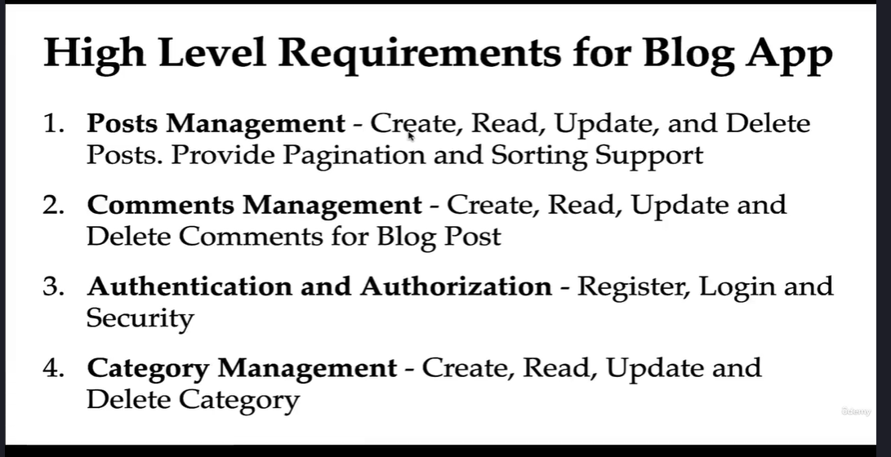
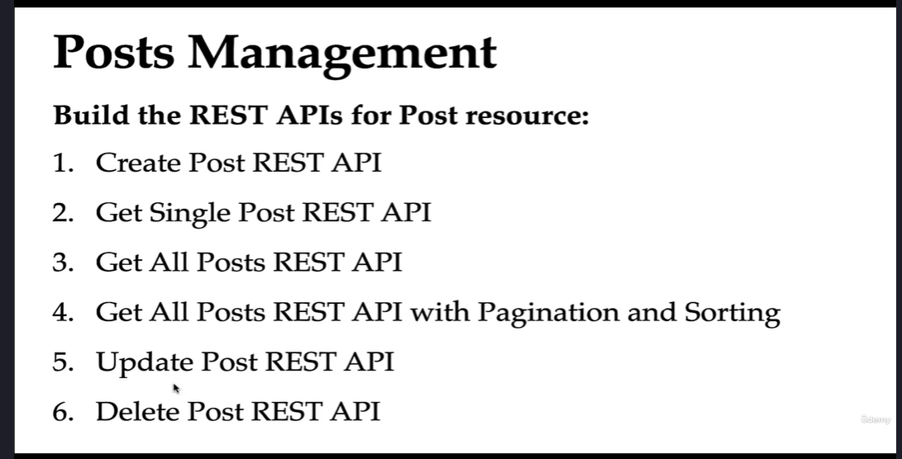
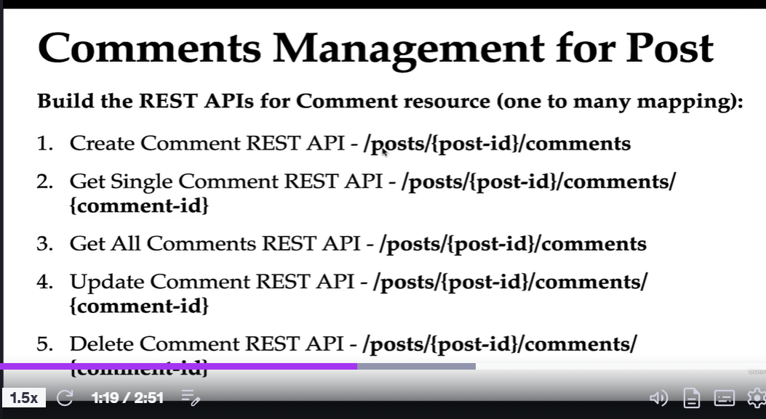
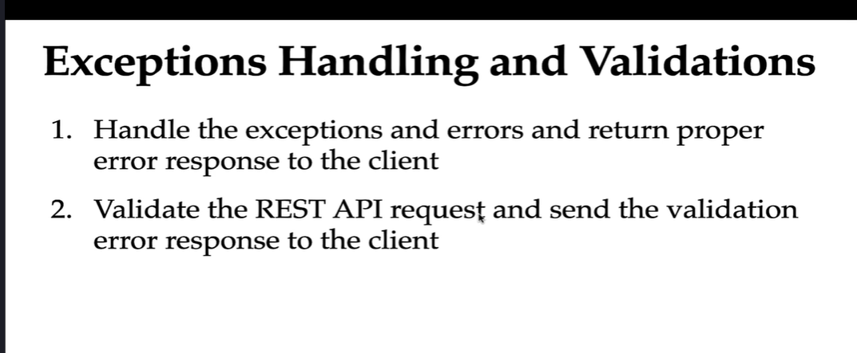
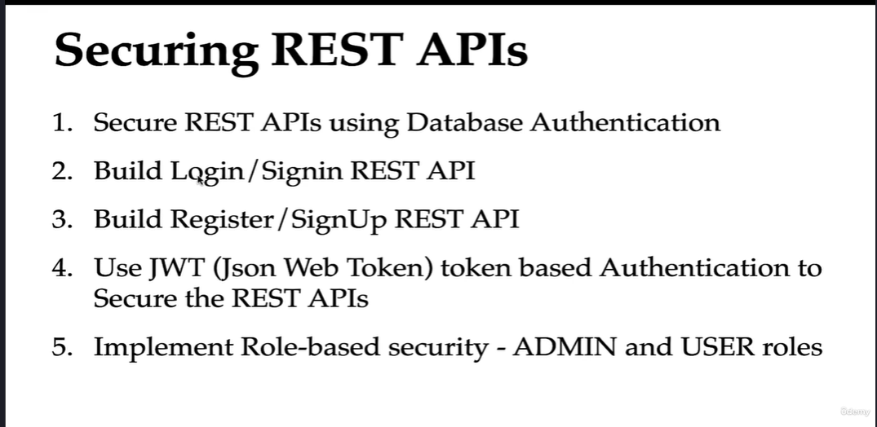

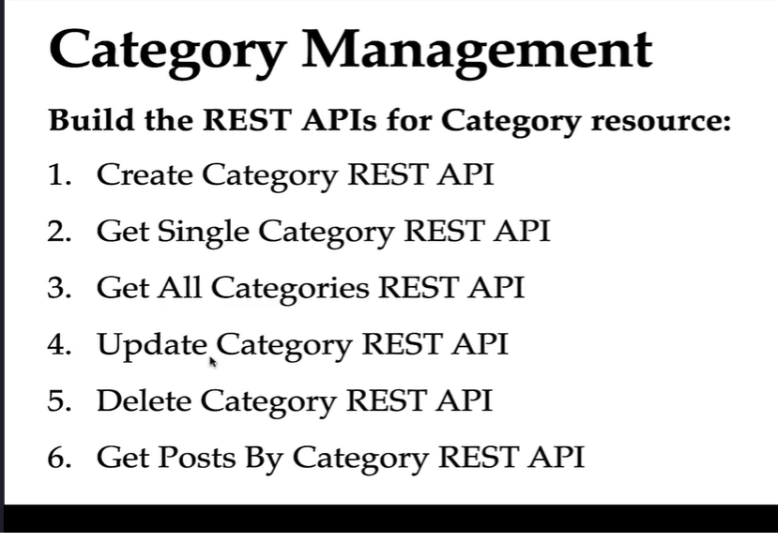
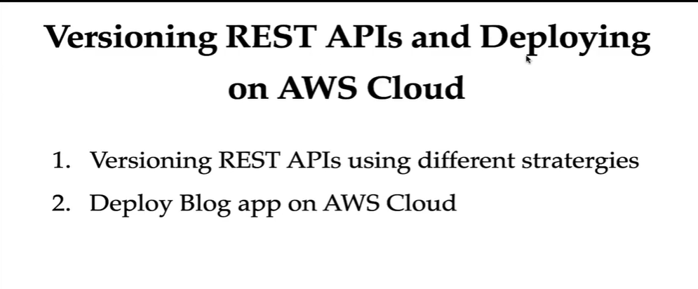
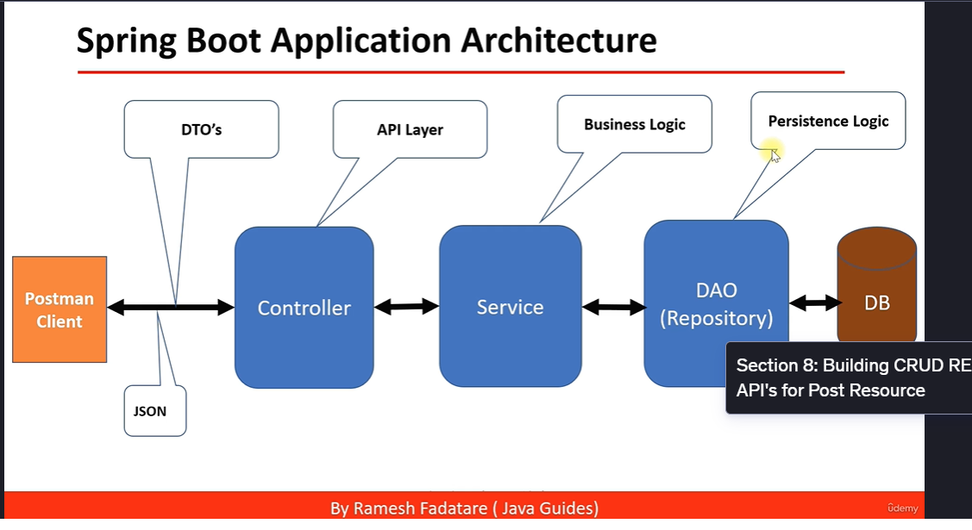
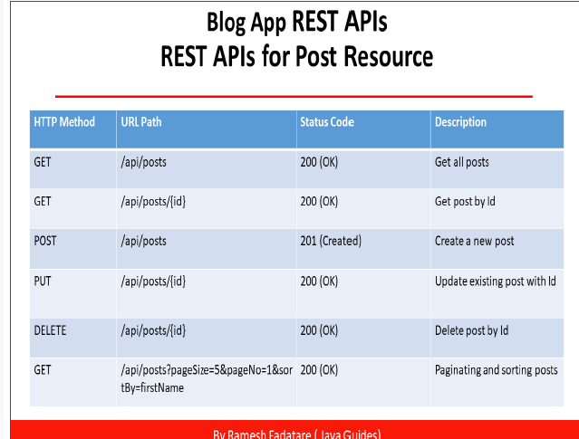
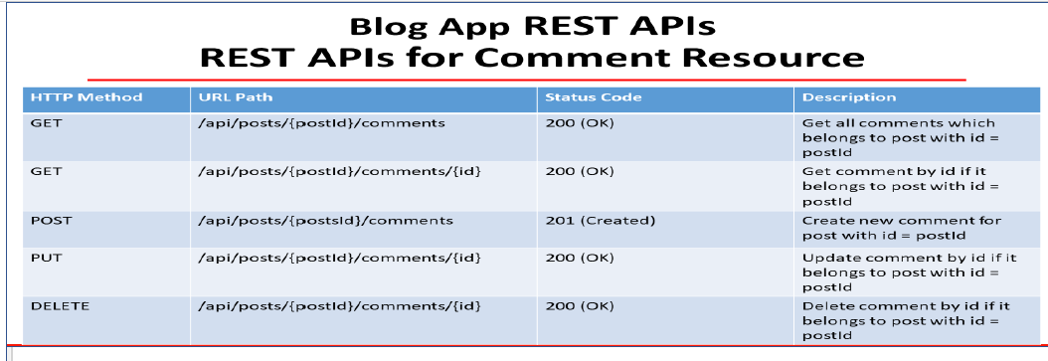
​In the Spring Framework, the @Service annotation is a specialized form of the @Component annotation, used to designate a class as a service within the service layer of an application. This annotation enables Spring to automatically detect and manage the class as a bean through classpath scanning. ​Home+4Medium+4Stack Overflow+4Medium+2Home+2CodeJava+2
Purpose and Usage:
- Semantic Clarification: Applying @Service to a class indicates that it contains business logic or service-related functionality. While it doesn't add additional behavior beyond what @Component provides, using @Service enhances code readability by clearly defining the role of the class within the application architecture. ​Medium
- Automatic Bean Detection: Classes annotated with @Service are automatically detected during Spring's component scanning process. This means Spring will instantiate these classes and manage them as beans within the application context, making them available for dependency injection where needed. ​Baeldung+1Medium+1
Example:
java
CopyEdit
import org.springframework.stereotype.Service;

@Service
public class UserService {

public List<User> getAllUsers() {
// Business logic to retrieve users
}
}
In this example, UserService is marked with @Service, signaling to Spring that it should be treated as a service component and managed accordingly. ​CodeJava
Distinction from Other Stereotype Annotations:
Spring provides several stereotype annotations, each serving a distinct purpose:​
- @Component: A generic stereotype for any Spring-managed component.​Baeldung
- @Service: Specifically indicates that the class holds business logic.​Medium+1Medium+1
- @Repository: Indicates that the class is a Data Access Object (DAO) and provides exception translation for database operations.​Medium
While all these annotations function similarly in terms of component scanning, choosing the appropriate one helps in clearly defining the role and responsibility of the component within the application. ​
Best Practices:
- Annotate Concrete Classes: The @Service annotation should be applied to concrete classes rather than interfaces or abstract classes. Spring's component scanning mechanism detects beans based on concrete class annotations. ​Baeldung+1Reddit+1
- Maintain Layered Architecture: Use @Service to define service layer components, separating business logic from controllers (@Controller) and data access components (@Repository). This separation enhances modularity and maintainability

- Imports:
These lines bring in other classes and interfaces from your project and Spring Framework:
  - Post is an entity class representing a blog post in the database.
  - ResourceNotFoundException is a custom exception used when a requested resource isn’t found.
  - PostDto is a Data Transfer Object that represents post data in a format suitable for communication with clients.
  - PostRepository is an interface extending a Spring Data repository for performing database operations.
  - PostService is the service interface that defines the contract for post-related operations.
  - @Service marks the class as a Spring-managed service component.
  - Other imports include Java utilities and Stream API for working with collections.

2. Class Declaration and Dependency Injection
java
CopyEdit
@Service
public class PostServiceImpl implements PostService {
- @Service Annotation:
Marks this class as a service component in the Spring context. It is discovered during component scanning and indicates that this class contains business logic.
- Class Implementation:
PostServiceImpl implements the PostService interface, meaning it provides concrete implementations for all methods declared in the PostService interface.
java
CopyEdit
private PostRepository postRepository;

// if it has only 1 Constructor we can ommit autowired annotation
public PostServiceImpl(PostRepository postRepository) {
this.postRepository = postRepository;
}
- Field:
postRepository is a dependency that interacts with the database. It is used to perform CRUD operations on Post entities.
- Constructor Injection:
The constructor takes PostRepository as a parameter. Spring automatically injects an instance of PostRepository into this class when it is created. When there’s only one constructor, the @Autowired annotation is optional.

3. Method Implementations

a. createPost Method
java
CopyEdit
@Override
public PostDto createPost(PostDto postDto) {

// convert DTO to entity
Post post = mapToEntity(postDto);
Post newPost = postRepository.save(post);

// convert entity to DTO
PostDto postResponse = mapToDTO(newPost);
return postResponse;
}
- Purpose:
Creates a new blog post.
- Process:
  - Convert DTO to Entity:
The method mapToEntity(postDto) transforms the incoming PostDto (data from the client) into a Post entity that can be persisted in the database.
  - Save to Database:
postRepository.save(post) saves the new Post entity. The save method returns the saved entity, which may include generated fields (like an ID).
  - Convert Entity to DTO:
The saved entity is then converted back into a PostDto using mapToDTO(newPost), preparing it to be sent back to the client.

b. getAllPosts Method
java
CopyEdit
@Override
public List<PostDto> getAllPosts() {
List<Post> posts = postRepository.findAll();
return posts.stream().map(post -> mapToDTO(post)).collect(Collectors.toList());
}
- Purpose:
Retrieves all blog posts.
- Process:
  - Fetch All Posts:
postRepository.findAll() returns a list of all Post entities from the database.
  - Convert Entities to DTOs:
The Stream API is used to iterate over each post and convert it into a PostDto using the mapToDTO method.
  - Collect Results:
The resulting stream is collected into a list of PostDto objects which is returned to the client.

c. getPostById Method
java
CopyEdit
@Override
public PostDto getPostById(long id) {
Post post = postRepository.findById(id)
.orElseThrow(() -> new ResourceNotFoundException("Post", "id", id));
return mapToDTO(post);
}
- Purpose:
Retrieves a single post by its ID.
- Process:
  - Fetch Post by ID:
postRepository.findById(id) returns an Optional<Post>. If the post is not found, orElseThrow triggers a ResourceNotFoundException.
  - Convert to DTO:
If found, the Post entity is converted into a PostDto using mapToDTO and returned.

d. updatePost Method
java
CopyEdit
@Override
public PostDto updatePost(PostDto postDto, long id) {
// get post by id from the database
Post post = postRepository.findById(id)
.orElseThrow(() -> new ResourceNotFoundException("Post", "id", id));

post.setTitle(postDto.getTitle());
post.setDescription(postDto.getDescription());
post.setContent(postDto.getContent());

Post updatedPost = postRepository.save(post);
return mapToDTO(updatedPost);
}
- Purpose:
Updates an existing post.
- Process:
  - Retrieve Existing Post:
Uses findById to get the current post. If not found, throws ResourceNotFoundException.
  - Update Fields:
The post’s title, description, and content are updated with values from the incoming PostDto.
  - Save Updates:
The updated entity is saved back to the database.
  - Convert and Return DTO:
The updated entity is converted to a PostDto and returned.

e. deletePostById Method
java
CopyEdit
@Override
public void deletePostById(long id) {
// get post by id from the database
Post post = postRepository.findById(id)
.orElseThrow(() -> new ResourceNotFoundException("Post", "id", id));
postRepository.delete(post);
}
- Purpose:
Deletes a post by its ID.
- Process:
  - Find Post:
Retrieves the post by ID, throwing an exception if it’s not found.
  - Delete Post:
Calls postRepository.delete(post) to remove the entity from the database.

4. Mapping Helper Methods

a. mapToDTO Method
java
CopyEdit
private PostDto mapToDTO(Post post){
PostDto postDto = new PostDto();
postDto.setId(post.getId());
postDto.setTitle(post.getTitle());
postDto.setDescription(post.getDescription());
postDto.setContent(post.getContent());
return postDto;
}
- Purpose:
Converts a Post entity into a PostDto.
- Process:
A new PostDto is created and its fields are populated with values from the Post entity.

b. mapToEntity Method
java
CopyEdit
private Post mapToEntity(PostDto postDto){
Post post = new Post();
post.setTitle(postDto.getTitle());
post.setDescription(postDto.getDescription());
post.setContent(postDto.getContent());
return post;
}
- Purpose:
Converts a PostDto into a Post entity.
- Process:
A new Post is created and its fields are populated with values from the PostDto. Notice that the ID is not set here, which is typical when creating a new record (the database will usually generate the ID).

Summary
- Service Layer Role:
The PostServiceImpl class contains business logic for managing blog posts. It handles the creation, retrieval, updating, and deletion of posts.
- Repository Interaction:
It uses a PostRepository to interact with the database.
- DTO vs. Entity:
  - Entity (Post): Represents the database model.
  - DTO (PostDto): Represents the data that is transferred between the client and server.
  - Helper methods (mapToDTO and mapToEntity) convert between these two representations.
- Exception Handling:
When a post is not found, the code throws a ResourceNotFoundException to signal an error condition.
This class demonstrates typical patterns in Spring Boot applications, such as dependency injection, exception handling, and the use of DTOs to decouple the internal entity model from the API representation.
The code snippet you mentioned is a common pattern used in Spring Boot applications to handle data conversion between different layers:
java
CopyEdit
// convert DTO to entity
Post post = mapToEntity(postDto);
Post newPost = postRepository.save(post);

// convert entity to DTO
PostDto postResponse = mapToDTO(newPost);
return postResponse;
Let's break down what each part does and why it's important.

Why Convert Between DTO and Entity?

Separation of Concerns:
- DTO (Data Transfer Object):
A DTO is used to encapsulate data that is sent to or received from the client. It typically contains only the fields needed for the API and is designed for communication between the client and server.
- Entity:
An entity represents the data as it is stored in the database. It might include additional information (e.g., auto-generated IDs, timestamps) or relationships that are not necessarily needed by the client.

Process Overview:
- Convert DTO to Entity:
The client sends data in the form of a DTO (postDto). Before saving this data to the database, you convert it into an entity (Post). This is done by the method mapToEntity(postDto).
- Persist the Entity:
Once converted, the entity is saved to the database using the repository (postRepository.save(post)). This operation may add additional information such as a generated ID.
- Convert Entity back to DTO:
After saving, you convert the entity back to a DTO using mapToDTO(newPost). This conversion ensures that the data you return to the client is in the desired format (and does not expose any internal details of the entity).

Explaining the Mapping Methods

1. mapToEntity Method
The purpose of mapToEntity is to take a DTO (which is typically received from the client) and create a new instance of the entity that will be stored in the database. Here's a typical implementation:
java
CopyEdit
private Post mapToEntity(PostDto postDto) {
Post post = new Post();
post.setTitle(postDto.getTitle());
post.setDescription(postDto.getDescription());
post.setContent(postDto.getContent());
return post;
}
- What It Does:
  - Creates a New Entity:
A new Post object is created.
  - Copies Data:
The method copies the title, description, and content from the DTO to the new entity.
  - Excludes Certain Fields:
Notice that fields like id are not set here. This is because when creating a new post, the id is typically generated by the database.
- Why It’s Useful:
This method encapsulates the logic for converting a DTO into an entity, making the code more modular and easier to maintain. If the conversion logic changes later (for example, if you need to transform or validate data), you only need to update this method.

2. mapToDTO Method
The purpose of mapToDTO is to convert an entity into a DTO that can be safely returned to the client. Here's a typical implementation:
java
CopyEdit
private PostDto mapToDTO(Post post) {
PostDto postDto = new PostDto();
postDto.setId(post.getId());
postDto.setTitle(post.getTitle());
postDto.setDescription(post.getDescription());
postDto.setContent(post.getContent());
return postDto;
}
- What It Does:
  - Creates a New DTO:
A new PostDto object is created.
  - Copies Data:
The method copies the id, title, description, and content from the entity to the DTO.
  - Prepares Data for the Client:
The DTO may have fewer fields than the entity or may format data differently to suit the API contract.
- Why It’s Useful:
Converting to a DTO before returning data to the client ensures that you are not exposing any internal representation or unnecessary information. This separation helps maintain a clean API contract.

Summary
- Conversion Process:
  - DTO to Entity: Convert the incoming data (DTO) to the format that the database expects (entity) using mapToEntity().
  - Persist Data: Save the entity to the database.
  - Entity to DTO: Convert the saved entity back into a DTO using mapToDTO() to send a well-structured response back to the client.
- Advantages:
  - Encapsulation: Hides internal data structures and only exposes what’s necessary.
  - Maintainability: Centralizes conversion logic, making the code easier to manage and update.
  - Flexibility: Allows the API layer and the persistence layer to evolve independently.
By following this approach, your application maintains a clear separation between how data is stored in your database and how it is exposed to your API consumers, which is a best practice in modern software development.

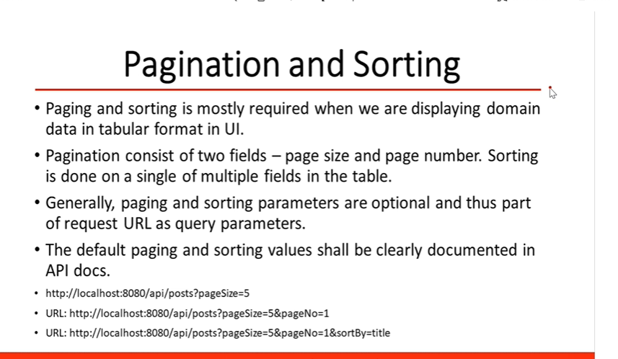
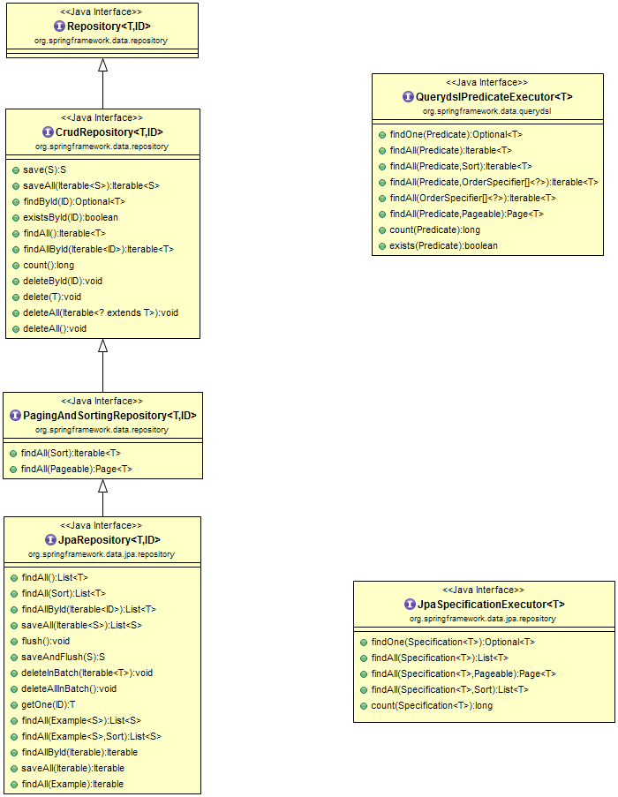

1. Overview
Pagination breaks down a large set of results into smaller, manageable chunks (pages).
Sorting lets you order the results by a specific field (or fields) in ascending or descending order.
Spring Data JPA provides built-in support for both features using the Pageable and Sort interfaces, which can be easily integrated into your repository methods.

2. Repository Setup
To take advantage of pagination and sorting, your repository should extend either PagingAndSortingRepository or JpaRepository (which extends PagingAndSortingRepository).

Example Repository
java
CopyEdit
import com.springboot.blog.entity.Post;
import org.springframework.data.jpa.repository.JpaRepository;
import org.springframework.stereotype.Repository;

@Repository
public interface PostRepository extends JpaRepository<Post, Long> {
// No extra code is needed for basic pagination and sorting
}
With this setup, you can now use methods like findAll(Pageable pageable) which return a Page<Post> object.

3. Service Layer Implementation
In your service layer, you can create a method that takes pagination and sorting parameters from the controller, builds a Pageable object, and uses the repository method to fetch data.

Example Service Method
java
CopyEdit
import com.springboot.blog.entity.Post;
import com.springboot.blog.payload.PostDto;
import com.springboot.blog.payload.PostResponse;
import com.springboot.blog.repository.PostRepository;
import com.springboot.blog.service.PostService;
import org.springframework.beans.factory.annotation.Autowired;
import org.springframework.data.domain.Page;
import org.springframework.data.domain.PageRequest;
import org.springframework.data.domain.Pageable;
import org.springframework.data.domain.Sort;
import org.springframework.stereotype.Service;

import java.util.List;
import java.util.stream.Collectors;

@Service
public class PostServiceImpl implements PostService {

private PostRepository postRepository;

public PostServiceImpl(PostRepository postRepository) {
this.postRepository = postRepository;
}

@Override
public PostResponse getAllPosts(int pageNo, int pageSize, String sortBy, String sortDir) {
// Determine sort direction
Sort sort = sortDir.equalsIgnoreCase(Sort.Direction.ASC.name()) ?
Sort.by(sortBy).ascending() :
Sort.by(sortBy).descending();

// Create Pageable instance
Pageable pageable = PageRequest.of(pageNo, pageSize, sort);

// Fetch paginated data from repository
Page<Post> postsPage = postRepository.findAll(pageable);

// Convert entities to DTOs
List<PostDto> content = postsPage.getContent().stream()
.map(this::mapToDTO)
.collect(Collectors.toList());

// Prepare response with pagination info
PostResponse postResponse = new PostResponse();
postResponse.setContent(content);
postResponse.setPageNo(postsPage.getNumber());
postResponse.setPageSize(postsPage.getSize());
postResponse.setTotalElements(postsPage.getTotalElements());
postResponse.setTotalPages(postsPage.getTotalPages());
postResponse.setLast(postsPage.isLast());

return postResponse;
}

// Mapping methods (similar to what you might already have)
private PostDto mapToDTO(Post post) {
PostDto postDto = new PostDto();
postDto.setId(post.getId());
postDto.setTitle(post.getTitle());
postDto.setDescription(post.getDescription());
postDto.setContent(post.getContent());
return postDto;
}
}

Explanation:
- Sort Creation:
We check the value of sortDir (e.g., "asc" or "desc") to build a Sort object.
- Pageable Creation:
We create a PageRequest with the given pageNo, pageSize, and Sort.
- Fetching Data:
The findAll(pageable) method returns a Page<Post> which includes both the data and metadata (like total pages, total elements, etc.).
- Mapping to DTOs:
We convert the list of Post entities into PostDto objects using Java Streams.
- Packaging Response:
We then prepare a custom response object (PostResponse) that includes the list of posts and pagination metadata.

4. Creating the Response Payload
It’s often useful to wrap your paginated data in a custom response object that includes metadata. For example:

PostResponse Class
java
CopyEdit
package com.springboot.blog.payload;

import java.util.List;

public class PostResponse {
private List<PostDto> content;
private int pageNo;
private int pageSize;
private long totalElements;
private int totalPages;
private boolean last;

// Getters and Setters

public List<PostDto> getContent() {
return content;
}

public void setContent(List<PostDto> content) {
this.content = content;
}

public int getPageNo() {
return pageNo;
}

public void setPageNo(int pageNo) {
this.pageNo = pageNo;
}

public int getPageSize() {
return pageSize;
}

public void setPageSize(int pageSize) {
this.pageSize = pageSize;
}

public long getTotalElements() {
return totalElements;
}

public void setTotalElements(long totalElements) {
this.totalElements = totalElements;
}

public int getTotalPages() {
return totalPages;
}

public void setTotalPages(int totalPages) {
this.totalPages = totalPages;
}

public boolean isLast() {
return last;
}

public void setLast(boolean last) {
this.last = last;
}
}
This class holds the list of posts along with additional pagination details.

5. Controller Layer
Your controller will receive pagination and sorting parameters from the client via query parameters and pass them to the service.

Example Controller Method
java
CopyEdit
import com.springboot.blog.payload.PostResponse;
import com.springboot.blog.service.PostService;
import org.springframework.web.bind.annotation.GetMapping;
import org.springframework.web.bind.annotation.RequestParam;
import org.springframework.web.bind.annotation.RestController;

@RestController
public class PostController {

private PostService postService;

public PostController(PostService postService) {
this.postService = postService;
}

@GetMapping("/api/posts")
public PostResponse getAllPosts(
@RequestParam(value = "pageNo", defaultValue = "0", required = false) int pageNo,
@RequestParam(value = "pageSize", defaultValue = "10", required = false) int pageSize,
@RequestParam(value = "sortBy", defaultValue = "id", required = false) String sortBy,
@RequestParam(value = "sortDir", defaultValue = "asc", required = false) String sortDir) {
return postService.getAllPosts(pageNo, pageSize, sortBy, sortDir);
}
}

Explanation:
- Query Parameters:
The method accepts parameters for page number (pageNo), page size (pageSize), sort field (sortBy), and sort direction (sortDir). Default values are provided if these parameters aren’t included in the request.
- Service Call:
These parameters are passed to the service method, which returns a PostResponse containing the paginated and sorted results.

6. How It Works in Practice
When you make a request like:
sql
CopyEdit
GET /api/posts?pageNo=1&pageSize=5&sortBy=title&sortDir=desc
- Pagination:
The API returns the second page (page index 1, as pagination is zero-indexed) containing 5 posts per page.
- Sorting:
The posts are sorted by the title field in descending order.
- Response:
The client receives a JSON response with the list of posts along with metadata such as total pages and total elements.

7. Summary
- Repository:
Extend JpaRepository to inherit pagination and sorting methods.
- Service:
Create methods that build Pageable objects and use repository methods to fetch a Page of data. Convert entities to DTOs and package them with pagination metadata.
- Controller:
Accept query parameters for pagination and sorting, then forward them to the service layer.
- Response Payload:
Use a custom response class (like PostResponse) to return both the data and the metadata needed for pagination.
This approach provides a robust and scalable way to handle large datasets, making your API more efficient and user-friendly.
Comments
- Entities (Comment, Post) → Represent the database tables for Comment and Post.
- Custom Exceptions (BlogAPIException, ResourceNotFoundException) → Handle API errors.
- DTO (CommentDto) → Used to transfer data.
- Repositories (CommentRepository, PostRepository) → Interfaces that interact with the database.
- ModelMapper → Converts between Entity and DTO.
- Service annotation (@Service) → Marks this class as a service in Spring.

2. Class Declaration and Dependencies
java
CopyEdit
@Service
public class CommentServiceImpl implements CommentService {
- @Service → This class is a Spring-managed service component.
- implements CommentService → Implements the CommentService interface, which defines the methods this service must provide.

Constructor-Based Dependency Injection
java
CopyEdit
private CommentRepository commentRepository;
private PostRepository postRepository;
private ModelMapper mapper;

public CommentServiceImpl(CommentRepository commentRepository, PostRepository postRepository, ModelMapper mapper) {
this.commentRepository = commentRepository;
this.postRepository = postRepository;
this.mapper = mapper;
}
- CommentRepository → Used to interact with the comments table.
- PostRepository → Used to fetch Post data.
- ModelMapper → Maps between Comment entity and CommentDto.

3. CRUD Methods for Comments

(A) Create a Comment
java
CopyEdit
@Override
public CommentDto createComment(long postId, CommentDto commentDto) {
Comment comment = mapToEntity(commentDto);

// Retrieve post entity by id
Post post = postRepository.findById(postId).orElseThrow(
() -> new ResourceNotFoundException("Post", "id", postId));

// Associate comment with post
comment.setPost(post);

// Save comment in DB
Comment newComment = commentRepository.save(comment);

return mapToDTO(newComment);
}

How It Works
- Convert commentDto (DTO) to a Comment entity.
- Retrieve the Post using postId:
  - If the post does not exist, throw a ResourceNotFoundException.
- Set the Post object in the Comment entity to establish the relationship.
- Save the comment in the database.
- Convert the saved comment back to CommentDto and return it.

(B) Retrieve Comments for a Post
java
CopyEdit
@Override
public List<CommentDto> getCommentsByPostId(long postId) {
// Retrieve comments by postId
List<Comment> comments = commentRepository.findByPostId(postId);

// Convert list of comment entities to list of comment DTOs
return comments.stream().map(comment -> mapToDTO(comment)).collect(Collectors.toList());
}

How It Works
- Fetch all comments for the given postId.
- Convert each Comment entity to CommentDto using mapToDTO.
- Return the list of CommentDto objects.

(C) Retrieve a Single Comment
java
CopyEdit
@Override
public CommentDto getCommentById(Long postId, Long commentId) {
// Retrieve post entity by id
Post post = postRepository.findById(postId).orElseThrow(
() -> new ResourceNotFoundException("Post", "id", postId));

// Retrieve comment by id
Comment comment = commentRepository.findById(commentId).orElseThrow(() ->
new ResourceNotFoundException("Comment", "id", commentId));

if(!comment.getPost().getId().equals(post.getId())){
throw new BlogAPIException(HttpStatus.BAD_REQUEST, "Comment does not belong to post");
}

return mapToDTO(comment);
}

How It Works
- Fetch the Post by postId.
- Fetch the Comment by commentId.
- Ensure the Comment belongs to the correct Post, otherwise throw BlogAPIException.
- Convert Comment to CommentDto and return.

(D) Update a Comment
java
CopyEdit
@Override
public CommentDto updateComment(Long postId, long commentId, CommentDto commentRequest) {
// Retrieve post entity by id
Post post = postRepository.findById(postId).orElseThrow(
() -> new ResourceNotFoundException("Post", "id", postId));

// Retrieve comment by id
Comment comment = commentRepository.findById(commentId).orElseThrow(() ->
new ResourceNotFoundException("Comment", "id", commentId));

if(!comment.getPost().getId().equals(post.getId())){
throw new BlogAPIException(HttpStatus.BAD_REQUEST, "Comment does not belong to post");
}

// Update comment details
comment.setName(commentRequest.getName());
comment.setEmail(commentRequest.getEmail());
comment.setBody(commentRequest.getBody());

// Save updated comment
Comment updatedComment = commentRepository.save(comment);
return mapToDTO(updatedComment);
}

How It Works
- Validate if the Post exists.
- Validate if the Comment exists.
- Check if the comment belongs to the correct post.
- Update the name, email, and body fields.
- Save the updated comment.
- Convert it to CommentDto and return.

(E) Delete a Comment
java
CopyEdit
@Override
public void deleteComment(Long postId, Long commentId) {
// Retrieve post entity by id
Post post = postRepository.findById(postId).orElseThrow(
() -> new ResourceNotFoundException("Post", "id", postId));

// Retrieve comment by id
Comment comment = commentRepository.findById(commentId).orElseThrow(() ->
new ResourceNotFoundException("Comment", "id", commentId));

if(!comment.getPost().getId().equals(post.getId())){
throw new BlogAPIException(HttpStatus.BAD_REQUEST, "Comment does not belong to post");
}

commentRepository.delete(comment);
}

How It Works
- Fetch the Post to ensure it exists.
- Fetch the Comment to ensure it exists.
- Validate if the comment belongs to the given post.
- Delete the comment.

4. Utility Methods for Mapping Between DTO and Entity

(A) Convert Entity to DTO
java
CopyEdit
private CommentDto mapToDTO(Comment comment){
return mapper.map(comment, CommentDto.class);
}
- Uses ModelMapper to map Comment entity to CommentDto.

(B) Convert DTO to Entity
java
CopyEdit
private Comment mapToEntity(CommentDto commentDto){
return mapper.map(commentDto, Comment.class);
}
- Uses ModelMapper to map CommentDto to Comment entity.

Summary

Main Features
✅ Create, Read, Update, and Delete (CRUD) operations for comments
✅ Each comment is associated with a post
✅ Uses DTOs to transfer data
✅ Ensures data integrity by verifying post-comment relationships
✅ Handles errors using ResourceNotFoundException and BlogAPIException
✅ Uses ModelMapper for entity-DTO conversion
REST API Validation in Spring Boot
​Validating RESTful APIs in Spring Boot is essential to ensure that incoming data meets the application's requirements, thereby maintaining data integrity and providing meaningful feedback to clients. Spring Boot leverages the Bean Validation API (JSR 380) and its reference implementation, Hibernate Validator, to facilitate this process. ​HowToDoInJava+4Baeldung+4CodeJava+4
1. Setting Up Validation Dependencies
To enable validation in a Spring Boot project, include the necessary dependencies in your pom.xml:​
xml
CopyEdit
<dependency>
<groupId>org.springframework.boot</groupId>
<artifactId>spring-boot-starter-web</artifactId>
</dependency>
<dependency>
<groupId>org.springframework.boot</groupId>
<artifactId>spring-boot-starter-validation</artifactId>
</dependency>
The spring-boot-starter-validation dependency provides the Hibernate Validator, which is the reference implementation of the Bean Validation API. ​Spring Boot Tutorial+3Baeldung+3CodeJava+3
2. Applying Validation Annotations
You can apply validation constraints directly to your model or DTO (Data Transfer Object) classes using annotations from the javax.validation.constraints package. For example:​
java
CopyEdit
import javax.validation.constraints.*;

public class UserDTO {

@NotBlank(message = "Name is mandatory")
@Size(min = 3, max = 50, message = "Name must be between 3 and 50 characters")
private String name;

@NotBlank(message = "Email is mandatory")
@Email(message = "Email should be valid")
private String email;

// Getters and setters
}
In this example, @NotBlank ensures the field is not null and contains at least one non-whitespace character, @Size restricts the length of the string, and @Email validates the email format. ​HowToDoInJava+1Baeldung+1
3. Validating Request Bodies in Controllers
To validate the request body of incoming HTTP requests, use the @Valid annotation in your controller methods:​HowToDoInJava
java
CopyEdit
import org.springframework.http.ResponseEntity;
import org.springframework.web.bind.annotation.*;

import javax.validation.Valid;

@RestController
@RequestMapping("/users")
public class UserController {

@PostMapping
public ResponseEntity<String> createUser(@Valid @RequestBody UserDTO userDTO) {
// Process the valid userDTO
return ResponseEntity.ok("User is valid");
}
}
Here, @Valid triggers the validation of the UserDTO object. If validation fails, a MethodArgumentNotValidException is thrown. ​HowToDoInJava+3Baeldung+3Medium+3
4. Handling Validation Exceptions
By default, Spring Boot returns a generic error response when validation fails. To customize this response, you can implement an exception handler:​
java
CopyEdit
import org.springframework.http.HttpStatus;
import org.springframework.http.ResponseEntity;
import org.springframework.web.bind.MethodArgumentNotValidException;
import org.springframework.web.bind.annotation.ExceptionHandler;
import org.springframework.web.bind.annotation.RestControllerAdvice;

import java.util.HashMap;
import java.util.Map;

@RestControllerAdvice
public class GlobalExceptionHandler {

@ExceptionHandler(MethodArgumentNotValidException.class)
public ResponseEntity<Map<String, String>> handleValidationExceptions(
MethodArgumentNotValidException ex) {
Map<String, String> errors = new HashMap<>();
ex.getBindingResult().getFieldErrors().forEach((error) -> {
errors.put(error.getField(), error.getDefaultMessage());
});
return new ResponseEntity<>(errors, HttpStatus.BAD_REQUEST);
}
}
This handler captures validation exceptions and returns a map of field errors with corresponding messages, providing clear feedback to clients. ​
5. Validating Path Variables and Query Parameters
For path variables and query parameters, you can apply validation annotations in a similar manner:​CodeJava
java
CopyEdit
import javax.validation.constraints.*;

@RestController
@RequestMapping("/products")
@Validated
public class ProductController {

@GetMapping("/{id}")
public ResponseEntity<String> getProduct(
@PathVariable @Positive(message = "ID must be positive") Long id) {
// Retrieve and return the product
return ResponseEntity.ok("Product retrieved");
}

@GetMapping
public ResponseEntity<String> getProductsByCategory(
@RequestParam @NotBlank(message = "Category is mandatory") String category) {
// Retrieve and return products by category
return ResponseEntity.ok("Products retrieved");
}
}
Note the use of @Validated at the class level to enable validation for path variables and query parameters. ​
6. Custom Validation Constraints
For more complex validation scenarios, you can create custom constraints:​
java
CopyEdit
import javax.validation.Constraint;
import javax.validation.Payload;
import java.lang.annotation.*;

@Documented
@Constraint(validatedBy = AdultValidator.class)
@Target({ElementType.FIELD})
@Retention(RetentionPolicy.RUNTIME)
public @interface Adult {
String message() default "Must be 18 or older";
Class<?>[] groups() default {};
Class<? extends Payload>[] payload() default {};
}
And the corresponding validator:​
java
CopyEdit
import javax.validation.ConstraintValidator;
import javax.validation.ConstraintValidatorContext;
import java.time.LocalDate;
import java.time.Period;

public class AdultValidator implements ConstraintValidator<Adult, LocalDate> {

@Override
public boolean isValid(LocalDate birthDate, ConstraintValidatorContext context) {
return birthDate != null && Period.between(birthDate, LocalDate.now()).getYears() >= 18;
}
}
Then, apply the custom constraint to a field:​
java
CopyEdit
public class PersonDTO {

@Adult
private LocalDate birthDate;

// Other fields, getters, and setters
}
This setup ensures that the birthDate field represents an individual who is at least 18 years old. ​Baeldung
7. Best Practices for Validation
- Validate at Multiple Layers: Perform validation at the DTO, entity, and database levels to ensure data integrity throughout the application.
- Important Validation Annotations in Spring Boot (JSR 380 - Bean Validation API)
- Spring Boot supports JSR 380 (Bean Validation 2.0), and the Hibernate Validator is its reference implementation. Below are some of the most important validation annotations categorized by their functionality:

- 1. Generic Constraints
- These annotations are used to validate the presence or format of values.
Annotation | Description
@NotNull | Field cannot be null, but can be empty (for Strings, Collections, etc.).
@NotEmpty | Field cannot be null and must contain at least one character (for Strings) or element (for Collections).
@NotBlank | Field cannot be null, empty, or only whitespace (for Strings).
@Size(min, max) | Defines minimum and maximum length for a String, Collection, or array.
@Pattern(regexp) | Validates a field using a regular expression (regex).
@Email | Ensures a valid email format.
@Digits(integer, fraction) | Ensures a number has a limited number of integer and fraction digits.
- Example
- java
- CopyEdit
- public class UserDTO {
- @NotNull(message = "Username cannot be null")
- @NotBlank(message = "Username cannot be blank")
- @Size(min = 3, max = 20, message = "Username must be between 3 and 20 characters")
- private String username;

- @NotEmpty(message = "Password cannot be empty")
- @Size(min = 6, message = "Password must be at least 6 characters")
- private String password;

- @Email(message = "Invalid email format")
- private String email;
- }

- 2. Numeric Constraints
- These annotations are used to validate numerical fields.
Annotation | Description
@Min(value) | Ensures a number is greater than or equal to a given value.
@Max(value) | Ensures a number is less than or equal to a given value.
@Positive | Ensures a number is strictly positive (> 0).
@PositiveOrZero | Ensures a number is positive or zero (>= 0).
@Negative | Ensures a number is strictly negative (< 0).
@NegativeOrZero | Ensures a number is negative or zero (<= 0).
- Example
- java
- CopyEdit
- public class ProductDTO {
- @Min(value = 1, message = "Price must be at least 1")
- private double price;

- @Positive(message = "Stock must be a positive number")
- private int stockQuantity;
- }

- 3. Date Constraints
- These annotations validate date and time fields.
Annotation | Description
@Future | Ensures a date is in the future.
@FutureOrPresent | Ensures a date is today or in the future.
@Past | Ensures a date is in the past.
@PastOrPresent | Ensures a date is today or in the past.
- Example
- java
- CopyEdit
- import java.time.LocalDate;
- import javax.validation.constraints.Future;
- import javax.validation.constraints.Past;

- public class EventDTO {
- @Future(message = "Event date must be in the future")
- private LocalDate eventDate;

- @Past(message = "Creation date must be in the past")
- private LocalDate createdAt;
- }

- 4. Object-Level Constraints
- These are applied at the class level when multiple fields need to be validated together.
Annotation | Description
@Valid | Ensures nested objects are also validated.
@AssertTrue | Ensures a boolean field is true.
@AssertFalse | Ensures a boolean field is false.
- Example
- java
- CopyEdit
- public class RegistrationDTO {
- private String password;
- private String confirmPassword;

- @AssertTrue(message = "Passwords must match")
- public boolean isPasswordMatching() {
- return password != null && password.equals(confirmPassword);
- }
- }

- 5. Custom Validation Using @Constraint
- For complex validation logic, you can create custom validation annotations.
- Step 1: Create a Custom Annotation
- java
- CopyEdit
- import javax.validation.Constraint;
- import javax.validation.Payload;
- import java.lang.annotation.*;

- @Documented
- @Constraint(validatedBy = AdultValidator.class)
- @Target(ElementType.FIELD)
- @Retention(RetentionPolicy.RUNTIME)
- public @interface Adult {
- String message() default "Age must be 18 or older";
- Class<?>[] groups() default {};
- Class<? extends Payload>[] payload() default {};
- }
- Step 2: Implement the Validator
- java
- CopyEdit
- import javax.validation.ConstraintValidator;
- import javax.validation.ConstraintValidatorContext;

- public class AdultValidator implements ConstraintValidator<Adult, Integer> {
- @Override
- public boolean isValid(Integer age, ConstraintValidatorContext context) {
- return age != null && age >= 18;
- }
- }
- Step 3: Apply the Custom Annotation
- java
- CopyEdit
- public class PersonDTO {
- @Adult
- private Integer age;
- }

- 6. Exception Handling for Validation
- Spring Boot provides built-in exception handling for validation failures using @Valid. However, you can customize error responses using @ExceptionHandler.
- Global Exception Handler
- java
- CopyEdit
- import org.springframework.http.HttpStatus;
- import org.springframework.http.ResponseEntity;
- import org.springframework.web.bind.MethodArgumentNotValidException;
- import org.springframework.web.bind.annotation.ExceptionHandler;
- import org.springframework.web.bind.annotation.RestControllerAdvice;

- import java.util.HashMap;
- import java.util.Map;

- @RestControllerAdvice
- public class GlobalExceptionHandler {

- @ExceptionHandler(MethodArgumentNotValidException.class)
- public ResponseEntity<Map<String, String>> handleValidationExceptions(MethodArgumentNotValidException ex) {
- Map<String, String> errors = new HashMap<>();
- ex.getBindingResult().getFieldErrors().forEach((error) -> {
- errors.put(error.getField(), error.getDefaultMessage());
- });
- return new ResponseEntity<>(errors, HttpStatus.BAD_REQUEST);
- }
- }

- 7. Validating Path Variables and Query Parameters
- Spring Boot allows validating request parameters and path variables.
- Validating Path Variables
- java
- CopyEdit
- import org.springframework.web.bind.annotation.*;

- import javax.validation.constraints.Positive;
- import javax.validation.constraints.Size;

- @RestController
- @RequestMapping("/users")
- @Validated // Required for validating method parameters
- public class UserController {

- @GetMapping("/{id}")
- public String getUserById(@PathVariable @Positive(message = "ID must be positive") Long id) {
- return "User with ID: " + id;
- }
- }
- Validating Query Parameters
- java
- CopyEdit
- @GetMapping
- public String getUsersByDepartment(@RequestParam @NotBlank(message = "Department is required") String department) {
- return "Users from department: " + department;
- }

- Summary
Annotation | Description
@NotNull, @NotBlank, @NotEmpty | Ensures a field is not null or empty.
@Size(min, max), @Pattern(regexp), @Email | Ensures a field has valid content.
@Min, @Max, @Positive, @Negative | Validates numerical fields.
@Future, @Past, @FutureOrPresent, @PastOrPresent | Validates date fields.
@Valid, @AssertTrue, @AssertFalse | Object-level constraints.
@Constraint(validatedBy = ...) | Custom validation.

Now we will be Adding Spring Security to our RESTAPI BlogAppp
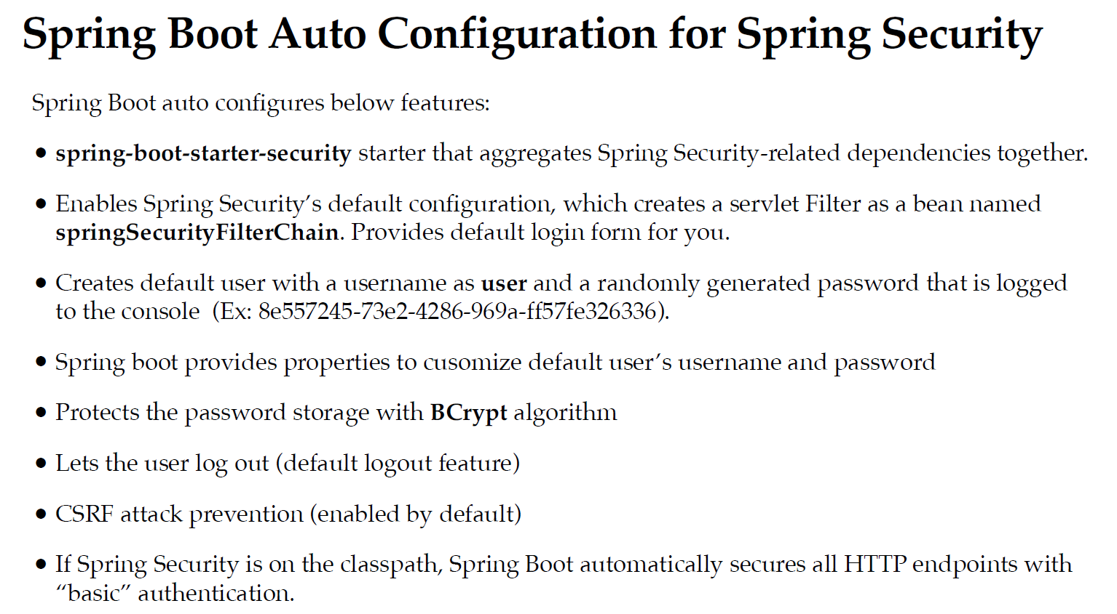
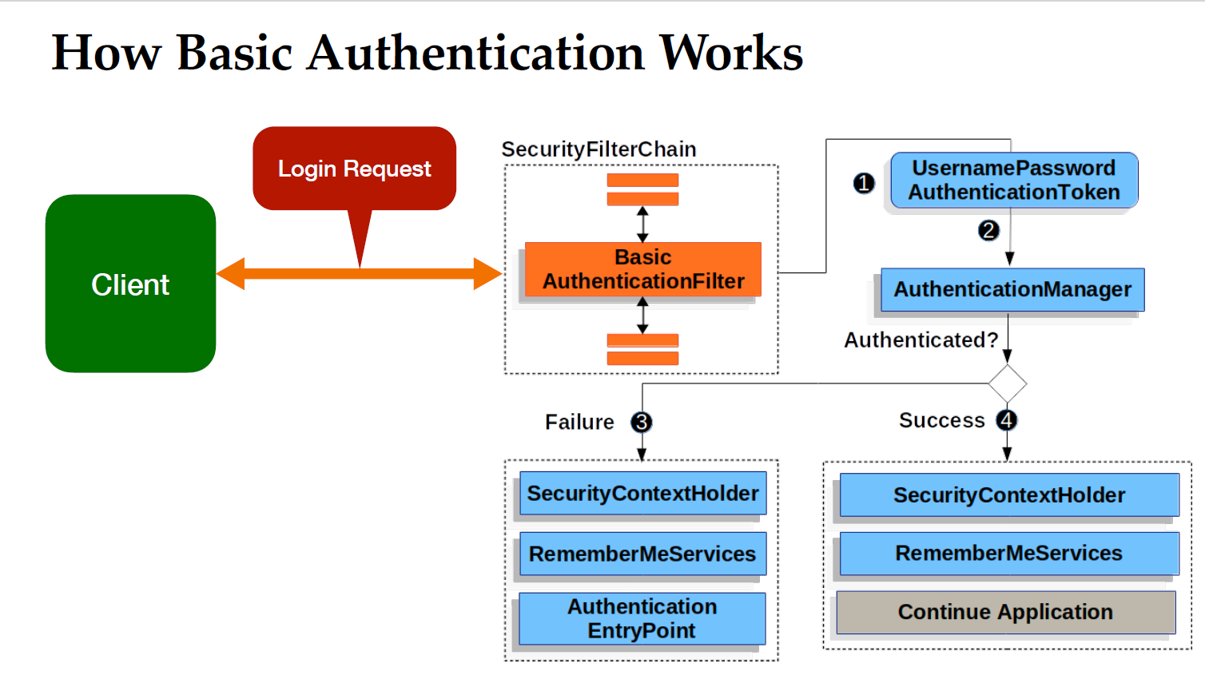
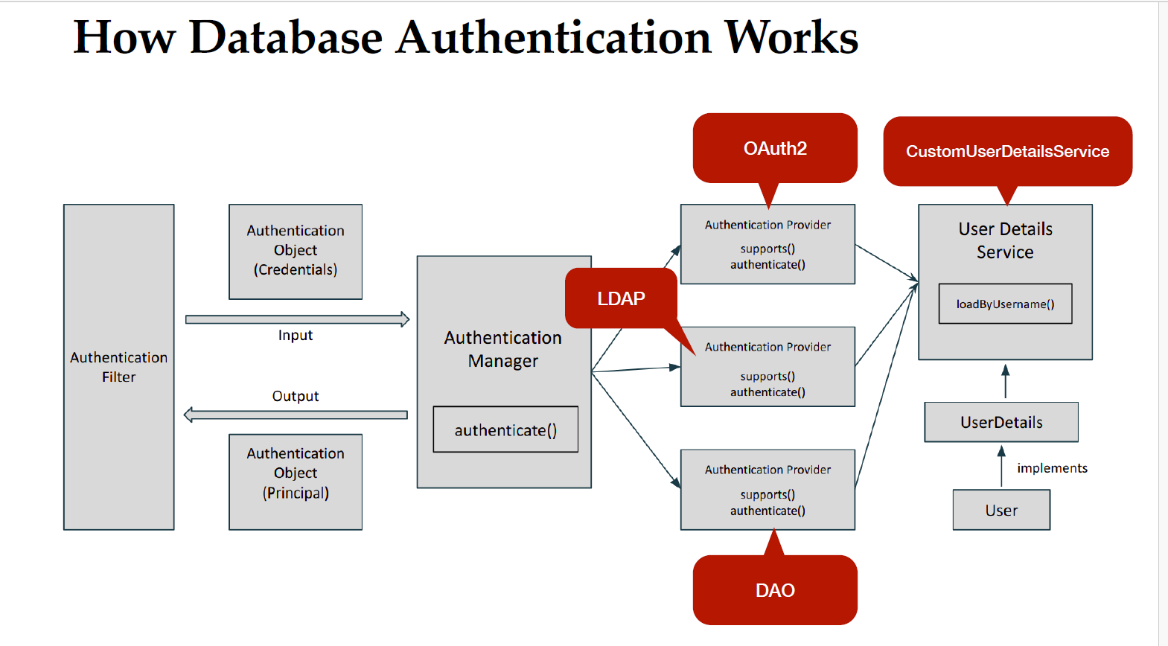
AuthenticationManager class in java

AuthenticationManager in Java (Spring Security) – Beginner to Pro

🔹 Introduction
In Spring Security, the AuthenticationManager is a core interface responsible for handling authentication requests. It validates user credentials and returns an authenticated user object upon successful authentication.
📌 Key Responsibilities:
- Accepts an Authentication request (such as username and password).
- Verifies credentials using an AuthenticationProvider.
- Returns a fully authenticated Authentication object if credentials are valid.
- Throws an exception (AuthenticationException) if authentication fails.

🔹 Authentication Flow in Spring Security
When a user logs in, Spring Security follows this authentication flow:
- User submits login credentials (e.g., username & password).
- Spring Security filters intercept the request.
- AuthenticationManager delegates authentication to an AuthenticationProvider.
- AuthenticationProvider validates the credentials.
- If successful, the user is authenticated and assigned a security context.
- If authentication fails, an AuthenticationException is thrown.

📌 SECTION 1: AuthenticationManager Interface

1️⃣ What is AuthenticationManager?
AuthenticationManager is a functional interface in Spring Security that processes authentication requests.
🔹 Declaration of AuthenticationManager:
java
CopyEdit
public interface AuthenticationManager {
Authentication authenticate(Authentication authentication) throws AuthenticationException;
}

✔️ authenticate() Method
- Accepts an Authentication request.
- Validates the credentials.
- Returns an authenticated Authentication object.
- Throws an AuthenticationException if authentication fails.

Example: Basic Custom AuthenticationManager
java
CopyEdit
public class CustomAuthenticationManager implements AuthenticationManager {

@Override
public Authentication authenticate(Authentication authentication) throws AuthenticationException {
String username = authentication.getName();
String password = authentication.getCredentials().toString();

// Simple authentication logic
if ("admin".equals(username) && "password".equals(password)) {
return new UsernamePasswordAuthenticationToken(username, password, new ArrayList<>());
} else {
throw new BadCredentialsException("Invalid username or password");
}
}
}
✅ Here, if the username is "admin" and password is "password", authentication succeeds.

📌 SECTION 2: How AuthenticationManager Works in Spring Security

1️⃣ AuthenticationManager in Default Spring Security Setup
Spring Security automatically provides a default AuthenticationManager when using form-based login or HTTP Basic Authentication.
📌 Example: How Spring Security Handles Authentication
java
CopyEdit
@Configuration
@EnableWebSecurity
public class SecurityConfig {

@Bean
public SecurityFilterChain securityFilterChain(HttpSecurity http) throws Exception {
http
.authorizeHttpRequests(auth -> auth
.requestMatchers("/admin").hasRole("ADMIN")
.anyRequest().authenticated()
)
.formLogin(Customizer.withDefaults()); // Enables login form authentication
return http.build();
}
}
✅ Spring Security internally configures an AuthenticationManager.

📌 SECTION 3: Custom AuthenticationManager Implementation

1️⃣ Using AuthenticationManager with AuthenticationProvider
Instead of implementing AuthenticationManager directly, we use AuthenticationProvider, which Spring Security internally supports.

✔️ Custom AuthenticationProvider
java
CopyEdit
@Component
public class CustomAuthenticationProvider implements AuthenticationProvider {

@Override
public Authentication authenticate(Authentication authentication) throws AuthenticationException {
String username = authentication.getName();
String password = authentication.getCredentials().toString();

if ("user".equals(username) && "pass123".equals(password)) {
return new UsernamePasswordAuthenticationToken(username, password, Collections.emptyList());
} else {
throw new BadCredentialsException("Invalid Credentials");
}
}

@Override
public boolean supports(Class<?> authentication) {
return authentication.equals(UsernamePasswordAuthenticationToken.class);
}
}
✅ This class validates the username & password and returns a successful authentication if credentials match.

📌 SECTION 4: Configuring AuthenticationManager in Spring Boot

1️⃣ Defining a Custom AuthenticationManager Bean
We can manually define an AuthenticationManager and use it across the application.
java
CopyEdit
@Configuration
@EnableWebSecurity
public class SecurityConfig {

@Bean
public AuthenticationManager authenticationManager(CustomAuthenticationProvider customAuthProvider) {
return new ProviderManager(Collections.singletonList(customAuthProvider));
}

@Bean
public SecurityFilterChain securityFilterChain(HttpSecurity http) throws Exception {
http
.authorizeHttpRequests(auth -> auth
.anyRequest().authenticated()
)
.formLogin(Customizer.withDefaults());
return http.build();
}
}
✅ Here, we create an AuthenticationManager bean that uses our custom AuthenticationProvider.

📌 SECTION 5: Advanced Authentication Scenarios

1️⃣ AuthenticationManager with Multiple Providers
We can use multiple AuthenticationProvider implementations for different authentication strategies, such as:
- Database authentication
- LDAP authentication
- OAuth2 authentication

✔️ Configuring Multiple Authentication Providers
java
CopyEdit
@Bean
public AuthenticationManager authenticationManager(
CustomAuthenticationProvider customProvider,
DaoAuthenticationProvider daoProvider) {
return new ProviderManager(Arrays.asList(customProvider, daoProvider));
}
✅ Here, Spring Security will check both providers for authentication.

📌 SECTION 6: Authenticating Users with Database (JDBC)
Instead of hardcoding users, we use a database for authentication.

1️⃣ Add Spring Security & JPA Dependencies
xml
CopyEdit
<dependency>
<groupId>org.springframework.boot</groupId>
<artifactId>spring-boot-starter-security</artifactId>
</dependency>
<dependency>
<groupId>org.springframework.boot</groupId>
<artifactId>spring-boot-starter-data-jpa</artifactId>
</dependency>
<dependency>
<groupId>com.h2database</groupId>
<artifactId>h2</artifactId>
<scope>runtime</scope>
</dependency>

2️⃣ Define a User Entity
java
CopyEdit
@Entity
@Table(name = "users")
public class User {
@Id @GeneratedValue(strategy = GenerationType.IDENTITY)
private Long id;
private String username;
private String password;
private String role;
}

3️⃣ Create a UserDetailsService for Authentication
java
CopyEdit
@Service
public class CustomUserDetailsService implements UserDetailsService {

@Autowired private UserRepository userRepository;

@Override
public UserDetails loadUserByUsername(String username) throws UsernameNotFoundException {
User user = userRepository.findByUsername(username)
.orElseThrow(() -> new UsernameNotFoundException("User not found"));

return new org.springframework.security.core.userdetails.User(
user.getUsername(), user.getPassword(), Collections.singleton(new SimpleGrantedAuthority(user.getRole())));
}
}

4️⃣ Configure AuthenticationManager with Database
java
CopyEdit
@Bean
public AuthenticationManager authenticationManager(
UserDetailsService userDetailsService, PasswordEncoder passwordEncoder) {
DaoAuthenticationProvider authProvider = new DaoAuthenticationProvider();
authProvider.setUserDetailsService(userDetailsService);
authProvider.setPasswordEncoder(passwordEncoder);
return new ProviderManager(Collections.singletonList(authProvider));
}
✅ This setup authenticates users from the database.

📌 SECTION 7: Best Practices
Best Practice | Why?
Use AuthenticationProvider instead of directly implementing AuthenticationManager | Better modularity
Use BCryptPasswordEncoder for password hashing | Increases security
Enable CSRF protection | Prevents cross-site request forgery attacks
Use OAuth2 for token-based authentication | More scalable authentication
Log authentication attempts | Helps in auditing and security

🔹 Conclusion
✅ Beginner → Understood AuthenticationManager basics.
✅ Intermediate → Implemented custom authentication.
✅ Advanced → Used database authentication and multiple providers.
OAuth and OAuth2.0 in Details

OAuth & OAuth 2.0 – Beginner to Pro Guide

🔹 Introduction
OAuth (Open Authorization) is an industry-standard authorization protocol that enables secure access to resources without exposing user credentials. It allows third-party applications to request limited access to a user’s data without requiring the user’s password.
- OAuth 1.0: The original version of OAuth, complex and required cryptographic signatures.
- OAuth 2.0: A more flexible, secure, and modern version that simplifies authentication and authorization.

📌 SECTION 1: What is OAuth?

1️⃣ OAuth Definition
OAuth is a framework that allows an application (client) to access a user’s resources (such as Google Drive, GitHub, etc.) on behalf of the user without sharing passwords.

2️⃣ Why Use OAuth?
✅ Security – No need to share passwords.
✅ Limited Access – Apps get only the necessary permissions.
✅ Scalability – Supports multiple authorization flows.
✅ User Experience – Users log in via trusted providers.

📌 SECTION 2: OAuth 1.0 Overview
OAuth 1.0 was complex and required cryptographic signatures for every request. It used:
- Consumer Key & Secret (like API credentials).
- Request Token & Access Token (used for authentication).
- Signature-Based Security (using HMAC-SHA1 or RSA-SHA1).

⚠️ Problems with OAuth 1.0
- Hard to implement due to complex cryptographic signing.
- Required multiple steps before obtaining access.
- Not as flexible as modern authentication mechanisms.
✅ OAuth 2.0 was introduced to fix these issues.

📌 SECTION 3: OAuth 2.0 – How It Works
OAuth 2.0 is a token-based authentication and authorization framework.

1️⃣ Key Components of OAuth 2.0
Component | Description
Resource Owner | The user who owns the data.
Client | The third-party application requesting access.
Authorization Server | Issues access tokens after verifying user identity.
Resource Server | The API that hosts the user’s protected resources.
Access Token | A temporary credential that allows access to protected resources.
Refresh Token | Used to obtain a new access token without user re-authentication.

📌 SECTION 4: OAuth 2.0 Grant Types (Authentication Flows)
OAuth 2.0 defines four different flows (grant types) to handle different use cases.

1️⃣ Authorization Code Flow (Most Secure)
✔️ Used by Web Applications (Backend)
✔️ Access tokens are obtained securely via a redirection.
Flow:
- User logs in via an authorization server (e.g., Google).
- The server returns an Authorization Code.
- The client exchanges this code for an Access Token.
- The access token is used to fetch data from the Resource Server.
🔹 Example Request to Get Authorization Code:
http
CopyEdit
GET https://authserver.com/authorize?
client_id=your-client-id
&response_type=code
&redirect_uri=https://yourapp.com/callback
&scope=read
🔹 Exchange Code for Token:
http
CopyEdit
POST https://authserver.com/token
Content-Type: application/x-www-form-urlencoded
grant_type=authorization_code
&code=xyz123
&redirect_uri=https://yourapp.com/callback
&client_id=your-client-id
&client_secret=your-client-secret
🔹 Response:
json
CopyEdit
{
"access_token": "abcd1234",
"expires_in": 3600,
"refresh_token": "refresh123"
}
✅ This is the most secure OAuth 2.0 flow since the client never sees the user’s credentials.

2️⃣ Implicit Flow (Deprecated, Used for Single Page Apps)
✔️ No Authorization Code, Token is given directly
✔️ Less secure (Access Token is exposed in URL)
✔️ Mainly used in frontend applications (Angular, React)
Flow:
- User logs in → Redirects to client app with access_token in URL.
- Client app extracts the access_token and uses it for API requests.
🔹 Example:
http
CopyEdit
GET https://authserver.com/authorize?
client_id=your-client-id
&response_type=token
&redirect_uri=https://yourapp.com/callback
&scope=read
🔹 Response:
http
CopyEdit
https://yourapp.com/callback#access_token=abcd1234&expires_in=3600
❌ Not recommended due to security risks (token in URL).

3️⃣ Client Credentials Flow (For Machine-to-Machine Communication)
✔️ No user involved, only client applications
✔️ Used for API-to-API authentication
🔹 Example Request:
http
CopyEdit
POST https://authserver.com/token
grant_type=client_credentials
&client_id=your-client-id
&client_secret=your-client-secret
🔹 Response:
json
CopyEdit
{
"access_token": "abcd1234",
"expires_in": 3600
}
✅ Used for internal services & backend applications.

4️⃣ Password Grant (Username & Password)
✔️ User provides username & password directly
✔️ Not recommended (risk of exposing credentials)
🔹 Example Request:
http
CopyEdit
POST https://authserver.com/token
grant_type=password
&username=user1
&password=secret
&client_id=your-client-id
&client_secret=your-client-secret
🔹 Response:
json
CopyEdit
{
"access_token": "abcd1234",
"expires_in": 3600
}
✅ Used in mobile apps, but not recommended for security reasons.

📌 SECTION 5: Refresh Tokens (Token Renewal)
OAuth 2.0 allows long-term sessions using refresh tokens.
🔹 Example Request for Refreshing Token:
http
CopyEdit
POST https://authserver.com/token
grant_type=refresh_token
&refresh_token=refresh123
&client_id=your-client-id
&client_secret=your-client-secret
🔹 Response:
json
CopyEdit
{
"access_token": "new-abcd1234",
"expires_in": 3600
}
✅ Improves security by preventing frequent logins.

📌 SECTION 6: OAuth 2.0 vs. OpenID Connect (OIDC)
Feature | OAuth 2.0 | OpenID Connect (OIDC)
Purpose | Authorization | Authentication & Identity
Returns | Access Token | Access Token + ID Token
Used For | API access | User authentication
Example | Google Drive API | Login with Google
✅ Use OAuth 2.0 for API Authorization.
✅ Use OpenID Connect (OIDC) for User Authentication.

📌 SECTION 7: Best Practices
✔️ Use Authorization Code Flow for web apps (most secure).
✔️ Use Refresh Tokens for long-term sessions.
✔️ Never expose client secrets in frontend apps.
✔️ Use HTTPS to encrypt communication.
✔️ Use OAuth with JWT (JSON Web Tokens) for better security.

🔹 Conclusion
✅ Beginner → Learned OAuth concepts & why it’s needed.
✅ Intermediate → Understood different OAuth 2.0 grant types.
✅ Advanced → Implemented OAuth 2.0 flows securely.

ModelMapper

ModelMapper in Detail (Complete Guide)

1. What is ModelMapper?
ModelMapper is a Java library that simplifies object mapping. It is widely used in Spring Boot applications to convert entities to DTOs (Data Transfer Objects) and vice versa. Instead of manually writing conversion logic, ModelMapper automatically maps fields with the same names and compatible types.

2. Why Use ModelMapper?
- Reduces Boilerplate Code: No need to write repetitive mapping logic.
- Automatic Mapping: Matches fields by name and type.
- Customizable: Allows fine-tuning mappings if needed.
- Improves Maintainability: Easier to update mappings without changing business logic.

3. Adding ModelMapper to a Spring Boot Project
To use ModelMapper, first add the dependency to your pom.xml (if using Maven):
xml
CopyEdit
<dependency>
<groupId>org.modelmapper</groupId>
<artifactId>modelmapper</artifactId>
<version>3.1.1</version> <!-- Check latest version if needed -->
</dependency>
For Gradle:
gradle
CopyEdit
implementation 'org.modelmapper:modelmapper:3.1.1'

4. Configuring ModelMapper in Spring Boot
To use ModelMapper in your Spring Boot application, define it as a Spring Bean.

Step 1: Create a Configuration Class
java
CopyEdit
import org.modelmapper.ModelMapper;
import org.springframework.context.annotation.Bean;
import org.springframework.context.annotation.Configuration;

@Configuration
public class ModelMapperConfig {

@Bean
public ModelMapper modelMapper() {
return new ModelMapper();
}
}
- The @Configuration annotation makes this a Spring configuration class.
- The @Bean annotation tells Spring to create a singleton instance of ModelMapper in the application context.

Step 2: Inject ModelMapper into Services
Now you can inject it into any service:
java
CopyEdit
import org.modelmapper.ModelMapper;
import org.springframework.stereotype.Service;

@Service
public class SomeService {

private final ModelMapper modelMapper;

public SomeService(ModelMapper modelMapper) {
this.modelMapper = modelMapper;
}

public DestinationObject convert(SourceObject source) {
return modelMapper.map(source, DestinationObject.class);
}
}

5. Basic Usage of ModelMapper
ModelMapper allows automatic mapping between objects that have similar field names.

Example 1: Mapping an Entity to a DTO
Imagine we have a User entity:
java
CopyEdit
public class User {
private Long id;
private String name;
private String email;
}
And a UserDTO:
java
CopyEdit
public class UserDTO {
private String name;
private String email;
}
Now, we can use ModelMapper to convert a User object to UserDTO:
java
CopyEdit
User user = new User();
user.setId(1L);
user.setName("John Doe");
user.setEmail("john@example.com");

UserDTO userDTO = modelMapper.map(user, UserDTO.class);

System.out.println(userDTO.getName()); // Output: John Doe
System.out.println(userDTO.getEmail()); // Output: john@example.com
- ModelMapper automatically maps fields with the same names.
- The id field is ignored since it doesn't exist in UserDTO.

6. Customizing ModelMapper
Sometimes, we need custom mappings because:
- Field names don’t match.
- Fields require transformations.

Example 2: Custom Field Mapping
Let’s say we have:
java
CopyEdit
public class Employee {
private String firstName;
private String lastName;
}
And a EmployeeDTO:
java
CopyEdit
public class EmployeeDTO {
private String fullName;
}
By default, ModelMapper won't know how to map firstName and lastName to fullName. We can define a custom mapping:
java
CopyEdit
ModelMapper modelMapper = new ModelMapper();

modelMapper.typeMap(Employee.class, EmployeeDTO.class).addMappings(mapper ->
mapper.map(src -> src.getFirstName() + " " + src.getLastName(), EmployeeDTO::setFullName)
);
- This tells ModelMapper to concatenate firstName and lastName into fullName.

7. Ignoring Fields
You can tell ModelMapper to ignore certain fields.

Example 3: Ignoring Fields
If we have:
java
CopyEdit
public class Product {
private Long id;
private String name;
private double price;
private String secretCode;
}
And a ProductDTO:
java
CopyEdit
public class ProductDTO {
private String name;
private double price;
}
To ignore the secretCode field:
java
CopyEdit
modelMapper.typeMap(Product.class, ProductDTO.class).addMappings(mapper ->
mapper.skip(ProductDTO::setSecretCode)
);
Now, secretCode will not be mapped.

8. Using ModelMapper with Lists
If you have a list of entities and want to map them to a list of DTOs:
java
CopyEdit
List<User> users = userRepository.findAll();

List<UserDTO> userDTOs = users.stream()
.map(user -> modelMapper.map(user, UserDTO.class))
.collect(Collectors.toList());

9. ModelMapper with Spring Boot Service
Let’s use ModelMapper in a real-world Spring Boot service:

Entity:
java
CopyEdit
@Entity
public class Book {
@Id
@GeneratedValue(strategy = GenerationType.IDENTITY)
private Long id;
private String title;
private String author;
private double price;
}

DTO:
java
CopyEdit
public class BookDTO {
private String title;
private String author;
}

Service:
java
CopyEdit
@Service
public class BookService {

private final BookRepository bookRepository;
private final ModelMapper modelMapper;

public BookService(BookRepository bookRepository, ModelMapper modelMapper) {
this.bookRepository = bookRepository;
this.modelMapper = modelMapper;
}

public List<BookDTO> getAllBooks() {
List<Book> books = bookRepository.findAll();
return books.stream()
.map(book -> modelMapper.map(book, BookDTO.class))
.collect(Collectors.toList());
}
}
Here:
- Book has more fields, but BookDTO only contains title and author.
- ModelMapper automatically ignores the id and price fields.

10. ModelMapper vs Manual Mapping

Without ModelMapper (Manual Mapping)
java
CopyEdit
BookDTO bookDTO = new BookDTO();
bookDTO.setTitle(book.getTitle());
bookDTO.setAuthor(book.getAuthor());
This becomes tedious when there are many fields.

With ModelMapper
java
CopyEdit
BookDTO bookDTO = modelMapper.map(book, BookDTO.class);
This is cleaner and less error-prone.

11. Performance Considerations
- ModelMapper is optimized for small to medium applications.
- For high-performance use cases, manual mapping may be faster.
- Lazy Loading Issues: If you use JPA with lazy-loaded fields, ensure proper fetching before mapping.

12. Summary
Feature | ModelMapper | Manual Mapping
Boilerplate Code | Low | High
Performance | Medium | High
Flexibility | High | Medium
Readability | High | Medium

13. When to Use ModelMapper?
✅ Use it when:
- You want less boilerplate code.
- Your DTOs and Entities have similar fields.
❌ Avoid it when:
- Performance is critical (manual mapping is faster).
- You have complex transformations.

14. Conclusion
- ModelMapper simplifies object conversion.
- It reduces boilerplate code.
- It is highly customizable for specific needs.
- For high-performance applications, manual mapping might be better.

📌 Project Overview
We'll build a Book Management System where:
- Entity: Book
- DTO: BookDTO
- Controller: BookController
- Service Layer: Handles business logic.
- Repository Layer: Interacts with the database.
- ModelMapper: Used for efficient DTO mapping.
- Custom Mapping: Custom transformations for fields.

📌 Step 1: Add Dependencies
First, add the necessary dependencies in pom.xml:
xml
CopyEdit
<dependency>
<groupId>org.springframework.boot</groupId>
<artifactId>spring-boot-starter-web</artifactId>
</dependency>

<dependency>
<groupId>org.springframework.boot</groupId>
<artifactId>spring-boot-starter-data-jpa</artifactId>
</dependency>

<dependency>
<groupId>org.postgresql</groupId> <!-- Using PostgreSQL -->
<artifactId>postgresql</artifactId>
</dependency>

<dependency>
<groupId>org.modelmapper</groupId>
<artifactId>modelmapper</artifactId>
<version>3.1.1</version>
</dependency>

📌 Step 2: Configure Database in application.properties
Modify src/main/resources/application.properties:
properties
CopyEdit
spring.datasource.url=jdbc:postgresql://localhost:5432/bookdb
spring.datasource.username=postgres
spring.datasource.password=yourpassword

spring.jpa.database-platform=org.hibernate.dialect.PostgreSQLDialect
spring.jpa.hibernate.ddl-auto=update
This configures PostgreSQL for database persistence.

📌 Step 3: Create Entity Class (Book.java)
This is the entity that will be stored in the database.
java
CopyEdit
import jakarta.persistence.*;
import lombok.*;

@Entity
@Getter
@Setter
@NoArgsConstructor
@AllArgsConstructor
@Table(name = "books")
public class Book {

@Id
@GeneratedValue(strategy = GenerationType.IDENTITY)
private Long id;

private String title;
private String author;
private double price;

@Column(name = "published_date")
private String publishedDate; // Format: "YYYY-MM-DD"
}
✅ Explanation:
- Uses Lombok (@Getter, @Setter, etc.) to reduce boilerplate code.
- The @Entity annotation makes this a database table.
- The @Column(name = "published_date") changes the column name in the DB.

📌 Step 4: Create DTO Class (BookDTO.java)
DTOs help in transferring only required data to the client.
java
CopyEdit
import lombok.Getter;
import lombok.Setter;

@Getter
@Setter
public class BookDTO {
private String title;
private String author;
private double price;
private String formattedDate; // Custom field
}
✅ Explanation:
- Does not include id (we don’t expose it to the client).
- Uses a different field name (formattedDate instead of publishedDate).

📌 Step 5: Configure ModelMapper (ModelMapperConfig.java)
java
CopyEdit
import org.modelmapper.ModelMapper;
import org.modelmapper.convention.MatchingStrategies;
import org.springframework.context.annotation.Bean;
import org.springframework.context.annotation.Configuration;

@Configuration
public class ModelMapperConfig {

@Bean
public ModelMapper modelMapper() {
ModelMapper modelMapper = new ModelMapper();
modelMapper.getConfiguration()
.setMatchingStrategy(MatchingStrategies.STRICT) // Enforce strict matching
.setFieldMatchingEnabled(true)
.setSkipNullEnabled(true);

return modelMapper;
}
}
✅ Explanation:
- setMatchingStrategy(MatchingStrategies.STRICT) → Ensures fields must match exactly.
- setFieldMatchingEnabled(true) → Enables mapping even for private fields.
- setSkipNullEnabled(true) → Ignores null values during mapping.

📌 Step 6: Create Repository (BookRepository.java)
java
CopyEdit
import org.springframework.data.jpa.repository.JpaRepository;

public interface BookRepository extends JpaRepository<Book, Long> {
}
✅ Explanation:
- Extends JpaRepository to get CRUD operations automatically.

📌 Step 7: Create Service Layer (BookService.java)
java
CopyEdit
import org.modelmapper.ModelMapper;
import org.springframework.stereotype.Service;
import java.util.List;
import java.util.stream.Collectors;

@Service
public class BookService {

private final BookRepository bookRepository;
private final ModelMapper modelMapper;

public BookService(BookRepository bookRepository, ModelMapper modelMapper) {
this.bookRepository = bookRepository;
this.modelMapper = modelMapper;
}

// Convert Book -> BookDTO with custom date formatting
private BookDTO convertToDTO(Book book) {
BookDTO bookDTO = modelMapper.map(book, BookDTO.class);
bookDTO.setFormattedDate("Published on: " + book.getPublishedDate()); // Custom Mapping
return bookDTO;
}

// Convert BookDTO -> Book
private Book convertToEntity(BookDTO bookDTO) {
return modelMapper.map(bookDTO, Book.class);
}

// Fetch all books
public List<BookDTO> getAllBooks() {
List<Book> books = bookRepository.findAll();
return books.stream()
.map(this::convertToDTO)
.collect(Collectors.toList());
}

// Add a new book
public BookDTO addBook(BookDTO bookDTO) {
Book book = convertToEntity(bookDTO);
book = bookRepository.save(book);
return convertToDTO(book);
}
}
✅ Explanation:
- convertToDTO(Book book) → Custom mapping for formattedDate.
- convertToEntity(BookDTO bookDTO) → Converts DTO to Entity.
- Streams are used for efficient list mapping.

📌 Step 8: Create Controller (BookController.java)
java
CopyEdit
import org.springframework.web.bind.annotation.*;
import java.util.List;

@RestController
@RequestMapping("/books")
public class BookController {

private final BookService bookService;

public BookController(BookService bookService) {
this.bookService = bookService;
}

// Fetch all books
@GetMapping
public List<BookDTO> getBooks() {
return bookService.getAllBooks();
}

// Add a new book
@PostMapping
public BookDTO createBook(@RequestBody BookDTO bookDTO) {
return bookService.addBook(bookDTO);
}
}
✅ Explanation:
- @RestController → Defines this as a REST API controller.
- @GetMapping → Fetches all books.
- @PostMapping → Saves a new book.

📌 Step 9: Test with Postman

1️⃣ Add a Book (POST /books)

Request Body:
json
CopyEdit
{
"title": "Spring Boot in Action",
"author": "Craig Walls",
"price": 45.99,
"formattedDate": "2024-03-15"
}

Response:
json
CopyEdit
{
"title": "Spring Boot in Action",
"author": "Craig Walls",
"price": 45.99,
"formattedDate": "Published on: 2024-03-15"
}

2️⃣ Fetch All Books (GET /books)

Response:
json
CopyEdit
[
{
"title": "Spring Boot in Action",
"author": "Craig Walls",
"price": 45.99,
"formattedDate": "Published on: 2024-03-15"
}
]

📌 Conclusion
✅ We built an advanced Spring Boot project with ModelMapper.
✅ We implemented custom field mappings.
✅ We followed best practices (DTOs, services, and repositories).

📌 Step 10: Update a Book (PUT /books/{id})
Modify BookService.java to include an update method.
java
CopyEdit
import org.springframework.http.HttpStatus;
import org.springframework.web.server.ResponseStatusException;

// Update an existing book
public BookDTO updateBook(Long id, BookDTO bookDTO) {
Book existingBook = bookRepository.findById(id)
.orElseThrow(() -> new ResponseStatusException(HttpStatus.NOT_FOUND, "Book not found"));

// Update fields
existingBook.setTitle(bookDTO.getTitle());
existingBook.setAuthor(bookDTO.getAuthor());
existingBook.setPrice(bookDTO.getPrice());
existingBook.setPublishedDate(bookDTO.getFormattedDate());

// Save updated book
existingBook = bookRepository.save(existingBook);
return convertToDTO(existingBook);
}
✅ Explanation:
- findById(id) checks if the book exists. If not, it throws a 404 error.
- If found, it updates the fields and saves the entity.

Modify Controller for Update (PUT /books/{id})
Modify BookController.java:
java
CopyEdit
@PutMapping("/{id}")
public BookDTO updateBook(@PathVariable Long id, @RequestBody BookDTO bookDTO) {
return bookService.updateBook(id, bookDTO);
}
✅ Now, you can update a book using:
- Request: PUT /books/1
- Body:
json
CopyEdit
{
"title": "Updated Title",
"author": "Updated Author",
"price": 49.99,
"formattedDate": "2024-05-10"
}

📌 Step 11: Delete a Book (DELETE /books/{id})
Modify BookService.java:
java
CopyEdit
public void deleteBook(Long id) {
Book existingBook = bookRepository.findById(id)
.orElseThrow(() -> new ResponseStatusException(HttpStatus.NOT_FOUND, "Book not found"));

bookRepository.delete(existingBook);
}
✅ Explanation:
- If the book exists, it gets deleted.
- If not found, it throws a 404 error.

Modify Controller for Delete (DELETE /books/{id})
Modify BookController.java:
java
CopyEdit
@DeleteMapping("/{id}")
public void deleteBook(@PathVariable Long id) {
bookService.deleteBook(id);
}
✅ Now, you can delete a book using:
- Request: DELETE /books/1
- Response: 204 No Content

📌 Step 12: Global Exception Handling
Let's centralize error handling with a @ControllerAdvice.

Create GlobalExceptionHandler.java
java
CopyEdit
import org.springframework.http.HttpStatus;
import org.springframework.http.ResponseEntity;
import org.springframework.web.bind.annotation.ExceptionHandler;
import org.springframework.web.bind.annotation.RestControllerAdvice;
import org.springframework.web.server.ResponseStatusException;

@RestControllerAdvice
public class GlobalExceptionHandler {

@ExceptionHandler(ResponseStatusException.class)
public ResponseEntity<String> handleNotFoundException(ResponseStatusException ex) {
return new ResponseEntity<>(ex.getReason(), ex.getStatusCode());
}

@ExceptionHandler(Exception.class)
public ResponseEntity<String> handleGenericException(Exception ex) {
return new ResponseEntity<>("An unexpected error occurred", HttpStatus.INTERNAL_SERVER_ERROR);
}
}
✅ Explanation:
- @RestControllerAdvice → Global exception handler.
- Handles ResponseStatusException → Returns the error message with HTTP status.
- Handles generic exceptions → Avoids exposing system errors.

📌 Step 13: Final Project Structure
css
CopyEdit
📂 src/main/java/com/example/bookstore
┣ 📂 controller
┃ ┗ 📜 BookController.java
┣ 📂 entity
┃ ┗ 📜 Book.java
┣ 📂 dto
┃ ┗ 📜 BookDTO.java
┣ 📂 service
┃ ┗ 📜 BookService.java
┣ 📂 repository
┃ ┗ 📜 BookRepository.java
┣ 📂 config
┃ ┗ 📜 ModelMapperConfig.java
┣ 📂 exception
┃ ┗ 📜 GlobalExceptionHandler.java

📌 Final Testing Scenarios

1️⃣ Create a Book (POST /books)
json
CopyEdit
{
"title": "Spring Security",
"author": "John Doe",
"price": 50.99,
"formattedDate": "2024-05-12"
}
✅ Response:
json
CopyEdit
{
"title": "Spring Security",
"author": "John Doe",
"price": 50.99,
"formattedDate": "Published on: 2024-05-12"
}

2️⃣ Get All Books (GET /books)
✅ Response:
json
CopyEdit
[
{
"title": "Spring Security",
"author": "John Doe",
"price": 50.99,
"formattedDate": "Published on: 2024-05-12"
}
]

3️⃣ Update a Book (PUT /books/1)
Request:
json
CopyEdit
{
"title": "Advanced Spring Security",
"author": "Jane Doe",
"price": 55.99,
"formattedDate": "2024-06-01"
}
✅ Response:
json
CopyEdit
{
"title": "Advanced Spring Security",
"author": "Jane Doe",
"price": 55.99,
"formattedDate": "Published on: 2024-06-01"
}

4️⃣ Delete a Book (DELETE /books/1)
✅ Response: 204 No Content

📌 What We Achieved
✅ Full CRUD API with ModelMapper
✅ Advanced Custom DTO Mapping
✅ Exception Handling
✅ Best Practices with Layered Architecture

📌 Step 14: Add Pagination, Sorting, and Filtering

Modify BookService.java to Support Pagination & Sorting
We will modify the method for fetching all books to support: ✅ Pagination (page, size)
✅ Sorting (sortBy, sortDir)
✅ Filtering (title, author)

📜 Update BookService.java
Modify the getAllBooks() method:
java
CopyEdit
import org.springframework.data.domain.Page;
import org.springframework.data.domain.PageRequest;
import org.springframework.data.domain.Pageable;
import org.springframework.data.domain.Sort;
import org.springframework.http.HttpStatus;
import org.springframework.web.server.ResponseStatusException;

import java.util.List;
import java.util.stream.Collectors;

public List<BookDTO> getAllBooks(int page, int size, String sortBy, String sortDir, String titleFilter, String authorFilter) {
// Determine sorting direction
Sort sort = sortDir.equalsIgnoreCase("asc") ? Sort.by(sortBy).ascending() : Sort.by(sortBy).descending();
Pageable pageable = PageRequest.of(page, size, sort);

// Fetch paginated and sorted data
Page<Book> bookPage;

// Apply filtering if title or author is provided
if (titleFilter != null && authorFilter != null) {
bookPage = bookRepository.findByTitleContainingIgnoreCaseAndAuthorContainingIgnoreCase(titleFilter, authorFilter, pageable);
} else if (titleFilter != null) {
bookPage = bookRepository.findByTitleContainingIgnoreCase(titleFilter, pageable);
} else if (authorFilter != null) {
bookPage = bookRepository.findByAuthorContainingIgnoreCase(authorFilter, pageable);
} else {
bookPage = bookRepository.findAll(pageable);
}

// Convert entities to DTOs
return bookPage.getContent().stream()
.map(this::convertToDTO)
.collect(Collectors.toList());
}
✅ Explanation:
- Pagination → Uses PageRequest.of(page, size, sort)
- Sorting → sortBy and sortDir determine sorting order
- Filtering → Searches books by title and author if provided

📌 Step 15: Modify BookRepository.java for Filtering
Modify the Spring Data JPA Repository to support search filtering:
java
CopyEdit
import org.springframework.data.domain.Page;
import org.springframework.data.domain.Pageable;
import org.springframework.data.jpa.repository.JpaRepository;
import java.util.List;

public interface BookRepository extends JpaRepository<Book, Long> {
Page<Book> findByTitleContainingIgnoreCase(String title, Pageable pageable);
Page<Book> findByAuthorContainingIgnoreCase(String author, Pageable pageable);
Page<Book> findByTitleContainingIgnoreCaseAndAuthorContainingIgnoreCase(String title, String author, Pageable pageable);
}
✅ Explanation:
- These methods automatically generate SQL queries like:
sql
CopyEdit
SELECT * FROM books WHERE LOWER(title) LIKE '%spring%' AND LOWER(author) LIKE '%john%' ORDER BY price ASC LIMIT 10 OFFSET 0;

📌 Step 16: Modify Controller to Support Pagination, Sorting & Filtering
Modify BookController.java:
java
CopyEdit
import org.springframework.web.bind.annotation.*;

import java.util.List;

@RestController
@RequestMapping("/api/books")
public class BookController {

private final BookService bookService;

public BookController(BookService bookService) {
this.bookService = bookService;
}

@GetMapping
public List<BookDTO> getAllBooks(
@RequestParam(defaultValue = "0") int page,
@RequestParam(defaultValue = "10") int size,
@RequestParam(defaultValue = "title") String sortBy,
@RequestParam(defaultValue = "asc") String sortDir,
@RequestParam(required = false) String title,
@RequestParam(required = false) String author
) {
return bookService.getAllBooks(page, size, sortBy, sortDir, title, author);
}
}
✅ Explanation:
- Default values → page=0, size=10, sortBy="title", sortDir="asc".
- Dynamic Filtering → Optional query params for title and author.

📌 Step 17: Test the Enhanced API

1️⃣ Get Paginated Books (GET /api/books?page=0&size=5)
http
CopyEdit
GET /api/books?page=0&size=5
✅ Response: (First 5 books)
json
CopyEdit
[
{"title": "Spring Boot", "author": "John Doe", "price": 45.99, "formattedDate": "Published on: 2024-05-10"},
{"title": "Spring Security", "author": "Jane Doe", "price": 55.99, "formattedDate": "Published on: 2024-06-01"}
]

2️⃣ Get Books Sorted by Price (GET /api/books?sortBy=price&sortDir=desc)
http
CopyEdit
GET /api/books?sortBy=price&sortDir=desc
✅ Response: (Sorted by highest price first)

3️⃣ Search Books by Title (GET /api/books?title=Spring)
http
CopyEdit
GET /api/books?title=Spring
✅ Response: (Books with "Spring" in the title)

4️⃣ Search Books by Author (GET /api/books?author=John)
http
CopyEdit
GET /api/books?author=John
✅ Response: (Books written by "John")

5️⃣ Combine Search and Sorting (GET /api/books?title=Spring&sortBy=price&sortDir=asc)
http
CopyEdit
GET /api/books?title=Spring&sortBy=price&sortDir=asc
✅ Response: (Books containing "Spring" sorted by price)

📌 Step 18: Final Project Structure
css
CopyEdit
📂 src/main/java/com/example/bookstore
┣ 📂 controller
┃ ┗ 📜 BookController.java
┣ 📂 entity
┃ ┗ 📜 Book.java
┣ 📂 dto
┃ ┗ 📜 BookDTO.java
┣ 📂 service
┃ ┗ 📜 BookService.java
┣ 📂 repository
┃ ┗ 📜 BookRepository.java
┣ 📂 config
┃ ┗ 📜 ModelMapperConfig.java
┣ 📂 exception
┃ ┗ 📜 GlobalExceptionHandler.java

📌 Summary of Enhancements
✅ Implemented Pagination → page and size params.
✅ Implemented Sorting → sortBy and sortDir params.
✅ Implemented Filtering → title and author params.
✅ Efficient Queries using Spring Data JPA.
✅ Robust Exception Handling with @RestControllerAdvice.

📌 Step 1: Understanding JWT Authentication
JWT (JSON Web Token) is a secure way to authenticate users and authorize access to APIs.
🔹 User logs in → Gets a JWT Token.
🔹 User includes JWT in request headers → Gains access to secure endpoints.
🔹 Server verifies JWT → If valid, grants access; otherwise, denies.

📌 Step 2: Add Dependencies
Add the following dependencies to pom.xml:
xml
CopyEdit
<!-- Spring Security -->
<dependency>
<groupId>org.springframework.boot</groupId>
<artifactId>spring-boot-starter-security</artifactId>
</dependency>

<!-- JWT Library -->
<dependency>
<groupId>io.jsonwebtoken</groupId>
<artifactId>jjwt</artifactId>
<version>0.11.5</version>
</dependency>

<!-- Spring Boot Starter Web -->
<dependency>
<groupId>org.springframework.boot</groupId>
<artifactId>spring-boot-starter-web</artifactId>
</dependency>
🔹 Spring Security → Secures APIs.
🔹 JWT Library → Generates & validates JWT tokens.

📌 Step 3: Create JwtUtils.java (Token Generator & Validator)
java
CopyEdit
import io.jsonwebtoken.*;
import io.jsonwebtoken.security.Keys;
import org.springframework.stereotype.Component;

import java.security.Key;
import java.util.Date;

@Component
public class JwtUtils {

private final String SECRET_KEY = "mySuperSecretKeyForJWTGeneration12345"; // Use a strong key!
private final long EXPIRATION_TIME = 86400000; // 24 hours

private final Key key = Keys.hmacShaKeyFor(SECRET_KEY.getBytes());

// Generate JWT Token
public String generateToken(String username) {
return Jwts.builder()
.setSubject(username)
.setIssuedAt(new Date())
.setExpiration(new Date(System.currentTimeMillis() + EXPIRATION_TIME))
.signWith(key, SignatureAlgorithm.HS256)
.compact();
}

// Extract Username from JWT
public String extractUsername(String token) {
return Jwts.parserBuilder()
.setSigningKey(key)
.build()
.parseClaimsJws(token)
.getBody()
.getSubject();
}

// Validate JWT Token
public boolean validateToken(String token) {
try {
Jwts.parserBuilder().setSigningKey(key).build().parseClaimsJws(token);
return true;
} catch (JwtException | IllegalArgumentException e) {
return false;
}
}
}
✅ Functions:
- generateToken(username) → Creates JWT Token.
- extractUsername(token) → Retrieves username from token.
- validateToken(token) → Checks if token is valid.

📌 Step 4: Create UserDetailsServiceImpl.java
Spring Security needs a user authentication service:
java
CopyEdit
import org.springframework.security.core.userdetails.User;
import org.springframework.security.core.userdetails.UserDetails;
import org.springframework.security.core.userdetails.UserDetailsService;
import org.springframework.security.core.userdetails.UsernameNotFoundException;
import org.springframework.stereotype.Service;
import java.util.Collections;

@Service
public class UserDetailsServiceImpl implements UserDetailsService {

@Override
public UserDetails loadUserByUsername(String username) throws UsernameNotFoundException {
// Dummy user (replace with database lookup)
if ("admin".equals(username)) {
return new User("admin", "{noop}password", Collections.emptyList());
}
throw new UsernameNotFoundException("User not found!");
}
}
✅ Hardcoded user (admin/password).
✅ Use {noop} for plain-text passwords (change later for hashing).

📌 Step 5: Create AuthController.java (Login API)
java
CopyEdit
import org.springframework.security.authentication.AuthenticationManager;
import org.springframework.security.authentication.UsernamePasswordAuthenticationToken;
import org.springframework.security.core.Authentication;
import org.springframework.security.core.userdetails.User;
import org.springframework.web.bind.annotation.*;

import java.util.Map;

@RestController
@RequestMapping("/api/auth")
public class AuthController {

private final AuthenticationManager authenticationManager;
private final JwtUtils jwtUtils;

public AuthController(AuthenticationManager authenticationManager, JwtUtils jwtUtils) {
this.authenticationManager = authenticationManager;
this.jwtUtils = jwtUtils;
}

@PostMapping("/login")
public Map<String, String> login(@RequestBody Map<String, String> credentials) {
String username = credentials.get("username");
String password = credentials.get("password");

Authentication authentication = authenticationManager.authenticate(
new UsernamePasswordAuthenticationToken(username, password)
);

String token = jwtUtils.generateToken(((User) authentication.getPrincipal()).getUsername());
return Map.of("token", token);
}
}
✅ Users send username & password → Get JWT Token.
✅ If valid, Spring Security authenticates the user.

📌 Step 6: Create JwtFilter.java (Secure API Requests)
java
CopyEdit
import jakarta.servlet.FilterChain;
import jakarta.servlet.ServletException;
import jakarta.servlet.http.HttpServletRequest;
import jakarta.servlet.http.HttpServletResponse;
import org.springframework.security.authentication.UsernamePasswordAuthenticationToken;
import org.springframework.security.core.context.SecurityContextHolder;
import org.springframework.security.core.userdetails.UserDetails;
import org.springframework.security.core.userdetails.UserDetailsService;
import org.springframework.stereotype.Component;
import org.springframework.web.filter.OncePerRequestFilter;
import java.io.IOException;

@Component
public class JwtFilter extends OncePerRequestFilter {

private final JwtUtils jwtUtils;
private final UserDetailsService userDetailsService;

public JwtFilter(JwtUtils jwtUtils, UserDetailsService userDetailsService) {
this.jwtUtils = jwtUtils;
this.userDetailsService = userDetailsService;
}

@Override
protected void doFilterInternal(HttpServletRequest request, HttpServletResponse response, FilterChain filterChain)
throws ServletException, IOException {
String token = request.getHeader("Authorization");

if (token != null && token.startsWith("Bearer ")) {
token = token.substring(7);

if (jwtUtils.validateToken(token)) {
String username = jwtUtils.extractUsername(token);
UserDetails userDetails = userDetailsService.loadUserByUsername(username);
UsernamePasswordAuthenticationToken auth = new UsernamePasswordAuthenticationToken(userDetails, null, userDetails.getAuthorities());
SecurityContextHolder.getContext().setAuthentication(auth);
}
}

filterChain.doFilter(request, response);
}
}
✅ Extracts JWT Token from Headers.
✅ Validates Token & Sets Authentication.

📌 Step 7: Configure Spring Security
Modify SecurityConfig.java:
java
CopyEdit
import org.springframework.context.annotation.Bean;
import org.springframework.context.annotation.Configuration;
import org.springframework.security.authentication.AuthenticationManager;
import org.springframework.security.config.annotation.authentication.configuration.AuthenticationConfiguration;
import org.springframework.security.config.annotation.web.builders.HttpSecurity;
import org.springframework.security.config.http.SessionCreationPolicy;
import org.springframework.security.web.authentication.UsernamePasswordAuthenticationFilter;

@Configuration
public class SecurityConfig {

private final JwtFilter jwtFilter;

public SecurityConfig(JwtFilter jwtFilter) {
this.jwtFilter = jwtFilter;
}

@Bean
public AuthenticationManager authenticationManager(AuthenticationConfiguration authenticationConfiguration) throws Exception {
return authenticationConfiguration.getAuthenticationManager();
}

@Bean
public SecurityFilterChain securityFilterChain(HttpSecurity http) throws Exception {
http.csrf().disable()
.authorizeHttpRequests(auth -> auth
.requestMatchers("/api/auth/login").permitAll()
.anyRequest().authenticated()
)
.sessionManagement(session -> session.sessionCreationPolicy(SessionCreationPolicy.STATELESS))
.addFilterBefore(jwtFilter, UsernamePasswordAuthenticationFilter.class);

return http.build();
}
}
✅ Allows /api/auth/login without authentication.
✅ Secures other API endpoints.

📌 Step 8: Test the API

1️⃣ Login to Get JWT
http
CopyEdit
POST /api/auth/login
Content-Type: application/json

{
"username": "admin",
"password": "password"
}
✅ Response:
json
CopyEdit
{
"token": "eyJhbGciOiJIUz..."
}

2️⃣ Access Secure API with JWT
http
CopyEdit
GET /api/books
Authorization: Bearer eyJhbGciOiJIUz...

📌 Step 9: Implement Role-Based Access Control (RBAC)
Role-Based Access Control (RBAC) restricts access based on user roles like ADMIN, USER, or MANAGER.

🔹 Step 9.1: Update UserDetailsServiceImpl.java (Add Roles)
Modify UserDetailsServiceImpl to return user roles.
java
CopyEdit
import org.springframework.security.core.GrantedAuthority;
import org.springframework.security.core.authority.SimpleGrantedAuthority;
import org.springframework.security.core.userdetails.User;
import org.springframework.security.core.userdetails.UserDetails;
import org.springframework.security.core.userdetails.UserDetailsService;
import org.springframework.security.core.userdetails.UsernameNotFoundException;
import org.springframework.stereotype.Service;

import java.util.List;
import java.util.Map;

@Service
public class UserDetailsServiceImpl implements UserDetailsService {

// Simulated User Database (Replace with DB Lookup)
private final Map<String, UserDetails> users = Map.of(
"admin", new User("admin", "{noop}password", List.of(new SimpleGrantedAuthority("ROLE_ADMIN"))),
"user", new User("user", "{noop}password", List.of(new SimpleGrantedAuthority("ROLE_USER")))
);

@Override
public UserDetails loadUserByUsername(String username) throws UsernameNotFoundException {
if (users.containsKey(username)) {
return users.get(username);
}
throw new UsernameNotFoundException("User not found!");
}
}
✅ Adds roles (ROLE_ADMIN, ROLE_USER).
✅ Uses SimpleGrantedAuthority to define roles.

🔹 Step 9.2: Modify JWT Token to Include Roles
Modify JwtUtils.java to add roles.
java
CopyEdit
import io.jsonwebtoken.*;
import io.jsonwebtoken.security.Keys;
import org.springframework.security.core.GrantedAuthority;
import org.springframework.security.core.userdetails.UserDetails;
import org.springframework.stereotype.Component;

import java.security.Key;
import java.util.Date;
import java.util.stream.Collectors;

@Component
public class JwtUtils {

private final String SECRET_KEY = "mySuperSecretKeyForJWTGeneration12345"; // Use a strong key!
private final long EXPIRATION_TIME = 86400000; // 24 hours

private final Key key = Keys.hmacShaKeyFor(SECRET_KEY.getBytes());

// Generate JWT Token with Roles
public String generateToken(UserDetails userDetails) {
String roles = userDetails.getAuthorities().stream()
.map(GrantedAuthority::getAuthority)
.collect(Collectors.joining(","));

return Jwts.builder()
.setSubject(userDetails.getUsername())
.claim("roles", roles) // Add roles to token
.setIssuedAt(new Date())
.setExpiration(new Date(System.currentTimeMillis() + EXPIRATION_TIME))
.signWith(key, SignatureAlgorithm.HS256)
.compact();
}

// Extract Username
public String extractUsername(String token) {
return Jwts.parserBuilder()
.setSigningKey(key)
.build()
.parseClaimsJws(token)
.getBody()
.getSubject();
}

// Extract Roles
public String extractRoles(String token) {
return Jwts.parserBuilder()
.setSigningKey(key)
.build()
.parseClaimsJws(token)
.getBody()
.get("roles", String.class);
}

// Validate Token
public boolean validateToken(String token) {
try {
Jwts.parserBuilder().setSigningKey(key).build().parseClaimsJws(token);
return true;
} catch (JwtException | IllegalArgumentException e) {
return false;
}
}
}
✅ JWT now contains roles.
✅ extractRoles() retrieves roles from token.

🔹 Step 9.3: Modify JwtFilter.java (Apply Roles)
Modify JwtFilter to apply user roles.
java
CopyEdit
import jakarta.servlet.FilterChain;
import jakarta.servlet.ServletException;
import jakarta.servlet.http.HttpServletRequest;
import jakarta.servlet.http.HttpServletResponse;
import org.springframework.security.authentication.UsernamePasswordAuthenticationToken;
import org.springframework.security.core.authority.SimpleGrantedAuthority;
import org.springframework.security.core.context.SecurityContextHolder;
import org.springframework.security.core.userdetails.UserDetails;
import org.springframework.security.core.userdetails.UserDetailsService;
import org.springframework.stereotype.Component;
import org.springframework.web.filter.OncePerRequestFilter;

import java.io.IOException;
import java.util.Arrays;
import java.util.List;
import java.util.stream.Collectors;

@Component
public class JwtFilter extends OncePerRequestFilter {

private final JwtUtils jwtUtils;
private final UserDetailsService userDetailsService;

public JwtFilter(JwtUtils jwtUtils, UserDetailsService userDetailsService) {
this.jwtUtils = jwtUtils;
this.userDetailsService = userDetailsService;
}

@Override
protected void doFilterInternal(HttpServletRequest request, HttpServletResponse response, FilterChain filterChain)
throws ServletException, IOException {
String token = request.getHeader("Authorization");

if (token != null && token.startsWith("Bearer ")) {
token = token.substring(7);

if (jwtUtils.validateToken(token)) {
String username = jwtUtils.extractUsername(token);
String rolesString = jwtUtils.extractRoles(token);

List<SimpleGrantedAuthority> authorities = Arrays.stream(rolesString.split(","))
.map(SimpleGrantedAuthority::new)
.collect(Collectors.toList());

UserDetails userDetails = userDetailsService.loadUserByUsername(username);
UsernamePasswordAuthenticationToken auth = new UsernamePasswordAuthenticationToken(userDetails, null, authorities);
SecurityContextHolder.getContext().setAuthentication(auth);
}
}

filterChain.doFilter(request, response);
}
}
✅ Extracts user roles from JWT.
✅ Applies roles to SecurityContextHolder.

🔹 Step 9.4: Configure Role-Based Access in SecurityConfig.java
Modify SecurityConfig.java:
java
CopyEdit
import org.springframework.context.annotation.Bean;
import org.springframework.context.annotation.Configuration;
import org.springframework.security.authentication.AuthenticationManager;
import org.springframework.security.config.annotation.authentication.configuration.AuthenticationConfiguration;
import org.springframework.security.config.annotation.web.builders.HttpSecurity;
import org.springframework.security.config.http.SessionCreationPolicy;
import org.springframework.security.web.authentication.UsernamePasswordAuthenticationFilter;

@Configuration
public class SecurityConfig {

private final JwtFilter jwtFilter;

public SecurityConfig(JwtFilter jwtFilter) {
this.jwtFilter = jwtFilter;
}

@Bean
public AuthenticationManager authenticationManager(AuthenticationConfiguration authenticationConfiguration) throws Exception {
return authenticationConfiguration.getAuthenticationManager();
}

@Bean
public SecurityFilterChain securityFilterChain(HttpSecurity http) throws Exception {
http.csrf().disable()
.authorizeHttpRequests(auth -> auth
.requestMatchers("/api/auth/login").permitAll()
.requestMatchers("/api/admin/**").hasRole("ADMIN") // Only ADMIN
.requestMatchers("/api/user/**").hasAnyRole("USER", "ADMIN") // USER & ADMIN
.anyRequest().authenticated()
)
.sessionManagement(session -> session.sessionCreationPolicy(SessionCreationPolicy.STATELESS))
.addFilterBefore(jwtFilter, UsernamePasswordAuthenticationFilter.class);

return http.build();
}
}
✅ Only ADMIN can access /api/admin/**.
✅ Both ADMIN & USER can access /api/user/**.

🔹 Step 9.5: Test Role-Based Access

1️⃣ Login as Admin
http
CopyEdit
POST /api/auth/login
Content-Type: application/json

{
"username": "admin",
"password": "password"
}
✅ Response:
json
CopyEdit
{
"token": "eyJhbGciOiJIUz..."
}

2️⃣ Access Admin API (Allowed)
http
CopyEdit
GET /api/admin/dashboard
Authorization: Bearer eyJhbGciOiJIUz...
✅ Success (Admin can access).

3️⃣ Login as User
http
CopyEdit
POST /api/auth/login
Content-Type: application/json

{
"username": "user",
"password": "password"
}
✅ Response:
json
CopyEdit
{
"token": "eyJhbGciOiJIUz..."
}

4️⃣ Try Accessing Admin API (Denied)
http
CopyEdit
GET /api/admin/dashboard
Authorization: Bearer eyJhbGciOiJIUz...
❌ 403 Forbidden (User has no ROLE_ADMIN).

✅ 🔥 JWT Authentication + RBAC Completed! 🚀

📌 Step 10: Implement a Custom Login Page in Spring Security
By default, Spring Security provides a built-in login page, but we will replace it with a custom HTML login page at /signin.

🔹 Step 10.1: Modify SecurityConfig.java to Use Custom Login Page
Update the SecurityConfig file to specify /signin as the login page.
java
CopyEdit
import org.springframework.context.annotation.Bean;
import org.springframework.context.annotation.Configuration;
import org.springframework.security.authentication.AuthenticationManager;
import org.springframework.security.config.annotation.authentication.configuration.AuthenticationConfiguration;
import org.springframework.security.config.annotation.web.builders.HttpSecurity;
import org.springframework.security.config.http.SessionCreationPolicy;
import org.springframework.security.web.authentication.UsernamePasswordAuthenticationFilter;

@Configuration
public class SecurityConfig {

private final JwtFilter jwtFilter;

public SecurityConfig(JwtFilter jwtFilter) {
this.jwtFilter = jwtFilter;
}

@Bean
public AuthenticationManager authenticationManager(AuthenticationConfiguration authenticationConfiguration) throws Exception {
return authenticationConfiguration.getAuthenticationManager();
}

@Bean
public SecurityFilterChain securityFilterChain(HttpSecurity http) throws Exception {
http.csrf().disable()
.authorizeHttpRequests(auth -> auth
.requestMatchers("/signin", "/api/auth/login").permitAll() // Allow login page
.requestMatchers("/api/admin/**").hasRole("ADMIN")
.requestMatchers("/api/user/**").hasAnyRole("USER", "ADMIN")
.anyRequest().authenticated()
)
.formLogin(form -> form
.loginPage("/signin") // Set custom login page
.loginProcessingUrl("/doLogin") // URL for login form submission
.defaultSuccessUrl("/dashboard", true) // Redirect after successful login
.failureUrl("/signin?error=true") // Redirect on login failure
.permitAll()
)
.logout(logout -> logout
.logoutUrl("/logout")
.logoutSuccessUrl("/signin?logout=true")
.invalidateHttpSession(true)
.deleteCookies("JSESSIONID")
)
.sessionManagement(session -> session.sessionCreationPolicy(SessionCreationPolicy.STATELESS))
.addFilterBefore(jwtFilter, UsernamePasswordAuthenticationFilter.class);

return http.build();
}
}
✅ Defines /signin as the custom login page.
✅ Redirects users after login success/failure.
✅ Implements /logout with session invalidation.

🔹 Step 10.2: Create the Login Controller
We need a controller to handle requests for the login page.
java
CopyEdit
import org.springframework.stereotype.Controller;
import org.springframework.web.bind.annotation.GetMapping;
import org.springframework.ui.Model;

@Controller
public class LoginController {

@GetMapping("/signin")
public String loginPage(Model model) {
return "login"; // Returns login.html
}
}
✅ Handles requests for /signin and returns login.html.

🔹 Step 10.3: Create login.html for the Login Page
Create a new HTML file in src/main/resources/templates/login.html.
html
CopyEdit
<!DOCTYPE html>
<html xmlns:th="http://www.thymeleaf.org">
<head>
<title>Login - My App</title>
<link rel="stylesheet" th:href="@{/css/style.css}">
</head>
<body>
<div class="login-container">
<h2>Login</h2>
<form th:action="@{/doLogin}" method="post">
<div>
<label>Username:</label>
<input type="text" name="username" required>
</div>
<div>
<label>Password:</label>
<input type="password" name="password" required>
</div>
<button type="submit">Login</button>
</form>

<div th:if="${param.error}">
<p class="error">Invalid username or password</p>
</div>

<div th:if="${param.logout}">
<p class="success">You have logged out successfully</p>
</div>
</div>
</body>
</html>
✅ User submits credentials via /doLogin.
✅ Displays error on invalid credentials.
✅ Shows logout success message.

🔹 Step 10.4: Create style.css for Styling
Create a CSS file in src/main/resources/static/css/style.css.
css
CopyEdit
body {
font-family: Arial, sans-serif;
background-color: #f4f4f4;
text-align: center;
}

.login-container {
width: 300px;
margin: 100px auto;
padding: 20px;
background: white;
border-radius: 8px;
box-shadow: 0px 0px 10px rgba(0, 0, 0, 0.1);
}

h2 {
margin-bottom: 20px;
}

input {
width: 100%;
padding: 8px;
margin: 10px 0;
}

button {
width: 100%;
padding: 10px;
background: #007bff;
color: white;
border: none;
border-radius: 4px;
cursor: pointer;
}

.error {
color: red;
margin-top: 10px;
}

.success {
color: green;
margin-top: 10px;
}
✅ Styled login form with error messages.
✅ Ensures a clean UI.

🔹 Step 10.5: Test the Custom Login Page

1️⃣ Start the Spring Boot Application
bash
CopyEdit
mvn spring-boot:run

2️⃣ Open the Login Page
Go to http://localhost:8080/signin
🔹 You will see the custom login page.

3️⃣ Try Logging in
Use the credentials from UserDetailsServiceImpl.java:
- Username: admin
- Password: password
🔹 Successful login redirects to /dashboard.
🔹 Incorrect login redirects to /signin?error=true.

🔹 Step 10.6: Test Logout Functionality

1️⃣ Click the Logout Button (Add to Dashboard Page)
Modify dashboard.html:
html
CopyEdit
<a href="/logout">Logout</a>
🔹 Redirects to /signin?logout=true after logout.

✅ 🔥 Custom Login Page + Logout Implemented Successfully! 🚀

📌 Step 11: Implement OAuth2 (Google Login) in Spring Security
OAuth 2.0 allows users to log in using third-party providers like Google, GitHub, or Facebook. We'll implement Google Login in Spring Boot.

🔹 Step 11.1: Add Dependencies
Add the required dependencies in pom.xml.
xml
CopyEdit
<dependency>
<groupId>org.springframework.boot</groupId>
<artifactId>spring-boot-starter-oauth2-client</artifactId>
</dependency>
<dependency>
<groupId>org.springframework.boot</groupId>
<artifactId>spring-boot-starter-security</artifactId>
</dependency>
<dependency>
<groupId>org.springframework.boot</groupId>
<artifactId>spring-boot-starter-thymeleaf</artifactId>
</dependency>
✅ Adds support for OAuth2 login.

🔹 Step 11.2: Register Your App in Google Developer Console
1️⃣ Go to Google Cloud Console
2️⃣ Create a new project (e.g., SpringBootOAuth2)
3️⃣ Enable "Google+ API" and "OAuth Consent Screen"
4️⃣ Create OAuth Credentials → Choose OAuth Client ID
5️⃣ Set Redirect URI:
bash
CopyEdit
http://localhost:8080/login/oauth2/code/google
6️⃣ Copy Client ID & Client Secret.

🔹 Step 11.3: Configure Google OAuth in application.yml
Replace CLIENT_ID and CLIENT_SECRET with values from Google.
yaml
CopyEdit
spring:
security:
oauth2:
client:
registration:
google:
client-id: YOUR_GOOGLE_CLIENT_ID
client-secret: YOUR_GOOGLE_CLIENT_SECRET
scope: profile,email
✅ Configures Google Login in Spring Boot.

🔹 Step 11.4: Update SecurityConfig.java
Modify SecurityConfig to enable OAuth2 login.
java
CopyEdit
import org.springframework.context.annotation.Bean;
import org.springframework.context.annotation.Configuration;
import org.springframework.security.config.annotation.web.builders.HttpSecurity;
import org.springframework.security.web.SecurityFilterChain;

@Configuration
public class SecurityConfig {

@Bean
public SecurityFilterChain securityFilterChain(HttpSecurity http) throws Exception {
http
.authorizeHttpRequests(auth -> auth
.requestMatchers("/", "/signin", "/css/**").permitAll()
.anyRequest().authenticated()
)
.oauth2Login(oauth2 -> oauth2
.loginPage("/signin")
.defaultSuccessUrl("/dashboard", true)
)
.logout(logout -> logout
.logoutSuccessUrl("/signin?logout=true")
.invalidateHttpSession(true)
.deleteCookies("JSESSIONID")
);

return http.build();
}
}
✅ OAuth2 login enabled with Google.
✅ Redirects to /dashboard after login.

🔹 Step 11.5: Modify LoginController.java
Redirect Google users to the login page.
java
CopyEdit
import org.springframework.stereotype.Controller;
import org.springframework.web.bind.annotation.GetMapping;

@Controller
public class LoginController {

@GetMapping("/signin")
public String loginPage() {
return "login"; // Redirects to login.html
}
}
✅ Serves the custom login page.

🔹 Step 11.6: Modify login.html to Add Google Login
Modify the login page to include Google OAuth.
html
CopyEdit
<!DOCTYPE html>
<html xmlns:th="http://www.thymeleaf.org">
<head>
<title>Login - My App</title>
</head>
<body>
<div class="login-container">
<h2>Login</h2>
<form th:action="@{/doLogin}" method="post">
<div>
<label>Username:</label>
<input type="text" name="username" required>
</div>
<div>
<label>Password:</label>
<input type="password" name="password" required>
</div>
<button type="submit">Login</button>
</form>

<div th:if="${param.error}">
<p class="error">Invalid username or password</p>
</div>

<div th:if="${param.logout}">
<p class="success">You have logged out successfully</p>
</div>

<!-- Google Login Button -->
<div>
<a th:href="@{/oauth2/authorization/google}">
<img src="/images/google-login.png" alt="Login with Google" width="200">
</a>
</div>
</div>
</body>
</html>
✅ Adds Google login button.

🔹 Step 11.7: Test Google OAuth Login
1️⃣ Start the application
bash
CopyEdit
mvn spring-boot:run
2️⃣ Go to http://localhost:8080/signin
3️⃣ Click "Login with Google"
4️⃣ Sign in using Google account
5️⃣ Redirects to /dashboard after success

✅ Final Flow:
1️⃣ User visits /signin
2️⃣ Clicks "Login with Google"
3️⃣ Redirects to Google OAuth Login
4️⃣ User logs in with Google
5️⃣ Redirects to /dashboard

📌 Step 12: Implement OAuth2 Login with GitHub in Spring Security
Now, let's add GitHub OAuth2 login to our Spring Boot app.

🔹 Step 12.1: Register Your App in GitHub Developer Console
1️⃣ Go to GitHub Developer Settings
2️⃣ Click "New OAuth App"
3️⃣ Fill in Details:
- Application name: Spring Boot OAuth2
- Homepage URL: http://localhost:8080
- Authorization callback URL:
bash
CopyEdit
http://localhost:8080/login/oauth2/code/github
4️⃣ Click "Register Application"
5️⃣ Copy Client ID & Client Secret

🔹 Step 12.2: Configure GitHub OAuth in application.yml
Add GitHub OAuth configuration.
yaml
CopyEdit
spring:
security:
oauth2:
client:
registration:
github:
client-id: YOUR_GITHUB_CLIENT_ID
client-secret: YOUR_GITHUB_CLIENT_SECRET
scope: user:email
✅ Configures GitHub login.

🔹 Step 12.3: Update SecurityConfig.java
Modify the security configuration.
java
CopyEdit
import org.springframework.context.annotation.Bean;
import org.springframework.context.annotation.Configuration;
import org.springframework.security.config.annotation.web.builders.HttpSecurity;
import org.springframework.security.web.SecurityFilterChain;

@Configuration
public class SecurityConfig {

@Bean
public SecurityFilterChain securityFilterChain(HttpSecurity http) throws Exception {
http
.authorizeHttpRequests(auth -> auth
.requestMatchers("/", "/signin", "/css/**").permitAll()
.anyRequest().authenticated()
)
.oauth2Login(oauth2 -> oauth2
.loginPage("/signin")
.defaultSuccessUrl("/dashboard", true)
)
.logout(logout -> logout
.logoutSuccessUrl("/signin?logout=true")
.invalidateHttpSession(true)
.deleteCookies("JSESSIONID")
);

return http.build();
}
}
✅ OAuth2 login enabled with GitHub.
✅ Redirects to /dashboard after login.

🔹 Step 12.4: Modify login.html to Add GitHub Login
Modify the login page to include GitHub login.
html
CopyEdit
<!-- GitHub Login Button -->
<div>
<a th:href="@{/oauth2/authorization/github}">
<img src="/images/github-login.png" alt="Login with GitHub" width="200">
</a>
</div>
✅ Adds GitHub login button.

🔹 Step 12.5: Test GitHub OAuth Login
1️⃣ Start the application
bash
CopyEdit
mvn spring-boot:run
2️⃣ Go to http://localhost:8080/signin
3️⃣ Click "Login with GitHub"
4️⃣ Sign in using GitHub
5️⃣ Redirects to /dashboard after success

✅ Final Flow:
1️⃣ User visits /signin
2️⃣ Clicks "Login with GitHub"
3️⃣ Redirects to GitHub OAuth Login
4️⃣ User logs in with GitHub
5️⃣ Redirects to /dashboard

📌 Step 13: Implement Two-Factor Authentication (2FA) in Spring Security
Now, let's add Two-Factor Authentication (2FA) to our Spring Boot application.
We'll use Google Authenticator or any TOTP-based app for this.

🔹 Step 13.1: Add Dependencies
First, add TOTP (Time-Based One-Time Password) support in pom.xml.
xml
CopyEdit
<dependency>
<groupId>dev.samstevens.totp</groupId>
<artifactId>totp</artifactId>
<version>1.7.1</version>
</dependency>
✅ Supports 2FA using Google Authenticator.

🔹 Step 13.2: Update the User Entity to Store 2FA Secret Key
Modify the User entity to store the 2FA secret key and 2FA enabled flag.
java
CopyEdit
import jakarta.persistence.*;
import lombok.Getter;
import lombok.Setter;

@Entity
@Getter
@Setter
public class User {

@Id
@GeneratedValue(strategy = GenerationType.IDENTITY)
private Long id;

private String username;
private String password;
private String email;

private String secretKey; // 2FA Secret Key
private boolean isTwoFactorEnabled; // 2FA Enabled
}
✅ Stores user's 2FA secret key and status.

🔹 Step 13.3: Generate a 2FA Secret Key
Create a service to generate TOTP secret keys.
java
CopyEdit
import dev.samstevens.totp.secret.DefaultSecretGenerator;
import dev.samstevens.totp.util.Utils;
import org.springframework.stereotype.Service;

@Service
public class TwoFactorAuthService {

public String generateSecretKey() {
return new DefaultSecretGenerator().generate();
}

public String getQRCodeUrl(String secret, String username) {
return Utils.getOtpAuthTotpUrl("SpringSecurityApp", username, secret);
}
}
✅ Generates a TOTP secret key for each user.
✅ Creates a QR Code URL for Google Authenticator.

🔹 Step 13.4: Display QR Code for 2FA Setup
Modify the registration page to show a QR code.
java
CopyEdit
import dev.samstevens.totp.qr.ZxingQrGenerator;
import org.springframework.stereotype.Controller;
import org.springframework.ui.Model;
import org.springframework.web.bind.annotation.GetMapping;

@Controller
public class TwoFactorAuthController {

private final TwoFactorAuthService twoFactorAuthService;

public TwoFactorAuthController(TwoFactorAuthService twoFactorAuthService) {
this.twoFactorAuthService = twoFactorAuthService;
}

@GetMapping("/2fa-setup")
public String setup2FA(Model model) {
String secretKey = twoFactorAuthService.generateSecretKey();
String qrCodeUrl = twoFactorAuthService.getQRCodeUrl(secretKey, "user@example.com");

model.addAttribute("qrCodeUrl", qrCodeUrl);
model.addAttribute("secretKey", secretKey);

return "2fa-setup";
}
}
✅ Shows QR Code to scan in Google Authenticator.

🔹 Step 13.5: Create 2fa-setup.html for QR Code
Create src/main/resources/templates/2fa-setup.html.
html
CopyEdit
<!DOCTYPE html>
<html>
<head>
<title>Setup Two-Factor Authentication</title>
</head>
<body>
<h2>Scan this QR Code in Google Authenticator</h2>
<img th:src="@{${qrCodeUrl}}" alt="QR Code">
<p>Or enter this secret manually: <strong th:text="${secretKey}"></strong></p>
</body>
</html>
✅ User scans the QR code in Google Authenticator.

🔹 Step 13.6: Validate the 2FA Code at Login
Modify authentication logic to verify the 2FA code.
java
CopyEdit
import dev.samstevens.totp.code.DefaultCodeVerifier;
import dev.samstevens.totp.code.HashingAlgorithm;
import dev.samstevens.totp.secret.DefaultSecretGenerator;
import dev.samstevens.totp.time.SystemTimeProvider;
import org.springframework.stereotype.Service;

@Service
public class TwoFactorAuthValidator {

public boolean isCodeValid(String secret, String code) {
DefaultCodeVerifier verifier = new DefaultCodeVerifier(
new SystemTimeProvider(),
HashingAlgorithm.SHA1
);
return verifier.isValidCode(secret, code);
}
}
✅ Verifies if the 2FA code entered is correct.

🔹 Step 13.7: Modify Login Flow to Ask for 2FA Code
Modify SecurityConfig.java to check if 2FA is enabled.
java
CopyEdit
import org.springframework.security.core.userdetails.UserDetails;
import org.springframework.security.authentication.UsernamePasswordAuthenticationToken;
import org.springframework.security.core.context.SecurityContextHolder;
import org.springframework.stereotype.Service;

@Service
public class CustomAuthenticationService {

private final UserRepository userRepository;
private final TwoFactorAuthValidator twoFactorAuthValidator;

public CustomAuthenticationService(UserRepository userRepository, TwoFactorAuthValidator twoFactorAuthValidator) {
this.userRepository = userRepository;
this.twoFactorAuthValidator = twoFactorAuthValidator;
}

public boolean process2FA(String username, String code) {
User user = userRepository.findByUsername(username);
if (user.isTwoFactorEnabled() && !twoFactorAuthValidator.isCodeValid(user.getSecretKey(), code)) {
return false;
}

UserDetails userDetails = new org.springframework.security.core.userdetails.User(
user.getUsername(), user.getPassword(), new ArrayList<>()
);
SecurityContextHolder.getContext().setAuthentication(
new UsernamePasswordAuthenticationToken(userDetails, null, userDetails.getAuthorities())
);

return true;
}
}
✅ If 2FA is enabled, it asks for a code during login.

🔹 Step 13.8: Create 2fa-login.html for Code Entry
Create src/main/resources/templates/2fa-login.html.
html
CopyEdit
<!DOCTYPE html>
<html>
<head>
<title>Enter 2FA Code</title>
</head>
<body>
<h2>Enter Two-Factor Authentication Code</h2>
<form action="/process-2fa" method="post">
<input type="text" name="code" placeholder="Enter 2FA Code">
<button type="submit">Verify</button>
</form>
</body>
</html>
✅ Asks user for 2FA code during login.

🔹 Step 13.9: Process 2FA Code on Login
Modify the login controller.
java
CopyEdit
import org.springframework.stereotype.Controller;
import org.springframework.web.bind.annotation.*;

@Controller
public class LoginController {

private final CustomAuthenticationService authenticationService;

public LoginController(CustomAuthenticationService authenticationService) {
this.authenticationService = authenticationService;
}

@PostMapping("/process-2fa")
public String verify2FA(@RequestParam("code") String code) {
String username = SecurityContextHolder.getContext().getAuthentication().getName();

if (authenticationService.process2FA(username, code)) {
return "redirect:/dashboard";
} else {
return "redirect:/2fa-login?error";
}
}
}
✅ If 2FA code is correct, user logs in.

✅ Final Flow
1️⃣ User logs in with username & password
2️⃣ If 2FA is enabled, show 2fa-login.html
3️⃣ User enters 2FA code from Google Authenticator
4️⃣ If correct, redirect to /dashboard
5️⃣ If incorrect, ask for 2FA code again

📌 Step 14: Implement "Remember Me" in Spring Security
Now, let's add the "Remember Me" functionality, allowing users to stay logged in even after closing their browser.

🔹 Step 14.1: Add "Remember Me" Support in SecurityConfig
Modify your SecurityConfig to enable Remember Me.
java
CopyEdit
import org.springframework.context.annotation.Bean;
import org.springframework.security.authentication.AuthenticationManager;
import org.springframework.security.config.annotation.authentication.configuration.AuthenticationConfiguration;
import org.springframework.security.config.annotation.web.builders.HttpSecurity;
import org.springframework.security.web.SecurityFilterChain;
import org.springframework.security.web.authentication.rememberme.PersistentTokenRepository;
import org.springframework.security.web.authentication.rememberme.PersistentTokenBasedRememberMeServices;

@Bean
public SecurityFilterChain securityFilterChain(HttpSecurity http, PersistentTokenRepository tokenRepository) throws Exception {
http
.authorizeHttpRequests(auth -> auth
.requestMatchers("/login", "/register").permitAll()
.anyRequest().authenticated()
)
.formLogin(form -> form
.loginPage("/login")
.permitAll()
)
.rememberMe(remember -> remember
.tokenRepository(tokenRepository) // Store remember-me tokens in DB
.tokenValiditySeconds(86400) // 1 day validity
.key("uniqueAndSecret") // Secret key for hashing
);

return http.build();
}
✅ "Remember Me" is enabled for 1 day (86400 seconds).
✅ Uses a token-based approach for security.

🔹 Step 14.2: Create a Database Table for "Remember Me" Tokens
Spring Security stores remember-me tokens in a database.
Create the persistent_logins table.
sql
CopyEdit
CREATE TABLE persistent_logins (
username VARCHAR(64) NOT NULL,
series VARCHAR(64) PRIMARY KEY,
token VARCHAR(64) NOT NULL,
last_used TIMESTAMP NOT NULL
);
✅ Stores username, token series, and last login.

🔹 Step 14.3: Implement PersistentTokenRepository to Store Tokens
Spring Security provides JdbcTokenRepositoryImpl for database-backed remember-me.
java
CopyEdit
import org.springframework.jdbc.core.JdbcTemplate;
import org.springframework.security.web.authentication.rememberme.JdbcTokenRepositoryImpl;
import org.springframework.security.web.authentication.rememberme.PersistentTokenRepository;
import org.springframework.context.annotation.Bean;
import javax.sql.DataSource;

@Bean
public PersistentTokenRepository persistentTokenRepository(DataSource dataSource) {
JdbcTokenRepositoryImpl tokenRepository = new JdbcTokenRepositoryImpl();
tokenRepository.setDataSource(dataSource);
return tokenRepository;
}
✅ Stores tokens securely in the database.

🔹 Step 14.4: Modify Login Form to Include "Remember Me"
Update login.html to add a "Remember Me" checkbox.
html
CopyEdit
<form action="/login" method="post">
<label>Username:</label>
<input type="text" name="username" required>

<label>Password:</label>
<input type="password" name="password" required>

<label>
<input type="checkbox" name="remember-me"> Remember Me
</label>

<button type="submit">Login</button>
</form>
✅ Adds a "Remember Me" checkbox in the login form.

🔹 Step 14.5: Validate Remember Me on Login
Modify login controller to support "Remember Me" tokens.
java
CopyEdit
import org.springframework.security.web.authentication.rememberme.PersistentTokenBasedRememberMeServices;
import org.springframework.security.web.authentication.rememberme.RememberMeAuthenticationToken;
import org.springframework.stereotype.Controller;
import org.springframework.web.bind.annotation.GetMapping;

@Controller
public class DashboardController {

@GetMapping("/dashboard")
public String dashboard(Authentication authentication) {
if (authentication instanceof RememberMeAuthenticationToken) {
System.out.println("User logged in via Remember Me!");
}
return "dashboard";
}
}
✅ Detects if the user is logged in via "Remember Me".

🔹 Step 14.6: Logout and Remove "Remember Me" Token
Modify SecurityConfig to clear Remember Me tokens on logout.
java
CopyEdit
http
.logout(logout -> logout
.logoutUrl("/logout")
.deleteCookies("JSESSIONID", "remember-me")
.logoutSuccessUrl("/login?logout")
);
✅ Clears session and Remember Me cookie on logout.

✅ Final Flow
1️⃣ User logs in with "Remember Me" checked.
2️⃣ A token is saved in the database and stored in the browser as a cookie.
3️⃣ If the user closes the browser, they stay logged in.
4️⃣ On logout, the Remember Me token is deleted.

