DesignCTER
A User Guide
Kittpos Sirivongrungson
2024-08-02
Table of contents

1. Introduction
 About
Welcome 👋, this is a user guide for DesignCTER, a cross-platform application for design CT protocols in emergency department.
Web App: https://design-cter.netlify.app
Desktop App: please see release in GitHub
Code: GitHub

1.1 Overview
This app consist of two modes in the bottom tab:
- Design: Design CT Protocol (Figure 1.1)
- Calculate: Calculators for commonly used formula in radiology (Figure 1.2)

1.2 Design Mode
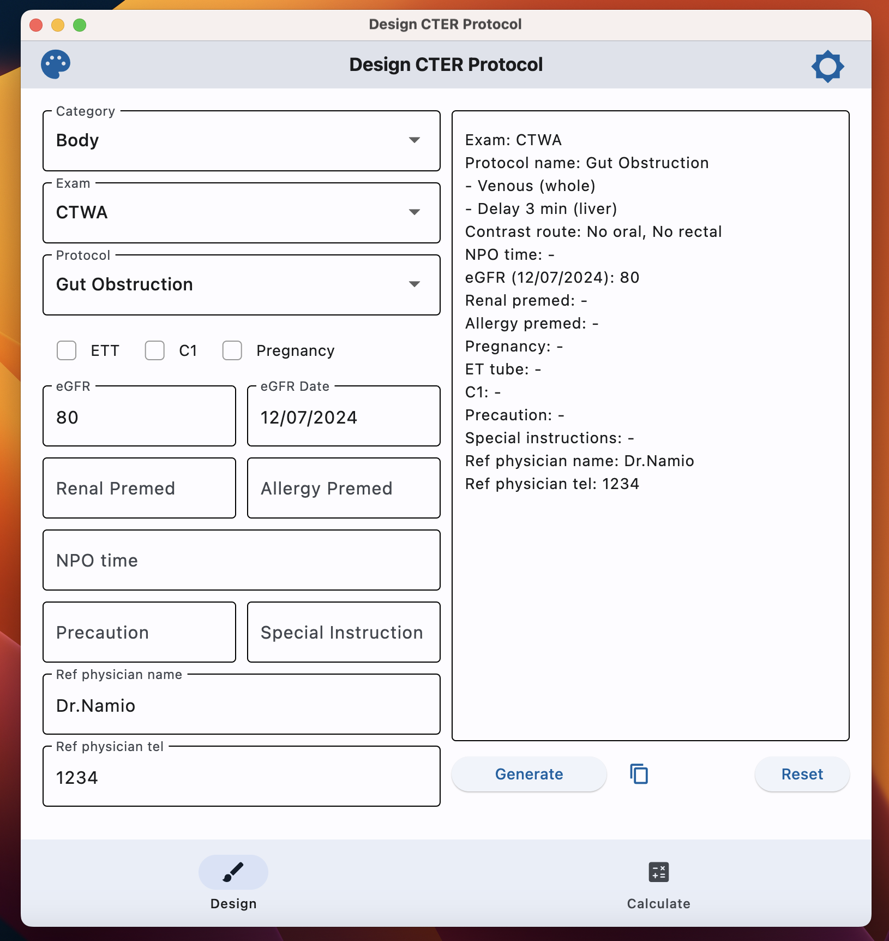
Figure 1.1: Design Mode
- This mode will generate CT protocols available from 3 levels dropdown: “category”, “exam”, and “protocol”.
- Other information can be filled in the input text field or checkboxes.
- Once finished, user can press Generate, then the protocol will render accordingly in the output text field.
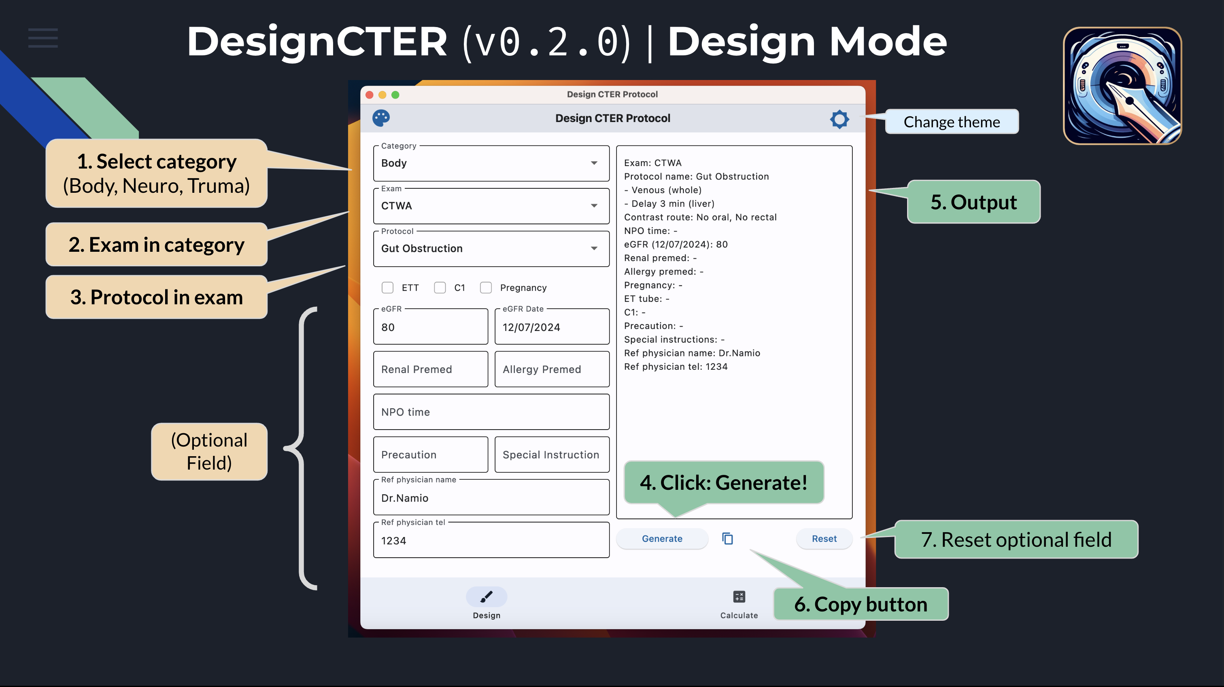

1.3 Calculator Mode
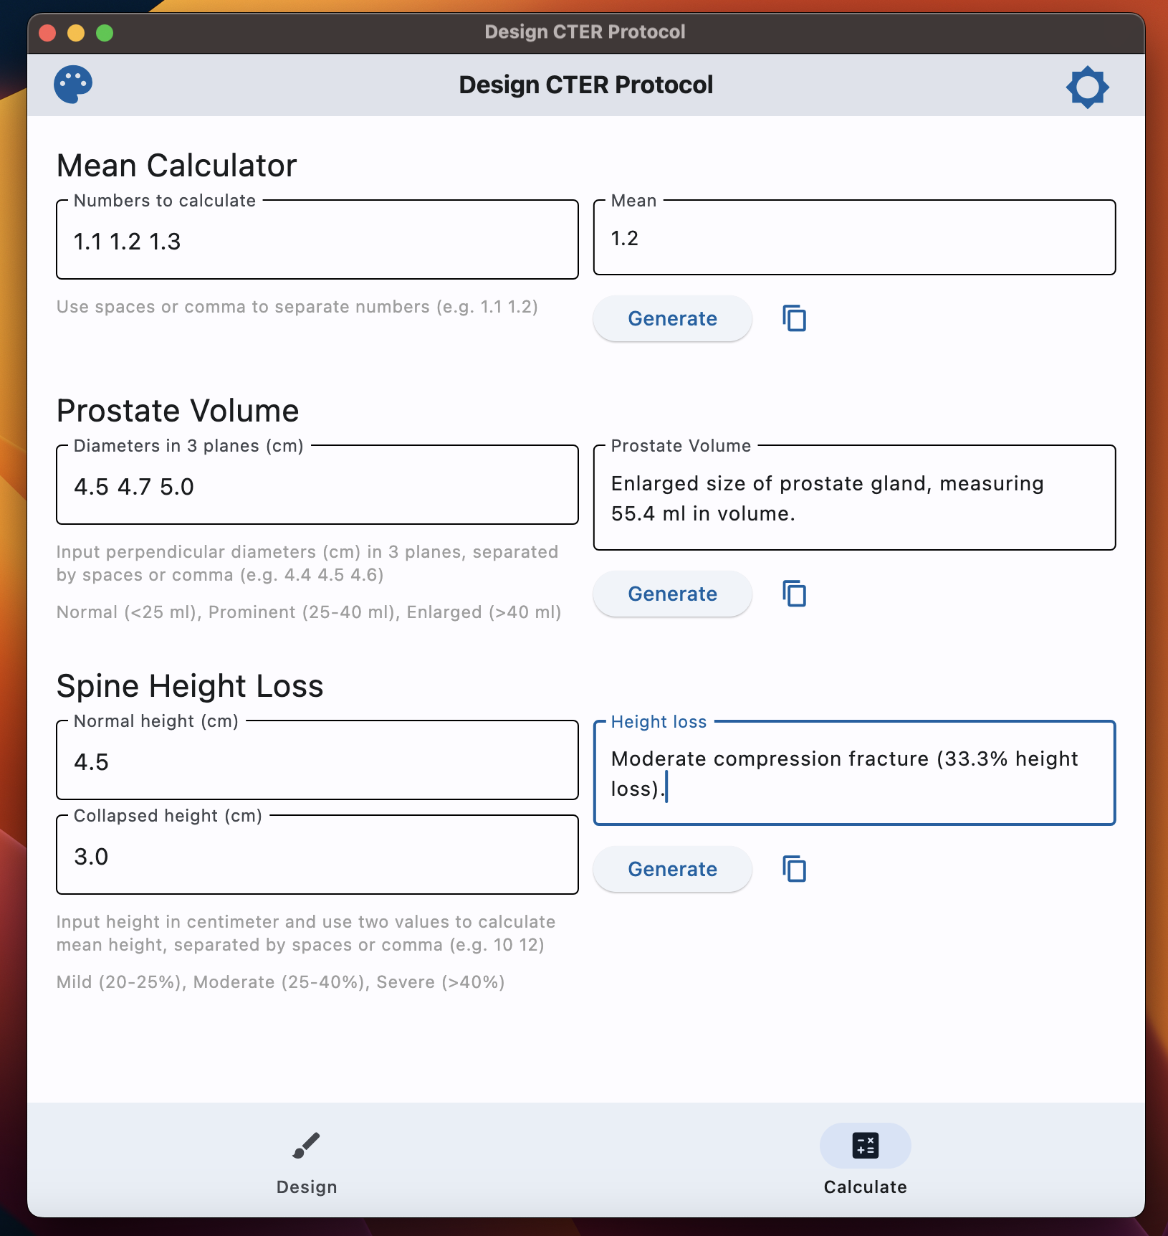
Figure 1.2: Calculator Mode
This helper mode can be use as a calculator for writing radiology report which includes build-in calculator for common task, such as mean calculator (for calculate dose), prostate volume, and spine height loss.

1.3.1 Mean calculator
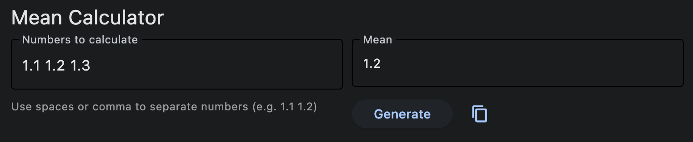
Mean Calculator
- To calculate mean value from any input numbers (separated by blank space or comma)
- For example, type 1.1 1.2 1.3 then press “Enter”, the app will calculate mean values, which is 1.2.

1.3.2 Prostate volume
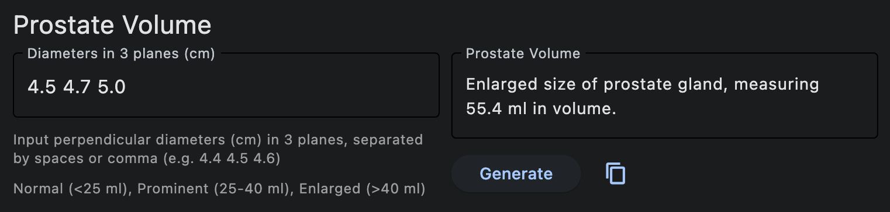
Prostate volume
- Input: Perpendicular diameter (cm) of prostate in 3 planes
- Output: A report for prostate volume, using ellipsoid formula.
Terminology based on prostate volume was based on the following:
- Normal (< 25 ml)
- Prominent (25-40 ml)
- Enlarged (> 40 ml)
 Ellipsoid volume formula
$$\frac{4}{3}π×r_{1}×r_{2}×r_{3} \left(1.1\right)$$
Where $r_{1}$, $r_{2}$, $r_{3}$ are radius along 3 perpendicular axis, or
$$\frac{1}{6}π×D_{1}×D_{2}×D_{3}≈0.5×D_{1}×D_{2}×D_{3} \left(1.2\right)$$
Where $D_{1}$, $D_{2}$, $D_{3}$ are diameter along 3 perpendicular axis.

1.3.3 Spine Height Loss
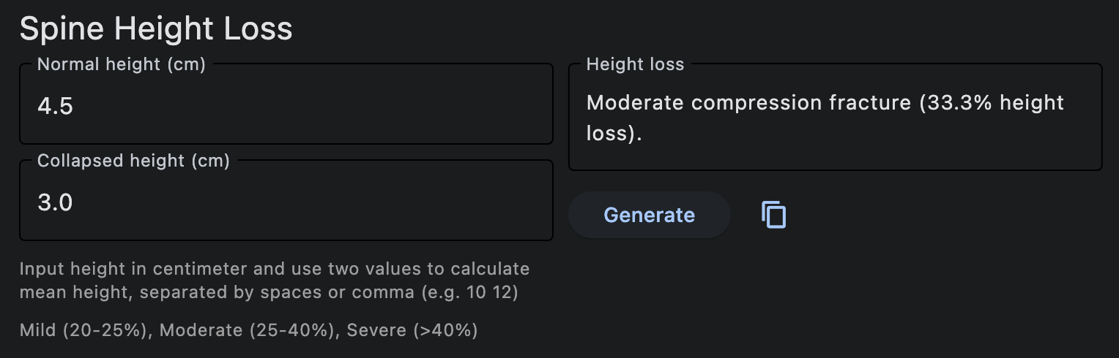
Spine height loss
- Input: Normal and collapsed height of spine. If there is no normal reference of the spine (e.g. severe collapse), the height of the two adjacent vertebrae can be used by input two numbers in the “Collapsed height (cm)” textbox (separated by blank space or comma).
- Output: A report for percentage of vertebral compression fracture with grading (mild, moderate, severe) using Genant’s classification.
For example:
- If Normal height = 4.5 cm, Collapsed height = 3.0 cm
- Height loss = $\left(4.5−3.0\right)×100/4.5=33.3\%$
Genant’s classification
- Grade 0: Normal
- Grade 1: Mild loss of height (20-25%)
- Grade 2: Moderate loss of height (25-40%)
- Grade 3: Severe loss of height (> 40%)

2. Protocols
Here are the protocols used in this application.

2.1 Body CT

2.1.1 CTWA
Protocol | Phase Design | Contrast
Routine WA | - - Venous (whole)  - - Delay (liver) | Oral (limited water), Rectal (water)
--- | - - Plain (whole)  - - Late A (upper)  - - Venous (whole)  - - Delay (liver) | Oral (?), Rectal (?)
Solid Organ Rupture | - - Plain (whole)  - - Late A (upper)  - - Venous (whole)  - - Delay (upper) | No oral, No rectal
Free Air | - - Plain  - - Venous (may be) | Oral (positive), Rectal (positive) [If not stable -> no oral, no rectal]
GI Perforation | - - Venous  - - Delay (liver) | Oral (limited positive), Rectal (positive)
Gut Obstruction | - - Venous (whole)  - - Delay 3 min (liver) | No oral, No rectal
HBP mass/abscess (CTWA) | - - Plain (upper)  - - Late A (upper)  - - Venous (whole)  - - Delay (upper) | Oral (limited water), No rectal
Kidney mass/abscess | - - Plain (KUB)  - - Late A (upper)  - - Venous (100 sec)  - - Delay (KUB) | Oral (limited water), No rectal
GI Mass | - - Venous (whole)  - - Delay (liver) | Oral (full positive), Rectal (water)
Diverticulitis | - - Venous (whole)  - - Delay (liver) | Oral (limited water), Rectal (1 L, positive CM)
Pancreatitis | - - Plain (upper)  - - Late A (upper)  - - Venous (whole)  - - Delay (upper) | Oral (limited water), No rectal
Intra-abdominal infection | - - Plain (whole)  - - Late A (upper)  - - Venous (whole)  - - Delay (upper) | Oral (limited water), Rectal (water)
Leak-Fistula-Collection | - - Venous (whole)  - - Delay (liver) | Oral (if Hx bowel resect -> full positive; If not -> limited positive), Rectal (positive) ?
CT Second look Abd (trauma) | - - Venous (whole) | IV contrast, Oral (full positive), Rectal (positive)

2.1.2 CTA Whole Abdomen
Protocol | Phase Design | Contrast
GI Bleed | - - Plain (whole)  - - CTA (whole)  - - Venous (whole)  - - Delay (whole) | No oral, No rectal
Mesenteric Ischemia | - - Plain (whole)  - - CTA (whole)  - - Venous (whole)  - - Delay (whole) | Oral (limited water), Rectal (water)
AAA Rupture | - - Plain (whole)  - - CTA (maybe ถ้ามีเวลา คนไข้ stable)  - - Venous (maybe ถ้ามีเวลา คนไข้ stable) | No oral, No rectal
CTA Blunt Abdomen (trauma) | - - CTA (whole)  - - Venous (whole)  - - may be Delay (in injury site) | IV contrast, No oral, No rectal
CTA Penetrating Abd (trauma) | - - CTA (whole)  - - Venous (whole)  - - may be Delay (in injury site) *** วาง marker ตําแหน่งแผลด้วย | IV contrast, Oral & Rectal full positive (ถ้ามีเวลา)

2.1.3 CT Upper Abdomen
Protocol | Phase Design | Contrast
Routine Upper Abd | - - Venous (upper)  - - Delay (upper) | Oral (limited water), No rectal
HBP mass/abscess (Upper) | - - Plain (upper)  - - Late A (upper)  - - Venous (upper)  - - Delay (upper) | Oral (limited water), No rectal
Biliary Stone | - - Plain (upper)  - - Late A (upper)  - - Venous (upper)  - - Delay (liver) | Oral (limited water), No rectal
Adrenal mass/abscess | - - Plain (upper)  - - Late A (upper)  - - Venous (upper)  - - Delay 3 min (upper) *** Check ภาพ +/- Delay 15 min (adrenal) | Oral (limited water), No rectal

2.1.4 CT Lower Abdomen
Protocol | Phase Design | Contrast
Appendicitis | - - Venous 120 sec (L3 to pubic symphysis) | Rectal (Positive 1 L สวนถึง cecum), No oral

2.1.5 CT KUB
Protocol | Phase Design | Contrast
Hematuria | - - Plain (KUB)  - - Late A (Kidney)  - - Venous (KUB)  - - Delay (KUB) *** Check ภาพก่อนเลิก | Oral (limited water), No Rectal
Kidney mass/Abscess | *** If suspect renal mass → consider CTWA for staging  - - Plain (KUB)  - - Late A (Upper)  - - Venous (100 sec)  - - Delay (KUB) *** Check ภาพก่อนเลิก | Oral (limited water), No Rectal

2.1.6 CTA for PE
Protocol | Phase Design | Contrast
CTA for PE (ไม่ลากขา) | - - CTPA (chest)  - - Venous (chest) | IV contrast
CTA for PE with DVT | - - CTPA (chest)  - - Venous (chest, legs) | IV contrast

2.1.7 CT Chest
Protocol | Phase Design | Contrast
Routine CT Chest | - - maybe plain (chest)  - - Late A (chest) | IV contrast
Nodule/mass characterization | - - Plain (chest)  - - Late A (chest) | IV contrast
Tracheobronchomalacia | - - Plain (chest, dynamic expiration) | No IV contrast
Dysphagia | - - Plain (chest)  - - Venous (chest) | IV contrast, Oral (limited water)
CT esophagogram | - - Plain (Chest, reduced dose) ก่อนกิน CM  - - จากนั้น กิน CM 1 cup (250 ml) ที่เตียง  - - Venous (Chest) หลังกิน CM | Oral (Positive CM)
SVC Obstruction | - - Plain (Chest, reduced dose)  - - Late A (Chest)  - - Immediate delay (Chest) | IV contrast

2.1.8 CT Chest + WA
Protocol | Phase Design | Contrast
--- | - - Plain (Chest + Whole abd)  - - Late A (Chest + Upper abd)  - - Venous (Whole abd)  - - Delay (liver) | Oral (?), Rectal (?)

2.1.9 CTA Chest
Protocol | Phase Design | Contrast
Hemoptysis | - - Plain (Chest)  - - CTA (Apex to L2) → Systemic arterial phase  - - Immediate delay (Chest)  - - Note: L2 (Celiac Axis) ให้เห็น renal artery origin | IV contrast
CTA Chest (trauma) | - - CTA (Chest)  - - Venous (Chest) | IV contrast, No Oral, No Rectal

2.1.10 CTA Whole Aorta
Protocol | Phase Design | Contrast
Aorta first time | - - Plain (whole aorta)  - - CTA (whole aorta)  - - Immediate delay (whole aorta) | IV contrast
Aortic Dissection | - - Plain (whole aorta)  - - CTA (whole aorta)  - - Immediate delay (whole aorta) | IV contrast
AAA Post-op | - - Plain (whole aorta)  - - CTA (whole aorta)  - - Immediate delay (whole aorta) | IV contrast

2.1.11 CTA Runoff
Protocol | Phase Design | Contrast
CTA Runoff | ขา → Aortic bifurcation to feet แขน → mid-heart to hands  - - Plain  - - CTA  - - Immediate delay | IV contrast
CTA Runoff (< 60 yr) | ขา → Aortic bifurcation to feet แขน → mid-heart to hands  - - CTA  - - Immediate delay | IV contrast

2.2 Neuro CT
Exam | Protocol | Phase Design | Contrast
CT Brain (non-contrast) | --- | --- | No IV contrast
CTA Brain | Intracranial aneurysm | - - Plain, CTA, post-contrast (Brain) | IV contrast
CTV Brain | Venous Sinus Thrombosis | - - Plain, CTV, post-contrast (Brain) | IV contrast
CT Brain with Contrast | --- | - - Plain, post-contrast (Brain) | IV contrast

2.3 Trauma CT
Exam | Protocol | Phase Design | Contrast
CTA Chest | CTA Chest (trauma) | - - CTA (Chest)  - - Venous (Chest) | IV contrast, No Oral, No Rectal
CTA Neck | CTA Neck (trauma) | - - CTA (brain, neck) COW to arch  - - Post-contrast (brain) | IV contrast
CT Facial Bone (non-contrast) | CT Facial Bone (trauma) | - - CT Facial Bones (plain) with 3D reformats | No IV contrast
CT Orbit (non-contrast) | CT Orbit (trauma) | --- | No IV contrast
CTA Whole Abd | CTA Blunt Abdomen (trauma) | - - CTA (whole)  - - Venous (whole)  - - may be Delay (in injury site) | IV contrast, No oral, No rectal
CTA Whole Abd | CTA Penetrating Abd (trauma) | - - CTA (whole)  - - Venous (whole)  - - may be Delay (in injury site) *** วาง marker ตําแหน่งแผลด้วย | IV contrast, Oral & Rectal full positive (ถ้ามีเวลา)
CTWA | CT Second look Abd (trauma) | - - Venous (whole) | IV contrast, Oral (full positive), Rectal (positive)

