**RS1 features:**

**Trace**

**DiagonalMean**

**SymmetricFrobeniusNorm**

**Dimension**

**Nnz**

**FrobeniusNorm**

**ColumnVariance**

**lowerBandwidth**

**upperBandwidth**

**BDT feature selection:**

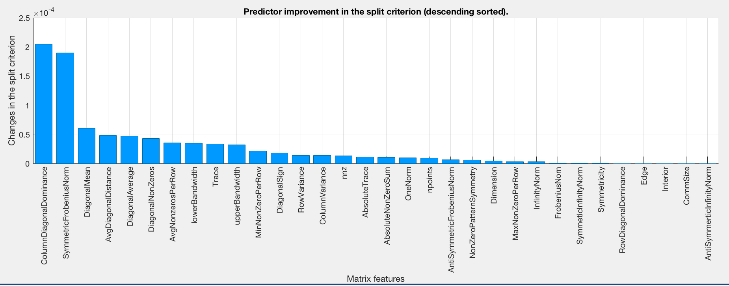

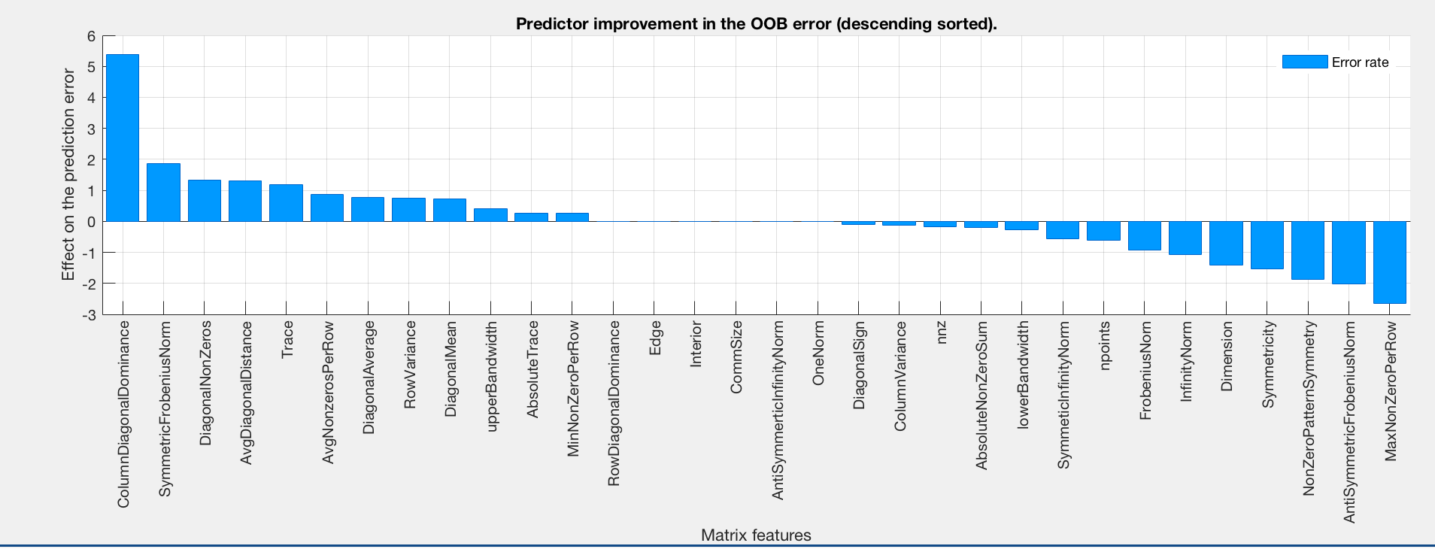

**Attribute selection from other attribute evaluators**

MinNonZeroPerRow

**nnz**

**FrobeniusNorn**

**ColumnVariance**

DiagonalNonZeros

**Trace**

**DiagonalMean**

**SymmetricFrobeniusNorm**

**Dimension**

**nnz**

**FrobeniusNorn**

**upperBandwidth**

**ColumnVariance**

**lowerBandwidth**

AbsoluteNonZeroSum

OneNorm

AvgDiagonalDistance

**Trace**

ColumnDiagonalDominance

MinNonZeroPerRow

DiagonalMean

**lowerBandwidth**

solver

SymmeticInfinityNorm

InfinityNorm

RowVariance

**ColumnVariance**

OneNorm

**DiagonalMean**

**Trace**

**SymmetricFrobeniusNorm**

**lowerBandwidth**

**upperBandwidth**

**Dimension**

ColumnDiagonalDominance