承認書
SPECIFICATION FOR APPROVAL

客戶(Customer)：
客戶料號(Customer P/N)：
本厂型號(Supplier P/N)： | LLX3020B8-02
產品名稱(Description)： | 喇叭
產品規格(Specification)： | 3020 4Ω 3W

客戶承認欄  (Customer Authorization Signature) | 電子 承認欄  (Supplier Audit)
 | 審核 | 檢查 | 制作
日期： 2025 年 12 月 13日
版次：A

Model No. | LLX3020B8-02 |  | Date | 2025-12-13 |  | Page No. | 1 / 6
產品規格內容 (SPECIFICATION)
1.使用範圍 (Scope)
此份規格書是針對多媒體產品內，所使用的微型揚聲器單體所提出的報告.
This specification covers our product of miniature speaker unit for multimedia product.
2.标准测试条件(Test condition)
一般规格试验状态（特殊要求除外）：常温5~35℃，常湿45%~85%，气压860~1060hPa.
判定上有疑问时，试验状态为：温度20±2℃，相对湿度60%~70%，气压860~1060 hPa.
The test conditions unless otherwise specified should be normal temperature 5 to 35 ℃,Normal humidity 45 to 85% and normal atmospheric pressure 860 to 1060 hPa,However,if there arises a doubt in judgment,the test conditions shall beas follows:
Temperature 20±2℃
Humidity 60%~70%
Atmosphere 860~1060 hPa
3.電聲特性 (ELECTRO-ACOUSTIC CHARACTERISTICS)
3.1額定阻抗(Rated Impedance):
4Ω ± 20% (AT 1.6K Hz ,1.0 Vrms)
3.2額定輸入功率(Rated Input Power)
1.8Watt (At 2.0 Vrms white noise 96 Hours)
3.3最大輸入功率(Max. Input Power)
3.0Watt
3.4最低共振頻率(Resonant Frequency)
1300 Hz ± 20%
3.5輸出音壓(Output S.P.L)
90 ± 3dB (1.0 Watt , 0.1 Meter. Average at 1.5K,2.0K,2.5K,3.0K Hz)
3.6實效頻率範圍(Frequency Range)
Fo ~ 20KHz (By Output S.P.L. –10dB)
3.7失真率(Distortion)
Less than 5% (At 1.6KHz ,3.4 Vrms)
3.8工作溫度(Operating Temperature)
-25℃ ~ +50℃
3.9儲存溫度(Storage temperature)
-25℃ ~ +55℃
制 定 |  | 审 核 | 核 准 |  | 文 件 编 号

產品規格內容 (SPECIFICATION)
Model No. | LLX3020B4-03 | Date | 2025-12-13 | Page No. | 2 / 6
4.可靠性測試 (Reliability Test)
4.1高低溫差循環測試(Temperature Cycling Test)
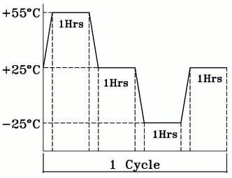
A | Low Temperature (-25℃±3℃)
B | High Temperature (+55℃±3℃)
C | Number of Cycle (3 Cycles)
D | Duration of Exposure 1 Hours, at Each Temperature Extremes
E | Duration of Recovery 1 Hours
4.2抗濕度試驗(Humidity Test)
A | 相對濕度(Relative Humidity) | 90-95% at + 40℃ ± 3℃
B | 測試時間(Durations) | 96 Hours
C | 恢覆時間(Durations of recovery) | 6 Hours
4.3連續負載測試(Load Test)
White Noise Without Weighted Filter 4 Volts.(RMS) 100 Hrs.
4.4跌落試驗(Drop Test)
75 cm Free Falling On Concrete Floor, 10 Times.
4.5異常音測試(Buzzes & Rattles)
Sine wave between at 4.0Vrms / 50~5000Hz
4.6極性測試(Polarity test)
Diaphragm Shall Move Forward When Apply a Positive DC. Current to the “+”or “Marked” Terminal.

產品規格內容 (SPECIFICATION)
Model No. | LLX3020B8-02 | Date | 2025-12-13 | Page No. | 3 / 6
5.測量方式 (Measurement Method)
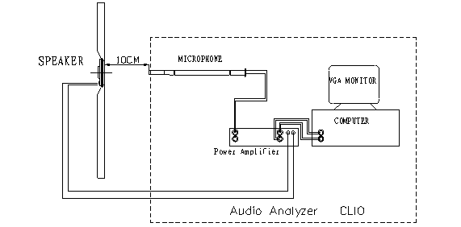

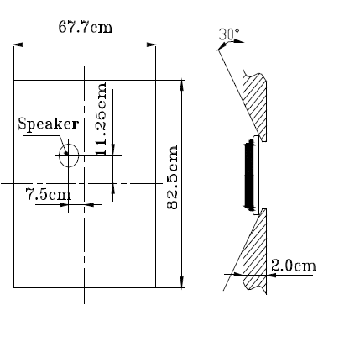

產品規格內容 (SPECIFICATION)
Model No. | LLX3020B8-02 | Date | 2025-12-13 | Page No. | 4/6
6. 頻率響應曲線圖(Frequency Response Curve)
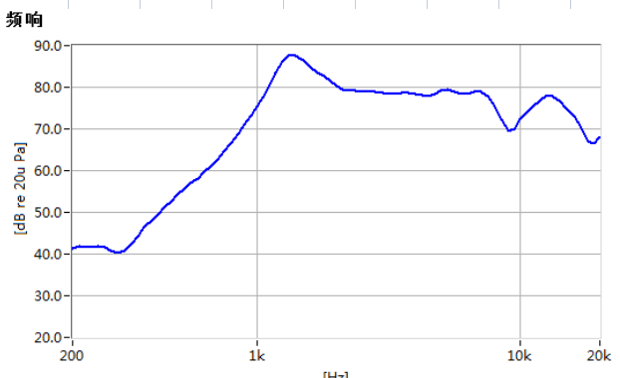

產品規格內容 (SPECIFICATION)
Model No. | LLX3020B8-02 | Date | 2025-12-13 | Page No. | 5 / 6
7. 喇叭外觀描述
（Unit:mm tolerance:±0.3）

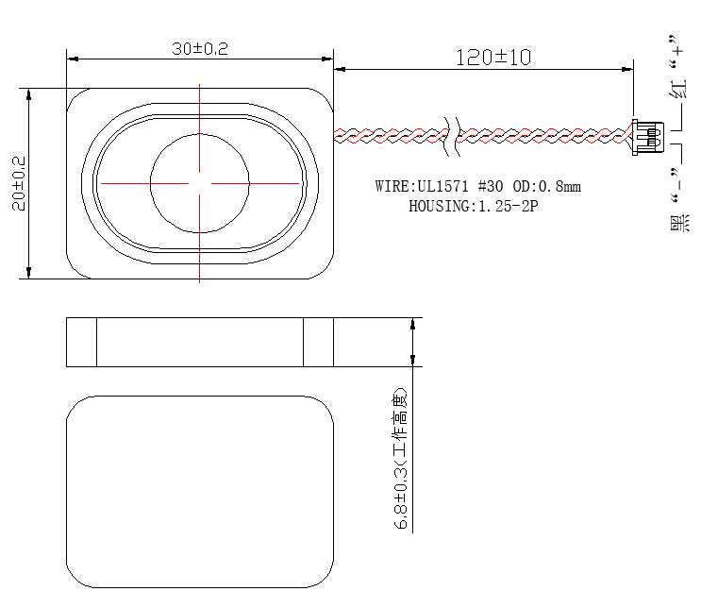

產品規格內容 (SPECIFICATION)
Model No. | LLX3020B8-02 | Date | 2025-12-13 | Page No. | 6/6
8.包裝示意圖(Packing Standard):
（Unit:cm tolerance:±3）

