performaceGraphing.R

roohac

Wed Feb 21 16:03:48 2018

library(readxl)

## Warning: package 'readxl' was built under R version 3.3.3

PVT <- read_excel("//root/public/roohac/nurses_study/completed-nurses/full_data_sets/processedtime2/Nurses_Study_Summary_Tables_2018_02_21_15_23_37_Complete.xlsx",   
 sheet = "PVT")  
  
GNG <- read_excel("//root/public/roohac/nurses_study/completed-nurses/full_data_sets/processedtime2/Nurses_Study_Summary_Tables_2018_02_21_15_23_37_Complete.xlsx",   
 sheet = "GNG")  
  
OB <- read_excel("//root/public/roohac/nurses_study/completed-nurses/full_data_sets/processedtime2/Nurses_Study_Summary_Tables_2018_02_21_15_23_37_Complete.xlsx",   
 sheet = "OB")  
  
   
 library(nlme)  
 library(lsmeans)

## Warning: package 'lsmeans' was built under R version 3.3.3

## Loading required package: estimability

library(ggplot2)

## Warning: package 'ggplot2' was built under R version 3.3.3

library(Rmisc)

## Loading required package: lattice

## Loading required package: plyr

library(MuMIn)

## Warning: package 'MuMIn' was built under R version 3.3.3

library(ggsignif)

## Warning: package 'ggsignif' was built under R version 3.3.3

ctrl <- lmeControl(opt='optim');  
 options(warn=-1)  
   
  
 ###GNG  
   
 GNG$Condition_period <- paste(GNG$Condition, GNG$Period, sep = "_")  
   
 GNG$SubjectID <- as.factor(GNG$SubjectID )  
 GNG$Shift <- as.factor(GNG$Shift )  
 GNG$Condition <- as.factor(GNG$Condition )  
 GNG$Period <- as.factor(GNG$Period )  
 GNG$Condition_period <- as.factor(GNG$Condition_period )  
 GNG$TimeBin <- as.factor(GNG$TimeBin )  
   
 GNG$avgResponseTimeCorrect <- as.numeric(GNG$avgResponseTimeCorrect )  
 GNG$HitRate <- as.numeric(GNG$HitRate )  
 GNG$FalsePositive <- as.numeric(GNG$FalsePositive )  
 GNG$Condition <- ifelse(GNG$Condition == "r", "Red",   
 ifelse(GNG$Condition == "b", "Blue", "White" ))  
 GNG$Period <- ifelse(GNG$Period == "b","Baseline", "Intervention")  
 GNG$Condition_period <- ifelse(GNG$Condition_period == "b_b", "Blue baseline",   
 ifelse(GNG$Condition_period == "b_i", "Blue intervention",   
 ifelse(GNG$Condition_period == "r_b", "Red baseline",   
 ifelse(GNG$Condition_period == "r_i", "Red intervention",   
 ifelse(GNG$Condition_period == "w_b", "White baseline", "White intervention" )))))  
 GNG$Condition_period <- factor(GNG$Condition_period, levels = c("Red baseline", "Red intervention", "Blue baseline", "Blue intervention", "White baseline", "White intervention" ))  
   
   
 #GNG2 <- subset(GNG, ValidPairedBin == "TRUE" & ValidTest == "TRUE" & !is.na(TimeBin))  
 #GNG2 <- subset(GNG,ValidTest == "TRUE" & !is.na(TimeBin))  
 GNG2 <- subset(GNG,!is.na(TimeBin) & !is.na(avgResponseTimeCorrect) & !is.na(avgResponseTime) & HasMaxTrials == "TRUE")  
   
   
 ###GNG hit  
   
 gng_hit_subs1 <- summarySE(GNG2, measurevar="HitRate", groupvars=c("SubjectID", "Condition_period", "TimeBin", "Shift", "Period", "Condition"))  
 gng_hit_subs2 <- summarySE(GNG2, measurevar="HitRate", groupvars=c("SubjectID", "Condition_period", "Shift", "Period", "Condition"))  
   
   
 gng_hit1 <- summarySE(gng_hit_subs1, measurevar="HitRate", groupvars=c("Condition_period", "TimeBin", "Shift", "Period", "Condition"))  
 gng_hit2 <- summarySE(gng_hit_subs2, measurevar="HitRate", groupvars=c("Condition_period", "Shift", "Condition", "Period"))  
   
   
 ggplot(gng_hit1, aes(x=Period, y=HitRate, fill = Condition_period)) +   
 geom_bar(position=position_dodge(), stat="identity") +  
 geom_errorbar(aes(ymin=HitRate-se, ymax=HitRate+se),  
 width=.2, # Width of the error bars  
 position=position_dodge(.9)) + facet_grid(Shift ~Condition*TimeBin) + #facet_grid(.~Condition*Period) +  
 coord_cartesian(ylim=c(19,21))+  
 geom_text(aes(label = round(HitRate, digits = 3), vjust=2))+  
 scale_fill_manual(values=c( "red4", "red1", "deepskyblue4", "deepskyblue2", "gray80", "gray90")) +  
 theme(panel.grid.major = element_blank(), panel.grid.minor = element_blank(), panel.background = element_blank(), axis.line = element_line(colour = "black"))

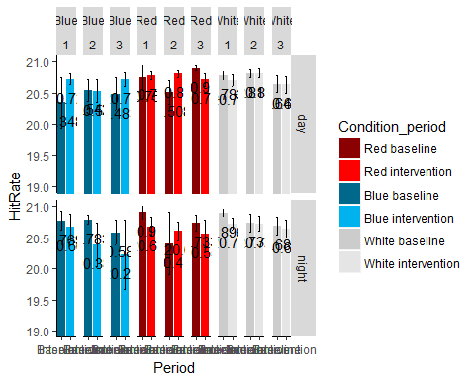

ggplot(gng_hit2, aes(x=Period, y=HitRate, fill = Condition_period)) +   
 geom_bar(position=position_dodge(), stat="identity") +  
 geom_errorbar(aes(ymin=HitRate-se, ymax=HitRate+se),  
 width=.2, # Width of the error bars  
 position=position_dodge(.9)) + facet_grid(.~Shift* Condition) +  
 coord_cartesian(ylim=c(19,21))+  
 geom_text(aes(label = round(HitRate, digits = 3), vjust=2))+  
 scale_fill_manual(values=c( "red4", "red1", "deepskyblue4", "deepskyblue2", "gray80", "gray90")) +  
 theme(panel.grid.major = element_blank(), panel.grid.minor = element_blank(), panel.background = element_blank(), axis.line = element_line(colour = "black"))

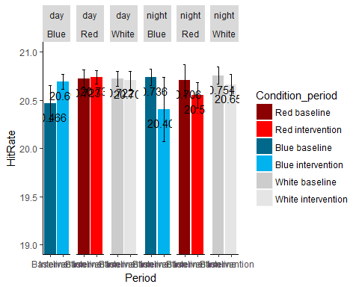

##GNG false postive  
   
   
 gng_fp_subs1 <- summarySE(GNG2, measurevar="FalsePositive", groupvars=c("SubjectID", "Condition_period", "TimeBin", "Shift", "Period", "Condition"))  
 gng_fp_subs2 <- summarySE(GNG2, measurevar="FalsePositive", groupvars=c("SubjectID", "Condition_period", "Shift", "Period", "Condition"))  
  
   
 gng_fp1 <- summarySE(gng_fp_subs1, measurevar="FalsePositive", groupvars=c("Condition_period", "TimeBin", "Shift", "Period", "Condition"))  
 gng_fp2 <- summarySE(gng_fp_subs2, measurevar="FalsePositive", groupvars=c("Condition_period", "Shift", "Condition", "Period"))  
   
 #df1 <- graph_table("FalsePositve", GNG2, 1)  
   
   
 ggplot(gng_fp1, aes(x=Period, y=FalsePositive, fill = Condition_period)) +   
 geom_bar(position=position_dodge(), stat="identity") +  
 geom_errorbar(aes(ymin=FalsePositive-se, ymax=FalsePositive+se),  
 width=.2, # Width of the error bars  
 position=position_dodge(.9)) + facet_grid(Shift ~Condition*TimeBin) + #facet_grid(.~Condition*Period) +  
 #coord_cartesian(ylim=c(20,21))+  
 geom_text(aes(label = round(FalsePositive, digits = 3), vjust=2))+  
 scale_fill_manual(values=c( "red4", "red1", "deepskyblue4", "deepskyblue2", "gray80", "gray90")) +  
 theme(panel.grid.major = element_blank(), panel.grid.minor = element_blank(), panel.background = element_blank(), axis.line = element_line(colour = "black"))

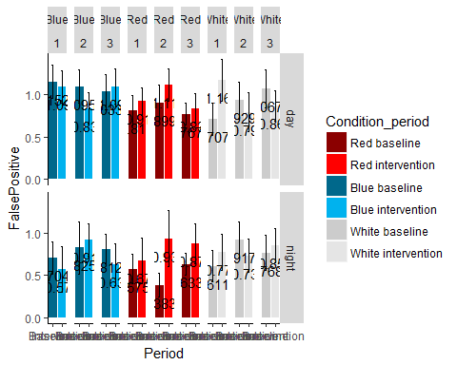

ggplot(gng_fp2, aes(x=Period, y=FalsePositive, fill = Condition_period)) +   
 geom_bar(position=position_dodge(), stat="identity") +  
 geom_errorbar(aes(ymin=FalsePositive-se, ymax=FalsePositive+se),  
 width=.2, # Width of the error bars  
 position=position_dodge(.9)) + facet_grid(.~Shift* Condition) +  
 #coord_cartesian(ylim=c(20,21))+  
 geom_text(aes(label = round(FalsePositive, digits = 3), vjust=2))+  
 scale_fill_manual(values=c( "red4", "red1", "deepskyblue4", "deepskyblue2", "gray80", "gray90")) +  
 theme(panel.grid.major = element_blank(), panel.grid.minor = element_blank(), panel.background = element_blank(), axis.line = element_line(colour = "black"))

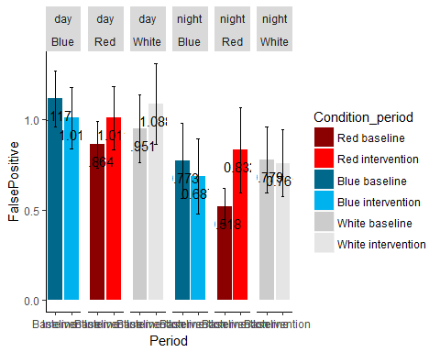

##GNG mean responsetime  
   
   
 gng_rt_subs1 <- summarySE(GNG2, measurevar="avgResponseTimeCorrect", groupvars=c("SubjectID", "Condition_period", "TimeBin", "Shift", "Period", "Condition"))  
 gng_rt_subs2 <- summarySE(GNG2, measurevar="avgResponseTimeCorrect", groupvars=c("SubjectID", "Condition_period", "Shift", "Period", "Condition"))  
   
   
 gng_rt1 <- summarySE(gng_rt_subs1, measurevar="avgResponseTimeCorrect", groupvars=c("Condition_period", "TimeBin", "Shift", "Period", "Condition"))  
 gng_rt2 <- summarySE(gng_rt_subs2, measurevar="avgResponseTimeCorrect", groupvars=c("Condition_period", "Shift", "Condition", "Period"))  
   
   
 ggplot(gng_rt1, aes(x=Period, y=avgResponseTimeCorrect, fill = Condition_period)) +   
 geom_bar(position=position_dodge(), stat="identity") +  
 geom_errorbar(aes(ymin=avgResponseTimeCorrect-se, ymax=avgResponseTimeCorrect+se),  
 width=.2, # Width of the error bars  
 position=position_dodge(.9)) + facet_grid(Shift ~Condition*TimeBin) + #facet_grid(.~Condition*Period) +  
 coord_cartesian(ylim=c(.4,.7))+  
 geom_text(aes(label = round(avgResponseTimeCorrect, digits = 3), vjust=2))+  
 scale_fill_manual(values=c( "red4", "red1", "deepskyblue4", "deepskyblue2", "gray80", "gray90")) +  
 theme(panel.grid.major = element_blank(), panel.grid.minor = element_blank(), panel.background = element_blank(), axis.line = element_line(colour = "black"))

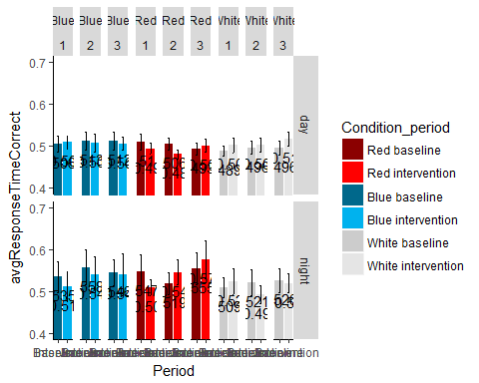

ggplot(gng_rt2, aes(x=Period, y=avgResponseTimeCorrect, fill = Condition_period)) +   
 geom_bar(position=position_dodge(), stat="identity") +  
 geom_errorbar(aes(ymin=avgResponseTimeCorrect-se, ymax=avgResponseTimeCorrect+se),  
 width=.2, # Width of the error bars  
 position=position_dodge(.9)) + facet_grid(.~Shift* Condition) +  
 coord_cartesian(ylim=c(.4,.7))+  
 geom_text(aes(label = round(avgResponseTimeCorrect, digits = 3), vjust=2))+  
 scale_fill_manual(values=c( "red4", "red1", "deepskyblue4", "deepskyblue2", "gray80", "gray90")) +  
 theme(panel.grid.major = element_blank(), panel.grid.minor = element_blank(), panel.background = element_blank(), axis.line = element_line(colour = "black"))

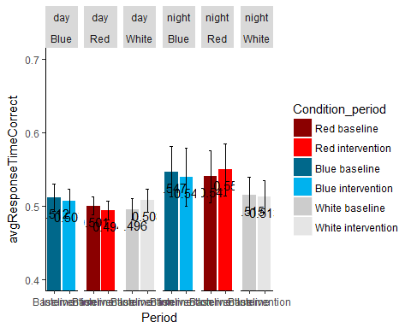

##GNG median responsetime  
   
   
 gng_rt_subs1 <- summarySE(GNG2, measurevar="medResponseTimeCorrect", groupvars=c("SubjectID", "Condition_period", "TimeBin", "Shift", "Period", "Condition"))  
 gng_rt_subs2 <- summarySE(GNG2, measurevar="medResponseTimeCorrect", groupvars=c("SubjectID", "Condition_period", "Shift", "Period", "Condition"))  
   
   
 gng_rt1 <- summarySE(gng_rt_subs1, measurevar="medResponseTimeCorrect", groupvars=c("Condition_period", "TimeBin", "Shift", "Period", "Condition"))  
 gng_rt2 <- summarySE(gng_rt_subs2, measurevar="medResponseTimeCorrect", groupvars=c("Condition_period", "Shift", "Condition", "Period"))  
   
   
 ggplot(gng_rt1, aes(x=Period, y=medResponseTimeCorrect, fill = Condition_period)) +   
 geom_bar(position=position_dodge(), stat="identity") +  
 geom_errorbar(aes(ymin=medResponseTimeCorrect-se, ymax=medResponseTimeCorrect+se),  
 width=.2, # Width of the error bars  
 position=position_dodge(.9)) + facet_grid(Shift ~Condition*TimeBin) + #facet_grid(.~Condition*Period) +  
 coord_cartesian(ylim=c(.4,.7))+  
 geom_text(aes(label = round(medResponseTimeCorrect, digits = 3), vjust=2))+  
 scale_fill_manual(values=c( "red4", "red1", "deepskyblue4", "deepskyblue2", "gray80", "gray90")) +  
 theme(panel.grid.major = element_blank(), panel.grid.minor = element_blank(), panel.background = element_blank(), axis.line = element_line(colour = "black"))

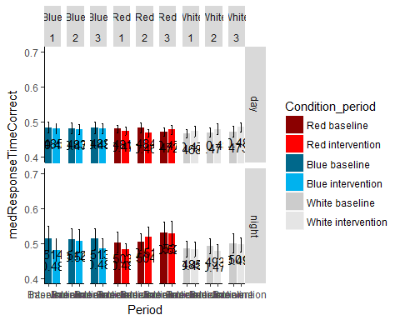

ggplot(gng_rt2, aes(x=Period, y=medResponseTimeCorrect, fill = Condition_period)) +   
 geom_bar(position=position_dodge(), stat="identity") +  
 geom_errorbar(aes(ymin=medResponseTimeCorrect-se, ymax=medResponseTimeCorrect+se),  
 width=.2, # Width of the error bars  
 position=position_dodge(.9)) + facet_grid(.~Shift* Condition) +  
 coord_cartesian(ylim=c(.4,.7))+  
 geom_text(aes(label = round(medResponseTimeCorrect, digits = 3), vjust=2))+  
 scale_fill_manual(values=c( "red4", "red1", "deepskyblue4", "deepskyblue2", "gray80", "gray90")) +  
 theme(panel.grid.major = element_blank(), panel.grid.minor = element_blank(), panel.background = element_blank(), axis.line = element_line(colour = "black"))

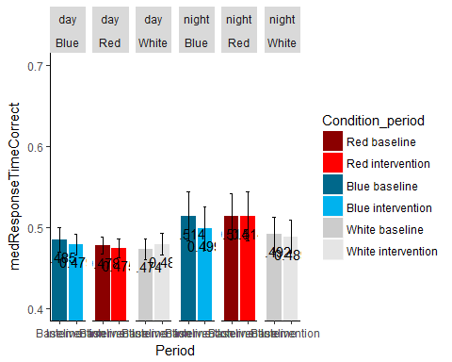

###Significance  
   
 gng_rt_subs3 <- summarySE(GNG2, measurevar="avgResponseTimeCorrect", groupvars=c("SubjectID", "TimeBin"))  
  
   
 gng_rt3 <- summarySE(gng_rt_subs3, measurevar="avgResponseTimeCorrect", groupvars=c("TimeBin"))  
   
 ggplot(gng_rt3, aes(x=TimeBin, y=avgResponseTimeCorrect)) +   
 geom_bar(position=position_dodge(), stat="identity") +  
 geom_errorbar(aes(ymin=avgResponseTimeCorrect-se, ymax=avgResponseTimeCorrect+se),  
 width=.2, # Width of the error bars  
 position=position_dodge(.9)) +   
 coord_cartesian(ylim=c(.4,.7))+  
 geom_text(aes(label = round(avgResponseTimeCorrect, digits = 3), vjust=2))+  
 theme(panel.grid.major = element_blank(), panel.grid.minor = element_blank(), panel.background = element_blank(), axis.line = element_line(colour = "black"))

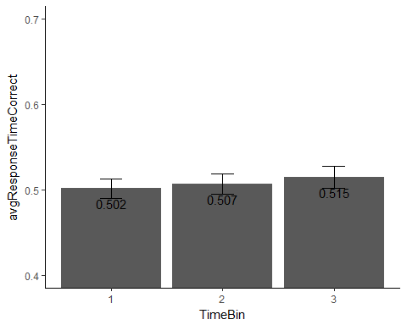

##OB  
   
 OB$Condition_period <- paste(OB$Condition, OB$Period, sep = "_")  
   
   
 OB$SubjectID <- as.factor(OB$SubjectID )  
 OB$Shift <- as.factor(OB$Shift )  
 OB$Condition <- as.factor(OB$Condition )  
 OB$Period <- as.factor(OB$Period )  
 OB$Condition_period <- as.factor(OB$Condition_period )  
   
 OB$TimeBin <- as.factor(OB$TimeBin )  
   
 OB$avgResponseTimeCorrect <- as.numeric(OB$avgResponseTimeCorrect )  
 OB$CorrectMatch <- as.numeric(OB$CorrectMatch )  
 OB$CorrectNoMatch <- as.numeric(OB$CorrectNoMatch )  
   
 OB$Condition <- ifelse(OB$Condition == "r", "Red",   
 ifelse(OB$Condition == "b", "Blue", "White" ))  
 OB$Period <- ifelse(OB$Period == "b","Baseline", "Intervention")  
 OB$Condition_period <- ifelse(OB$Condition_period == "b_b", "Blue baseline",   
 ifelse(OB$Condition_period == "b_i", "Blue intervention",   
 ifelse(OB$Condition_period == "r_b", "Red baseline",   
 ifelse(OB$Condition_period == "r_i", "Red intervention",   
 ifelse(OB$Condition_period == "w_b", "White baseline", "White intervention" )))))  
 OB$Condition_period <- factor(OB$Condition_period, levels = c("Red baseline", "Red intervention", "Blue baseline", "Blue intervention", "White baseline", "White intervention" ))  
   
   
   
 #OB2 <- subset(OB, ValidPairedBin == "TRUE" & isValid == "TRUE" & !is.na(TimeBin))  
 #OB2 <- subset(OB,isValid == "TRUE" & !is.na(TimeBin))  
 OB2 <- subset(OB,!is.na(TimeBin) & !is.na(avgResponseTimeCorrect) & !is.na(avgResponseTime) & HasMaxTrials == "TRUE" )  
   
 OB_half <-subset(OB2, HalfAnswered == "TRUE" )  
 OB_normal <-subset(OB2, HalfAnswered == "FALSE" )  
   
 ##OB  
   
 OB_percentCorrect_subs1 <- summarySE(OB_normal, measurevar="PercentCorrect", groupvars=c("SubjectID", "Condition_period", "TimeBin", "Shift", "Period", "Condition"))  
 OB_percentCorrect_subs2 <- summarySE(OB_normal, measurevar="PercentCorrect", groupvars=c("SubjectID", "Condition_period", "Shift", "Period", "Condition"))  
   
   
 OB_percentCorrect1 <- summarySE(OB_percentCorrect_subs1, measurevar="PercentCorrect", groupvars=c("Condition_period", "TimeBin", "Shift", "Period", "Condition"))  
 OB_percentCorrect2 <- summarySE(OB_percentCorrect_subs2, measurevar="PercentCorrect", groupvars=c("Condition_period", "Shift", "Condition", "Period"))  
   
   
 ggplot(OB_percentCorrect1, aes(x=Period, y=PercentCorrect, fill = Condition_period)) +   
 geom_bar(position=position_dodge(), stat="identity") +  
 geom_errorbar(aes(ymin=PercentCorrect-se, ymax=PercentCorrect+se),  
 width=.2, # Width of the error bars  
 position=position_dodge(.9)) + facet_grid(Shift ~Condition*TimeBin) + #facet_grid(.~Condition*Period) +  
 coord_cartesian(ylim=c(.8,1))+  
 geom_text(aes(label = round(PercentCorrect, digits = 3), vjust=2))+  
 scale_fill_manual(values=c( "red4", "red1", "deepskyblue4", "deepskyblue2", "gray80", "gray90")) +  
 theme(panel.grid.major = element_blank(), panel.grid.minor = element_blank(), panel.background = element_blank(), axis.line = element_line(colour = "black"))

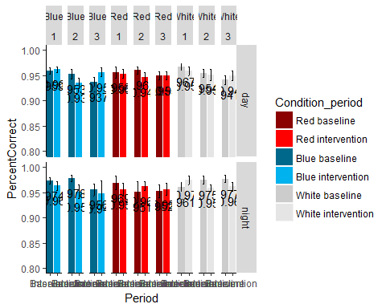

ggplot(OB_percentCorrect2, aes(x=Period, y=PercentCorrect, fill = Condition_period)) +   
 geom_bar(position=position_dodge(), stat="identity") +  
 geom_errorbar(aes(ymin=PercentCorrect-se, ymax=PercentCorrect+se),  
 width=.2, # Width of the error bars  
 position=position_dodge(.9)) + facet_grid(.~Shift* Condition) +  
 coord_cartesian(ylim=c(.8,1))+  
 geom_text(aes(label = round(PercentCorrect, digits = 3), vjust=2))+  
 scale_fill_manual(values=c( "red4", "red1", "deepskyblue4", "deepskyblue2", "gray80", "gray90")) +  
 theme(panel.grid.major = element_blank(), panel.grid.minor = element_blank(), panel.background = element_blank(), axis.line = element_line(colour = "black"))

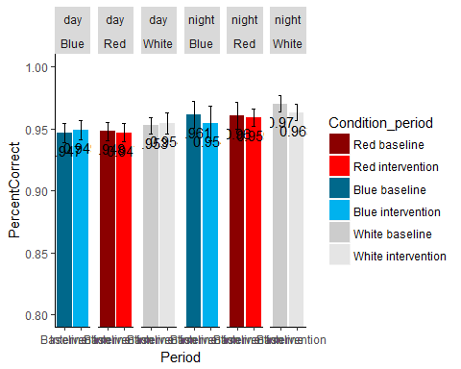

OB_avgResponseTimeCorrect_subs1 <- summarySE(OB_normal, measurevar="avgResponseTimeCorrect", groupvars=c("SubjectID", "Condition_period", "TimeBin", "Shift", "Period", "Condition"))  
 OB_avgResponseTimeCorrect_subs2 <- summarySE(OB_normal, measurevar="avgResponseTimeCorrect", groupvars=c("SubjectID", "Condition_period", "Shift", "Period", "Condition"))  
 OB_avgResponseTimeCorrect_subs3 <- summarySE(OB_normal, measurevar="avgResponseTimeCorrect", groupvars=c("SubjectID", "Condition_period", "Period", "Condition"))  
   
 OB_avgResponseTimeCorrect1 <- summarySE(OB_avgResponseTimeCorrect_subs1, measurevar="avgResponseTimeCorrect", groupvars=c("Condition_period", "TimeBin", "Shift", "Period", "Condition"))  
 OB_avgResponseTimeCorrect2 <- summarySE(OB_avgResponseTimeCorrect_subs2, measurevar="avgResponseTimeCorrect", groupvars=c("Condition_period", "Shift", "Condition", "Period"))  
 OB_avgResponseTimeCorrect3 <- summarySE(OB_avgResponseTimeCorrect_subs3, measurevar="avgResponseTimeCorrect", groupvars=c("Condition_period", "Condition", "Period"))  
   
   
 ggplot(OB_avgResponseTimeCorrect1, aes(x=Period, y=avgResponseTimeCorrect, fill = Condition_period)) +   
 geom_bar(position=position_dodge(), stat="identity") +  
 geom_errorbar(aes(ymin=avgResponseTimeCorrect-se, ymax=avgResponseTimeCorrect+se),  
 width=.2, # Width of the error bars  
 position=position_dodge(.9)) + facet_grid(Shift ~Condition*TimeBin) + #facet_grid(.~Condition*Period) +  
 coord_cartesian(ylim=c(.5,1))+  
 geom_text(aes(label = round(avgResponseTimeCorrect, digits = 3), vjust=2))+  
 scale_fill_manual(values=c( "red4", "red1", "deepskyblue4", "deepskyblue2", "gray80", "gray90")) +  
 theme(panel.grid.major = element_blank(), panel.grid.minor = element_blank(), panel.background = element_blank(), axis.line = element_line(colour = "black"))

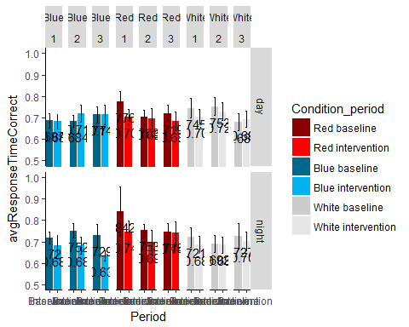

ggplot(OB_avgResponseTimeCorrect2, aes(x=Period, y=avgResponseTimeCorrect, fill = Condition_period)) +   
 geom_bar(position=position_dodge(), stat="identity") +  
 geom_errorbar(aes(ymin=avgResponseTimeCorrect-se, ymax=avgResponseTimeCorrect+se),  
 width=.2, # Width of the error bars  
 position=position_dodge(.9)) + facet_grid(.~Shift* Condition) +  
 coord_cartesian(ylim=c(.5,1))+  
 geom_text(aes(label = round(avgResponseTimeCorrect, digits = 3), vjust=2))+  
 scale_fill_manual(values=c( "red4", "red1", "deepskyblue4", "deepskyblue2", "gray80", "gray90")) +  
 theme(panel.grid.major = element_blank(), panel.grid.minor = element_blank(), panel.background = element_blank(), axis.line = element_line(colour = "black"))

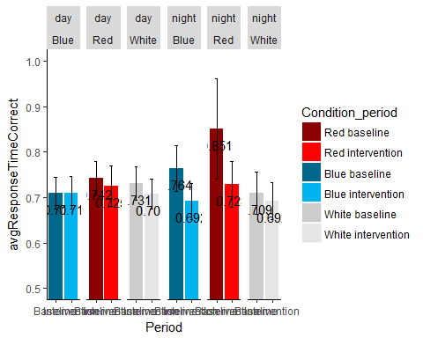

ggplot(OB_avgResponseTimeCorrect3, aes(x=Condition_period, y=avgResponseTimeCorrect, fill = Condition_period)) +   
 geom_bar(position=position_dodge(), stat="identity") +  
 geom_errorbar(aes(ymin=avgResponseTimeCorrect-se, ymax=avgResponseTimeCorrect+se),  
 width=.2, # Width of the error bars  
 position=position_dodge(.9)) + # facet_grid(.~ Condition) +  
 coord_cartesian(ylim=c(.5,1))+  
 geom_text(aes(label = round(avgResponseTimeCorrect, digits = 3), vjust=2))+  
 scale_fill_manual(values=c( "red4", "red1", "deepskyblue4", "deepskyblue2", "gray80", "gray90")) +  
 theme(panel.grid.major = element_blank(), panel.grid.minor = element_blank(), panel.background = element_blank(), axis.line = element_line(colour = "black"))+  
 geom_signif(comparisons = list(c("Red baseline", "Red intervention")), annotations=".003")

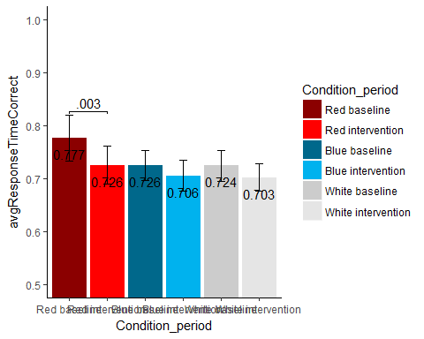

#PVT  
   
 PVT$Condition_period <- paste(PVT$Condition, PVT$Period, sep = "_")  
   
   
 PVT$SubjectID <- as.factor(PVT$SubjectID )  
 PVT$Shift <- as.factor(PVT$Shift )  
 PVT$Condition <- as.factor(PVT$Condition )  
 PVT$Period <- as.factor(PVT$Period )  
 PVT$Condition_period <- as.factor(PVT$Condition_period )  
   
 PVT$TimeBin <- as.factor(PVT$TimeBin )  
   
 PVT$avgResponseTime <- as.numeric(PVT$avgResponseTime )  
 PVT$accuracy <- PVT$nCorrect/PVT$nTrials  
   
 PVT$Condition <- ifelse(PVT$Condition == "r", "Red",   
 ifelse(PVT$Condition == "b", "Blue", "White" ))  
 PVT$Period <- ifelse(PVT$Period == "b","Baseline", "Intervention")  
 PVT$Condition_period <- ifelse(PVT$Condition_period == "b_b", "Blue baseline",   
 ifelse(PVT$Condition_period == "b_i", "Blue intervention",   
 ifelse(PVT$Condition_period == "r_b", "Red baseline",   
 ifelse(PVT$Condition_period == "r_i", "Red intervention",   
 ifelse(PVT$Condition_period == "w_b", "White baseline", "White intervention" )))))  
 PVT$Condition_period <- factor(PVT$Condition_period, levels = c("Red baseline", "Red intervention", "Blue baseline", "Blue intervention", "White baseline", "White intervention" ))  
   
   
   
   
 #PVT2 <- subset(PVT, ValidPairedBin == "TRUE" & ValidTest == "TRUE" & !is.na(TimeBin))  
 #PVT2 <- subset(PVT,ValidTest == "TRUE" & !is.na(TimeBin))  
 PVT2 <- subset(PVT, !is.na(TimeBin) & !is.na(avgResponseTime) & HasMaxTrials == "TRUE")  
   
 PVT_percentCorrect_subs1 <- summarySE(PVT2, measurevar="accuracy", groupvars=c("SubjectID", "Condition_period", "TimeBin", "Shift", "Period", "Condition"))  
 PVT_percentCorrect_subs2 <- summarySE(PVT2, measurevar="accuracy", groupvars=c("SubjectID", "Condition_period", "Shift", "Period", "Condition"))  
 PVT_percentCorrect_subs3 <- summarySE(PVT2, measurevar="accuracy", groupvars=c("SubjectID", "Condition_period", "Period", "Condition"))  
   
 PVT_percentCorrect1 <- summarySE(PVT_percentCorrect_subs1, measurevar="accuracy", groupvars=c("Condition_period", "TimeBin", "Shift", "Period", "Condition"))  
 PVT_percentCorrect2 <- summarySE(PVT_percentCorrect_subs2, measurevar="accuracy", groupvars=c("Condition_period", "Shift", "Condition", "Period"))  
 PVT_percentCorrect3 <- summarySE(PVT_percentCorrect_subs2, measurevar="accuracy", groupvars=c("Condition_period", "Condition", "Period"))  
   
   
 ggplot(PVT_percentCorrect1, aes(x=Period, y=accuracy, fill = Condition_period)) +   
 geom_bar(position=position_dodge(), stat="identity") +  
 geom_errorbar(aes(ymin=accuracy-se, ymax=accuracy+se),  
 width=.2, # Width of the error bars  
 position=position_dodge(.9)) + facet_grid(Shift ~Condition*TimeBin) + #facet_grid(.~Condition*Period) +  
 coord_cartesian(ylim=c(.8,1))+  
 geom_text(aes(label = round(accuracy, digits = 3), vjust=2))+  
 scale_fill_manual(values=c( "red4", "red1", "deepskyblue4", "deepskyblue2", "gray80", "gray90")) +  
 theme(panel.grid.major = element_blank(), panel.grid.minor = element_blank(), panel.background = element_blank(), axis.line = element_line(colour = "black"))

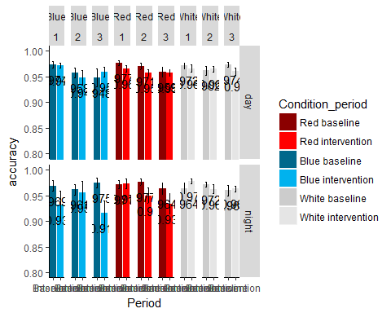

ggplot(PVT_percentCorrect2, aes(x=Period, y=accuracy, fill = Condition_period)) +   
 geom_bar(position=position_dodge(), stat="identity") +  
 geom_errorbar(aes(ymin=accuracy-se, ymax=accuracy+se),  
 width=.2, # Width of the error bars  
 position=position_dodge(.9)) + facet_grid(.~Shift* Condition) +  
 coord_cartesian(ylim=c(.8,1))+  
 geom_text(aes(label = round(accuracy, digits = 3), vjust=2))+  
 scale_fill_manual(values=c( "red4", "red1", "deepskyblue4", "deepskyblue2", "gray80", "gray90")) +  
 theme(panel.grid.major = element_blank(), panel.grid.minor = element_blank(), panel.background = element_blank(), axis.line = element_line(colour = "black"))

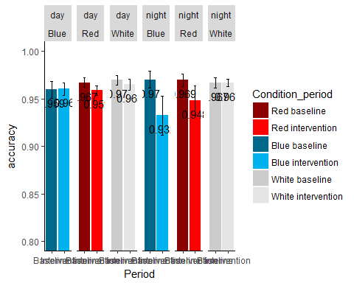

ggplot(PVT_percentCorrect3, aes(x=Condition_period, y=accuracy, fill = Condition_period)) +   
 geom_bar(position=position_dodge(), stat="identity") +  
 geom_errorbar(aes(ymin=accuracy-se, ymax=accuracy+se),  
 width=.2, # Width of the error bars  
 position=position_dodge(.9)) +  
 coord_cartesian(ylim=c(.8,1))+  
 geom_text(aes(label = round(accuracy, digits = 3), vjust=2))+  
 scale_fill_manual(values=c( "red4", "red1", "deepskyblue4", "deepskyblue2", "gray80", "gray90")) +  
 theme(panel.grid.major = element_blank(), panel.grid.minor = element_blank(), panel.background = element_blank(), axis.line = element_line(colour = "black"))+  
 geom_signif(comparisons = list(c("Red baseline", "Red intervention")), annotations=".0134", y_position = .985)

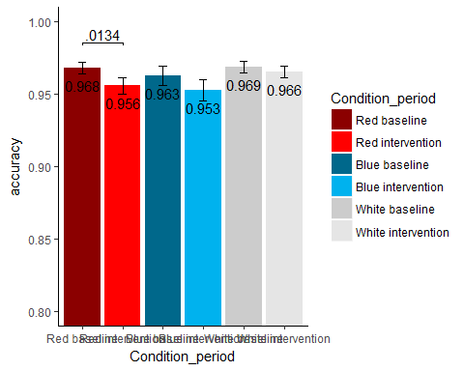

PVT_avgResponseTime_subs1 <- summarySE(PVT2, measurevar="avgResponseTime", groupvars=c("SubjectID", "Condition_period", "TimeBin", "Shift", "Period", "Condition"))  
 PVT_avgResponseTime_subs2 <- summarySE(PVT2, measurevar="avgResponseTime", groupvars=c("SubjectID", "Condition_period", "Shift", "Period", "Condition"))  
   
 PVT_avgResponseTime1 <- summarySE(PVT_avgResponseTime_subs1, measurevar="avgResponseTime", groupvars=c("Condition_period", "TimeBin", "Shift", "Period", "Condition"))  
 PVT_avgResponseTime2 <- summarySE(PVT_avgResponseTime_subs2, measurevar="avgResponseTime", groupvars=c("Condition_period", "Shift", "Condition", "Period"))  
   
   
 ggplot(PVT_avgResponseTime1, aes(x=Period, y=avgResponseTime, fill = Condition_period)) +   
 geom_bar(position=position_dodge(), stat="identity") +  
 geom_errorbar(aes(ymin=avgResponseTime-se, ymax=avgResponseTime+se),  
 width=.2, # Width of the error bars  
 position=position_dodge(.9)) + facet_grid(Shift ~Condition*TimeBin) + #facet_grid(.~Condition*Period) +  
 coord_cartesian(ylim=c(.4,.6))+  
 geom_text(aes(label = round(avgResponseTime, digits = 3), vjust=2))+  
 scale_fill_manual(values=c( "red4", "red1", "deepskyblue4", "deepskyblue2", "gray80", "gray90")) +  
 theme(panel.grid.major = element_blank(), panel.grid.minor = element_blank(), panel.background = element_blank(), axis.line = element_line(colour = "black"))

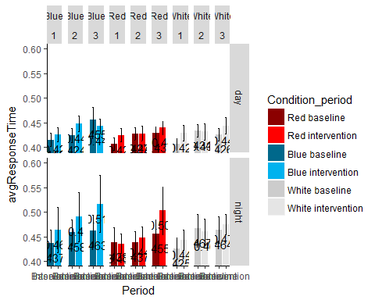

ggplot(PVT_avgResponseTime2, aes(x=Period, y=avgResponseTime, fill = Condition_period)) +   
 geom_bar(position=position_dodge(), stat="identity") +  
 geom_errorbar(aes(ymin=avgResponseTime-se, ymax=avgResponseTime+se),  
 width=.2, # Width of the error bars  
 position=position_dodge(.9)) + facet_grid(.~Shift* Condition) +  
 coord_cartesian(ylim=c(.4,.6))+  
 geom_text(aes(label = round(avgResponseTime, digits = 3), vjust=2))+  
 scale_fill_manual(values=c( "red4", "red1", "deepskyblue4", "deepskyblue2", "gray80", "gray90")) +  
 theme(panel.grid.major = element_blank(), panel.grid.minor = element_blank(), panel.background = element_blank(), axis.line = element_line(colour = "black"))

