Game Design Document

Fill up the Following document

1. Write the title of your project.

Archery

1. What is the goal of the game?

To hit the target with the arrow.

1. Write a brief story of your game?

Jeb liked to go play Archery with his dad but his left arm broke so he can’t. Make a game so that Jeb can still play Archery.

1. Which are the playing characters of this game?

* Playing characters are the ones which respond to the user based on the input from the user
* Cars, monkeys, dinos, wizards etc, are the playing characters in the game.

|  |  |  |
| --- | --- | --- |
| Number | Character Name | What can this character do? |
| 1 | Bow | Move up and down the screen with Arrow keys. |

1. Which are the Non Playing Characters of this game?

* Non Playing characters are the ones which don't have an action or a behaviour when the user interacts with the game.
* Hurdles, stones, bananas, coins, etc are non playing characters in the game.

|  |  |  |
| --- | --- | --- |
| Number | Character Name | What can this character do? |
| 1 | Target | Be hit by the arrow and move up and down. |
| 2 | String | Connect the bow to the Arrow |
| 3 | Arrow | Fly when the mouse is released |

Draw your imagination of this game. What does this game look like?

* Draw the game either on your computer or on paper,
* Add images of scenes of the game to show each of the playing and non-playing characters at least once.

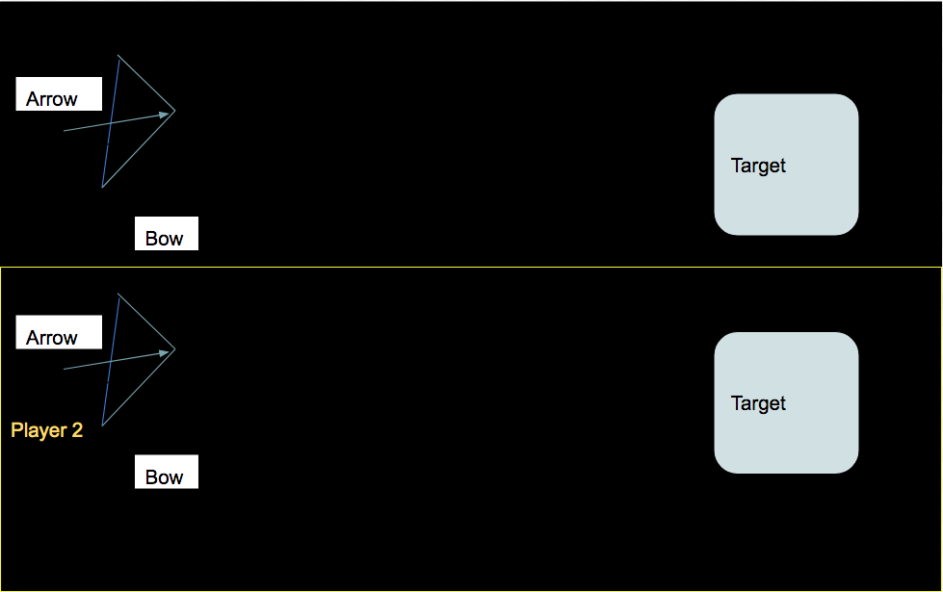

How do you plan to make your game engaging?

It is a two player versus game.