**-- Creating Table Loan_stats**

create table Loan_stats

(

    id int,

    member_id int,

    loan_amnt int,

    funded_amnt int,

    funded_amnt_inv int,

    term string,

    init_rate string,

    installment float,

    grade string,

    subgrade string,

    emp_title string,

    emp_length string,

    home_ownership string,

    annual_inc bigint,

    verification_status string,

    issue_d string,

    loan_status string,

    pymt_plan string,

    url string,

    desc string,

    purpose string,

    title string,

    zip_code string,

    addr_state string,

    dti float,

    delinq_2yrs int,

    earliest_cr_line string,

    inq_last_6mths int,

    mths_since_last_delinq string,

    mths_since_last_record string,

    open_acc int,

    pub_rec int,

    revol_bal int,

    revol_util string,

    total_acc int,

    initial_list_status string,

    out_prncp float,

    out_prncp_inv double,

    total_pymnt float,

    total_pymnt_inv float,

    total_rec_int float,

    total_rec_late_fee float,

    recoveries float,

    collection_recovery_fee float,

    last_pymnt_d string,

    last_pymnt_amnt float,

    next_pymnt_d string,

    last_credit_pull_d string,

    collections_12_mths_ex_med float,

    mths_since_last_major_derog string,

    policy_code int, application_type string,

    annual_inc_joint string,

    dti_joint string,

    verification_status_joint string,

    acc_now_delinq int,

    tot_coll_amt string,

    tot_cur_bal string,

    open_acc_6m string,

    open_il_6m string,

    open_il_12m string,

    open_il_24m string,

    mths_since_rcnt_il string,

    total_bal_il string,

    il_util string,

    open_rv_12m string,

    open_rv_24m string,

    max_bal_bc string,

    all_util string,

    total_credit_rv string,

    inq_fi string,

    total_fi_tl string,

    inq_last_12m string

)

ROW FORMAT SERDE 'org.apache.hadoop.hive.serde2.OpenCSVSerde'

WITH SERDEPROPERTIES

(

    "separatorChar" = ",",

    "quoteChar"     = "\""

) tblproperties('serialization.null.format'='','skip.header.line.count'='2');

**-- Creating Reject status**

create external table reject_stats

(

    amount_requested string,

    Application_date string,

    loan_title string,

    risk_score string,

    Debt_To_Income string,

    zipcode string,

    state string,

    employment_length string,

    policy_code string

)

ROW FORMAT SERDE 'org.apache.hadoop.hive.serde2.OpenCSVSerde'

WITH SERDEPROPERTIES

(

"separatorChar" = ",",

"quoteChar" = "\""

) STORED AS TEXTFILE

tblproperties('serialization.null.format'='','skip.header.line.count'='2');

**-- Q1. Total Loan issuance by yearly & Quarterly and calculate growth rate by quarter**

**-- on quarter and year on year.**

create table quarter_table as

select

    id as id,

    case

        when lower(month) in ('jan','feb','mar') then 1

        when lower(month) in('apr','may','jun') then 2

        when lower(month) in ('jul','aug','sep') then 3

        when lower(month) in ('oct','nov','dec') then 4

        else 0 end as year_quarter,

    loan_amnt as total_amnt,

    loan_year as loan_year

from loan_timeline;

select

    sum(loan_amnt) total_loan_issued,

    substr(issue_d,5)  Year

from Loan_stats

where isnotnull(year) and isnotnull(total_loan_issued)

group by substr(issue_d,5) ;

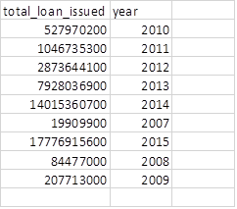

**-- Total Loan Issuance by Quarter**

select

    year_quarter,

sum(total_amnt) quarter_wise_loan

from quarter_table

where year_quarter > 0

group by year_quarter;

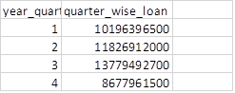

select

    Year,

    round((diff/previous)*100) Percentage_Growth

from (

    select

        substr(issue_d,5)  Year,

        sum(loan_amnt) - lag(sum(loan_amnt)) over( order by substr(issue_d,5)) diff,

        lag(sum(loan_amnt)) over(order by substr(issue_d,5)) previous

    from loan_stats

    group by substr(issue_d,5)) t1

where isnotnull(round((diff/previous)*100))

order by Year;

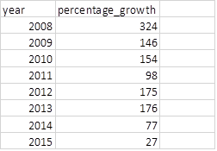

**-- calculating growth rate by quarter on quarter and year on year**

select

    loan_year,

    year_quarter,

    round((diff/previous)*100) Percentage_Growth

from

(

    select

        loan_year ,

        year_quarter,

        sum(total_amnt) - lag(sum(total_amnt)) over(order by loan_year,year_quarter) diff,

        lag(sum(total_amnt)) over(order by loan_year,year_quarter) previous

    from quarter_table

    group by loan_year, year_quarter

) t2

where year_quarter <> 0 and not isnull((diff/previous)*100)

order by loan_year,year_quarter;

;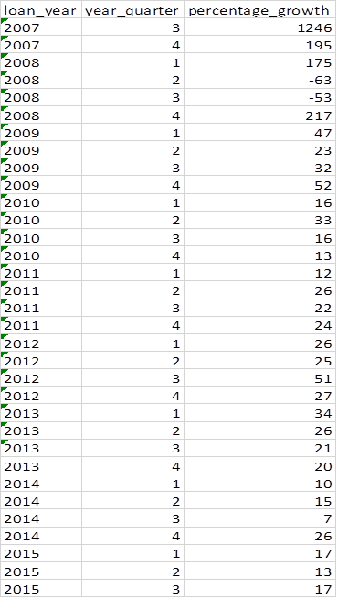

**--Q2. Percentage of loans based on the reported loan purpose. (Note: Loan purpose describes**

**--  the reported intent of borrowers from the most recent completed quarter and may not**

**--  reflect actual usage. Investors should rely on loan grades rather than loan purpose)**

select

    purpose ,

    100*(sum(loan_amnt)/sum(distinct total_amt)) Percentage_of_Loans

from (

        select

            *,

            sum(loan_amnt) over() as total_amt

            from loan_stats

    ) t1

group by purpose;

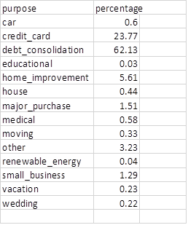

**-- Q3. Loan Issuance by state – classify the states based on loan issuance**

**--      by $50+ MM, $25-50 MM, $10-25 MM and $0-10 MM**

Select addr_state, sum(loan_amnt) total_Amount

From Loan_stats

Group by addr_state;

Select addr_state, case

When total_Amount <1000000 then 'LOW'

When total_Amount <2500000 then 'MEDIUM'

When total_Amount <5000000 then 'HIGH'

When total_Amount >5000000 then 'VERY HIGH'

End as Category

from state_class

WHERE isnotnull(addr_state)

Order by Category DESC;

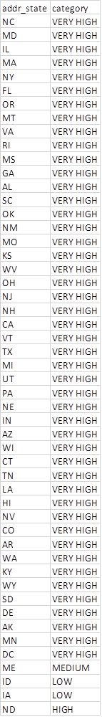

**-- Q4. Find the last quarter average interest rates by different term loans and overall**

SELECT

    avg(intrest_rate) as average_intrest_rate_byterm,

    t_term as term

FROM interest_term

GROUP BY t_term;

SELECT

    avg(intrest_rate) as average_intrest_rate_byterm,

    t_term as term

FROM interest_term

GROUP BY t_term;

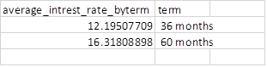

SELECT

    avg(intrest_rate) as average_intrest_rate_overall

FROM interest_term;



**-- Q5. Find the historical returns by loan grade (Historical performance by grade**

**--      for all issued loans) and overall**

select

    grade,

    sum(loan_amnt) as total_loan,

    sum (total_pymnt) as total_pymnt

from loan_stats

group by grade;

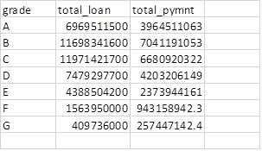

select

    sum(total_pymnt - loan_amnt) as return

from loan_stats;



**-- Q6. Find the historical average interest rates by loan terms and loan grades (also for overall)**

select

    term,

    grade,

    avg(regexp_replace(int_rate,'[^0-9.]','')) avg_intrest_rate_byterm_grade

from loan_stats

group by term, grade;

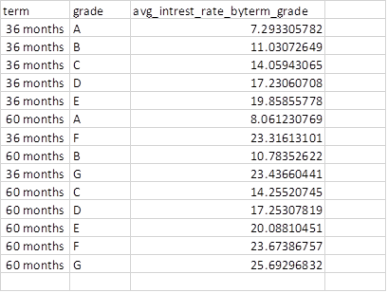

SELECT

     avg(regexp_replace(init_rate,'[^0-9.]','')) Avg_interest_rate

from loan_stats;



**-- Q7. What is percentage of loans by different loan grades by each year**

**--     and loan term level (also for overall**

select

    grade,

    term,

    substr(issue_d,5) as year ,

    100*(count(*)/sum(distinct ctr))

from (

    select

        *,

        count(*) over() as ctr

    from loan_stats

    ) t1

group by grade, term , substr(issue_d,5);

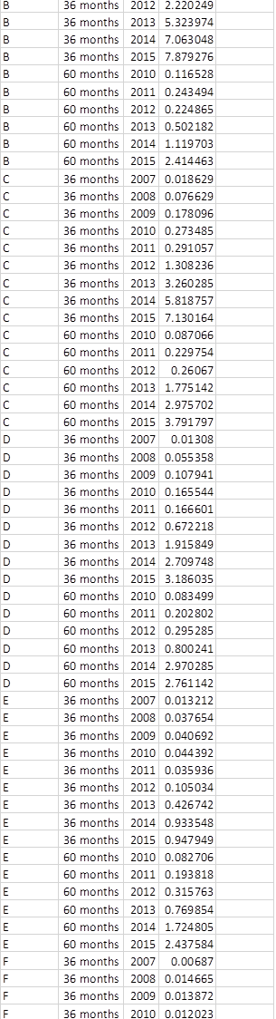

select

    substr(issue_d,5) as year ,

    100*(count(*)/sum(distinct ctr))

from (

        select

            *,

                count(*) over() as ctr from loan_stats) t1

group by  substr(issue_d,5);

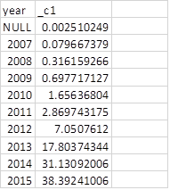

**-- Q8. What is the loan performance details by different loan grades and overall**

select

    loan_status,

    grade,

    100*(count(*)/sum(distinct ctr))

from (

        select

            *,

            count(*) over() as ctr

        from loan_stats

    ) t2

group by loan_status,grade;

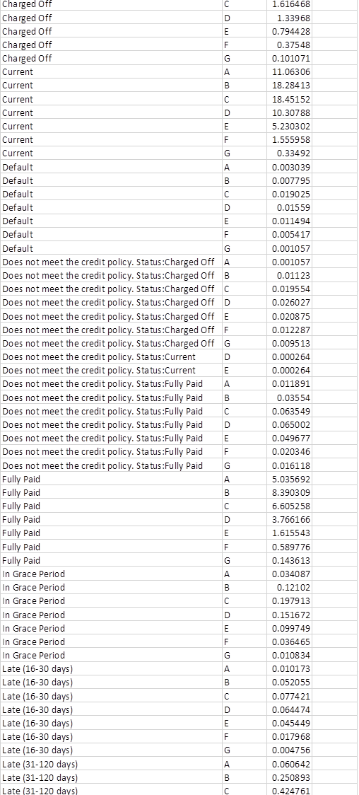

**-- Q9. Find Net Annualized returns by vintage by different loan grades and different loan terms (also for overall)**

select

    grade,

    term,

    sum((cast(regexp_replace(int_rate,'[^0-9.]','') as float)*loan_amnt)/100) annualized_return

from loan_stats

where isnotnull(grade)

group by grade ,term ;

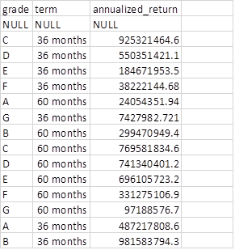

**--Q10 What is loan status migration over 9 months (Net Charge offs: 120+days delinquency)**

create table loan_migrate_status as

select

    loan_status as status,

    count(loan_status) as cnt

from loan_stats

group by loan_status

having loan_status in ('In Grace Period', 'Late (16-30 days)', 'Late (31-120 days)', 'Default');

Create table charged_off as

Select

    count(loan_status) as loan_count

from loan_stats

GROUP BY loan_status

Having loan_status='Charged Off';

Create table migrate_status as

select

    loan_migrate_status.status as status,

    loan_migrate_status.cnt as count,

    charged_off.loan_count as chargeed_count

from loan_migrate_status

cross join charged_off;

Select

    status,

    100*(count/chargeed_count) as Migrtn_Status

from migrate_status;

