**-- Creating Table**

**-- Creating HVAC and Building Table**

create table hvac

( H_date string,

time string,

target_temp int,

actual_temp int,

system int,

system_age int,

building_id string)

ROW FORMAT SERDE 'org.apache.hadoop.hive.serde2.OpenCSVSerde'

WITH SERDEPROPERTIES

(

"separatorChar" = ",",

"quoteChar" = "\""

)

tblproperties('serialization.null.format'='','skip.header.line.count'='1');

**-- create table building**

(building_id string,

building_mgr string,

building_age int,

hvac_product string,

country string)

ROW FORMAT SERDE 'org.apache.hadoop.hive.serde2.OpenCSVSerde'

WITH SERDEPROPERTIES

(

"separatorChar" = ",",

"quoteChar" = "\""

)

tblproperties('serialization.null.format'='','skip.header.line.count'='1');

**-- Creating HVAC temperature Variables and merging every table**

CREATE TABLE hvac_temperature as

select

*,

actual_temp - target_temp as temp_diff,

case

when (actual_temp - target_temp) > 5 THEN 'HOT'

when (actual_temp - target_temp) < -5 THEN 'COLD'

else 'NORMAL'end

as temp_range,

case

when abs(actual_temp - target_temp) <5 THEN '0'

else '1' end

AS extreme_temp

from hvac;

create table hvac_building as

select

ht.*,

b.building_mgr,

b.building_age,

b.hvac_product,

b.country

from hvac_temperature ht inner join building b on ht.building_id = b.building_id;

**-- Analysis**

**-- Q1. Data Visualization/analysis by mapping the buildings that are most frequently outside of the optimal**

**-- temperature range. Calculate count of extremetemp (i.e where the temperature was more than five degrees**

**-- or lower than the target temperature) by each country and temp range.**

select

building_id,

count(temp_range) as optimal_count

from hvac_building

where temp_range !='NORMAL'

group by building_id

order by optimal_count desc;

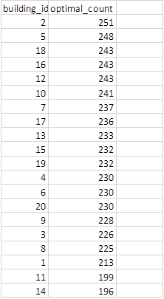

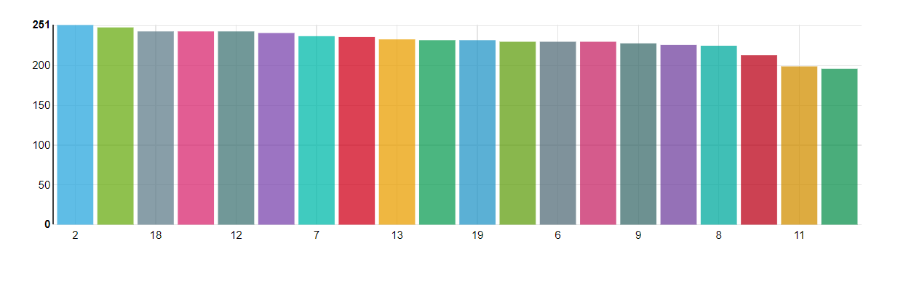

select

country,

temp_range,

sum(cast(extreme_temp as int)) as extreme_temperature

from hvac_building

group by country, temp_range

order by extreme_temperature;



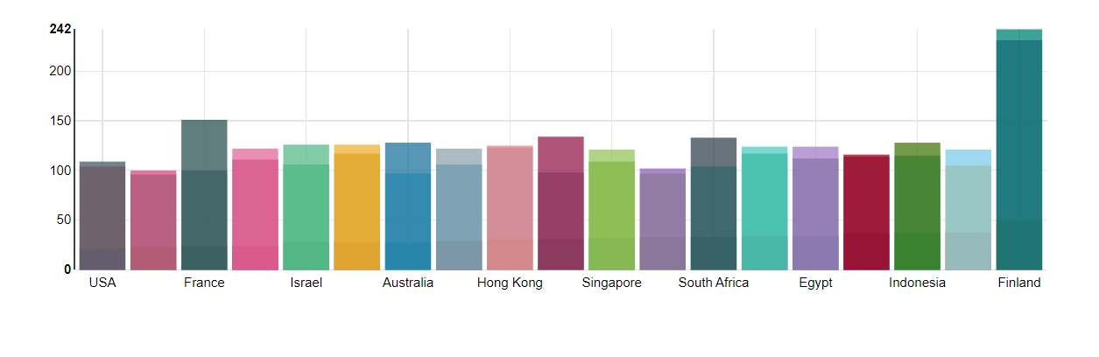

**-- Q2. Which country offices run hot (Hot offices can lead to employee complaints and reduced productivity)**

**-- and which offices run cold (Cold offices cause elevated energy expenditures and employee discomfort).**

**-- Calculate count of offices run in hot and count of office run in cold by country.**

select

country,

temp_range,

count(temp_range) Office_Count

from hvac_building

where temp_range != 'NORMAL'

group by country, temp_range;



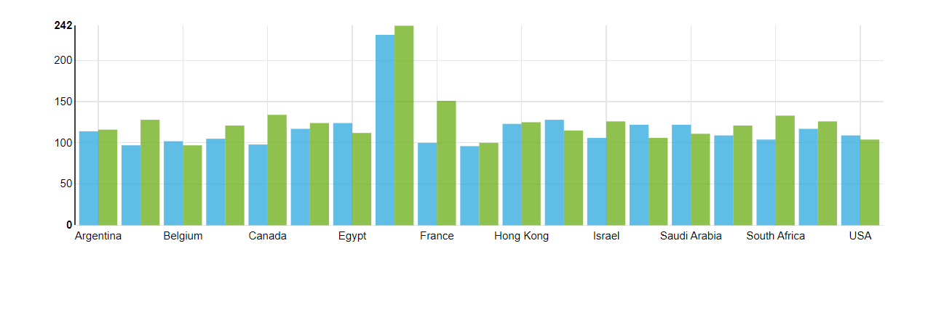

**-- Q3. Our data set includes information about the performance of five brands of HVAC equipment, distributed**

**-- across many types of buildings in a wide variety of climates. We can use this data to assess the relative**

**-- reliability of the different HVAC models(i.e We can see that the which model seems to regulate**

**-- temperature most reliably and maintain the appropriate temperature range). Calculate count of**

**-- extreamtemp by hvacproduct**

select

hvac_product,

sum(cast(extreme_temp as int)) as extreme_temperature

from hvac_building

group by hvac_product;



