## Step 1 – Certificate Installation:

* Click on P2SClientCert.pfx file
* Go through the steps of installing the certificate (Password: 1234)
* Install for Current User

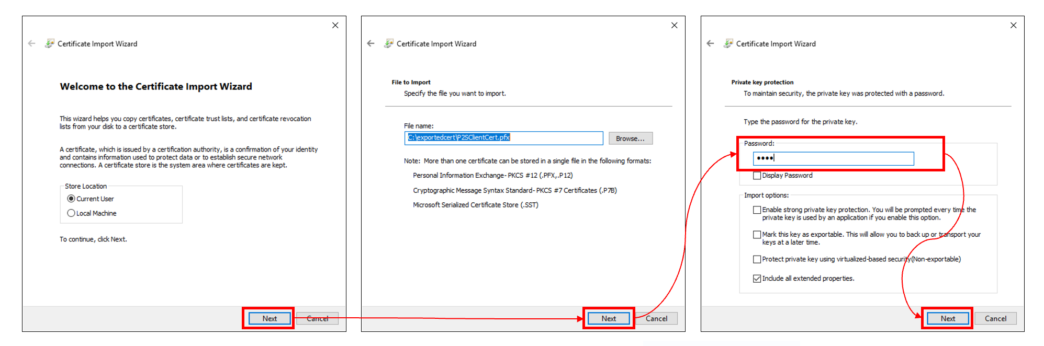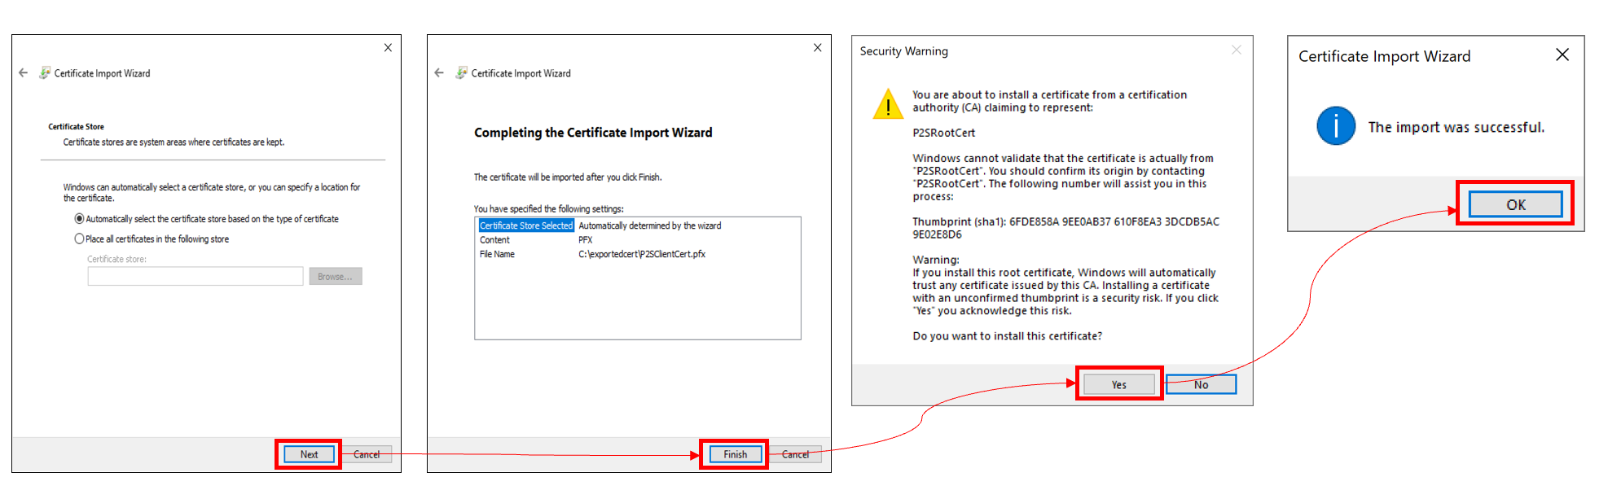

## Step 2 – Install VPN Client Profile

* Click on VPNClientSetupAmd64.exe
* Install the VPN Client
* Go to Settings->Network->VPN or just use Search at the bottom of the screen and type “VPN”
* Click on the VPN Profile and press Connect

## Step 3 – Run the Script

* Right Click on the MapDrive.ps1 and click Run with PowerShell
* The Script will first test the connectivity to the Drive
* Then the script will map the network drive to your Windows Machine on letter F: