**Project plan**

***Joint Efforts***

*Lectorate Interaction Design*

***Eindhoven***

|  |
| --- |
| **Date** **:** **Date 1/11/2023** |
| **Version** **:** **Version 0.3** |
| **Status** **:** **Reviewed** |
| **Author** **:** **Group 1 Advanced Media** |

#### Version

|  |  |  |  |  |
| --- | --- | --- | --- | --- |
| **Version** | **Date** | **Author(s)** | **Amendments** | **Status** |
| 0.1 | 11-10-2023 |  | Initial version | Reviewed |
| 0.2 | 30-10-2023 |  | Made the finished products, test environment, and project breakdown | Reviewed |
| 0.3 | 1-11-2023 |  | Changed the risks and scope based on a talk with the stakeholders (Dennis & Teague) | Reviewed |

**Table of content**

Version 1

1. Project Assignment 3

1.1 Context 4

1.2 Goal of the project 4

1.3 The assignment 4

1.4 Scope 4

1.5 Conditions 5

1.6 Finished products 5

1.7 Research questions 5

2. Approach and Planning 5

2.1 Approach 5

2.2 Research methods 6

2.3 Breakdown of the project 7

2.4 Time plan 7

3. Project Organization 7

3.1 Team members 8

3.2 Communication 8

3.3 Test environment 8

4. Finance and Risks 8

4.1 Cost budget 9

4.2 Risks and fall-back activities 9

# Project Assignment

## Context

During this semester, our group will be working on the Joint Efforts (Samen aan Z) project for the Lectorate Interaction Design of Fontys University of Applied Sciences. This project is an ongoing project with healthcare in the Netherlands and in Belgium.

The Healthcare industry has been suffering from a rising staff shortage for the past few years. Job openings aren't being filled and in the short term there is a need for replacement in the current health and care sectors, because one in three Flemish people are 50 years of age. In North-Brabant 36% of Dutch people are 55 years of age and in Zeeland that number is 43%

In order to tackle these issues and get insight from the source (the healthcare professionals) our partner companies created a set of surveys to gather insightful data that could help find the right solutions and create the right working environment for them to keep growing.

The Joint Efforts project is a collaboration between several companies and research institutions. There have already been some things presented to the stakeholders of the project, for instance the dashboard for the researchers.

## Goal of the project

The goal of Joint Efforts is to gather as much useful data as possible from surveys, so that researchers can research the data and potentially find solutions to the low healthcare worker retention. By researching with the surveys, the project aims to create a work environment that doesn't stress out the healthcare workers and keeps them motivated an interested in their work while they get the chance to learn and develop themselves. The Joint Effort projects want to connect several organisations to divide the workload between different organisations and thus increase the impact and possibilities of the project, as tried before by organisations during the COVID-19 pandemic.

The goal of the lectorate project is to develop and design a dashboard where healthcare workers can see their data, how it's being used and why they should fill in the surveys.

## The assignment

Our assignment is to design a dashboard that makes it appealing for healthcare workers to fill in the surveys as provided by the Joint Efforts project and to give them more information regarding how their data is being used to improve their working conditions.

## Scope

|  |  |
| --- | --- |
| **The project includes:** | **The project does not include:** |
| 1. Dashboard for healthcare workers | 1. Dashboard for the researchers |
| 1. Design a website for desktop and or mobile | 1. Making changes to the surveys made by the project |
| 1. Physical interactions to entice workers to fill in the survey |  |

## Conditions

The researcher dashboard uses Angular and Tailwind. These are libraries that we also have to use to make the project more transferable. We also won't be able to adjust the surveys that were previously made.

## Finished products

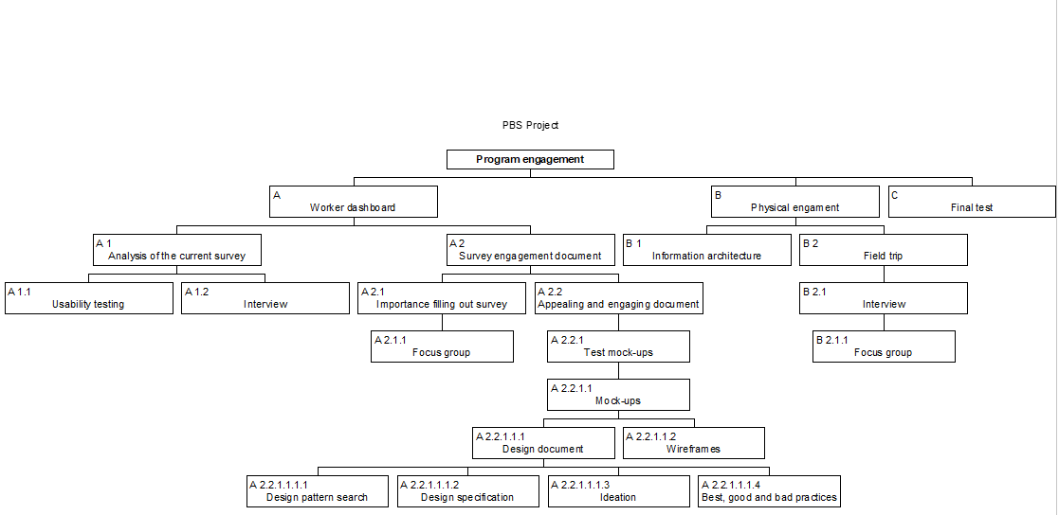

## Research questions

Main research question:

How can we make the existing program more appealing and engaging to healthcare workers?

1. Sub-question: What are the issues of the current surveys?
2. Sub-question: How do we communicate the importance of the survey to the healthcare workers in the dashboard?
3. Sub-question: What are ways that we can make the program more appealing to fill in?
4. Sub-question: What are ways that we can make the program more engaging to fill in?
5. Sub-question: How can we make an appealing dashboard in terms of design for the healthcare workers?

# Approach and Planning

## Approach

We are going to use scrum for the project. We are going to have sprints of 2 weeks. We start every day with a standup, to check how everyone is doing and how the products are coming along. At the end of the sprint, we'll have a sprint demo for our stakeholder. After the sprints we are also going to do retrospective to reflect what went well in the sprint and what could be improved upon in the next sprint.

## Research methods

For the research question ‘What are the issues of the current survey?’ we are going to use the CMD method usability testing. This way we can experience ourselves how long the survey is and what we as non-healthcare workers experience during the filling out of the survey. This way we can find the general problems of the survey. We're also going to use the research method (expert, if possible) interview. An expert interview could help us point out more efficiently what are the main issues with the survey and how they affect the goals of this project. An interview brings the users perspective on the issues these surveys might have and helps us identify what kind of design approach we might use.

For the research question ‘How do we communicate the importance of the survey to the healthcare workers in the dashboard?’ we are going to use the CMD method Focus Group. By communicating directly with the users and making them part of the design process, we can bring their unique professional and personal context that will help us understand how the surveys importance relates to their daily tasks and responsibilities. This will also help us convey this importance within our design process. We are also going to use the method Diaries and Probes. We will rely on direct communication and interpersonal interactions. By doing things such as providing participants with diaries where they can record their daily experiences with survey, we will be able to find any specific information that is related to our topic. This will aim to understand participants experiences and perspectives in a more personal and interactive manner.

For the research question ‘What are ways that we can make the surveys more appealing to fill in?’ we are going to use the CMD methods Design Pattern search to find potential solutions for this common problem. The second CMD method that we are going to use is Design Specification. This method would describe precisely the characteristics of the product that leads to the chosen choices.

For the research question ‘What are ways that we can make the surveys more engaging to fill in?’ we are going to use the CMD method Best, Good and Bad practices to identify the best outlines for our design, what good practices can be beneficial to our design and how to avoid the bad ones to have the best scenario to create an engaging product for our users. The second method we would be using is Ideation. This will allow the generation/creation of new ideas by using existing techniques, for example Brainstorming, using analogies and metaphors, to conclude what the best practices are to create an engaging product.

For the research question ‘How we can make an appealing dashboard in terms of design for the healthcare workers?’ we are going to use the CMD methods Literature Study and Prototyping. The literature study would help to have an insight on the best practices used in a good dashboard and guide us toward an ideal dashboard for our user. The prototyping will be useful to test out the final product and concept and receive feedback from the end users.

|  |  |  |
| --- | --- | --- |
| **Research question** | **CMD method 1** | **CMD method 2** |
| What are the issues of the current survey? | Usability testing | (Expert) interview |
| How do we communicate the importance of the survey to the healthcare workers? | Focus Group | Diaries and probes |
| What are ways that we can make the surveys more appealing to fill in? | Design Pattern Search | Design Specification |
| What are ways that we can make the surveys more engaging to fill in? | Best, Good and Bad practices | Ideation |
| How can we make an appealing dashboard in term of design for the healthcare workers? | Literature Study | Prototyping |

## Breakdown of the project

We are going to start the project with an analysis into the current problems of the survey. We then are going to investigate conveying the importance of the survey and at the same time looking into how to make the survey more appealing and engaging. With this information on how to make it more engaging and appealing we are going to make a design document. After which we are going to design mock-ups which we are going to test with our target audience. We are then going to take their feedback and make a final version of our prototype.

## Time plan

|  |  |  |
| --- | --- | --- |
| **Phasing** | **Start** | **Ready** |
| 1. Analysis of the survey | 31-10-2023 | 11-11-2023 |
| 1. Importance of the survey | 13-11-2023 | 24-11-2023 |
| 1. Design document | 13-11-2023 | 24-11-2023 |
| 1. Mock-ups | 27-11-2023 | 8-12-2023 |
| 1. Testing | 11-12-2023 | 15-12-2023 |
| 1. Final prototype | 18-12-2023 | 12-01-2024 |

# Project Organization

## Team members

|  |  |  |  |
| --- | --- | --- | --- |
| **Name** | **Abbr.** | **Role/tasks** | **Availability** |
| *Tessa van de Langenberg* | *TL* | *Team Lead*  *Reserve Contact Person* | *Every workday from 9 to 4, except Friday* |
| *Robin Friesen* | *RF* | *Contact Person*  *Reserve Team Lead* | *Every workday from 9 to 4* |
| *Matias Flores* | *MF* | *Presentation Lead*  *Reserve Note Taker* | *Monday to Friday from 9 to 4* |
| *Sarah* | *SD* | *Note Taker* | *Every workday from 9 to 4 except Friday all day and Monday Morning.* |
| *Adryan* | *ABS* | *Document Manager* | *Monday to Thursday 9 to 4* |
| *Dylan Pipping* | *DP* | *Time Manager* | *Work project Monday to Thursday from 09:00 till 16:00 and Friday work from 09:00 till 16:00 on portfolio.* |
| *Dennis Kirsch* | *DK* | *Stakeholder* | *Tuesday and Wednesday, unknown times* |
| *Rose Weterings* | *RW* | *Coach* | *Monday & Tuesday from 13-16h* |
| *Teague Murray Marshall* | *TM* | *Software Stakeholder* | *Unknown* |

## Communication

We have weekly meetings with our semester coach at 13:30 every Monday to discuss what we've done that week and if we came across any problems and to receive feedback. We also want to setup biweekly meetings with Dennis, our stakeholder for the project. Every day we have a standup at 10:00 to discuss what we're going to do during the day and to discuss the upcoming planning.

## Test environment

We're going to test with a group working within the project, as well as people outside of it that are part of the target audience (healthcare workers). We will conduct tests both during a special testing sprint of the project, as well as during the other sprints/parts of the project development. For now, we cannot conform the specifics of this as it is still a WIP in both terms of user contact and testing grounds.

# Finance and Risks

## Cost budget

Regarding the cost budget for this project, we are (at the moment) not in need of any budget, as we have currently everything in disposition. If, at any time during this project, we are in need of a sum, this will be discussed with our stakeholder.

## Risks and fall-back activities

|  |  |  |
| --- | --- | --- |
| **Risk** | **Prevention activities included in plan** | **Fall-back Activities** |
| 1. Contact problems with stakeholders and/or test users | Try to get in contact with the test group as soon as possible | Test the product with the people available within the project |
| 1. Project design limitations | Adapt the design and scope of the project accordingly within our capabilities | Try to work around the frigidity of the project |
| 1. Dutch Design Week and Autumn holiday time constraints | Schedule the timeline and scope of the project accordingly | Try to do as much work in the time we have for the project |
| 4 Team conflicts and/or breakup | Communication within the team and with semester coach.  Making a group contract and following the contract. | Restructure of workflow, seek semester coach for help and advice |
| 5 Illness or long-term unavailability of group member | Team communication (updates, finding ways to continue work) | Back-up roles assignment.  Reducing the scope depending on how many group members are ill and for how long |