


Sri Sri University
Predictive Maintenance for Aircraft Engines & Aviation Safety

SYNOPSIS
Predictive Maintenance

Baccalaureus Technologiae
Faculty Of Engineering & Technology

SUBMITTED BY
Subham Nayak | FET-BDS-2022-26-019
Indigibilli Harshit | FET-BDS-2022-26-015
Dhruti Deepam Mohapatra | FET-BDS-2022-26-005
Khushi Singhania | FET-BDS-2022-26-013
Lokesh Patra | FET-BDS-2022-26-20

Under the Guidance of
Dr. Pradipta Kumar Mishra
Asst. Professor
Faculty Of Engineering & Technology
Sri University

Content
Sl. No. | Topics | Page
1 | Introduction | 00
2 | Literature Survey | 01
3 | Methodology | 02
4 | Facilities Required for Proposed Work | 03
5 | Reference | 04

~ Introduction ~
Predictive Maintenance

Predictive maintenance (PdM) is a data-driven, proactive approach that aims to improve the reliability and safety of aircraft operations by forecasting potential failures and anomalies in aircraft components and engines. It can help airlines reduce maintenance costs, optimize resource allocation, and minimize downtime.
However, applying PdM in the aviation industry poses several challenges, such as the complexity and heterogeneity of the data, the high accuracy and reliability requirements, and the regulatory and ethical issues. In this project, we propose to develop a Data Science + Machine Learning based PdM system for aircraft engines that can leverage sensor and historical data to perform failure prediction and anomaly detection.
We will also evaluate the performance and impact of our system on maintenance planning and decision making.

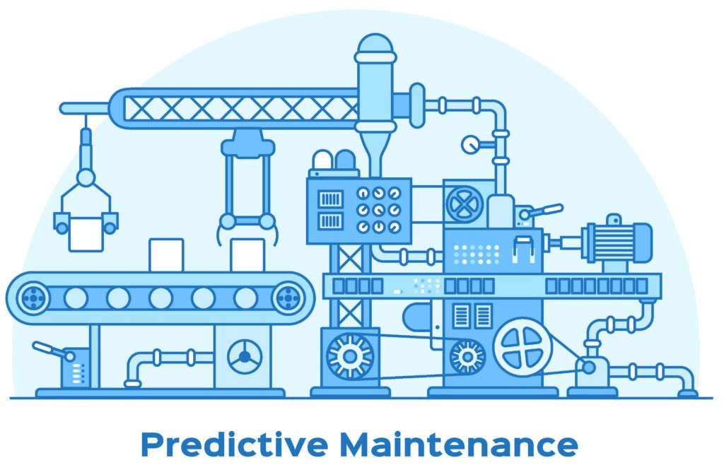

~ Literature Survey ~

Numerous projects have been made in the bright past of science which put light on the predictive maintenance of aeronautical safety. Our minor project has also been inspired by a few of them as listed below:

- Maria E., Jihad A., Mustafa H., Abdel M. (2022) | Towards Predictive Maintenance: The Case of The Aeronautical Industry | Procedia Computer Science [ Vol. 203, p.769 - 774 ] | Industrial Engineering Department AICSE Laboratory, ENSAM University Of Hassan II + Mathematics and Computer Sciences Department LTIM Laboratory, Faculty Of Sciences, University Of Hassan II, Casablanca 7955, Morocco
- Michael J. S., Wim J. C. V., Maria T. B., Pier M., Jongmyon K., Farzin P. (Sep. ‘22) | Predictive Maintenance for Defence Fixed-Wing Aircraft Sustainment and Operations | PubMed Central® | National Library of Medicine
- Izaak S., Kamran M., Ahsan I., Muhrad E. B. (2022) | Predictive Maintenance Analytics and Implementation for Aircraft: Challenges and Opportunities | Systems Engineering [ Vol. 2, Issue 2, p. 216 - 237 ]
- Juseong L., Mihaela M., Henk A. P. B., Pierre B., Floris F. (Feb. ‘23) | Analysing Emerging Challenges for Data-Driven Predictive Aircraft Maintenance Using Agent-Based Modelling and Hazard Identification | Aerospace Engineering [ Vol. 10, Issue 2, p.186 ] | Faculty of Aerospace Engineering, Delft University of Technology, Kluyverweg 1, 2629 HS Delft, The Netherlands + ONERA/DTIS, Université de Toulouse, BP 74025, CEDEX 04, 31055 Toulouse, France
- Sharan H. (2022) https://www.kaggle.com/code/sharanharsoor/aircraft-predictive-maintenance [ Python \ DataScience \ MachineLearning \ Aeronautics ] 5133 Views
- Maren D. D., Ian K. J., Steve K., Zakwan S. (Mar. ‘22) | A Rare Failure Detection Model for Aircraft Predictive Maintenance Using a Deep Hybrid Learning Approach | Neural Computing & Applications [ Vol. 35, p. 2991 - 3009 ] | 15K Accesses + 5 Citations
- Nhungoc (2019)
https://www.kaggle.com/code/ngocbe643/predict-maintenance-21-sensor
[ Python \ DataScience \ MachineLearning \ Aeronautics ] 7080 View
~ Methodology ~
- Data Collection & Pre-Processing
To obtain and process the data, these steps were followed:
- Data Acquisition
- Data Preprocessing
- Data Analysis
- Data Science & Machine Learning Algorithms
The data science and machine learning algorithms that are used for predictive maintenance for aircraft engines and aviation safety are as follows:
- Long Short-Term Memory (LSTM) Networks
- Support Vector Machines (SVM)
- Random Forests (RF)
- Failure Prediction & Anomaly Detection
To perform failure prediction and anomaly detection, I will use the following steps:
- Failure Prediction
- Anomaly Detection
- Performance Evaluation
- Maintenance Planning & Decision Making
To provide recommendations and insights for maintenance planning and decision making, we use the following steps:
- Maintenance Optimization
- Maintenance Impact

~ Facilities Required for Proposed Work ~

Software Requirements:
Python Environment | ML Model Building Libraries | Visualization Modules:
Pandas
NumPy
MatPlot Library
Seaborn
OS: For File Manipulation
SciKit Learning
TensorFlow
…

Hardware Requirements:
Windows 10+ | 4GB+ RAM | 20GB+ Storage | Faster Processor

~Reference~

[1] Deep Learning for Predictive Maintenance https://github.com/Azure/lstms_for_predictive_maintenance/blob/master/Deep%20Learning%20Basics%20for%20Predictive%20Maintenance.ipynb/
[2] Predictive Maintenance: Step 2A of 3, Train and Evaluate Regression Models https://gallery.cortanaintelligence.com/Experiment/Predictive-Maintenance-Step-2A-of-3-train-and-evaluate-regression-models-2/
[3] A. Saxena and K. Goebel (2008). "Turbofan Engine Degradation Simulation Data Set", NASA Ames Prognostics Data Repository
https://ti.arc.nasa.gov/tech/dash/groups/pcoe/prognostic-data-repository/#turbofan
NASA Ames Research Centre, Moffett Field, CA
[4] Sharan H. (2022)
https://www.kaggle.com/code/sharanharsoor/aircraft-predictive-maintenance
[ Python \ DataScience \ MachineLearning \ Aeronautics ] 5133 Views
[5] Sander de B. (2023) Maximize the Benefits of Predictive Maintenance in Aircraft Maintenance
https://www.exsyn.com/blog/how-to-maximize-the-benefits-of-predictive-maintenance-in-aircraft-maintenance#:~:text=With%20predictive%20maintenance%2C%20the%20idea,components%20would%20justify%20performing%20maintenance
[ Predictive Maintenance | Data Analytics | Aircraft Data ]

