**–Create a DataBase**

CREATE DATABASE ecommerce;

**–Switch to the created database**

USE ecommerce;

**Create the customers Table**

CREATE TABLE customers(

id INT AUTO_INCREMENT PRIMARY KEY,

name VARCHAR(20) NOT NULL,

email VARCHAR(20) UNIQUE NOT NULL,

address VARCHAR(255) NOT NULL

);

**Create the orders Table with a foreign key as customer id**

CREATE TABLE orders(

id INT AUTO_INCREMENT PRIMARY KEY,

customer_id INT NOT NULL,

order_date DATE NOT NULL,

total_amount DECIMAL(10,2) NOT NULL,

FOREIGN KEY (customer_id) REFERENCES customer(id)

);

**Create the products table**

CREATE TABLE products(

id INT AUTO_INCREMENT PRIMARY KEY,

name VARCHAR(100) NOT NULL,

price DECIMAL(10,2) NOT NULL,

description text

);

**Insert sample data to customers**

INSERT INTO customers(name,email,address)

VALUES

('Ligin George', 'ligin@gmail.com', 'C1, Gandhi Street'),

('Dhibahar', 'dhiabhar@gmail.com', 'D1 Park Street'),

('Satheesh', 'satheesh@gmail.com', '789 Pine Road');

**Insert sample data to products**

INSERT INTO products(name,price,description)

VALUES

('Product A', 20.00, 'Description of Product A'),

('Product B', 35.00, 'Description of Product B'),

('Product C', 50.00, 'Description of Product C'),

('Product D', 15.00, 'Description of Product D');

**Insert sample data to orders**

INSERT INTO orders(customer_id,order_date,total_amount)

VALUES

(1,CURDATE(),75.00),

(2,CURDATE() - INTERVAL 10 DAY, 45.00),

(3,CURDATE() - INTERVAL 35 DAY, 150.00)

(1,CURDATE() - INTERVAL 40 DAY, 30.00);

**Fetch customers who placed an order in the last 30 days**

SELECT c.* FROM customers c JOIN orders o ON c.id = o.customer_id WHERE o.order_date>= CURDATE() - INTERVAL 30 DAY;

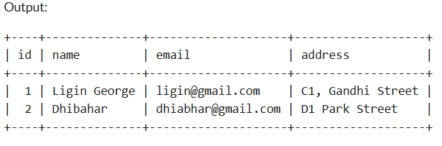

**Calculate total order amount for each customer**

SELECT c.name, SUM(o.total_amount) AS Total_spent FROM customers c JOIN orders o ON c.id=o.customer_id GROUP BY c.name;

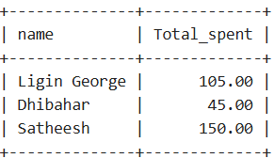

**Update the price of Product C - Initially it was 50.00**

UPDATE products SET price=45.00 WHERE name='Product C';

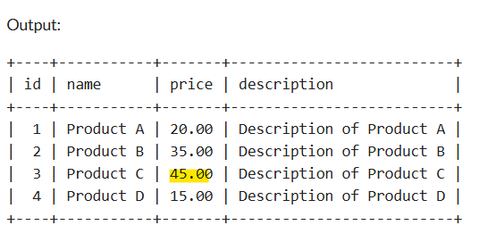

**Add a discount column to the products table - defaulting all the values to zero**

ALTER TABLE products ADD COLUMN discount DECIMAL(10,2) DEFAULT 0.00;

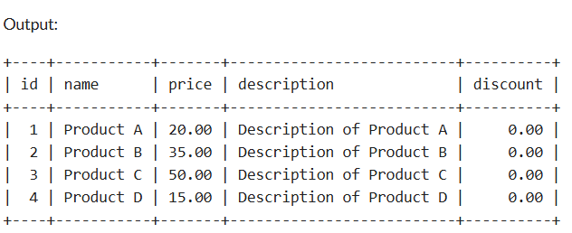

**Get the top 3 most expensive products**

SELECT * FROM products ORDER BY price DESC LIMIT 3;

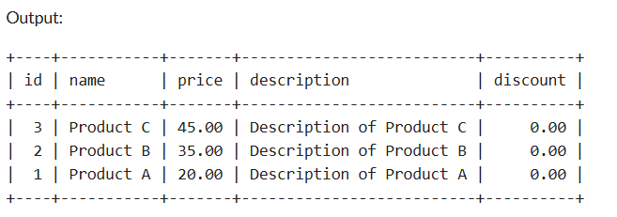

**Add Normalization step to include an order_items table**

CREATE TABLE order_items(

id INT AUTO_INCREMENT PRIMARY KEY,

order_id INT NOT NULL,

product_id INT NOT NULL,

quantity INT NOT NULL,

FOREIGN KEY (order_id) REFERENCES orders(id),

FOREIGN KEY (product_id) REFERENCES product(id)

);

**Inserting sample data to order_items**

INSERT INTO order_items(order_id,product_id,quantity)

VALUES

(1,1,2),

(2,2,1),

(3,3,3);

**Fetch the customer names who ordered Product A**

SELECT c.name FROM customers c JOIN orders o ON c.id=o.customer_id JOIN order_items oi on o.id = oi.order_id JOIN products p ON p.id = oi.product_id WHERE p.name='Product A';

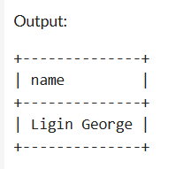

**Fetch customer names and their order dates**

SELECT c.name,o.order_date FROM customers c JOIN orders o ON c.id = o.customer_id

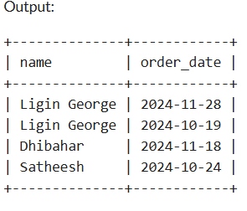

**Fetch orders with a total amount exceeding 150.00**

SELECT * FROM orders WHERE total_amount > 150;

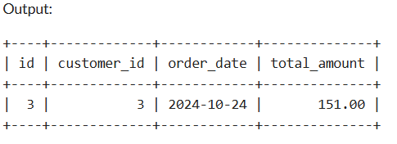

**Calculate the average total amount of all orders**

SELECT AVG(total_amount) AS average_order_total from orders;

