Modular Water Quality Monitoring for Clam Processing
  - System deployment and architecture progress report
Lihong Yang / Virginia Tech student internship
Status as of November 14, 2026

Abstract
A modular monitoring system is being developed for wastewater at a clam processing facility. Three independently programmed ESP32-S3 nodes acquire dissolved oxygen, oxidation–reduction potential, electrical conductivity, associated temperatures, and estimated salinity. Sensor records are transmitted over a local wireless network to a Jetson Orin Nano running an authenticated MQTT broker, a Python receiver, SQLite storage, and a browser dashboard. An Ethernet camera supplies a separate image stream for live viewing. Sensor telemetry and dashboard integration have been demonstrated. Live camera frames at the new static address were verified on November 14, 2026. Calibration and compensation are not yet analytically verified. The present contribution is the acquisition and visualization infrastructure; a trained biochemical oxygen demand model and a synchronized image archive are not yet implemented. This report describes the deployment sequence, system architecture, evidence boundaries, and procurement inventory needed to advance toward a validated multimodal monitoring platform.
Keywords: water quality; clam processing; ESP32; edge gateway; multimodal monitoring; MQTT

Specifications
Field | Current implementation
Hardware | Modular sensor nodes and Ethernet camera with a Jetson gateway
Application | Environmental monitoring for a clam processing facility
Acquisition | DO and ORP over RS485; EZO-EC over UART; RGB over RTSP
Software | Arduino firmware / Mosquitto / Python / SQLite / browser UI
Evidence stage | Bench and local-network commissioning; analytical validation pending
Inventory amount | 2,262.32 as listed; currency unspecified; see Appendix A and B
Source baseline | clam_factory_deployment / local Git revision a85608c
Firmware, operating procedures, and procurement records are organized by device to support replication and subsequent performance testing.

1 System deployment

Intended use and hardware context
The first deployment stage gives workers one page for current water-quality readings and camera imagery. Each sensor board is commissioned separately so that wiring, firmware, network identity, and data quality can be traced to an individual device. Actuator control is outside the current scope. Laboratory BOD₅ estimation is a later research objective, rather than an existing measurement channel.
TinZr demonstrates a modular microcontroller approach to external sensor integration and reports communication, acquisition, and performance tests separately [1]. Water-monitoring studies in HardwareX likewise describe the hardware and data path alongside application-specific validation: Ryu reports a real-time water-quality monitoring and visualization platform [2], while Martinez Vargas et al. document a modular acquisition platform for complex water environments [3]. These precedents inform the organization of this report; their performance results are not evidence for the present system.

Device configuration and commissioning state
Table 1. Project slots and measured quantities. A reserved slot is not an installed sensor.
Slot | Hardware and quantities | Deployment state
01 | DFRobot SEN0681  DO, oxygen saturation, temperature | Real telemetry and dashboard
02 | DFRobot SEN0709  ORP and temperature | Real telemetry and dashboard
03 | pH node | Planned; inventory also lists an ammonia/pH unit
04 | Turbidity node | Planned; sensor not purchased in batch list
05 | Atlas EZO-EC with K10 probe  EC and estimated salinity | Real telemetry and dashboard; firmware 0.1.4
06 | Barlus IPC5MPIR-PBX10  RGB camera | Live JPEG preview verified at new IP on November 14, 2026
07 | UV254 / optical COD proxy | Provisional; hardware not selected

Power and physical assembly
DO and ORP use RS485-to-TTL interfaces between the probes and their ESP32 boards. The EC node uses an electrically isolated EZO carrier and UART rather than an RS485 converter. Its confirmed signal connections are ESP32 GPIO17 to carrier RX and GPIO18 to carrier TX, with 3.3 V and GND at the carrier. USB connects the Mac during programming and diagnostics.
The reported sensor supply is rated 12 V DC, 5 A. Standalone ESP32 power uses a regulated 5 V rail at the 5V/GND pins. The exact regulator and power-distribution wiring remain to be documented; 12 V must not be applied to the 5 V pin. The camera is separately powered. Enclosure, strain relief, and wet-area installation details require completion before routine factory use.

Deployment procedure
Commissioning follows the same sequence for each node. First, identify the probe, interface board, voltage rails, and UART assignment. Flash the node-specific sketch from the Mac, then read the serial diagnostics to confirm device identity and valid sensor responses. Record the Wi-Fi station MAC and reserve the intended address in the router. Reconnect or renew the lease and confirm the active address rather than relying only on the reservation field.
Next, create the node’s MQTT account and topic permissions on the Jetson. Verify receipt of real telemetry at the broker, then verify the same node and sequence in the gateway and dashboard. A broker connection alone is not a database check. Run Mosquitto and the gateway as systemd services so central acquisition can restart independently of the development computer.
The camera is commissioned separately: connect Ethernet to a router LAN port, discover the stream through ONVIF, and configure the private RTSP URI on the Jetson. After a camera address change, verify a newly received image and its age. A successful ping establishes network reachability but does not establish video recovery.

Network configuration
Table 2. Addresses are deployment records, not assumptions about current reachability.
Device | LAN address | Evidence or remaining action
Router | 192.168.88.1 | MikroTik project LAN
Jetson | 192.168.88.250 | Gateway and MQTT operation verified
Node 01 | 192.168.88.101 | Reserved address verified
Node 02 | 192.168.88.102 | Confirmed in serial diagnostics
Node 05 | 192.168.88.105 planned | Last observed at .97 on November 12; reserve .105
Camera 06 | 192.168.88.106 static | Live preview checked November 14; DHCP conflict prevention pending

Evidence and remaining validation
Nodes 01, 02, and 05 have delivered real sensor data to the deployed gateway and web interface [5]. Node 01’s initial MQTT checkpoint includes successive five-second records; Node 02 later reported synchronized UTC and connected MQTT. EC and its estimated-salinity field have been integrated without marking their calibration as verified. After the static-IP migration, three checks six seconds apart returned fresh JPEGs with advancing timestamps. The configured camera host was .106, and a retrieved laboratory image was visually inspected on November 14, 2026.
These checks establish functional acquisition, transport, and display. They do not quantify accuracy, packet loss, uptime, latency, or performance in factory wastewater. ORP calibration received an undocumented reply, and EC calibration writes were followed by inconsistent independent checks. All three nodes therefore retain unverified calibration and compensation status. Earlier microSD I/O errors also make storage endurance and recovery tests necessary before unattended operation.

2 Architecture

Acquisition and communication paths
The architecture separates low-rate numerical telemetry from camera decoding. ESP32 nodes publish sensor records through the local router; the camera streams directly to a dedicated worker on the Jetson. The browser receives normalized JSON and JPEG images from the gateway and does not connect to the probes or use broker credentials.
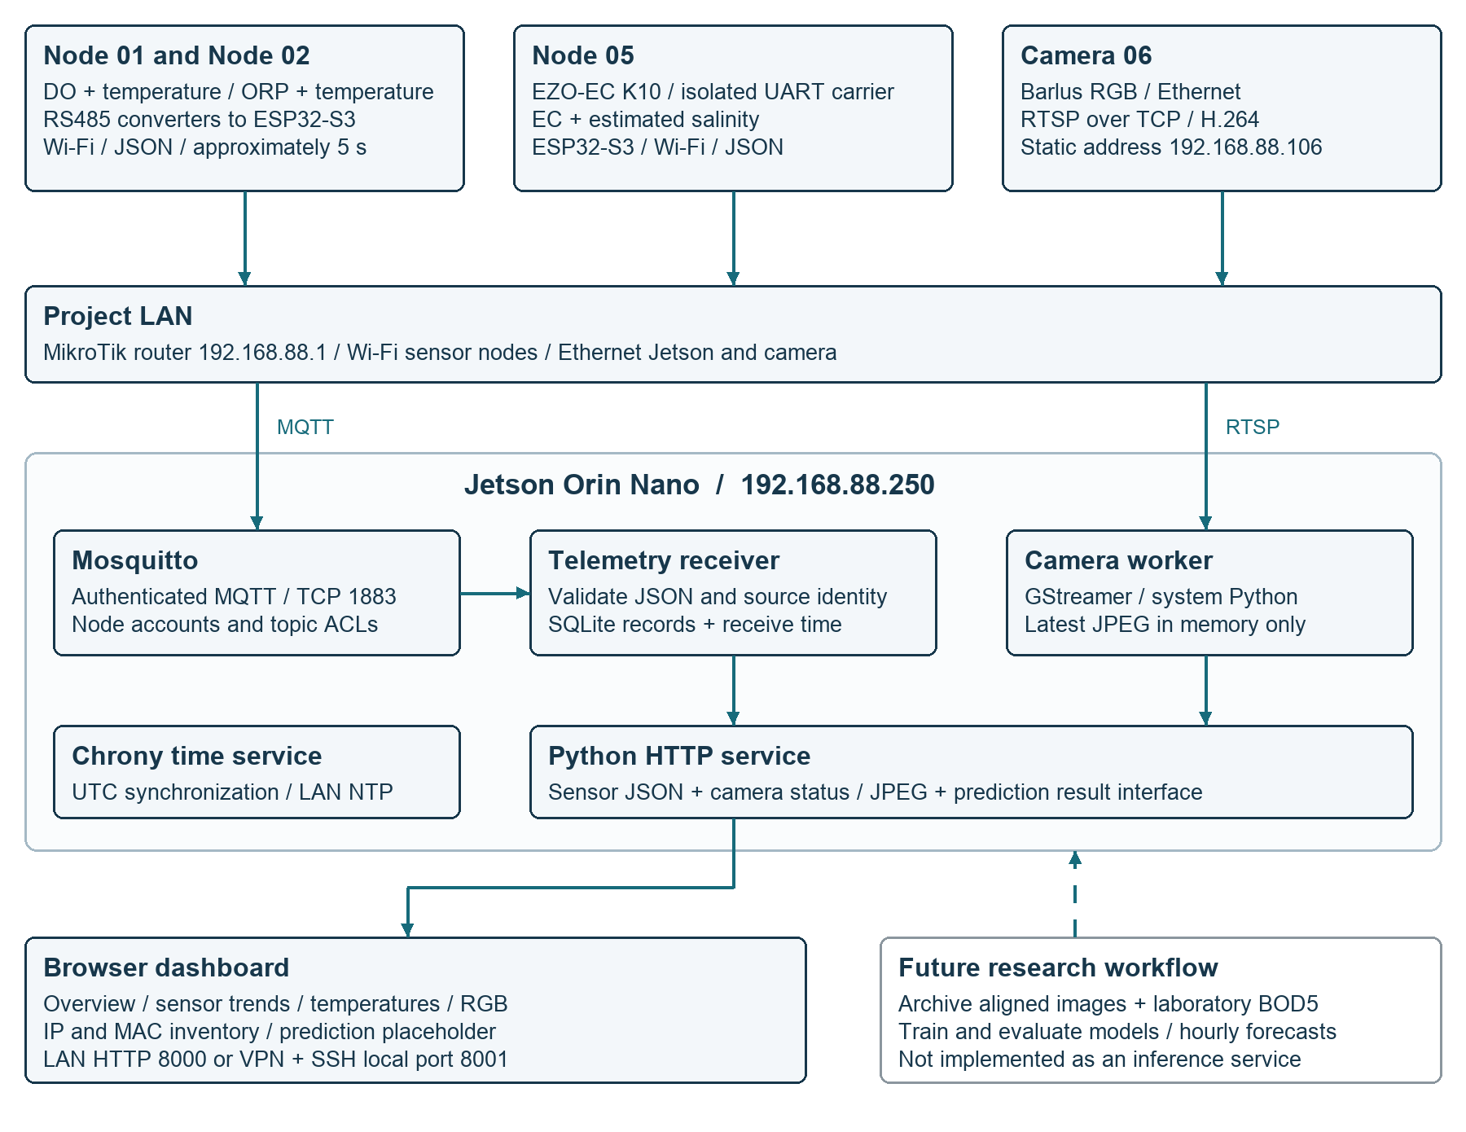
Figure 1. Implemented transport and presentation paths. The future research connection is dashed. Live JPEG delivery at 192.168.88.106 was verified on November 14, 2026. Chrony provides a common UTC reference; it does not hardware-trigger simultaneous sampling.

Sensor transport and gateway persistence
Each node publishes schema-versioned JSON approximately every five seconds to its own clam/node_XX/telemetry topic. MQTT uses authenticated accounts, topic access control, and QoS 1. The gateway subscribes to the node telemetry namespace, validates messages, and stores accepted records in SQLite. A node identifier, boot identifier, and sequence number support duplicate detection and distinguish a reboot from a continuation of the same acquisition run.
Gateway acknowledgments follow successful database processing. Nodes do not maintain a durable offline queue, so the design cannot guarantee lossless collection during network or gateway outages. Raw payloads and explicit quality fields are retained to support later diagnosis rather than replacing unavailable readings with fabricated values.

Time and measurement quality
The record carries sample_time_utc, uptime_ms, clock_status, sensor_status, calibration_status, and compensation_status. A node without synchronized time sends a null UTC timestamp. The gateway independently records reception time, preserving the difference between sampling and arrival. Chrony on the Jetson provides the LAN time service after synchronization with upstream NTP sources.
Table 3. Interpretation of the quality fields shown to operators.
Field | Meaning | Current interpretation
Sensor response | Communication and decoding result | OK does not establish analytical accuracy
Node clock | Availability of synchronized sample UTC | Sample UTC available; timing accuracy not independently quantified
Calibration | Evidence for sensor calibration | UNVERIFIED until the procedure and independent checks pass
Compensation | Evidence for applied environmental settings | UNVERIFIED; configured values are not independent measurements
The temperature page preserves DO and ORP temperatures separately and averages only valid, fresh sources. This is an equal-weight display summary, not a replacement for the original readings or a demonstrated uncertainty reduction. Node 05’s compensation temperature is a configuration value and is excluded. EZO-derived salinity is calculated from the same EC measurement; it is not a second independent sensor and remains provisional for the wastewater matrix.

Dashboard and camera behavior
The English dashboard groups chemical properties, physical properties, and image information. It provides an Overview, sensor detail pages, a multi-probe temperature view, a prediction page, and a separate IP and MAC inventory. Missing integrations are labeled explicitly. Sensor polling is every five seconds, and stale readings are identified rather than presented as current.
GStreamer decodes the camera stream on the Jetson and retains only the latest JPEG in memory. The browser refreshes the preview every two seconds. Frames older than ten seconds are unavailable, and frame time represents gateway reception rather than verified camera exposure. Images and video are not currently archived. Authorized remote viewing uses VT VPN and an SSH tunnel to local port 8001; the dashboard is not a public Internet service.

Prediction interface and the BOD research path
The existing prediction page and read-only result API are prepared for hourly batches forecasting selected measurements 12 hours ahead. No trained LSTM, scheduled inference process, or BOD prediction is deployed. The present prediction contract covers DO, ORP, and their source temperatures, rather than every future sensor.
A BOD₅ study will require paired laboratory reference samples, production context, and an image archive aligned with sensor time windows. Model development should compare sensor-only and image-assisted inputs, separate training and test periods, and report errors on held-out process conditions. These are proposed research steps; no predictive performance is claimed.

3 Appendix

Appendix A Batch inventory
Source: Batch1-111626.xlsx, Sheet1, rows 3–26 [6]. The worksheet is labeled for November 16, 2026, which is later than this report’s status date. It is treated as a procurement and inventory schedule, not proof that every listed item is commissioned. Descriptions below are shortened; row numbers preserve traceability to the original workbook.
Amounts are reproduced as listed. The workbook does not explicitly identify the currency. Quantities refer to the listed purchasing unit, including packs. Zero-priced entries are existing laboratory items, not evidence of zero replacement cost. H denotes Hokiemart order 464879; P denotes P-card; L denotes available laboratory inventory; U denotes an unspecified procurement source.
Table A1. Complete priced inventory, including zero-priced laboratory items.
Row | Component and purchasing unit | Qty | Unit amount | Line amount | Source
3 | DO probe / RS485 fluorescence, seawater | 1 | 164.68 | 164.68 | P
4 | ORP probe / industrial RS485 | 1 | 192.28 | 192.28 | P
5 | Conductivity K10 kit | 1 | 242.99 | 242.99 | P
6 | Ammonia nitrogen and pH sensor / RS485 | 1 | 0.00 | 0.00 | L
7 | Barlus underwater camera / 5 MP, IP68, 32 ft cable | 1 | 205.00 | 205.00 | H
8 | MikroTik router / C53UiG+5HPaxD2HPaxD | 1 | 165.99 | 165.99 | H
9 | ESP32-S3 N16R8 boards / pack of 3 | 2 | 18.05 | 36.10 | H
10 | Waveshare isolated TTL-to-RS485 converter | 4 | 18.99 | 75.96 | H
11 | SanDisk Extreme microSD / 1 TB + adapter | 1 | 234.88 | 234.88 | H
12 | NVIDIA Jetson Orin Nano Super Developer Kit | 1 | 399.00 | 399.00 | H
13 | Electrically isolated EZO carrier board | 2 | 0.00 | 0.00 | L
14 | Jumper-wire assortment / 120 pieces | 1 | 13.99 | 13.99 | H
15 | HDMI cable | 1 | 0.00 | 0.00 | L
16 | USB power adapters / 5 V, 2 A, pack of 10 | 1 | 21.99 | 21.99 | H
17 | USB power/data cable / 3 ft, pack of 2 | 3 | 9.49 | 28.47 | H
18 | Lever connectors / 2-in 8-out, pack of 10 | 1 | 11.39 | 11.39 | U
19 | ALITOVE sensor power supply / 12 V, 5 A | 2 | 12.99 | 25.98 | H
20 | Anhydrous sodium sulfite / 500 g | 1 | 41.29 | 41.29 | H
21 | ORP test solution / 200 mV, 500 mL | 1 | 114.00 | 114.00 | H
22 | ORP test solution / 600 mV label, 500 mL¹ | 1 | 114.00 | 114.00 | H
23 | Plastic clips / pack of 32 | 1 | 7.59 | 7.59 | H
24 | Power strip / 15 outlets, USB-A and USB-C | 2 | 31.98 | 63.96 | H
25 | BTSKY carry box / two layers | 1 | 22.79 | 22.79 | H
26 | Spectra monitor / size notation to confirm | 1 | 79.99 | 79.99 | H
¹ Row 22 is identified as 600 mV in the material column, but its model column says 200 mV. The line amount is unchanged. See Appendix B for reconciliation.
Rows 31–32 list turbidity and COD sensors as not yet purchased, with no quantities or prices. They are excluded from the priced total. The future UV254/COD-proxy instrument remains unselected; the inventory label is not a confirmed sensor specification.

Appendix B Inventory reconciliation
Table B1. Arithmetic reconciliation of the source worksheet.
Measure | Amount | Interpretation
All listed line items | 2,262.32 | Rows 3–26; matches F27
P-card sensor subtotal | 599.95 | DO + ORP + EC; rows 3–5
NSF material allocation subtotal | 1,662.37 | Matches F28; excludes the P-card sensors
Allocation used in formula | 1,732.00 | Budget figure embedded in F29
Remaining allocation | 69.63 | 1,732.00 less 1,662.37; matches F29
The 1,662.37 subtotal is the amount assigned to the NSF material allocation in this worksheet, not the total hardware inventory value. The 2,262.32 sum includes accessories, purchasing packs, and shared equipment; it is not the cost of a single installed sensor node. Shipping, taxes, labor, and the replacement value of reused items are not separately itemized.

Items requiring confirmation
The microSD entry lists quantity 1 and an extended amount of 234.88, while its purchase note states “5 from Hokiemart.” This report retains the numeric quantity and amount pending reconciliation with the order. If five units were intended, both the inventory count and financial totals would need review.
The 600 mV ORP solution entry conflicts with its 200 mV model description. Earlier bottle photographs distinguish 200 mV and 600 mV products, but the purchasing record should be corrected against the actual order. The source workbook has not been modified.
The ESP32 entry is two three-board packs, or six boards; three two-cable packs represent six cables. Neither quantity establishes the number deployed. Four RS485 converters are listed for purchase with two additional units noted as available in the laboratory. The ESP32 supply entry similarly notes three existing supplies in addition to the purchasing pack.
The terminal-connector procurement field is blank. The monitor description is recorded as “Spectra 28'”; its precise model and size should be checked. The camera’s procurement description mentions PoE, whereas the commissioned setup uses separate power; exact part and powering details should be recorded rather than inferred from the listing.

Relationship to deployed hardware
The BOM supports three commissioned sensor types and a camera, plus shared infrastructure and spares. The ammonia/pH sensor is recorded as laboratory inventory but has not been established as the commissioned Node 03 implementation. EC has replaced the earlier TSS slot; no active TSS node is reported. The remaining planned measurements should enter the deployed device table only after their own commissioning checks.

Appendix C Reproducibility and next validation
The source baseline is local repository revision a85608c, reviewed on November 14, 2026 [5]. The workbook is a separate inventory attachment. Firmware credentials and gateway secrets belong in ignored local configuration and are not included in this report. The following paths link hardware identity to implementation and operating instructions.
Table C1. Implementation and operation records relative to the repository root.
Record | Repository path
DO node | monitoring_nodes/node_01/README.md
ORP node | monitoring_nodes/node_02/README.md
EC and salinity node | monitoring_nodes/node_05/README.md
Gateway ingestion and HTTP | gateway/app.py / gateway/README.md
Camera worker and setup | gateway/camera.py / docs/camera_setup.md
Dashboard and deployment | web/ / docs/dashboard_setup.md
Prediction result contract | docs/predictions.md
Network and remote access | docs/network_setup.md / tips.md

Next validation sequence
First, close deployment gaps: exclude camera .106 from conflicting DHCP assignments, reserve Node 05 at .105, confirm the power-distribution hardware, and document the physical installation. Second, resolve probe calibration and compensation with independent verification samples and recorded liquid temperatures. Do not infer success from a calibration acknowledgment or a plausible displayed value alone.
Third, characterize the complete system with a defined-duration multi-node run. Use boot IDs and sequence counters to measure missing records and duplicates, and compare sample and receive timestamps only while clocks are synchronized. Record power interruptions, reconnection behavior, storage errors, camera freshness, and recovery time. TinZr’s separation of communication tests from sensing demonstrations provides a useful reporting model [1]; the present system still needs its own measurements.
Finally, introduce image archiving and paired laboratory BOD₅ labels before training or benchmarking multimodal models. A commissioning dataset should distinguish calibration sessions, ordinary water tests, and factory samples so that later models do not learn from mislabeled operating conditions.

Preparation for a hardware publication
The HardwareX template identifies design files, a bill of materials, build instructions, operation instructions, and validation as distinct reporting elements [4]. The current project has firmware, gateway code, and operating documentation, but still needs complete as-built wiring and power drawings, an explicit license, an archived release, and quantitative field characterization. Funding acknowledgments, author contributions, and any commercial comparison also require confirmation before a journal manuscript is submitted.

References
[1] L. Alkhoury, T. Moore, P. Swissler, N. J. Hill, S. A. Shah, and M. Kam. TinZr: A compact wireless ESP32-C3 platform for multi-modal physiological sensor integration and data acquisition. HardwareX 28 (2026), e00833.
https://doi.org/10.1016/j.ohx.2026.e00833
[2] J. H. Ryu. Prototyping a low-cost open-source autonomous unmanned surface vehicle for real-time water quality monitoring and visualization. HardwareX 12 (2022), e00369.
https://doi.org/10.1016/j.ohx.2022.e00369
[3] S. Martinez Vargas, A. J. Vitale, S. A. Genchi, S. F. Nogueira, A. H. Arias, G. M. E. Perillo, A. Siben, and C. A. Delrieux. Monitoring multiple parameters in complex water scenarios using a low-cost open-source data acquisition platform. HardwareX 16 (2023), e00492.
https://doi.org/10.1016/j.ohx.2023.e00492
[4] HardwareX. HardwareX article template, Version 2, June 2021. Historical reporting template consulted November 14, 2026; consult the current author guide before submission.
https://zenodo.org/records/5078227/files/HardwareXTemplate_20210707.pdf
[5] LihongYang99. clam_factory_deployment. Project README, node guides, gateway and dashboard source, and deployment documentation. Local revision a85608c, reviewed November 14, 2026.
https://github.com/LihongYang99/clam_factory_deployment
[6] Batch1-111626.xlsx. Sheet1, “For company inventory for 11/16/2026—batch 1.” Project procurement and inventory workbook, supplied with this report. Rows 3–26 contain the priced inventory; rows 27–29 contain totals and allocation calculations; rows 31–32 identify unpurchased sensors.
The original workbook remains the detailed purchasing record. Appendix A retains all 24 priced or zero-priced lines and source row references; Appendix B explains the arithmetic and unresolved metadata conflicts.

