Late Night Tea Gathering

Location:

The game can be found at this link: <https://github.com/LiibanTemp/Late-Night-Tea-Gathering>

A world of … Tea?

You are thrust into a castle with no escape. The only thing in your view is the never ending view of tea fields. While looking for a means of escape, you are suddenly attacked by enemies at all sides. When things are looking grim, you unleash your hidden power of an ethereal being. With this newfound power, you fight through the endless wave of enemies so you can survive long enough to find an exit.

The World’s Denizens:

The Player:

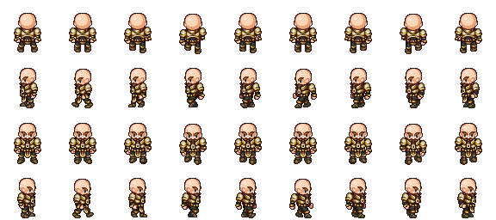

This is the character you will be playing during the course of your adventure. He possesses the ability but contains no fighting ability himself.

Your Spirit:



This is your spirit who will aid you in your struggle to get through the castle and find a means of escape. This metaphysical being contains the ability to smite enemies with it powerful sword and to allow you a moment’s reprieve by forcing enemies a great distance from you.

The Enemies:

These creatures fester the castle in endless numbers. They might not look fearsome, but will make quick work of your life if they are not dealt with in a timely manner

Gameplay:

Game Screen: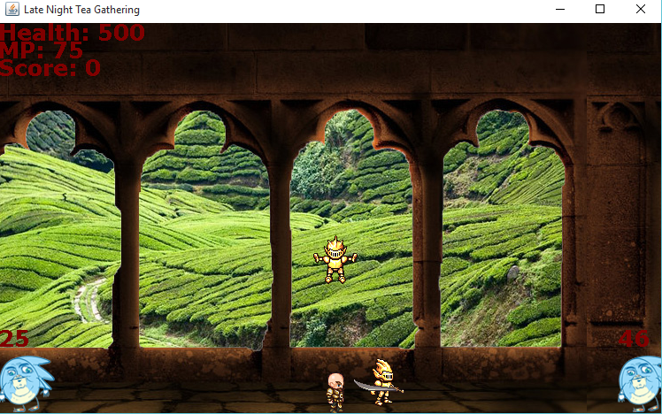

|  |  |
| --- | --- |
| Image | Description |
|  | The value of your vitality during your struggles. It will decrease with contact with enemies. If This value reaches 0, you will perish. (Max value 500) |
|  | MP (MP stands for Mana Points) is the value of your spiritual power. Decreases whenever you summon your spirit to aid you. Be careful, if this reaches 0, you will be vulnerable to enemy onslaught. (Max value 500) |
|  | When your MP value reaches 0, this will appear over the MP display and countdown until you are able to use your spirit again. |
|  | The value showing how many enemies you have slain. |
|  | The character you will be controlling during your time in the castle. You will control this character using WASD. |
|  | Your Spirit who will aid you in your struggles through the castle. It possesses 2 abilities, Attack and Force.(Attack and Force cannot be used simultaneously) |
|  | The enemy who will be hunting you down until you perish. The value above its head shows its vitality |

Death Screen

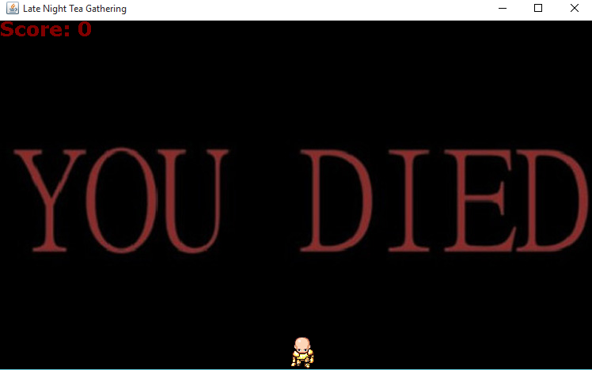

When you eventually perish from the hordes of vicious enemies, you will reach this screen which will display the you on the ground wearing the armour of your spirit. The number of enemies slain will also be displayed.

Controls: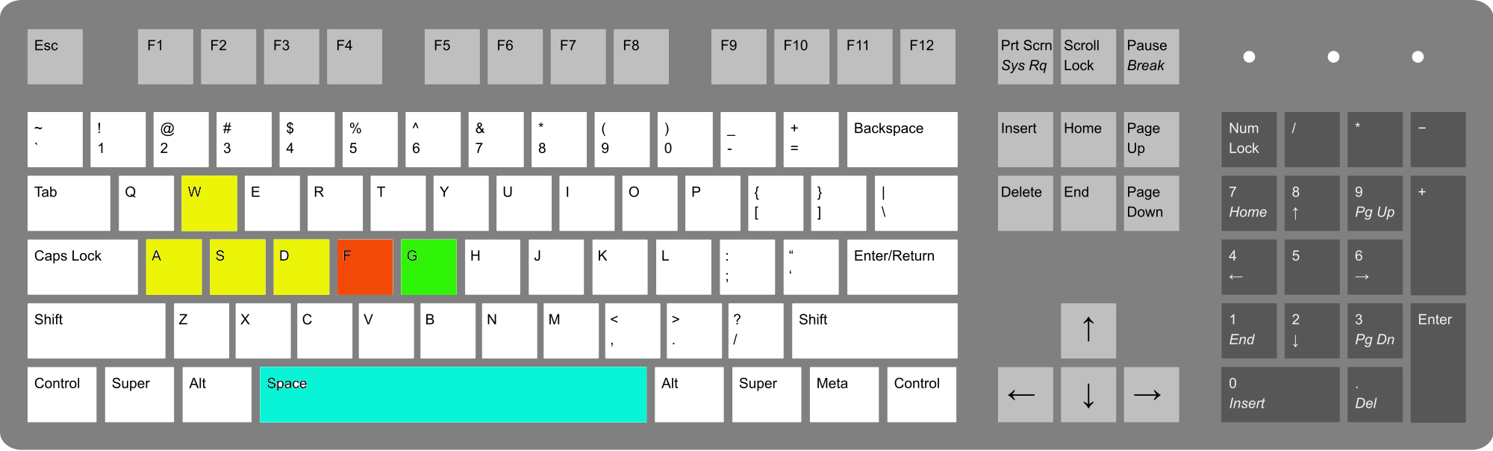

|  |  |
| --- | --- |
| Input | Action |
| W, A, S, D Keys | Movement controls  W for Jumping |
| Space Bar | Attack - Summons Spirit to Smite enemies with its blade (Cost 5MP) |
| F Key | Force Ability - Summons Spirit to push enemies back (Costs 20MP) |
| G Key | Heal Ability - Player heals themselves for 100 HP (Uses all MP) |

The Goal:

The goal of this game is to slay as many enemies as you can in order for you to survive for the longest possible time.