**Website Proposal**

1. **Problem Statement:**

How might we help young exhibition lovers (18-35) in Shanghai to sift through various exhibitions so that they can easily choose the exhibitions that meet their specific requirements on location/theme/time, etc?

1. **Pain Points**

The pain points that the exhibition lovers would encounter throughout their journey of using existing products to find a satisfied exhibition:

1. Find out the list of exhibition information using different platforms

2. Compare the theme/location/time/price/comments of various exhibitions

3. Choose the exhibition that meet certain requirement (eg. Fashion-themed, within Jing’an district, going to close recently, free entrance, etc.)

4. Use external map APP to plan transport route to the exhibition

1. **Solutions**

The proposed website will address the 1st and 4th pain points by inserting the information needed into one single website, so that the users will no longer need to switch between different APP/websites/WeChat Account to collect the information needed.

Besides, the 2nd and 3rd step used to be done manually by the users, which would be very time consuming and annoying. The proposed website will solve this problem by allowing the users to use search filters to quickly and accurately find out the suitable exhibitions for them.

1. *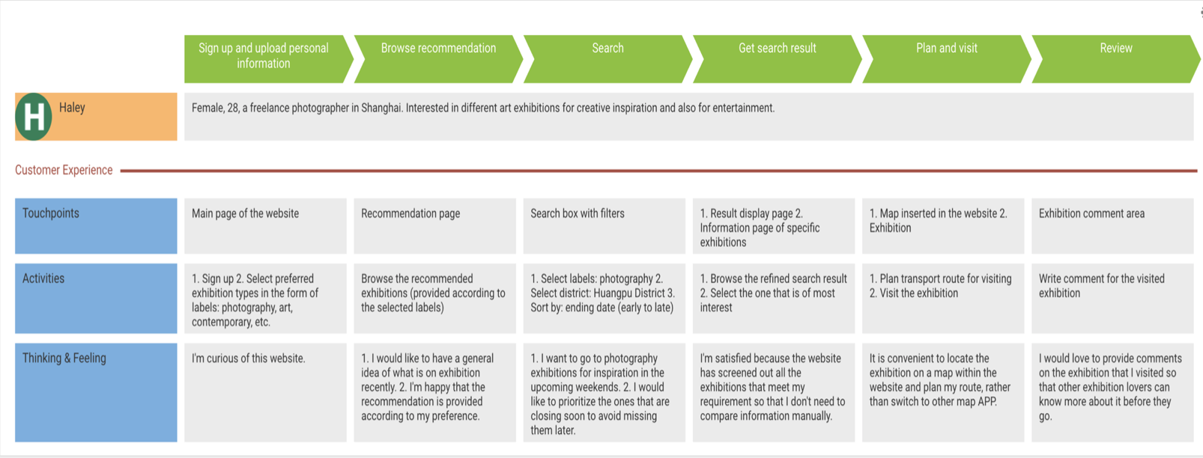***User Journey map** (of the proposed website)
2. **Dataflow diagram**



1. **Entity-relationship diagram**

