AWS

# Task 1: Create an EC2 instance

EC2 – Launch Instance

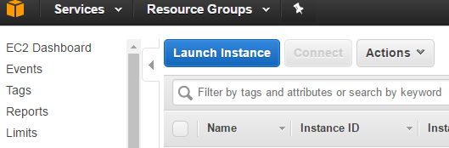

Install Ubuntu 16.04



Go to security groups – default to configure firewall

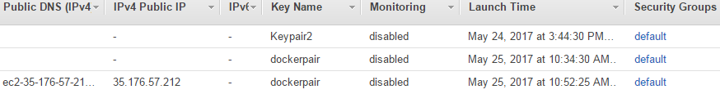

On security group, open port 22 for SSH, and others as required e.g. 8080

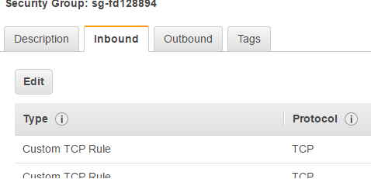

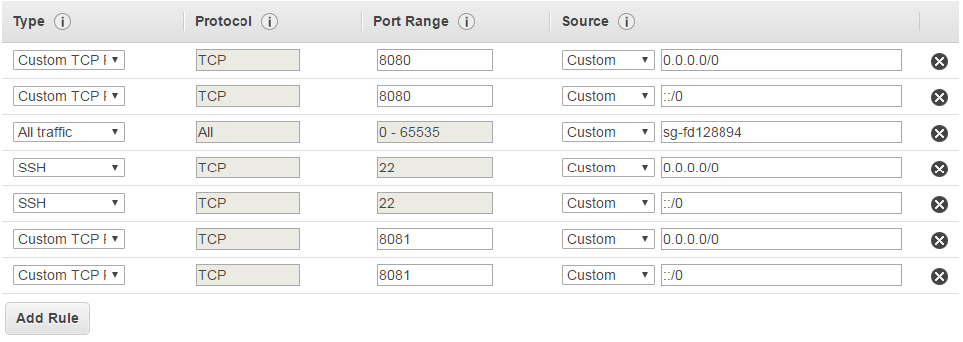

Review and click launch instance and a screen will pop up to create keypair.

The .pem file provided by AWS to access SSH can be broken down into a private/public key pair. The private key can be created by using the .pem file on PuTTYgen – click save private key.

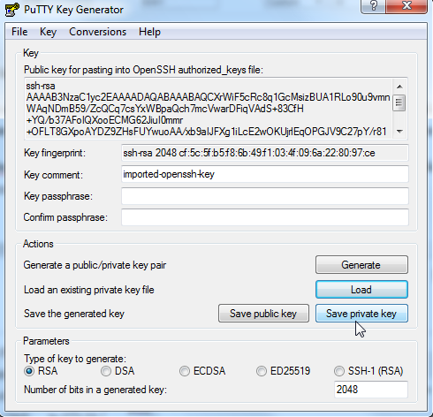

Put your privatekey to SSH-Auth on PuTTY Config. Insert the username (Ubuntu) public IP address and port 22 to access SSH.

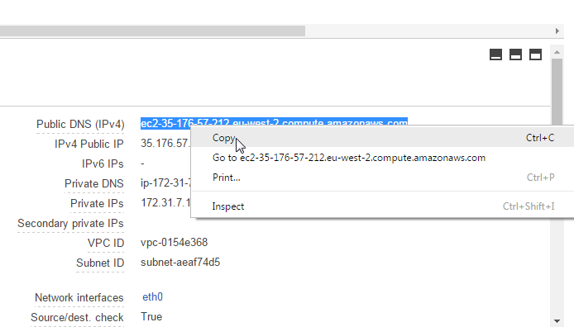

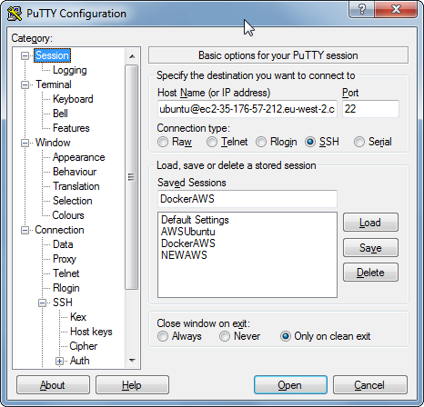

# Task 2: Using the CLI

Download windows installer from:

<http://docs.aws.amazon.com/cli/latest/userguide/awscli-install-windows.html#awscli-install-windows-path>

<http://docs.aws.amazon.com/cli/latest/userguide/tutorial-ec2-ubuntu.html>

**aws --version** on a command line to confirm installation

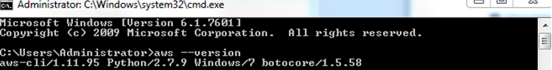

## Configure the CLI

**aws configure** to configure the aws account

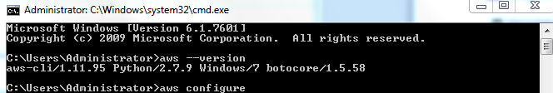

## Creating a security group, key pair and role

Create security group with the following command.

**aws ec2 create-security-group --group-name devenv-sg --description "security group for development environment in EC2"**

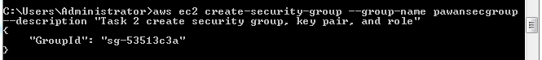

*Note groupid: sg-53513c3a*

To open port 22 for ssh, use the following command. Cidr can be replaced with ip address of host OS for security.

**aws ec2 authorize-security-group-ingress --group-name devenv-sg --protocol tcp --port 22 --cidr *0.0.0.0/0***

Use **aws ec2 describe-security-groups** command to view the change.

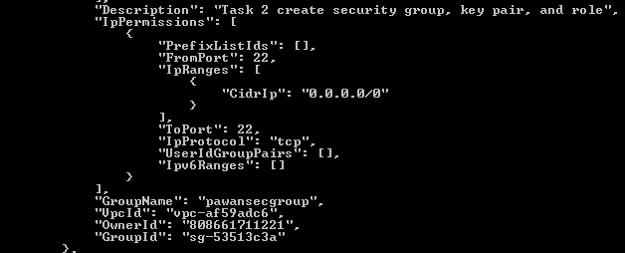

Create a keypair

*Note: KeyMaterial must be inside double quotes.*

**aws ec2 create-key-pair --key-name devenv-key --query "KeyMaterial" --output text > devenv-key.pem**



Find Amazon Machine Image on EC2 dashboard

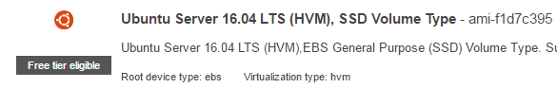

Note: ami-f1d7c395

## Launch your EC2 Instance

Run the aws instance with the AMI and Group ID



**aws ec2 run-instances --image-id ami-f1d7c395 --security-group-ids sg-53513c3a --count 1 --instance-type *t2.micro* --key-name pkey2 --query "Instances[0].InstanceId** **"**

Note: i-0cd654ca88933e947

## Obtain the IP Address & SSH

To get the public ip address of instance, the following command is run

aws ec2 describe-instances --instance-ids i-0cd654ca88933e947 --query "Reservations[0].Instances[0].PublicIpAddress "



**aws ec2 describe-instances --instance-ids *i-ec3e1e2k* --query "Reservations[0].Instances[0].PublicIpAddress"**

Create private key using the pem file created earlier.

On windows make sure there is no single quote but rather double quote on the command

**aws ec2 create-key-pair --key-name devenv-key --query "KeyMaterial" --output text > devenv-key.pem**

Using PuTTYgen, create private key using the pem file.

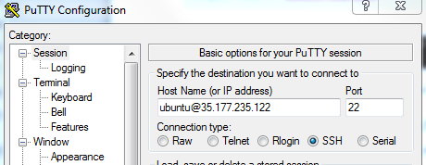

To start a stopped instance:

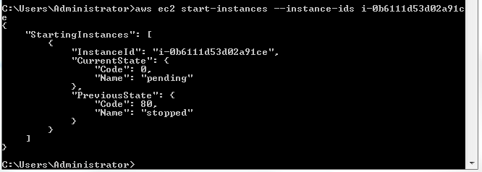

# Task 3 – Using Amazon S3

## Creating a Bucket in Amazon S3

Click S3 and click create bucket.

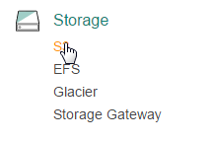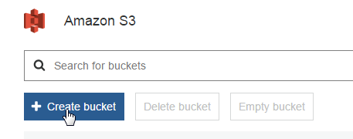

Step 1: Name, region

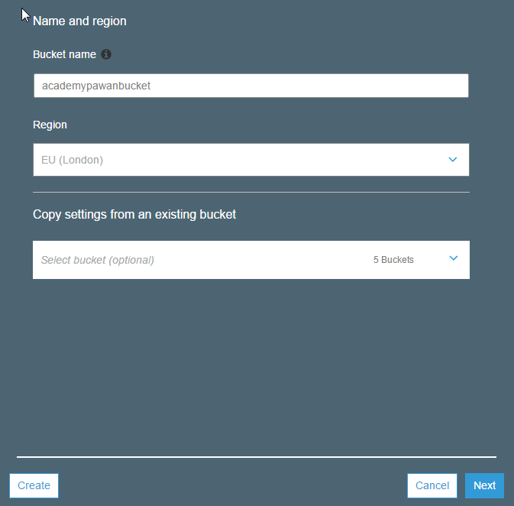

Step2: Set versioning, tags, logging options

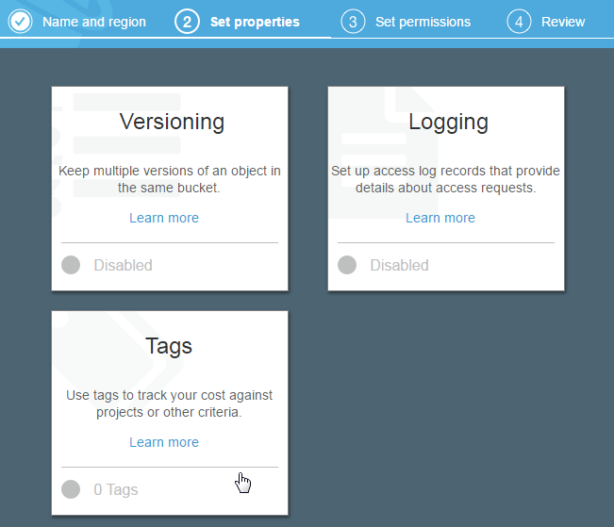

Step 3: Users and permissions

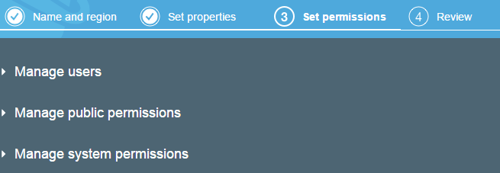

Step 4: Review and create bucket



## Adding objects to your bucket

Click the bucket created

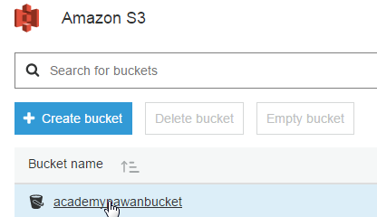

Click upload to upload a file to bucket

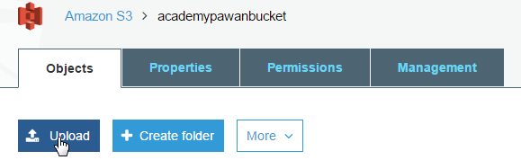

Add files.

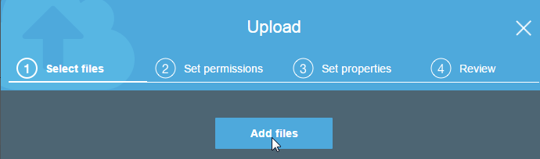

Set users, permissions, encryption, metadata etc as required.

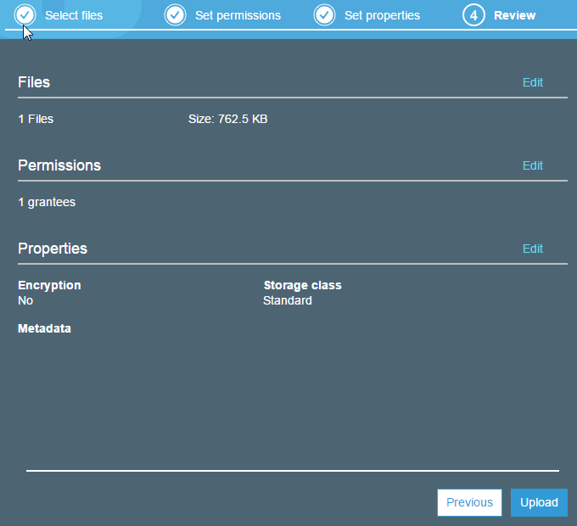

Click the image to find its properties

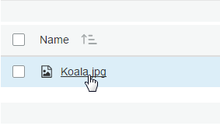

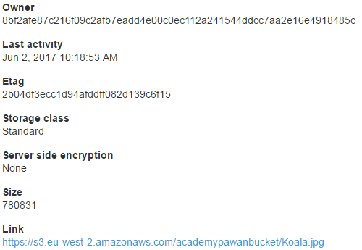

By default file is private for public use, make public.

Select image and choose make public option.

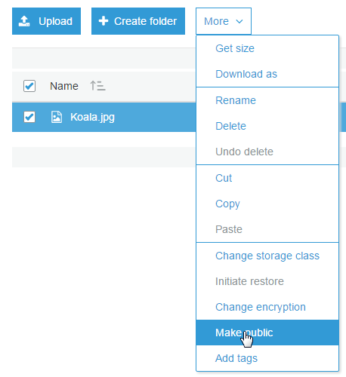

To make it private again, click the image to see its properties.

Under public permissions, everyone has read access. 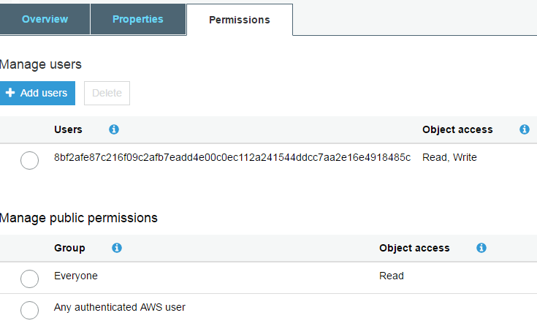

Uncheck the Read access permission and save to make the file private again.

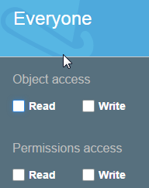

To delete a bucket, delete all objects inside the bucket.

Select the bucket and delete it.

