Linux

# Task1: Your first Virtual Machine

Download virtualbox at <https://www.virtualbox.org/wiki/Downloads>.

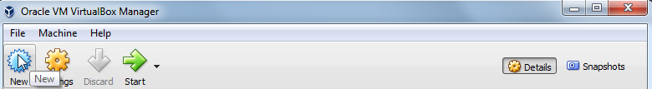

Create a new VM, Choose the OS that you have on version. If not present, choose others 64/32 bits.

Max recommended is half of available RAM.

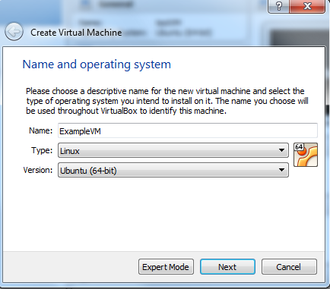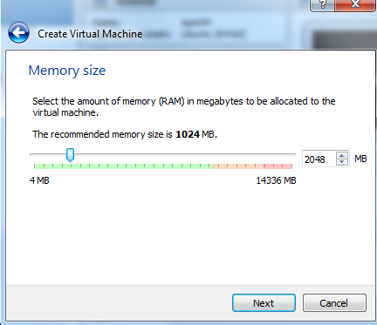

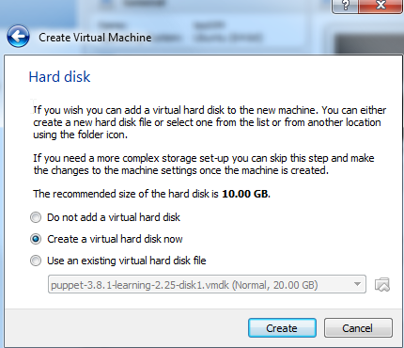

Create a virtual hard disk

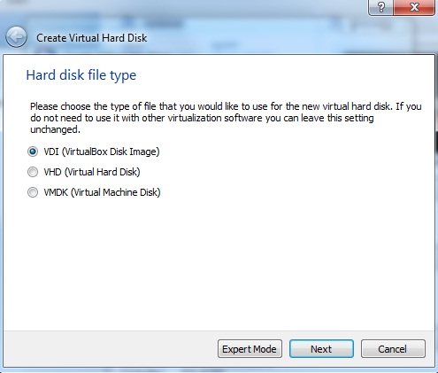

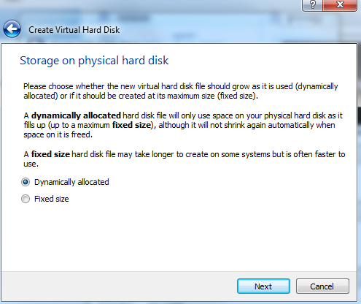

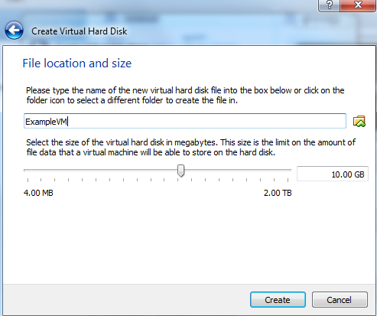

Start the VM

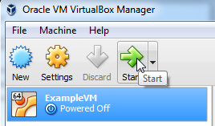

Select the ISO file of your ubuntu machine and install it.

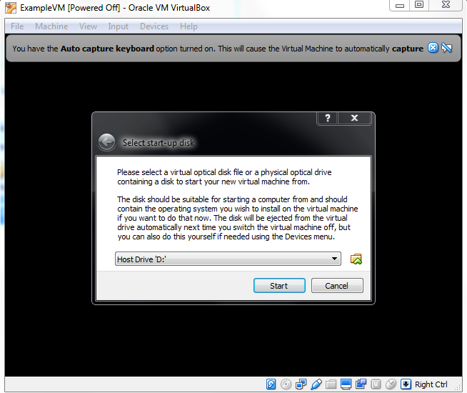

# Task 2: Terminal Exploration

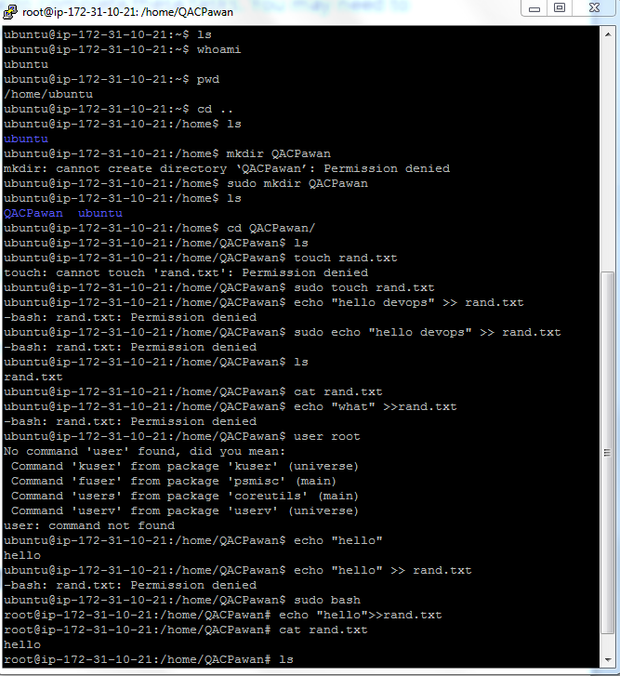

# Task 3: Creating a script file

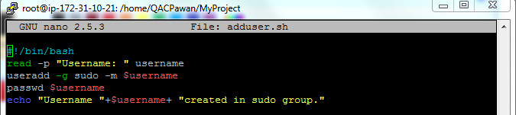

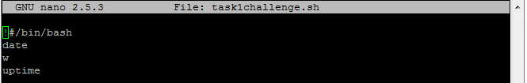

# Task 4: Configuring the Linux environment

**apt-get update**

**apt-get install maven**

(Maven installed itself and java as well)

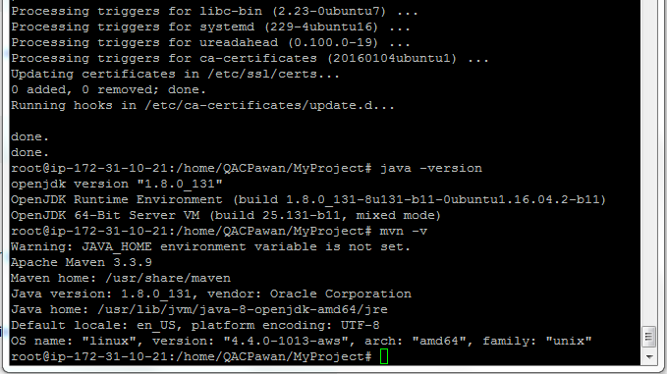

# Task 5: Using Iptables

Start iptables:

**sudo ufw enable**

Stop iptables:

**sudo ufw disable**

Show status:

**sudo ufw status**

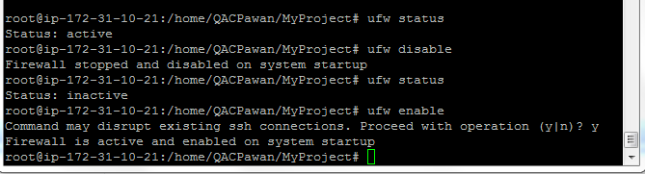

Allowing ftp at port 21 rule:

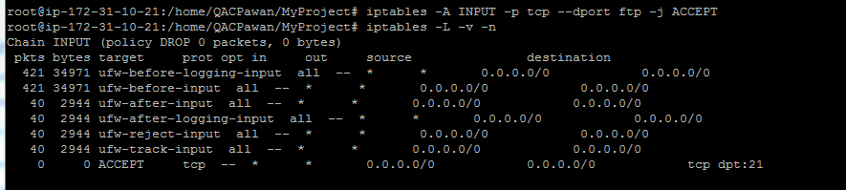

View rule by input chain and by line number, delete by input chain+linenumber

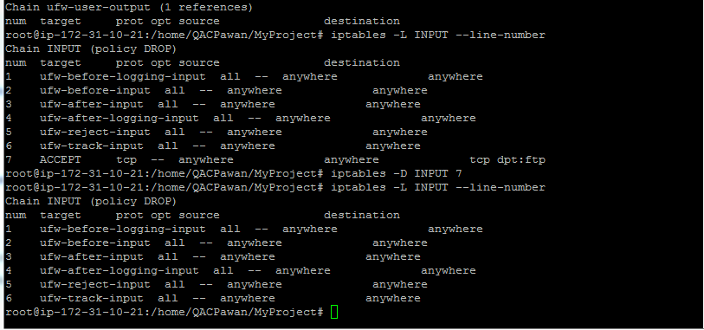

# Task 6: Vagrant scripting

Create directory “Vagrant Setup” - in here open Git bash and use the command, *vagrant init*, to initialise a new vagrant repository. This should add a Vagrantfile to the directory

Create a shared folder to use with VM.

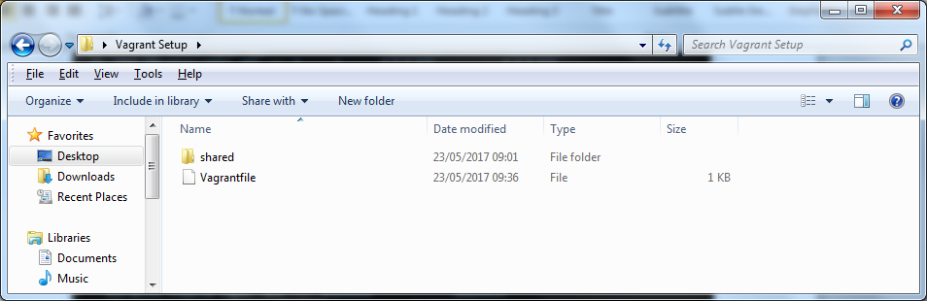

## For single VM installation

Edited vagrantfile to setup the VM with required specification.

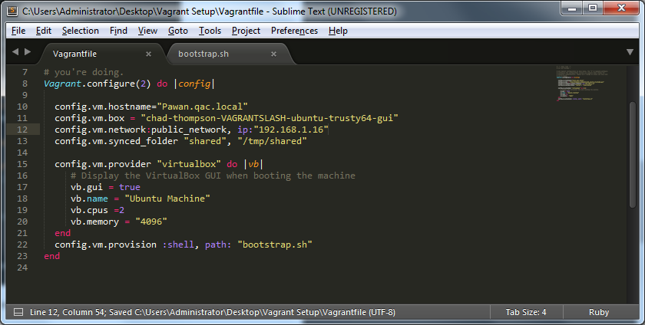

Bash script used to install JAVA, Maven and Git on VM.

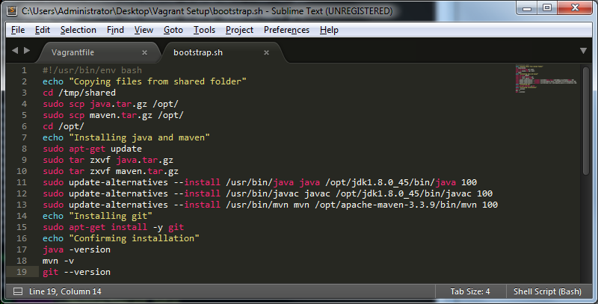

Use “vagrant up” on the folder with vagrantfile to create VM and run bash script.

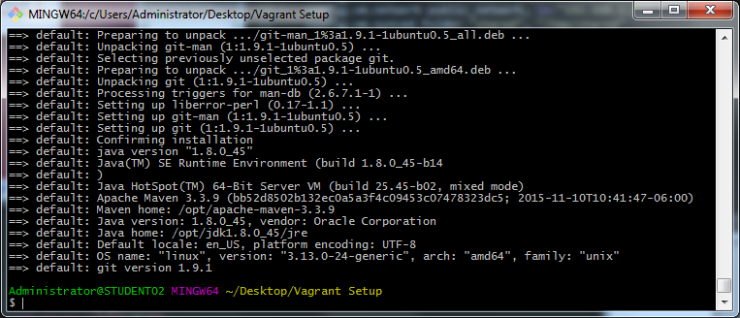

## For multiple VM installation

For CentOS installation, edit C:\Users\Administrator\.vagrant.d\boxes\centos-VAGRANTSLASH-7\1704.01\virtualbox\Vagrantfile

**config.vm.synced_folder ".", "/vagrant", type: "rsync"**

**config.vm.synced_folder ".", "/vagrant", type: "virtualbox"**

Rsync isn’t installed.

Run **vagrant plugin install vagrant-vbguest** on git bash as the shared folder encounters problem with centOS due to mismatch of GuestAdditions between centOS and virtualbox.

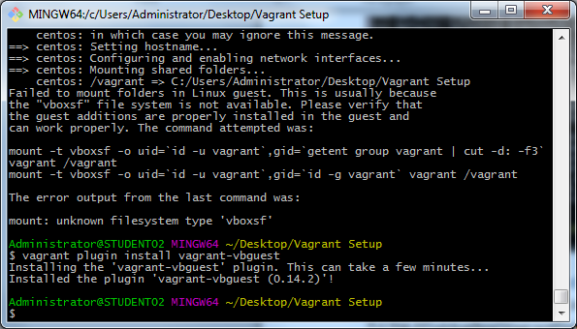

Vagrantfile for multiple VM

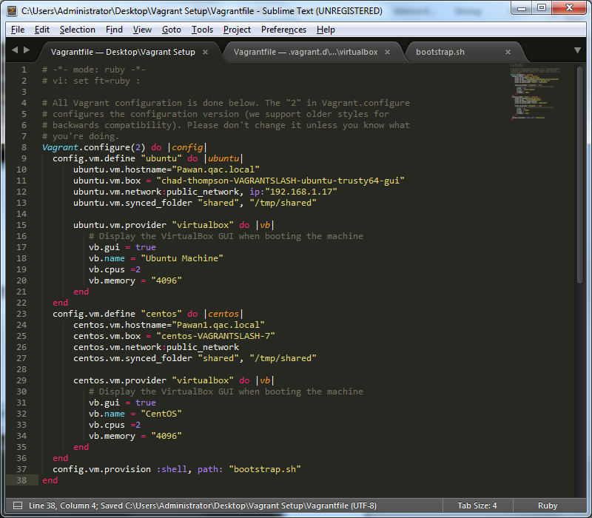

Script file for multiple VM

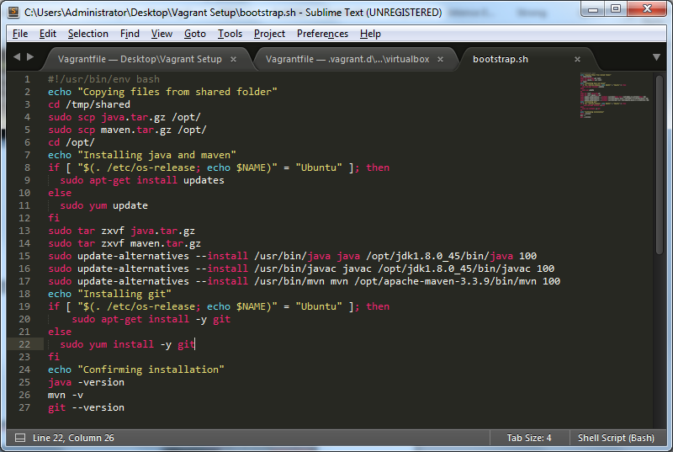

Use “vagrant up” on the folder with vagrantfile to create VM and run bash script.

Ubuntu installed with JAVA, MAVEN, and GIT.

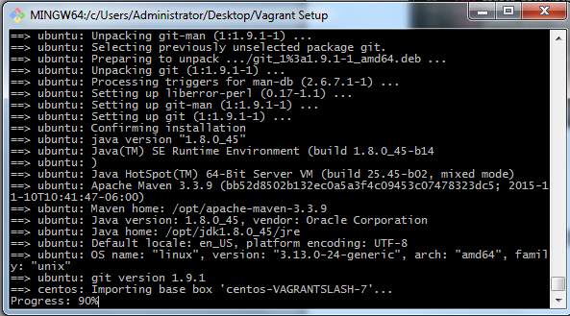

CentOS installed with JAVA, MAVEN, and GIT.

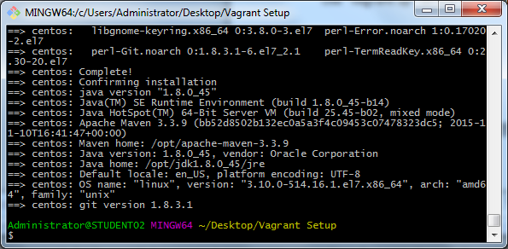

# Task 7: Repository Management

Confirmed Git is installed in VM

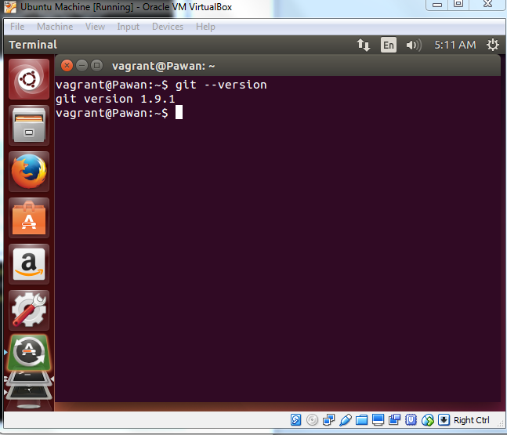

On Windows host machine, create a repository on github.

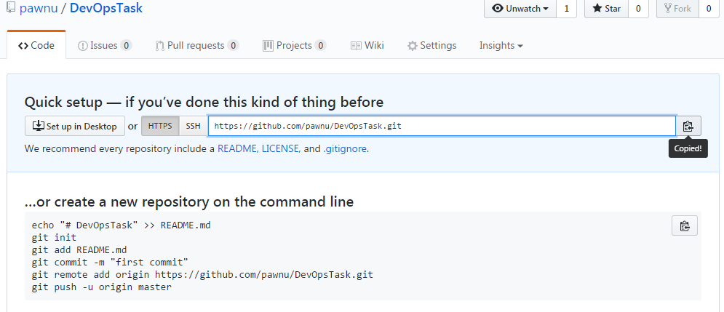

On host windows machine, create a directory for git and use “git init” command on that folder. Create a file, add and commit it.

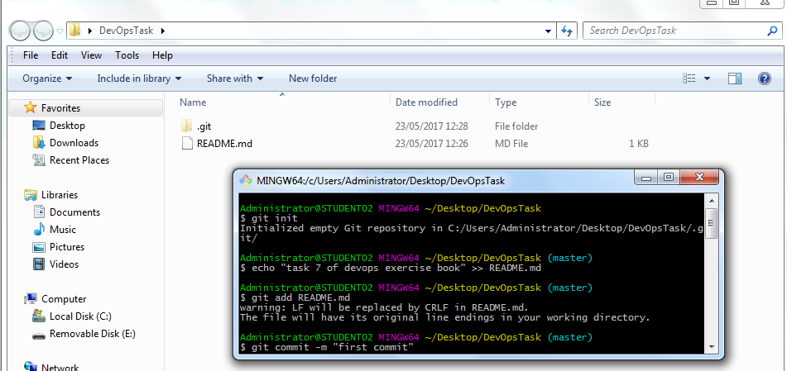

Add the commit to your repository on github with HTTPS link and push the changes.

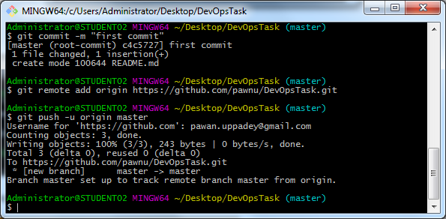

On Ubuntu guest machine, clone and confirm the file created earlier is present.

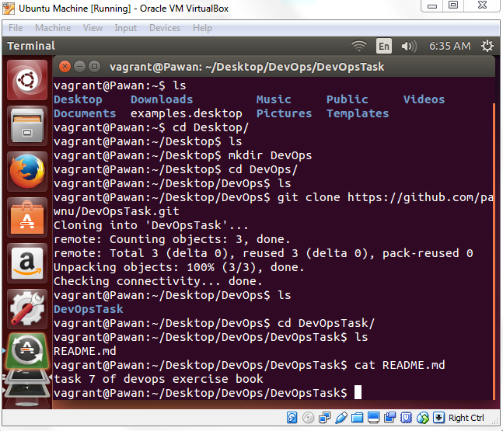

Create a new file on Windows host machine and push change to repository.

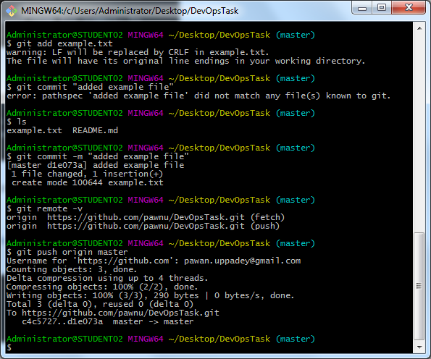

Confirm the file present on Ubuntu guest machine.

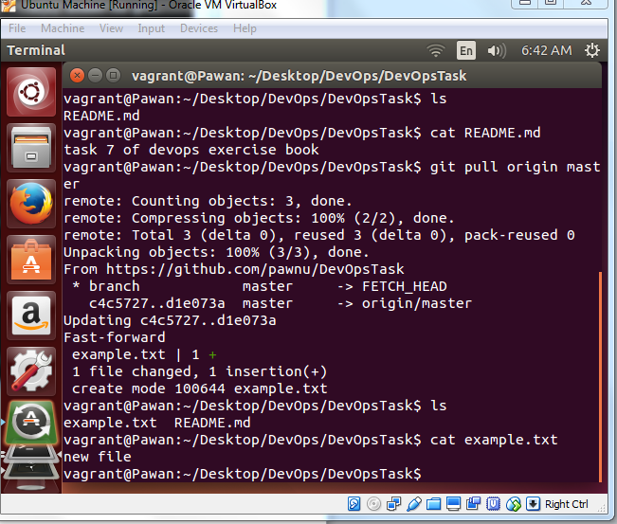

Make change to a file on Ubuntu and push to repository

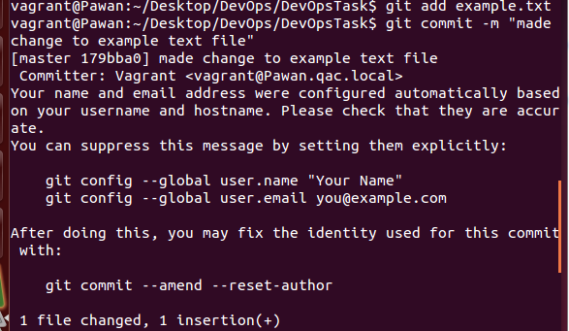

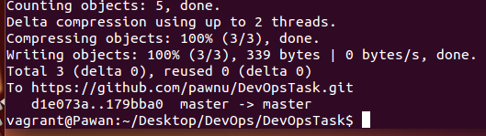

Confirm changes on Windows host machine side

