Tooling

# Task 1a – Setting up Jenkins

sudo scp jenkins_2.1_all.deb /home/vagrant/Desktop/

cd /home/vagrant/Desktop

sudo dpkg –i jenkins_2.1_all.deb

sudo apt-get install –y –f

sudo apt-get install –y jenkins

sudo service jenkins start

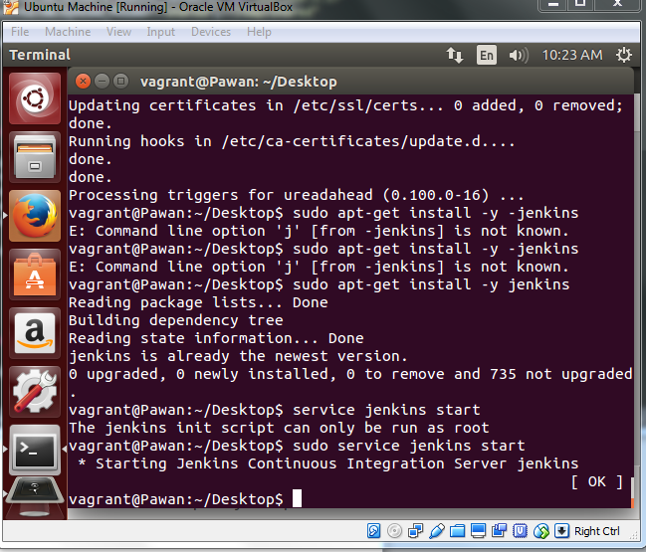

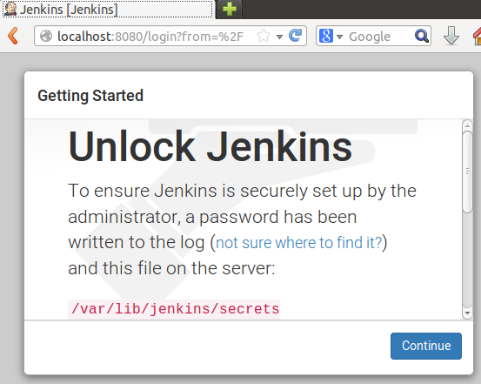

# Task 1b – Setting up Bamboo

Navigate to directory to install bamboo, e.g. /opt

sudo wget <https://www.atlassian.com/software/bamboo/downloads/binary/atlassian-bamboo-5.8.1.tar.gz>

sudo tar xvzf atlassian-bamboo-5.8.1.tar.gz

After installed, edit **/opt/atlassian-bamboo/WEB-INF/classes/bamboo-init.properties** and add the proper home directory.

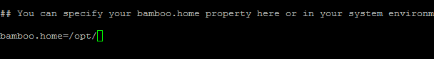

Execute the **bamboo.sh** file.

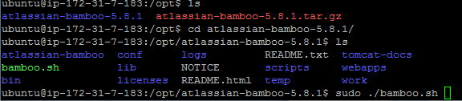

Make sure java is installed. If not use **sudo apt-get install default-jdk** to install required java

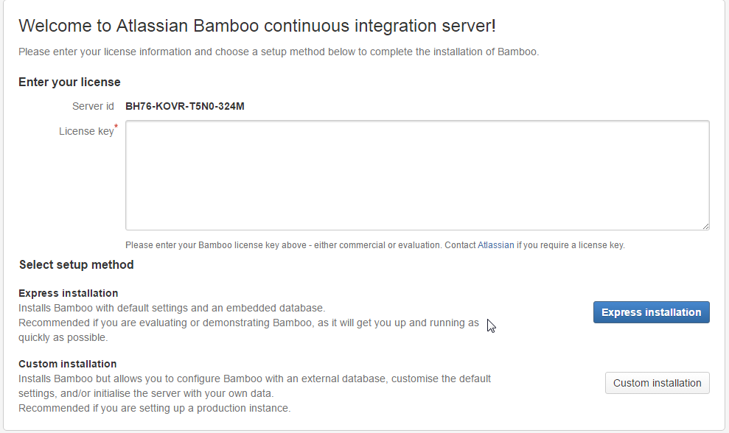

# Task 2 – Setting up Jira

cd /opt/

sudo chmod a+x jira.bin

sudo ./jira.bin

Choose custom install, install on port 8081, custom port 80

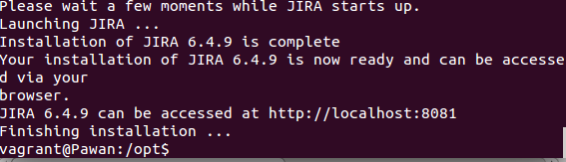

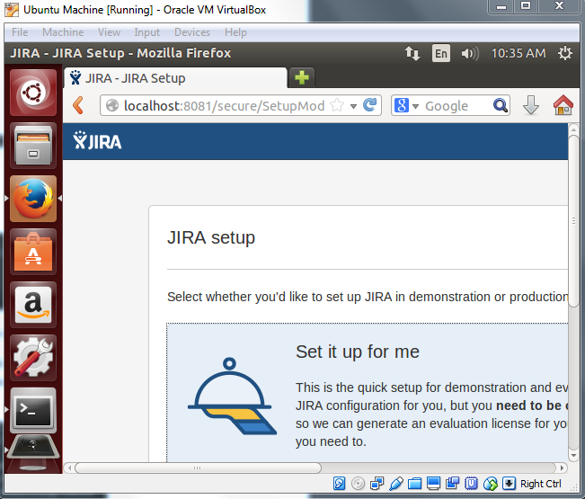

# Task 3 – Configuring Jira and Git

<https://confluence.atlassian.com/adminjiracloud/connect-jira-cloud-to-github-814188429.html>

Install Jira and Git on machine.

On github, select your profile

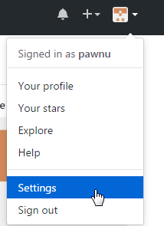

Under developer settings, click OAuth applications.

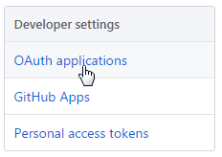

Next, click register a new application



Fill in the details, the homepage URL and callback URL must be same.

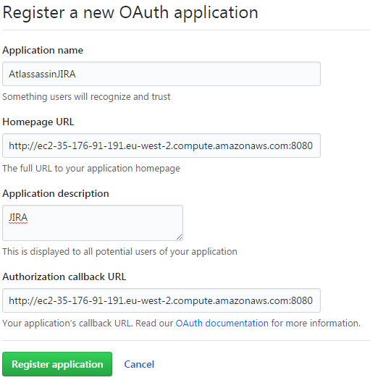

On Jira,

Select Applications – Integrations – DVCS accounts

Click link github account

Fill in the popup box with name, client ID and client secret found on github oAuth application list.

When prompted, click **grant access** to allow jira to link with github.

# Task 4 – Installing Nexus

cd /opt/

sudo scp nexus-2.14.4-03-bundle.tar.gz /usr/local

cd /usr/local

sudo tar xvzf nexus-2.14.4-03-bundle.tar.gz

sudo ln –s nexus-2.14.4-03 nexus

echo "1" | sudo update-alternatives --config java

sudo chowm -R vagrant nexus* sonatype-work

cd /usr/local/nexus

./bin/nexus console

./bin/nexus start

**Notes:**

nexus-3.* didn’t work with this setup

nexus won’t run with sudo, change a user to be owner of nexus and sonawork directory to run

nexus requires JVM 1.8. JVM might show as 1.7. Make sure java 1.8 is installed.

Use **sudo update-alternatives - -config java** and select the 1.8 version of java to run nexus

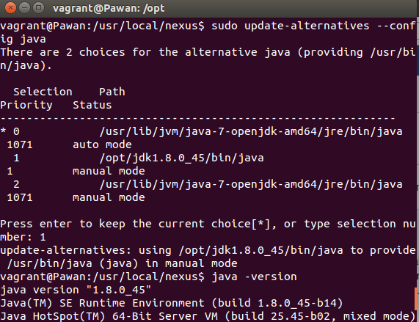

Nexus by default runs on port 8081, to change it edit the **conf/properties** file

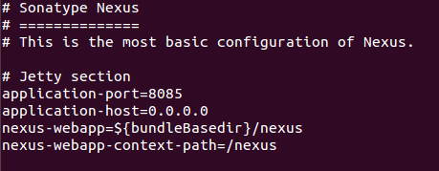

Run nexus as follows:

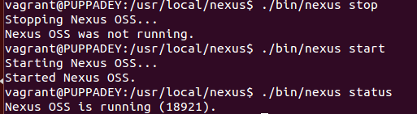

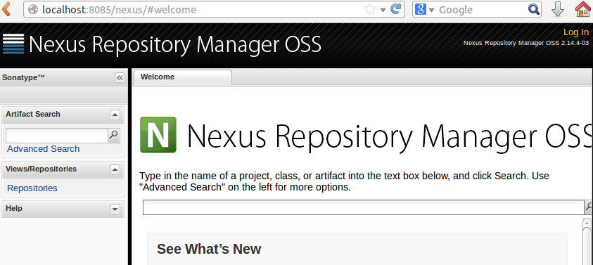

# Task 5 – Install Zabbix

cd /opt/

wget http://repo.zabbix.com/zabbix/2.4/ubuntu/pool/main/z/zabbix-release/zabbix-release_2.4-1+trusty_all.deb

sudo dpkg -i zabbix-release_2.4-1+trusty_all.deb

sudo apt-get install -y zabbix-server-mysql zabbix-frontend-php php5-mysql

Edit **/etc/php5/apache2/php.ini**

post_max_size = 16M

max_execution_time = 300

max_input_time = 300

date.timezone = Europe/London

sudo service apache2 restart

Create **/etc/zabbix/apache.conf**

# Define /zabbix alias, this is the default  
<IfModule mod_alias.c>  
Alias /zabbix /usr/share/zabbix  
</IfModule>

sudo cp /etc/zabbix/apache.conf /etc/apache2/conf-available/zabbix.conf

sudo a2enconf zabbix.conf

sudo service apache2 restart

sudo service zabbix-server start

