Skill Description:
In this assignment, you will apply your knowledge of Flask to build a Food Tracker App. The app will allow users to log their daily food intake, view their eating history, and calculate total calorie consumption for a specific day. You will be using Flask to handle routes, interact with a database, and create a dynamic web application.
Problem Statement 3:
Enhance the Food Tracker App by allowing users to view their total calorie intake for a specific day. Implement logic to calculate and display this information.
Learning Outcomes:
- Apply aggregate functions in database queries.
- Gain experience in processing and displaying calculated data.
- Understand how to refine and optimize database queries for specific requirements.

##################################################################################
I created basic html pags for adding and viewing history and total intake –

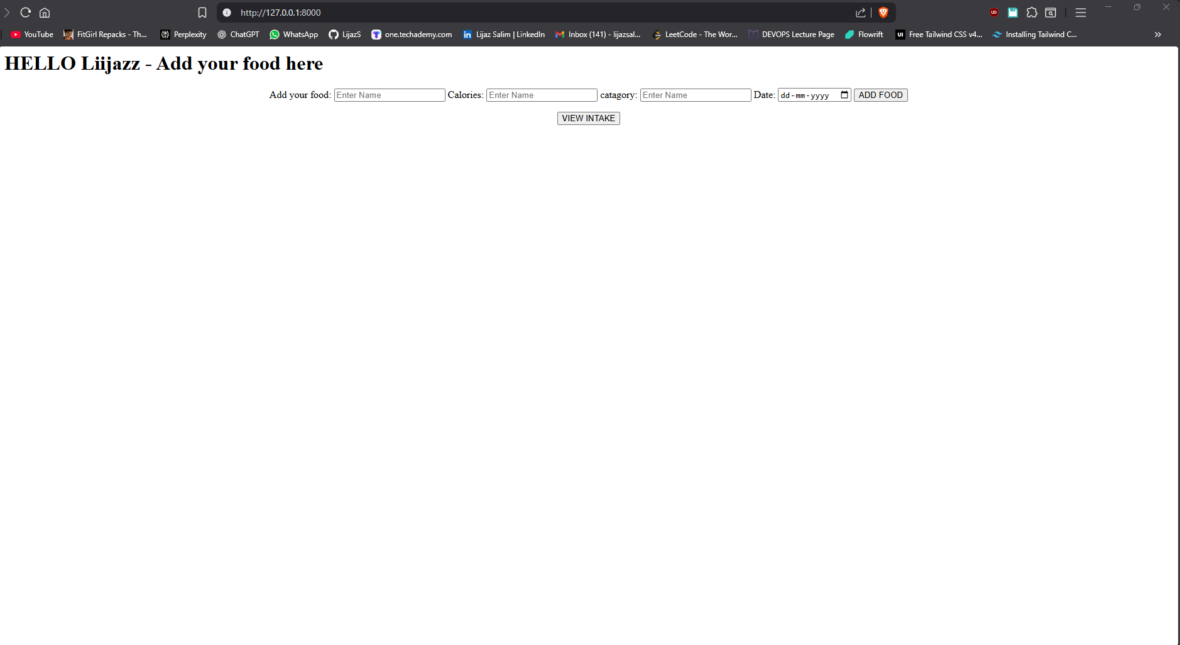
For adding
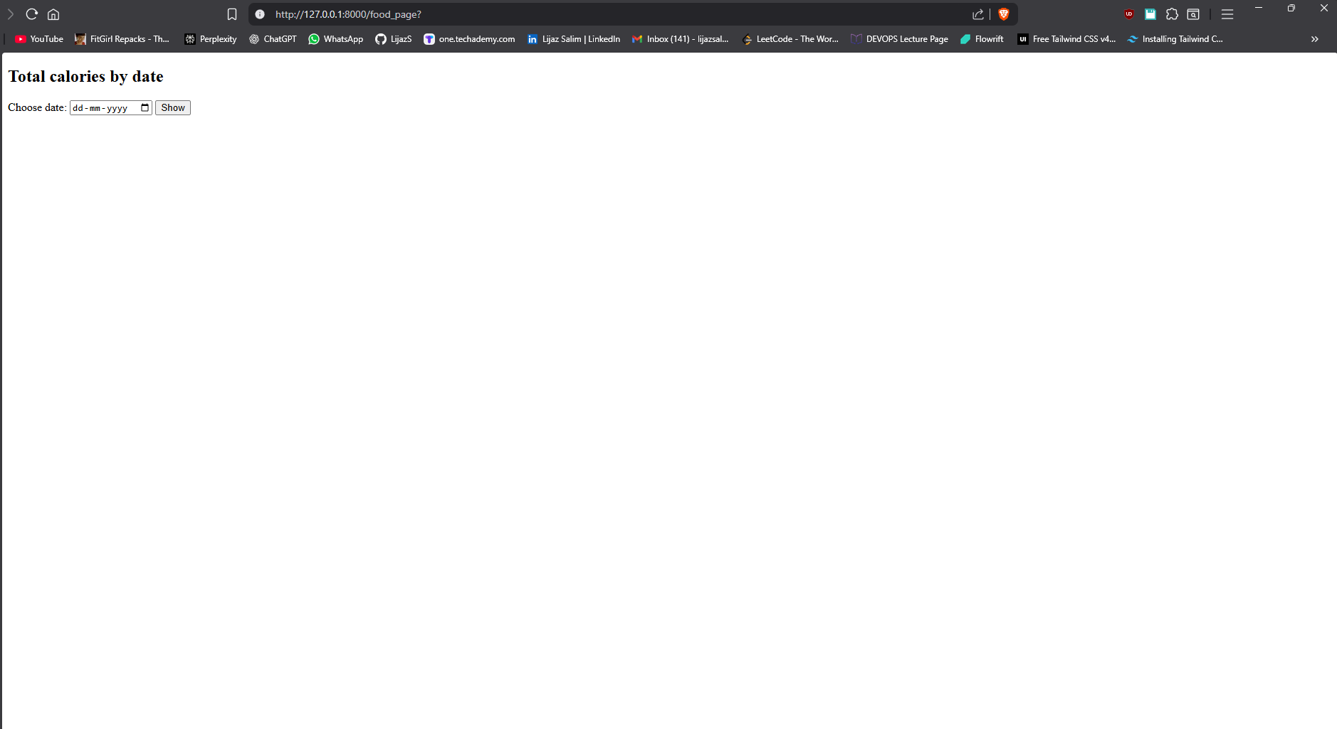
For viewing intake

I created database and used sqlite3. Made a table which take the foods name,calories,category and date which we took it.

I then created the endpoints to handle it.

