外部排序-优化顺串生成阶段

09022313 李晶晶

问题描述/需求分析

在之前的外部排序中，初始顺串的生成是已经固定好RUN_SIZE，在本次实验中，将优化顺串生成阶段，增大顺串长度。

系统结构/算法设计

采用败者树的方式生成不等长的顺串，

初始顺串生成完毕后，采用哈夫曼树的方式进行2路归并

功能模块设计

败者树生成不等长顺串

class Node

{

public:

int value;

int index;

bool vaild = true;

Node(int v, int i) :value(v), index(i) {}

Node() {}

};

class LoserTree

{

public:

int size;

int leaf;

vector<Node> tree;

int max;

LoserTree(int n,vector<int> input)

Node build()

Node update(int index,int num)

bool checkVaild()

void turntrue()

};

顺串生成大致流程

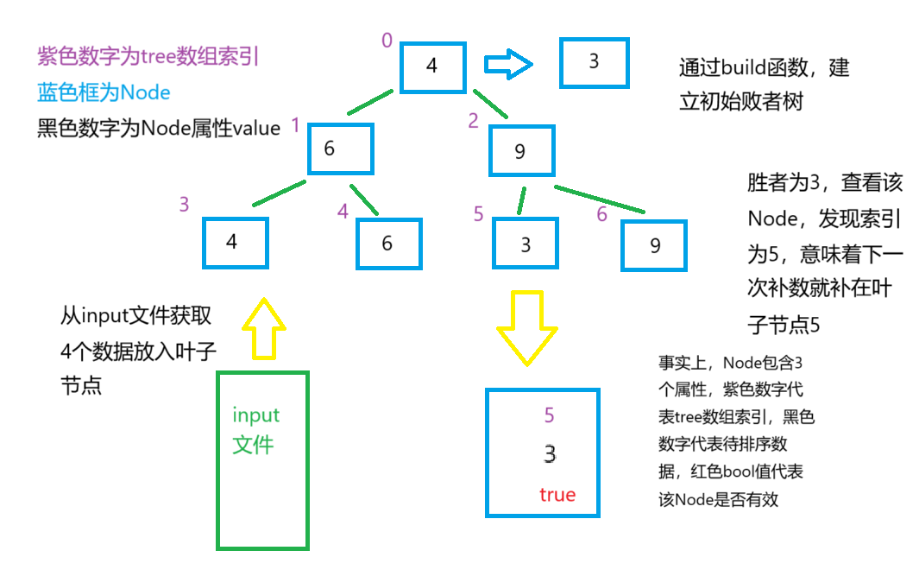

设置input缓冲区大小为leaf大小，input中的数据预取自file input.txt。

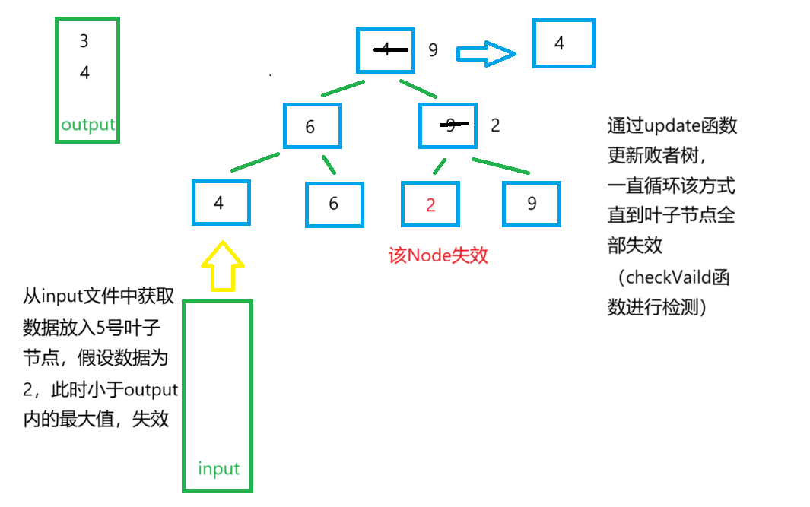

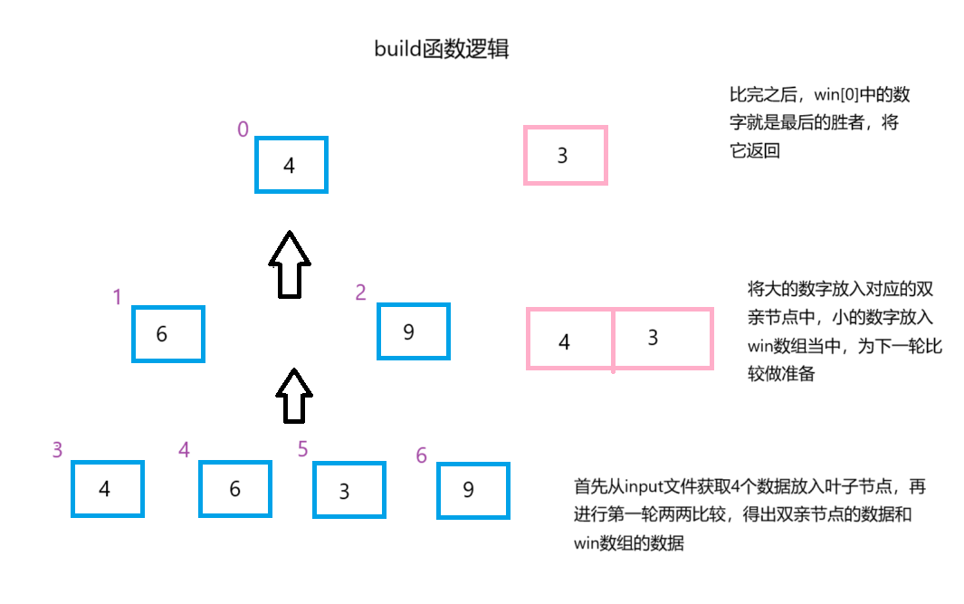

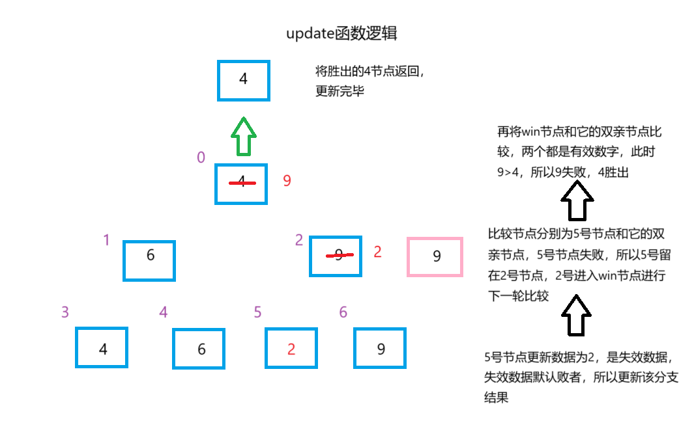

当叶子节点中所有节点均为false，则该初始顺串生成完毕。

此时败者树构建完毕，初始顺串生成完毕，存储到临时文件，文件名形如0tempx

并将叶子节点均重置为true，重复上述过程。

接下来通过哈夫曼树进行2路归并

哈夫曼树进行2路归并

class HuffmanNode

{

public:

int length;

string filename;

HuffmanNode(int l,string f):length(l),filename(f){}

HuffmanNode(){}

};

class HuffmanTree

{

public:

vector<HuffmanNode> tree;

int ioReadCount = 0; // To count read operations

int ioWriteCount = 0; // To count write operations

static bool compareByAttribute1(const HuffmanNode& a, const HuffmanNode& b)

{

return a.length < b.length;

}

// Function to count the number of data entries in the file

int countData(const string& filename)

HuffmanTree(int num)

// Function to merge two chunks into an output file

void mergeChunks(const string& file1, const string& file2, const string& outputFile)

int merge()

};

哈夫曼树大致流程

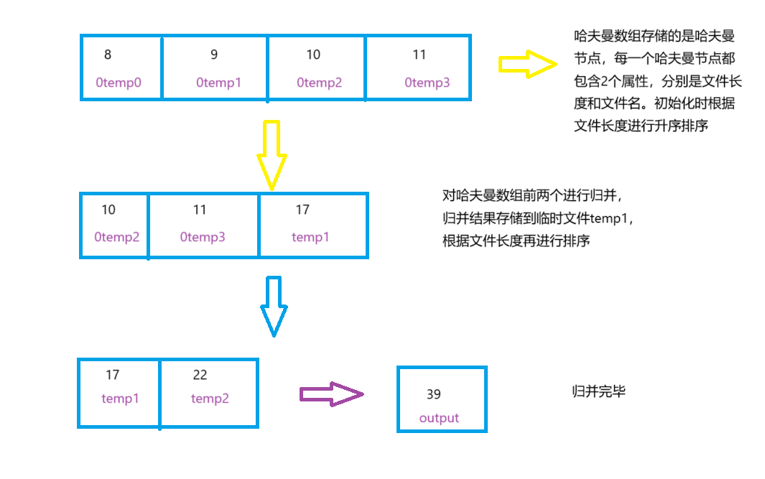

2个文件归并的思路与前一份报告思路一致

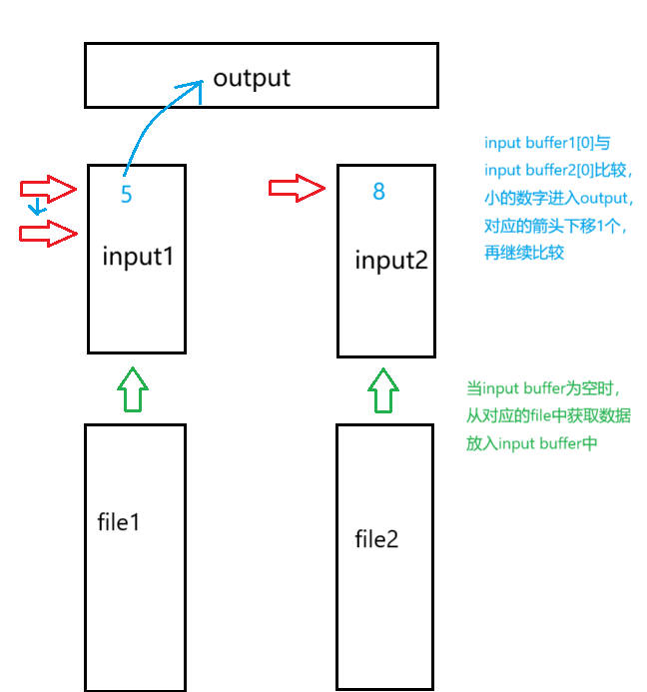

结果测试与分析

实验结果与预期一致

顺串生成

文本

长度11

长度17

长度16

长度6

可以看到生成了一系列不等长顺串

接下来是归并

分析可以得出，首先对0temp0和0temp3进行归并生成temp1，长度变为17，接下来对0temp2和0temp1进行归并生成temp2，最后对temp1和temp2进行归并生成temp3，返回3的索引，最后将temp3更名为output文件，归并完成。

IO性能分析

设定leaf为8，以N为横坐标，IO次数为纵坐标，同时与前一份报告中没有优化的外部排序数据做对比

蓝色线为未优化的曲线，橙色线为优化过后的曲线。可以看出，优化顺串生成后的IO次数少于未优化。

实验总结

这个实验当中遇到了最多的问题，一开始就是出现了如何处理失效数据的问题，这个问题直接影响力这个败者树应该怎么构建。一开始我想将失效数据直接变成无穷大再重新构建败者树，但这个解决办法让下一轮解除失效后进行排序这一环节无法进行，如果设置真假值的话显然不行，于是加入了vaild属性。接踵而来的问题就是如何拿到下一个填充数据的位置。所以很自然的加入了index属性，这样在返回胜者后可以直接获取胜者在败者树叶子节点的索引，获取下一次填充数据的位置。那么败者树怎么构建？怎么更新？这是下面的问题。构建败者树时引入win数组来存储这一轮的胜者，解决构建问题。根据vaild值，解决更新败者树的问题。后面哈夫曼树构建比较顺畅，有了之前的框架打底，自然就能构建出来。

附录

#include<iostream>

#include<vector>

using namespace std;

class Node

{

public:

int value;

int index;

bool vaild = true;

Node(int v, int i) :value(v), index(i) {}

Node() {}

};

#include<iostream>

#include<vector>

#include<limits>

#include<cmath>

#include"Node.h"

using namespace std;

class LoserTree

{

public:

int size;

int leaf;

vector<Node> tree;

int max;

LoserTree(int n, vector<int> input)

{

size = 2 * n - 1; leaf = n;

tree.resize(size);

for (int i = 0; i < n; i++)

{

tree[i + n - 1] = Node(input[i], i + n - 1);

}

}

Node build()

{

int pass = log2(size + 1);

vector<Node> win(leaf);

for (int i = 0; i < leaf; i++)

{

win[i] = tree[leaf - 1 + i];

}

for (int i = 1; i < pass; i++)

{

int num_count = leaf / i;

int new_count = num_count / 2;

vector<Node> temp(new_count);

int start = pow(2, pass - 1 - i) - 1;

for (int j = 0; j < new_count; j++)

{

tree[start + j] = win[2 * j].value < win[2 * j + 1].value ? win[2 * j + 1] : win[2 * j];

temp[j] = win[2 * j].value < win[2 * j + 1].value ? win[2 * j] : win[2 * j + 1];

}

win.resize(new_count);

for (int j = 0; j < new_count; j++)

{

win[j] = temp[j];

}

}

max = win[0].value;

return win[0];

}

Node update(int index, int num)

{

tree[index].value = num;

if (num < max)

{

tree[index].vaild = false;

}

else

{

tree[index].vaild = true;

}

int compare = (index - 1) / 2;

Node win = tree[index];

while (compare > 0)

{

if (win.vaild == false && tree[compare].vaild == true)

{

Node temp = win;

win = tree[compare];

tree[compare] = temp;

}

if (win.vaild == true && tree[compare].vaild == true)

{

if (win.value > tree[compare].value)

{

Node temp = win;

win = tree[compare];

tree[compare] = temp;

}

}

compare = (compare - 1) / 2;

}

compare = 0;

if (win.vaild == false && tree[compare].vaild == true)

{

Node temp = win;

win = tree[compare];

tree[compare] = temp;

}

if (win.vaild == true && tree[compare].vaild == true)

{

if (win.value > tree[compare].value)

{

Node temp = win;

win = tree[compare];

tree[compare] = temp;

}

}

max = win.value;

return win;

}

bool checkVaild()

{

for (int i = leaf - 1; i < size; i++)

{

if (tree[i].vaild == true)

return true;

}

return false;

}

void turntrue()

{

for (int i = leaf - 1; i < size; i++)

{

tree[i].vaild = true;

}

}

};

#include<iostream>

#include<vector>

using namespace std;

class HuffmanNode

{

public:

int length;

string filename;

HuffmanNode(int l, string f) :length(l), filename(f) {}

HuffmanNode() {}

};

#include<iostream>

#include<vector>

#include <fstream>

#include <string>

#include <algorithm>

#include"HuffmanNode.h"

const int BUFFER_SIZE = 3;

class HuffmanTree

{

public:

vector<HuffmanNode> tree;

int ioReadCount = 0; // To count read operations

int ioWriteCount = 0; // To count write operations

static bool compareByAttribute1(const HuffmanNode& a, const HuffmanNode& b)

{

return a.length < b.length;

}

// Function to count the number of data entries in the file

int countData(const string& filename)

{

ifstream input(filename);

int count = 0;

int num;

while (input >> num)

{

count++;

}

return count;

}

HuffmanTree(int num)

{

tree.resize(num);

for (int i = 0; i < num; i++)

{

string file = to_string(0) + "temp" + to_string(i) + ".txt";

int length = countData(file);

HuffmanNode node(length, file);

tree[i] = node;

}

sort(tree.begin(), tree.end(), compareByAttribute1);

}

// Function to merge two chunks into an output file

void mergeChunks(const string& file1, const string& file2, const string& outputFile)

{

ifstream input1(file1);

ifstream input2(file2);

ofstream output(outputFile);

vector<int> buffer1(BUFFER_SIZE);

vector<int> buffer2(BUFFER_SIZE);

size_t index1 = 0, index2 = 0;

while (index1 < BUFFER_SIZE && input1 >> buffer1[index1])

{

index1++;

}

ioReadCount++;

while (index2 < BUFFER_SIZE && input2 >> buffer2[index2])

{

index2++;

}

ioReadCount++;

while (index1 > 0 || index2 > 0)

{

if (index1 == 0)

{

output << buffer2[0] << " ";

copy(buffer2.begin() + 1, buffer2.begin() + index2, buffer2.begin());

index2--;

if (input2 >> buffer2[index2])

{

index2++;

}

}

else if (index2 == 0)

{

output << buffer1[0] << " ";

copy(buffer1.begin() + 1, buffer1.begin() + index1, buffer1.begin());

index1--;

if (input1 >> buffer1[index1])

{

index1++;

}

}

else if (buffer1[0] < buffer2[0])

{

output << buffer1[0] << " ";

copy(buffer1.begin() + 1, buffer1.begin() + index1, buffer1.begin());

index1--;

if (input1 >> buffer1[index1])

{

index1++;

}

}

else

{

output << buffer2[0] << " ";

copy(buffer2.begin() + 1, buffer2.begin() + index2, buffer2.begin());

index2--;

if (input2 >> buffer2[index2])

{

index2++;

}

}

}

input1.close();

input2.close();

output.close();

}

int merge()

{

int fileIndex = 1;

while (tree.size() > 1)

{

string file1 = tree[0].filename;

string file2 = tree[1].filename;

string file = "temp" + to_string(fileIndex) + ".txt";

mergeChunks(file1, file2, file);

HuffmanNode node(tree[0].length + tree[1].length, file);

tree = vector<HuffmanNode>(tree.begin() + 2, tree.end());

tree.push_back(node);

sort(tree.begin(), tree.end(), compareByAttribute1);

fileIndex++;

}

return fileIndex;

}

};

#include <iostream>

#include <vector>

#include <limits>

#include <fstream>

#include <queue>

#include <string>

#include <algorithm>

#include <filesystem>

#include <cstdlib>

#include <ctime>

#include <algorithm>

#include "LoserTree.h"

#include"HuffmanTree.h"

const int leaf = 16;

int ioReadCount = 0; // To count read operations

int ioWriteCount = 0; // To count write operations

// Function to generate an input file with N random numbers

void generateInputFile(const string& filename, int N)

{

ofstream output(filename);

if (!output.is_open())

{

cerr << "Error creating input file." << endl;

return;

}

// Seed the random number generator

srand(static_cast<unsigned int>(time(0)));

for (int i = 0; i < N; ++i)

{

output << rand() % 100 << " ";

}

output.close();

}

int generateRun(ifstream& input)

{

vector<int> inputbuffer;

vector<int> outputbuffer;

int num;

while (inputbuffer.size() < leaf && input >> num)

{

inputbuffer.push_back(num);

}

ioReadCount++;

LoserTree lt(leaf, inputbuffer);

Node win = lt.build();

outputbuffer.push_back(win.value);

inputbuffer.clear();

int i = 0;// runIndex

while (true)

{

while (lt.checkVaild())

{

if (inputbuffer.empty())

{

while (inputbuffer.size() < leaf && input >> num)

{

inputbuffer.push_back(num);

}

ioReadCount++;

if (input.eof())

{

goto label;

}

}

if (!inputbuffer.empty())

{

num = inputbuffer.back();

inputbuffer.pop_back();

win = lt.update(win.index, num);

outputbuffer.push_back(win.value);

}

} // One run is generated

outputbuffer.pop_back();

ofstream tempFile(to_string(0) + "temp" + to_string(i) + ".txt");

for (int val : outputbuffer)

{

tempFile << val << " ";

}

ioWriteCount++;

tempFile.close();

outputbuffer.clear();

lt.max = 0;

lt.turntrue();

win = lt.build();

outputbuffer.push_back(win.value);

i++;

}

label:

int index = win.index;

for (int i = leaf - 1; i < 2 * leaf - 1; i++)

{

if (lt.tree[i].vaild == true&&i!=index)

{

outputbuffer.push_back(lt.tree[i].value);

}

}

sort(outputbuffer.begin(), outputbuffer.end());

ofstream tempFile(to_string(0) + "temp" + to_string(i) + ".txt");

for (int val : outputbuffer)

{

tempFile << val << " ";

}

ioWriteCount++;

tempFile.close();

i++;

vector<int> remain;

for (int i = leaf - 1; i < 2 * leaf - 1; i++)

{

if (lt.tree[i].vaild == false)

{

remain.push_back(lt.tree[i].value);

}

}

sort(remain.begin(), remain.end());

ofstream tempFile1(to_string(0) + "temp" + to_string(i) + ".txt");

for (int val : remain)

{

tempFile1 << val << " ";

}

ioWriteCount++;

tempFile1.close();

return i;

}

void huffmanTreeMerge(int totalChunks)

{

HuffmanTree ht(totalChunks);

int num = ht.merge();

string oldFileName = "temp" + to_string(num - 1) + ".txt";

string newFileName = "output.txt";

ioReadCount += ht.ioReadCount;

ioWriteCount += ht.ioWriteCount;

filesystem::rename(oldFileName, newFileName);

}

int main()

{

const string inputFileName = "input.txt";

const int N = 8000;

generateInputFile(inputFileName, N);

ifstream input("input.txt");

input.clear();

input.seekg(0);

int num = generateRun(input);

huffmanTreeMerge(num + 1);

cout << "ioRead count " << ioReadCount << endl;

cout << "ioWrite count " << ioWriteCount << endl;

cout << ioReadCount + ioWriteCount << endl;

}