BASIC FUNCTIONS
&
DATA VISUALISATION TOOLS
IN R- LANGUAGE

Prepared By Under the Guidance of
Lijin S Reji Dr. Jacob Thomas Koickal
Student CEO
Beach Theory Beach Theory

# save the workspace to the file .RData in the cwd
save.image()
# save specific objects to a file
# if you don't specify the path, the cwd is assumed
save(object list,file="myfile.RData")
# load a workspace into the current session
# if you don't specify the path, the cwd is assumed
load("myfile.RData")

When you want to tell R to perform several commands one after the other without waiting for additional instructions, you use the source() function. R users refer to this process as sourcing a script.

In RStudio, click anywhere in the source editor and press Ctrl+Shift+Enter. Alternatively, you can click the Source button.

- The function help.start() opens a browser interface to help information, manuals, and
helpful links. It may take practice, and time, to learn to navigate the wealth of information
that is on offer.
- The function RSiteSearch() initiates (assuming a live internet connection) a search
of R manuals and help pages, and of the R-help mailing list archives, for key words
or phrases. The argument restrict allows some limited targeting of the search. See
help(RSiteSearch) for details
- # - used to make comments
- ctrl+L clears the console
- ctrl + Enter – to excecute a command in top left box
- ctrl + D – to quit

VARIABLES , FACTORS, LEVELS
All column in a data set are variables
some variables are numeric while some others are factors.
A factor is stored internally as a numeric vector with values 1, 2, 3, . . . , k. The value k is
the number of levels. The levels are character strings.
> str(rainforest)
'data.frame': 65 obs. of 7 variables:
$ dbh : num 6 23 20 23 24 5 5 8 10 8 ...
$ wood : num NA 353 208 445 590 14 10 31 59 30 ...
$ bark : num NA NA NA NA NA NA NA NA NA NA ...
$ root : num 6 135 NA NA NA 2 NA NA NA 6 ...
$ rootsk : num 0.3 13 NA NA NA 2.4 NA NA NA 1 ...
$ branch : num NA 35 41 50 NA NA NA NA NA 4 ...
$ species: Factor w/ 4 levels "Acacia mabellae",..: 1 1 1 1 1 1 1 1 1 1 ...

> x <- c(rep("male", 100), rep("female", 102))
> levels(x)
NULL ### character vector has no levels
> x <- factor(x)
> levels(x)
[1] "female" "male"
> x <- factor(x, levels = c("male", "female")) ## to change order of factors
> levels(x)
[1] "male" "female"

RANDOM NORMAL DISTRIBUTION
- rnorm(100,10,3)- 100 numbers generated in random distribution with mean 10 and sd 3.
[rnorm(100)- default mean 0 ,sd 1

- TO SEE WHICH ALL PACKAGES ARE ATTACHED AND BASIC INFO
sessionInfo()
> library(xlsx)
Loading required package: rJava
Loading required package: xlsxjars

> sessionInfo()
R version 3.2.3 (2015-12-10)
Platform: x86_64-pc-linux-gnu (64-bit)
Running under: Ubuntu 16.04.1 LTS

locale:
[1] LC_CTYPE=en_IN.UTF-8 LC_NUMERIC=C LC_TIME=en_IN.UTF-8
[4] LC_COLLATE=en_IN.UTF-8 LC_MONETARY=en_IN.UTF-8 LC_MESSAGES=en_IN.UTF-8
[7] LC_PAPER=en_IN.UTF-8 LC_NAME=en_IN.UTF-8 LC_ADDRESS=en_IN.UTF-8
[10] LC_TELEPHONE=en_IN.UTF-8 LC_MEASUREMENT=en_IN.UTF-8 LC_IDENTIFICATION=en_IN.UTF-8

attached base packages:
[1] stats graphics grDevices utils datasets methods base

other attached packages:
[1] xlsx_0.5.7 xlsxjars_0.6.1 rJava_0.9-8

loaded via a namespace (and not attached):
[1] tools_3.2.3

TO REPEAT rep()
> rep(c(1,2,3), 4)
[1] 1 2 3 1 2 3 1 2 3 1 2 3
> rep(c(1,2,3), 4)
[1] 1 2 3 1 2 3 1 2 3 1 2 3

TAKING SUBSET FROM A DATA FRAME BAESD ON A VARIABLE OF FACTOR TYPE WITH DIFFERENT LEVELS
install.packages("DAAG")
library(DAAG)
> head(rainforest)
dbh wood bark root rootsk branch species
27 6 NA NA 6 0.3 NA Acacia mabellae
61 23 353 NA 135 13.0 35 Acacia mabellae
62 20 208 NA NA NA 41 Acacia mabellae
63 23 445 NA NA NA 50 Acacia mabellae
65 24 590 NA NA NA NA Acacia mabellae
80 5 14 NA 2 2.4 NA Acacia mabellae

nbranch <- subset(rainforest, species == "Acacia mabellae")$branch
> nbranch
[1] NA 35 41 50 NA NA NA NA NA 4 30 13 10 17 46 92

DIRECTORY SETTINGS
- getwd ()– to know the current working directory
- setwd(“~/path”) - to change directory while using r in ubuntu
- list.files() - will list files in current drectory

HISTOGRAM
- hist()- plots histogram, frequency distribution of individual objects, each vertical bars are called bins, by default – 9 bins,
- hist(name, breaks = 15, main = “title”, col = “colours”, xlab = “x axis heading”) – histogram with 15 bins

> hist(cars$speed)
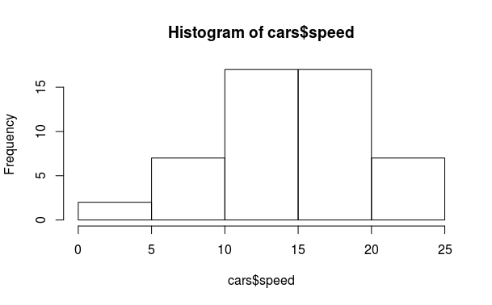

SAVING AS PDF
- pdf(“name.pdf”)- convert the graphical to pdf but does not save it
- dev.off() - close graphical ouyput file and saves it in current directory

NEW R SCRIPT
- ctrl+shift+n- new R script
- use top left box to make and save R scripts
- source(“name.R”) - will call the .R script and excecute

SEARCHING FILES & PACKAGES
- file.exists(“ name with extension”) - check if the file exists in current directory
- ls() or objects() - will show the vectors and data frames in the workspace/enveronment only, no files will be shown.
- search() - will search for packages which are right now loaded

- FINDING FUNCTION- help.search()
> help.search("sort") ## list functions with ‘sort’ as a title or as an alias in the help page

MAKING A VECTOR
- x <- c(1 ,2 , 4) - creatng a vector x using combine function
- q<-c(x,x,4);q or (q<-c(x,x,4)) – creating q and then printing q in one step
> (dd <- c(1,0,8,0,10)) ## equivalent to assignmet & print(dd)
[1] 1 0 8 0 10

PRINTING
- x or print (x) – both are same

CALLING ELEMENTS
- x[3] – using unique operator [] to call third element of vector x
- x[2:4] – call elements from second position to fourth

MEAN
- mean(x) – find mean- numerical measure of central location of data
> nbranch
[1] NA 35 41 50 NA NA NA NA NA 4 30 13 10 17 46 92
> mean(nbranch) ## when NA is not ommitted
[1] NA
> mean(nbranch, na.rm = T) ## when NA is ommitted
[1] 33.8

STANDARD DEVIATION
- sd(x) – standard deviation of x

PRE – INSTALLED DATA SETS IN R
- data() - to know the data sets allready in R
To see what other data sets come bundled with R, we can use the data()
command to obtain a list of data sets along with a short description of
each. If we modify the data from a data set, we can reload it by providing
the name of the data set in question as an input parameter to the data()
command, for example, data(iris) reloads the iris data set.

- ? or help() – used to get information

- attach()- to call coloumns of a data frame by direct name
> attach(Cars93.summary)
> abbrev
[1] C L M Sm Sp V
Levels: C L M Sm Sp V
> Min.passengers
[1] 4 6 4 4 2 7
> detach(Cars93.summary)

- Nile – prints data in Nile
- length () - prints length- no of coloumns of a data frame, use nrow to get actual number rows in dataframe
- mode () - print data type

PASTE & STRING SPLITTING
- paste(“li”,”j”) - outputs “li j”- used to combine words
- strsplit(u,”space“)- split character with spaces in between eg “li” “j”

SAVING A FILE
- save (a, file = “a.csv”)

READING CSV
- data1<-read.csv(file.choose() , header = T) OR WE CAN USE
- data<- read.csv(file = “~/famili.csv”, header = T )

READING ANY FILE USING READ.TABLE
- data2 <- read.table(file = "~/family.csv", header = TRUE , sep = ",") “,” is for .csv and “\t” is for .txt or tsv

REMOVING DATA rm()
- rm(data1) - removes data

TO READ TAB DELIMITED FILE TXT
- read.delim() - to read txt file

LOADING A DATA SET eg: IRIS
data(iris)

OPERATIONS IN DATA SETS
- dim(data) – dimensions – rows columns
- head(iris)
> head(iris, n=3)
Sepal.Length Sepal.Width Petal.Length Petal.Width Species
1 5.1 3.5 1.4 0.2 setosa
2 4.9 3.0 1.4 0.2 setosa
3 4.7 3.2 1.3 0.2 setosa

Collectively, the sepal length, sepal width,
petal length, and petal width are referred to as features, attributes, predictors,
dimensions, or independent variables in literature

Similarly, the species column in the data frame is what we are trying to predict with our model, and so it is referred to as the dependent variable, output, or target

Each row in the data frame corresponding
to a single data point is referred to as an observation, though it typically involves
observing the values of a number of features.

- tail(iris)
- iris[c(3 , 4 , 7), ] -read rows 3,4,7- without coma space – 3,4,7 coloumns are taken default
- iris[3:5, ] -
- iris[-(3:148), ]
- names(iris)- coloumn names

VIEW DATA
- view(data1)
- importing file directly from console is same that as the combination of – read.XXX functio and view function

STRUCTURE OF DATA
- str(data1) gives number of observations for number of variables= 1 observation of 4
variables- family

SUMMARY
- summary(iris)
> summary(cars)
speed dist
Min. : 4.0 Min. : 2.00
1st Qu.:12.0 1st Qu.: 26.00
Median :15.0 Median : 36.00
Mean :15.4 Mean : 42.98
3rd Qu.:19.0 3rd Qu.: 56.00
Max. :25.0 Max. :120.00

FIX DATA- EDIT COLOUMN TITLE
- fix(data1) – edit the data frame

INSTALLING PACKAGES
- sudo apt-get install r-cran-xml - to install XMLpackages if normal installing of packages fails via R consloe fails – type this in Terminal
- for installing Rcurl install sudo apt-get install libcurl4-openssl-dev in Terminal then try – install.packages(“RCurl”) in R
- if Rcurl does not work for installing httr package initially type -sudo apt-get install libssl-dev- in terminal. The type- install.package (“httr”) -in R console

SIMPLE WEBSCRAPING (FIRSTPROGRAM.R)
- webscrapping for websites that are not full HTML -
library(XML)
library(httr)
url<-"http://en.wikipedia.org/wiki/Brazil_national_football_team"
tabs <- GET(url)
tabs <- readHTMLTable(rawToChar(tabs$content), stringAsFactors = F)

- reading XML files
library(XML)
library(methods)
data3<- xmlToDataFrame("~/simple.xml")

- reading HTML data from websites which are pure HTML eg:
library(XML)
lijin <- readHTMLTAble (“http://www.w3schools.com/colors/color_tryit.asp?hex=000000” , which = 1)

- to read excel files (.xlsx)-
sudo apt-get install r-can-rjava - install rjava packagevia terminal
install.packages(“xlsx”) - install package in R
library(xlsx)
data<-read.xlsx(“~/family.xlsx”, sheetIndex = 1)

- reading data from a url where there is only data:
sampleurl <- "https://archive.ics.uci.edu/ml/machine-learning databases/iris/iris.data"
> setwd("~/datascience")
> local<- file.path("data", "demo.data")
> download.file(smapleurl, local)
> data3<- read.table("~/datascience/demo.data", header = T, sep = ",")
> View(data3)

- variance- shows how the values are diferrent from the mean value for one factor or column larger value of variance ,larger seperation between the values and the values are widely seperated in that way- var(iris$sepallength)

- covariance between two factors- the covariance shows how the different factors are inter related, anegative covariance value will indicate an inverse relation while a positive value will indicate a direct prportional relation.- cov(x,y)

- corelation coefficient is the measure of how the data is linearly related, if the value of cor coefficient is close to one the values are positively linearly related- cor(x,y)

- apropos(“med”)- to search if we dont know the exact name of the function

> apropos("sort")
[1] "is.unsorted" ".rs.sortCompletions" "sort" "sort.default"
[5] "sortedXyData" "sort.int" "sort.list" "sort.POSIXlt"

- class(x)- print the class of x that is the data type of x

- is.integer(x)- is x an intiger- returns TRUE or FALSE

- y <-as.integer (3) – to assign y integer data type , also can be used for coercing decimal values ie as.integer(3.12) gives a value of only 3 as output.

- as.complex(1) – 1+0i

TO COMBINE SENTENCES
- sprintf("%s has %d rupees", "lijn", 10000)
[1] "lijn has 10000 rupees"
sprintf funtion can be used to write sentence using place holders as in C

TO DERIVE SENTENCES
- substr("lijin has 100 rupees", start = 2, stop = 10)
[1] "ijin has “
substr () can be used to extract a group of words from a full sentence

TO SUBSTITUTE SOME WORDS FROM A SENTENCE
- sub("little", "BIG","mary has a little lamb" )
[1] "mary has a BIG lamb"
sub() function can be used to replace one string with another string

MATRIX CREATION
- creating a matrix
A<- matrix(data = c(1,2,3,4,5,6), nrow = 3, ncol = 2, byrow = T)
> A
[,1] [,2]
[1,] 1 2
[2,] 3 4
[3,] 5 6

- for giving names to rows and coloumns
dimnames(A)<- list(
+ c("row1","row2","row3"),
+ c("co1","col2"))
> A
co1 col2
row1 1 2
row2 3 4
row3 5 6

- To take the trnspose of a matrix, use t() function:
>A
co1 col2
row1 1 2
row2 3 4
row3 5 6
> t(A)
row1 row2 row3
co1 1 3 5
col2 2 4 6

COMBINE ROWS AND COLOUMNS
- cbind(A,B) – to bind matrix A and B by coloumn, A and B has equal number of rows
- rbind(A,B) – vice versa of cbind
- c(A) – will deconstruct matrix A -
>A
[,1] [,2] [,3]
[1,] 1 2 3
[2,] 4 5 6

DECONSTRUCTION OF A MATRIX
> c(A)
[1] 1 4 2 5 3 6

- nrow(mtcars)
- ncol(mtcars)
- head(mtcars)

VECTOR SLICE
- mtcars[[9]] or mtcars[[“am”]] or mtcars[ ,”am”] or mtcars$am ($ sign cannot be used for calling rows)– all calls 9th coloumn VECTOR ONLY NOT SLICE of mtcars data set
- for VECTOR SLICES – mtcars[1] or mtcars[“mg”] or mtcars[c(“mg”,”cc”)]

ROW SLICE
- mtcars[1,] or mtcars[“name1”, ] - will give first row slice – adding coma will be used for calling rows-
- mtcars[c(1,2),] or mtcars [c(“name1”,”name2”), ] can both be used for row slicing more than 1 row

- Logical indexing for calling rows-
>L <- mtcars$am ==0 #L logical vector with all 0 true and 1 false in “am” variable
>mtcars[L,] # calling a data frame with all “am” values = 0.
> mtcars[L,]$mpg # calling a vector of variable “mpg” with “am” values = 0

FREQUENCY DISTRIBUTION
- table(painters$school) - this can be used to find the frequency distribution of qualitative data only – the data which cannot be measured in numbers- cbind() function can be used to prind the data in coloumn format, for quantitative continous data, we have to convert that to descrete data

> head(tinting)
case id age sex tint target it csoa agegp
1 1 1 22.4 f no hicon 26.00 46.80 younger
2 1 1 22.4 f lo hicon 32.24 37.44 younger
3 1 1 22.4 f hi hicon 27.04 42.64 younger
4 1 1 22.4 f no locon 17.68 41.60 younger
5 1 1 22.4 f lo locon 20.80 37.44 younger
6 1 1 22.4 f hi locon 26.00 40.56 younger

> table(tinting$sex)

f m
91 91
> table(Sex=tinting$sex, Agegp= tinting$agegp)
Agegp
Sex younger older
f 63 28
m 28 63
> table(Sex=tinting$sex, Agegp= tinting$agegp, Tint = tinting$tint, Target = tinting$target)
, , Tint = no, Target = locon

Agegp
Sex younger older
f 9 4
m 4 9

, , Tint = lo, Target = locon

Agegp
Sex younger older
f 9 4
m 4 9

, , Tint = hi, Target = locon

Agegp
Sex younger older
f 9 4
m 4 9

, , Tint = no, Target = hicon

Agegp
Sex younger older
f 18 8
m 8 18

, , Tint = lo, Target = hicon

Agegp
Sex younger older
f 9 4
m 4 9

, , Tint = hi, Target = hicon

Agegp
Sex younger older
f 9 4
m 4 9

relative frequency distribution - percentage of each distributed variables out of total frequency - frquency distribution/ nrow(painters) - the values can be rounded off to 2 digits by – old = options(digits=1)- use cbind()

TO ROUND OFF DECIMAL NUMBERS- OLD
old = options(digits=1

BAR AND PIE PLOT
- barplot(school.freq) – gives the bar plot of frequency distribution
colour can be given to each bar by – barploat (school.freq, col= colour)- here colours is another variable- colour<- c("red","blue", "green", "yellow", "brown", "black", "grey", "white")

barplot(sl) sepel length of iris
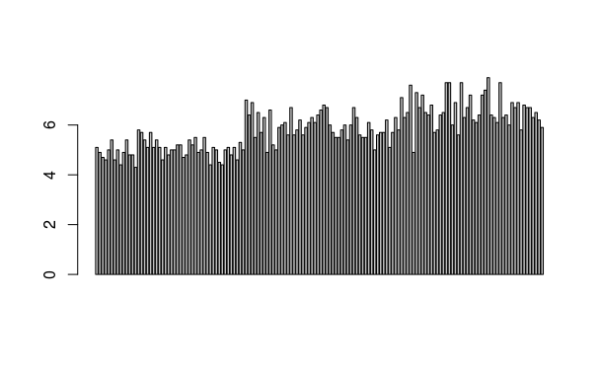

- pie(schoo.freq, col = colour)- for pie chart

QUALITATIVE DATA
- to classify a data into diffterent data frame based the value of some qualitative data variable- 1) we have to make another variable which contains only the values of this qualitative data variable- c_school <- painters$school 2) we have to make a logical vector whose value are true only when the value of the “some qualitative data variable under study” is available – B_school<- c_school==“C” 3)make another data frame having school value “C” - C_school <- painters [B_school, ] 4)find mean by mean(C_school$composition)

TAPPLY
- tapply(painters$composition, painters$school , mean)- will give mean of composition based on different schools in one step

RANGE
- range(faithful$eruption)- gives the range
> fossil_fuel
year carbon
1 1800 8
2 1850 54
3 1900 534
4 1950 1630
5 2000 6611

> range(fossil_fuel$carbon)
[1] 8 6611

MAKING A SEQUENCE
- seq(1.5, 5.5, by=0.5)- will give a sequence 1.5 2.0 2.5 3.0 3.5 4.0 4.5 5.0 5.5

QUANTITATIVE DATA
- to find the frequency distribution of quantitative variable 1) find range- range(). 2) make a sequence based on this range – seq(1.5, 5.5, by = 0.5). 3)cut the quantitative based on this sequence in to varoious intervals- cut(A, B, right = F) 4)use table function on the resultant variable – table(A) 5) to plot – hist(B, right = F)

CUMULATIVE DISTRIBUTION FREQUENCY
- cumulative frequency – cumsum(table(A))- apply cumsum () function on frequency distribution table
- cum.eruption <- c(0, cumsum(table(eruption.cut)))
> plot(cutting, cum.eruption, main = "faithful eruption", xlab = "duration in mnutes", ylab = "cumulative eruption"

PROBABILITY DENSITY FUNCTION
- > plot(density(eruption))
density is the probability density function

TO JOIN DOTS IN A PLOT WITH LINES
lines(cutting, cum.eruption)

RELATIVE CUMULATIVE DISTRIBUTION= CUMULATIVE DISTRIBUTION/nrow(dataset)
ecdf function- to make relative cumulative distribution funtion in one step
ecdf(faithful$eruptions)

STEM AND LEAF PLOT
stem(eruption)

SCATTER PLOT or just plot()
same as that of plot()- it is called so since it is the plot of two random variable
carbon <- c(8, 54, 534, 1630, 6611)
year <- c(1800, 1850, 1900, 1950, 2000)
plot(year, carbon, pch = 16) OR plot(carbon ~ year)

The construct
Carbon ̃ Year
is a graphics formula. The
plot()
function interprets
this formula to mean “Plot
Carbon
as a function of
Year
” or “Plot
Carbon
on the
y
-axis against
Year
on the
x
-axis”.

The setting
pch=16
(where
pch
is “plot character”) gives a solid black dot

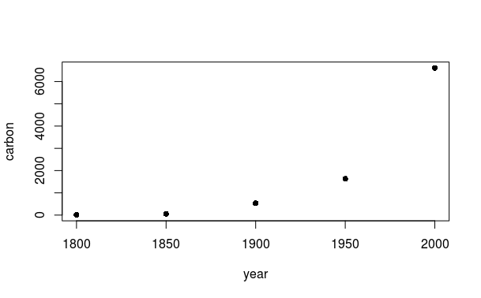

LINEAR REGRESSION MODEL
lm(waiting ~ eruption)

TO DRAW LINE IN SCATTER PLOT based on linear regression model
abline(lm(waiting ~ eruption))

WITH AND WITHIN

both are used as a substitude of $ function, but mainly done when more than 1 operation has to be done on a data frame.

with(data, plot()) - is used to operations directly on the data frame and we cannot s tore the resultant on the variable as the out put of that variable will be null.
within() is used when we have to store the resultant operations on a variable

In repeated computations with the same data frame, it is tiresome to keep repeating the name of the data frame. The function with() is often helpful in this connection.

> with(Cars93.summary, c(mean(Min.passengers), median(Max.passengers)))
[1] 4.5 6.0

AGGREGATE

The aggregate() function yields a data frame that has the mean or value of another specified function for each combination of factor levels.

data("iris")
head(iris)
iris_av <- with(iris, aggregate(Sepal.Length, by= list(Species), mean))
iris_av

Group.1 x
1 setosa 5.006
2 versicolor 5.936
3 virginica 6.588

BOX PLOT
boxplot(desity)

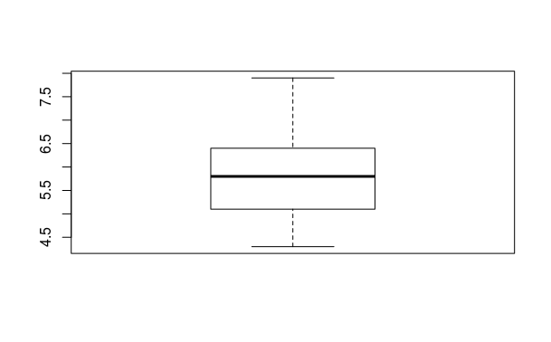

> sl.b<- boxplot(sl)
> summary(sl.b)
Length Class Mode
stats 5 -none- numeric
n 1 -none- numeric
conf 2 -none- numeric
out 0 -none- numeric
group 0 -none- numeric
names 1 -none- character
> names(sl.b)
[1] "stats" "n" "conf" "out" "group" "names"
> sl.b$stats
[,1]
[1,] 4.3
[2,] 5.1
[3,] 5.8
[4,] 6.4
[5,] 7.9
> sl.b$stats[1]
[1] 4.3
> sl.b$stats[3]
[1] 5.8

PAIRS – to see scatter plotting in matrix format-
pairs(iris[,1:4])
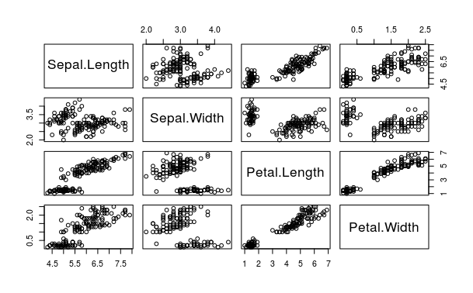

QQ plot- used to check normality- normally distributed or not ie Gaussian

qqnorm(sl)
qqline(sl)
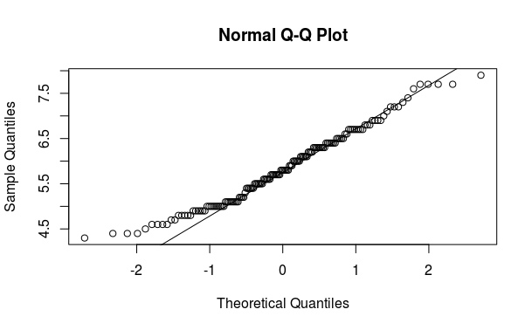

PAR- to see multiple types of plot at same console
par(mfrow=c(2,2))
hist(sl, freq = F)
lines(sl.d)
qqnorm(sl)
qqline(sl)
barplot(sl)
boxplot(sl)

par(mfrow=c(1,1))- this line of code is to make it back to view one plot at a time

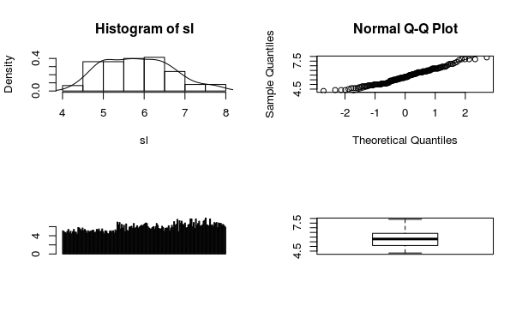

MAKING OUR OWN FUNCTION

function( arglist ) expr
return(value)
eucl_dist <- function(x1, x2) sqrt(sum(x1-x2)^2)

TO APPLY FUNCTION ON A DATA SET

apply(X, MARGIN, FUN, ...)
distance <- apply(iris_features, 1, function(x) eucl_dist(x, new_sample))

TO SORT A DATA SET
distance_sort <- sort(distance, index.return = T)
the index.return
parameter set to TRUE , so that we also get back the indexes of the row numbers in our
iris data frame corresponding to each distance computed.

> fourcities <- c("trivandrum", "chennai", "bangalore", "hyderabad")
> sort(fourcities)
[1] "bangalore" "chennai" "hyderabad" "trivandrum"

> sort(fourcities, index.return = T)
$x
[1] "bangalore" "chennai" "hyderabad" "trivandrum"

$ix
[1] 3 2 4 1

FINDING NUMBER OF CHARACTERS nchar()

> fourcities <- c("trivandrum", "chennai", "bangalore", "hyderabad")
> nchar("hyderabad")
[1] 9
> nchar(fourcities)
[1] 10 7 9 9

BOX AND WHISKERS PLOT
library("lattice")
bwplot(Sepal.Length~Sepal.Width, data = iris)
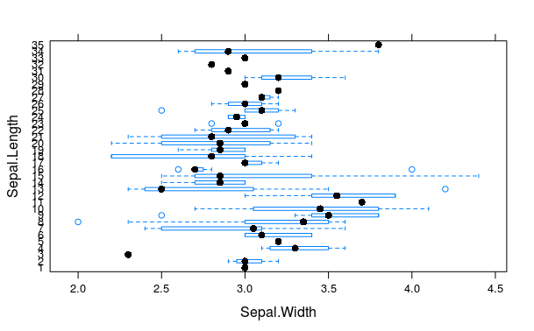

DOT PLOT
library("lattice")
dotplot(Sepal.Length~Sepal.Width, data = iris)
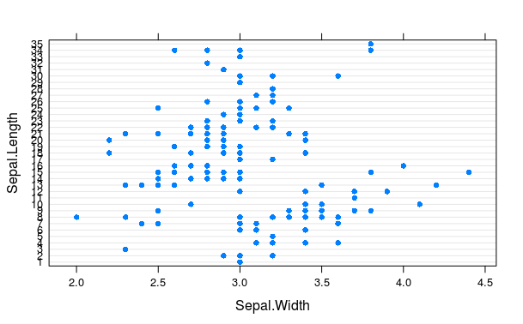

XY PLOT- we can add third variable in XY PLOT
library("lattice")
xyplot(Sepal.Length~Sepal.Width|Species, data = iris)

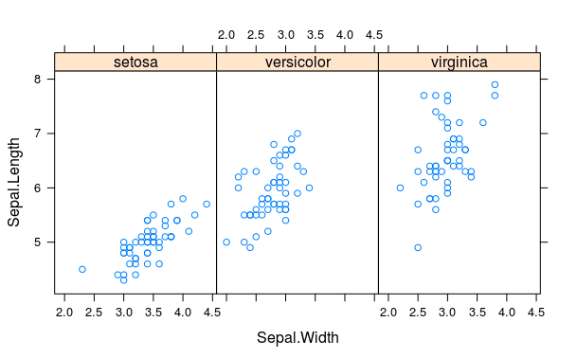

PAIRS.PANELS
library("psych")
pairs.panels(iris)

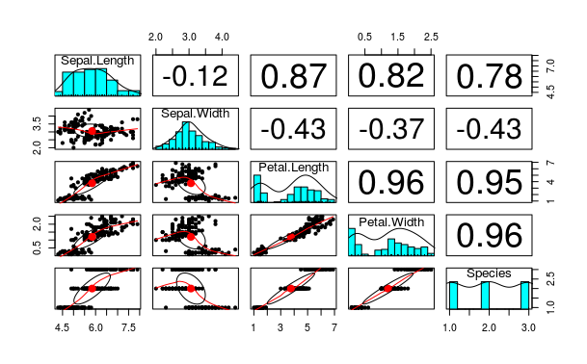

HEAT MAP- can only be used when data is converted to matrix format.

Install.packages(“ggplot2”)
library(ggplot2)
heatmap(as.matrix(mtcars), scale = "column", col = heat.colors(256)
, main = "heat map of mtcars", Rowv = NA, Colv = NA)

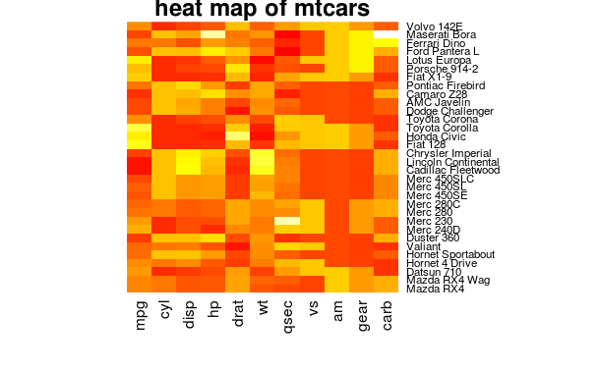

TIME SERIES – to make data periodic, as in the cases of data which has dates, years
ts() - ts will make data in the form of a time frame
> jobs <- seq(950,1070, by = 5)
> jobs
[1] 950 955 960 965 970 975 980 985 990 995 1000 1005 1010 1015 1020 1025 1030 1035
[19] 1040 1045 1050 1055 1060 1065 1070
> jobs <- ts(jobs, start = 1975, frequency = 12)
> jobs
Jan Feb Mar Apr May Jun Jul Aug Sep Oct Nov Dec
1975 950 955 960 965 970 975 980 985 990 995 1000 1005
1976 1010 1015 1020 1025 1030 1035 1040 1045 1050 1055 1060 1065
1977 1070

use window() to extract subset from a time series
> subjobs <- window(jobs, start = 1975.25, end = 1976.75)
> subjobs
Jan Feb Mar Apr May Jun Jul Aug Sep Oct Nov Dec
1975 965 970 975 980 985 990 995 1000 1005
1976 1010 1015 1020 1025 1030 1035 1040 1045 1050 1055

DATA FRAME
- df <- data.frame(a,b,c) – used to make dta frames with other vectors
- mtcars[1,2] - element in first row second coloumn
- mtcars [“mazda”,”cyl”]
making a data frame
carbon <- c(8, 54, 534, 1630, 6611)
year <- c(1800, 1850, 1900, 1950, 2000)
fossil_fuel <- data.frame(year=year, carbon = carbon)
plot (carbon~year, data = fossil_fuel, pch = 16)

> fossil_fuel
year carbon
1 1800 8
2 1850 54
3 1900 534
4 1950 1630
5 2000 6611

class() can be used to check the type of factor in a data frame
> Cars93.summary
Min.passengers Max.passengers No.of.cars abbrev
Compact 4 6 16 C
Large 6 6 11 L
Midsize 4 6 22 M
Small 4 5 21 Sm
Sporty 2 4 14 Sp
Van 7 8 9 V
> class(Cars93.summary$abbrev)
[1] "factor"
> class(Cars93.summary$Min.passengers)
[1] "numeric"

edit() can be used to edit the data frame
> Cars93.summary <- edit(Cars93.summary)
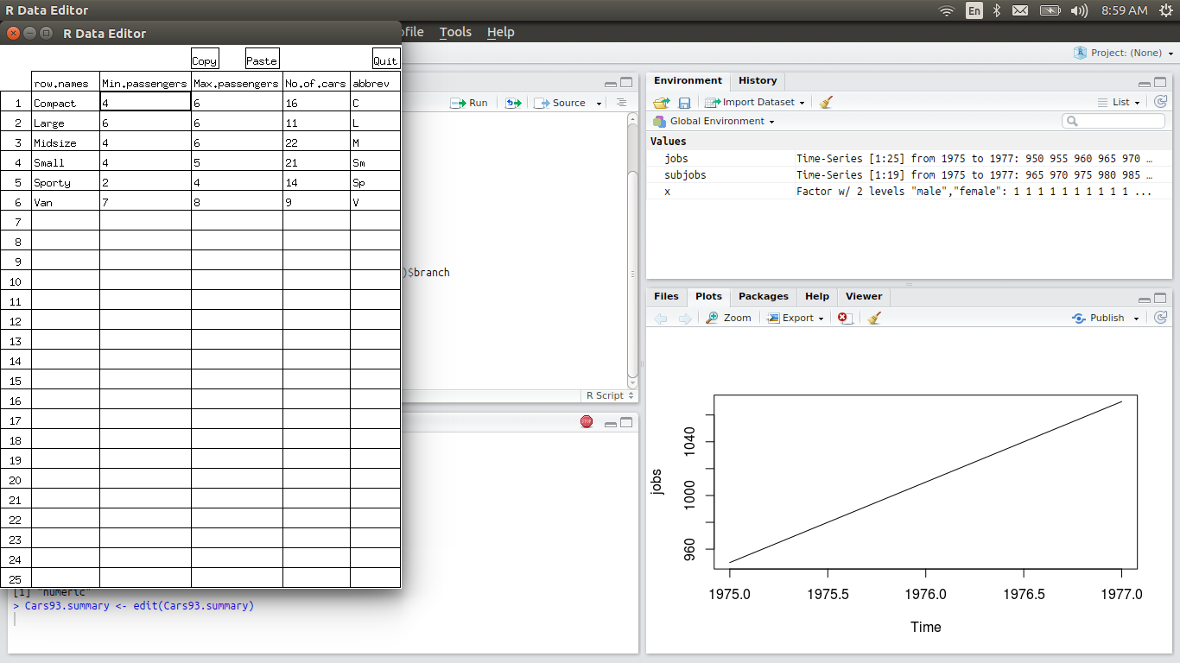
To know the names of rows and coloumns of a data frame
row-- rownames() or row.names()
coloumn – colnames or names
> Cars93.summary
Min.passengers Max.passengers No.of.cars abbrev
Compact 4 6 16 C
Large 6 6 11 L
Midsize 4 6 22 M
Small 4 5 21 Sm
Sporty 2 4 14 Sp
Van 7 8 9 V

> rownames(Cars93.summary)
[1] "Compact" "Large" "Midsize" "Small" "Sporty" "Van"
> colnames(Cars93.summary)
[1] "Min.passengers" "Max.passengers" "No.of.cars" "abbrev"
> row.names(Cars93.summary)
[1] "Compact" "Large" "Midsize" "Small" "Sporty" "Van"
> names(Cars93.summary)
[1] "Min.passengers" "Max.passengers" "No.of.cars" "abbrev"

The functions names() (or colnames()) and rownames() can also be used to
assign new names
before changing
> names(Cars93.summary)
[1] "Min.passengers" "Max.passengers" "No.of.cars" "abbrev"

after changing
> names(Cars93.summary)[3] <- "numofcars"
> names(Cars93.summary)
[1] "Min.passengers" "Max.passengers" "numofcars" "abbrev"

calling rows and coloumns in a data frame

Cars93.summary[4, 2]
Cars93.summary[1:3, 2:3] # Rows 1-3 and columns 2-3
Cars93.summary[, 2:3] # Columns 2-3 (all rows)
Cars93.summary[, c("No.of.cars", "abbrev")] # Cols 2-3, by name
Cars93.summary[, -c(2,3)] # omit columns 2 and 3

> Cars93.summary
Min.passengers Max.passengers numofcars abbrev
Compact 4 6 16 C
Large 6 6 11 L
Midsize 4 6 22 M
Small 4 5 21 Sm
Sporty 2 4 14 Sp
Van 7 8 9 V
> Cars93.summary[2,3]
[1] 11
> Cars93.summary[1:2,2:3]
Max.passengers numofcars
Compact 6 16
Large 6 11
> Cars93.summary[,2:3]
Max.passengers numofcars
Compact 6 16
Large 6 11
Midsize 6 22
Small 5 21
Sporty 4 14
Van 8 9
> Cars93.summary[1:2,]
Min.passengers Max.passengers numofcars abbrev
Compact 4 6 16 C
Large 6 6 11 L

> Cars93.summary[,c("Max.passengers", "numofcars")]
Max.passengers numofcars
Compact 6 16
Large 6 11
Midsize 6 22
Small 5 21
Sporty 4 14
Van 8 9
> Cars93.summary[,-c(2,3)]
Min.passengers abbrev
Compact 4 C
Large 6 L
Midsize 4 M
Small 4 Sm
Sporty 2 Sp
Van 7 V

The subset() function offers an alternative way to extract rows and columns
Use the argument select to specify a subset of columns

> Cars93.summary
Min.passengers Max.passengers numofcars abbrev
Compact 4 6 16 C
Large 6 6 11 L
Midsize 4 6 22 M
Small 4 5 21 Sm
Sporty 2 4 14 Sp
Van 7 8 9 V

> subset(Cars93.summary, subset = c(T,F,T,F,F,F)) ## by default it selects rows
to select coloumns use “select=” instead of “subset=”
Min.passengers Max.passengers numofcars abbrev
Compact 4 6 16 C
Midsize 4 6 22 M

Use of the subscript notation to extract a column, as in Cars93.summary[, 1],
returns a vector. By contrast, extraction of the raw Cars93.summary[1, ] returns
a data frame, necessary because this allows different elements (columns) to retain their
existing classes

MAKING LIST- list is a collection of R objects
- V<-list(A,B) - can be used to make vector of by combining diffent kind of vector
- attach(V) – attach list eg- V to R so that we will only call the name of vectors only
- detach (V) – vice versa of R

> USACanadapop <- list( USAcities = c("NY", "LA", "Chicago"),
+ Canadacities = c("orlando", "montreal"),
+ population = c(USA = 120, Canada = 145))
> USACanadapop
$USAcities
[1] "NY" "LA" "Chicago"

$Canadacities
[1] "orlando" "montreal"

$population
USA Canada
120 145

STACK- used to convert different coloumns of a data frame in to another data frame of two coloumns whose first coloumn has the stacked values of all the columns of initial data frame and second coloumn is a factor with levels as names of coloumns of initial data frame

> Cars93.summary
Min.passengers Max.passengers numofcars abbrev
Compact 4 6 16 C
Large 6 6 11 L
Midsize 4 6 22 M
Small 4 5 21 Sm
Sporty 2 4 14 Sp
Van 7 8 9 V

> cars <- stack(Cars93.summary, select = 1:4)
Warning message:
In stack.data.frame(Cars93.summary, select = 1:4) :
non-vector columns will be ignored
> head(cars)
values ind
1 4 Min.passengers
2 6 Min.passengers
3 4 Min.passengers
4 4 Min.passengers
5 2 Min.passengers
6 7 Min.passengers
> str(cars)
'data.frame': 18 obs. of 2 variables:
$ values: num 4 6 4 4 2 7 6 6 6 5 ...
$ ind : Factor w/ 3 levels "Max.passengers",..: 2 2 2 2 2 2 1 1 1 1 ...

unstack will remove stacked format
> unstack(cars)
Max.passengers Min.passengers numofcars
1 6 4 16
2 6 6 11
3 6 4 22
4 5 4 21
5 4 2 14
6 8 7 9

SOME IMPORTANT FUNCTIONS

all()- Given a set of logical vectors, are all of the values true?
> all(jobs)
[1] TRUE
Warning message:
In all(jobs) : coercing argument of type 'double' to logical
> all(x)
Error in Summary.factor(c(1L, 1L, 1L, 1L, 1L, 1L, 1L, 1L, 1L, 1L, 1L, :
‘all’ not meaningful for factors
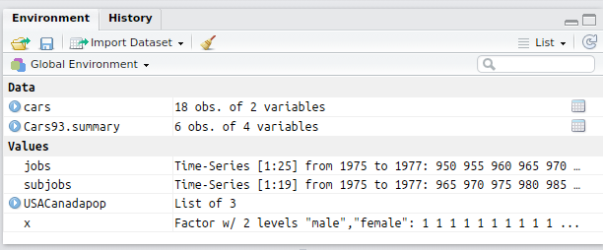

SAPPLY – it can be used to apply mean or median or value of a function on all the coloumns of a data frame together (except factors)

> head(iris)
Sepal.Length Sepal.Width Petal.Length Petal.Width Species
1 5.1 3.5 1.4 0.2 setosa
2 4.9 3.0 1.4 0.2 setosa
3 4.7 3.2 1.3 0.2 setosa
4 4.6 3.1 1.5 0.2 setosa
5 5.0 3.6 1.4 0.2 setosa
6 5.4 3.9 1.7 0.4 setosa
> sapply(iris[ ,-5], range)
Sepal.Length Sepal.Width Petal.Length Petal.Width
[1,] 4.3 2.0 1.0 0.1
[2,] 7.9 4.4 6.9 2.5

CREATING MY OWN FUNCTION

> mean.and.sd <- function(x){
+ Mean <- mean(x)
+ SD <- sd(x)
+ c(MN = Mean, Sdev = SD)
+ }
> mean.and.sd(dd)
MN Sdev
3.800000 4.816638

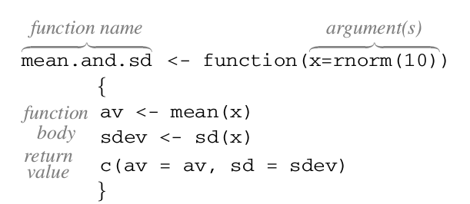

IF ELSE STATEMENTS-

> if(mean(dd) > median(dd)) print("mean > meadian") else print("mean < = median")
[1] "mean > meadian"
> mean(dd)
[1] 3.8
> median(dd)
[1] 1

FINDING VALUES IN A GIVEN VECTOR -- %in%

> y <- rep(1:4, each = 2)
> y
[1] 1 1 2 2 3 3 4 4
> y [y %in% c(2,3)]
[1] 2 2 3 3
> y [y %in% c(2)]
[1] 2 2
> y [y %in% 2]
[1] 2 2
> z <- "lijin is happy"
> z [z %in% "happy"]
character(0)
> a <- z [z %in% "happy"]
> a
character(0)
MATCHING the values of a vector
> y
[1] 1 1 2 2 3 3 4 4
> match(y, c(2,3))
[1] NA NA 1 1 2 2 NA NA
> match(y, c(2,3), nomatch = 0) ## arguemnt nomatch will make NA values 0
[1] 0 0 1 1 2 2 0 0
> match(z, "happy")
[1] NA
> match(z, "lijin is happy")
[1] 1
> b <- strsplit(z, " ")
> b
[[1]]
[1] "lijin" "is" "happy"
> match(b, c("is", "happy"))
[1] NA

IDENTIFICATION OF ROWS THAT HAS MISSING VALUES AND OMIT THE SAME-
complete.cases()
> science [!complete.cases(science), ] ## science is data set in DAAG package
State PrivPub school class sex like Class
671 ACT public 19 1 <NA> 5 19.1
672 ACT public 19 1 <NA> 5 19.1

The function na.omit() omits any rows that contain missing values. For example,
> dim(science)
[1] 1385 7
> Science <- na.omit(science)
> dim(Science)
[1] 1383 7

is.na() can be used in the same case when dealing with individual vectors
>nbranch1[is.na(nbranch1)]

SCATTER PLOT 3D
install.packages("scatterplot3d")
library(scatterplot3d)
scatterplot3d(iris[1:3])
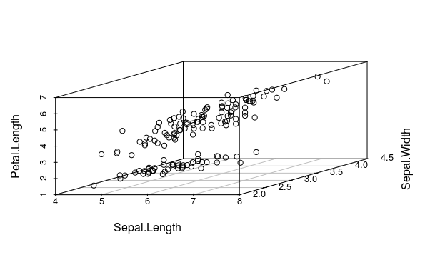

CORRELOGRAM OR CORRGRAM

> cor(iris[,1:4])
Sepal.Length Sepal.Width Petal.Length Petal.Width
Sepal.Length 1.0000000 -0.1175698 0.8717538 0.8179411
Sepal.Width -0.1175698 1.0000000 -0.4284401 -0.3661259
Petal.Length 0.8717538 -0.4284401 1.0000000 0.9628654
Petal.Width 0.8179411 -0.3661259 0.9628654 1.0000000

library(corrgram)
> corrgram(iris, order = T, lower.panel = panel.shade, upper.panel = panel.pie,
+ text.panel = panel.txt)

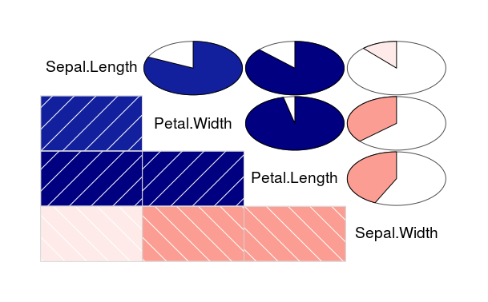
JITTER – USED TO ADD NOICE TO THE DATA
> dd
[1] 1 0 8 0 10
> jitter(dd)
[1] 1.19015523 0.07055692 7.91184899 0.06337822 10.19998752
> jitter(dd, factor = 2)
[1] 1.0757836 -0.2615765 8.3119029 -0.0171281 9.8966233
> jitter(dd, factor = 2, amount = 2)
[1] -0.1065645 1.0107661 6.9332359 -0.2859592 11.1876223

CONTOUR PLOT- same as contour lines used in maps
> str(volcano)
num [1:87, 1:61] 100 101 102 103 104 105 105 106 107 108 ...
matrix with 87 rows and 61 columns, rows corresponding to grid lines running east to west and columns to grid lines running south to north
> contour(volcano)

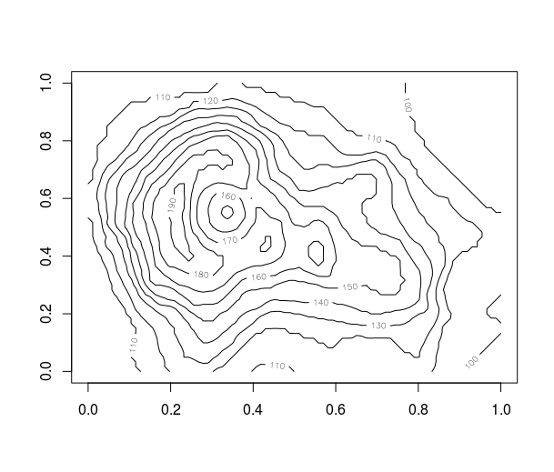

FILLED CONTOUR- uses colors in a contour map to indicate height difference
> filled.contour(volcano)
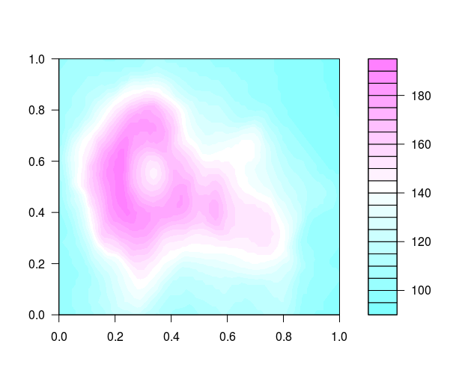

3D- PERSPECTIVE PLOT-
> persp(volcano, expand = 0.3)

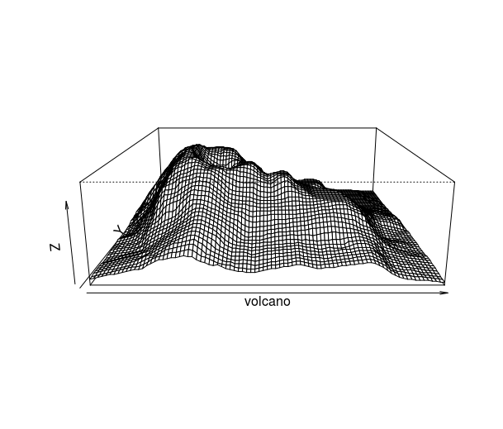

LEVEL PLOT- SIMILAR TO CONTOUR PLOT- instead of lines we use colours
sl <- iris$Sepal.Length
sw <- iris$Sepal.Width
pw <- iris$Petal.Width
levelplot(pw ~ sl*sw, data = iris) ### pw as function of sw and sl
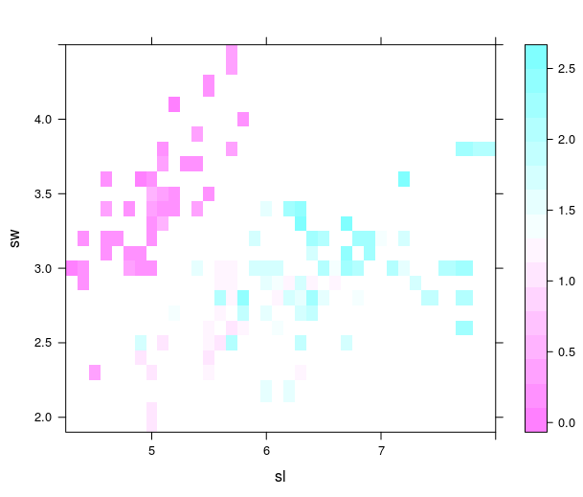

UNLIST- unlist()- it is a very important function to convert a large value of text data in to individual words, in which each word will be concidered as a factor with different levels

> happy.words <- read.xlsx("~/worldcloud.xlsx", sheetIndex = 1, header = F)
> match(b2,happy.words, nomatch = 0)
[1] 0 0 0
> str(happy.words)
'data.frame': 46 obs. of 1 variable ### happy.words is a data frame

> happy.wordsL <- unlist(happy.words) ### using unlist()
> str(happy.wordsL)
Factor w/ 45 levels "best","carefree",..: 26 23 32 10 44 7 21 24 5 25 ...
- attr(*, "names")= chr [1:47] "X11" "X12" "X13" "X14" ...
> match(b2,happy.wordsL, nomatch = 0)
[1] 0 0 1

IF ELSE - similar to if else statements in C
> happy.score
[1] 0 0 1

> sad.score
[1] 0 0 0

> if(sum(happy.score) > sum(sad.score)) print("This Person is Happy!") else print("This person is not Happy")
[1] "This Person is Happy!"

HAPPY NOT HAPPY TEXT ANALYSIS- Program
library(xlsx)
happy.words <- read.xlsx("~/worldcloud.xlsx", sheetIndex = 1, header = F)
happy.wordsL <- unlist(happy.words)
sad.words <- read.xlsx("~/worldcloud.xlsx", sheetIndex = 2, header = F)
sad.wordsL <- unlist(sad.words)
input.sent <- read.delim(file = "~/input_sentence", header = F, stringsAsFactors = F)
input.sentC <- as.character(input.sent)
input.sentSP <- strsplit(input.sentC, " ")
input.sentL <- unlist(input.sentSP)
happy.score <- match(input.sentL,happy.wordsL, nomatch = 0)
sad.score <- match(input.sentL,sad.wordsL, nomatch = 0)
if(sum(happy.score) > sum(sad.score)) print("This Person is Happy!") else print("This person is not Happy")

> library(xlsx)
Loading required package: rJava
Loading required package: xlsxjars
> happy.words <- read.xlsx("~/worldcloud.xlsx",
+ sheetIndex = 1, header = F) ## use header = F argument else the element in happy.words will be concidered Title of data frame

> happy.wordsL <- unlist(happy.words)
> sad.words <- read.xlsx("~/worldcloud.xlsx",
+ sheetIndex = 2, header = F)
> sad.wordsL <- unlist(sad.words) ## unlisting the data frame is important in matching
> input.sent <- read.delim(file = "~/input_sentence",
+ header = F, stringsAsFactors = F) #stringsAsFactors = F so that the input sentence is taken string itself which can later be converted to character

> input.sentC <- as.character(input.sent) ## converting to character format
> input.sentSP <- strsplit(input.sentC, " ")
> input.sentL <- unlist(input.sentSP)
> happy.score <- match(input.sentL,happy.wordsL, nomatch = 0)
> sad.score <- match(input.sentL,sad.wordsL, nomatch = 0)
> if(sum(happy.score) > sum(sad.score)) print("This Person is Happy!") else print("This person is not Happy")
[1] "This person is not Happy"

LOOPS
FOR LOOP-
> for(i in 1:3) print(i)
[1] 1
[1] 2
[1] 3

library(DAAG)
> for (j in seq(from=2,to=9)){
+ relgrowth [j-1] <- (austpop[9,j] - austpop[1,j])/austpop[1,j]
+ }
> names(relgrowth) <- names(austpop[c(-1,-10)])
> relgrowth
NSW Vic Qld SA WA Tas NT ACT
2.295168 2.268275 3.979502 2.363636 4.875817 1.455959 36.400000 102.333333

How to make various changes in plot or scatter plot
> structure(primates) #### DAAG
Bodywt Brainwt
Potar monkey 10.0 115
Gorilla 207.0 406
Human 62.0 1320
Rhesus monkey 6.8 179
Chimp 52.2 440

intial plot
> with(primates, plot(Brainwt ~ Bodywt, pch = 16))
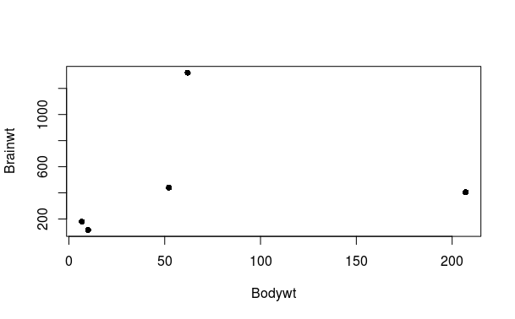

to change length of x axis (xlim = ) & y axis (ylim = )
> with(primates, plot(Brainwt ~ Bodywt, pch = 16, xlim = c(0,100))) ## bodywt axis reduced to 100
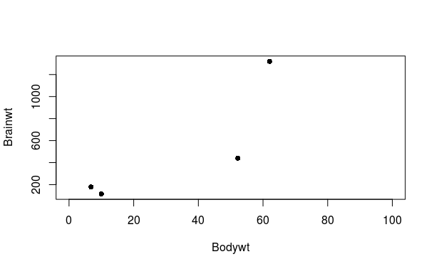
to add names/labels to each – use text() function with arguement labels = row.names
> with(primates, text(Brainwt ~ Bodywt,labels=row.names(primates), pos = 4))
## pos 4 is to keep labels on right side 3
2 4
1
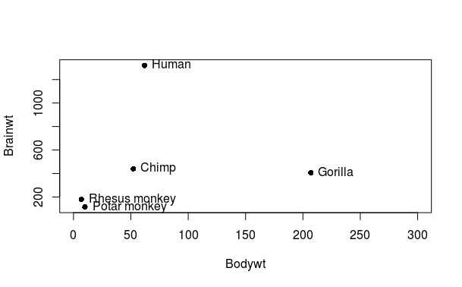

To change the size of dots in scatter plot characters used in graph-- using- cex = parameter
> theta <- (1:50)* 0.92
> plot(theta, sin(theta), pch = 16)

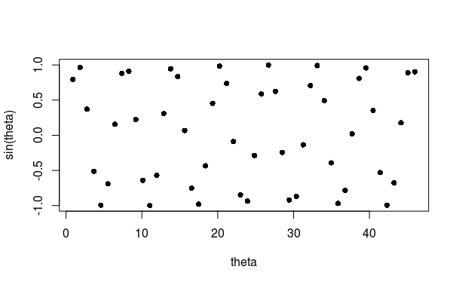
> plot(theta, sin(theta), pch = 16, cex = 2)

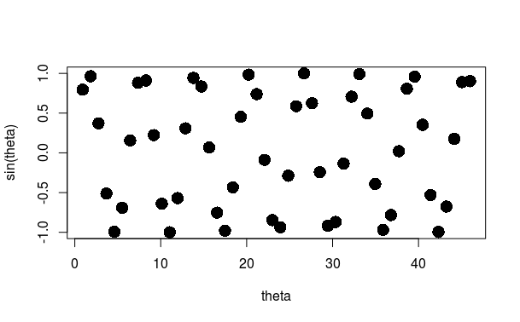

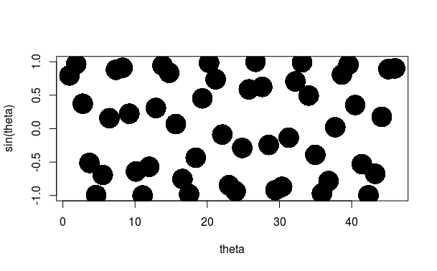
> plot(theta, sin(theta), pch = 16, cex = 4)

Adding Colours to the graph points-- col =
> plot(theta, sin(theta), pch = 16, cex = 4, xlim = c(0,60), ylim = c(-4,4))
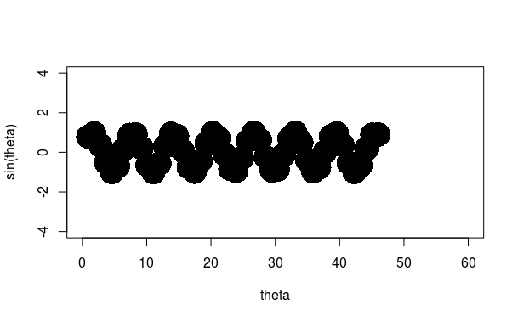
> plot(theta, sin(theta), pch = 16, cex = 4, col = 1:50, xlim = c(0,60), ylim = c(-4,4))
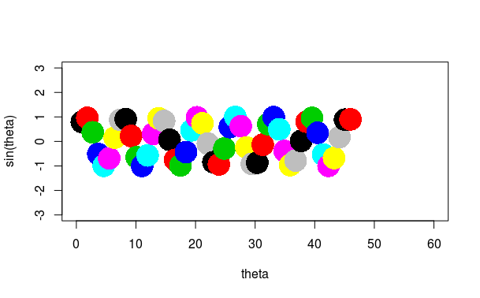
the same Cane be done using colors () function
plot(theta, sin(theta), col=colors()[1:50], pch=16, cex=4)

using ggplot2 packages
qplot() or quickplot () - similar to plot() -- geom is geometry(poin, line etc) and aes is aesthwtics- basic format >qplot(displ, displ, data = mpg) ## mpg is data frame
qplot can read data only in data frame format.
> quickplot(Year, mdbRain, data = bomregions, geom = c("point", "smooth"), span = 0.5,
+ xlab = "", ylab = "Av.rainfall, M-D Basin")

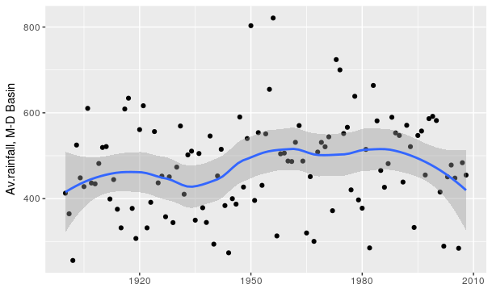

> quickplot(Year, mdbRain, data = bomregions, geom = c("point", "smooth"), span = 1,
+ xlab = "", ylab = "Av.rainfall, M-D Basin") ## curve width compressed using span value between 0 to 1d
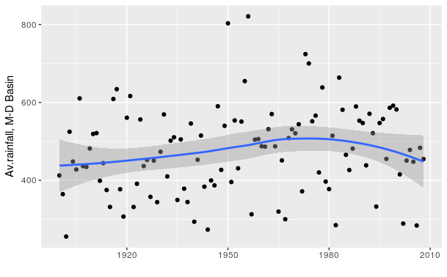

> quickplot(Year, mdbRain, data = bomregions, geom = c("point", "smooth"), span = 0.2,
+ xlab = "", ylab = "Av.rainfall, M-D Basin") ## curve width expands

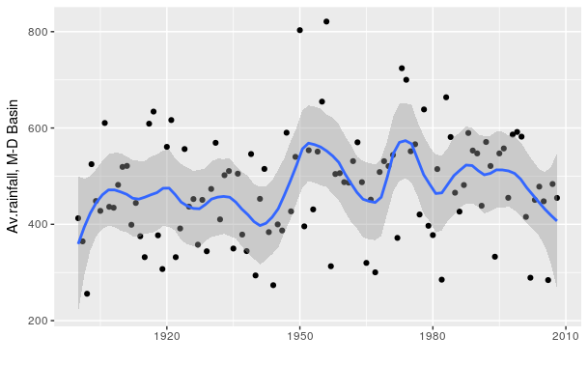
> quickplot(Year, mdbRain, data = bomregions, geom = c("point"), span = 0.2,
+ xlab = "", ylab = "Av.rainfall, M-D Basin") ## excluding lines , only points
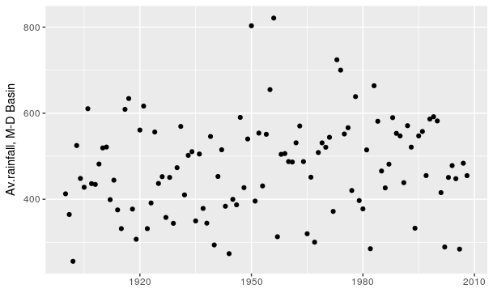

> quickplot(Year, mdbRain, data = bomregions, geom = c("smooth"), span = 0.2,
+ xlab = "", ylab = "Av.rainfall, M-D Basin") ## excluding points, only lines
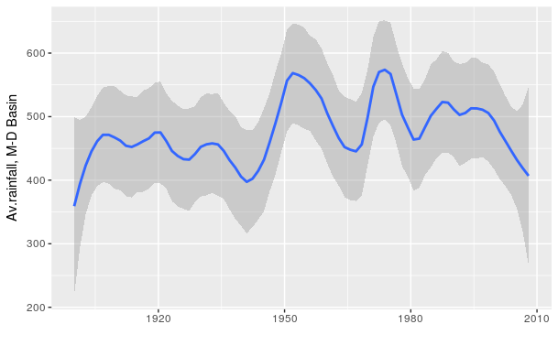

> quickplot(Year, mdbRain, data = bomregions, geom = c("point","smooth"), span = 0.2,
+ ylab = "Av.rainfall, M-D Basin") ## xlabel not given , coloumn name will be printed as default
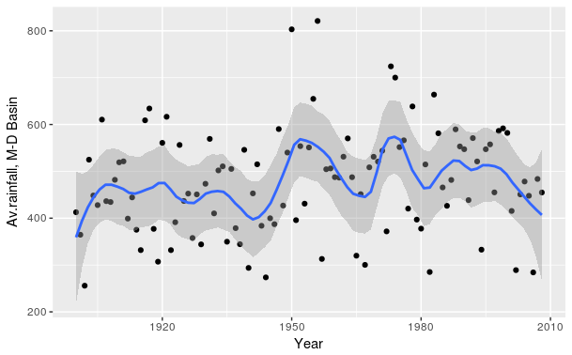

> quickplot(Year, mdbRain, data = bomregions, geom = c("point","smooth"),se = F, span = 0.2,
+ xlab = "", ylab = "Av.rainfall, M-D Basin") ## to remove band around curve

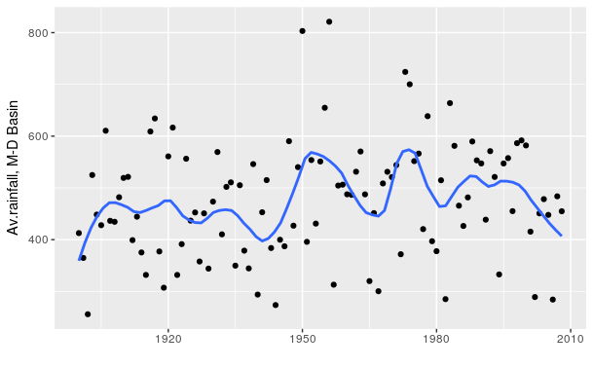

To colour the points with respect to a factor
> qplot(displ, hwy, data = mpg, col = drv) ## drv is a factor with 3 levels

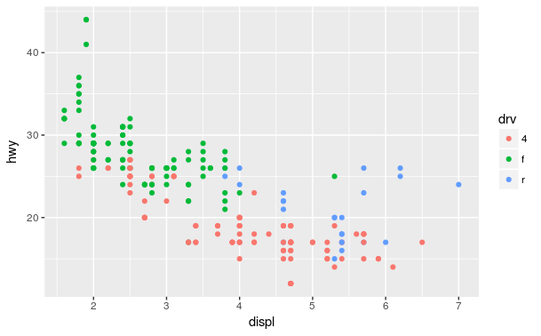
> qplot(displ, hwy, data = mpg, col = drv, geom = c("ponits", "smooth"))
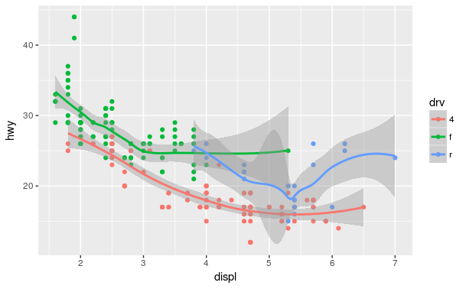
> qplot(hwy, data = mpg) ## to do histogram usin ggplot2
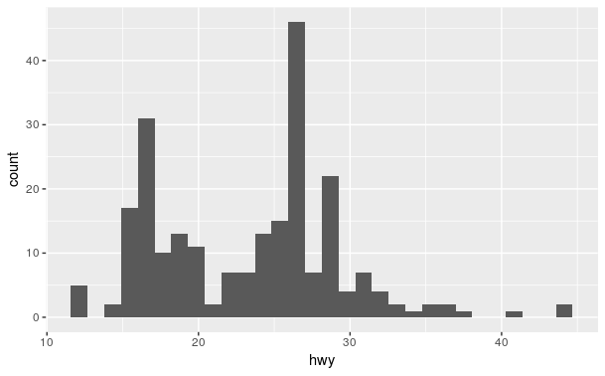

> qplot(hwy, data = mpg, fill = drv) ## to add color use fill
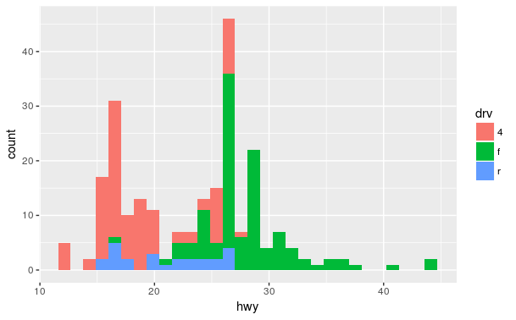
Facets can be used to show graphs of factors with different levels seperately
> qplot(displ, hwy,data = mpg, facets = .~ drv) ## by seperate coloumns
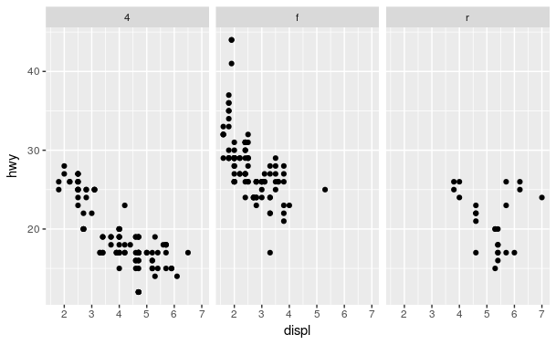

> qplot(hwy, data = mpg, facets = drv~.) ## by rows

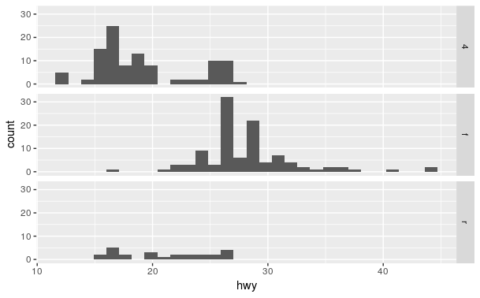
Plottinng probability density function
> qplot(Sepal.Length, data = iris, geom = "density")

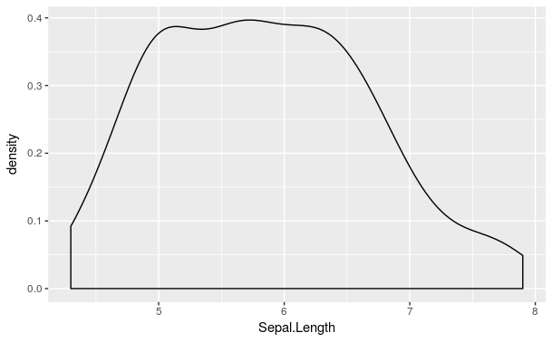
> qplot(Sepal.Length, data = iris, geom = "density", color = Species)

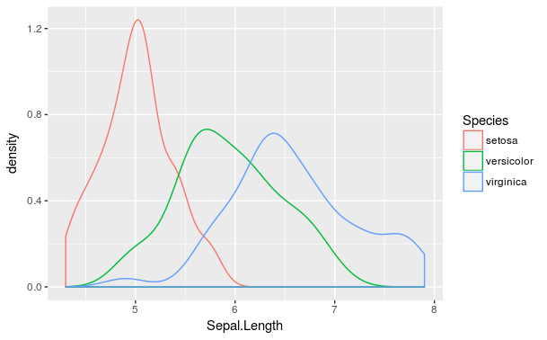
To give different shapes in qplot()
> qplot(Sepal.Length, Sepal.Width, data = iris, shape = Species)
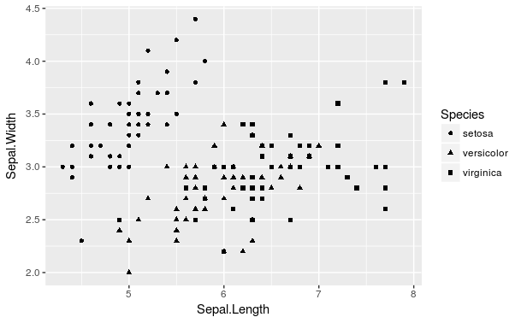

to get a linear model line in the qplot:
> qplot(Sepal.Length, Sepal.Width, data = iris, shape = Species, color = Species,
+ geom = c("point", "smooth") ,method = "lm")

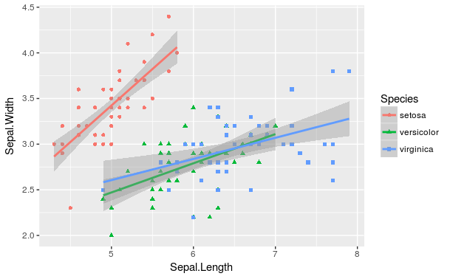

USING ggplot() function
Feeding the data in to the ggplot
> g <- ggplot(iris, aes(Sepal.Length, Sepal.Width))
> summary(g)
data: Sepal.Length, Sepal.Width, Petal.Length, Petal.Width, Species [150x5]
mapping: x = Sepal.Length, y = Sepal.Width
faceting: <ggproto object: Class FacetNull, Facet>

> print(g) ## it does not know how to plot, hence no graph or error message will be displayed

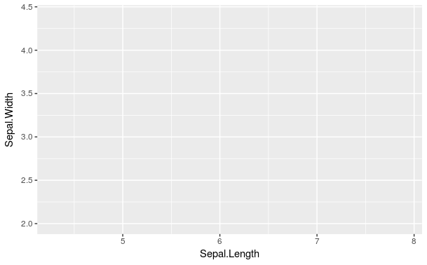

To do normal plot we have to use geom_point ( ) along with ggplot()
> g+geom_point()
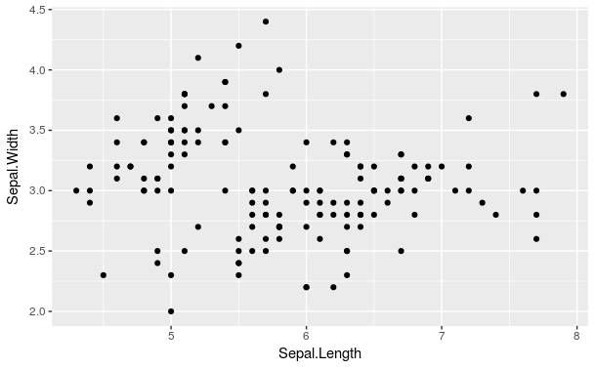
To draw a line using normal loess
> g+geom_point()+geom_smooth() ## to draw line using loess
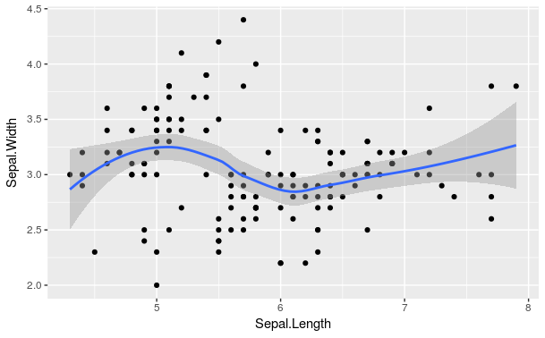

To fit a line using the linear model
> g+geom_point()+geom_smooth(method = "lm") ## to draw line using linear model

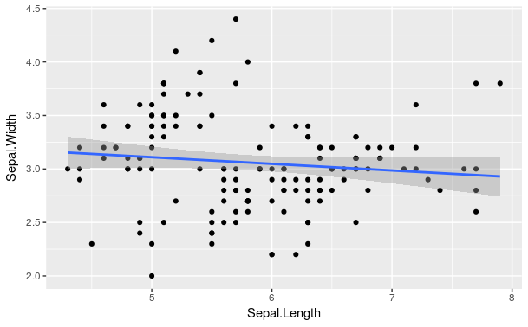

To make facets using ggplot()
> g+geom_point()+geom_smooth(method = "lm") +
+ facet_grid(.~Species) ## to make facets as in qplot
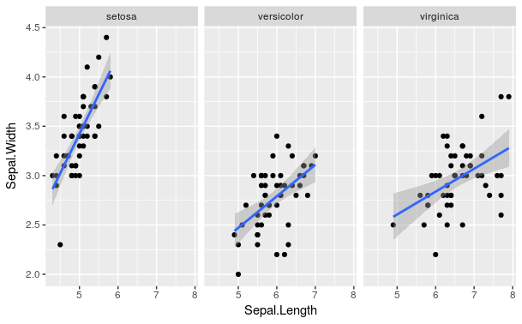
To change color, size, transparency
> g+geom_point(color = "steelblue", size = 4, alpha = 1/2) ## alpha value for transparency

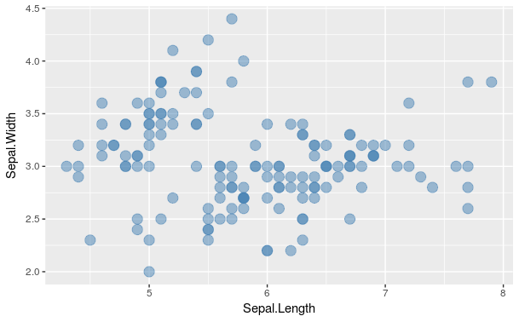

> g+geom_point(aes(color = Species), size = 4, alpha = 1/2) ## whenever color or any other aesthrtics has to be assigned a data variable as input , use aes() in geom_point()

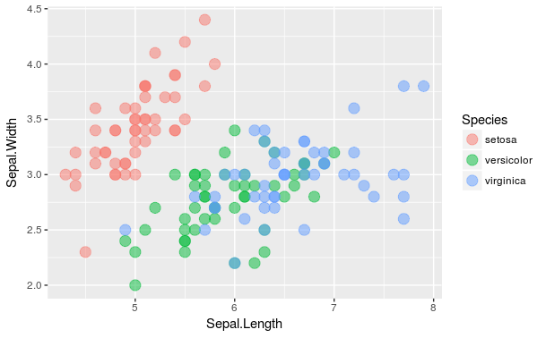

To give labels in The graph, use labs() function

> g+geom_point(aes(color = Species), size = 4, alpha = 1/2) +
+ labs(title = "IRIS", x= "sl", y="sw")

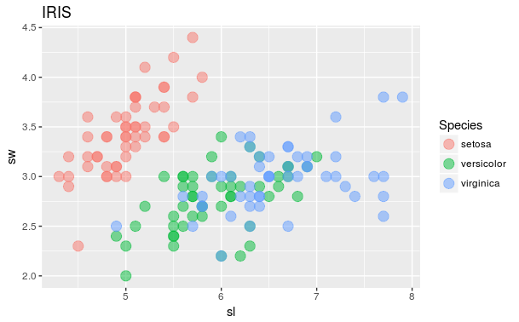

\

To plot basic symbols (circles, rectangle, square)

> symbols(x = 1.5, y=0, circles = 1.2, xlim = c(0,3), ylim = c(-1.5,1.5),
+ bg = "gray", inches = T)
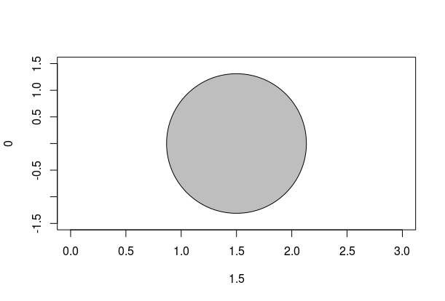
To insert text inside the given plot- text()

> text(1.5,0.5, expression("Area" == pi* phantom(" ' ")* italic(r)^2)) ## expression for formulaes that requires ^(to the power status)
> text(1.5, -0.5, "lijin")
> text(1.5, -0.5, "lijin = radius")
> text(1.5, -0.5, "lijin = radius")
> text(1.5, -0.8, "lijin = radius")
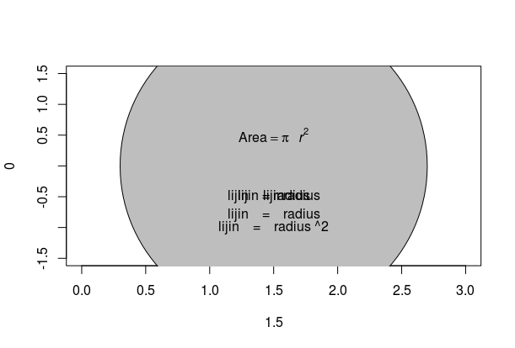
> text(1.5, -1, "lijin = radius ^2")

# Use ’==’ to insert ’=’.
# Text or symbols that appear either side of ’*’ are juxtaposed.
# Notice the use of phantom("’") to insert a small space.

To locate and identify points in a plot locate(), identify()

> head(primates)
Bodywt Brainwt
Potar monkey 10.0 115
Gorilla 207.0 406
Human 62.0 1320
Rhesus monkey 6.8 179
Chimp 52.2 440
> plot(Brainwt ~ Bodywt, data = primates)
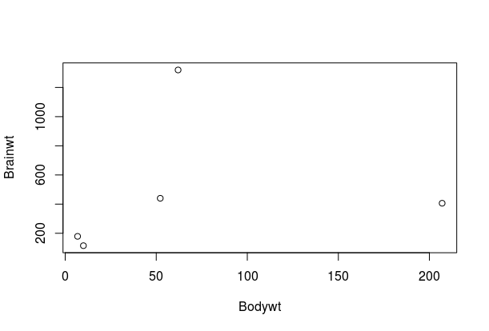

> with(primates, identify(Brainwt~Bodywt, labels = row.names(primates), n= 2))
warning: nearest point already identified
warning: nearest point already identified ## identify the point names in graphs on clicking
warning: nearest point already identified
warning: nearest point already identified
warning: nearest point already identified
[1] 3 5
> with(primates, identify(Brainwt~Bodywt, labels = row.names(primates), n= 1))
[1] 2
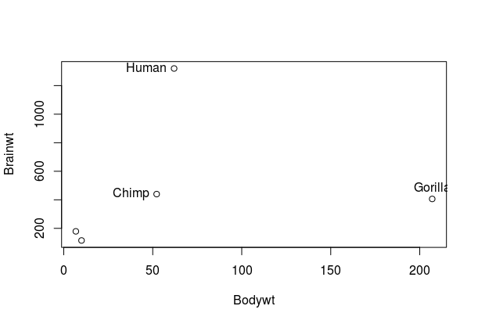

> locator(n=2, type = "n") ## will give the cordinates of points clicked on plot
$x
[1] 50.77596 51.65496

$y
[1] 445.5526 456.5182

Making Linear regression model-SIMPLE LINEAR REGRESSION USING R – ONE PREDICTOR for a given response variable

Steps

First we do a scatter plot of two variables
> names(airquality)
[1] "Ozone" "Solar.R" "Wind" "Temp" "Month" "Day"
> head(airquality)
Ozone Solar.R Wind Temp Month Day
1 41 190 7.4 67 5 1
2 36 118 8.0 72 5 2
3 12 149 12.6 74 5 3
4 18 313 11.5 62 5 4
5 NA NA 14.3 56 5 5
6 28 NA 14.9 66 5 6
> summary(airquality)
Ozone Solar.R Wind Temp Month Day
Min. : 1.00 Min. : 7.0 Min. : 1.700 Min. :56.00 Min. :5.000 Min. : 1.0
1st Qu.: 18.00 1st Qu.:115.8 1st Qu.: 7.400 1st Qu.:72.00 1st Qu.:6.000 1st Qu.: 8.0
Median : 31.50 Median :205.0 Median : 9.700 Median :79.00 Median :7.000 Median :16.0
Mean : 42.13 Mean :185.9 Mean : 9.958 Mean :77.88 Mean :6.993 Mean :15.8
3rd Qu.: 63.25 3rd Qu.:258.8 3rd Qu.:11.500 3rd Qu.:85.00 3rd Qu.:8.000 3rd Qu.:23.0
Max. :168.00 Max. :334.0 Max. :20.700 Max. :97.00 Max. :9.000 Max. :31.0
NA's :37 NA's :7
> str(airquality)
'data.frame': 153 obs. of 6 variables:
$ Ozone : int 41 36 12 18 NA 28 23 19 8 NA ...
$ Solar.R: int 190 118 149 313 NA NA 299 99 19 194 ...
$ Wind : num 7.4 8 12.6 11.5 14.3 14.9 8.6 13.8 20.1 8.6 ...
$ Temp : int 67 72 74 62 56 66 65 59 61 69 ...
$ Month : int 5 5 5 5 5 5 5 5 5 5 ...
$ Day : int 1 2 3 4 5 6 7 8 9 10 ...
> attach(airquality)
> plot(Ozone~Solar.R)
> mean(Ozone)
[1] NA
> mean(Ozone, na.rm = T) ## removing na values
[1] 42.12931
> mn.ozone <- mean(Ozone, na.rm = T)
> abline(h=mn.ozone)
> model1 <- lm(Ozone~Solar.R)
> model1

Call:
lm(formula = Ozone ~ Solar.R)

Coefficients:
(Intercept) Solar.R
18.5987 0.1272

> abline(model1, col = "red")
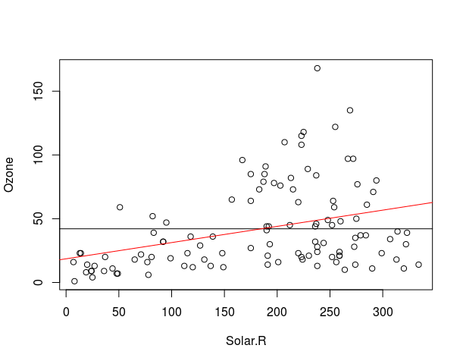
> plot(model1) ## which = 1:2 will limit the plots to these two plots
Hit <Return> to see next plot:
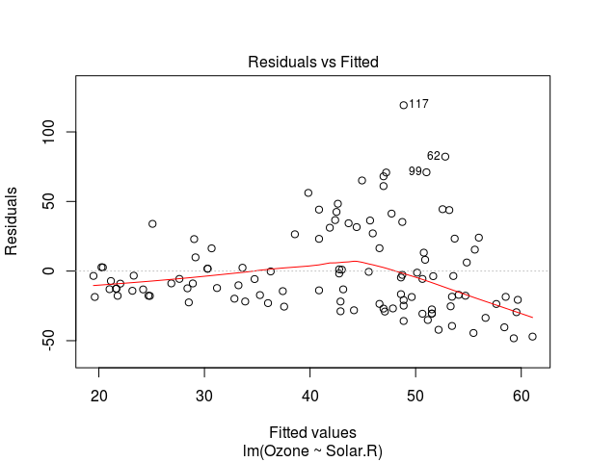

The residual (= actual – predicted) and fitted value (predicted)

the points must be equaly distributed for a good model

here the line bends down as we can see

Hit <Return> to see next plot:

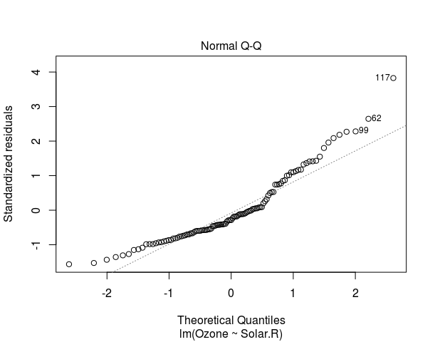
the qq plot of residuals- the residuals must be normally distributed- that is they must lie in th dotted line, instead of above or below as shown above

> summary(model1)

Call:
lm(formula = Ozone ~ Solar.R)

Residuals: ## for good linear relation ship the residuals must be equlay distributed
Min 1Q Median 3Q Max
-48.292 -21.361 -8.864 16.373 119.136

Coefficients:
Estimate Std. Error t value Pr(>|t|)
(Intercept) 18.59873 6.74790 2.756 0.006856 **
Solar.R 0.12717 0.03278 3.880 0.000179 ***

### pvalue > 0.05 means the variable does not influence the response variable- null hypothesis is valid
### coefficient means for one unit change in Solar.R the Ozone value will change by 0.12717 units Ozone = 0.12717 Solar.R + 18.59873

---
Signif. codes: 0 ‘***’ 0.001 ‘**’ 0.01 ‘*’ 0.05 ‘.’ 0.1 ‘ ’ 1

Residual standard error: 31.33 on 109 degrees of freedom
(42 observations deleted due to missingness)
Multiple R-squared: 0.1213, Adjusted R-squared: 0.1133
F-statistic: 15.05 on 1 and 109 DF, p-value: 0.0001793

SIMPLE LINEAR MODEL y=15x+3

CHECKING HOW THE MODEL CHANGES WHEN THE OUTPUT y IS CHANGED BY ADDING MORE NOICE WHILE THE INPUT x IS KEPT UNCHANGED

x <- c(1:100) ## making a vector x values 1 to 100
y <- 15*x + 3 ## making an equation of straight line y= 15x+3

> plot(y~x) ## plotting y as a function of x- perfect linear model of a perfect linear equation
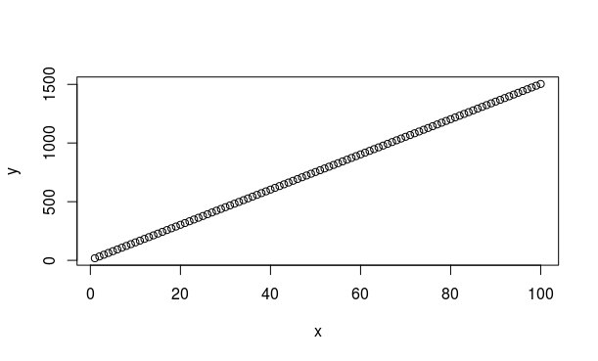

> model <- lm(y~x) ### making the perfect model
> summary(model)

Call:
lm(formula = y ~ x)

Residuals:
Min 1Q Median 3Q Max
-2.697e-12 -6.670e-15 2.460e-14 5.420e-14 3.424e-13

Coefficients:
Estimate Std. Error t value Pr(>|t|)
(Intercept) 3.000e+00 5.639e-14 5.320e+13 <2e-16 ***
x 1.500e+01 9.694e-16 1.547e+16 <2e-16 ***
---
Signif. codes: 0 ‘***’ 0.001 ‘**’ 0.01 ‘*’ 0.05 ‘.’ 0.1 ‘ ’ 1

Residual standard error: 2.798e-13 on 98 degrees of freedom
Multiple R-squared: 1, Adjusted R-squared: 1
F-statistic: 2.394e+32 on 1 and 98 DF, p-value: < 2.2e-16

Warning message:
In summary.lm(model) : essentially perfect fit: summary may be unreliable

> plot(model, which = 1:2) ## plotting the perfect model
Hit <Return> to see next plot:
Hit <Return> to see next plot:
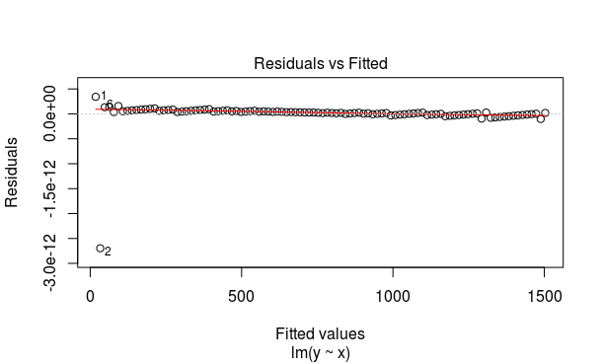

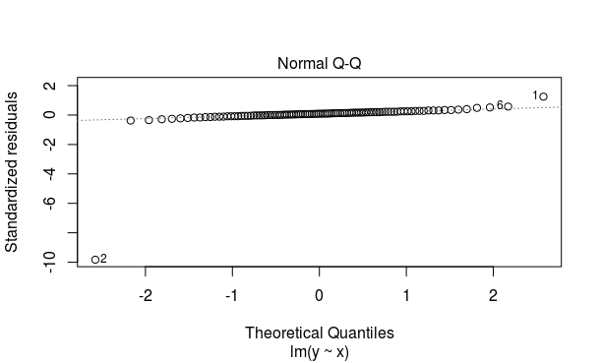

y1 <- jitter(y, factor = 20) ## adding noice to vector values of vector y using jitter function. Use factor arguement to get more deviation in points

> head(y)
[1] 18 33 48 63 78 93

> head(y1)
[1] -38.59435 11.53011 23.56301 114.78606 37.07146 78.03806

> plot(y1~x,type = "p", col="blue") ## plottig noice added values of y which is y1 as a function of x as points with colour as blue

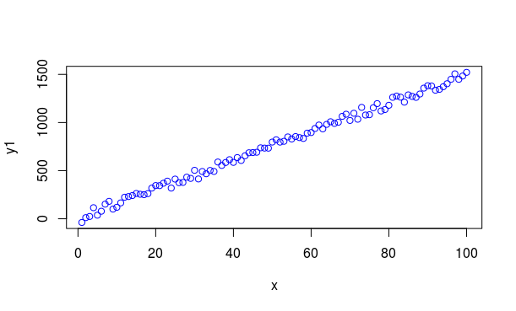
> abline(lm(y~x)) ## adding a line which is the representation of first plot(y~x)
using abline function which is indeed the perfect model
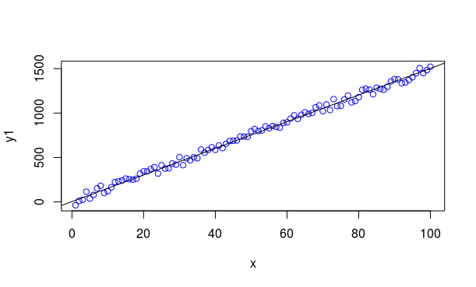
model1 <- lm(y1~x) ## model with less noice

> summary(model1)

Call:
lm(formula = y1 ~ x)

Residuals:
Min 1Q Median 3Q Max
-65.336 -24.004 3.454 26.515 59.727

Coefficients:
Estimate Std. Error t value Pr(>|t|)
(Intercept) 11.8733 6.4853 1.831 0.0702 .
x 14.8685 0.1115 133.357 <2e-16 ***
---
Signif. codes: 0 ‘***’ 0.001 ‘**’ 0.01 ‘*’ 0.05 ‘.’ 0.1 ‘ ’ 1

Residual standard error: 32.18 on 98 degrees of freedom
Multiple R-squared: 0.9945, Adjusted R-squared: 0.9945
F-statistic: 1.778e+04 on 1 and 98 DF, p-value: < 2.2e-16
plot(model1, which = 1:2)
Hit <Return> to see next plot:
Hit <Return> to see next plot:
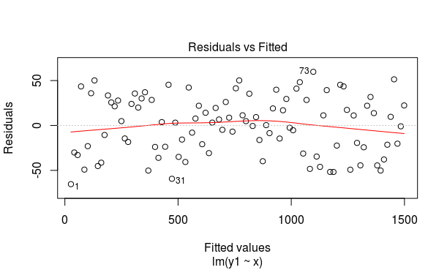

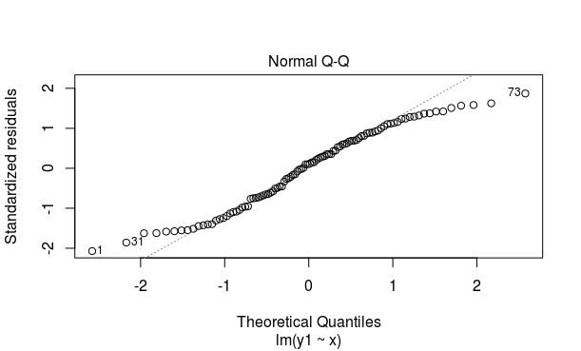

> y2 <- jitter(y, factor = 50) ##adding more noice
> plot(y2~x, type = "p", col="blue")
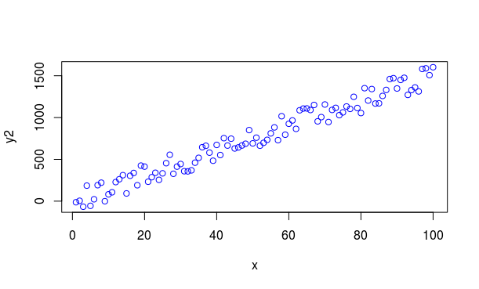
> abline(model) ## comparing with the perfect model
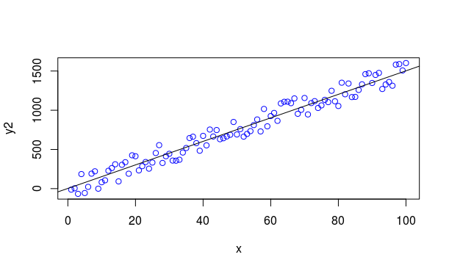

> model2 <- lm(y2~x) ## making new model with y2
> abline(model2) ## drawing abline with new model

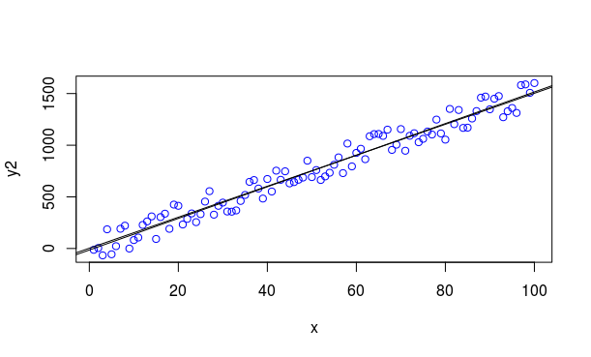

> summary(model2)

Call:
lm(formula = y2 ~ x)

Residuals:
Min 1Q Median 3Q Max
-155.94 -75.65 -14.56 86.46 155.99

Coefficients:
Estimate Std. Error t value Pr(>|t|)
(Intercept) -14.2766 18.2389 -0.783 0.436
x 15.3031 0.3136 48.805 <2e-16 ***
---
Signif. codes: 0 ‘***’ 0.001 ‘**’ 0.01 ‘*’ 0.05 ‘.’ 0.1 ‘ ’ 1

Residual standard error: 90.51 on 98 degrees of freedom
Multiple R-squared: 0.9605, Adjusted R-squared: 0.9601
F-statistic: 2382 on 1 and 98 DF, p-value: < 2.2e-16

> plot(model2, which = 1:2)
Hit <Return> to see next plot:
Hit <Return> to see next plot:

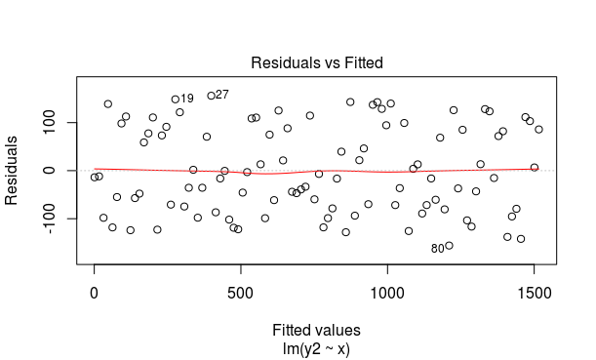
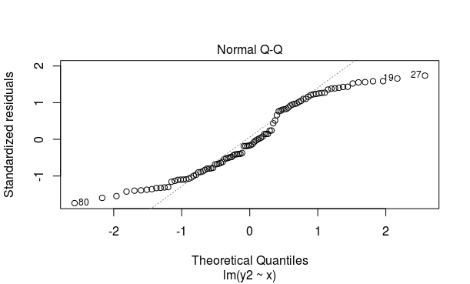

> y3 <- jitter(y, factor = 250) ## adding more noice
> plot(y3~x, type = "p", col="blue")
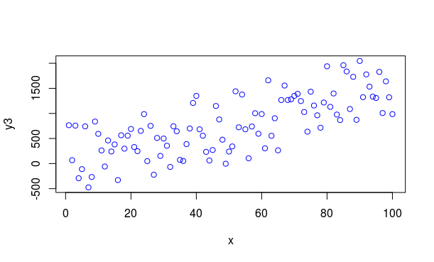
> abline(model)
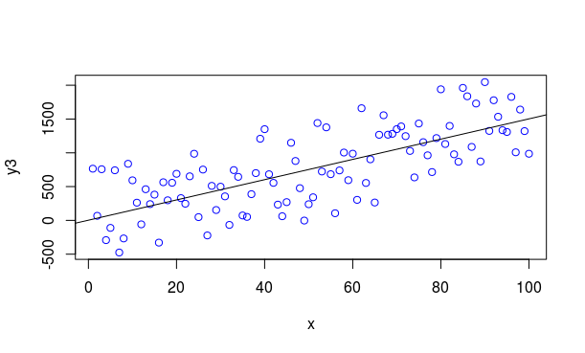
> model3 <- lm(y3~x)
> abline(model3)
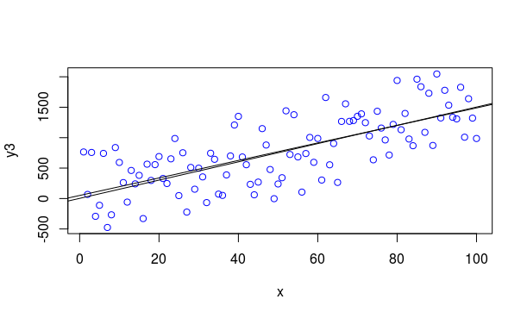

>summary(model3)

Call:
lm(formula = y3 ~ x)

Residuals:
Min 1Q Median 3Q Max
-758.31 -326.52 -11.78 275.97 738.04

Coefficients:
Estimate Std. Error t value Pr(>|t|)
(Intercept) 50.783 82.098 0.619 0.538
x 14.383 1.411 10.191 <2e-16 ***
---
Signif. codes: 0 ‘***’ 0.001 ‘**’ 0.01 ‘*’ 0.05 ‘.’ 0.1 ‘ ’ 1

Residual standard error: 407.4 on 98 degrees of freedom
Multiple R-squared: 0.5145, Adjusted R-squared: 0.5095
F-statistic: 103.9 on 1 and 98 DF, p-value: < 2.2e-16

> plot(model3, which = 1:2)
Hit <Return> to see next plot:
Hit <Return> to see next plot:

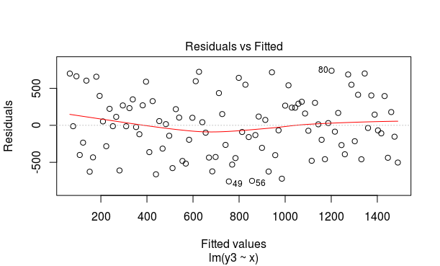
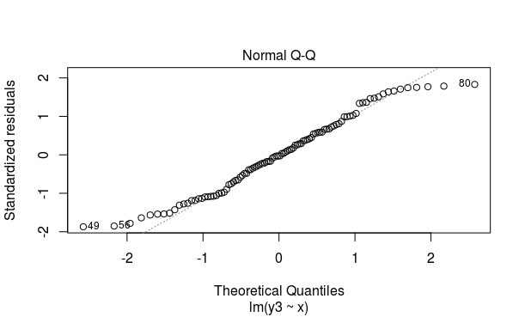

> y4 <- jitter(y, factor = 2000) ## adding a high amount of jitter due to a high noise factor
> plot(y4~x, type = "p", col="blue"
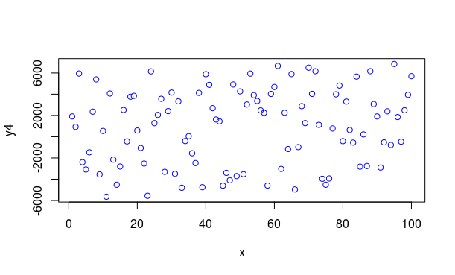
> abline(model)
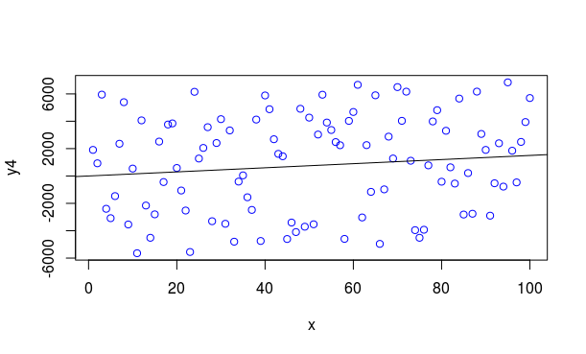

> abline(model4)
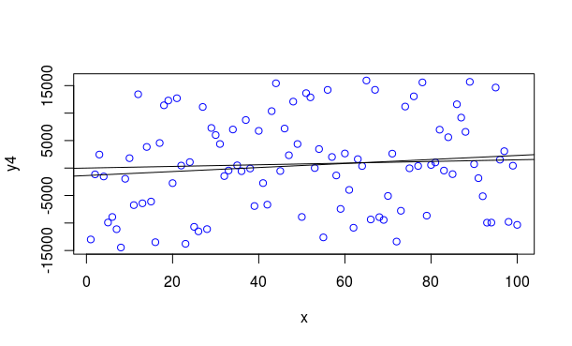

> summary(model4)

Call:
lm(formula = y4 ~ x)

Residuals:
Min 1Q Median 3Q Max
-14651.0 -7016.9 -549.5 6368.2 15177.4

Coefficients:
Estimate Std. Error t value Pr(>|t|)
(Intercept) -1359.13 1706.02 -0.797 0.428
x 36.54 29.33 1.246 0.216

Residual standard error: 8466 on 98 degrees of freedom
Multiple R-squared: 0.01559, Adjusted R-squared: 0.00555
F-statistic: 1.552 on 1 and 98 DF, p-value: 0.2157

> plot(model4, which = 1:2)
Hit <Return> to see next plot:
Hit <Return> to see next plot:

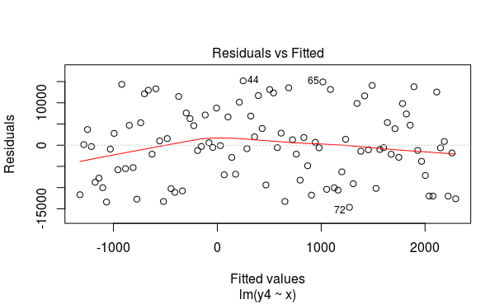

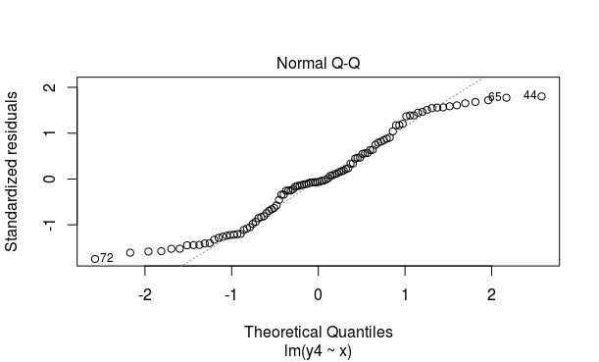

Using Linear Model in a Real World Example That has some linear relationsip
----------- Sepal width VS Sepal length of setosa in Iris
> head(iris)
Sepal.Length Sepal.Width Petal.Length Petal.Width Species
1 5.1 3.5 1.4 0.2 setosa
2 4.9 3.0 1.4 0.2 setosa
3 4.7 3.2 1.3 0.2 setosa
4 4.6 3.1 1.5 0.2 setosa
5 5.0 3.6 1.4 0.2 setosa
6 5.4 3.9 1.7 0.4 setosa
> sw <- subset(iris, Species == "setosa")$ Sepal.Width
> sl <- subset(iris, Species == "setosa")$ Sepal.Length
> plot(sw~sl)
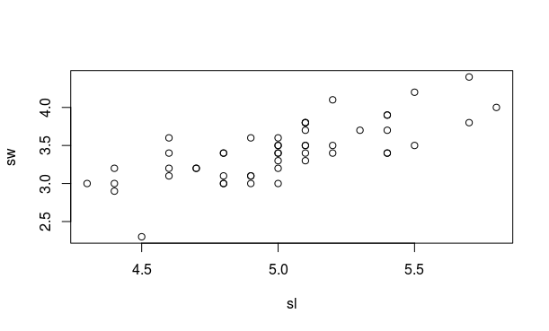
> realmodel <- lm(sw~sl)

> summary(realmodel)

Call:
lm(formula = sw ~ sl)

Residuals:
Min 1Q Median 3Q Max
-0.72394 -0.18273 -0.00306 0.15738 0.51709

Coefficients:
Estimate Std. Error t value Pr(>|t|)
(Intercept) -0.5694 0.5217 -1.091 0.281
sl 0.7985 0.1040 7.681 6.71e-10 ***
---
Signif. codes: 0 ‘***’ 0.001 ‘**’ 0.01 ‘*’ 0.05 ‘.’ 0.1 ‘ ’ 1

Residual standard error: 0.2565 on 48 degrees of freedom
Multiple R-squared: 0.5514, Adjusted R-squared: 0.542
F-statistic: 58.99 on 1 and 48 DF, p-value: 6.71e-10

> abline(realmodel)
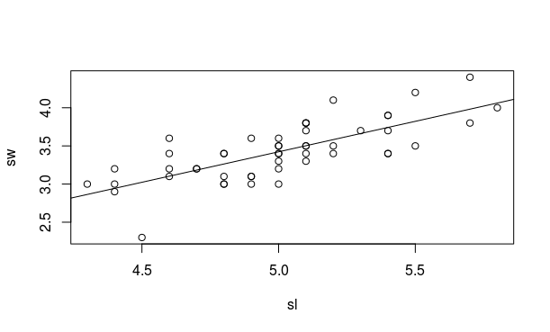
> plot(realmodel)
Hit <Return> to see next plot:
Hit <Return> to see next plot:

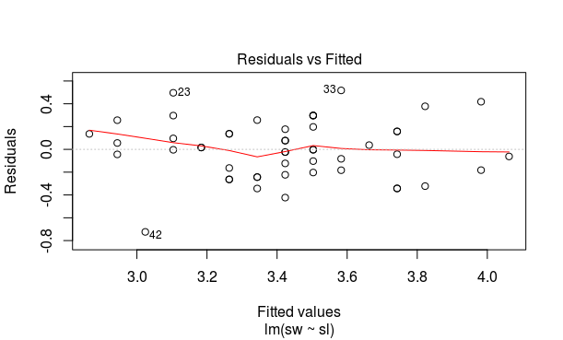

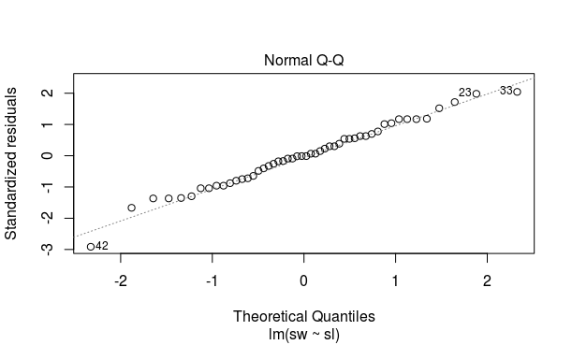

Working with a data for another comparison which may or may not be linear
pw <- subset(iris, Species== "setosa")$Petal.Width
plot(sw~pw)
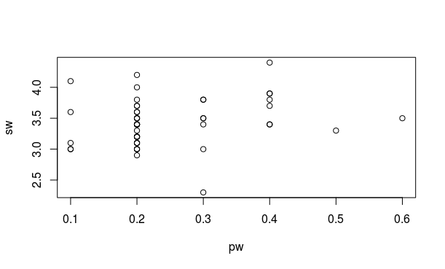
nonlmodel <- lm(sw~pw)
abline(nonlmodel)
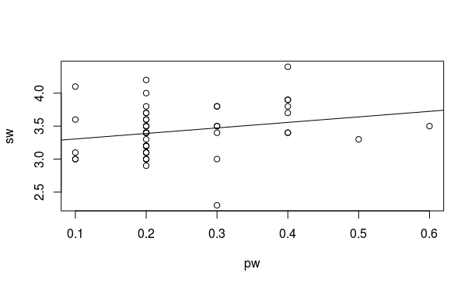
> summary(nonlmodel)

Call:
lm(formula = sw ~ pw)

Residuals:
Min 1Q Median 3Q Max
-1.17321 -0.21972 0.01051 0.23493 0.84307

Coefficients:
Estimate Std. Error t value Pr(>|t|)
(Intercept) 3.2221 0.1349 23.882 <2e-16 ***
pw 0.8372 0.5049 1.658 0.104
---
Signif. codes: 0 ‘***’ 0.001 ‘**’ 0.01 ‘*’ 0.05 ‘.’ 0.1 ‘ ’ 1

Residual standard error: 0.3725 on 48 degrees of freedom
Multiple R-squared: 0.05417, Adjusted R-squared: 0.03447
F-statistic: 2.749 on 1 and 48 DF, p-value: 0.1038

> plot(nonlmodel, which = 1:2)
Hit <Return> to see next plot:
Hit <Return> to see next plot:
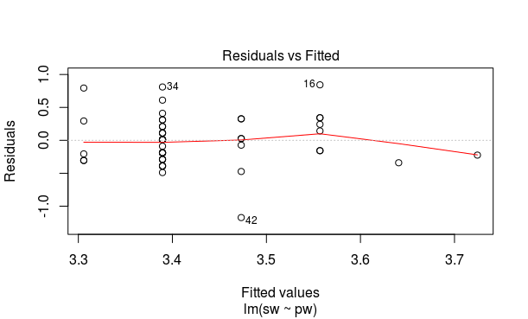
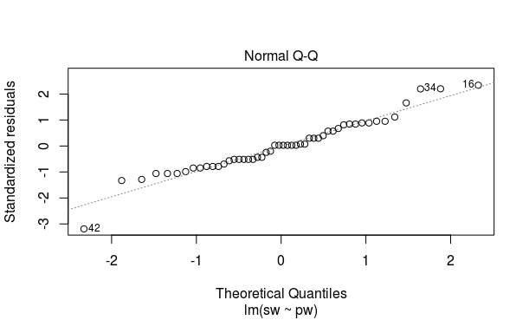

THE SAME SIMPLE MODEL y=15x + 3 IS NOW ANALYSED BY ADDING NOICE IN TO THE INPUT x BUT KEEPING THE OUTPUT y CONSTANT
THIS ANALYSIS HELP US TO VALDATE THE MODEL, - TO WHAT EXTEND OUR MODEL WILL REMAIN THE SAME UNDERLYING FUNCTION WHEN WE CONTINUE TO ADD MORE AND MORE NOISE
BECAUSE IN REAL WORLD THE DATA THAT WE COLLECT HAS SOME NOISE AND THE MODEL THAT WE MAKE MUST BE ABLE TO PREDICT THE SAME EVEN IN SLIGHT VARIATION IN DATA due to noise
## Adding noice in to the input
x1 <- jitter(x,1) # little noise
plot(y~x1)# #no fifference noted from actual plot hence no need to create model and compare
x2 <- jitter(x,5)# adding more noise
plot(y~x2)# slight distrotion noted
modelx2 <- lm(y~x2) #making new model
abline(modelx2) # no much difference noted from the perfect model
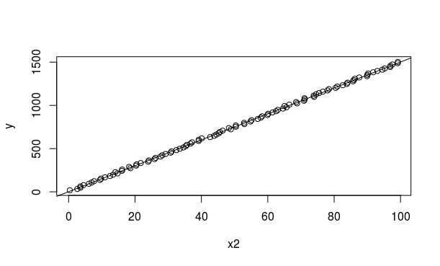

x3 <- jitter(x,20) #adding more noice than x2
plot(y~x3) #moderate distortion noted
modelx3 <- lm(y~x3) #making new model with x3
abline(modelx3) #NO difference noted
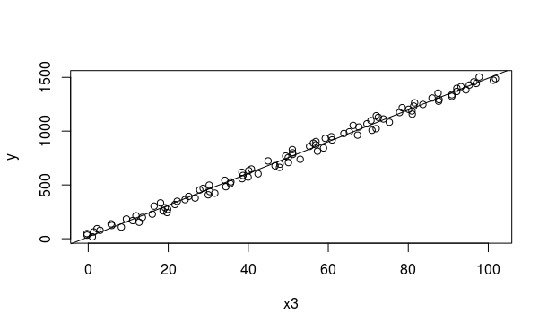

x4 <- jitter(x,100) #repeating steps above
plot(y~x4) #moderate distortion noted
modelx4 <- lm(y~x4) #making new model with x4
abline(modelx4)
abline(model, col="red") #slight deviation noted from above line
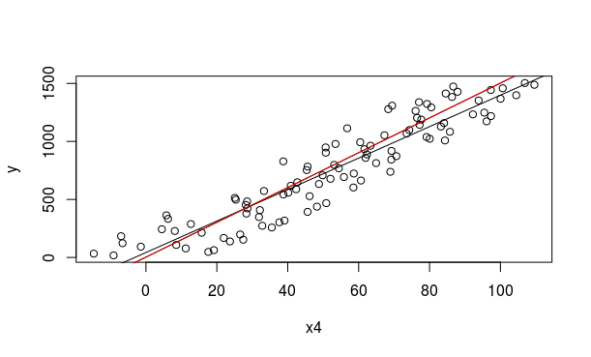
x5 <- x+ rnorm(100,0,50) # adding noice using rnorm instead of jitter
plot(y~x5) #much noise is added
modelx5 <- lm(y~x5)
abline(modelx5)
abline(model, col="red") #the new model has totally lost when compared to actual model
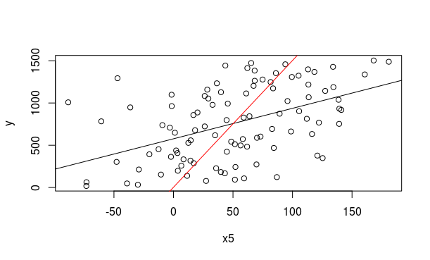
COMPARISON OF SUMMARYS OF DIFFERENT MODELS MADE BY CHANGING INPUT X

> summary(model)

Call:
lm(formula = y ~ x)

Residuals:
Min 1Q Median 3Q Max
-2.697e-12 -6.670e-15 2.460e-14 5.420e-14 3.424e-13

Coefficients:
Estimate Std. Error t value Pr(>|t|)
(Intercept) 3.000e+00 5.639e-14 5.320e+13 <2e-16 ***
x 1.500e+01 9.694e-16 1.547e+16 <2e-16 ***
---
Signif. codes: 0 ‘***’ 0.001 ‘**’ 0.01 ‘*’ 0.05 ‘.’ 0.1 ‘ ’ 1

Residual standard error: 2.798e-13 on 98 degrees of freedom
Multiple R-squared: 1, Adjusted R-squared: 1
F-statistic: 2.394e+32 on 1 and 98 DF, p-value: < 2.2e-16

Warning message:
In summary.lm(model) : essentially perfect fit: summary may be unreliable
> summary(modelx2)

Call:
lm(formula = y ~ x2)

Residuals:
Min 1Q Median 3Q Max
-13.4351 -7.2129 -0.5242 7.7711 15.8177

Coefficients:
Estimate Std. Error t value Pr(>|t|)
(Intercept) 1.77745 1.73290 1.026 0.308
x2 14.99669 0.02975 504.090 <2e-16 ***
---
Signif. codes: 0 ‘***’ 0.001 ‘**’ 0.01 ‘*’ 0.05 ‘.’ 0.1 ‘ ’ 1

Residual standard error: 8.588 on 98 degrees of freedom
Multiple R-squared: 0.9996, Adjusted R-squared: 0.9996
F-statistic: 2.541e+05 on 1 and 98 DF, p-value: < 2.2e-16

> summary(modelx3)

Call:
lm(formula = y ~ x3)

Residuals:
Min 1Q Median 3Q Max
-64.272 -30.726 4.898 25.861 63.661

Coefficients:
Estimate Std. Error t value Pr(>|t|)
(Intercept) 16.4493 6.8523 2.401 0.0183 *
x3 14.7621 0.1176 125.533 <2e-16 ***
---
Signif. codes: 0 ‘***’ 0.001 ‘**’ 0.01 ‘*’ 0.05 ‘.’ 0.1 ‘ ’ 1

Residual standard error: 34.39 on 98 degrees of freedom
Multiple R-squared: 0.9938, Adjusted R-squared: 0.9938
F-statistic: 1.576e+04 on 1 and 98 DF, p-value: < 2.2e-16

> summary(modelx4)

Call:
lm(formula = y ~ x4)

Residuals:
Min 1Q Median 3Q Max
-268.2 -115.6 -9.6 114.0 323.4

Coefficients:
Estimate Std. Error t value Pr(>|t|)
(Intercept) 42.9365 32.0786 1.338 0.184
x4 13.5603 0.5282 25.670 <2e-16 ***
---
Signif. codes: 0 ‘***’ 0.001 ‘**’ 0.01 ‘*’ 0.05 ‘.’ 0.1 ‘ ’ 1

Residual standard error: 157.4 on 98 degrees of freedom
Multiple R-squared: 0.8705, Adjusted R-squared: 0.8692
F-statistic: 659 on 1 and 98 DF, p-value: < 2.2e-16

> summary(modelx5)

Call:
lm(formula = y ~ x5)

Residuals:
Min 1Q Median 3Q Max
-766.88 -285.10 -46.54 365.15 885.92

Coefficients:
Estimate Std. Error t value Pr(>|t|)
(Intercept) 576.5941 51.6182 11.170 < 2e-16 ***
x5 3.6066 0.6746 5.346 5.87e-07 ***
---
Signif. codes: 0 ‘***’ 0.001 ‘**’ 0.01 ‘*’ 0.05 ‘.’ 0.1 ‘ ’ 1

Residual standard error: 384.9 on 98 degrees of freedom
Multiple R-squared: 0.2258, Adjusted R-squared: 0.2179
F-statistic: 28.58 on 1 and 98 DF, p-value: 5.868e-07

>

VALIDATING THE REAL MODELTHAT WAS MADE WITH iris SETOSA SPECIES Data which has a linear relationship

1. the real model that we made for sw~sl
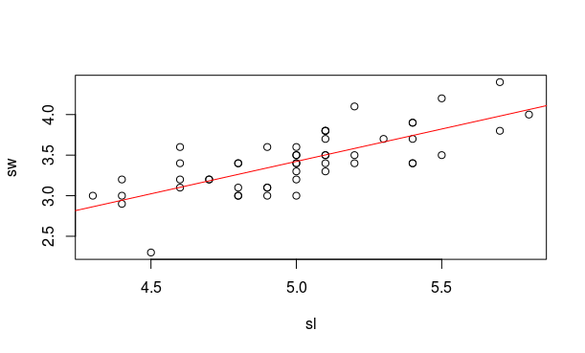

2.Adding slight noise in to input using jitter, then plotting the same and comparing the new model with the actual model
sl1 <- jitter(sl,5)
realmodel1 <- lm(sw~sl1)
plot(sw~sl1, pch = 16, col = "blue")
abline(lm(sw~sl1))
abline(realmodel, col ="red")
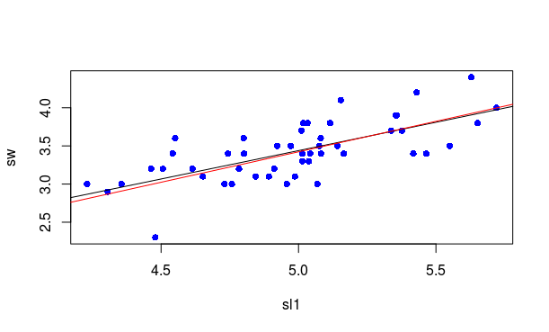
3, adding significant noise in to the input sl and doing the same steps again
sl2 <- sl + rnorm(50,0,3)
plot(sw~sl2, pch = 16, col = "blue")
abline(realmodel, col= "red")
abline(realmodel1, col = "black")
abline(lm(sw~sl2), col = "green")
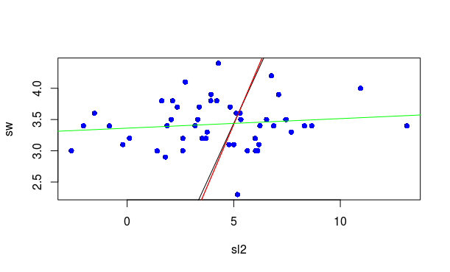

4. reducing the number of samples from end and comparing the old and new models
# Reducing the number of samples from end

sl3 <- sl[1:40]
plot(sw[-c(41:50)]~sl3)
abline(realmodel, col = "red")
abline(lm(sw[-c(41:50)]~sl3))
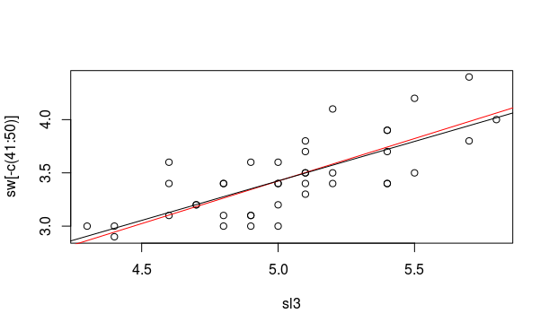

5, Reducing the number of samples from begining and comparing with the real model
#reducing samples from begining
plot(sw[-c(1:10)]~sl[-c(1:10)])
abline(realmodel, col = "red")
abline(lm(sw[-c(1:10)]~sl[-c(1:10)]))

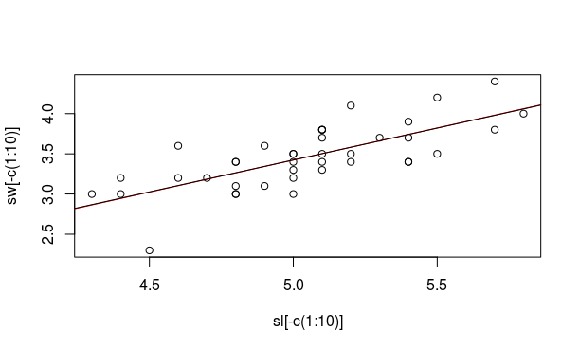

LOGISTC REGRESSION USING R
> head(mtcars[c(6,8)])
wt vs
Mazda RX4 2.620 0
Mazda RX4 Wag 2.875 0
Datsun 710 2.320 1
Hornet 4 Drive 3.215 1
Hornet Sportabout 3.440 0
Valiant 3.460 1

plot(vs~wt)
model <- glm(vs~wt, family = binomial)

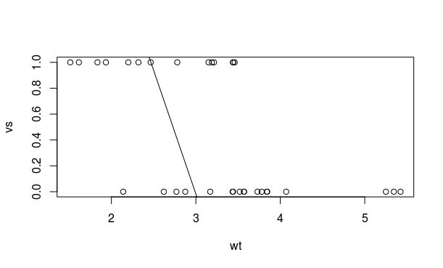
> plot(jitter(vs,0.2) ~ wt)
> xv <- seq(min(wt),max(wt), 0.01)
> yv <- predict(model, list(wt = xv), type = "response")
> lines(xv,yv,col = "red")
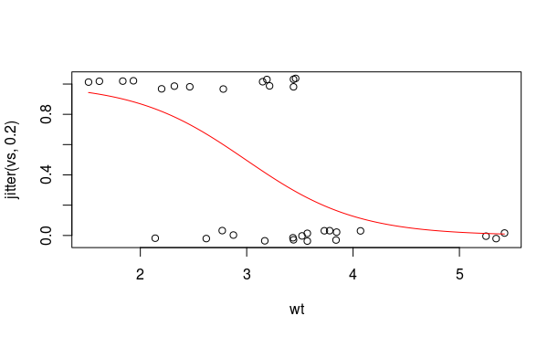
> summary(model)

Call:
glm(formula = vs ~ wt, family = binomial)

Deviance Residuals:
Min 1Q Median 3Q Max
-1.9003 -0.7641 -0.1559 0.7223 1.5736

Coefficients:
Estimate Std. Error z value Pr(>|z|)
(Intercept) 5.7147 2.3014 2.483 0.01302 *
wt -1.9105 0.7279 -2.625 0.00867 **
---
Signif. codes: 0 ‘***’ 0.001 ‘**’ 0.01 ‘*’ 0.05 ‘.’ 0.1 ‘ ’ 1

(Dispersion parameter for binomial family taken to be 1)

Null deviance: 43.860 on 31 degrees of freedom
Residual deviance: 31.367 on 30 degrees of freedom
AIC: 35.367

Number of Fisher Scoring iterations: 5

Non Linear regression

done with the help of lm () function.

We ourselves will predetrmine the equation and will make a model based on that

allways use lines function to plot the non linear model un like the case of a linear model were we use a abline

for linear model both abline and lines will give same result

> head(cars
+ )
speed dist
1 4 2
2 4 10
3 7 4
4 7 22
5 8 16
6 9 10

> plot(dist ~ speed, pch = 16, col = "blue")
> model1 <- lm(dist ~ speed)
> abline(model1)
> lines(lowess(dist ~ speed), col = "red")
> summary(model1)

Call:
lm(formula = dist ~ speed)

Residuals:
Min 1Q Median 3Q Max
-29.069 -9.525 -2.272 9.215 43.201

Coefficients:
Estimate Std. Error t value Pr(>|t|)
(Intercept) -17.5791 6.7584 -2.601 0.0123 *
speed 3.9324 0.4155 9.464 1.49e-12 ***
---
Signif. codes: 0 ‘***’ 0.001 ‘**’ 0.01 ‘*’ 0.05 ‘.’ 0.1 ‘ ’ 1

Residual standard error: 15.38 on 48 degrees of freedom
Multiple R-squared: 0.6511, Adjusted R-squared: 0.6438
F-statistic: 89.57 on 1 and 48 DF, p-value: 1.49e-12
> model2 <- lm(dist ~ speed + I(speed^2)) ### making the non linear model allways use I() function when we are using the ~ symbol ie in an expression showing as a function of.
> abline(model2, col = "black")

> lines(speed, predict(model2), col = "yellow")
> lines(speed, predict(model2), col = "violet")
> lines(speed, predict(model1), col = "black")
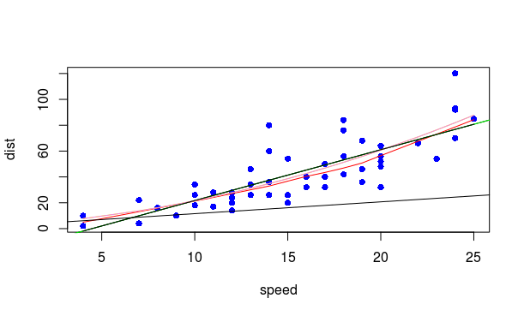

PREDICTIVE MODELLING ALGORITHMS
1) KNN Algorithm
Applied to the iris data set in order to find which group does the new data set belongs to:
# finding the species of a new given flower using the knn algorithm
new_sample2 <- data.frame(4.8, 2.9, 3.7, 1.7)# making new sample in then form of a data frame
names(new_sample2) <- names(iris[1:4]) # giving col names to the new set from iris
new_sample2
iris_features <- iris[1:4] ## making another data frame with only first four coloumns of iris
dis_eucl <- function(x1,x2) sqrt(sum((x1 - x2)^2)) ## making our own function to
## eucledian distance
distances <- apply(iris_features, 1, function(x) dis_eucl(x, new_sample2)) # measuring the
# euclid distance from the new sample to all data points in iris_features
distances_sorted <- sort(distances, index.return = T) # sorting the distance in increasing
# order along with index values
str(distances_sorted) # to print the out put
nn_5 <- iris[distances_sorted$ix[1:5], ]# calling values of iris based on
#first 5 values of index distance_sorted
nn_5 #print out put

> nn_5 #print out put
Sepal.Length Sepal.Width Petal.Length Petal.Width Species
60 5.2 2.7 3.9 1.4 versicolor
65 5.6 2.9 3.6 1.3 versicolor
107 4.9 2.5 4.5 1.7 virginica
90 5.5 2.5 4.0 1.3 versicolor
58 4.9 2.4 3.3 1.0 versicolor

It is clear from the output that the given new data point belong to versicolor species by majority
allways choose odd number greater than the number of species in the iris data set to avoid deadlocks. If such situation arises then we will decide the output by random picking.

TYPES OF MODELS

Supervised Model
The model whose output value is available while the time of training is called Supervised model.
Above case is an example of supervised model.

Unsupervised Model
The scenario in which a model has to be formed without the output values present is called unsupervised model
clustering is an example of unsupervised model.

Semi – Supervisedmodel
some output are available while some are not, the available values are used to predict the un avialable values

Reinforcement Learning Model
Here the output values are not directly provided but the values that directly leading to the to the output values are provided.
eg- is the case of predicting a chess game’s next move were the model will predict the next best move without knowing the output.

Parametric & Non Parametric
In parametric model the model is in the form of an equation with different parameters.
This reduce the confusion of selecting a proper function that defines the model.
Linear model and multiple linear models are example of parametric models

in non-parametric model, the there is no function which is pre determined. The funtion is created such that the near by points are taken in to account in each instance. The KNN algorithm is an example of non parametric model.

Regression and Classification Models

The Regression model gives a quantitative output ie a numerical output
The classification model is used to classify the given input belongs to which group.

Real Time & Batch Machine Learning Models
In Real time Learning Model, the data collected for predictioon is used to predict output that is time dependent.
The weather predicting model is a good example

STEPS INVOLVED IN MAKING A MODE
1)Defining a Model’s Objective
--- What is the desired outcome
----what sort of performance and how to measure it , should discusss the performance & expectation of model at beginning with stakeholders , Models are never perfect
---- finding the data available to us
2)Collecting the data
--- Most time & Resource consuming venture- make sure that we have collected the data correctly,
---- How much data has to be collected
3) Picking a Model

Feature Engineering & Dimensionality Reduction
The number & type of features that we select plays a critical role in the performance of a model.
The number of features determines the number of dimensions of a model.
Due to higher number of dimensions, a large number of possible combinations of features result in lesser data availablity and this is called Data Sparsity, also known as curse of dimensionality.
Also a large nuber of dimensions will result in larger space of input points. But the data points that we have collected are not enough to satisfy this demand and are highly seperated from each other. So algorithms such as KNN which works on measuring Eucledian distance will perform very poorly un higher dimension models.
It is also time consuming to train & predict higher dimension model.
This is the need for dimensionality reduction and feature engineering.

In feature engineering involves learning and understanding the features.
There are two methods of feature engineering:
The first method invoves, deriving a new feature from a combination of other existing features. But this demands large amount domain specific experience & it will not guarantee the fact that the new feature will not dampen the current performance of the model.
The second way of feature engineering is feature reduction. It involves:
Feature Selection – It means we will select a subset from the existing set of features that are highly influential to our target output.
Another method is Dimensionality reduction and it involves converting the entire given set of features in to a new set which is less in number.
This can be done by:
1) Principal Component Analysis
In this method we creatw a new set of features which are lesser in number and are the linear combimations of the given features.
These new features are called Principal Components
The first principal component is selected such that, the weights of the linear combination of the original features reflects the maximaum variance in the data, ie if the data has two features then the new principal component is a straight line which is the most closer to all the points and hence has very high variance.
Number of features = No of Principal Components
Principal Component Analysis
library(caret)
pp_pca <- preProcess(iris_features, method = c("BoxCox", "center", "scale", "pca"),
thresh = 0.95)
iris_features_pca <- predict(pp_pca, iris_features)
head(iris_features_pca)
PC1 PC2
1 -2.303540 -0.4748260
2 -2.151310 0.6482903
3 -2.461341 0.3463921
4 -2.413968 0.6066839
5 -2.432777 -0.6110057
6 -1.979172 -1.3950594

After PCA two principal components are generated which has the highest variation
## To know the coefficients/ weights of the features
> pp_pca$rotation
PC1 PC2
Sepal.Length 0.52 -0.386
Sepal.Width -0.27 -0.920
Petal.Length 0.58 -0.049
Petal.Width 0.57 -0.037

##0.52 ⋅ Sepal . Length − 0.27 ⋅ Sepal.Width + 0.58 ⋅ Petal.Length + 0.57 ⋅ Petal.Width

Since there are 4 features there are 4 principal components, but we have got only 2 principal components, which has highest variations.
To know this the following analysis is done:

Singular Value Decomposition (SVD):
This method of feature reduction is mainly applied in Rating Matrix
The Rating Matrix is a Matrix whose coloumns are products and rows are users. Each value in matrix is a rating value that the user has given to the product.
SVD is also used in dimensionality reduction of dimensions where instead of rating matrix we use a data frame similar other data frames.
The actual process of SVD is that the given input matrix is expressed as a product of other matrices similar to that of matrix factorisation, the equation is given by:

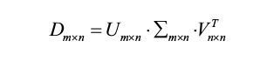

where
m is the number of rows and n is the number of coloumns
D is the input matrix
{ sigma is the SVD matrix , same dimension as that of D and is a diagonal matrix whose diagonal elements are arrainged in decreasing order known as Singular Values.
U and V are square matrices

> dmatrix <- as.matrix(iris[1:4])
> options(digits = 2) # keeping the matrix value up to 2 decimol places
> dsvd <- svd(dmatrix)
> dsvd
$d
[1] 96.0 17.8 3.5 1.9

$u
[,1] [,2] [,3] [,4]
[1,] -0.062 1.3e-01 0.00214 1.6e-03
[2,] -0.058 1.1e-01 0.07067 5.2e-02
[3,] -0.057 1.2e-01 0.00434 9.6e-03
[4,] -0.057 1.1e-01 0.00592 -4.2e-02
[5,] -0.061 1.3e-01 -0.03188 -3.2e-02
[6,] -0.068 1.3e-01 -0.06854 -1.1e-02
[7,] -0.057 1.2e-01 -0.06641 -2.7e-02
[8,] -0.061 1.2e-01 0.00543 -2.4e-02
[9,] -0.054 1.0e-01 0.01764 -1.7e-02
[10,] -0.059 1.1e-01 0.06497 -3.0e-02
[11,] -0.065 1.4e-01 0.00494 -6.5e-03
[12,] -0.060 1.1e-01 -0.02530 -8.4e-02
[13,] -0.057 1.1e-01 0.07168 -5.2e-03
[14,] -0.052 1.2e-01 0.00426 -1.4e-02
[15,] -0.068 1.6e-01 0.00957 8.8e-02
[16,] -0.071 1.6e-01 -0.11914 6.6e-03
[17,] -0.065 1.5e-01 -0.06170 9.1e-02
[18,] -0.062 1.3e-01 -0.01338 4.2e-02
[19,] -0.069 1.3e-01 0.01002 1.7e-02
[20,] -0.064 1.3e-01 -0.07362 -3.4e-02
[21,] -0.065 1.2e-01 0.06005 -7.0e-03
[22,] -0.063 1.3e-01 -0.06962 2.2e-02
[23,] -0.056 1.4e-01 -0.08308 1.7e-03
[24,] -0.063 1.1e-01 -0.01052 7.8e-02
[25,] -0.062 1.0e-01 -0.03043 -1.6e-01
[26,] -0.060 1.0e-01 0.08176 1.8e-02
[27,] -0.062 1.1e-01 -0.02731 3.0e-02
[28,] -0.063 1.3e-01 0.01494 -6.8e-03
[29,] -0.062 1.3e-01 0.03616 3.5e-02
[30,] -0.058 1.1e-01 -0.00079 -6.7e-02
[31,] -0.059 1.0e-01 0.03323 -3.3e-02
[32,] -0.064 1.2e-01 0.03243 1.2e-01
[33,] -0.065 1.5e-01 -0.08661 -1.5e-01
[34,] -0.068 1.6e-01 -0.07640 -4.8e-02
[35,] -0.059 1.1e-01 0.04945 9.4e-03
[36,] -0.059 1.3e-01 0.04958 8.6e-02
[37,] -0.064 1.4e-01 0.06189 9.5e-02
[38,] -0.060 1.3e-01 -0.03087 -8.9e-02
[39,] -0.054 1.1e-01 -0.00016 -7.8e-03
[40,] -0.062 1.2e-01 0.01994 -7.0e-03
[41,] -0.060 1.3e-01 -0.02618 5.0e-02
[42,] -0.052 8.5e-02 0.13540 1.7e-01
[43,] -0.054 1.1e-01 -0.03919 -4.2e-02
[44,] -0.063 1.1e-01 -0.07786 9.3e-02
[45,] -0.066 1.2e-01 -0.09597 -9.7e-02
[46,] -0.057 1.1e-01 0.04065 7.5e-02
[47,] -0.064 1.3e-01 -0.05981 -1.0e-01
[48,] -0.057 1.1e-01 -0.01188 -3.3e-02
[49,] -0.065 1.3e-01 -0.00957 -2.3e-02
[50,] -0.060 1.2e-01 0.02665 1.8e-02
[51,] -0.095 -4.1e-03 0.09373 1.3e-02
[52,] -0.089 -7.7e-03 -0.00542 1.3e-03
[53,] -0.095 -1.9e-02 0.07980 1.2e-03
[54,] -0.076 -2.6e-02 0.07917 4.7e-02
[55,] -0.089 -2.2e-02 0.08542 6.0e-02
[56,] -0.082 -2.7e-02 0.00209 -1.3e-01
[57,] -0.090 -1.6e-02 -0.05838 -4.4e-02
[58,] -0.067 1.3e-03 0.03112 -1.3e-02
[59,] -0.090 -1.4e-02 0.11145 -1.9e-02
[60,] -0.075 -1.6e-02 -0.05621 -5.6e-03
[61,] -0.068 -1.7e-02 0.12025 2.1e-02
[62,] -0.083 -9.9e-03 -0.03382 2.6e-02
[63,] -0.079 -1.5e-02 0.21778 3.0e-02
[64,] -0.087 -2.8e-02 0.02168 -9.0e-02
[65,] -0.077 1.0e-02 -0.01654 6.5e-02
[66,] -0.091 -2.2e-05 0.07484 5.5e-02
[67,] -0.082 -2.7e-02 -0.08247 -1.0e-01
[68,] -0.080 -7.0e-03 0.08950 -1.1e-01
[69,] -0.084 -4.2e-02 0.16067 1.4e-01
[70,] -0.077 -1.0e-02 0.08740 -2.4e-02
[71,] -0.088 -3.3e-02 -0.12965 -4.1e-02
[72,] -0.082 -9.6e-04 0.06867 6.5e-02
[73,] -0.088 -4.7e-02 0.10981 7.8e-05
[74,] -0.086 -2.7e-02 0.07222 -1.5e-01
[75,] -0.087 -5.1e-03 0.08756 2.3e-02
[76,] -0.090 -4.7e-03 0.07984 5.5e-02
[77,] -0.092 -2.4e-02 0.14105 2.0e-02
[78,] -0.094 -3.3e-02 0.03755 3.8e-02
[79,] -0.085 -2.3e-02 -0.00493 -1.6e-02
[80,] -0.075 1.2e-02 0.10476 3.9e-02
[81,] -0.075 -1.1e-02 0.09411 1.7e-03
[82,] -0.074 -5.1e-03 0.11134 -1.3e-02
[83,] -0.079 -2.9e-03 0.06188 1.7e-02
[84,] -0.088 -5.5e-02 0.00832 -9.6e-02
[85,] -0.081 -3.0e-02 -0.11149 -1.4e-01
[86,] -0.087 -9.8e-03 -0.11800 -6.1e-02
[87,] -0.092 -1.4e-02 0.05420 1.8e-02
[88,] -0.084 -2.9e-02 0.18841 8.1e-02
[89,] -0.080 -6.8e-03 -0.04460 -7.9e-02
[90,] -0.077 -2.0e-02 0.04015 1.4e-02
[91,] -0.079 -3.1e-02 0.02932 -1.5e-01
[92,] -0.087 -2.1e-02 0.00388 -8.1e-02
[93,] -0.079 -1.0e-02 0.07968 8.0e-03
[94,] -0.068 -2.2e-04 0.06514 2.1e-02
[95,] -0.079 -2.0e-02 0.01222 -5.4e-02
[96,] -0.081 -7.2e-03 -0.01629 -1.3e-01
[97,] -0.081 -1.2e-02 -0.01229 -7.1e-02
[98,] -0.085 -8.3e-03 0.05854 -1.1e-02
[99,] -0.068 1.8e-02 0.03024 1.2e-01
[100,] -0.080 -1.1e-02 0.00893 -2.8e-02
[101,] -0.099 -8.5e-02 -0.22025 -1.6e-02
[102,] -0.087 -6.4e-02 -0.06725 -1.0e-02
[103,] -0.103 -7.0e-02 0.01813 3.6e-02
[104,] -0.094 -6.8e-02 -0.02675 -1.3e-01
[105,] -0.098 -7.8e-02 -0.08273 -3.6e-04
[106,] -0.110 -9.0e-02 0.07871 -5.7e-02
[107,] -0.075 -5.7e-02 -0.11752 -5.6e-02
[108,] -0.105 -8.0e-02 0.10637 -1.3e-01
[109,] -0.097 -8.2e-02 0.10591 -4.2e-02
[110,] -0.108 -6.6e-02 -0.14991 6.1e-02
[111,] -0.094 -4.0e-02 -0.07875 6.5e-02
[112,] -0.092 -6.3e-02 0.01639 4.1e-02
[113,] -0.098 -5.9e-02 -0.01856 8.7e-02
[114,] -0.085 -7.0e-02 -0.05654 7.2e-02
[115,] -0.088 -7.1e-02 -0.16434 1.7e-01
[116,] -0.095 -5.5e-02 -0.14323 1.2e-01
[117,] -0.095 -5.8e-02 -0.01554 -8.3e-02
[118,] -0.115 -7.0e-02 -0.08009 -1.6e-01
[119,] -0.111 -1.2e-01 0.13510 3.1e-02
[120,] -0.085 -6.5e-02 0.12310 -2.6e-02
[121,] -0.101 -6.3e-02 -0.07752 9.9e-02
[122,] -0.085 -5.8e-02 -0.12787 3.0e-02
[123,] -0.111 -9.7e-02 0.14605 -7.2e-02
[124,] -0.089 -4.6e-02 0.02423 8.6e-02
[125,] -0.100 -5.9e-02 -0.09502 -3.1e-02
[126,] -0.104 -6.1e-02 0.03846 -1.3e-01
[127,] -0.088 -4.1e-02 -0.00808 7.8e-02
[128,] -0.089 -4.0e-02 -0.06332 1.5e-03
[129,] -0.095 -7.5e-02 -0.03928 2.7e-02
[130,] -0.102 -5.5e-02 0.11193 -1.2e-01
[131,] -0.105 -7.6e-02 0.12829 -9.7e-03
[132,] -0.115 -5.1e-02 -0.01491 -1.3e-01
[133,] -0.095 -7.7e-02 -0.05480 6.7e-02
[134,] -0.090 -4.6e-02 0.04785 -1.0e-01
[135,] -0.090 -7.3e-02 0.06483 -2.7e-01
[136,] -0.109 -7.2e-02 0.07074 1.7e-01
[137,] -0.097 -6.4e-02 -0.21740 2.9e-02
[138,] -0.095 -5.6e-02 -0.04956 -1.2e-01
[139,] -0.088 -3.8e-02 -0.07611 1.0e-02
[140,] -0.099 -5.0e-02 -0.02185 1.1e-01
[141,] -0.099 -6.7e-02 -0.10084 1.5e-01
[142,] -0.098 -4.2e-02 -0.04775 2.7e-01
[143,] -0.087 -6.4e-02 -0.06725 -1.0e-02
[144,] -0.101 -7.3e-02 -0.09545 3.1e-02
[145,] -0.100 -6.7e-02 -0.15708 1.3e-01
[146,] -0.096 -5.2e-02 -0.05897 2.3e-01
[147,] -0.089 -5.9e-02 0.04603 1.3e-01
[148,] -0.094 -5.0e-02 -0.04144 7.3e-02
[149,] -0.095 -5.6e-02 -0.21298 2.3e-02
[150,] -0.088 -5.2e-02 -0.09575 -8.4e-02

$v
[,1] [,2] [,3] [,4]
[1,] -0.75 0.28 0.502 0.32
[2,] -0.38 0.55 -0.675 -0.32
[3,] -0.51 -0.71 -0.059 -0.48
[4,] -0.17 -0.34 -0.537 0.75
Here
$d
[1] 96.0 17.8 3.5 1.9

are the SVD values that we need.

APPLICATION ON CANCER DETECTION DATA SET

## Cnr Data Study 5/1/2016
#colon cnr alon et al 1999
install.packages("devtools") # we are using datamicroarray package in github and to install
# we need devtools packge
library(devtools)
install_github("ramhiser/datamicroarray") #installing data microarray package from github

# setting working directory
setwd("~/RWorld")
library(datamicroarray)
data("alon", package = "datamicroarray")# attaching the alon data set in microarray package
str(alon)
str(iris3) #comparing with iris3
head(alon)
alon1 <- alon[[1]] #alon is a list hence asssigning the first value of list to a vector
str(alon1)
str(iris3)
dni <- dimnames(alon1)
dni

#comparing the case with iris3
iris3
head(iris)
?aperm
#ii <- data.frame(matrix(aperm(iris3, c(1,3,2)), ncol = 4,
#dimnames =list(NULL, sub("L.", ".Length",
# sub("W.", ".Width", dni3[[2]])))),
#Species = gl(3, 50, labels = sub("S", "s", sub("V", "v", dni3[[3]]))))
test_iris3 <- aperm(iris3, c(1,3,2))
test_iris3
Tstirs3mx <- matrix(test_iris3, ncol = 4)
Tstirs3mx

#continuing with original case
#No need of aperm function here since we will be given gene data of a un known patient
# and we have to predict which group the patient belongs to thus gene data are features
new_alon <- data.frame(alon1) #no need to use matrix function and dimnames as it is allredy
#in this format
head(new_alon)
new_alon[1:4, 1:4] # head function is not helpfull here due to large number of features
> new_alon[1:4, 1:4] # head function is not helpfull here due to large number of features
X1 X2 X3 X4
1 8589.42 5468.24 4263.41 4064.94
2 9164.25 6719.53 4883.45 3718.16
3 3825.71 6970.36 5369.97 4705.65
4 6246.45 7823.53 5955.84 3975.56

Next step is to add the n, t column indicating which person which one does not:

