Olist Brazilian E-Commerce Analysis
Final Insights Report

Analysis period: January 2017 – August 2018
Dataset: Brazilian E-Commerce Public Dataset by Olist
License: CC BY-NC-SA 4.0
Prepared by: Lijo John Daniel

Executive Summary
This report analyzes 96,478 delivered orders from the Olist Brazilian marketplace, covering a two-year window from September 2016 to October 2018. The analysis produced four core findings:
- Revenue is concentrated. A small number of product categories and a single state (São Paulo) drive a disproportionate share of total revenue.
- Seasonality is real and predictable. November 2017 (Black Friday) is the largest revenue month on record, demonstrating strong consumer responsiveness to promotional events.
- Delivery performance is the primary driver of customer satisfaction. Late orders receive review scores roughly 40% lower than early orders.
- Repeat purchase behavior is very low. Approximately 97% of customers place a single order in the analysis window — a significant retention opportunity.

Headline Metrics
Metric | Value
Delivered orders | 96,478
Total revenue (BRL) | R$ 15,419,773.75
Avg item value (BRL) | R$ 139.93
Unique customers | 93,358
Active sellers | 2,970
Active products | 32,216

1. Revenue Performance

1.1 Monthly revenue trend
Revenue grew steadily through 2017, peaked sharply in November 2017, and stabilized through 2018. The November spike coincides with Black Friday — a well-documented retail phenomenon in Brazil — and represents the single largest month of revenue in the dataset.
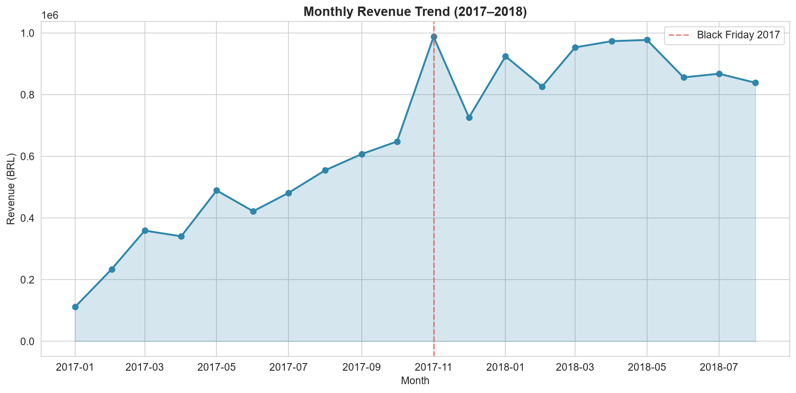

1.2 Revenue concentration by category
Ten product categories account for the majority of marketplace revenue. The top five alone — bed_bath_table, health_beauty, sports_leisure, computers_accessories, and furniture_decor — represent a substantial portion of total GMV.
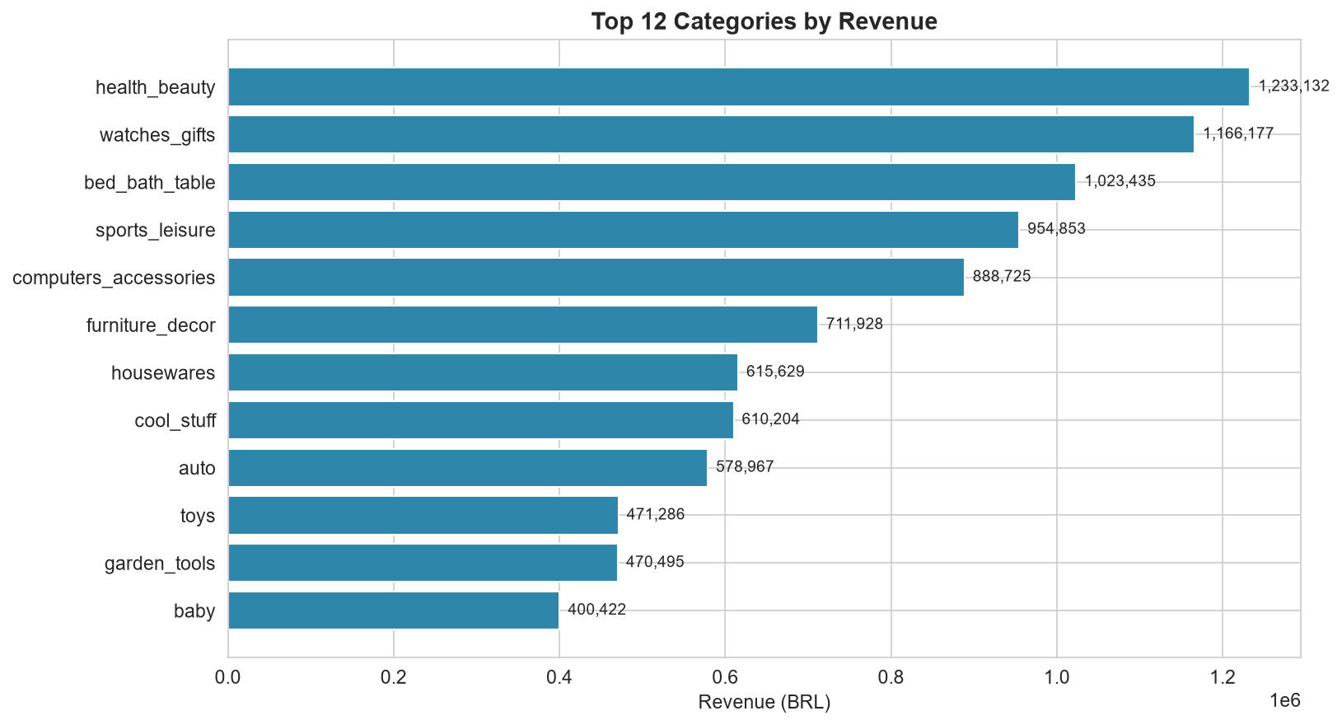
Table 1. Top 10 categories by revenue
Category | Orders | Revenue
health_beauty | 8,647 | 1,233,131.72
watches_gifts | 5,495 | 1,166,176.98
bed_bath_table | 9,272 | 1,023,434.76
sports_leisure | 7,530 | 954,852.55
computers_accessories | 6,530 | 888,724.61
furniture_decor | 6,307 | 711,927.69
housewares | 5,743 | 615,628.69
cool_stuff | 3,559 | 610,204.10
auto | 3,810 | 578,966.65
toys | 3,804 | 471,286.48

2. Geographic Distribution
The Southeast region dominates the marketplace. São Paulo (SP) alone accounts for roughly one third of both orders and revenue. Rio de Janeiro (RJ) and Minas Gerais (MG) follow. Northern states show minimal penetration, likely due to logistics cost and delivery time.
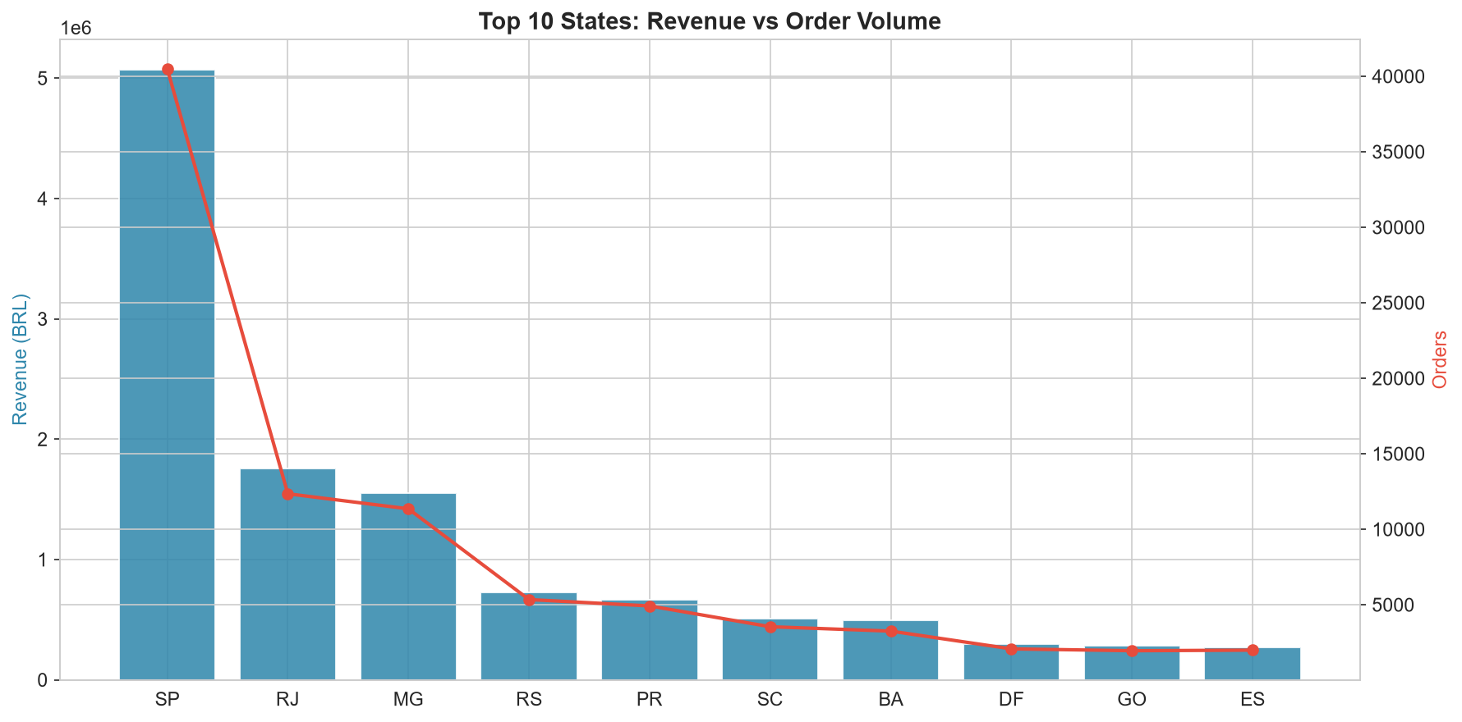
Table 2. Top 10 states by revenue
Customer State | Customers | Revenue
SP | 39,156 | 5,769,703.15
RJ | 11,917 | 2,055,401.57
MG | 11,001 | 1,818,891.67
RS | 5,168 | 861,472.79
PR | 4,769 | 781,708.80
SC | 3,449 | 595,127.78
BA | 3,158 | 591,137.81
DF | 2,019 | 346,123.35
GO | 1,895 | 334,212.35
ES | 1,928 | 317,657.93

3. Delivery Performance
The vast majority of orders arrive on or before their estimated delivery date. Late deliveries are the exception, not the rule — but their impact on customer satisfaction is disproportionate.
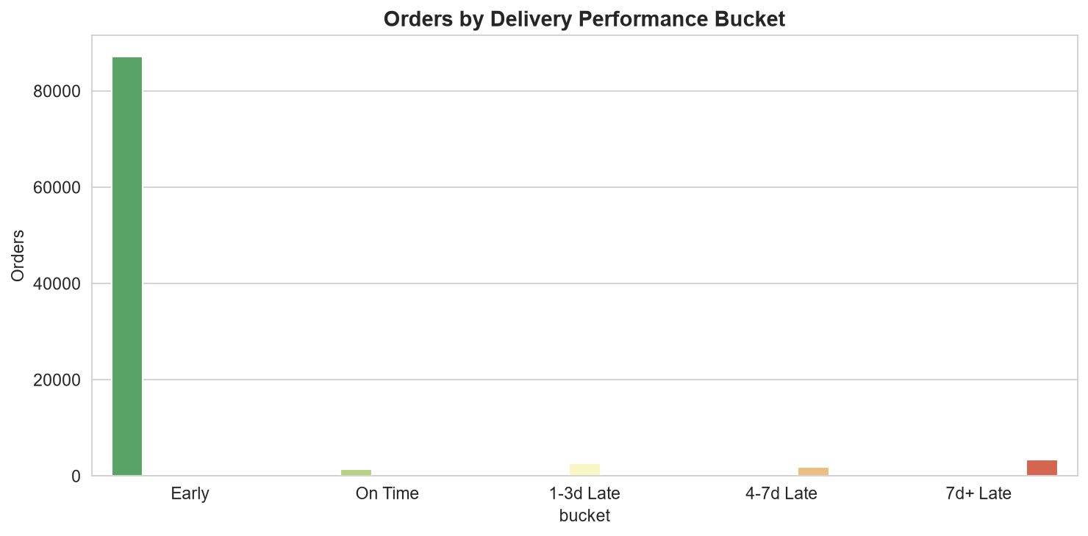
Table 3. Average review score by delivery performance
Bucket | Reviews | Avg Review
Early | 87,956 | 4.30
Late | 7,638 | 2.57

The table above tells the whole story: a late delivery cuts the expected review score by roughly 40%. There is no other operational metric in this dataset with that magnitude of impact on customer sentiment.

4. Customer Satisfaction

4.1 Review score distribution
Reviews are bimodal. Roughly 57% of orders receive a perfect 5-star rating, but 1-star reviews are the second most common outcome. This polarization indicates that customer experience is not evenly distributed — the marketplace reliably delivers for most customers, but when something goes wrong, it goes very wrong.
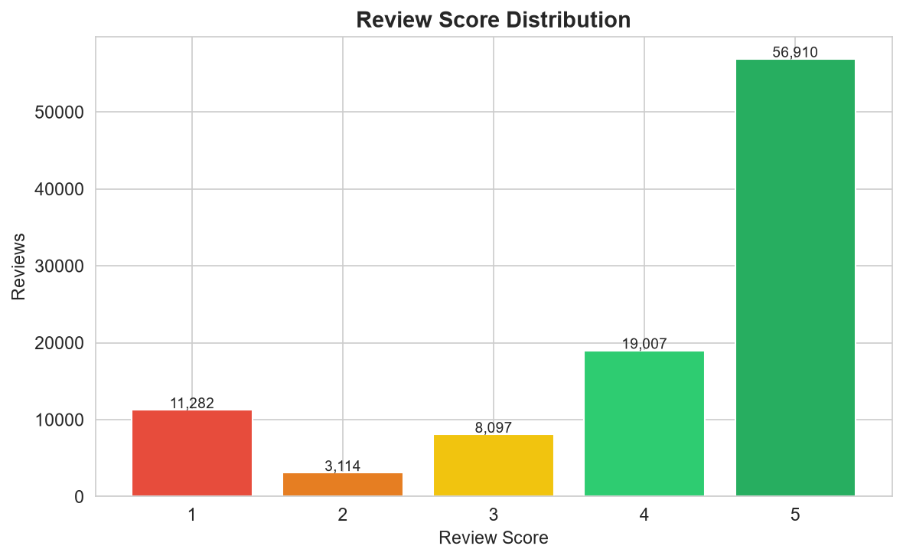
Table 4. Review score distribution
Review Score | Reviews | Pct
1.00 | 11,282.00 | 11.46
2.00 | 3,114.00 | 3.16
3.00 | 8,097.00 | 8.23
4.00 | 19,007.00 | 19.31
5.00 | 56,910.00 | 57.83

4.2 Delivery impact on satisfaction
The strongest single predictor of review score in this dataset is not product quality, price, or category — it is whether the order arrived on time. The relationship between delay and score is roughly linear: each additional day of delay depresses the average review.
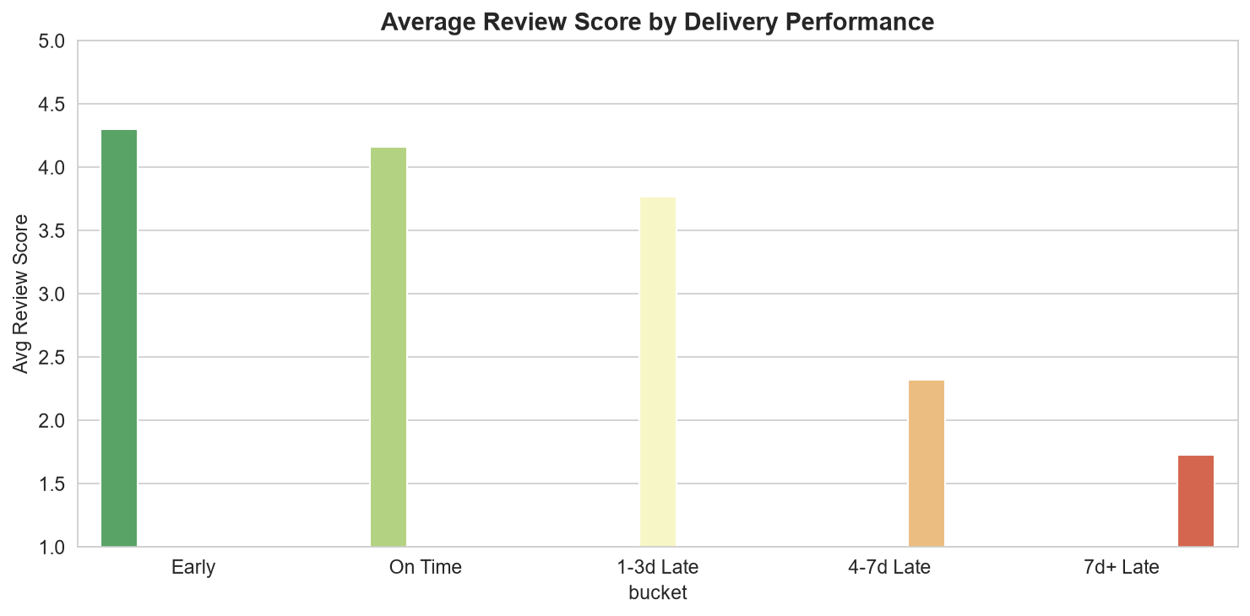

5. Payment Behavior
Credit card is the dominant payment method, accounting for approximately three quarters of payments. Boleto (the Brazilian bank slip) is second at roughly one fifth. Vouchers and debit cards are minor. Most credit card customers settle in a single installment — a signal that customers view the marketplace as a low-friction, single-purchase channel rather than a financed retail experience.
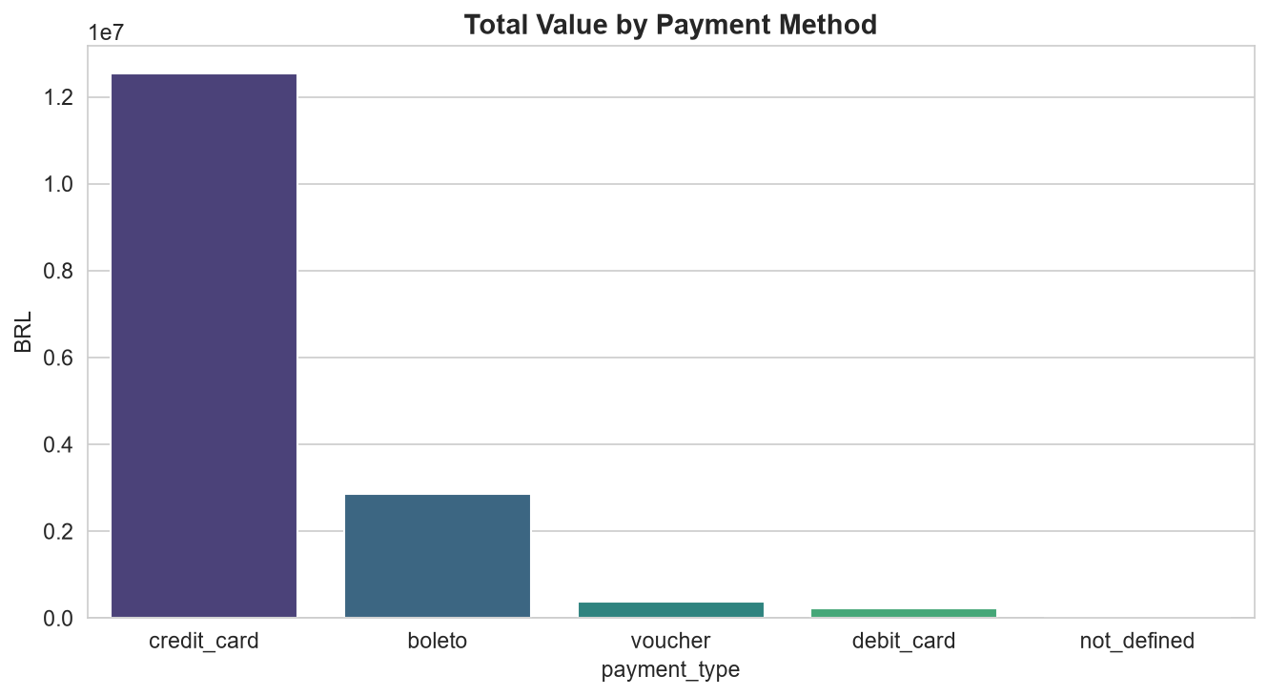
Table 5. Payment method breakdown
Payment Type | Payments | Total Value | Avg Installments
credit_card | 76,795 | 12,542,084.19 | 3.51
boleto | 19,784 | 2,869,361.27 | 1.00
voucher | 5,775 | 379,436.87 | 1.00
debit_card | 1,529 | 217,989.79 | 1.00
not_defined | 3 | 0.00 | 1.00

6. Customer Segmentation (RFM)
Customers were scored on Recency, Frequency, and Monetary value, then grouped into five segments. The distribution reveals the marketplace's core structural challenge: a very small Champion segment and a very large Regular segment, with few customers occupying the Loyal middle.
Table 6. RFM segment distribution
Segment | Customers | Avg Monetary | Avg Frequency
Regular | 35,860 | 100.91 | 1.00
At Risk | 22,212 | 143.65 | 1.05
Lost | 15,004 | 140.83 | 1.00
Loyal | 13,864 | 181.90 | 1.06
Champion | 6,418 | 276.93 | 1.17

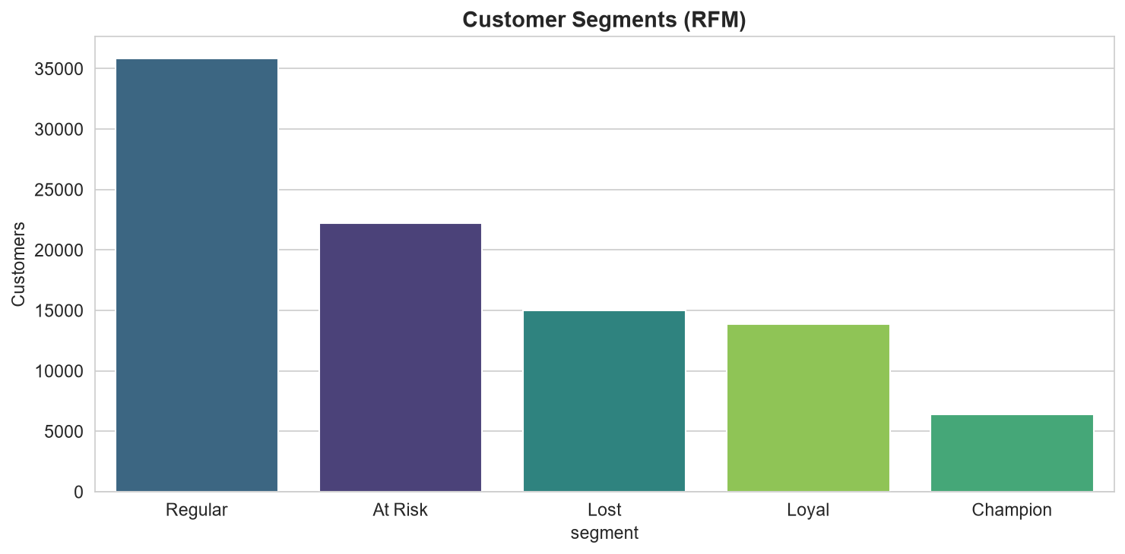

7. Business Recommendations

For operations
- Reduce late-delivery rate. This is the single highest-leverage operational improvement available. A modest reduction in the late rate would lift overall review scores materially.
- Invest in logistics for remote states. Delivery times are meaningfully longer outside the Southeast. Partnering with regional carriers or establishing forward-stocking points could compress delivery windows without major capital expenditure.

For marketing
- Plan around Black Friday. The November 2017 spike is not an anomaly — it reflects genuine seasonal demand. Inventory, logistics, and campaign spend should all scale accordingly.
- Build retention campaigns. With roughly 97% single-order customers, there is a large untapped repeat-purchase opportunity. A simple post-purchase email sequence with a time-limited offer could meaningfully improve the repeat rate.

For product
- Promote installment options on higher-value orders. Credit card installments are already common, but higher-value baskets could be further unlocked by making installment plans more visible at checkout.
- Focus category merchandising on the top revenue drivers. The concentrated revenue distribution suggests that deep focus on five to ten categories will outperform broad portfolio expansion.

8. Methodology
This analysis was built on a reproducible data pipeline. All numbers in this document can be regenerated from the source dataset by running the project's pipeline scripts.

Data preparation
- Source: 9 CSV files from the Brazilian E-Commerce Public Dataset by Olist.
- All analysis uses customer_unique_id (not customer_id) for customer counts.
- Revenue is defined as the sum of item price and freight value on delivered orders.
- Datetime columns are parsed with errors='coerce'; unparseable values become NULL.
- Integer columns stored as floats in the source are cast to nullable Int64.
- Duplicate review_id rows are deduplicated, keeping the latest answer.
- Geolocation is used opportunistically; it contains multiple rows per zip prefix.

Analytical techniques
- SQL analytics: multi-table joins, CTEs, window functions (RANK, NTILE, LAG).
- RFM segmentation: quintile scoring (NTILE 5) on recency, frequency, monetary.
- Python EDA: pandas for transformation, Matplotlib and Seaborn for visualization.
- PostgreSQL as the analytical database, loaded via the COPY protocol.

Limitations
- The dataset's 2-year window is short for lifetime-value or cohort analysis.
- Repeat purchase rates are very low, limiting RFM's frequency-based signal.
- Geolocation coordinates are not used for distance calculation; state-level proxies substitute.
- Review text is not analyzed; only numeric scores are used.
- Margin data is absent — monetary values represent revenue, not profit.

Prepared using Python, PostgreSQL, pandas, Matplotlib, and Seaborn.
Dataset © Olist, licensed under CC BY-NC-SA 4.0.

