MEDI – Diagnose

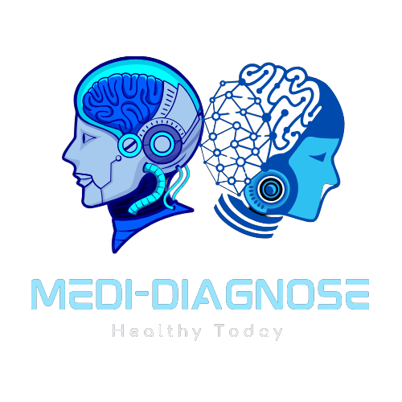

Problem Statement

* Medi-Diagnose focuses on revolutionizing healthcare in rural areas by providing an online platform that utilizes AI-driven tools to analyze patients' X-rays. This innovative approach offers quick and accurate diagnosis, empowering remote medical professionals to provide high-quality care to underserved communities and improve patient outcomes.
* Medi-Diagnose leverages advanced AI and machine learning to revolutionize healthcare by providing precise, automated diagnostic tools for early detection of dental cavities, enzyme stability prediction, and brain tumor identification. This innovative approach enhances patient care and supports efficient, accurate, and compassionate treatment planning across various medical fields.
* What if Medi-Diagnose could deliver precise, AI-driven diagnoses from patient X-rays tailored to each individual's medical history and needs, offering highly personalized treatment plans for optimal health outcomes?

"Revolutionizing Healthcare: Precision Diagnoses for a Brighter Tomorrow."

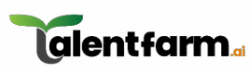

Statistics

"32% of healthcare providers plan to implement AI-powered diagnostic tools for enhanced precision in medical imaging."

"AI-powered medical imaging solutions set to surge, with a projected growth to $10 billion by 2025 in North America."  
  
  
  
SOURCE LINK:

<https://drive.google.com/file/d/1c6tCYKQu0_2L9lMU6aWnOCODwyPiQJE4/view>



Stakeholders

* Patients
* Doctors
* Medical Researchers
* Technology Partners
* Patients' Families
* Software and Hardware Developers



**Present Scenario**

- Manual Analysis: Time-consuming and susceptible to human error, manual image analysis impacts diagnostic efficiency.

- Variable Diagnostic Quality: Differences in skill levels among medical professionals can lead to inconsistent and potentially inaccurate diagnostics.

- Resource Constraints: Limited access to specialized radiologists and imaging equipment in underserved areas delays diagnoses and treatment.

- Integration Challenges: Incorporating AI-driven diagnostics into existing healthcare workflows can pose interoperability and adoption barriers.



Proposed Solution - Predictive/ Preventive Maintainance

- Real-Time Monitoring: Implementing real-time monitoring systems to continuously assess the performance and condition of medical imaging equipment, enabling early detection of potential issues.

- Predictive Diagnostics: Employing automation techniques such as deep learning and machine learning models to predict diseases at an early stage for better treatment outcomes, while also suggesting appropriate medications for more targeted and effective care.

- Instant Multilingual Report Evaluation: Offering AI-driven instant evaluation of medical reports in the absence of a doctor, with results presented in multiple languages for more diversified communication and clarification of medical issues. This enables quicker decision-making and better patient guidance across different linguistic backgrounds.

- Regular Maintenance Scheduling: Leveraging data insights to create optimized maintenance schedules that proactively address potential problems, extending the lifespan of equipment and improving overall reliability.

- Navigation to Nearest Doctor: Integrating a feature that guides patients to the nearest doctor or healthcare facility for physical consultation, ensuring quick and efficient access to medical assistance when needed.



Features

- Telemedicine Integration: Seamlessly integrates with telemedicine platforms to offer remote medical consultations and diagnostic support, enhancing access to healthcare for patients and doctors alike.

- Dual Assistance: Provides support for both doctors and patients, facilitating a smooth healthcare experience and fostering collaboration between medical professionals and those they treat.

- Accessibility for Remote Areas: Ensures healthcare access for all, including remote villages and underserved communities, by leveraging technology to bridge geographic barriers.

- Multilingual Support: Offers services in multiple languages for inclusive and accessible healthcare, ensuring clear communication and understanding for all patients.

- Reduced Clinical Errors: Utilizes AI-powered tools to minimize human error in diagnostics and treatment planning, enhancing patient safety and care quality.

- Accurate AI Predictions: Delivers better and more precise results through AI-driven diagnostic tools, enabling efficient and targeted treatments for improved health outcomes.

- Navigation to Nearest Healthcare Providers: Guides patients towards the best and nearest healthcare providers, ensuring prompt access to quality care and efficient treatment.

