**参考答案：**

【范文】

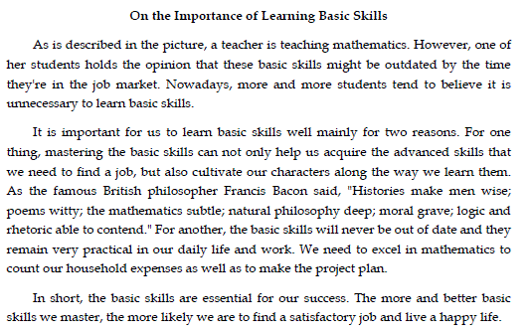

【快速阅读】

1. B 2. A 3. C 4. D 5. C 6. A 7. D

8. Man of the Year

9. poor management

10. micromanaging

【听力部分：短对话】

11. D 12. B 13. D 14. A 15. A 16. C 17. B 18. D

【长对话】

19. B 20. D 21. C 22. A 23. C 24. D 25. D

【篇章听力】

26. D 27. A 28. B 29. C 30. A 31. B 32. B

33. A 34. C 35. B

【复合式听写】

36. agencies

37. Secretaries

38. president

39. specialized

40. recommend

41. establish

42. financial

43. corporation

44. It is believed that one can start out at the bottom and go all the way to the top

45. education plays a central part in the selection of people for management jobs

46. they can easily get promoted if they show the necessary personality and ability

【选词填空】

47 L 48 G 49 K 50 D 51 F

52 I 53 N 54 J 55 C 56 B

【仔细阅读】

57 A 58 B 59 D 60 D 61 C

62 A 63 B 64 B 65 A 66 C

【完型填空】

67-86. CBACB DCADB ACDDB ADBAC

【翻译】

87. No matter how many mistakes you've made

88. lying in a stranger s room

89. the result is far from satisfactory

90. have his parents heard from him

91. without regard to/with no regard for/completely ignoring the traffic lights