STQA Lab final answer script.

Section D4

**Submitted By:**

Md. Likhan Mia

Id. 201002340

Green university of Bangladesh.

**Answer to the question no: 02**

5 test case writing for othoba.com website

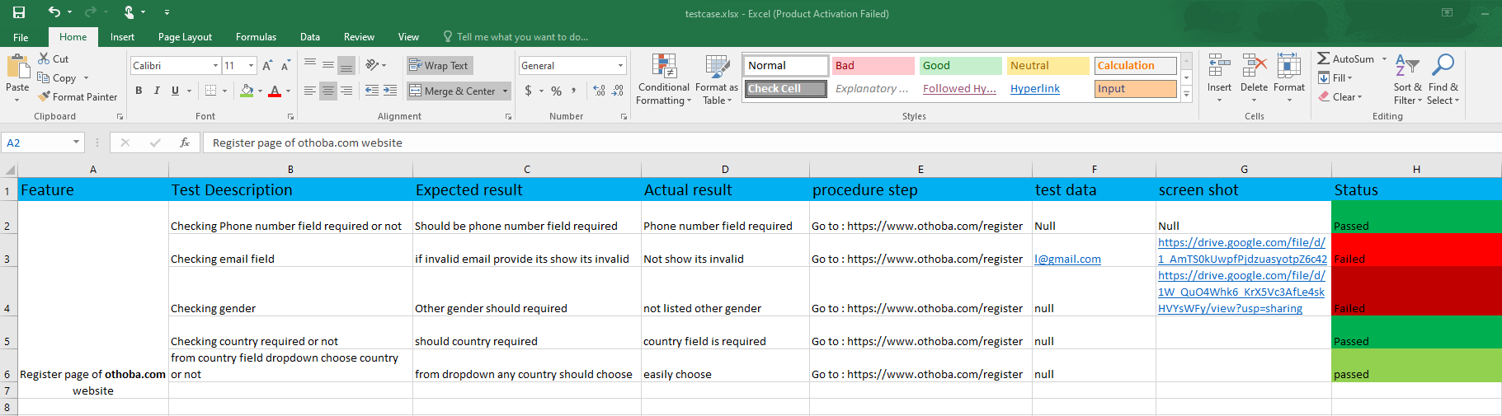

Excel sheet link:

<https://docs.google.com/spreadsheets/d/1yHUuHg3w9xweGYjKKZsSMjC9TUc9r8Vd/edit?usp=sharing&ouid=113008965883269395540&rtpof=true&sd=true>

**Answer to the question number 03**

Test the login functionality of the given website using selenium.

package finalselenium;

import org.openqa.selenium.By;

import org.openqa.selenium.WebDriver;

import org.openqa.selenium.chrome.ChromeDriver;

public class FinalSelenium {

public static void main(String[]args) throws InterruptedException {

System.setProperty("webdriver.chrome.driver", "C:\\Users\\LIKHAN\\Desktop\\selenium\\chromedriver-win64\\chromedriver-win64\\chromedriver.exe");

WebDriver driver= new ChromeDriver(); driver.get("http://demo.openmrs.org/openmrs/" + "/");

driver.manage().window().maximize();

driver.findElement(By.id("username")).sendKeys("Admin");

Thread.sleep(3000);

driver.findElement(By.id("password")).sendKeys("Admin123");

Thread.sleep(3000);

driver.findElement(By.id("Inpatient Ward")).click();

Thread.sleep(3000);

driver.findElement(By.id("loginButton")).click();

//driver.close(); if(actual.equalsIgnoreCase(expected))

{

//System.out.println("Test Successfully");

}

{

//System.out.println("Test fail");

}

}}

**Answer to the question no 04**

Bug reporting using Bugzilla

Finding Bug from website:

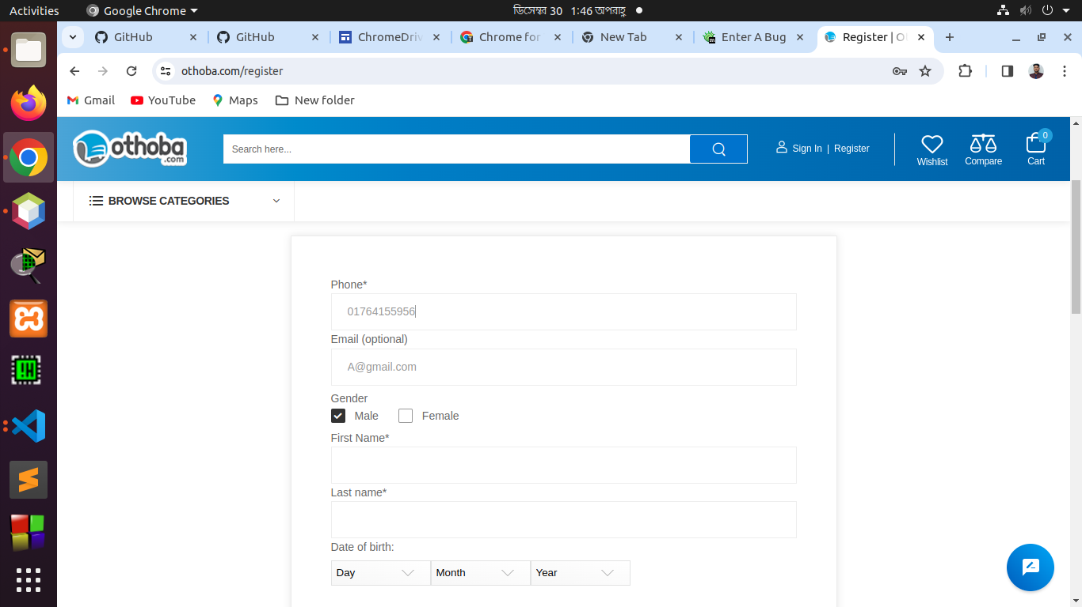

Bug reporting:

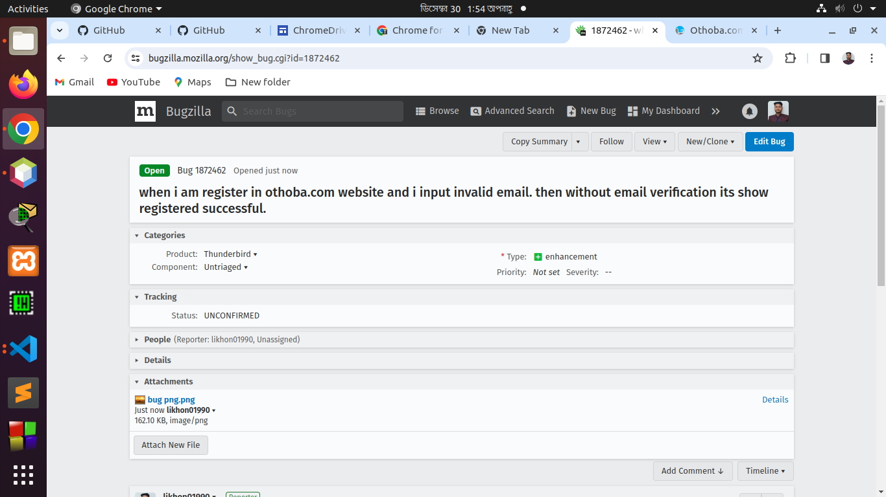

They provide replay after certain time of reporting this bug:

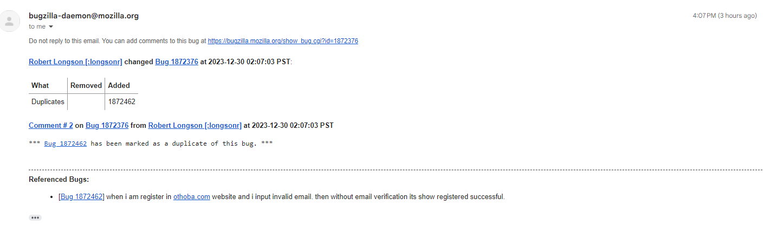

**Answer to the question no:05**

