I have done the assignments in Python and have used Visual Studio 2017 IDE for coding.

I have attached the code files in the zip folder in the assignment. In code I have provided inline comments to make it easily readable and understandable.

I have used various python libraries such as pandas, numpy, graphviz etc. for completing the assignment.

**Question 1:**

**Solution:** Data2 is split into randomly selected 210 training instances and remaining 100 as test instance using following code:

“X_train, X_test, y_train, y_test= train_test_split(X, y,random_state =11, test_size=0.32) “

Where train_test_split is imported from sklearn.model_selection.

The above train and test data are saved in csv files for future analysis purpose. The name format of the files generated are: ‘Data_2C_X_test.csv’, ‘Data_2C_y_test’ etc. for the rest of the data.

**Solution: 1(a):**

The decision tree is generated for all the cases of minimum leaf nodes i.e., 3, 8, 12, 30, 50

Every decision tree is saved in a png file and the name of the png file generated is displayed in the output of the program.

We observe that with minimum leaf node 3 we are facing the issue of Overfitting. We also observe that the predicted values are least accurate with min_leaf nodes = 3. I would prefer decision tree with 30 min_leaf nodes because we are getting maximum accuracy through it and if we further increase number of min_leaf nodes then also the accuracy remains same. So, this is the most stable and accurate decision tree in this scenario.

Decision Tree for Minimum Leaf Nodes: 3:

Name: “Tree_With_3_Node_Biomechanical_Data_column_2C_weka.png”

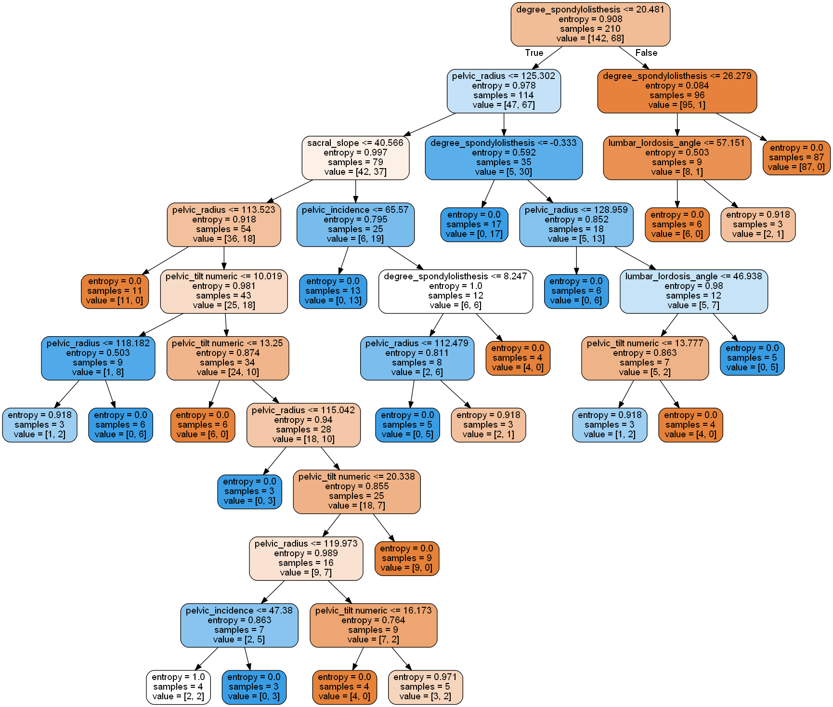

Decision Tree for Minimum Leaf Nodes: 8:

Name: “Tree_With_8_Node_Biomechanical_Data_column_2C_weka.png”

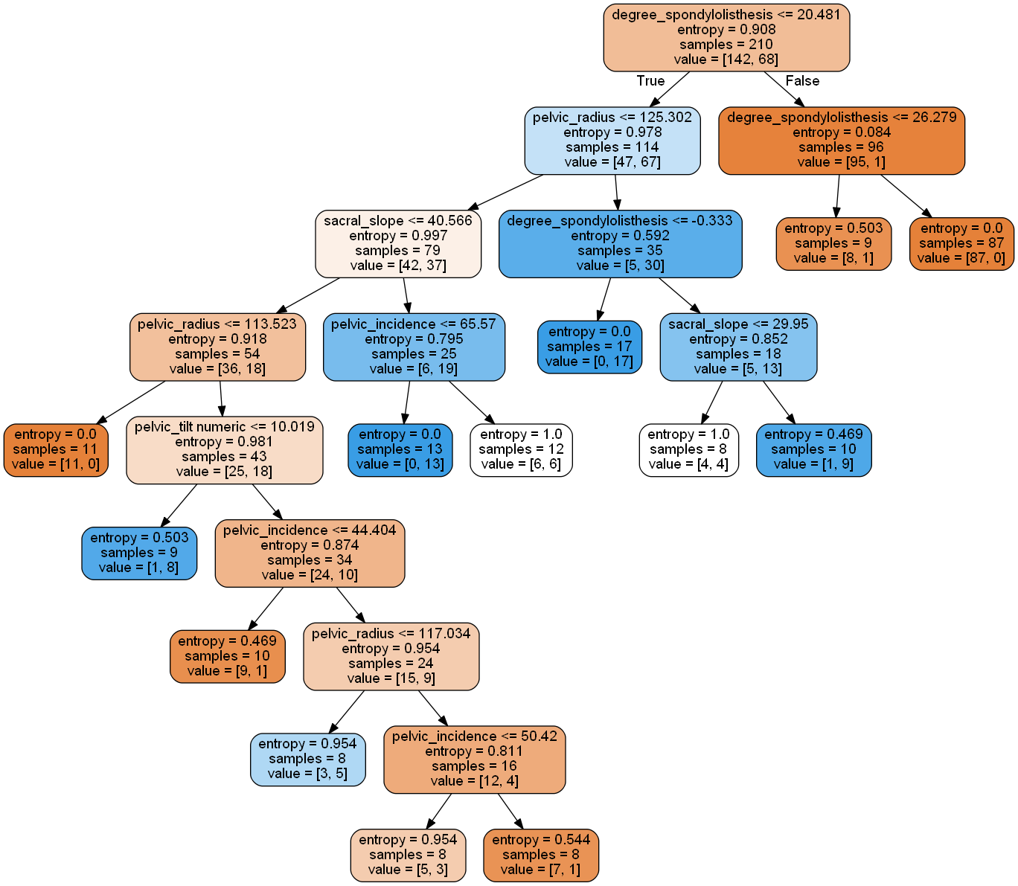

Decision Tree for Minimum Leaf Nodes: 12:

Name: “Tree_With_12_Node_Biomechanical_Data_column_2C_weka.png”

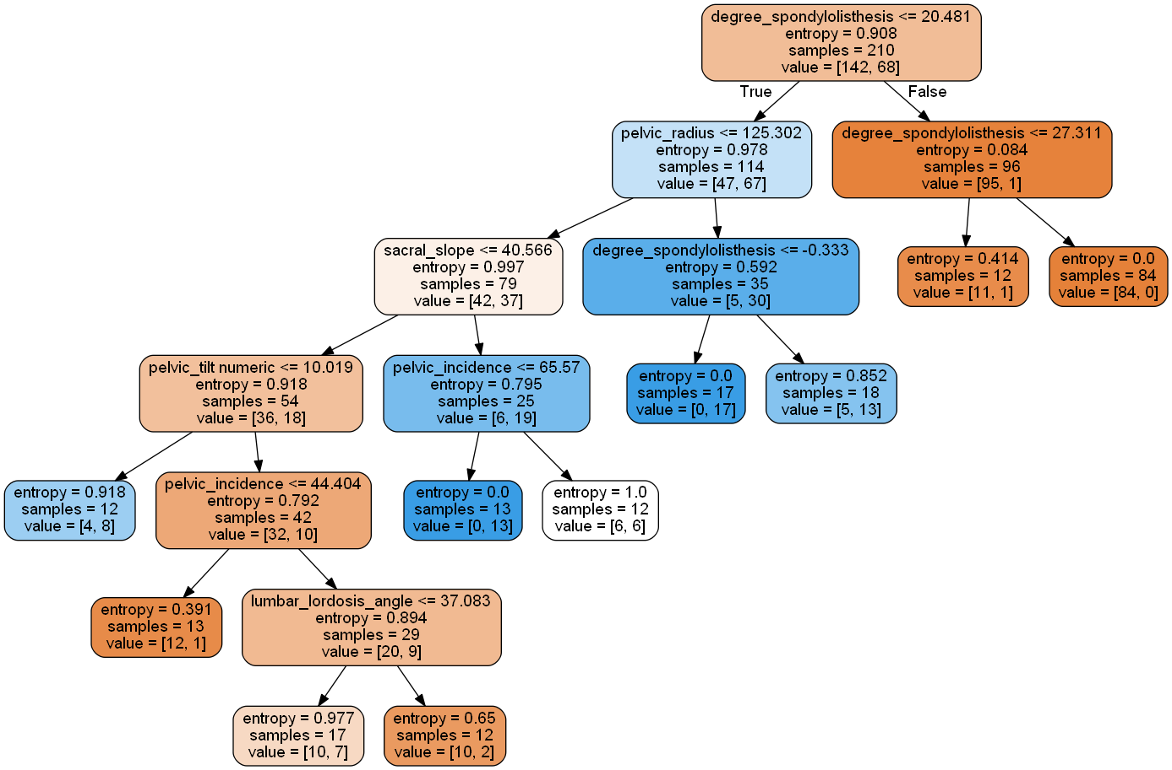

Decision Tree for Minimum Leaf Nodes: 30:

Name: “Tree_With_30_Node_Biomechanical_Data_column_2C_weka.png”

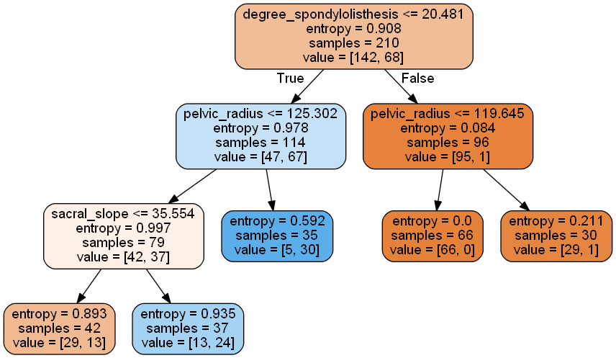

Decision Tree for Minimum Leaf Nodes: 50:

Name: “Tree_With_50_Node_Biomechanical_Data_column_2C_weka.png”

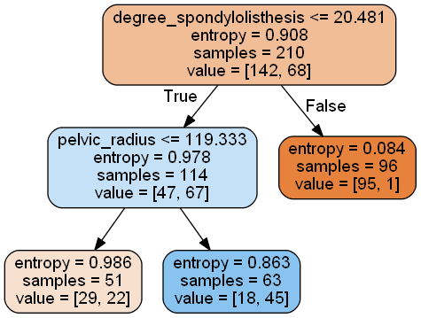

**Solution 1(b):**

Accuracy, Precision and Recall is computed for each decision tree and is displayed in the program output.

Plot for all decision trees against no. of minimum leaf nodes is displayed and saved in png files. The png file name is displayed in the output of the program.

We observe that the accuracy increases with min_leaf nodes but after 30, it remains constant. Recall and Precision values are fluctuating.

Calculation for Minimum Leaf Nodes= 3

Confusion Matrix:

[[62 6]

[ 7 25]]

Precision: 0.8064516129032258

Recall: 0.78125

Accuracy: 0.87

Calculation for Minimum Leaf Nodes= 8

Confusion Matrix:

[[62 6]

[10 22]]

Precision: 0.7857142857142857

Recall: 0.6875

Accuracy: 0.84

Calculation for Minimum Leaf Nodes= 12

Confusion Matrix:

[[63 5]

[10 22]]

Precision: 0.8148148148148148

Recall: 0.6875

Accuracy: 0.85

Calculation for Minimum Leaf Nodes= 30

Confusion Matrix:

[[59 9]

[ 5 27]]

Precision: 0.75

Recall: 0.84375

Accuracy: 0.86

Calculation for Minimum Leaf Nodes= 50

Confusion Matrix:

[[62 6]

[ 8 24]]

Precision: 0.8

Recall: 0.75

Accuracy: 0.86

Plot for Accuracy:

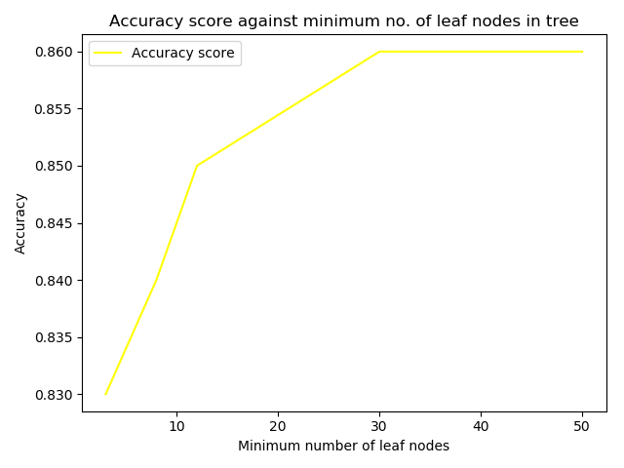

Plot for precision:

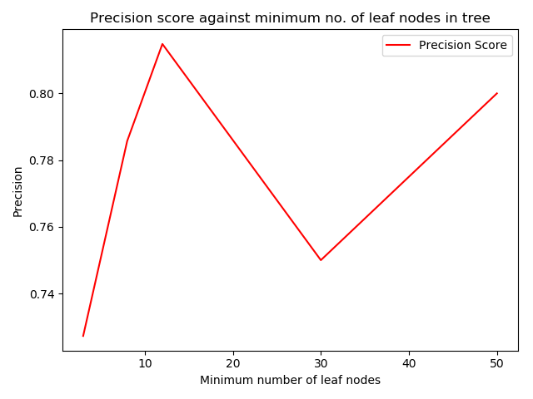

Plot for Recall:

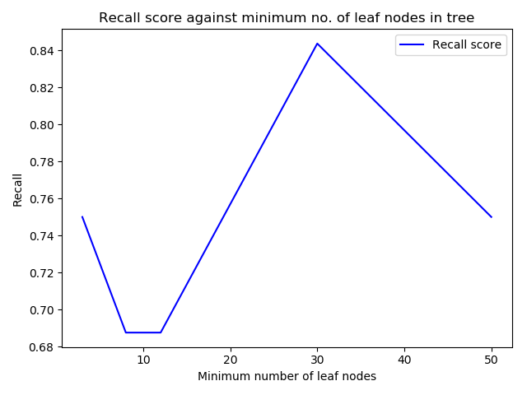

**Solution 2:** Data3 is split into randomly selected 210 training instances and remaining 100 as test instance using following code:

“X_train, X_test, y_train, y_test= train_test_split(X, y,random_state =11, test_size=0.32) “

Where train_test_split is imported from sklearn.model_selection.

The above train and test data are saved in csv files for future analysis purpose. The name format of the files generated are: ‘Data_3C_X_test.csv’, ‘Data_3C_y_test’ etc. for the rest of the data.

**Solution: 2(a):**

The decision tree is generated for all the cases of minimum leaf nodes i.e., 3, 8, 12, 30, 50

Every decision tree is saved in a png file and the name of the png file generated is displayed in the output of the program.

I will choose min_leaf node =3 because it gives maximum accuracy.

Decision Tree for Minimum Leaf Nodes: 3:

Name: “Tree_With_3_Node_Biomechanical_Data_column_3C_weka.png”

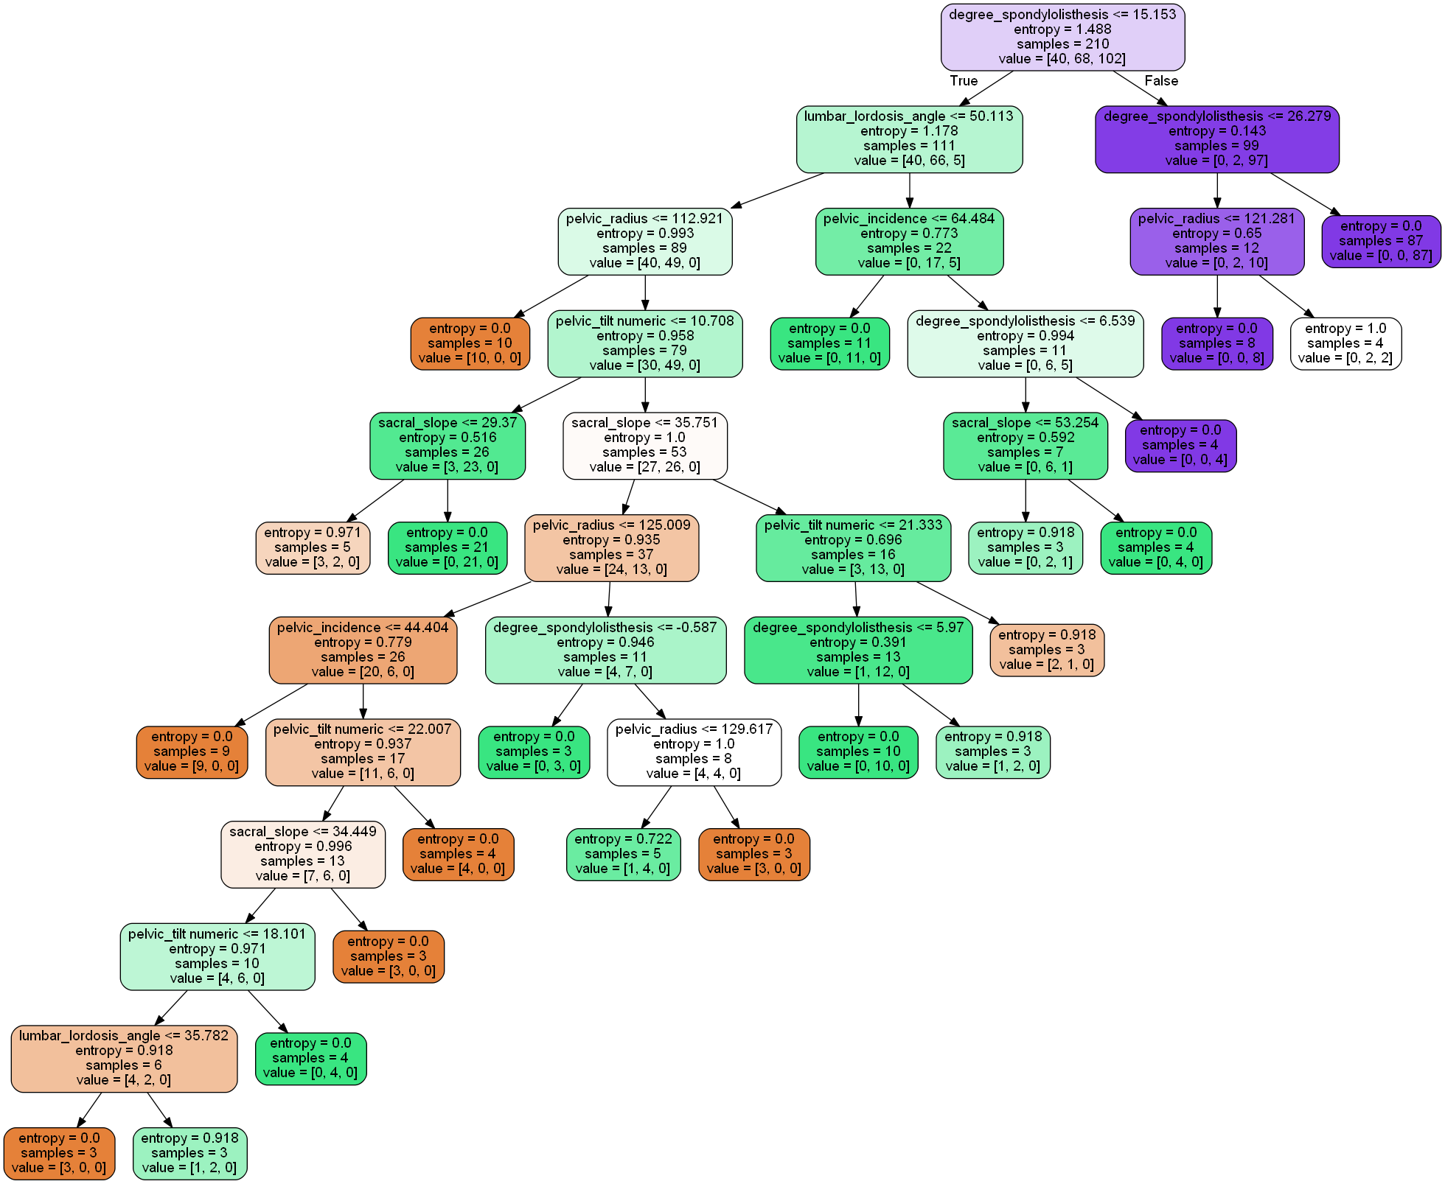

Decision Tree for Minimum Leaf Nodes: 8:

Name: “Tree_With_8_Node_Biomechanical_Data_column_3C_weka.png”

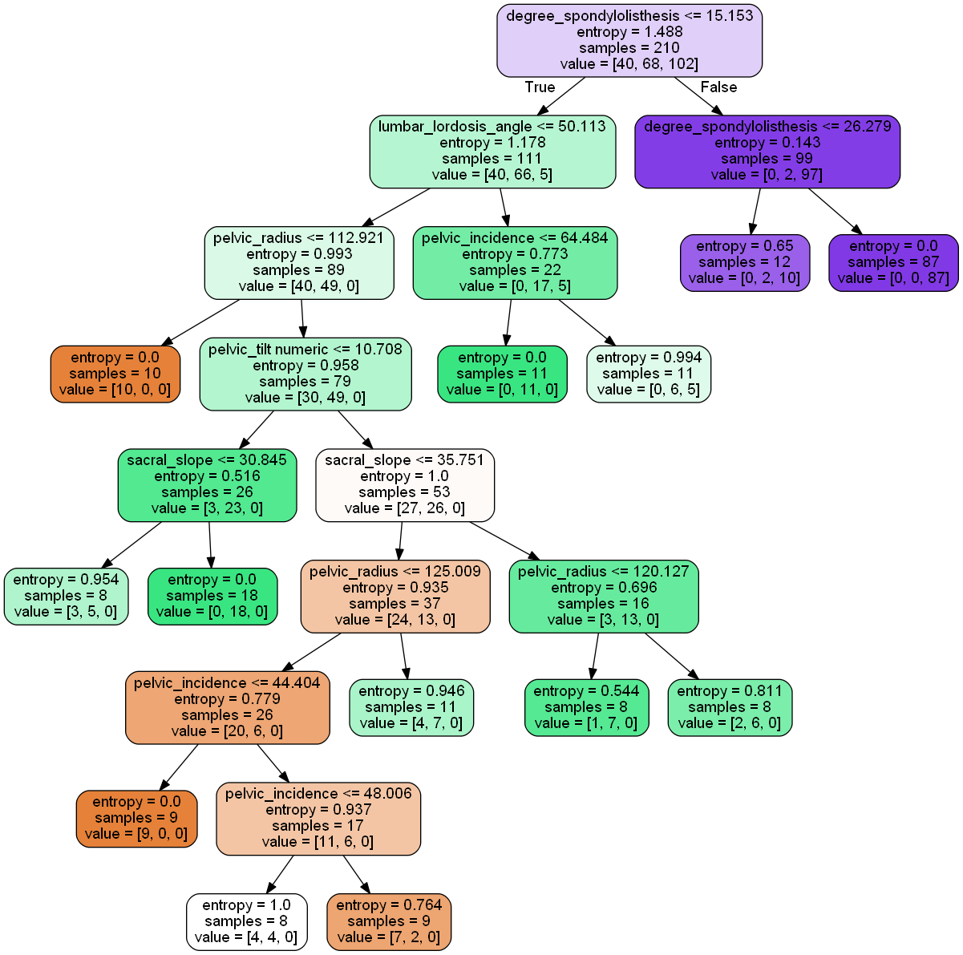

Decision Tree for Minimum Leaf Nodes: 12:

Name: “Tree_With_12_Node_Biomechanical_Data_column_3C_weka.png”

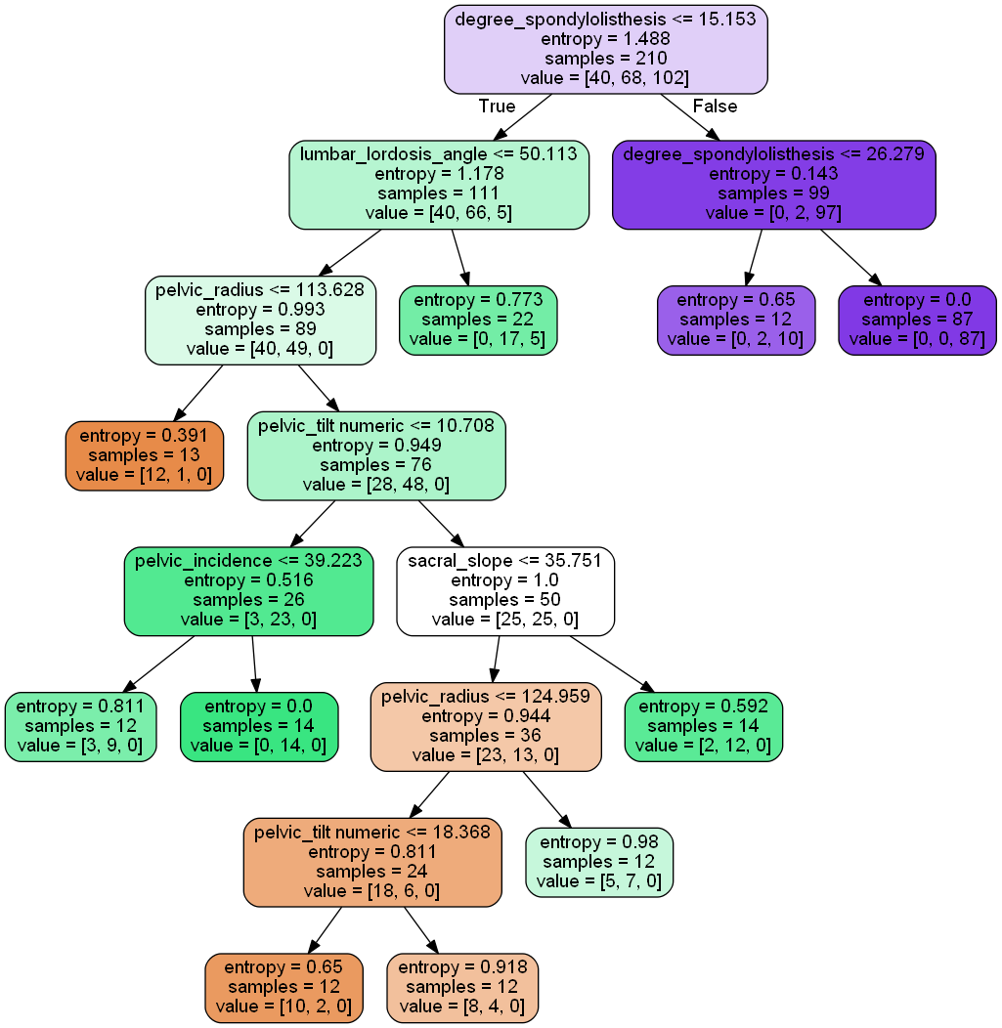

Decision Tree for Minimum Leaf Nodes: 30:

Name: “Tree_With_30_Node_Biomechanical_Data_column_3C_weka.png”

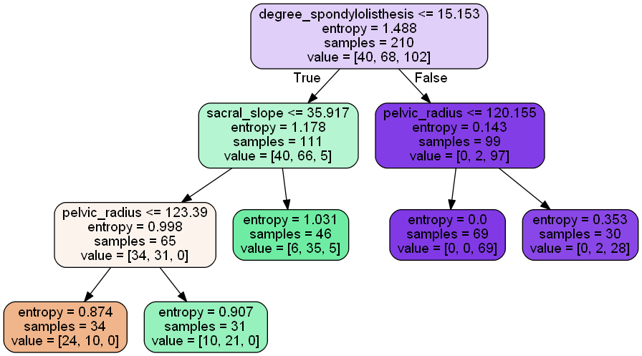

Decision Tree for Minimum Leaf Nodes: 50:

Name: “Tree_With_50_Node_Biomechanical_Data_column_3C_weka.png”

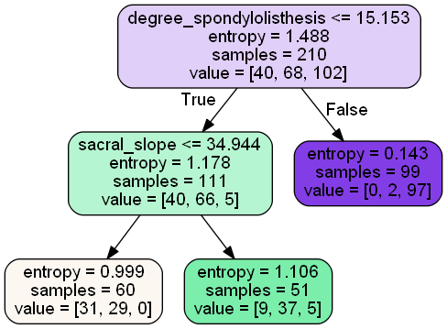

**Solution 2(b):**

Accuracy, Precision and Recall is computed for each decision tree and is displayed in the program output.

Plot for all decision trees against no. of minimum leaf nodes is displayed and saved in png files. The png file name is displayed in the output of the program.

Through the plots we observed that the accuracy is highest when min_leaf node =3 and precision and recall are fluctuating.

Calculation for Minimum Leaf Nodes= 3

Confusion Matrix:

[[12 7 1]

[ 4 26 2]

[ 0 2 46]]

Precision: [ 0.7500000000 0.7428571429 0.9387755102]

Recall: [ 0.6000000000 0.8125000000 0.9583333333]

Accuracy: 0.84

Calculation for Minimum Leaf Nodes= 8

Confusion Matrix:

[[13 6 1]

[ 4 27 1]

[ 0 0 48]]

Precision: [ 0.7647058824 0.8181818182 0.9600000000]

Recall: [ 0.6500000000 0.8437500000 1.0000000000]

Accuracy: 0.88

Calculation for Minimum Leaf Nodes= 12

Confusion Matrix:

[[13 6 1]

[ 4 27 1]

[ 0 0 48]]

Precision: [ 0.7647058824 0.8181818182 0.9600000000]

Recall: [ 0.6500000000 0.8437500000 1.0000000000]

Accuracy: 0.88

Calculation for Minimum Leaf Nodes= 30

Confusion Matrix:

[[11 8 1]

[ 3 28 1]

[ 0 0 48]]

Precision: [ 0.7857142857 0.7777777778 0.9600000000]

Recall: [ 0.5500000000 0.8750000000 1.0000000000]

Accuracy: 0.87

Calculation for Minimum Leaf Nodes= 50

Confusion Matrix:

[[14 5 1]

[ 8 23 1]

[ 0 0 48]]

Precision: [ 0.6363636364 0.8214285714 0.9600000000]

Recall: [ 0.7000000000 0.7187500000 1.0000000000]

Accuracy: 0.85

Plot for Accuracy:

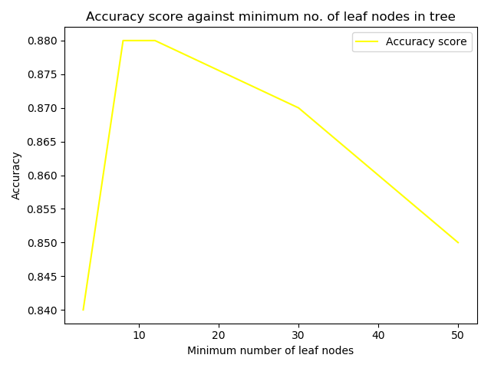

Plot for Precision:

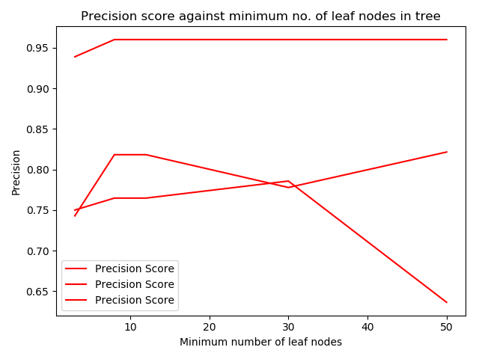

Plot for Recall:

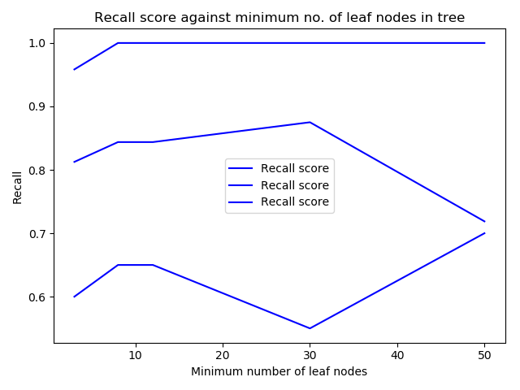

**Solution 3:**

Data2 is taken for this problem. Each column is taken in one iteration and the column values are divided into four equal parts and replaced with 0,1,2,3 according to the boundary the value falls in.

Data is then split into randomly selected 210 training instances and remaining 100 as test instance using following code:

“X_train, X_test, y_train, y_test= train_test_split(X, y,random_state =23, test_size=0.32) “

Where train_test_split is imported from sklearn.model_selection.

The above train and test data are saved in csv files for future analysis purpose. The name format of the files generated are: ‘ColumnName1_X_test.csv’, ‘ColumnName1_y_test’ etc. for the rest of the data.

**Solution: 3(a):**

Boundaries for division of column attribute: pelvic_incidence

1st Interval which is replaced by 0: 26.14792141 to 38.9954905025

2nd Interval which is replaced by 1: 38.9954905025 to 77.990981005

3rd Interval which is replaced by 2: 77.990981005 to 116.986471508

last Interval which is replaced by 3: 116.986471508 to 129.8340406

Boundaries for division of column attribute:pelvic_tilt numeric

1st Interval which is replaced by 0:-6.554948347 to 10.7192288132

2nd Interval which is replaced by 1:10.7192288132 to 21.4384576265

3rd Interval which is replaced by 2:21.4384576265 to 32.1576864398

Boundaries for division of column attribute:lumbar_lordosis_angle

1st Interval which is replaced by 0:14.0 to 34.935596375

2nd Interval which is replaced by 1:34.935596375 to 69.87119275

3rd Interval which is replaced by 2:69.87119275 to 104.806789125

last Interval which is replaced by 3:104.806789125 to 125.7423855

Boundaries for division of column attribute:sacral_slope

1st Interval which is replaced by 0:13.3669307 to 33.699124075

2nd Interval which is replaced by 1:33.699124075 to 67.39824815

3rd Interval which is replaced by 2:67.39824815 to 101.097372225

last Interval which is replaced by 3:101.097372225 to 121.4295656

Boundaries for division of column attribute:pelvic_radius

1st Interval which is replaced by 0:70.08257486 to 58.28840384

2nd Interval which is replaced by 1:58.28840384 to 116.57680768

3rd Interval which is replaced by 2:116.57680768 to 174.86521152

last Interval which is replaced by 3:174.86521152 to 163.0710405

Boundaries for division of column attribute:degree_spondylolisthesis

1st Interval which is replaced by 0:-11.05817866 to 101.87122586

2nd Interval which is replaced by 1:101.87122586 to 203.74245172

3rd Interval which is replaced by 2:203.74245172 to 305.61367758

last Interval which is replaced by 3:305.61367758 to 418.5430821

**Solution : 3(b)**

The decision tree is generated for all the cases of minimum leaf nodes i.e., 8, 12.

Every decision tree is saved in a png file and the name of the png file generated is displayed in the output of the program.

Here I am just showing decision tree for leaf nodes: 12

Decision Tree for Minimum Leaf Nodes: 12:

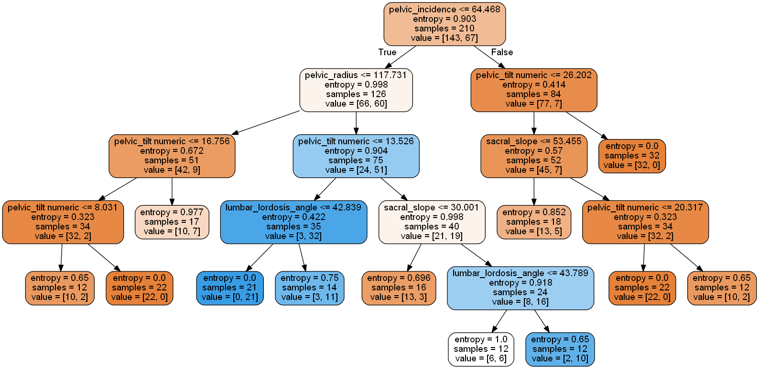

Decision Tree for Minimum Leaf Nodes: 12:

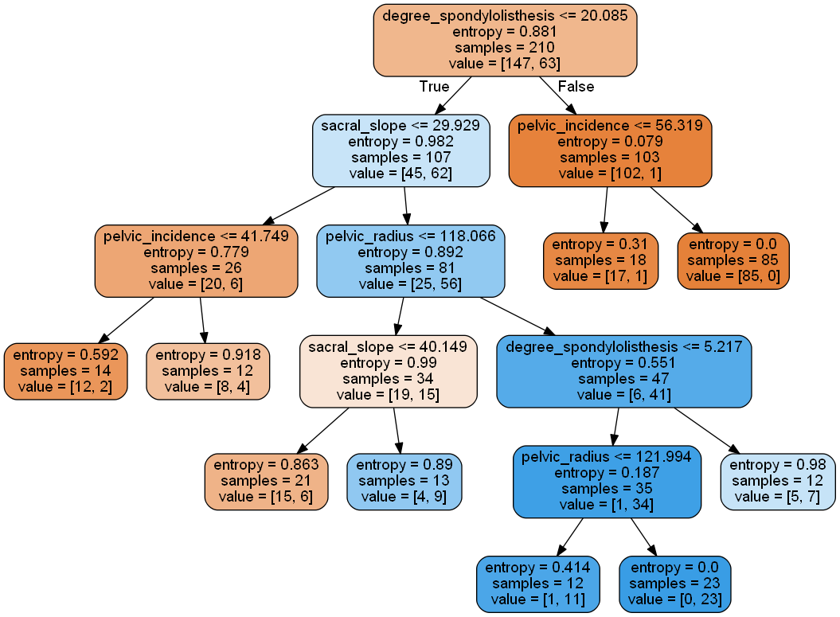

Decision Tree for Minimum Leaf Nodes: 12

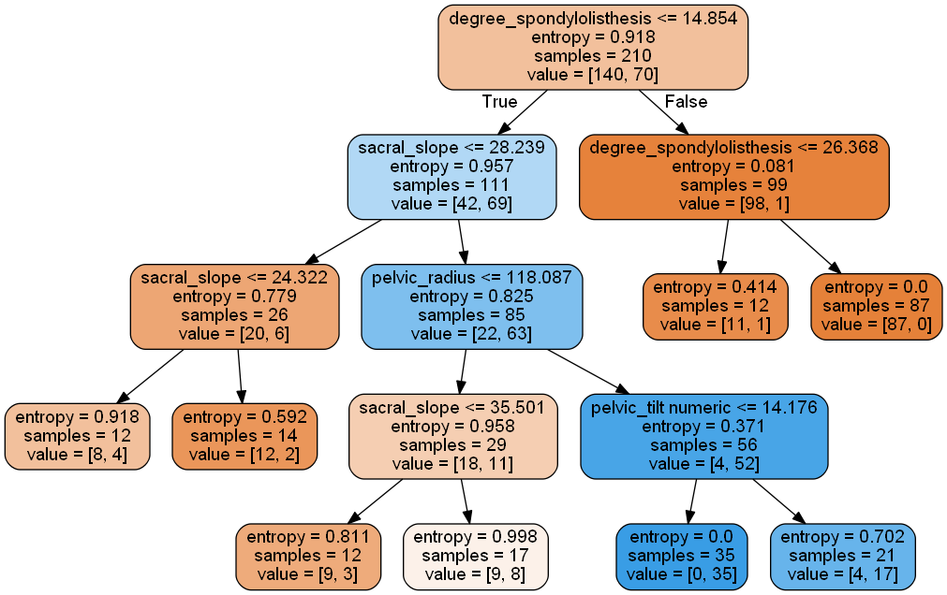

Decision Tree for Minimum Leaf Nodes: 12:

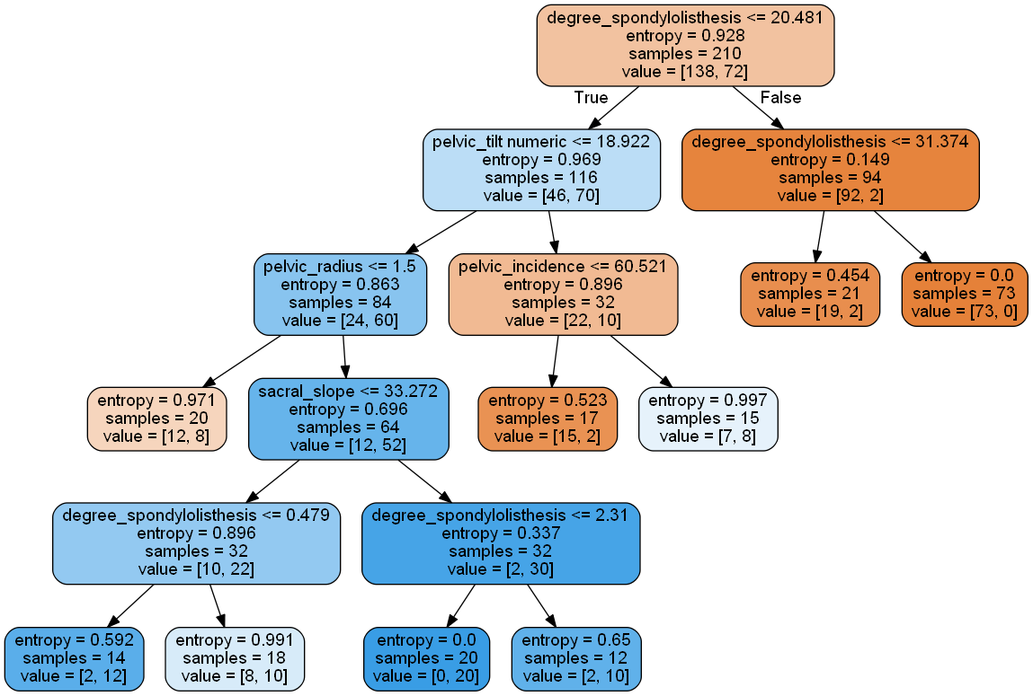

Decision Tree for Minimum Leaf Nodes: 12

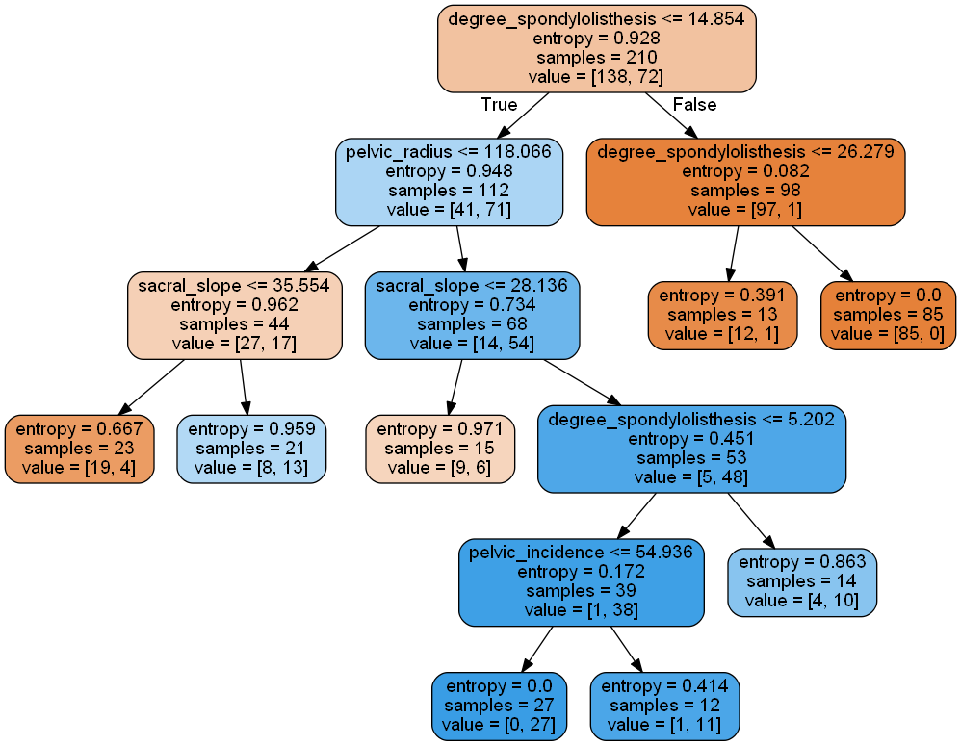

Decision Tree for Minimum Leaf Nodes: 12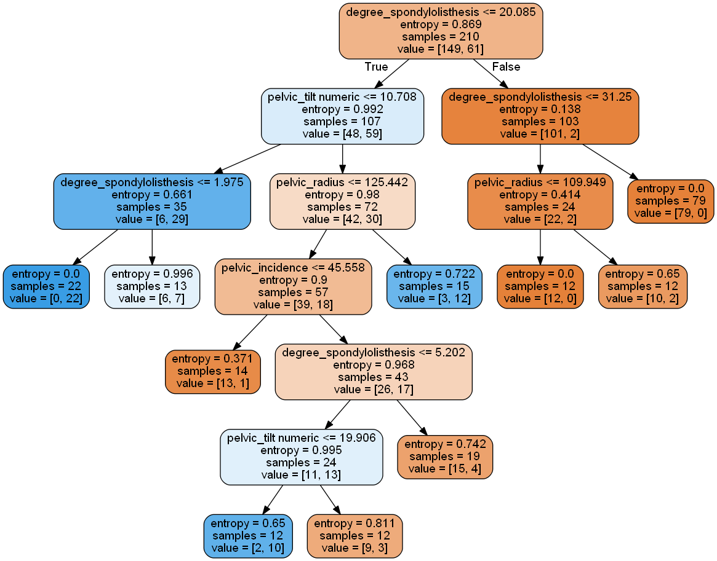

The performance matric and plots can be seen in output of the program and images.

**Solution: 3(c):**

The performance of this data is not really good because it fluctuates a lot with different parameters. We can still choose one attribute when accuracy is coming better than in 1(b) or 2 (b)

Output of the Program:

Solution starts for question Number: 1

taking Data from file:Biomechanical_Data_column_2C_weka.csv

X - Test

[[30.14993632 11.91744524 34.0 18.23249108 112.68414080000001 11.46322327]

[81.11260488 20.69044356 60.68700588 60.42216132 94.01878339 40.51098228]

[74.37767772 32.05310438 78.77201304 42.32457334 143.5606905 56.12590603]

[58.78254775 7.667044186 53.33894082 51.11550357 98.50115697 51.58412476]

[54.5036853 6.819910137999999 46.99999999 47.68377516 111.7911722 -4.406769011000001]

[41.76773173 17.89940172 20.030886300000002 23.86833001 118.36338889999999 2.062962549]

[48.91555137 19.96455616 40.26379358 28.95099521 119.321358 8.028894629]

[66.50717865 20.89767207 31.72747138 45.60950658 128.9029049 1.517203356]

[48.99595771 13.11382047 51.87351997 35.88213725 126.3981876 0.535471617]

[50.20966979 29.76012218 36.10400731 20.44954761 128.2925148 5.740614083]

[83.70317740000002 20.26822858 77.1105979 63.43494882 125.48017390000001 69.27957099999999]

[77.12134424 30.3498745 77.48108264 46.77146974 110.61114840000002 82.09360704]

[63.83498162 20.36250706 54.55243367 43.47247456 1...

X - Train

[[88.02449890000001 39.84466878 81.77447308 48.17983012 116.60153759999999 56.76608323]

[44.5510115 21.93114655 26.78591597 22.61986495 111.07291969999999 2.652320636]

[87.67908663 20.36561331 93.82241589 67.31347333 120.9448288 76.73062904]

...

[70.95272771 20.15993121 62.85910914 50.7927965 116.1779325 32.522331]

[77.10657122 30.46999418 69.48062839 46.63657704 112.1516 70.75908308]

[86.47290500000001 40.30376567 61.14101155 46.16913933 97.40418879999999 55.75222146]]

y - Test

['Abnormal' 'Abnormal' 'Abnormal' 'Abnormal' 'Normal' 'Abnormal' 'Abnormal' 'Normal' 'Normal' 'Abnormal' 'Abnormal' 'Abnormal'

'Abnormal' 'Abnormal' 'Normal' 'Abnormal' 'Normal' 'Abnormal' 'Normal' 'Abnormal' 'Abnormal' 'Abnormal' 'Normal' 'Abnormal'

'Normal' 'Normal' 'Abnormal' 'Abnormal' 'Abnormal' 'Abnormal' 'Abnormal' 'Abnormal' 'Normal' 'Abnormal' 'Abnormal' 'Normal'

'Abnormal' 'Normal' 'Abnormal' 'Normal' 'Normal' 'Abnormal' 'Abnormal' 'Abnormal' 'Normal' 'Abnormal' 'Abnormal' 'Abnormal'

'Abnormal' 'Abnormal' 'Abnormal' 'Abnormal' 'Normal' 'Abnormal' 'Normal' 'Abnormal' 'Abnormal' 'Abnormal' 'Abnormal' 'Normal'

'Abnormal' 'Abnormal' 'Abnormal' 'Normal' 'Normal' 'Normal' 'Abnormal' 'Abnormal' 'Normal' 'Normal' 'Abnormal' 'Abnormal'

'Normal' 'Abnormal' 'Abnormal' 'Abnormal' 'Abnormal' 'Abnormal' 'Abnormal' 'Abnormal' 'Abnormal' 'Normal' 'Normal' 'Normal'

'Normal' 'Abnormal' 'Abnormal' 'Normal' 'Abnormal' 'Abnormal' 'Abnormal' 'Normal' 'Abnormal' 'Abnormal' 'Normal' 'Abnormal...

y - Train

['Abnormal' 'Abnormal' 'Abnormal' 'Abnormal' 'Normal' 'Abnormal' 'Abnormal' 'Abnormal' 'Normal' 'Abnormal' 'Normal' 'Abnormal'

'Abnormal' 'Normal' 'Abnormal' 'Abnormal' 'Abnormal' 'Abnormal' 'Normal' 'Normal' 'Abnormal' 'Normal' 'Abnormal' 'Abnormal'

'Normal' 'Abnormal' 'Abnormal' 'Normal' 'Abnormal' 'Abnormal' 'Abnormal' 'Normal' 'Abnormal' 'Abnormal' 'Abnormal' 'Abnormal'

'Abnormal' 'Abnormal' 'Normal' 'Abnormal' 'Normal' 'Abnormal' 'Normal' 'Abnormal' 'Abnormal' 'Abnormal' 'Abnormal' 'Abnormal'

'Abnormal' 'Normal' 'Abnormal' 'Abnormal' 'Normal' 'Normal' 'Normal' 'Abnormal' 'Abnormal' 'Abnormal' 'Abnormal' 'Normal'

'Abnormal' 'Abnormal' 'Abnormal' 'Normal' 'Abnormal' 'Abnormal' 'Normal' 'Normal' 'Abnormal' 'Abnormal' 'Abnormal' 'Abnormal'

'Abnormal' 'Abnormal' 'Abnormal' 'Abnormal' 'Abnormal' 'Abnormal' 'Normal' 'Abnormal' 'Abnormal' 'Normal' 'Normal' 'Abnormal'

'Normal' 'Normal' 'Normal' 'Normal' 'Normal' 'Abnormal' 'Abnormal' 'Abnormal' 'Abnormal' 'Normal' 'Normal' 'Normal' ...

Building decision trees with Min leaf node as: 3, 8, 12, 30,50

Calculation for Minimum Leaf Nodes= 3

Confusion Matrix:

[[61 7]

[ 7 25]]

precision

0.78125

recall

0.78125

Accuracy

0.86

Decision Tree with 3Nodes is saved in: Tree_With_3_Node_Biomechanical_Data_column_2C_weka.png

pydev debugger: New process is launching (breakpoints won't work in the new process).

pydev debugger: To debug that process please enable 'Attach to subprocess automatically while debugging?' option in the debugger settings.

Calculation for Minimum Leaf Nodes= 8

Confusion Matrix:

[[62 6]

[10 22]]

precision

0.7857142857142857

recall

0.6875

Accuracy

0.84

Decision Tree with 8Nodes is saved in: Tree_With_8_Node_Biomechanical_Data_column_2C_weka.png

Calculation for Minimum Leaf Nodes= 12

Confusion Matrix:

[[63 5]

[10 22]]

precision

0.8148148148148148

recall

0.6875

Accuracy

0.85

Decision Tree with 12Nodes is saved in: Tree_With_12_Node_Biomechanical_Data_column_2C_weka.png

Calculation for Minimum Leaf Nodes= 30

Confusion Matrix:

[[59 9]

[ 5 27]]

precision

0.75

recall

0.84375

Accuracy

0.86

Decision Tree with 30Nodes is saved in: Tree_With_30_Node_Biomechanical_Data_column_2C_weka.png

Calculation for Minimum Leaf Nodes= 50

Confusion Matrix:

[[62 6]

[ 8 24]]

precision

0.8

recall

0.75

Accuracy

0.86

Decision Tree with 50Nodes is saved in: Tree_With_50_Node_Biomechanical_Data_column_2C_weka.png

For min_leaf nodes 3,8,12,30,50

Accuracy

0.86

0.84

0.85

0.86

0.86

Precision

0.78125

0.7857142857142857

0.8148148148148148

0.75

0.8

Recall

0.78125

0.6875

0.6875

0.84375

0.75

Plotting the results

Accuracy plot saved in Plot_Biomechanical_Data_column_2C_weka_Accuracy_score_plot.png

Precision Plot saved in Plot_Biomechanical_Data_column_2C_weka_Precision_score_plot.png

Recall plot saved in Plot_Biomechanical_Data_column_2C_weka_Recall_score_plot.png

Evaluating classifiers

Solution starts for question Number: 2

taking Data from file:BiomechanicalData_column_3C_weka.csv

X - Test

[[30.14993632 11.91744524 34.0 18.23249108 112.68414080000001 11.46322327]

[81.11260488 20.69044356 60.68700588 60.42216132 94.01878339 40.51098228]

[74.37767772 32.05310438 78.77201304 42.32457334 143.5606905 56.12590603]

[58.78254775 7.667044186 53.33894082 51.11550357 98.50115697 51.58412476]

[54.5036853 6.819910137999999 46.99999999 47.68377516 111.7911722 -4.406769011000001]

[41.76773173 17.89940172 20.030886300000002 23.86833001 118.36338889999999 2.062962549]

[48.91555137 19.96455616 40.26379358 28.95099521 119.321358 8.028894629]

[66.50717865 20.89767207 31.72747138 45.60950658 128.9029049 1.517203356]

[48.99595771 13.11382047 51.87351997 35.88213725 126.3981876 0.535471617]

[50.20966979 29.76012218 36.10400731 20.44954761 128.2925148 5.740614083]

[83.70317740000002 20.26822858 77.1105979 63.43494882 125.48017390000001 69.27957099999999]

[77.12134424 30.3498745 77.48108264 46.77146974 110.61114840000002 82.09360704]

[63.83498162 20.36250706 54.55243367 43.47247456 1...

X - Train

[[88.02449890000001 39.84466878 81.77447308 48.17983012 116.60153759999999 56.76608323]

[44.5510115 21.93114655 26.78591597 22.61986495 111.07291969999999 2.652320636]

[87.67908663 20.36561331 93.82241589 67.31347333 120.9448288 76.73062904]

...

[70.95272771 20.15993121 62.85910914 50.7927965 116.1779325 32.522331]

[77.10657122 30.46999418 69.48062839 46.63657704 112.1516 70.75908308]

[86.47290500000001 40.30376567 61.14101155 46.16913933 97.40418879999999 55.75222146]]

y - Test

['Hernia' 'Spondylolisthesis' 'Spondylolisthesis' 'Spondylolisthesis' 'Normal' 'Hernia' 'Hernia' 'Normal' 'Normal' 'Hernia'

'Spondylolisthesis' 'Spondylolisthesis' 'Hernia' 'Spondylolisthesis' 'Normal' 'Spondylolisthesis' 'Normal' 'Spondylolisthesis'

'Normal' 'Spondylolisthesis' 'Spondylolisthesis' 'Spondylolisthesis' 'Normal' 'Spondylolisthesis' 'Normal' 'Normal' 'Hernia'

'Spondylolisthesis' 'Spondylolisthesis' 'Spondylolisthesis' 'Spondylolisthesis' 'Spondylolisthesis' 'Normal' 'Spondylolisthesis'

'Hernia' 'Normal' 'Spondylolisthesis' 'Normal' 'Spondylolisthesis' 'Normal' 'Normal' 'Hernia' 'Spondylolisthesis'

'Spondylolisthesis' 'Normal' 'Spondylolisthesis' 'Hernia' 'Spondylolisthesis' 'Spondylolisthesis' 'Spondylolisthesis'

'Spondylolisthesis' 'Spondylolisthesis' 'Normal' 'Spondylolisthesis' 'Normal' 'Hernia' 'Spondylolisthesis' 'Hernia'

'Spondylolisthesis' 'Normal' 'Spondylolisthesis' 'Spondylolisthesis' 'Spondylolisthesis' 'Normal' 'Normal' 'Normal' 'Hernia'

'Spondylolisth...

y - Train

['Spondylolisthesis' 'Hernia' 'Spondylolisthesis' 'Spondylolisthesis' 'Normal' 'Hernia' 'Hernia' 'Spondylolisthesis' 'Normal'

'Hernia' 'Normal' 'Hernia' 'Spondylolisthesis' 'Normal' 'Hernia' 'Hernia' 'Spondylolisthesis' 'Spondylolisthesis' 'Normal'

'Normal' 'Spondylolisthesis' 'Normal' 'Spondylolisthesis' 'Hernia' 'Normal' 'Spondylolisthesis' 'Spondylolisthesis' 'Normal'

'Spondylolisthesis' 'Spondylolisthesis' 'Spondylolisthesis' 'Normal' 'Spondylolisthesis' 'Hernia' 'Spondylolisthesis'

'Spondylolisthesis' 'Spondylolisthesis' 'Hernia' 'Normal' 'Hernia' 'Normal' 'Hernia' 'Normal' 'Hernia' 'Spondylolisthesis'

'Hernia' 'Spondylolisthesis' 'Spondylolisthesis' 'Hernia' 'Normal' 'Hernia' 'Spondylolisthesis' 'Normal' 'Normal' 'Normal'

'Spondylolisthesis' 'Spondylolisthesis' 'Spondylolisthesis' 'Hernia' 'Normal' 'Spondylolisthesis' 'Spondylolisthesis'

'Spondylolisthesis' 'Normal' 'Hernia' 'Spondylolisthesis' 'Normal' 'Normal' 'Spondylolisthesis' 'Spondylolisthesis' 'Hernia'

'Hernia' 'S...

Building decision trees with Min leaf node as: 3, 8, 12, 30,50

Calculation for Minimum Leaf Nodes= 3

Confusion Matrix:

[[12 7 1]

[ 4 26 2]

[ 0 2 46]]

precision

[ 0.7500000000 0.7428571429 0.9387755102]

recall

[ 0.6000000000 0.8125000000 0.9583333333]

Accuracy

0.84

Decision Tree with 3Nodes is saved in: Tree_With_3_Node_BiomechanicalData_column_3C_weka.png

Calculation for Minimum Leaf Nodes= 8

Confusion Matrix:

[[13 6 1]

[ 4 27 1]

[ 0 0 48]]

precision

[ 0.7647058824 0.8181818182 0.9600000000]

recall

[ 0.6500000000 0.8437500000 1.0000000000]

Accuracy

0.88

Decision Tree with 8Nodes is saved in: Tree_With_8_Node_BiomechanicalData_column_3C_weka.png

Calculation for Minimum Leaf Nodes= 12

Confusion Matrix:

[[13 6 1]

[ 4 27 1]

[ 0 0 48]]

precision

[ 0.7647058824 0.8181818182 0.9600000000]

recall

[ 0.6500000000 0.8437500000 1.0000000000]

Accuracy

0.88

Decision Tree with 12Nodes is saved in: Tree_With_12_Node_BiomechanicalData_column_3C_weka.png

Calculation for Minimum Leaf Nodes= 30

Confusion Matrix:

[[11 8 1]

[ 3 28 1]

[ 0 0 48]]

precision

[ 0.7857142857 0.7777777778 0.9600000000]

recall

[ 0.5500000000 0.8750000000 1.0000000000]

Accuracy

0.87

Decision Tree with 30Nodes is saved in: Tree_With_30_Node_BiomechanicalData_column_3C_weka.png

Calculation for Minimum Leaf Nodes= 50

Confusion Matrix:

[[14 5 1]

[ 8 23 1]

[ 0 0 48]]

precision

[ 0.6363636364 0.8214285714 0.9600000000]

recall

[ 0.7000000000 0.7187500000 1.0000000000]

Accuracy

0.85

Decision Tree with 50Nodes is saved in: Tree_With_50_Node_BiomechanicalData_column_3C_weka.png

For min_leaf nodes 3,8,12,30,50

Accuracy

0.84

0.88

0.88

0.87

0.85

Precision

[ 0.7500000000 0.7428571429 0.9387755102]

[ 0.7647058824 0.8181818182 0.9600000000]

[ 0.7647058824 0.8181818182 0.9600000000]

[ 0.7857142857 0.7777777778 0.9600000000]

[ 0.6363636364 0.8214285714 0.9600000000]

Recall

[ 0.6000000000 0.8125000000 0.9583333333]

[ 0.6500000000 0.8437500000 1.0000000000]

[ 0.6500000000 0.8437500000 1.0000000000]

[ 0.5500000000 0.8750000000 1.0000000000]

[ 0.7000000000 0.7187500000 1.0000000000]

Plotting the results

Accuracy plot saved in Plot_BiomechanicalData_column_3C_weka_Accuracy_score_plot.png

Precision Plot saved in Plot_BiomechanicalData_column_3C_weka_Precision_score_plot.png

Recall plot saved in Plot_BiomechanicalData_column_3C_weka_Recall_score_plot.png

Evaluating classifiers

Solution starts for question Number: 3

taking Data from file:Biomechanical_Data_column_2C_weka.csv

Taking column number: 0 Column name is: pelvic_incidence

[ 26.1479214100 30.1499363200 30.7419381200 31.2323873400 31.2760118400 31.4842183400 32.0909867900

33.0416875400 33.7888431400 33.8416407500 34.3822993900 34.6499224100 34.7567380900 35.4924461700

35.7034578100 35.8775708000 36.1256834700 36.1578298100 36.4224854900 36.6863528600 37.1401497800

37.7319919000 37.9039101400 38.0465507200 38.1265885400 38.5052728300 38.6632570800 38.6979124300

39.0569509800 39.0872644900 39.3587053100 39.6569020100 40.2501996800 40.3492963700 40.4133656600

40.5573566300 40.6832291000 40.7469961200 41.1716798900 41.1877697200 41.3525040700 41.6469159000

41.7299630800 41.7677317300 42.0213860300 42.5156101400 42.5172724900 42.9180405200 43.1179510300

43.1919153000 43.2031849900 43.3496062100 43.4364506100 43.5809639400 43.7182623000 43.7901902600

43.9228398300 44.2164644600 44...

129.8340406

26.14792141

Boundaries for division of column attribute:pelvic_incidence

1st Interval which is replaced by 0:26.14792141 to 38.9954905025

2nd Interval which is replaced by 1:38.9954905025 to 77.990981005

3rd Interval which is replaced by 2:77.990981005 to 116.986471508

last Interval which is replaced by 3:116.986471508 to 129.8340406

[3 38.44950127 50.83851954 79.69515353 81.0245406 74.04376736 'Abnormal']

[3 8.404475005 48.38405705 121.42956559999999 107.69046599999999 418.54308210000005 'Abnormal']

X - Test

[[1 33.2755899 96.28306169 34.23746278 145.6010328 88.30148594]

[1 29.39654543 63.23230243 48.0127875 118.4507311 93.56373734]

[1 20.02462134 67.49870507 43.33971763 130.9992576 37.55670552]

[0 13.35496594 35.90352597 17.38697218 142.4101072 -2.005372903]

[0 19.44325311 20.7 16.26020471 137.5406125 -0.263489651]

[1 17.32120599 33.46940277 23.85047391 116.37788940000002 -9.569249858]

[1 24.15748726 45.77516991 41.3785153 136.4403015 16.37808564]

[0 13.87942449 20.24256187 22.543060999999998 126.0768612 0.179717077]

[2 15.38076983 67.70572132 78.79405249 114.8901128 53.25522004]

[2 41.28630543 61.99999999 42.64670314 115.01233400000001 26.58810016]

[1 21.93114655 26.78591597 22.61986495 111.07291969999999 2.652320636]

[1 23.89620111 43.696665100000004 47.29061004 119.86493829999999 27.28398451]

[1 33.64707522 50.90985841 23.87528085 140.9817119 148.75371090000002]

[1 9.064729049 56.29999999 41.760299700000004 78.99945411 23.04152435]

[1 13.90908417 62.69325884 60.9453959 11...

X - Train

[[3 38.44950127 50.83851954 79.69515353 81.0245406 74.04376736]

[1 20.5959577 64.53526221 40.03025927 117.22555420000002 104.85924740000002]

[1 16.06094486 63.12373633 47.8985768 142.3601245 6.298970934]

...

[1 16.57736351 30.70619135 24.77514057 113.2666746 -4.497957556]

[1 17.38519079 51.99999999 55.17551084 119.19372379999999 32.10853735]

[1 12.08935067 38.99999999 35.6553281 117.51200390000001 21.68240136]]

y - Test

['Abnormal' 'Abnormal' 'Abnormal' 'Normal' 'Abnormal' 'Abnormal' 'Abnormal' 'Normal' 'Abnormal' 'Abnormal' 'Abnormal' 'Abnormal'

'Abnormal' 'Abnormal' 'Abnormal' 'Abnormal' 'Abnormal' 'Abnormal' 'Abnormal' 'Abnormal' 'Abnormal' 'Abnormal' 'Abnormal'

'Abnormal' 'Abnormal' 'Normal' 'Abnormal' 'Normal' 'Normal' 'Normal' 'Abnormal' 'Abnormal' 'Normal' 'Normal' 'Abnormal'

'Abnormal' 'Normal' 'Abnormal' 'Abnormal' 'Abnormal' 'Abnormal' 'Abnormal' 'Abnormal' 'Normal' 'Normal' 'Abnormal' 'Normal'

'Abnormal' 'Normal' 'Normal' 'Abnormal' 'Abnormal' 'Normal' 'Abnormal' 'Abnormal' 'Abnormal' 'Abnormal' 'Normal' 'Abnormal'

'Abnormal' 'Abnormal' 'Abnormal' 'Abnormal' 'Abnormal' 'Abnormal' 'Abnormal' 'Abnormal' 'Abnormal' 'Normal' 'Normal' 'Abnormal'

'Normal' 'Abnormal' 'Abnormal' 'Abnormal' 'Abnormal' 'Normal' 'Abnormal' 'Abnormal' 'Normal' 'Normal' 'Normal' 'Normal' 'Normal'

'Abnormal' 'Abnormal' 'Abnormal' 'Normal' 'Abnormal' 'Abnormal' 'Abnormal' 'Abnormal' 'Abnormal' 'Abnormal' 'Normal' '...

y - Train

['Abnormal' 'Abnormal' 'Normal' 'Normal' 'Abnormal' 'Normal' 'Abnormal' 'Normal' 'Abnormal' 'Normal' 'Abnormal' 'Abnormal'

'Normal' 'Abnormal' 'Abnormal' 'Normal' 'Normal' 'Abnormal' 'Normal' 'Abnormal' 'Abnormal' 'Abnormal' 'Abnormal' 'Abnormal'

'Abnormal' 'Abnormal' 'Abnormal' 'Normal' 'Abnormal' 'Abnormal' 'Normal' 'Abnormal' 'Abnormal' 'Abnormal' 'Abnormal' 'Abnormal'

'Abnormal' 'Abnormal' 'Abnormal' 'Abnormal' 'Abnormal' 'Abnormal' 'Normal' 'Normal' 'Normal' 'Abnormal' 'Normal' 'Abnormal'

'Normal' 'Abnormal' 'Normal' 'Normal' 'Abnormal' 'Normal' 'Abnormal' 'Abnormal' 'Abnormal' 'Abnormal' 'Abnormal' 'Abnormal'

'Abnormal' 'Normal' 'Abnormal' 'Abnormal' 'Normal' 'Abnormal' 'Abnormal' 'Normal' 'Abnormal' 'Abnormal' 'Normal' 'Abnormal'

'Abnormal' 'Abnormal' 'Abnormal' 'Abnormal' 'Abnormal' 'Abnormal' 'Abnormal' 'Normal' 'Abnormal' 'Abnormal' 'Abnormal' 'Normal'

'Normal' 'Abnormal' 'Abnormal' 'Normal' 'Abnormal' 'Normal' 'Abnormal' 'Normal' 'Normal' 'Abnormal' 'Abnormal' 'Abnorm...

Building decision trees with Min leaf node as: 8, 12

Calculation for Minimum Leaf Nodes= 8

Confusion Matrix:

[[60 10]

[16 14]]

precision

0.5833333333333334

recall

0.4666666666666667

Accuracy

0.74

Decision Tree with 8Nodes is saved in: Tree_With_Column_pelvic_incidence8_Node_Biomechanical_Data_column_2C_weka.png

Calculation for Minimum Leaf Nodes= 12

Confusion Matrix:

[[64 6]

[16 14]]

precision

0.7

recall

0.4666666666666667

Accuracy

0.78

Decision Tree with 12Nodes is saved in: Tree_With_Column_pelvic_incidence12_Node_Biomechanical_Data_column_2C_weka.png

For min_leaf nodes 3,8,12,30,50

Accuracy

0.74

0.78

Precision

0.5833333333333334

0.7

Recall

0.4666666666666667

0.4666666666666667

Plotting the results

Accuracy plot saved in Plot_Biomechanical_Data_column_2C_weka_Spliting_ColumnsColumn_pelvic_incidence_Accuracy_score_plot.png

Precision Plot saved in Plot_Biomechanical_Data_column_2C_weka_Spliting_ColumnsColumn_pelvic_incidence_Precision_score_plot.png

Recall plot saved in Plot_Biomechanical_Data_column_2C_weka_Spliting_ColumnsColumn_pelvic_incidence_Recall_score_plot.png

Taking column number: 1 Column name is: pelvic_tilt numeric

[ -6.5549483470 -5.8459943410 -3.7599298720 -2.9700243370 -1.3294123980 -0.8105140930 -0.3246784590

-0.2614990460 0.3457279900 1.1010867140 1.1123735610 1.5070745010 1.8355242710 2.0626828820

2.6317396460 3.1446694800 3.6751099860 3.9698147430 4.4790989600 5.0108841210 5.0739914090

5.2656654220 5.2682704540 5.5366024770 5.5875886580 5.6870321260 5.7929738710 5.8653534160

6.3309109740 6.4615012710 6.4668048600 6.5576174080 6.6207950490 6.6769999000 6.8199101380

6.8740889700 6.9893780810 7.0112618060 7.1946610960 7.4674689640 7.5147827840 7.6670441860

7.7248725990 7.8262213400 8.3016694200 8.3950358900 8.4044750050 8.5736802950 8.6931573640

8.8355491010 8.8755412760 8.9454348920 8.9612616110 9.0647290490 9.1203401830 9.1484371950

9.3065944280 9.3862982760 9...

49.4318636

-6.554948347000001

Boundaries for division of column attribute:pelvic_tilt numeric

1st Interval which is replaced by 0:-6.554948347 to 10.7192288132

2nd Interval which is replaced by 1:10.7192288132 to 21.4384576265

3rd Interval which is replaced by 2:21.4384576265 to 32.1576864398

last Interval which is replaced by 3:32.1576864398 to 49.4318636

[89.68056731 3 83.13073216 56.97613244 129.9554764 92.02727682 'Abnormal']

[86.90079431 3 47.79434664 53.97262661 135.0753635 101.71909190000001 'Abnormal']

[84.97413208 3 60.85987263 51.95295747 125.65953359999999 74.33340864 'Abnormal']

[67.51305267 3 96.28306169 34.23746278 145.6010328 88.30148594 'Abnormal']

[74.46908181 3 66.94210105 41.18592517 146.4660009 124.9844057 'Abnormal']

[78.42595126 3 76.27743927 45.0 138.5541111 77.15517241 'Abnormal']

[57.52235608 3 50.90985841 23.87528085 140.9817119 148.75371090000002 'Abnormal']

[80.11157156 3 85.10160773 46.16913933 125.5936237 100.2921068 'Abnormal']

[83.39660609 3 78.42329287 49.08561678 110.46651640000002 49.67209559 'Abnormal']

[92.02630795 3 77.41696348 56.633633999999994 115.72353000000001 58.05754155 'Abnormal']

[86.75360946 3 69.22104479 50.71059314 139.414504 110.8607824 'Abnormal']

[80.98807441 3 86.96060151 44.1449026 141.0881494 85.87215224 'Abnormal']

[115.92326059999999 3 76.79999999 78.40782459 104.69860329999999 81.19892712 'Abnormal']

[71.00194076 3 84.53709256 33.48616882 125.1642324 67.77118983 'Abnormal']

[58.82837872 3 125.7423855 21.25050551 135.6294176 117.31468290000001 'Abnormal']

[118.1446548 3 50.83851954 79.69515353 81.0245406 74.04376736 'Abnormal']

[85.68094951 3 82.68097744 47.03091424 120.84070690000001 61.95903428 'Abnormal']

[86.04127982 3 47.87140494 47.29061004 122.09295359999999 61.98827709 'Abnormal']

[70.22145219 3 68.11840309 30.39872771 148.5255624 145.37814319999998 'Abnormal']

[88.02449890000001 3 81.77447308 48.17983012 116.60153759999999 56.76608323 'Abnormal']

[86.47290500000001 3 61.14101155 46.16913933 97.40418879999999 55.75222146 'Abnormal']

[83.93300857 3 61.99999999 42.64670314 115.01233400000001 26.58810016 'Abnormal']

[74.43359316 3 27.7 32.87626175 107.9493045 5.000088788 'Abnormal']

[76.31402766 3 93.2848628 34.38034472 132.26728549999999 101.2187828 'Abnormal']

[76.32600187 3 57.19999999 33.92979742 124.267007 50.12745689 'Abnormal']

[85.64378664 3 78.7506635 42.95459151 105.1440758 42.88742577 'Abnormal']

[95.48022873 3 58.99999999 48.93017555 96.68390337 77.28307195 'Abnormal']

[80.07491418 3 52.40343873 32.00538321 110.70991210000001 67.72731595 'Abnormal']

[89.5049473 3 72.0034229 40.60129465 134.63429119999998 118.35337009999999 'Abnormal']

[68.72190982 3 68.0560124 19.29004622 125.0185168 54.69128928 'Abnormal']

X - Test

[[63.92947003 1 40.17704963 43.95837332 113.0659387 -11.05817866]

[95.38259648 2 95.15763273 70.55996517 89.3075466 57.66084135]

[67.41253785 1 60.14464036 49.96974073 111.12397 33.15764573]

[55.08076562 0 55.99999999 58.84069549 109.9153669 31.77358318]

[34.75673809 0 29.50438112 32.12499844 127.13984950000001 -0.460894198]

[67.26314926 0 51.69688681 60.06848816 97.8010854 42.13694325]

[52.41938511 1 35.87265953 33.40782459 116.5597709 1.694705102]

[37.90391014 0 24.71027447 33.42481118 157.84879899999999 33.60702661]

[76.31402766 3 93.2848628 34.38034472 132.26728549999999 101.2187828]

[74.37767772 2 78.77201304 42.32457334 143.5606905 56.12590603]

[43.7182623 0 51.99999999 33.90627699 88.43424213 40.88092253]

[81.08232025 1 78.76675639 59.82647997 90.07187999 49.159426]

[51.62467183 1 35.0 35.6553281 129.385308 1.00922834]

[70.39930842 1 61.19999999 56.92932218 102.3375244 25.53842852]

[72.2223343 2 90.99999999 49.14462374 137.73665459999998 56.80409277]

[55.84328595 ...

X - Train

[[89.5049473 3 72.0034229 40.60129465 134.63429119999998 118.35337009999999]

[75.29847847 1 61.29620362 58.62699486 118.8833881 31.57582292]

[85.29017283 1 100.7442198 67.01128320000001 110.66070049999999 58.88494802]

...

[34.64992241 0 42.99999999 27.13513962 123.98774080000001 -4.082937601]

[44.5510115 2 26.78591597 22.61986495 111.07291969999999 2.652320636]

[30.14993632 1 34.0 18.23249108 112.68414080000001 11.46322327]]

y - Test

['Normal' 'Abnormal' 'Abnormal' 'Abnormal' 'Normal' 'Abnormal' 'Abnormal' 'Abnormal' 'Abnormal' 'Abnormal' 'Abnormal' 'Abnormal'

'Normal' 'Abnormal' 'Abnormal' 'Abnormal' 'Normal' 'Normal' 'Abnormal' 'Abnormal' 'Abnormal' 'Abnormal' 'Abnormal' 'Abnormal'

'Abnormal' 'Abnormal' 'Normal' 'Abnormal' 'Normal' 'Abnormal' 'Abnormal' 'Normal' 'Normal' 'Abnormal' 'Abnormal' 'Abnormal'

'Abnormal' 'Abnormal' 'Abnormal' 'Abnormal' 'Abnormal' 'Normal' 'Abnormal' 'Normal' 'Normal' 'Abnormal' 'Normal' 'Abnormal'

'Normal' 'Abnormal' 'Abnormal' 'Abnormal' 'Normal' 'Abnormal' 'Abnormal' 'Abnormal' 'Abnormal' 'Abnormal' 'Abnormal' 'Abnormal'

'Normal' 'Abnormal' 'Abnormal' 'Abnormal' 'Abnormal' 'Abnormal' 'Abnormal' 'Abnormal' 'Abnormal' 'Abnormal' 'Normal' 'Abnormal'

'Normal' 'Abnormal' 'Normal' 'Abnormal' 'Normal' 'Normal' 'Abnormal' 'Abnormal' 'Abnormal' 'Abnormal' 'Abnormal' 'Normal'

'Normal' 'Abnormal' 'Abnormal' 'Normal' 'Abnormal' 'Abnormal' 'Abnormal' 'Abnormal' 'Normal' 'Normal' 'Abnormal'...

y - Train

['Abnormal' 'Abnormal' 'Abnormal' 'Abnormal' 'Normal' 'Abnormal' 'Abnormal' 'Normal' 'Abnormal' 'Abnormal' 'Abnormal' 'Normal'

'Abnormal' 'Normal' 'Abnormal' 'Normal' 'Abnormal' 'Abnormal' 'Abnormal' 'Normal' 'Normal' 'Abnormal' 'Abnormal' 'Abnormal'

'Abnormal' 'Abnormal' 'Abnormal' 'Abnormal' 'Abnormal' 'Abnormal' 'Normal' 'Normal' 'Abnormal' 'Normal' 'Abnormal' 'Abnormal'

'Abnormal' 'Abnormal' 'Abnormal' 'Normal' 'Abnormal' 'Normal' 'Abnormal' 'Abnormal' 'Abnormal' 'Abnormal' 'Abnormal' 'Abnormal'

'Normal' 'Abnormal' 'Abnormal' 'Normal' 'Abnormal' 'Normal' 'Abnormal' 'Abnormal' 'Normal' 'Abnormal' 'Normal' 'Normal'

'Abnormal' 'Abnormal' 'Abnormal' 'Normal' 'Abnormal' 'Normal' 'Abnormal' 'Abnormal' 'Normal' 'Abnormal' 'Abnormal' 'Normal'

'Normal' 'Abnormal' 'Abnormal' 'Abnormal' 'Abnormal' 'Abnormal' 'Abnormal' 'Normal' 'Abnormal' 'Abnormal' 'Abnormal' 'Normal'

'Abnormal' 'Abnormal' 'Abnormal' 'Abnormal' 'Abnormal' 'Normal' 'Abnormal' 'Abnormal' 'Abnormal' 'Abnormal' 'Normal' '...

Building decision trees with Min leaf node as: 8, 12

Calculation for Minimum Leaf Nodes= 8

Confusion Matrix:

[[62 10]

[ 6 22]]

precision

0.6875

recall

0.7857142857142857

Accuracy

0.84

Decision Tree with 8Nodes is saved in: Tree_With_Column_pelvic_tilt numeric8_Node_Biomechanical_Data_column_2C_weka.png

Calculation for Minimum Leaf Nodes= 12

Confusion Matrix:

[[61 11]

[ 5 23]]

precision

0.6764705882352942

recall

0.8214285714285714

Accuracy

0.84

Decision Tree with 12Nodes is saved in: Tree_With_Column_pelvic_tilt numeric12_Node_Biomechanical_Data_column_2C_weka.png

For min_leaf nodes 3,8,12,30,50

Accuracy

0.84

0.84

Precision

0.6875

0.6764705882352942

Recall

0.7857142857142857

0.8214285714285714

Plotting the results

Accuracy plot saved in Plot_Biomechanical_Data_column_2C_weka_Spliting_ColumnsColumn_pelvic_tilt numeric_Accuracy_score_plot.png

Precision Plot saved in Plot_Biomechanical_Data_column_2C_weka_Spliting_ColumnsColumn_pelvic_tilt numeric_Precision_score_plot.png

Recall plot saved in Plot_Biomechanical_Data_column_2C_weka_Spliting_ColumnsColumn_pelvic_tilt numeric_Recall_score_plot.png

Taking column number: 2 Column name is: lumbar_lordosis_angle

[ 14.0000000000 15.5000000000 15.5903634500 19.0710746000 20.0308863000 20.2425618700 20.7000000000

24.0000000000 24.2848181500 24.7102744700 25.0153782200 25.1249496000 25.3235653800 25.5000000000

26.2368300400 26.7859159700 26.9320383500 27.7000000000 27.7805755500 28.0000000000 28.0654827900

28.3174060000 28.9381492700 29.0000000000 29.0372302000 29.0383489600 29.2205338100 29.3602161800

29.5043811200 30.1225864600 30.2983205900 30.7061913500 30.8965224300 30.9827680900 31.0000000000

31.0215925200 31.3345000900 31.4741539200 31.7274713800 32.1365534500 32.1684626700 32.2434952000

32.3908199600 32.5000000000 32.5629959200 32.7790597800 33.1000000000 33.2585778200 33.4694027700

33.6273135300 33.7741429700 34.0000000000 34.0000000000 34.0000000000 34.4575405100 35.0000000000

35.0000000000 35.0000000000 35...

125.7423855

14.0

Boundaries for division of column attribute:lumbar_lordosis_angle

1st Interval which is replaced by 0:14.0 to 34.935596375

2nd Interval which is replaced by 1:34.935596375 to 69.87119275

3rd Interval which is replaced by 2:69.87119275 to 104.806789125

last Interval which is replaced by 3:104.806789125 to 125.7423855

[58.82837872 37.57787321 3 21.25050551 135.6294176 117.31468290000001 'Abnormal']

X - Test

[[82.90535054 29.89411893 1 53.01123161 110.7089577 6.079337831]

[68.72190982 49.4318636 1 19.29004622 125.0185168 54.69128928]

[80.07491418 48.06953097 1 32.00538321 110.70991210000001 67.72731595]

[35.49244617 11.701672300000002 0 23.79077387 106.9388517 -3.4603579910000004]

[38.04655072 8.30166942 0 29.744881300000003 123.8034132 3.8857734880000003]

[66.50717865 20.89767207 0 45.60950658 128.9029049 1.517203356]

[65.66534698 10.54067533 1 55.12467166 109.16277679999999 53.93202006]

[44.93667457 17.44383762 0 27.49283695 117.98032450000001 5.569619587]

[76.31402766 41.93368293 2 34.38034472 132.26728549999999 101.2187828]

[85.64378664 42.68919513 2 42.95459151 105.1440758 42.88742577]

[30.74193812 13.35496594 1 17.38697218 142.4101072 -2.005372903]

[63.90063261 13.706203699999998 1 50.19442891 114.1292425 41.42282844]

[69.75666532 19.27929659 1 50.47736873 96.49136982 51.1696403]

[43.79019026 13.533753099999998 1 30.25643716 125.00289270000002 13.28901817]

[63.7723908 1...

X - Train

[[85.29017283 18.27888963 2 67.01128320000001 110.66070049999999 58.88494802]

[64.31186727 26.32836901 1 37.98349826 106.1777511 3.1182212889999996]

[47.80555887 10.68869819 1 37.11686068 125.3911378 -0.40252321799999996]

...

[50.06678595 9.120340183 0 40.94644577 99.71245318 26.76669655]

[70.95272771 20.15993121 1 50.7927965 116.1779325 32.522331]

[46.85578065 15.35151393 1 31.50426672 116.2509174 1.662705589]]

y - Test

['Normal' 'Abnormal' 'Abnormal' 'Abnormal' 'Normal' 'Normal' 'Abnormal' 'Abnormal' 'Abnormal' 'Abnormal' 'Normal' 'Abnormal'

'Abnormal' 'Abnormal' 'Abnormal' 'Normal' 'Normal' 'Abnormal' 'Normal' 'Abnormal' 'Abnormal' 'Abnormal' 'Abnormal' 'Abnormal'

'Abnormal' 'Abnormal' 'Normal' 'Abnormal' 'Abnormal' 'Abnormal' 'Normal' 'Abnormal' 'Abnormal' 'Abnormal' 'Normal' 'Abnormal'

'Normal' 'Abnormal' 'Normal' 'Abnormal' 'Abnormal' 'Normal' 'Abnormal' 'Normal' 'Normal' 'Abnormal' 'Abnormal' 'Abnormal'

'Abnormal' 'Normal' 'Normal' 'Abnormal' 'Normal' 'Abnormal' 'Normal' 'Abnormal' 'Normal' 'Normal' 'Abnormal' 'Abnormal'

'Abnormal' 'Abnormal' 'Normal' 'Normal' 'Abnormal' 'Normal' 'Normal' 'Abnormal' 'Normal' 'Abnormal' 'Normal' 'Abnormal' 'Normal'

'Abnormal' 'Abnormal' 'Normal' 'Abnormal' 'Normal' 'Normal' 'Normal' 'Abnormal' 'Normal' 'Abnormal' 'Abnormal' 'Abnormal'

'Abnormal' 'Abnormal' 'Abnormal' 'Abnormal' 'Abnormal' 'Abnormal' 'Normal' 'Abnormal' 'Normal' 'Abnormal' 'Normal' 'Abnorma...

y - Train

['Abnormal' 'Normal' 'Normal' 'Abnormal' 'Normal' 'Abnormal' 'Abnormal' 'Normal' 'Abnormal' 'Normal' 'Normal' 'Abnormal'

'Abnormal' 'Normal' 'Normal' 'Abnormal' 'Abnormal' 'Abnormal' 'Abnormal' 'Normal' 'Abnormal' 'Abnormal' 'Abnormal' 'Abnormal'

'Normal' 'Abnormal' 'Abnormal' 'Abnormal' 'Abnormal' 'Abnormal' 'Normal' 'Normal' 'Normal' 'Abnormal' 'Abnormal' 'Abnormal'

'Abnormal' 'Abnormal' 'Abnormal' 'Normal' 'Abnormal' 'Abnormal' 'Abnormal' 'Abnormal' 'Abnormal' 'Abnormal' 'Normal' 'Normal'

'Abnormal' 'Abnormal' 'Abnormal' 'Normal' 'Abnormal' 'Abnormal' 'Normal' 'Normal' 'Normal' 'Normal' 'Normal' 'Abnormal'

'Abnormal' 'Abnormal' 'Abnormal' 'Abnormal' 'Abnormal' 'Normal' 'Normal' 'Normal' 'Normal' 'Abnormal' 'Abnormal' 'Abnormal'

'Abnormal' 'Abnormal' 'Normal' 'Abnormal' 'Abnormal' 'Abnormal' 'Abnormal' 'Abnormal' 'Abnormal' 'Abnormal' 'Abnormal'

'Abnormal' 'Normal' 'Abnormal' 'Abnormal' 'Normal' 'Abnormal' 'Abnormal' 'Abnormal' 'Normal' 'Abnormal' 'Abnormal' 'Normal'

'Abnorma...

Building decision trees with Min leaf node as: 8, 12

Calculation for Minimum Leaf Nodes= 8

Confusion Matrix:

[[56 7]

[12 25]]

precision

0.78125

recall

0.6756756756756757

Accuracy

0.81

Decision Tree with 8Nodes is saved in: Tree_With_Column_lumbar_lordosis_angle8_Node_Biomechanical_Data_column_2C_weka.png

Calculation for Minimum Leaf Nodes= 12

Confusion Matrix:

[[55 8]

[10 27]]

precision

0.7714285714285715

recall

0.7297297297297297

Accuracy

0.82

Decision Tree with 12Nodes is saved in: Tree_With_Column_lumbar_lordosis_angle12_Node_Biomechanical_Data_column_2C_weka.png

For min_leaf nodes 3,8,12,30,50

Accuracy

0.81

0.82

Precision

0.78125

0.7714285714285715

Recall

0.6756756756756757

0.7297297297297297

Plotting the results

Accuracy plot saved in Plot_Biomechanical_Data_column_2C_weka_Spliting_ColumnsColumn_lumbar_lordosis_angle_Accuracy_score_plot.png

Precision Plot saved in Plot_Biomechanical_Data_column_2C_weka_Spliting_ColumnsColumn_lumbar_lordosis_angle_Precision_score_plot.png

Recall plot saved in Plot_Biomechanical_Data_column_2C_weka_Spliting_ColumnsColumn_lumbar_lordosis_angle_Recall_score_plot.png

Taking column number: 3 Column name is: sacral_slope

[ 13.3669307000 13.5165681100 15.3884678300 16.2602047100 17.3869721800 18.2324910800 19.2900462200

20.4495476100 20.6589100600 21.2505055100 21.5409759200 22.5430610000 22.5795725600 22.6198649500

22.7028421200 23.4480625800 23.5400392700 23.6579970000 23.7907738700 23.8504739100 23.8683300100

23.8752808500 24.7751405700 25.1016087100 25.2531633900 25.6768156800 25.9743939600 26.1048540100

26.3282931100 26.8163468400 26.9958383900 27.0720802400 27.1351396200 27.4744316300 27.4928369500

27.5972958700 27.8972710300 28.1313423600 28.1416012300 28.3456936200 28.7676493400 28.9509952100

28.9959595100 29.3022074800 29.4758890000 29.7448813000 29.7448813000 30.1137331500 30.1545479200

30.2564371600 30.2564371600 30.3987277100 30.5182306800 30.7841465300 30.7841465300 30.8668094500

31.5042667200 31.5347919100 31...

121.42956559999999

13.3669307

Boundaries for division of column attribute:sacral_slope

1st Interval which is replaced by 0:13.3669307 to 33.699124075

2nd Interval which is replaced by 1:33.699124075 to 67.39824815

3rd Interval which is replaced by 2:67.39824815 to 101.097372225

last Interval which is replaced by 3:101.097372225 to 121.4295656

[129.8340406 8.404475005 48.38405705 3 107.69046599999999 418.54308210000005 'Abnormal']

X - Test

[[69.62628302 21.12275138 52.76659472 1 116.80309129999999 54.81686729]

[72.56070163 17.38519079 51.99999999 1 119.19372379999999 32.10853735]

[50.67667667 6.461501271 35.0 1 116.5879699 -0.214710615]

[26.14792141 10.75945357 14.0 0 125.2032956 -10.09310817]

[44.48927476 21.78643263 31.47415392 0 113.7784936 -0.284129366]

[42.51727249 14.37567126 25.32356538 0 128.9056892 0.75702014]

[63.61919213 16.93450781 49.34926218 1 117.08974690000001 -0.357811974]

[35.49244617 11.701672300000002 15.59036345 0 106.9388517 -3.4603579910000004]

[85.35231529 15.84491006 71.66865979 2 124.4197875 76.02060340000001]

[70.25043628 10.34012252 76.37007032 1 119.2370072 32.66650243]

[34.38229939 2.062682882 32.39081996 0 128.3001991 -3.365515555]

[63.7723908 12.76338484 65.36052425 1 89.82274067 55.99545386]

[56.53505139 14.37718927 44.99154663 1 101.7233343 25.77317356]

[48.99595771 13.11382047 51.87351997 1 126.3981876 0.535471617]

[72.64385013 18.92911726 67.99999999 1 116.9634162 25.3842...

X - Train

[[118.1446548 38.44950127 50.83851954 2 81.0245406 74.04376736]

[44.25347645 1.101086714 38.0 1 98.27410705 23.9106354]

[60.753893500000004 15.7538935 43.19915768 1 113.0533309 31.69354839]

...

[33.84164075 5.073991409 36.64123294 0 123.9452436 -0.199249089]

[66.80479632 14.55160171 72.08491177 1 82.45603817 41.6854736]

[54.91944259 21.06233245 42.19999999 1 125.2127163 2.432561437]]

y - Test

['Abnormal' 'Abnormal' 'Normal' 'Abnormal' 'Normal' 'Normal' 'Normal' 'Abnormal' 'Abnormal' 'Abnormal' 'Normal' 'Abnormal'

'Abnormal' 'Normal' 'Abnormal' 'Abnormal' 'Abnormal' 'Abnormal' 'Normal' 'Abnormal' 'Abnormal' 'Normal' 'Abnormal' 'Abnormal'

'Abnormal' 'Abnormal' 'Normal' 'Normal' 'Normal' 'Normal' 'Normal' 'Normal' 'Abnormal' 'Abnormal' 'Abnormal' 'Abnormal' 'Normal'

'Abnormal' 'Abnormal' 'Abnormal' 'Abnormal' 'Abnormal' 'Normal' 'Normal' 'Normal' 'Abnormal' 'Normal' 'Abnormal' 'Normal'

'Abnormal' 'Normal' 'Normal' 'Normal' 'Normal' 'Abnormal' 'Abnormal' 'Abnormal' 'Abnormal' 'Abnormal' 'Normal' 'Abnormal'

'Abnormal' 'Abnormal' 'Abnormal' 'Normal' 'Abnormal' 'Normal' 'Normal' 'Abnormal' 'Normal' 'Abnormal' 'Abnormal' 'Abnormal'

'Normal' 'Abnormal' 'Abnormal' 'Abnormal' 'Abnormal' 'Abnormal' 'Abnormal' 'Abnormal' 'Abnormal' 'Abnormal' 'Normal' 'Abnormal'

'Abnormal' 'Abnormal' 'Abnormal' 'Normal' 'Normal' 'Abnormal' 'Normal' 'Normal' 'Normal' 'Abnormal' 'Normal' 'Abnormal'...

y - Train

['Abnormal' 'Abnormal' 'Abnormal' 'Normal' 'Abnormal' 'Abnormal' 'Abnormal' 'Abnormal' 'Abnormal' 'Normal' 'Abnormal' 'Abnormal'

'Normal' 'Normal' 'Abnormal' 'Abnormal' 'Normal' 'Abnormal' 'Normal' 'Abnormal' 'Normal' 'Abnormal' 'Abnormal' 'Abnormal'

'Abnormal' 'Abnormal' 'Abnormal' 'Normal' 'Normal' 'Normal' 'Abnormal' 'Abnormal' 'Normal' 'Normal' 'Normal' 'Abnormal'

'Abnormal' 'Abnormal' 'Abnormal' 'Normal' 'Abnormal' 'Abnormal' 'Normal' 'Abnormal' 'Normal' 'Abnormal' 'Abnormal' 'Abnormal'

'Abnormal' 'Abnormal' 'Abnormal' 'Abnormal' 'Abnormal' 'Abnormal' 'Abnormal' 'Normal' 'Abnormal' 'Abnormal' 'Abnormal'

'Abnormal' 'Abnormal' 'Abnormal' 'Abnormal' 'Abnormal' 'Abnormal' 'Normal' 'Abnormal' 'Abnormal' 'Abnormal' 'Abnormal'

'Abnormal' 'Abnormal' 'Abnormal' 'Abnormal' 'Normal' 'Abnormal' 'Abnormal' 'Abnormal' 'Normal' 'Abnormal' 'Abnormal' 'Normal'

'Abnormal' 'Normal' 'Abnormal' 'Abnormal' 'Abnormal' 'Abnormal' 'Abnormal' 'Abnormal' 'Abnormal' 'Abnormal' 'Abnormal' 'Normal'

'Ab...

Building decision trees with Min leaf node as: 8, 12

Calculation for Minimum Leaf Nodes= 8

Confusion Matrix:

[[54 7]

[ 8 31]]

precision

0.8157894736842105

recall

0.7948717948717948

Accuracy

0.85

Decision Tree with 8Nodes is saved in: Tree_With_Column_sacral_slope8_Node_Biomechanical_Data_column_2C_weka.png

Calculation for Minimum Leaf Nodes= 12

Confusion Matrix:

[[54 7]

[ 9 30]]

precision

0.8108108108108109

recall

0.7692307692307693

Accuracy

0.84

Decision Tree with 12Nodes is saved in: Tree_With_Column_sacral_slope12_Node_Biomechanical_Data_column_2C_weka.png

For min_leaf nodes 3,8,12,30,50

Accuracy

0.85

0.84

Precision

0.8157894736842105

0.8108108108108109

Recall

0.7948717948717948

0.7692307692307693

Plotting the results

Accuracy plot saved in Plot_Biomechanical_Data_column_2C_weka_Spliting_ColumnsColumn_sacral_slope_Accuracy_score_plot.png

Precision Plot saved in Plot_Biomechanical_Data_column_2C_weka_Spliting_ColumnsColumn_sacral_slope_Precision_score_plot.png

Recall plot saved in Plot_Biomechanical_Data_column_2C_weka_Spliting_ColumnsColumn_sacral_slope_Recall_score_plot.png

Taking column number: 4 Column name is: pelvic_radius

[ 70.0825748600 78.9994541100 81.0245406000 82.4560381700 84.2414151700 88.4342421300 89.3075466000

89.4718344600 89.8227406700 90.0718799900 90.2984680000 93.6922086300 94.0187833900 94.7385254200

94.8823360700 95.2524542100 95.4437574900 95.9036288000 96.4913698200 96.6839033700 97.4041888000

97.8010854000 98.2497807100 98.2741070500 98.5011569700 98.6225116500 98.6729167500 98.7279298200

98.7745463300 98.7771150600 99.7124531800 100.5011917000 100.7154129000 100.8921596000 101.7233343000

101.8684951000 102.0428116000 102.3375244000 103.0083545000 103.0486975000 103.3488802000 103.4045971000

103.5825398000 104.3949585000 104.6986033000 104.7312342000 105.0673556000 105.1316639000 105.1440758000

105.4173040000 105.6453997000 105.9851355000 106.1777511000 106.4243295000 106.8295898000 106.9388517000

107.1723576000 107.1822176000 107...

163.0710405

70.08257486

Boundaries for division of column attribute:pelvic_radius

1st Interval which is replaced by 0:70.08257486 to 58.28840384

2nd Interval which is replaced by 1:58.28840384 to 116.57680768

3rd Interval which is replaced by 2:116.57680768 to 174.86521152

last Interval which is replaced by 3:174.86521152 to 163.0710405

X - Test

[[38.69791243 13.44474904 31.0 25.25316339 2 1.429185758]

[74.09473084 18.82372712 76.03215571 55.27100372 2 73.38821617]

[71.18681115 23.89620111 43.696665100000004 47.29061004 2 27.28398451]

[118.1446548 38.44950127 50.83851954 79.69515353 1 74.04376736]

[48.25991962 16.41746236 36.32913708 31.84245726 1 28.34379914]

[70.67689818 21.70440224 59.18116082 48.97249594 1 27.8101478]

[49.82813487 16.73643493 28.0 33.09169994 2 1.91330704]

[69.75666532 19.27929659 48.49999999 50.47736873 1 51.1696403]

[67.51305267 33.2755899 96.28306169 34.23746278 2 88.30148594]

[44.529051 9.433234212999999 51.99999999 35.09581679 2 29.10657504]

[60.419931999999996 5.265665422 59.8142356 55.15426658 1 30.26578534]

[68.72190982 49.4318636 68.0560124 19.29004622 2 54.69128928]

[44.93667457 17.44383762 27.78057555 27.49283695 2 5.569619587]

[39.05695098 10.06099147 25.01537822 28.99595951 1 4.564258645]

[84.99895554 29.61009772 83.35219438 55.38885782 2 71.32117542]

[46.42636614 6.620795049 48...

X - Train

[[37.90391014 4.47909896 24.71027447 33.42481118 2 33.60702661]

[69.78100617 13.77746531 57.99999999 56.00354085 2 17.91456046]

[96.65731511 19.46158117 90.21149828 77.19573393 2 64.08099841]

...

[41.18776972 5.792973871 42.86739151 35.39479584 1 27.66027669]

[47.80555887 10.68869819 53.99999999 37.11686068 2 -0.40252321799999996]

[72.95564397 19.57697146 61.00707117 53.37867251 1 0.813491154]]

y - Test

['Abnormal' 'Abnormal' 'Abnormal' 'Abnormal' 'Abnormal' 'Abnormal' 'Normal' 'Abnormal' 'Abnormal' 'Abnormal' 'Abnormal'

'Abnormal' 'Abnormal' 'Abnormal' 'Abnormal' 'Normal' 'Abnormal' 'Abnormal' 'Abnormal' 'Abnormal' 'Abnormal' 'Abnormal'

'Abnormal' 'Abnormal' 'Normal' 'Abnormal' 'Normal' 'Abnormal' 'Abnormal' 'Abnormal' 'Abnormal' 'Abnormal' 'Abnormal' 'Abnormal'

'Abnormal' 'Normal' 'Abnormal' 'Normal' 'Abnormal' 'Normal' 'Abnormal' 'Normal' 'Normal' 'Normal' 'Abnormal' 'Normal' 'Abnormal'

'Abnormal' 'Abnormal' 'Abnormal' 'Normal' 'Abnormal' 'Abnormal' 'Normal' 'Abnormal' 'Normal' 'Abnormal' 'Abnormal' 'Normal'

'Abnormal' 'Normal' 'Abnormal' 'Abnormal' 'Abnormal' 'Normal' 'Abnormal' 'Normal' 'Abnormal' 'Abnormal' 'Abnormal' 'Abnormal'

'Normal' 'Abnormal' 'Abnormal' 'Abnormal' 'Normal' 'Abnormal' 'Abnormal' 'Abnormal' 'Abnormal' 'Abnormal' 'Abnormal' 'Normal'

'Abnormal' 'Abnormal' 'Abnormal' 'Normal' 'Normal' 'Normal' 'Normal' 'Normal' 'Abnormal' 'Abnormal' 'Abnormal' 'Abnormal'...

y - Train

['Abnormal' 'Abnormal' 'Abnormal' 'Abnormal' 'Abnormal' 'Normal' 'Normal' 'Abnormal' 'Normal' 'Abnormal' 'Abnormal' 'Abnormal'

'Abnormal' 'Normal' 'Abnormal' 'Abnormal' 'Normal' 'Normal' 'Normal' 'Abnormal' 'Abnormal' 'Normal' 'Normal' 'Normal' 'Abnormal'

'Abnormal' 'Abnormal' 'Abnormal' 'Abnormal' 'Abnormal' 'Abnormal' 'Abnormal' 'Abnormal' 'Abnormal' 'Normal' 'Abnormal' 'Normal'

'Normal' 'Normal' 'Normal' 'Normal' 'Normal' 'Abnormal' 'Abnormal' 'Abnormal' 'Normal' 'Abnormal' 'Normal' 'Abnormal' 'Normal'

'Abnormal' 'Abnormal' 'Abnormal' 'Abnormal' 'Abnormal' 'Abnormal' 'Normal' 'Abnormal' 'Normal' 'Abnormal' 'Normal' 'Abnormal'

'Normal' 'Abnormal' 'Abnormal' 'Abnormal' 'Abnormal' 'Abnormal' 'Abnormal' 'Abnormal' 'Normal' 'Abnormal' 'Abnormal' 'Normal'

'Abnormal' 'Normal' 'Normal' 'Abnormal' 'Normal' 'Normal' 'Abnormal' 'Abnormal' 'Normal' 'Normal' 'Abnormal' 'Abnormal'

'Abnormal' 'Normal' 'Normal' 'Abnormal' 'Abnormal' 'Abnormal' 'Abnormal' 'Abnormal' 'Abnormal' 'Abnormal' 'Abn...

Building decision trees with Min leaf node as: 8, 12

Calculation for Minimum Leaf Nodes= 8

Confusion Matrix:

[[63 9]

[ 8 20]]

precision

0.6896551724137931

recall

0.7142857142857143

Accuracy

0.83

Decision Tree with 8Nodes is saved in: Tree_With_Column_pelvic_radius8_Node_Biomechanical_Data_column_2C_weka.png

Calculation for Minimum Leaf Nodes= 12

Confusion Matrix:

[[59 13]

[ 5 23]]

precision

0.6388888888888888

recall

0.8214285714285714

Accuracy

0.82

Decision Tree with 12Nodes is saved in: Tree_With_Column_pelvic_radius12_Node_Biomechanical_Data_column_2C_weka.png

For min_leaf nodes 3,8,12,30,50

Accuracy

0.83

0.82

Precision

0.6896551724137931

0.6388888888888888

Recall

0.7142857142857143

0.8214285714285714

Plotting the results

Accuracy plot saved in Plot_Biomechanical_Data_column_2C_weka_Spliting_ColumnsColumn_pelvic_radius_Accuracy_score_plot.png

Precision Plot saved in Plot_Biomechanical_Data_column_2C_weka_Spliting_ColumnsColumn_pelvic_radius_Precision_score_plot.png

Recall plot saved in Plot_Biomechanical_Data_column_2C_weka_Spliting_ColumnsColumn_pelvic_radius_Recall_score_plot.png

Taking column number: 5 Column name is: degree_spondylolisthesis

[ -11.0581786600 -10.6758708300 -10.0931081700 -9.5692498580 -8.9417094210 -8.2902033730 -7.8259857550

-6.1736748230 -6.0545379560 -5.1000533280 -4.9871296180 -4.9689798810 -4.4979575560 -4.4067690110

-4.2453954220 -4.0832984140 -4.0829376010 -3.6042553360 -3.5303173140 -3.4603579910 -3.3889099900

-3.3655155550 -3.3620446540 -3.2375624890 -3.1144508610 -2.9190759550 -2.7078795170 -2.5267015110

-2.5116185960 -2.3256838410 -2.1440439110 -2.0925065040 -2.0058917480 -2.0053729030 -1.9821200380

-1.8596885290 -1.7761112340 -1.6322382630 -1.5373830740 -1.4710672620 -1.2444024880 -1.0579855260

-0.9109405670 -0.7996244690 -0.7594613500 -0.6316029510 -0.6225266430 -0.5420220100 -0.4608941980

-0.4436608100 -0.4210103920 -0.4025232180 -0.3578119740 -0.2841293660 -0.2634896510 -0.2543999860

-0.2147106150 -0.1992490890 0...

418.54308210000005

-11.05817866

Boundaries for division of column attribute:degree_spondylolisthesis

1st Interval which is replaced by 0:-11.05817866 to 101.87122586

2nd Interval which is replaced by 1:101.87122586 to 203.74245172

3rd Interval which is replaced by 2:203.74245172 to 305.61367758

last Interval which is replaced by 3:305.61367758 to 418.5430821

[129.8340406 8.404475005 48.38405705 121.42956559999999 107.69046599999999 3 'Abnormal']

X - Test

[[63.40448058 14.11532726 48.13680562 49.28915333 111.91600749999999 0]

[68.72190982 49.4318636 68.0560124 19.29004622 125.0185168 0]

[84.5856071 30.36168482 65.47948563 54.22392228 108.01021850000001 0]

[26.14792141 10.75945357 14.0 15.38846783 125.2032956 0]

[47.90356517 13.61668819 36.0 34.28687698 117.4490622 0]

[40.55735663 17.97778407 34.0 22.57957256 121.04624579999998 0]

[48.25991962 16.41746236 36.32913708 31.84245726 94.88233607 0]

[68.83202098 22.21848205 50.09219357 46.61353893 105.9851355 0]

[86.75360946 36.04301632 69.22104479 50.71059314 139.414504 1]

[85.58171024 30.45703858 78.23137949 55.12467166 114.8660487 0]

[74.56501543 15.72431994 58.61858244 58.84069549 105.417304 0]

[79.93857026 18.7740711 63.31183486 61.16449915 114.787107 0]

[69.00491277 13.29178975 55.5701429 55.71312302 126.61162150000001 0]

[39.05695098 10.06099147 25.01537822 28.99595951 114.4054254 0]

[76.32600187 42.39620445 57.19999999 33.92979742 124.267007 0]

[80.43342782 16.998479 66....

X - Train

[[57.52235608 33.64707522 50.90985841 23.87528085 140.9817119 1]

[69.78100617 13.77746531 57.99999999 56.00354085 118.9306656 0]

[77.69057712 21.38064464 64.42944191 56.30993248 114.818751 0]

...

[41.72996308 12.25407408 30.12258646 29.475889000000002 116.58570559999998 0]

[81.11260488 20.69044356 60.68700588 60.42216132 94.01878339 0]

[52.86221391 9.410371612999999 46.98805181 43.451842299999996 123.0912395 0]]

y - Test

['Abnormal' 'Abnormal' 'Abnormal' 'Abnormal' 'Normal' 'Abnormal' 'Abnormal' 'Abnormal' 'Abnormal' 'Abnormal' 'Normal' 'Abnormal'

'Normal' 'Abnormal' 'Abnormal' 'Abnormal' 'Abnormal' 'Normal' 'Normal' 'Abnormal' 'Abnormal' 'Abnormal' 'Abnormal' 'Normal'

'Abnormal' 'Normal' 'Normal' 'Abnormal' 'Abnormal' 'Normal' 'Abnormal' 'Normal' 'Abnormal' 'Abnormal' 'Normal' 'Abnormal'

'Normal' 'Abnormal' 'Normal' 'Abnormal' 'Abnormal' 'Abnormal' 'Abnormal' 'Normal' 'Normal' 'Abnormal' 'Abnormal' 'Abnormal'

'Abnormal' 'Normal' 'Abnormal' 'Abnormal' 'Normal' 'Abnormal' 'Normal' 'Abnormal' 'Abnormal' 'Abnormal' 'Abnormal' 'Abnormal'

'Abnormal' 'Abnormal' 'Normal' 'Abnormal' 'Abnormal' 'Abnormal' 'Normal' 'Abnormal' 'Abnormal' 'Normal' 'Normal' 'Abnormal'

'Abnormal' 'Abnormal' 'Normal' 'Abnormal' 'Normal' 'Normal' 'Normal' 'Normal' 'Abnormal' 'Normal' 'Abnormal' 'Abnormal' 'Normal'

'Abnormal' 'Normal' 'Abnormal' 'Abnormal' 'Abnormal' 'Abnormal' 'Abnormal' 'Normal' 'Abnormal' 'Normal' 'Abnormal' ...

y - Train

['Abnormal' 'Abnormal' 'Abnormal' 'Abnormal' 'Normal' 'Abnormal' 'Abnormal' 'Abnormal' 'Abnormal' 'Normal' 'Abnormal' 'Abnormal'

'Abnormal' 'Abnormal' 'Abnormal' 'Normal' 'Normal' 'Abnormal' 'Abnormal' 'Abnormal' 'Abnormal' 'Abnormal' 'Abnormal' 'Abnormal'

'Normal' 'Normal' 'Abnormal' 'Abnormal' 'Abnormal' 'Normal' 'Abnormal' 'Normal' 'Abnormal' 'Normal' 'Abnormal' 'Abnormal'

'Abnormal' 'Abnormal' 'Abnormal' 'Normal' 'Abnormal' 'Normal' 'Abnormal' 'Normal' 'Abnormal' 'Abnormal' 'Abnormal' 'Abnormal'

'Abnormal' 'Abnormal' 'Normal' 'Normal' 'Abnormal' 'Normal' 'Normal' 'Normal' 'Normal' 'Normal' 'Abnormal' 'Abnormal' 'Abnormal'

'Normal' 'Abnormal' 'Abnormal' 'Abnormal' 'Normal' 'Abnormal' 'Abnormal' 'Abnormal' 'Abnormal' 'Normal' 'Abnormal' 'Abnormal'

'Abnormal' 'Abnormal' 'Abnormal' 'Abnormal' 'Abnormal' 'Abnormal' 'Normal' 'Abnormal' 'Normal' 'Abnormal' 'Normal' 'Abnormal'

'Abnormal' 'Normal' 'Abnormal' 'Abnormal' 'Normal' 'Abnormal' 'Normal' 'Abnormal' 'Abnormal' 'Abnormal' 'Ab...

Building decision trees with Min leaf node as: 8, 12

Calculation for Minimum Leaf Nodes= 8

Confusion Matrix:

[[52 15]

[21 12]]

precision

0.4444444444444444

recall

0.36363636363636365

Accuracy

0.64

Decision Tree with 8Nodes is saved in: Tree_With_Column_degree_spondylolisthesis8_Node_Biomechanical_Data_column_2C_weka.png

Calculation for Minimum Leaf Nodes= 12

Confusion Matrix:

[[55 12]

[21 12]]

precision

0.5

recall

0.36363636363636365

Accuracy

0.67

Decision Tree with 12Nodes is saved in: Tree_With_Column_degree_spondylolisthesis12_Node_Biomechanical_Data_column_2C_weka.png

For min_leaf nodes 3,8,12,30,50

Accuracy

0.64

0.67

Precision

0.4444444444444444

0.5

Recall

0.36363636363636365

0.36363636363636365

Plotting the results

Accuracy plot saved in Plot_Biomechanical_Data_column_2C_weka_Spliting_ColumnsColumn_degree_spondylolisthesis_Accuracy_score_plot.png

Precision Plot saved in Plot_Biomechanical_Data_column_2C_weka_Spliting_ColumnsColumn_degree_spondylolisthesis_Precision_score_plot.png

Recall plot saved in Plot_Biomechanical_Data_column_2C_weka_Spliting_ColumnsColumn_degree_spondylolisthesis_Recall_score_plot.png

Evaluating classifiers

The thread 0x1 has exited with code 0 (0x0).

The program 'python.exe' has exited with code 0 (0x0).