**CHATBOT ANALYTICS**

Team Name: **Noob Entity**

M Jaipal (9919004177)

S V Nagendra (9919004270)

H Nikhil Reddy (9919004106)

S Likhil Srinivas (9919004269)

**ABSTRACT:**

In this fast-moving data-driven world, it is vital that we draw the accurate insights to make the right decisions at the right time. In terms of online websites, there are many web analytics tools that will give us performance reports. However, it is tedious and time consuming to master the tools leave alone to derive insights to understand the business impacts. In this paper, We are using wotnot analytics tools based on their ease of use. In the light of the same, We created a food website and added an Intelligent chatbot, that is fueled with analytics, that will enable bot-users to reach their goals by just typing in the query.

**INTRODUCTION:**

In today’s world everything is possible online; From paying the bills to buying a product. For businesses to survive in this era, it is important to have their presence online, like a website, and to know how well they are performing in the online world. For them, accurate business insights, at the right time, can make miracles come true. There are many web analytics tools available in the market, that tracks the website-user performance in the websites. However, mastering these tools and drawing insights is time consuming and is tedious.

In this project, we are proposing an intelligent chatbot that is not only easy to use but also helps the bot-user derive faster business insights. The bot is friendly as it can respond to common greetings and conversations. The raw data consists of all tracking details made by every website-user.

In this project, we will be conferring about 2 types of users such as bot-user and website-user. Bot-users are the users for whom the chat bot is designed and website-users are the users of the website of which the bot-users wants to know the performance. Bot-users would mainly be the website owners or marketing team members.

***A. Working of a basic web analytics tool***

Web analytics is the method by which a website-user’s journey is tracked in a website. By doing so, the overall success of the website can be understood. On what basis we should measure the website performance depends on why the website is created. Once the key measurement parameters are identified, web analytics tools can be configured accordingly to track the same.

A web analytics tool, when integrated to a website, will track every website-user’s activity. The tool is integrated to the website by placing a code snippet in the head or body section of all the page that needs to be tracked. The code runs when the page is loaded and every time a website-user interacts with the page, the data is collected in configured variables which is then sent to the analytics server. The raw data is then processed and classified as reports based on the tool configuration. The variables collected can be laid out either as a dimension or a metric. A desired report can be viewed by selecting a dimension and measuring it against the respective metric. The unprocessed analytics raw data is the source of data for the chatbot. Unprocessed raw data consists of URLs, Country, Devices, etc as dimensions and number of instances of all the dimensions as metrics

**ARCHITECTURE:**

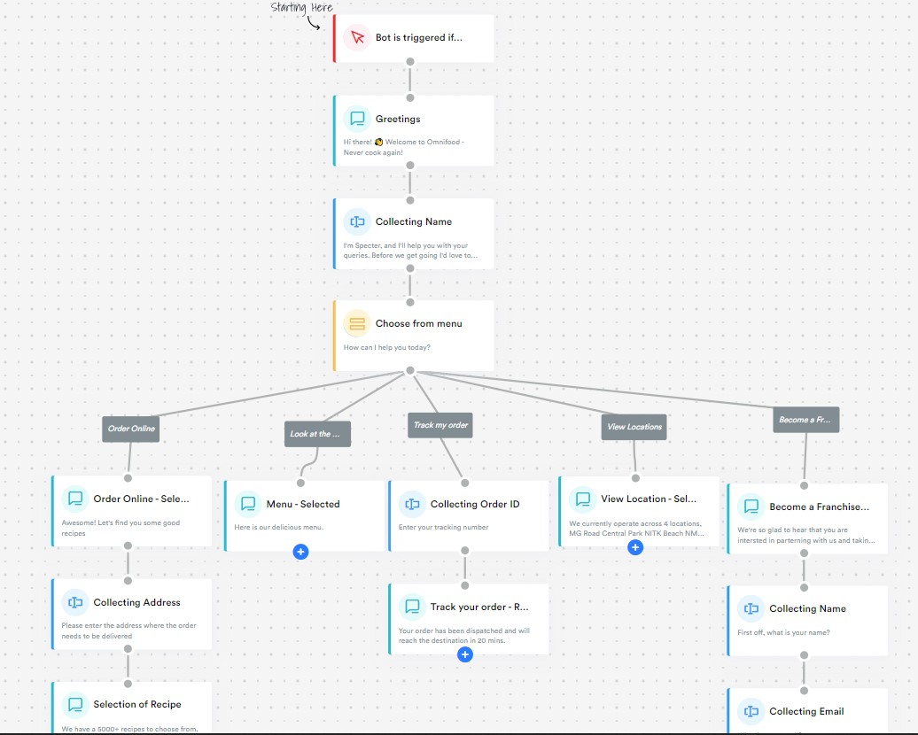

**METHODOLOGY:**

**1- Total Users:** This is the most basic metric. It captures the number of people using your chatbot. This matters because its trend shows the change in the number of users and therefore the amount of data your chatbot has been exposed to. Also, this would provide critical information regarding the market size calculations and potentially the effect of your chatbot.

**2- Active Users:** Active users can be defined as the people who read a message in the chatbot in a defined time frame. These are your potential targets. Measuring the potential effects of a promotional activity can be estimated from that number. The number of people who read your message is critical. This is something like the promotional content on social media. Engagement is not guaranteed but, the content is seen by the people

**3- Engaged Users:** Those users are the ones who communicate with the chatbot. They receive and send messages. This is important since your chatbot will be able to provide the conversation statistics based on this sub-sample. They are likely to shape your decision regarding the effectiveness of the chatbot. It doesn’t make any sense if the chatbot is not able to start the conversation with the users.

**4- New Users:** This metric captures the overall success of your chatbot promotion campaign. New users will be necessary to keep an active user number. Customers’ preferences changes over time and the amount of interaction with the chatbot shows an exponential decay. For that reason, new users will keep your customer base strong.

**5-Total Conversations:** Number of conversations started and successfully completed on a given day. This is the concept engaged users.

**6-New Conversations:** Number of new conversations started. This captures both the inexperienced users and the conversations that are initiated by the returning users on a different matter, problem, or order.

**7-User Satisfaction:** A new metric can be defined through the exit surveys. Customers or the people engaging with the chatbot can rate their experience to achieve further product excellence. This can be implemented as a binary variable such as “did the bot perform well? – Yes, or No” or we can create more complex evaluation forms to rank and provide points for each different category. This metric would capture the overall effectiveness of the bot from the user experience point directly provided by the user.

**EXPERIMENTAL RESULTS:**

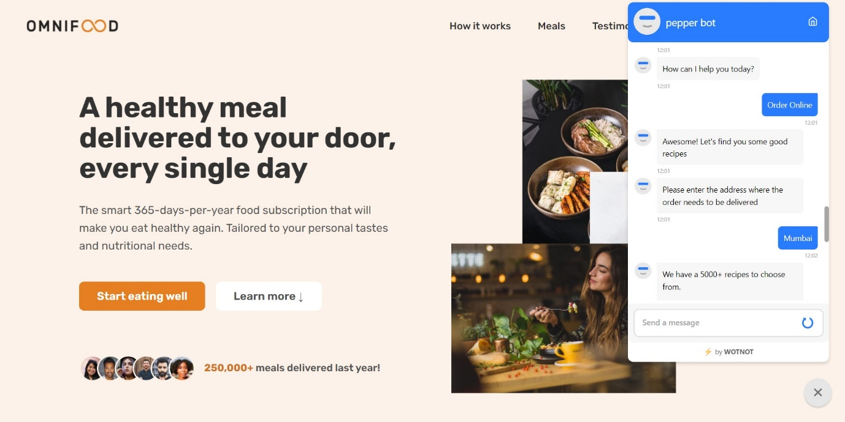

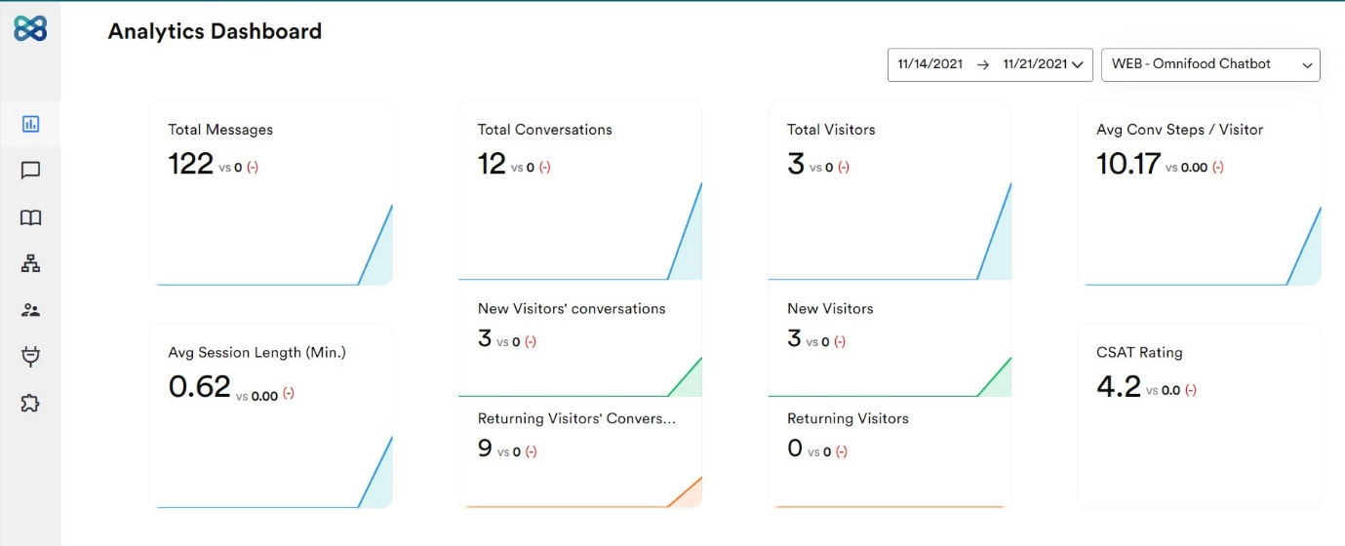

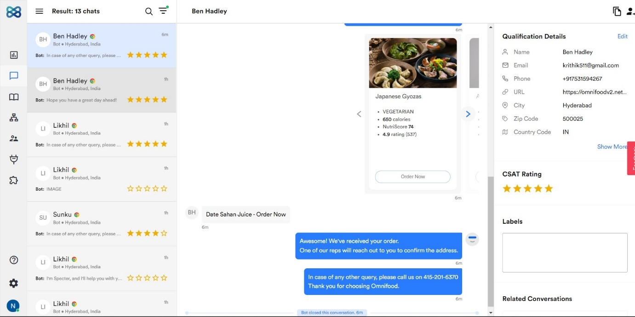

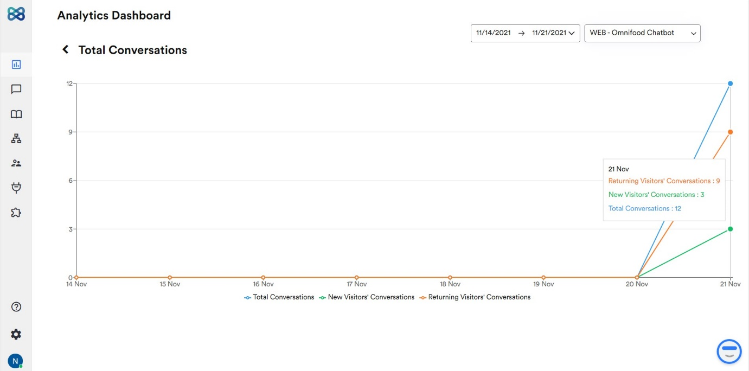

**CONCLUSION:**

In this project, we proposed a chatbot that would enable bot users to just type in the query related to web analytics and will get response immediately. This is to avoid the time-consuming task of mastering a web analytics tool. Experiments were conducted to understand the performance of the tool. The tool was evaluated based on the quality of response and it performed well. Since the chatbot is developed, the bot-user has to follow a pattern by which he can type in the query. I would like to extend my work by further refining the chatbot and making it more intelligent so that the bot-user need not follow a predefined pattern while entering the query.

**APPENDIX:**

https://github.com/Nikhil-Reddy-H-07/chatbot-analytics