TASK 1: XRAY FUNDAMENTALS – INTRODUCTION
Xray is a test management tool built natively inside Jira that enables teams to manage manual and automated tests efficiently. It supports Agile and DevOps practices by maintaining full traceability between requirements, tests, executions, and defects. Xray integrates seamlessly with Jira issues, unlike external tools.
Xray is widely used in Agile projects to ensure continuous testing, sprint-level execution tracking, and release quality visibility. Compared to Jira’s default issue types, Xray provides specialized test-related entities such as Test, Test Execution, Test Plan, and Test Set.

1. Xray Menu in Jira
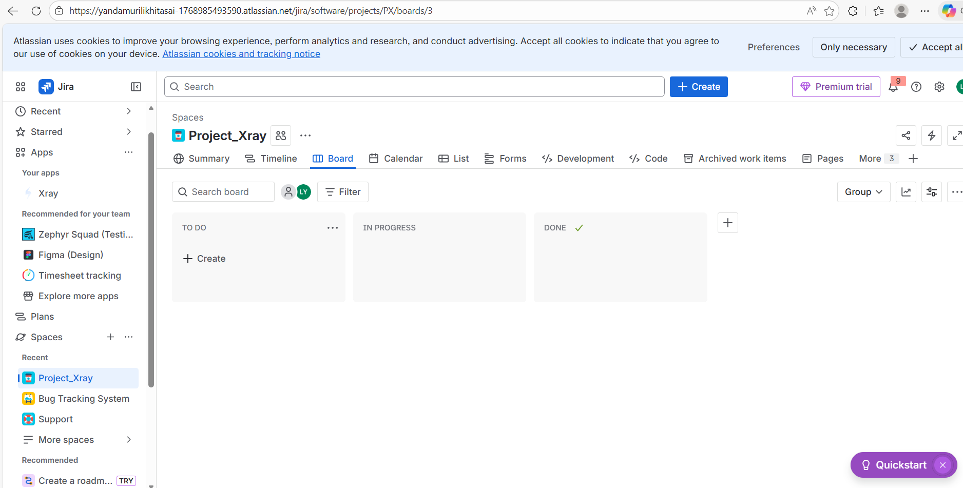
This shows the Xray menu integrated within Jira. Unlike external testing tools, Xray works directly inside Jira, allowing testers to manage test cases, executions, and reports without switching tools. This integration improves productivity and maintains better traceability between requirements and tests.

2. Jira Story vs Xray Test Issue
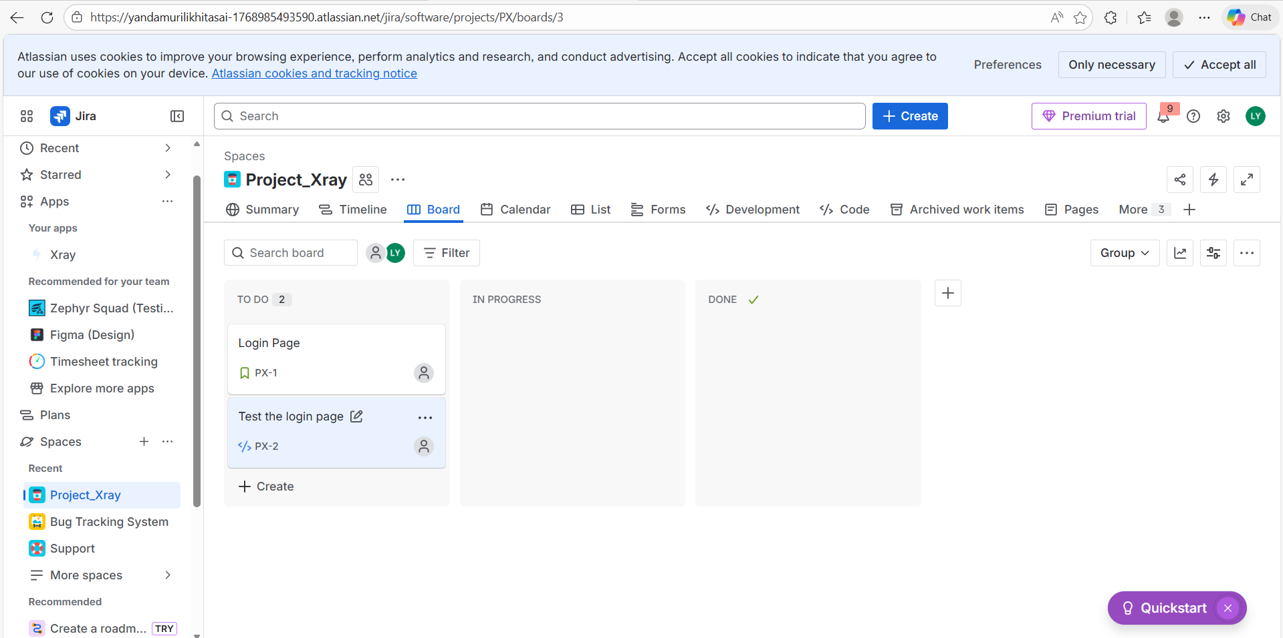
This screenshot highlights the difference between a Jira Story and an Xray Test issue. While a Story represents a requirement, a Test represents a test case designed to validate that requirement. Xray adds test-specific fields such as test steps, preconditions, and execution status, which are not available in normal Jira issues.

3. Xray Architecture
