TASK 2: XRAY SETUP, ISSUE TYPES & UI
Proper configuration of Xray is essential for effective test management. Xray introduces specialized issue types and provides multiple UI panels that help testers track coverage, execution status, and defects. This task covers Xray setup, issue types, UI panels, and permissions.

- Xray Issue Types
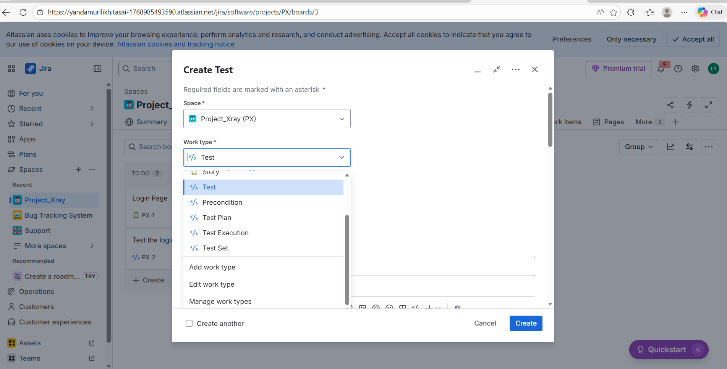
It shows various Xray issue types such as Test, Test Execution, Test Plan, Test Set, and Precondition. Each issue type serves a specific purpose, helping testers organize, execute, and track tests in a structured manner.

- Xray Panels in Jira Issue
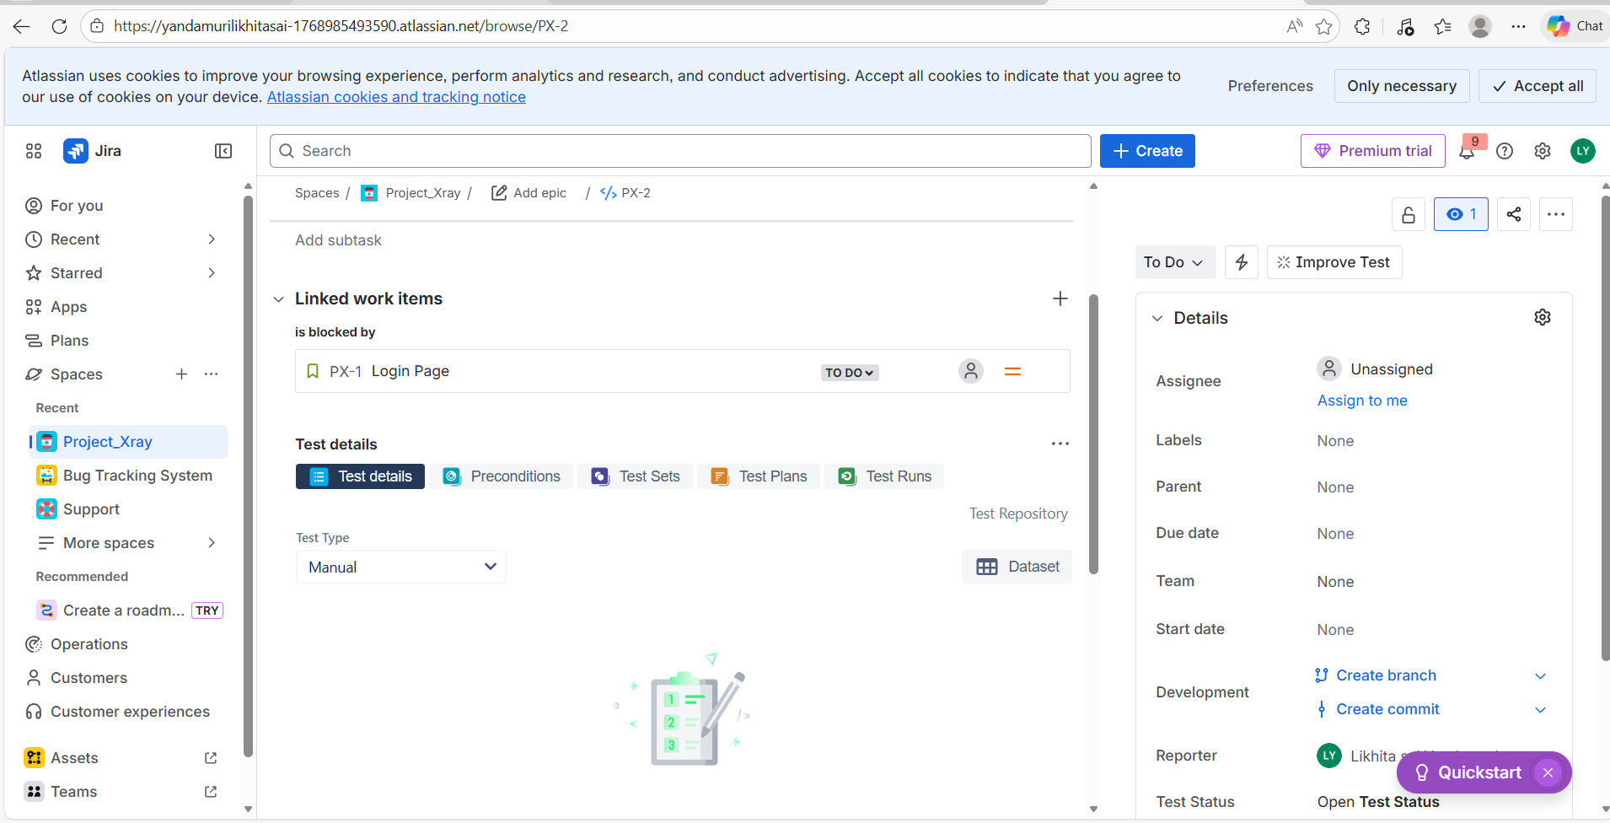
It displays Xray panels inside a Jira issue. These panels provide information about test coverage, execution status, and linked defects. They help teams quickly understand the testing status of a requirement.

- Access

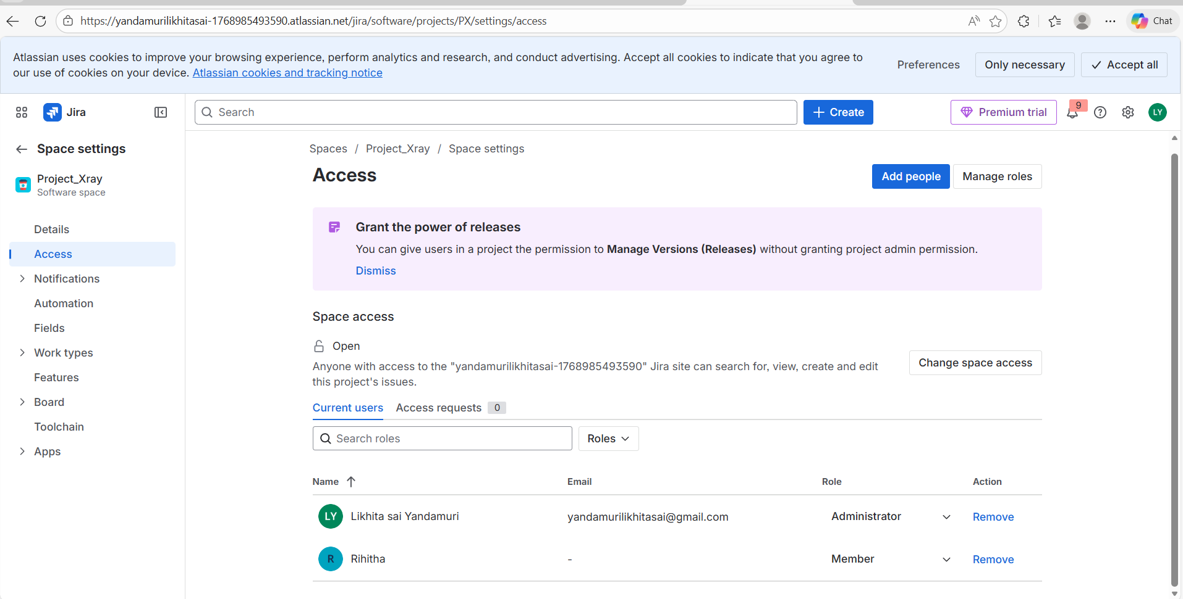
This screenshot shows the project members and their roles in a team-managed Jira project. In team-managed projects, permissions are controlled through project roles instead of separate permission schemes. This ensures that users have appropriate access to create, edit, and execute work items, including Xray tests.

