TASK 3: MANUAL TEST CASE MANAGEMENT
Manual test case management is a core activity in software testing. Xray allows testers to create structured test cases, reuse preconditions, and organize tests into logical groups such as smoke and regression suites.

- Creating a Manual Test Case
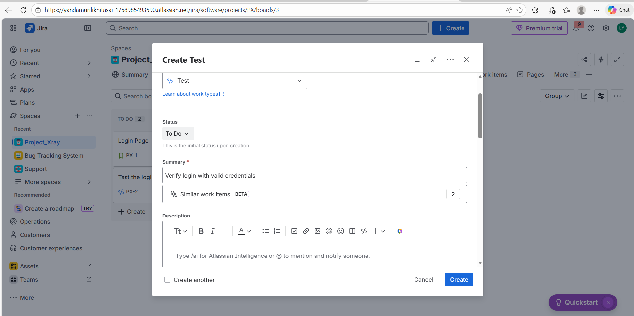
This screenshot shows a manually created test case with test steps and expected results. Step-based tests improve clarity and ensure consistent execution across test cycles.

- Using Preconditions
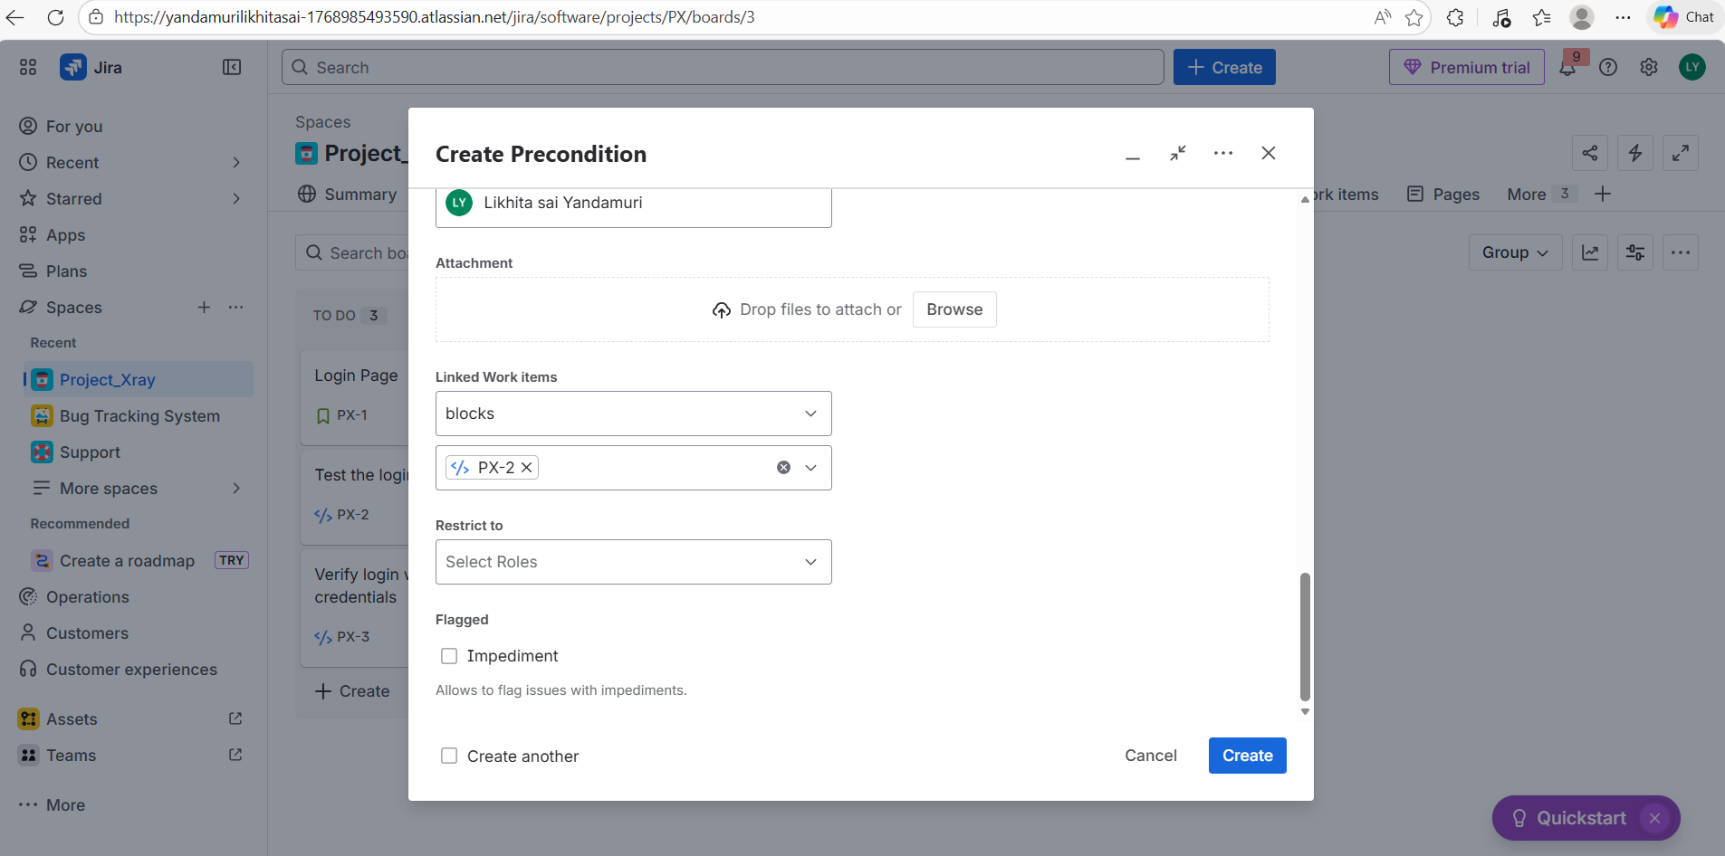
This screenshot demonstrates the use of Preconditions. Preconditions define the required system state before test execution and help avoid repetition across multiple test cases.

- Test Sets for Organization
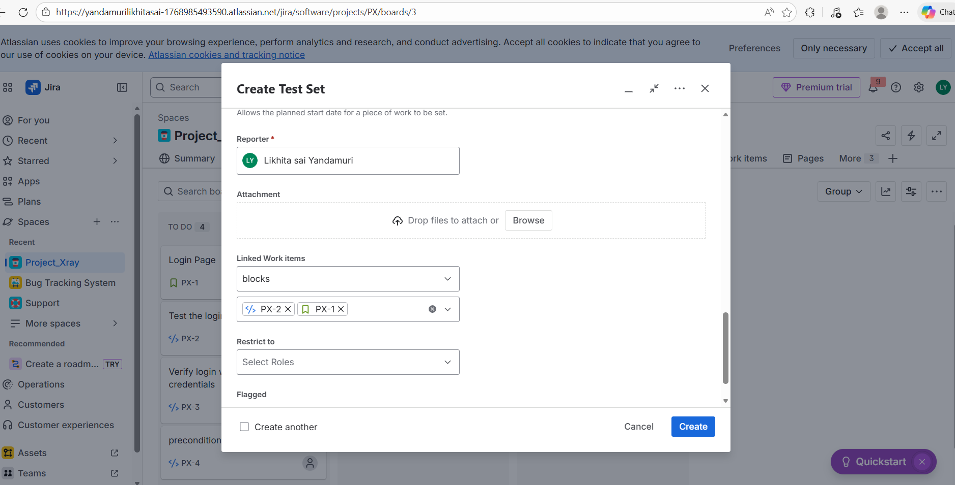
This screenshot shows a Test Set used to group multiple tests together. Test Sets help manage smoke tests, regression tests, and feature-based testing efficiently.

