Jira Fundamentals
Understanding Jira Projects and Project Types: Team-Managed vs Company-Managed
What’s a Jira Project?
Think of a project in Jira as a container that holds all the work for a team, product, or process. Inside it, you’ll find tasks (called issues), boards to track progress, workflows that show how work moves forward, and permission settings to control access.
Team-Managed Projects
These are projects that teams set up and run themselves. They’re quick to create, easy to customize, and perfect for smaller or independent groups. The team can tweak workflows, fields, and boards on their own—no need to wait for an admin.
Company-Managed Projects
These are overseen by Jira administrators. They come with more advanced customization options, shared configurations, and detailed permission controls. They’re best suited for larger teams or organizations that want consistent processes across multiple projects.
The Key Difference
Team-Managed projects give flexibility directly to the team, while Company-Managed projects give the organization more control and consistency.

Steps to Create a Jira Project
Step 1: Log in to your Jira account.
Step 2: Go to the Spaces.
Step 3: Click the plus icon to create the project Space.
Step 4: Choose a Space template (Scrum, Kanban, Bug Tracking, etc.).
Step 5: Select the Project Type – Team-Managed or Company-Managed.
Step 6: Enter the Project Name and confirm the Project Key.
Step 7: Review optional settings like access and workflow.
Step 8: Click Create to finish setup.
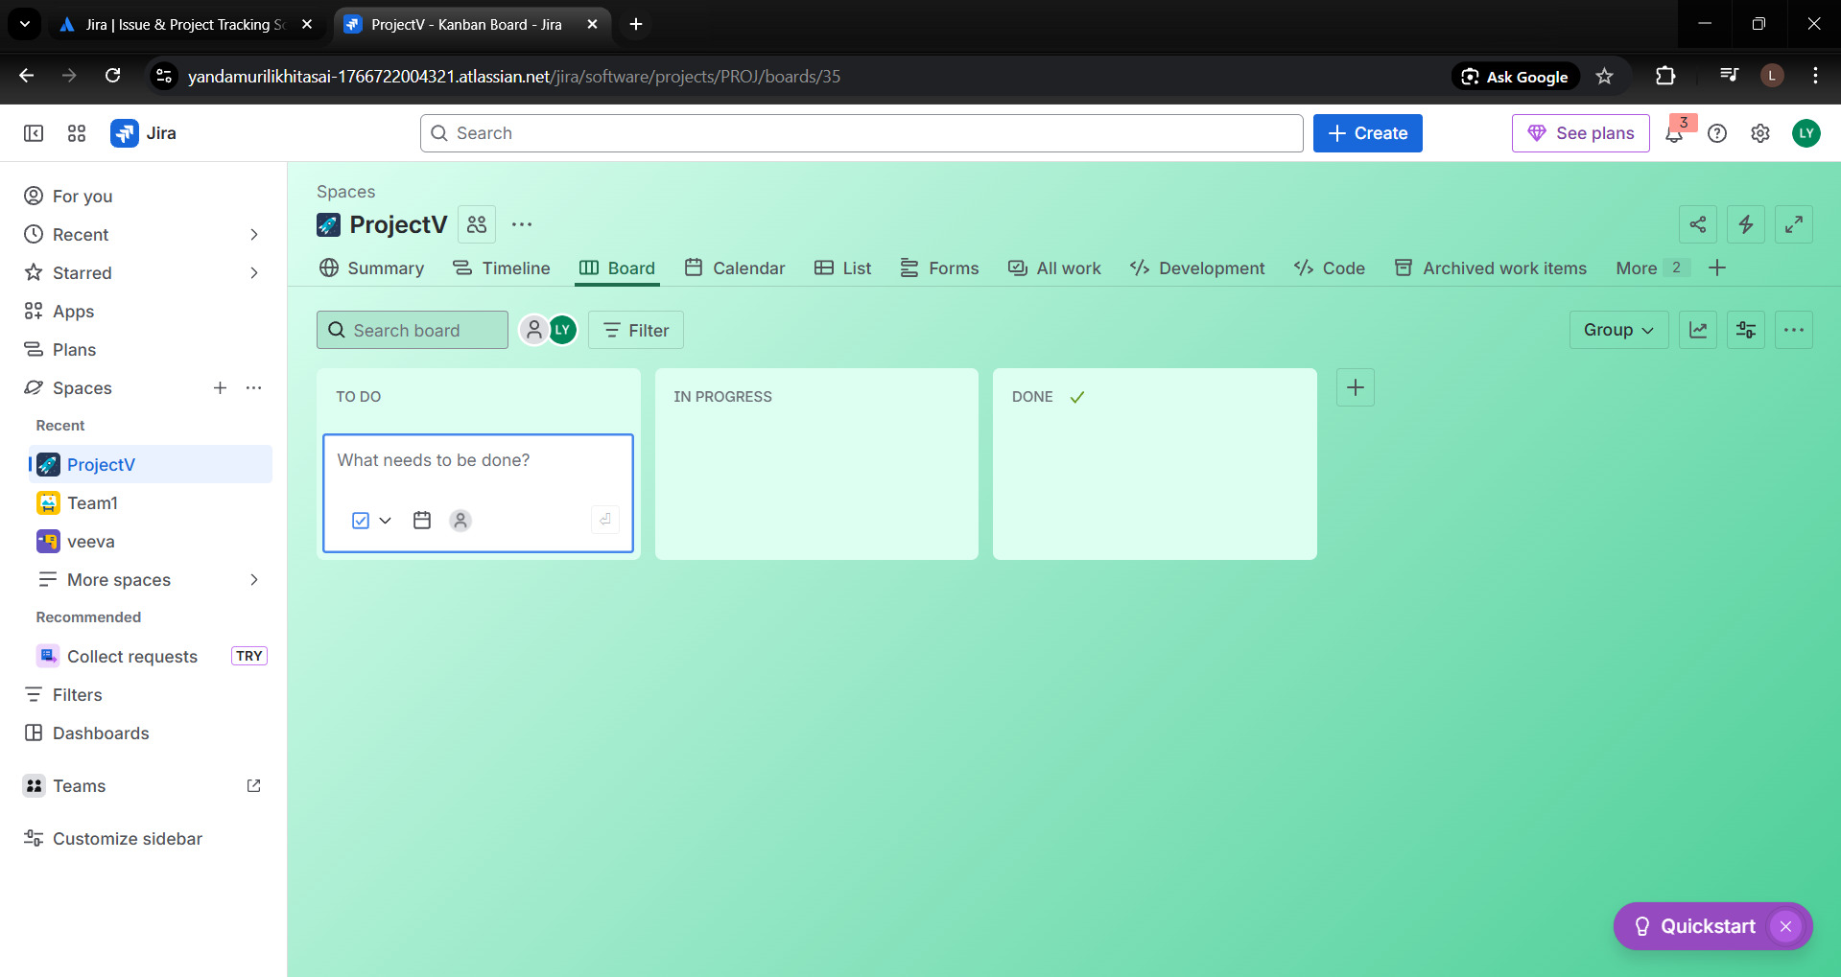
Jira Issue Types Explained: Task, Story, Bug, Epic, and Subtask
Task – A general work item that needs to be completed.
Story – A feature or requirement described from the user’s perspective.
Bug – A problem, error, or defect that needs to be fixed.
Epic – A large body of work that is broken down into multiple stories or tasks.
Subtask – A smaller piece of work that belongs to a task or story.

How to Create Issues in Jira
Step 1: Log in to your Jira account.
Step 2: Click the Create button at the top of the screen.
Step 3: Choose the Issue Type (Task, Story, Bug, Epic, Subtask).
Step 4: Select the Project where the issue should be created.
Step 5: Enter the Summary (title of the issue).
Step 6: Add details such as Description, Priority, Assignee, or Attachments (optional).
Step 7: Click Create to save the issue.

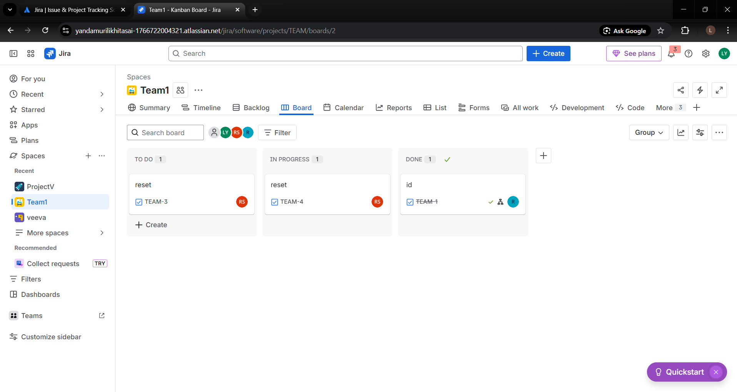
Managing Issues:
- Update Status: Move issues through workflow stages (To Do, In Progress, Done).
- Edit Details: Modify fields such as description, assignee, priority, or due date.
- Add Comments: Communicate with team members inside the issue.
- Attach Files: Upload documents, screenshots, or logs.
- Link Issues: Connect related issues like blockers, duplicates, or dependencies.
- Add Subtasks: Break larger work into smaller actionable pieces.
- Transition Issues: Move the issue to the next stage of the workflow.

Issue Hierarchy and Linking Issues: Epics, Stories, and Subtasks
Epic – The highest-level issue representing a large feature or goal. It contains multiple stories and tasks.
Story – A user-focused requirement that sits under an epic. Stories describe what needs to be built or delivered.
Subtask – A smaller piece of a story or task. Subtasks break the work into manageable actions for team members.
Hierarchy Structure:
Epic → Story/Task → Subtask
Linking Issues:
Jira allows issues to be connected to show relationships. Common link types include:
- Blocks / Is Blocked By – One issue prevents another from moving forward.
- Clones / Is Cloned By – Duplicate or copy of another issue.
- Relates To – Issues are connected but not dependent.
- Duplicates / Is Duplicated By – Identical work items.

Linking issues helps teams understand dependencies, relationships, and the impact of changes across work items.
Creating Hierarchy:
- Create the Epic Issue type.
- Create the Epic related Stories.
- And link the epic to each of that story.
- To create subtasks go to that task or story.
- Click to create the subtasks and create.
Link Issues (Dependencies & Relationships)
- Open any issue (Epic, Story, or Task)
- Click More (•••) → Link issue
- Choose a Link Type:
  - Blocks / Is Blocked By → for dependencies
  - Relates To → general relationship
  - Clones / Duplicates → similar or copied work
- Search for the issue key or summary
- Click Link
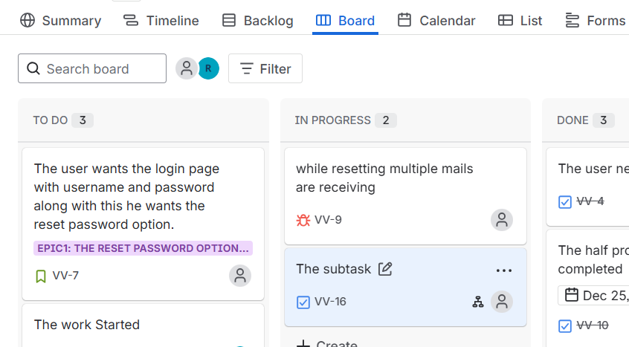
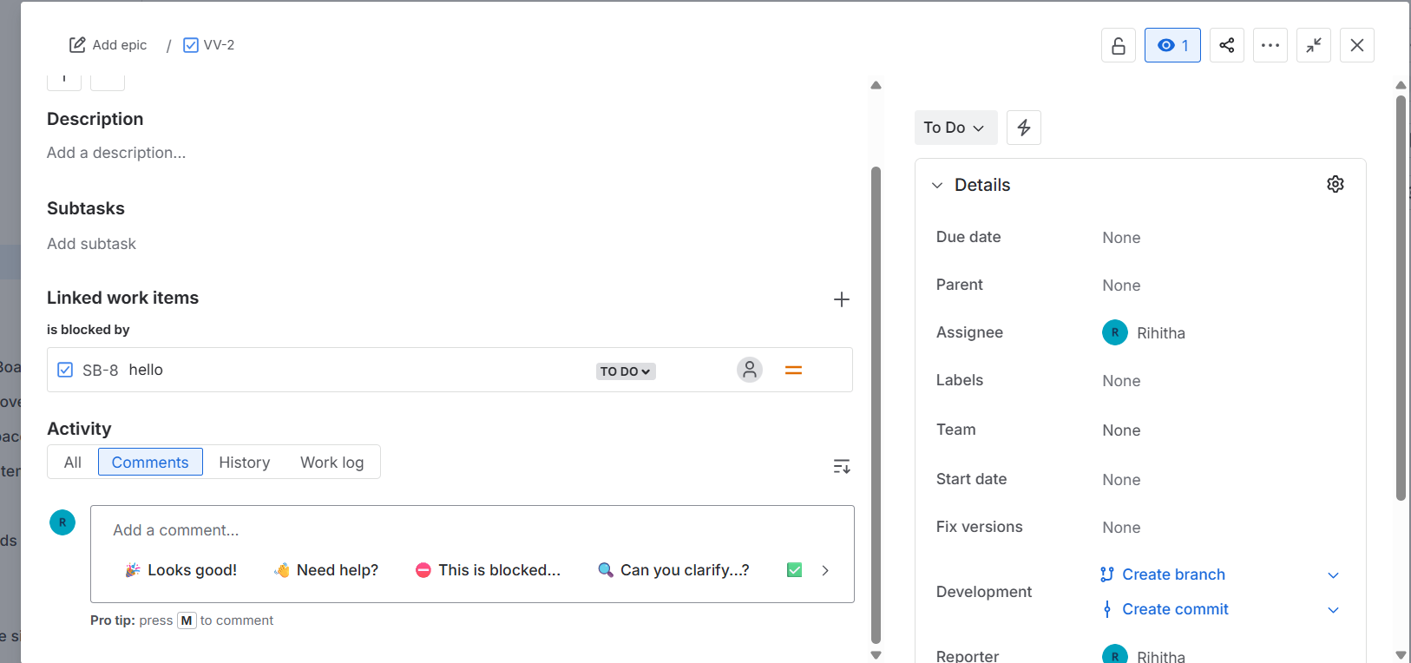

Working with Kanban and Scrum Boards in Jira
Jira supports both Scrum and Kanban frameworks to help teams plan, track, and deliver work efficiently. While both use boards to visualize work, they differ in structure, cadence, and use cases.
Scrum Board in Jira
Scrum boards are designed for teams working in time-boxed iterations (sprints) and are best suited for projects with well-defined deliverables.
Key Features
- Backlog: A prioritized list of Epics, Stories, and Tasks
- Sprints: Fixed-length iterations (e.g., 2 weeks)
- Sprint Planning: Team commits to work for the sprint
- Burndown Chart: Tracks remaining work vs. time
- Reports: Velocity, Sprint Report, Burndown

How to Work with a Scrum Board
- Create a Scrum Project in Jira
- Add issues (Epics, Stories, Tasks) to the Backlog
- Assign stories to a sprint
- Start the sprint
- Move issues across columns (To Do → In Progress → Done)
- Complete the sprint and review reports
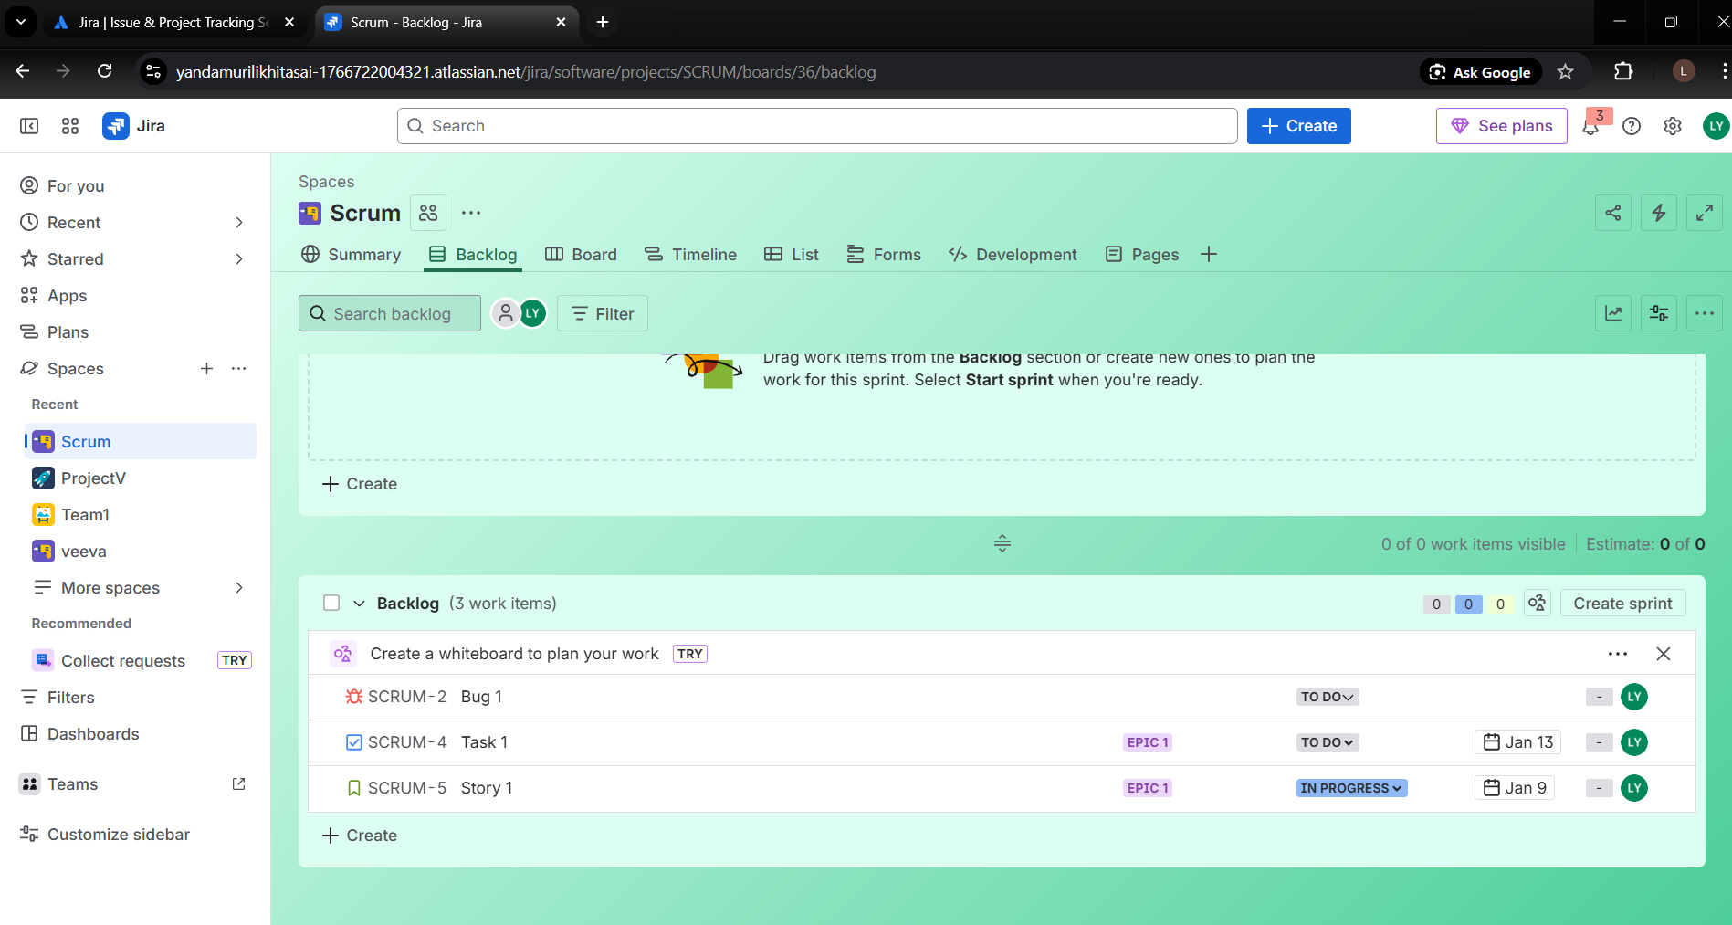

Kanban Board in Jira
Kanban boards focus on continuous flow of work without fixed iterations. They are ideal for operational, maintenance, or support-based teams.
Key Features
- Continuous Workflow: No sprints
- Work in Progress (WIP) Limits: Prevent overloading the team
- Cycle Time & Throughput Reports
- Backlog (Optional): Work is pulled as capacity allows
How to Work with a Kanban Board
- Create a Kanban Project in Jira
- Add issues directly to the board
- Define workflow columns (e.g., To Do, In Progress, Review, Done)
- Track progress using cumulative flow and control charts

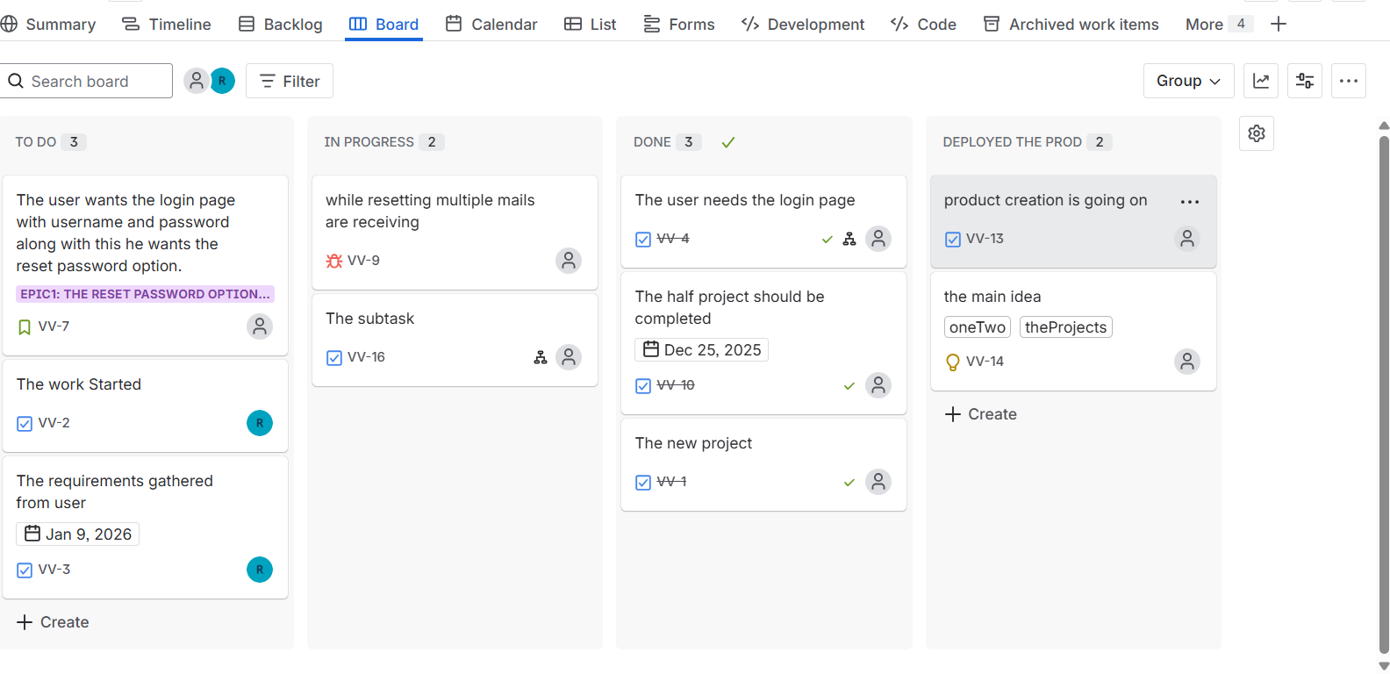

Backlog, Board, and Detail Views in Jira
- Backlog View
Used to plan and prioritize upcoming work. Shows all issues not yet started and helps teams prepare work for future sprints.
- Board View
Visualizes active work using columns (e.g., To Do, In Progress, Done). Helps teams track progress and identify blockers in real time.
- Detail (Issue) View
Displays complete information for a single issue, including description, status, assignee, comments, and history.

