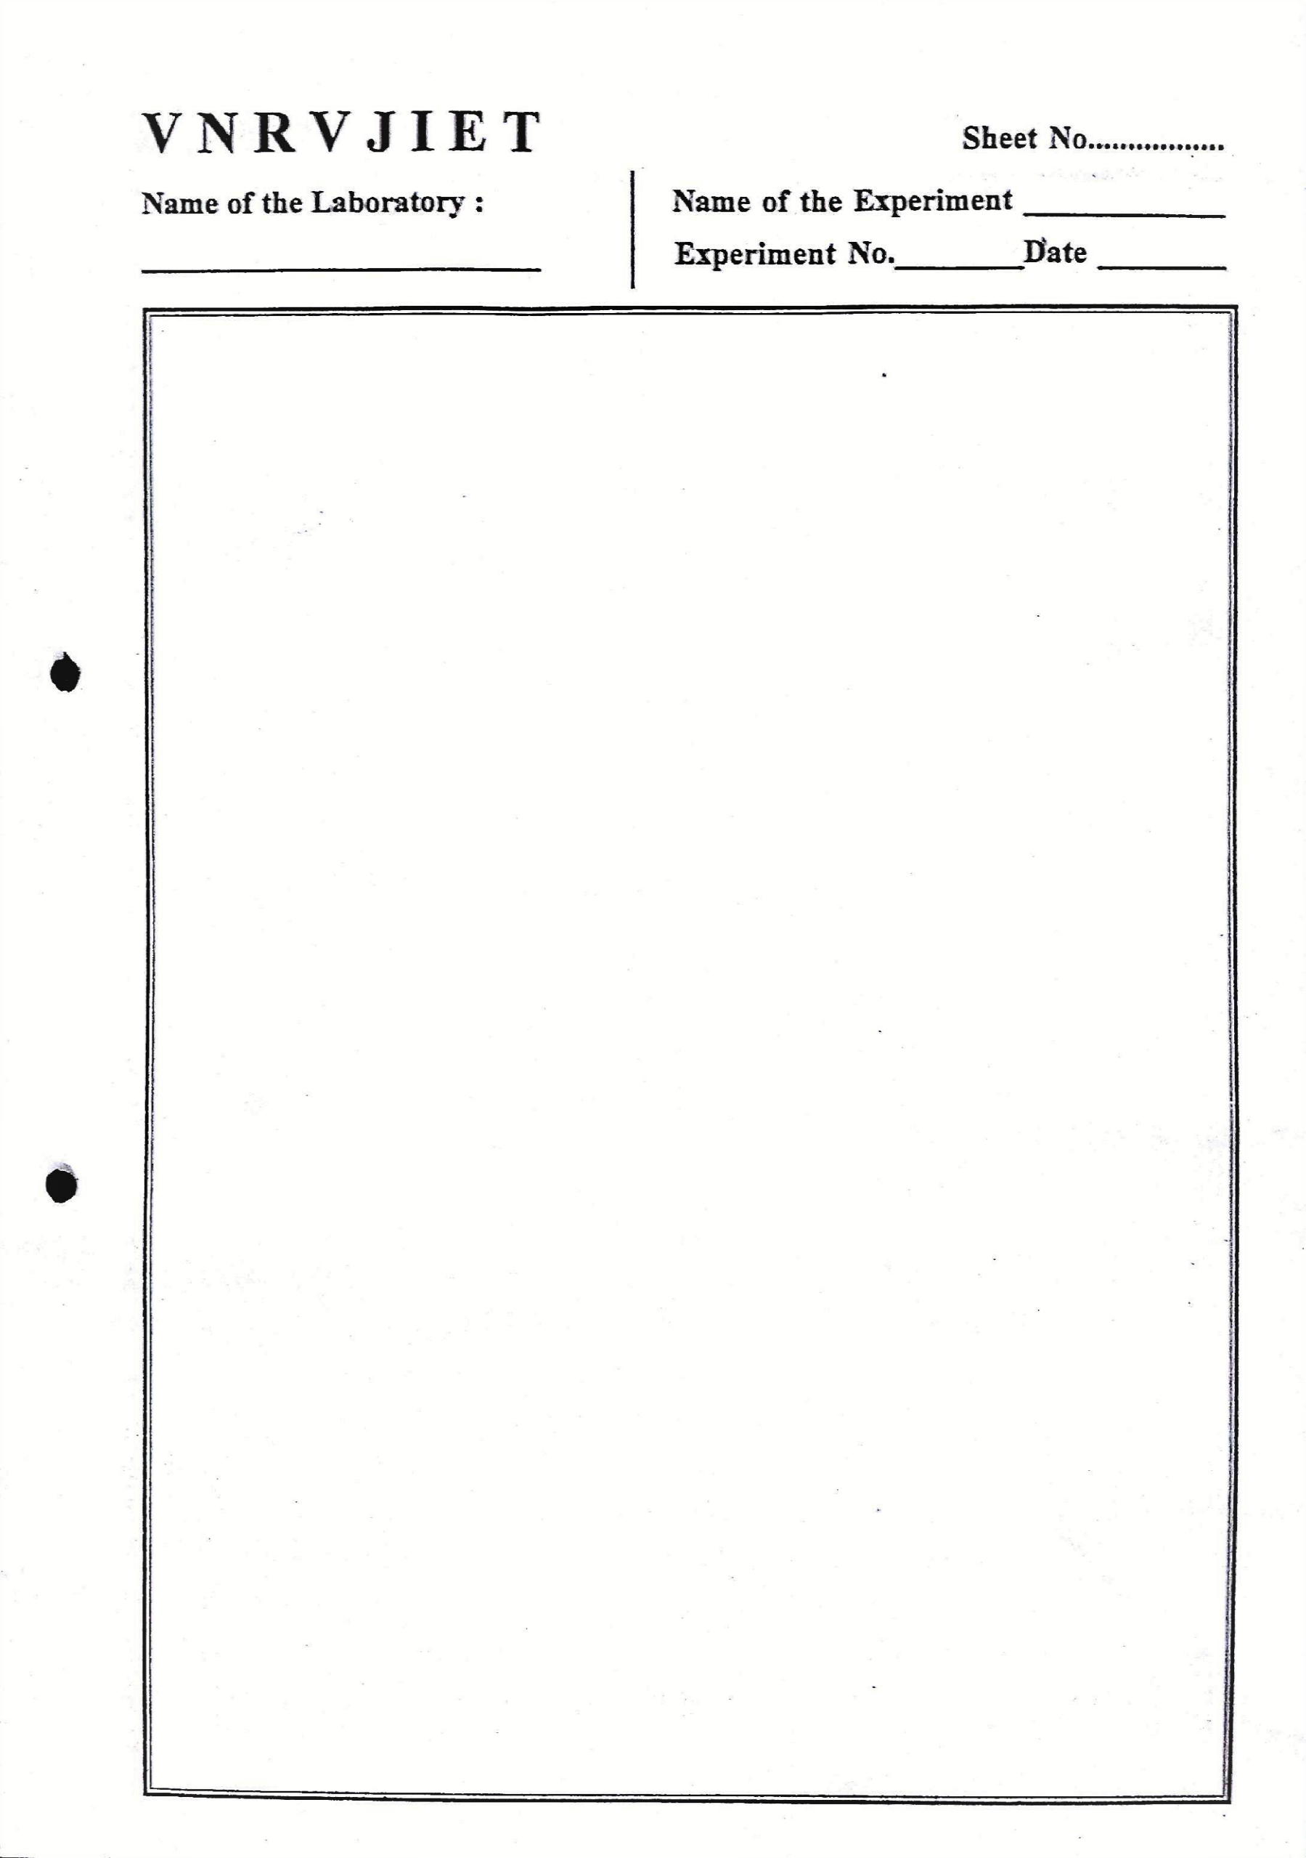

Home.html
<!DOCTYPE html>
<html lang="en">
<head>
<meta charset="UTF-8">
<meta http-equiv="X-UA-Compatible" content="IE=edge">
<meta name="viewport" content="width=device-width, initial-scale=1.0">
<link rel="stylesheet" type="text/css" href="style.css">
<title>Home</title>
</head>
<frameset rows="200,*">
<frame name="f1" src="topframe.html">
</frame>
<frameset cols="20,80">
<frame name="f2" src="courses.html">
</frame>
<frame name="f3" src="description.html">
</frame>
</frameset>
</frameset>
</html>
Topframe.html
<!DOCTYPE html>
<html lang="en">
<head>
<meta charset="UTF-8">
<meta http-equiv="X-UA-Compatible" content="IE=edge">

<meta name="viewport" content="width=device-width, initial-scale=1.0">
<link rel="stylesheet" type="text/css" href="style.css">
<title>Document</title>
</head>
<body class="fr1main">
<div class="heads">
<img src="VNRVJIETLogo.png" alt="vnr" class="logo">
<div class="btnclass">
<h1 class="content">ONLINE BOOKSTORE</h1>
<button class="btn"><a href="description.html" target="f3">HOME</a></button>
<button class="btn"><a href="login.html" target="f3">LOGIN</a></button>
<button class="btn"><a href="register.html" target="f3">REGISTER</a></button>
<button class="btn"><a href="catalogue.html" target="f3">CATALOGUE</a></button>
<button class="btn"><a href="">ADD TO CART</a></button>
</div>
</div>
</body>
</html>
Style.css
.fr1main{
background-color: #FFF7E9;
color: #1746A2;
overflow:hidden;
display: inline-flex;
}
.logo{
padding: 1rem;

padding-bottom: none;
height: 10rem;
}
.heads{
display: inline-flex;
}
.content{
font-size: 2.5rem;
color: #FF731D;
font-family: 'Lucida Sans', 'Lucida Sans Regular', 'Lucida Grande', 'Lucida Sans Unicode', Geneva, Verdana, sans-serif;
padding-top:1.3rem;
margin-left: 10rem;
}
.btnclass{
width: 70rem;
margin-top: .5rem;
/* margin-left: 10rem; */
}
.btn{
margin-left: 2rem;
width: 15%;
padding: .4rem;
font-size: 1rem;
background-color: #5F9DF7;
border-radius: 0.3rem;
}
.btn:hover{

background-color: rgb(221, 220, 217);
cursor: pointer;
}
a{
text-decoration: none;
color: #FFF7E9;
}
.aa{
color: #1746A2;
}
.course{
color: #1746A2;
padding-left: 2rem;
padding-top: 2rem;
}
.subject{
margin: 1rem;
padding:1rem;
text-decoration: none;
}
Courses.html
<!DOCTYPE html>
<html lang="en">
<head>
<meta charset="UTF-8">
<meta http-equiv="X-UA-Compatible" content="IE=edge">
<meta name="viewport" content="width=device-width, initial-scale=1.0">

<link rel="stylesheet" type="text/css" href="style.css">
<title>Document</title>
</head>
<body>
<div class="course">
<h1 class="subject"><a class="aa" href="cse.html" target="f3">CSE</a></h1>
<h1 class="subject"><a class="aa" href="ece.html" target="f3">ECE</a></h1>
<h1 class="subject"><a class="aa" href="eee.html" target="f3">EEE</a></h1>
<h1 class="subject"><a class="aa" href="civil.html" target="f3">CIVIL</a></h1>
</div>
</body>
</html>
Catalogue.html
<!DOCTYPE html>
<html>
<head>
<meta charset="utf-8">
<meta http-equiv="X-UA-Compatible" content="IE=edge">
<title></title>
<meta name="description" content="">
<meta name="viewport" content="width=device-width, initial-scale=1">
<!-- <link rel="stylesheet" href=""> -->
</head>
<body>
<table border="1" align="center" width="100%">
<th>
<td>DETAILS</td>

<td>CART</td>
</th>
<tr>
<td><img src="https://m.media-amazon.com/images/I/51419XJoJhL._SY264_BO1,204,203,200_QL40_FMwebp_.jpg" style="width:10rem"></td>
<td><div width="100rem">
<p>Book:Web Technologies</p>
<p>Author: Achyut Godbole</p>
<p>Edition: Third Edition</p>
</div></td>
<td><button style="margin-top:1rem;margin-left:1rem;margin-right:1rem;height:2.5rem;width:5rem;border-radius: 0.5rem;border-width: 0rem;background-color:green;color:rgb(232, 243, 243)">Add to cart</button></td>
</tr>
<tr>
<td><img src="https://m.media-amazon.com/images/I/51HfkDbya7L._SX198_BO1,204,203,200_QL40_FMwebp_.jpg" style="width:10rem"></td>
<td><div>
<p>Book: HTML & CSS</p>
<p>Author: Thomas A Powell</p>
<p>Edition: Indian Edition</p>
</div></td>
<td><button style="margin-top:1rem;margin-left:1rem;margin-right:1rem;height:2.5rem;width:5rem;border-radius: 0.5rem;border-width: 0rem;background-color:green;color:rgb(232, 243, 243)">Add to cart</button></td>
</tr>
<tr>

<td><img src="https://m.media-amazon.com/images/I/51419XJoJhL._SY264_BO1,204,203,200_QL40_FMwebp_.jpg" style="width:10rem"></td>
<td><div width="100rem">
<p>Book:Web Technologies</p>
<p>Author: Achyut Godbole</p>
<p>Edition: Third Edition</p>
</div></td>
<td><button style="margin-top:1rem;margin-left:1rem;margin-right:1rem;height:2.5rem;width:5rem;border-radius: 0.5rem;border-width: 0rem;background-color:green;color:rgb(232, 243, 243)">Add to cart</button></td>
</tr>
</table>
</body>
</html>
Catalogue.css
td,th{
text-align: center;
text-decoration: solid;
}
Login.html
<!DOCTYPE html>
<html lang="en">
<head>
<meta charset="UTF-8">
<meta http-equiv="X-UA-Compatible" content="IE=edge">
<meta name="viewport" content="width=device-width, initial-scale=1.0">
<link rel="stylesheet" type="text/css" href="login.css">
<title>login</title>
</head>

<body class="main">
<h1>LOGIN</h1>
<form class="content">
<label for="userId">Username:</label>
<input type="text" id="userId" name="userId"><br>
<label for="password">Password:</label>
<input type="text" id="password" name="password">
</form>
<button type="submit">Submit</button>
</body>
</html>
Login.css
.main{
width: 30%;
margin-left: 30%;
margin-top: 5%;
padding: 2rem;
overflow: hidden;
border: #1746A2;
border-radius: 10%;
border-style:inset;
}
h1{
margin-left: 23%;
color: #1746A2;
font-size: 4rem;
}
label{
font-size: 1.5rem;
color:#1746A2;

padding: 5%;
}
input{
padding: .5rem;
margin: 1rem;
}
button{
padding:0.3rem;
margin-top: .3rem;
width: 50%;
margin-left: 5rem;
color: #FFF7E9;
background-color: #5F9DF7;
border-color:#5F9DF7;
font-size: 1.5rem;
}
Register.html
<!DOCTYPE html>
<html lang="en">
<head>
<meta charset="UTF-8" />
<meta http-equiv="X-UA-Compatible" content="IE=edge" />
<meta name="viewport" content="width=device-width, initial-scale=1.0" />
<link rel="stylesheet" type="text/css" href="register.css" />
<title>Document</title>

</head>
<body class="main" >
<h1>REGISTER</h1>

<div class="form-group">
<label for="userId">Username:</label>
<input type="text" class="form-control" id="name" placeholder="Name" />
</div>
<div class="form-group">
<label for="emailId">Email Id:</label>
<input type="email" class="form-control" id="email" placeholder="Email" />
</div>
<div class="form-group">
<label for="password">Password:</label>
<input
type="password"
class="form-control"
id="password"
placeholder="Password"
/>
</div>
<div class="form-group">
<label for="repassword">Confirm Password:</label>
<input
type="password"
class="form-control"
id="confirm-password"
placeholder="Renter password"
/>
</div>

<button class="btn btn-primary"><a href="#">Login</a></button>
<button class="btn btn-primary">Create Account</button>

</body>
</html>
Register.css
.main{
width: 35%;
margin-left: 30%;
margin-top: 5%;
overflow: hidden;
border: #1746A2;
border-radius: 10%;
border-style:inset;
}
h1{
margin-left:12%;
margin-bottom: 0;
color: #1746A2;
font-size: 4rem;
}
label{
justify-content: end;
font-size: 1.5rem;
color:#1746A2;
display: inline-block;
clear: left;
padding: 4%;
}
input{
display: inline-block;
float: right;
margin-right: 5%;

padding: .5rem;
margin-top: 1rem;
}
button{
padding:0.3rem;
margin-top: 1rem;
width: 35%;
margin-left: 3rem;
margin-bottom: 1rem;
color: #FFF7E9;
background-color: #5F9DF7;
border-color:#5F9DF7;
font-size: 1rem;
}
a{
color: #FFF7E9;
text-decoration:none ;
}

