

MATHEMATICS FOR ROBOTICS
PROJECT

ProfessorName:-KUMAR UJJWAL
Student Name:- IMMANDI SRI LIKHITA
Roll.No:-SE25MROB009

Smart Room Temperature Control Using Fuzzy Logic Controller
Abstract
This project presents the design and implementation of a Smart Air Conditioner using a Fuzzy Logic Controller (FLC). The controller regulates room temperature by adjusting cooling power based on temperature error and change in temperature.
Objective
To design a fuzzy logic based temperature control system using MATLAB Fuzzy Logic Designer and Simulink.
Inputs and Output
Input 1: Temperature Error
Input 2: Change in Temperature
Output: Cooling Power
Membership Functions
Triangular membership functions (trimf) were used.
Temperature Error:
NL = [-10 -10 0]
ZE = [-5 0 5]
PL = [0 10 10]
Change in Temperature:
N = [-30 -30 0]
Z = [-5 0 5]
P = [0 30 30]
Cooling Power:
Low = [0 0 50]
Medium = [25 50 75]
High = [50 100 100]
Fuzzy Rules
1. IF Error is NL AND Change is N THEN Cooling is High
2. IF Error is NL AND Change is Z THEN Cooling is High
3. IF Error is NL AND Change is P THEN Cooling is Medium
4. IF Error is ZE AND Change is N THEN Cooling is Medium
5. IF Error is ZE AND Change is Z THEN Cooling is Low
6. IF Error is ZE AND Change is P THEN Cooling is Low
7. IF Error is PL AND Change is N THEN Cooling is Low
8. IF Error is PL AND Change is Z THEN Cooling is Low
9. IF Error is PL AND Change is P THEN Cooling is Low
Mathematical Model
Error Equation:
E = Tset - Troom
Change in Error:
ΔE = E(k) - E(k-1)
Transfer Function:
G(s) = 1 / (10s + 1)
Simulink Implementation
The Simulink model contains Step block, Sum blocks, Unit Delay, Mux, Fuzzy Logic Controller, Transfer Function, and Scope blocks.
Results
The response curve shows stable and smooth temperature regulation. The fuzzy controller successfully adjusts cooling power dynamically.

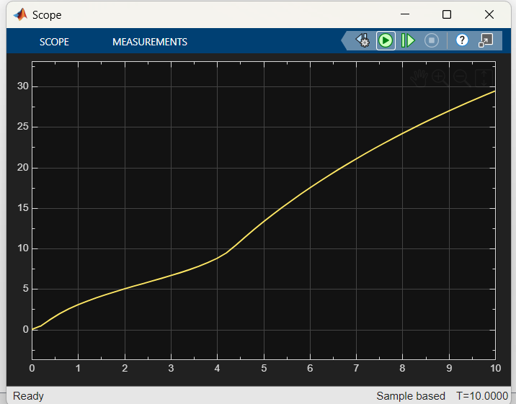
Conclusion
The fuzzy logic based smart AC system effectively controls room temperature without requiring an exact mathematical model. The system provides smooth and intelligent cooling control suitable for real-time applications.

