**ECOSMART SYSTEM**

1. **Project Overview**

Our project aims to ensure the protection of the earth via smart waste management and prevent forest fire.

**1.1 Vision**

A comprehensive smart waste management solution with Smart Bin and User App components, featuring real-time monitoring, QR code generation, and point-based rewards.

This collaborates with an Advanced Forest Fire Detection and prevention mechanism a comprehensive, production-ready system for detecting and monitoring forest fires using satellite imagery, combining thermal hotspot detection with optical confirmation and advanced machine learning.

**1.2 Objectives**

1. **Encourage Waste Segregation** – Reward citizens for proper disposal of waste.
2. **Improve Operational Efficiency** – Reduce unnecessary collection trips through real-time monitoring.
3. **Promote Recycling & Sustainability** – Increase recycling rates and reduce landfill dependency.
4. **Enable Data-Driven Decision Making** – Provide municipalities with analytics for better planning.
5. **Detects and monitors forest fire in real time** – It helps to detect the forest fire beforehanded so that it can be prevented.
6. **Enhance Public Engagement** – Introduce gamification and rewards to boost user retention.

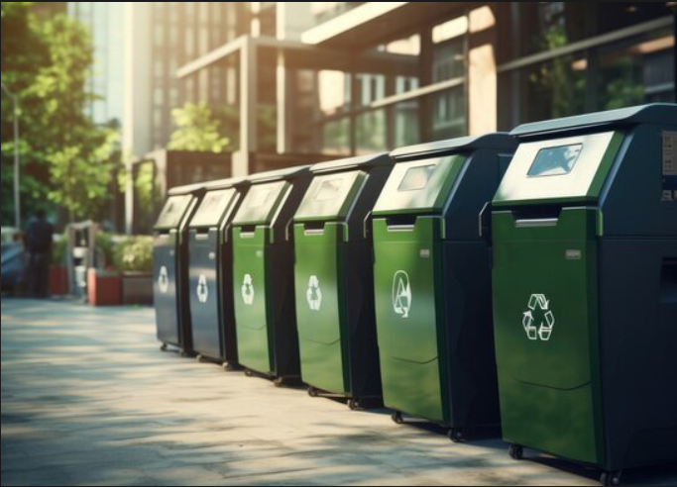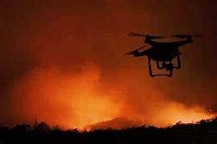

Fig 1.2 Smart waste management and forest fire prevention

**1.3 Scope**

* **Public Sector (Citizens):** Use of mobile app for waste disposal tracking, bin location, and reward redemption.
* **Municipal Sector (Government):** Real-time dashboard for bin monitoring, automated scheduling, and performance analytics.
* **Technology:** IoT sensors, AI-based waste classification, cloud data storage, and blockchain for secure transactions.
* **Geographical Rollout:** Pilot deployment in selected urban areas, followed by city-wide and multi-city expansion.
* **Detect and monitor forest fire in real time :** This process is done via satellite imagery and AI- powered analysis.
* **Provides web interface :** This includes interactive maps, dashboards and filters for region, time, and satellite data selection.
* **Supports emergency response, research and land management :** delivers reliable, consistent and testable results.
* **Geographic Intelligence :** Smart region detection, Water body avoidance, Realistic placement, Multi-region support.
* **Deterministic Results :** Consistent outputs, reliable seeding , professional accuracy, testable system.

## 2. System Architecture

The architecture ensures seamless data flow of both the system that is combined into one.

* 1. **Smart Waste Management System**

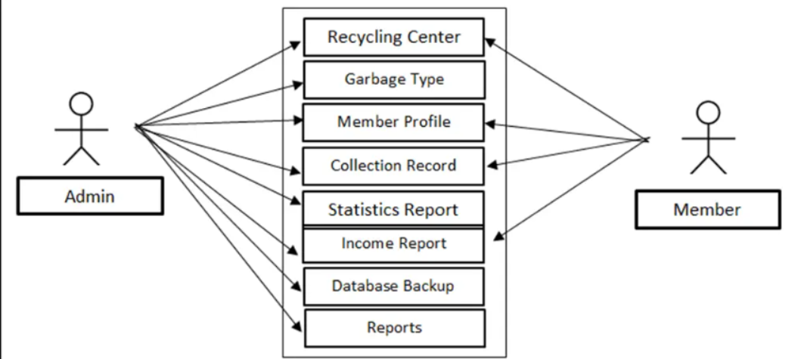

Fig 2.1 : Use case diagram of the system

**Actors:**

* **Primary:** Citizen/User
* **Secondary:** Municipal Waste Management Department

**Description:**  
A citizen approaches an IoT-enabled smart bin to dispose of waste. The bin identifies the waste type using AI-based classification and weight sensors, calculates the reward in digital coins, and updates the user’s account instantly.

**Preconditions:**

* User is registered in the system and has the mobile application installed.
* Smart bin is operational and connected to the network.

**Postconditions:**

* User’s reward balance increases.
* Municipal system updates waste collection schedule based on bin status.

**Exceptions:**

* **Bin full:** System displays alert and suggests nearest available bin.
* **Connectivity loss:** Data stored locally and synced when network resumes.

# How It Works - Step by Step

* 1. Waste Disposal Flow
* User logs into Smart Bin interface
* Selects waste type and enters weight
* System calculates points and generates QR code
* Transcation is recorded in real time
* Points are available for claiming
  1. Point Claiming flow
* User opens user app and logs in
* Sacns QR code from smart bin
* Points are added to users wallet
* Transcation history is updated
* User can redeem points for money
  1. Real time monitoring
* Live updates of all waste disposal activities
* Statistics by waste type and user
* Transcation history with timestamps
* Environmental impacttracking
  1. **Forest Fire Detection System**

The system consists of two major components:  
  
1. Frontend (Web Interface)  
- Technology: HTML5, CSS3, JavaScript, Bootstrap 5, Leaflet.js  
- Location: web/index.html  
- Features: Interactive map, real-time dashboard, region/date/satellite selection, cloud cover control, modern UI.  
  
2. Backend (API Server)  
- Technology: FastAPI (Python), Uvicorn  
- Location: src/api/simple_main.py  
- Features: RESTful API endpoints, background tasks, deterministic fire detection algorithms, mock data generation, CORS support.

**Alert System**

**Processing**

**Data Ingest**

Fig 2.2 Block diagram of forest fire prevention system.

Primary Use case:

* Emergency response – Real time monitoring and detection, burned area assessment, resource and deployment planning.
* Research and Analysis – Study historical fire patterns, climate and environmental research, geographical and ecological impact assessment.
* Land and forest management – Monitoring forest reserves, identifying high risk fire zones.

# Data Flow

1. User Input → 2. API Request → 3. Background Processing → 4. Detection Analysis → 5. Results → 6. Frontend Display

# How It Works - Step by Step

1. User Interface: User opens web/index.html to see the dashboard.  
2. Detection Request: User clicks 'Start Detection' → Frontend sends API request.  
3. API Processing: API receives request → Background task → Processes detection.  
4. Detection Algorithm: Spectral analysis, thermal detection, classification.  
5. Results Generation: Results structured and displayed in frontend.

## 3. System Components

**3.1. Hardware Components**

* Weight Sensors: Load cells with ±0.1 kg precision for accurate measurement of waste quantity.
* Waste Classification: AI-powered image recognition, spectral sensors for material detection
* IoT Connectivity: 4G/5G modules or Wi-Fi support for seamless data transmission.
* Payment & Reward Interface: NFC rea QR code scanner for user identification and reward redemption.
* User Interface: Integrated LCD display with audio feedback for real-time interaction.
* Security Features: Tamper-proof construction and GPS tracking for location monitoring.
* Power Management**:** Solar panels with battery backup for uninterrupted operation.
  1. **Software Components**
* Edge AI Processing: On-device waste classification for faster and more efficient operations.
* Cloud Data Transmission: Real-time updates to the central municipal dashboard and mobile applications.
* Mobile Application Integration: Secure user authentication and profile management.
* Reward Calculation Engine: Dynamic pricing algorithms to determine rewards based on waste type and quantity.
* Web interface : HTML5, CSS3, JavaScript, Bootstrap 5, Leaflet.js
* API Server : FastAPI (Python), Uvicorn
* PostgreSQL : It is used for user data
* MongoDB for transaction history
* Redis : for real time features , Load balancing consists of multiple server instances
* CDN for static file delivery .

### 3.2 Waste Classification Categories & Rewards

|  |  |  |
| --- | --- | --- |
| Waste Type | Points per kg | Environment value |
| Electronic | 15 pts | High recycling value |
| Metal | 10 pts | Valuable material |
| Plastics | 5 pts | Moderate recycling |
| Glass | 7 pts | Reusable material |
| Paper | 3 pts | Basic recycling |
| Organic | 2 pts | Composting value |

- **Conversion Rate**: 10 points = ₹1 INR

**- License** : MIT license

### 4 Collection Management

The collection management module ensures timely and efficient waste collection by integrating smart alerts, AI optimization, and municipal systems.

* **Threshold Alerts:** Smart bins send notifications to the municipal dashboard when they reach 80% capacity, preventing overflow and ensuring timely pickups.
* **AI-Based Fleet Route Optimization:** Artificial intelligence calculates the most efficient routes for collection vehicles, reducing fuel consumption, travel time, and operational costs.
* **System Integration:** Seamless connection with municipal ERP and traffic management systems enables better scheduling, resource allocation, and minimal disruption during peak traffic hours.
* **Predictive Waste Generation Analysis:** Historical data and AI forecasting help municipalities anticipate waste patterns, allowing proactive scheduling and capacity planning.

## 5. Technical Implementation

### 5.1 Mobile Applications

### User App : The mobile application framework consists of two dedicated apps. The User App includes functionalities such as registration, locating nearby bins, tracking reward points, accessing waste management tips, and engaging with the community through a leaderboard. Interactive map, real-time dashboard, region/date/satellite selection, cloud cover control, modern UI.

### 5.2 Backend Infrastructure

The backend is deployed using **PostgreSQL** for user data and **MongoDB** for transaction history, **Redis** for real time features, **Load balancing** consists of multiple server instances , **CDN** for static file delivery . RESTful API endpoints, background tasks, deterministic fire detection algorithms, mock data generation, CORS support.

## 6. Financial Model

Revenue Sources:  
1. Municipal contracts (SaaS)  
2. Waste processing partnerships  
3. Data analytics services  
4. Smart bin advertising

Costs:  
- Hardware production  
- Cloud & infrastructure  
- App development & updates  
- Maintenance & customer support

## 7. Risk Assessment

Technical:  
- Hardware reliability → Use industrial-grade materials  
- Connectivity issues → Offline data sync  
- AI accuracy → Continuous retraining  
  
Operational:  
- Low adoption → Strong marketing incentives  
- Municipal hesitation → ROI demonstration  
  
Financial:  
- Reward system sustainability → Dynamic adjustment algorithms  
- Market competition → Focus on innovation

## 8. Technology Stack

Hardware: ARM Cortex-M, LTE/5G modules, industrial IoT sensors, solar power  
Software: Node.js/Python, PostgreSQL, MongoDB, React Native, TensorFlow/PyTorch, HTML5, CSS3, JavaScript, Bootstrap 5, Leaflet.js, FastAPI (Python), Uvicorn.  
Security: AES-256, OAuth 2.0, GDPR compliance

# 9. Detection Algorithm of forest fire

Key Algorithms:  
- Spectral Indices: NBR, dNBR, BAI, NDVI  
- Thermal Analysis: Brightness temperature and FRP  
- Geographic Logic: Land vs water detection  
- Confidence Scoring: Based on satellite quality and conditions

# 10. Key Features

**10.1** **Smart Bin Component :**

- Waste Disposal Interface: Submit different types of waste with weights

- Point Calculation: Automatic points based on waste type and weight

- QR Code Generation: Each disposal generates a unique QR code

- Real-time Monitoring: Live dashboard showing waste flow and statistics

- User Management: Create and manage user accounts

User App Component

- QR Code Scanner: Scan QR codes to claim points

- Wallet Management: View balance and transaction history

- Point Redemption: Convert points to money

- Transaction History: Complete audit trail of all activities

Real-time Features

- Live Waste Flow: Monitor waste disposal by type and quantity

- Statistics Dashboard: Total transactions, waste disposed, points generated

- Auto-refresh: Real-time updates every 5 seconds

- Transaction Tracking: Complete history with timestamps

**10.2 Advanced forest fire detection**

Currently Working

- Real-time API: FastAPI backend with async processing

- Interactive Web Interface: Modern dashboard with Leaflet maps

- Mock Detection System: Realistic fire detection simulation

- Progress Tracking: Real-time detection progress updates

- Multiple Regions: California, Australia, and Global monitoring

- Satellite Selection: Sentinel-2 and Landsat support

Ready for Enhancement

- Machine Learning Models: U-Net, Transformers, XGBoost

- Real Satellite Data: NASA FIRMS, Copernicus, Google Earth Engine

- Advanced Processing: Cloud masking, atmospheric correction

- Production Features: Database, caching, monitoring

**11**. **Future enhancements** :

11.1 Smart bin system

* IoT Integration: Real smart bin sensors
* Blockchain: Secure point transactions
* AI Analytics: Waste pattern prediction
* Mobile Apps: Native iOS/Android apps
* GPS Tracking: Bin location services
* Social Features: Community challenges

11.2 Advanced forest fire detection

* Risk nowcasting with fuel and weather data
* On device inference for edge deployment
* Temporal analysis for fire progression tracking
* Integration with emergency response systems.

# 12.Project Highlights

* Current: Deterministic accuracy, modern interface, smart detection, robust backend, scalable architecture
* Achievements: Fixed accuracy issues, enhanced UI/UX, reliable API, comprehensive testing

## 13. Conclusion

The ecosmart system integrates a smart waste management solution with advanced forest fire prevention, creating a sustainable and techno driven approach to environmental protection.By ensuring efficient waste disposal through smart bins and leveraging AI-powered monitoring for early fire detection, the system not only promotes cleaner communities but also safeguards forests.This dual impact solution contributes to reducing pollution, preventing disasters, and suupporting a greener, safe future.