Screenshots
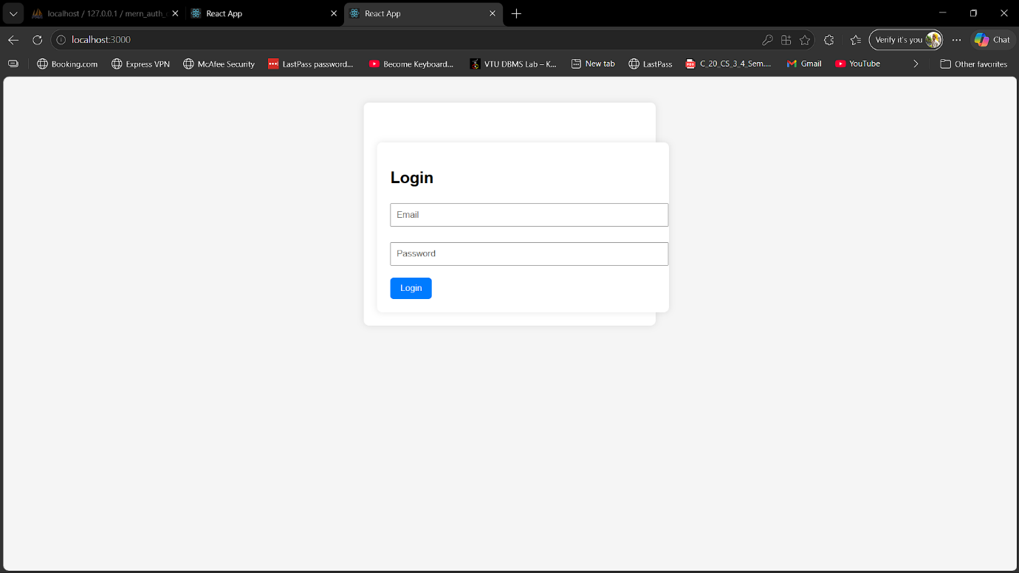

Fig 1.1 Login Page

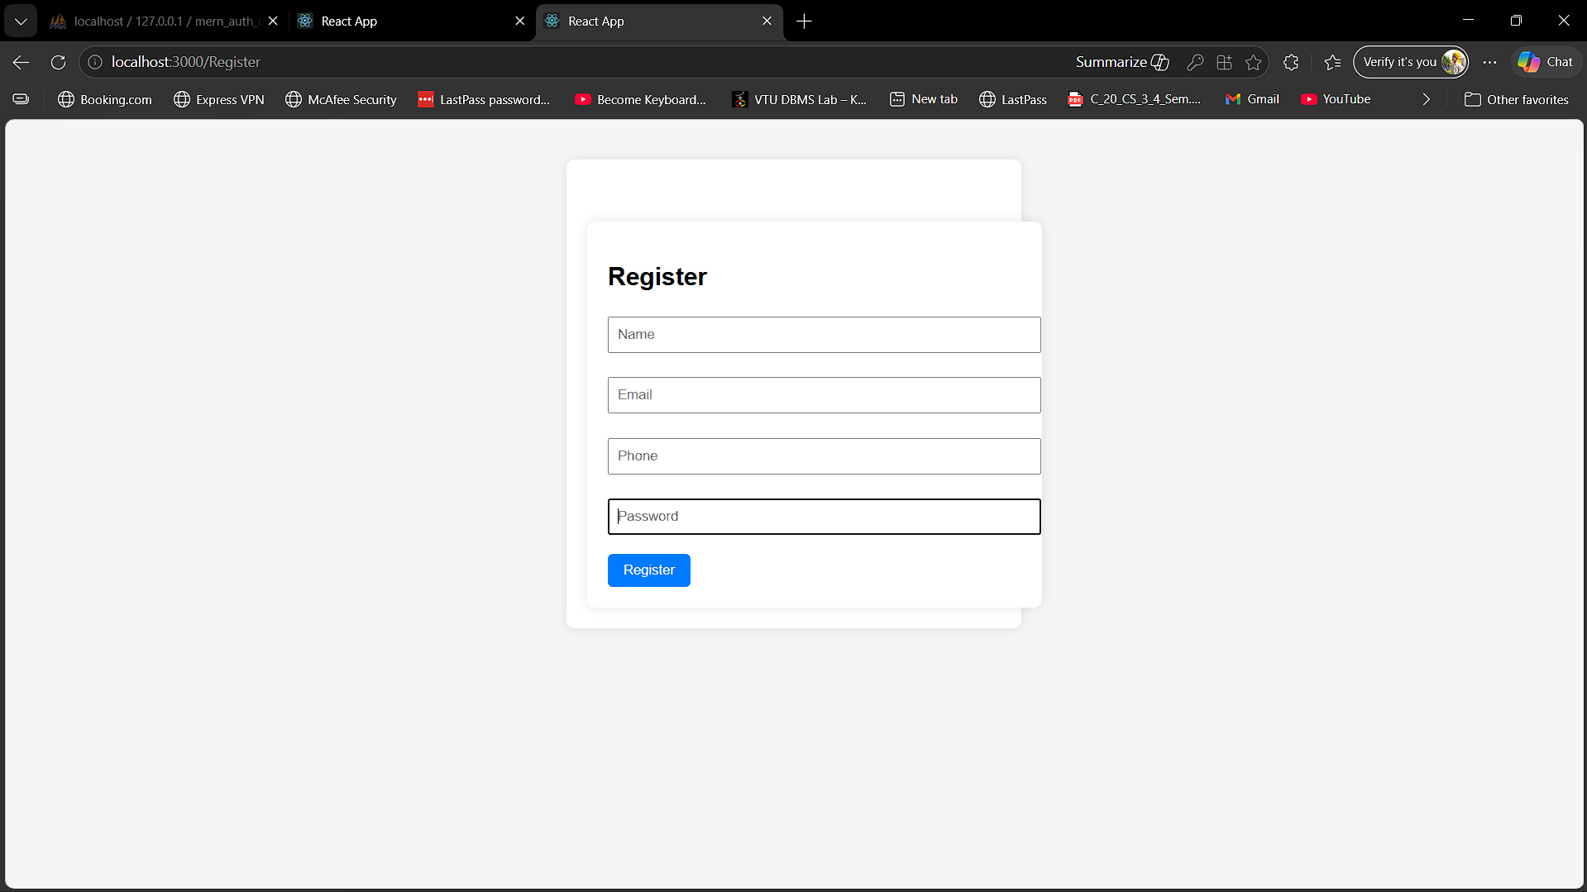
Fig 1.2 Register Page

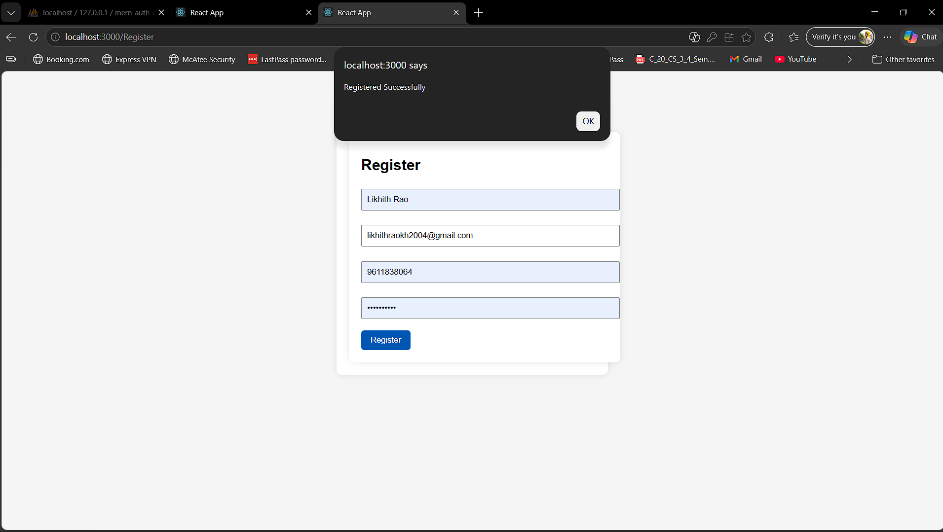
Fig 1.3 After Registration Success

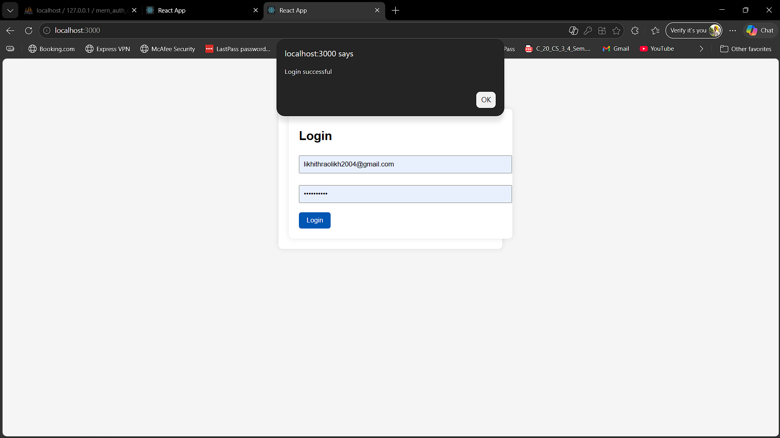
Fig 1.4 After Login Successful

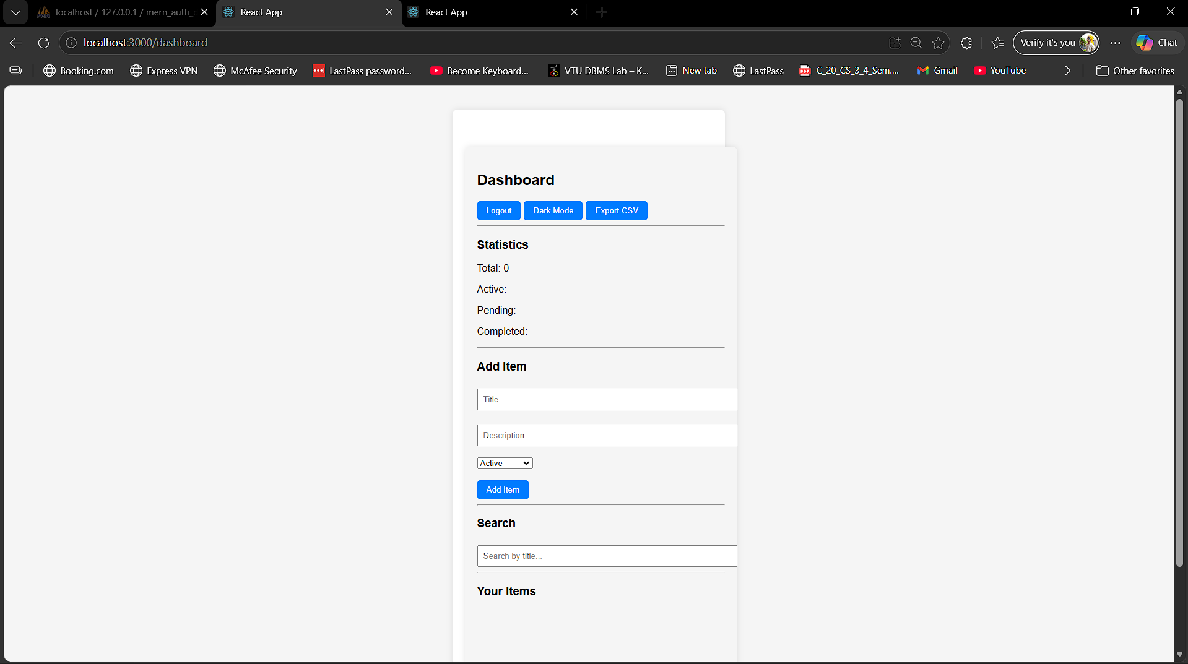
Fig 1.5 Dashboard before adding items
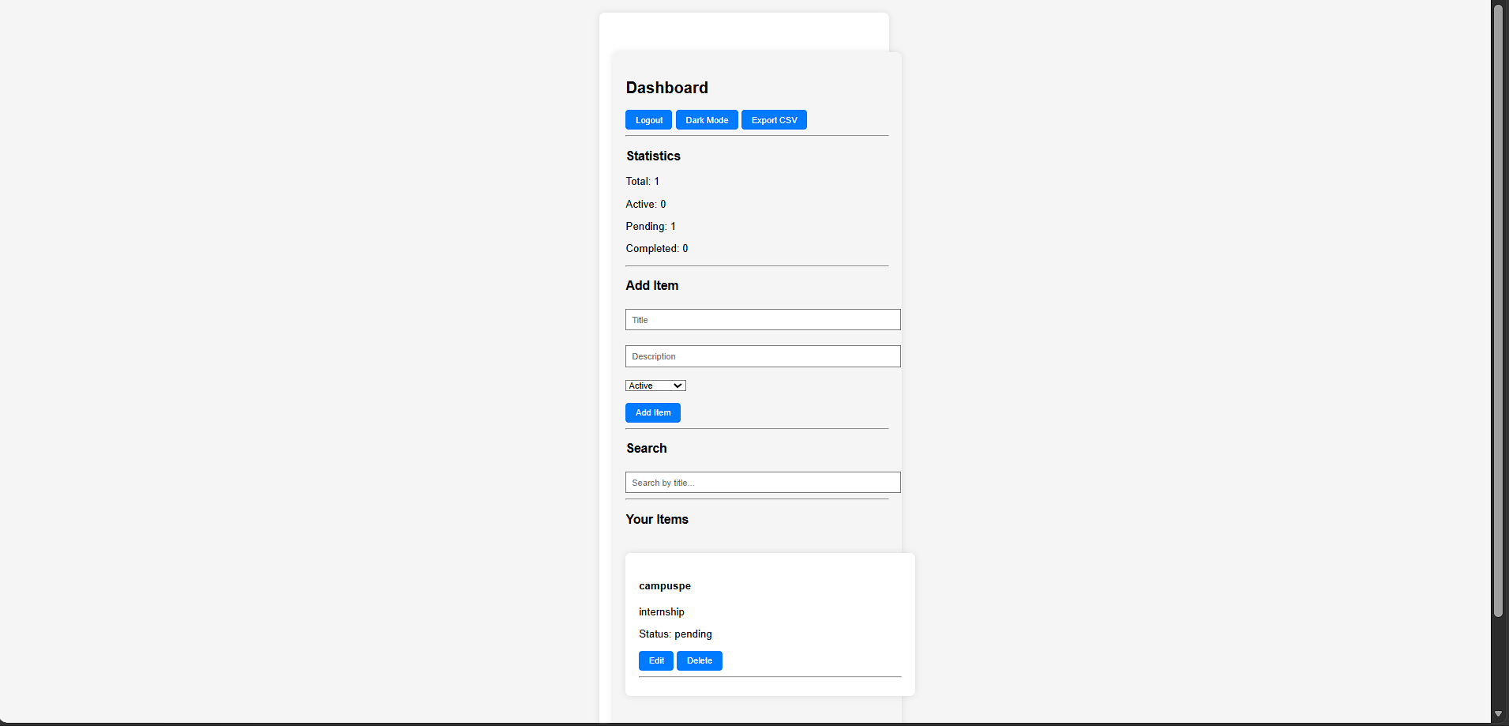
Fig 1.6 Dashboard After adding items
Fig 1.6 After Adding item
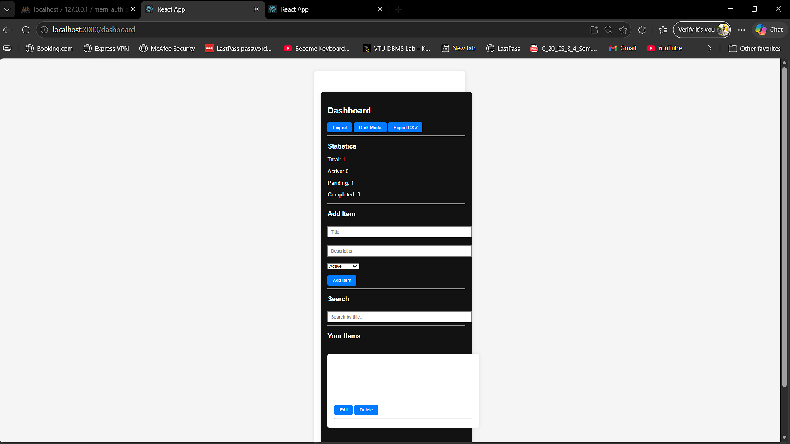
Fig 1.7 Dashboard in Dark mode
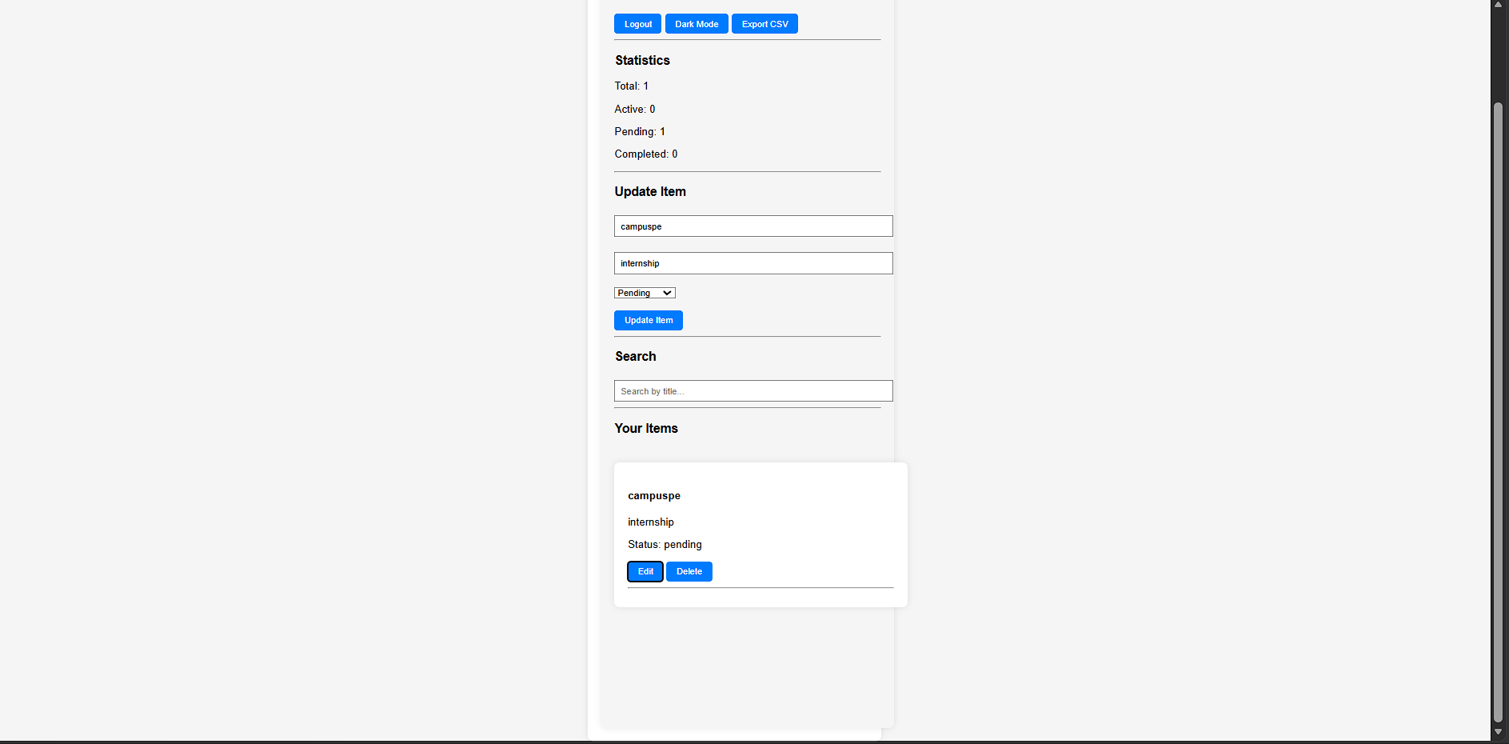
Fig 1.8 Edit item functionality

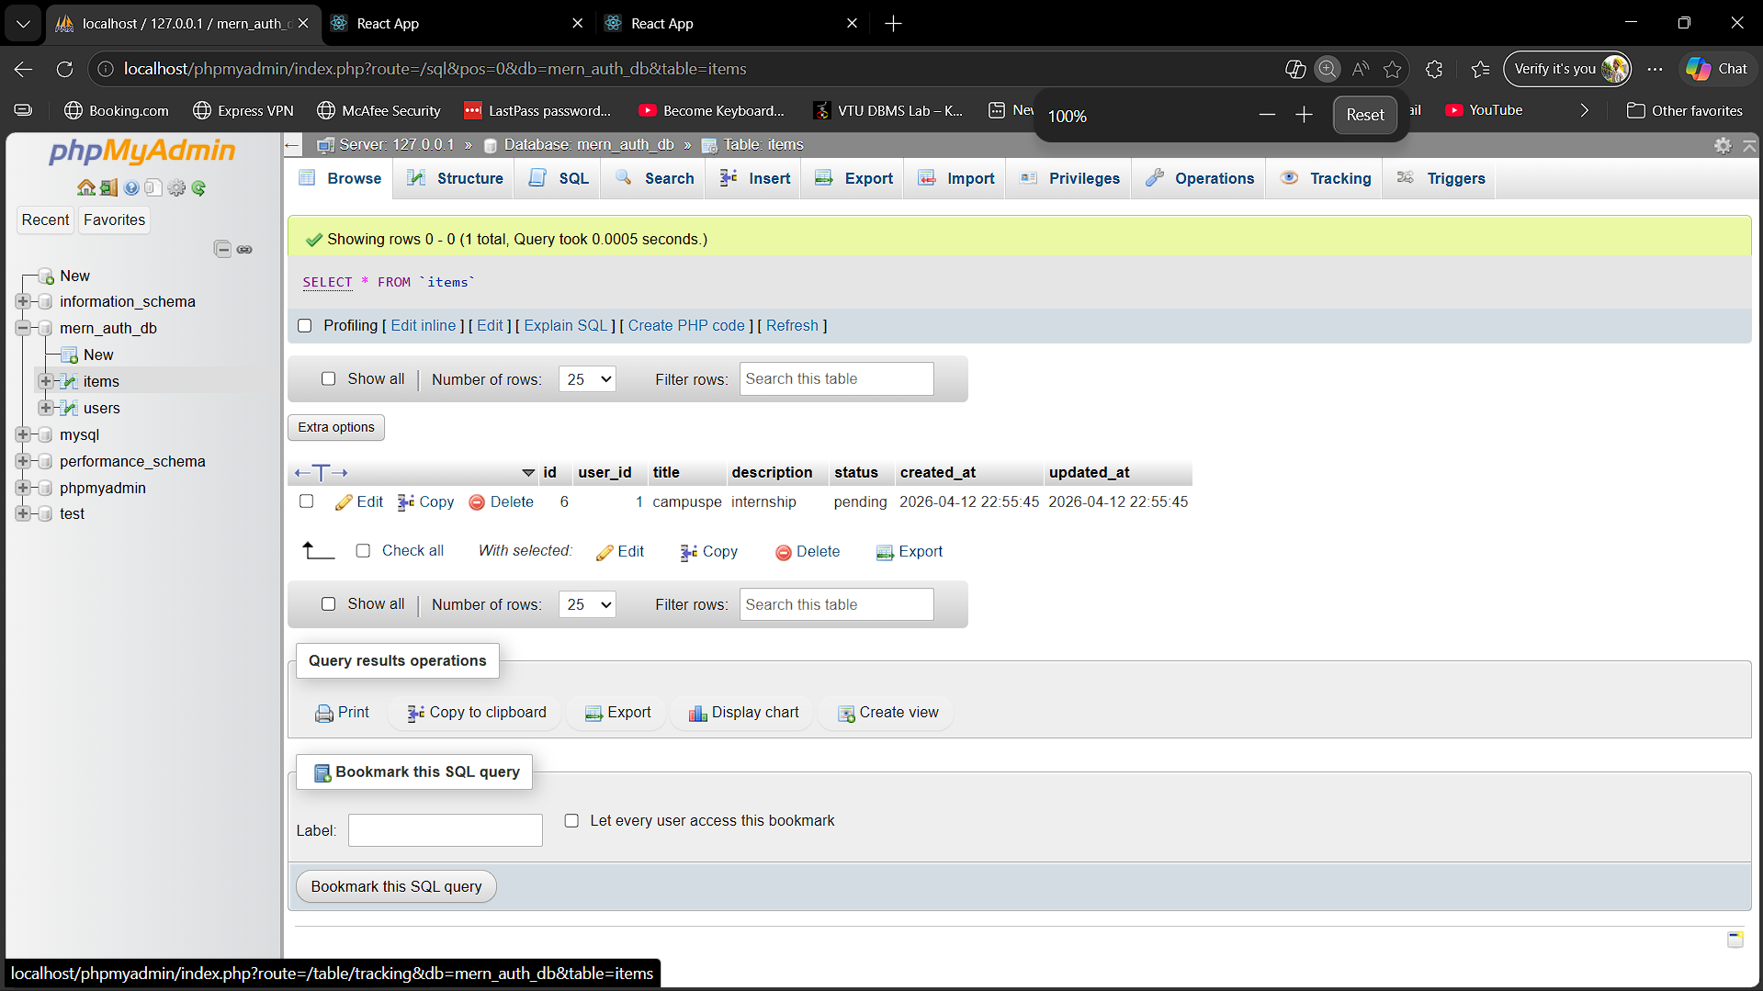
Fig 1.9 MySQL database showing tables with data(items)

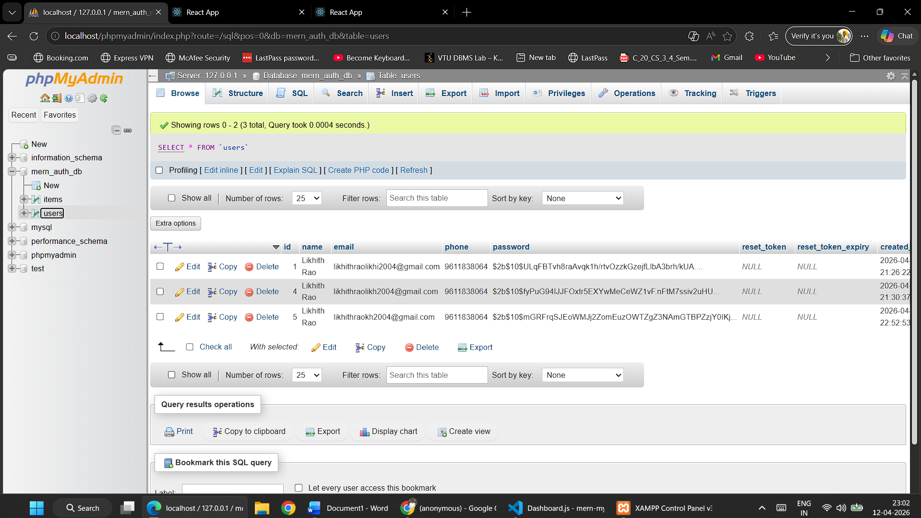
Fig 1.10 MySQL database showing tables with data(users)

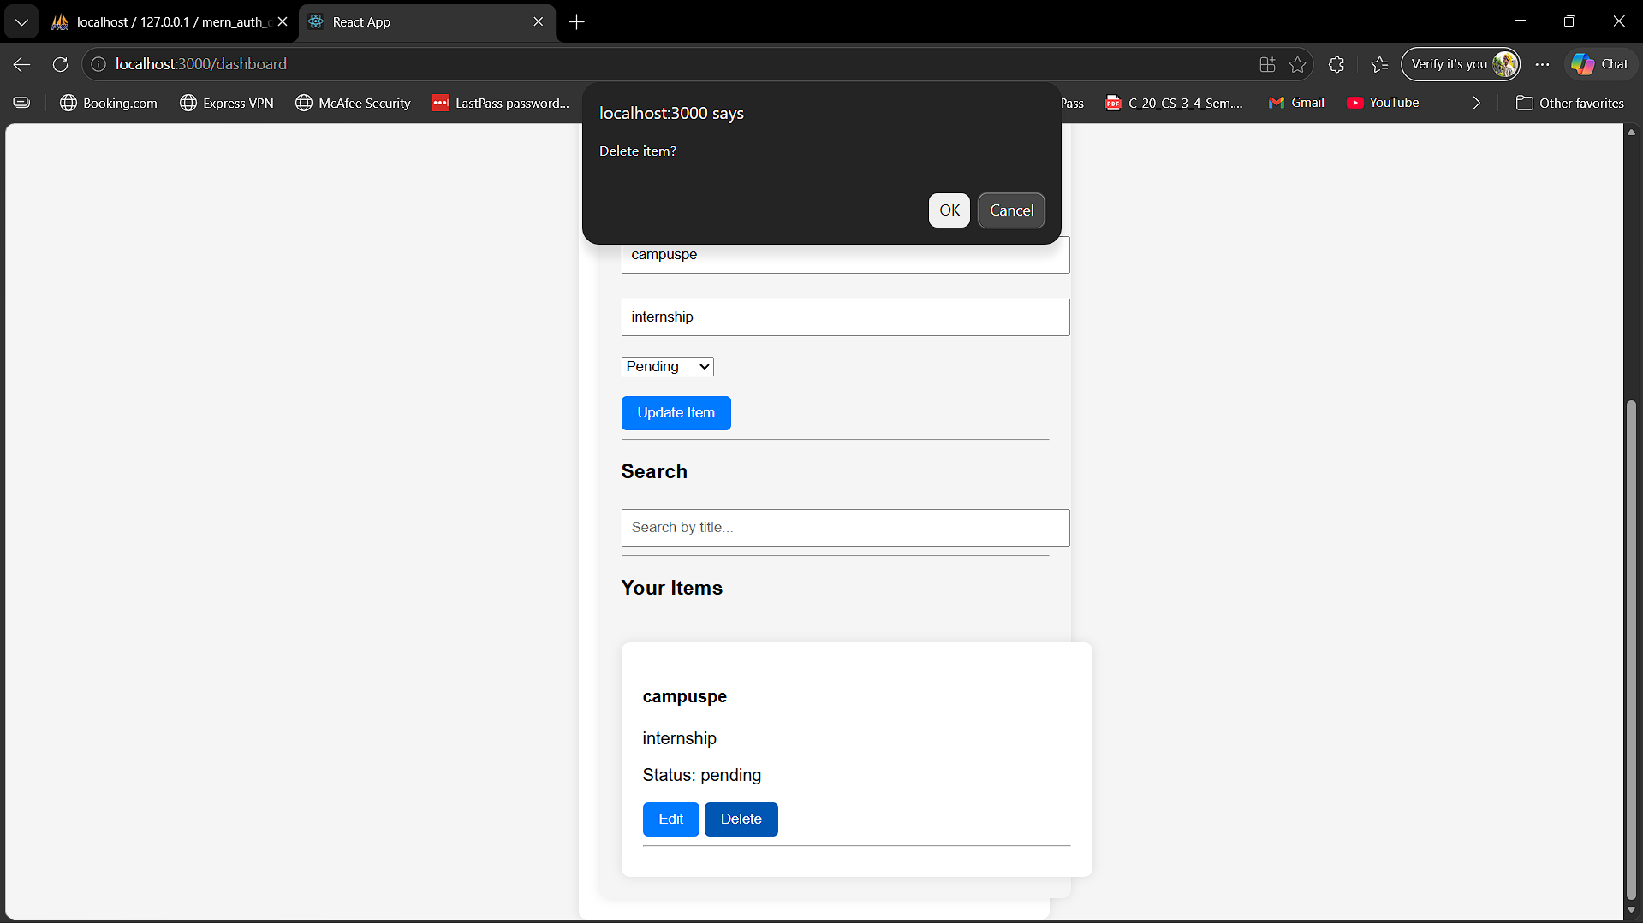
Fig 1.11 Delete confirmation

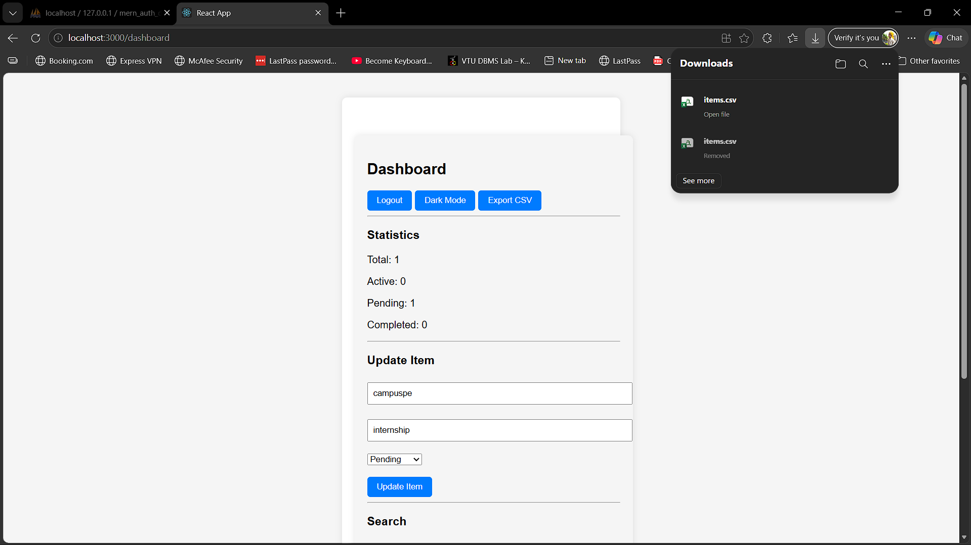
Fig 1.12 Export to CSV

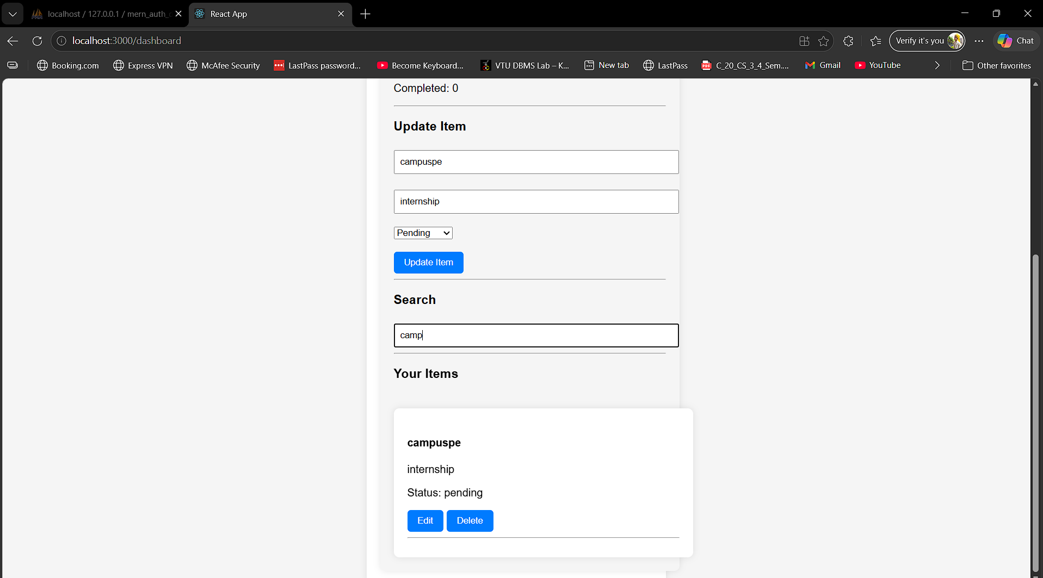
Fig1.13 Search bar in Dashboard

