create database Likhith_insurance ;

use Likhith_insurance ;

create table Person

(

driver_id varchar(10) primary key ,

name varchar(20) not null ,

address varchar(30) not null

);

create table car

(

reg_num varchar(10) primary key,

model varchar(10) not null,

year int(4) not null

);

create table owns

(

driver_id varchar(10),

reg_num varchar(10),

primary key (driver_id , reg_num),

foreign key (driver_id) references Person(driver_id) on delete cascade on update cascade,

foreign key (reg_num) references car (reg_num) on delete cascade on update cascade

);

create table accident

(

report_num varchar(10) primary key,

accident_date date ,

location varchar(30)

);

create table participated

(

driver_id varchar(10),

reg_num varchar(10),

report_num varchar(10),

damage_amount float(6),

primary key (driver_id , reg_num , report_num ),

foreign key (driver_id) references Person(driver_id) on delete cascade on update cascade,

foreign key (reg_num) references car (reg_num) on delete cascade on update cascade,

foreign key (report_num) references accident (report_num) on delete cascade on update cascade

);

Desc Person ;

insert into Person

values('21RC23A235', 'Likhith' , 'Bengaluru') ;

insert into Person

values ('21RC23A236' , 'Ram' , 'Chennai') , ('21RC23A238' , 'Shyam', 'Mumbai') , ('21RC23A227' , 'Suresh' , 'Delhi') , ('21RC23A231' , 'Mahesh' , 'Kolkata');

select *from Person;

desc car

insert into car

values ('21RN19A123', 'Q1', '2016'), ('21RN19A124', 'Q2', '2017'),('21RN19A125', 'Q3', '2018'),('21RN19A126', 'Q4', '2019'),('21RN19A127', 'Q5' ,'2020');

select *from car

insert into owns

values('21RC23A235','21RN19A123'),('21RC23A236','21RN19A124'),('21RC23A238','21RN19A125'),('21RC23A227','21RN19A126'),('21RC23A231','21RN19A127');

select *from owns

insert into accident

values('11','2021-08-11','basavanagudi');

insert into accident

values('12','2021-08-01','banashankari'),('15','2021-07-11','majestic'),('21','2021-08-17','bannerghatta'),('13','2021-03-11','c.v nagar');

select *from accident

insert into participated

values('21RC23A235','21RN19A123','11',42354.2),('21RC23A236','21RN19A124','12',36823.72),('21RC23A238','21RN19A125','15',23999.9),('21RC23A227','21RN19A126','21',83345),('21RC23A231','21RN19A127','13',53245);

**Queries:**

select *from car order by year asc;

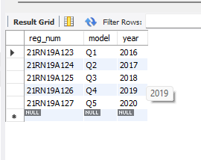

select count(distinct driver_id)

from participated a , accident b

where a.report_num=b.report_num AND b.accident_date like '__21%' ;

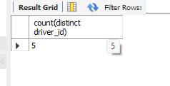

select count(report_num)

from car c, participated p

where c.model="Q1" and c.reg_num= p.reg_num;

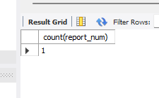

select *from participated order by damage_amount desc;

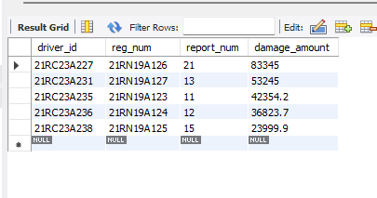

select avg(damage_amount) from participated ;

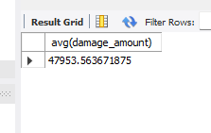

select p.name from person p , participated pa

where p.driver_id = pa.driver_id and pa.damage_amount > (select avg(damage_amount) from participated );

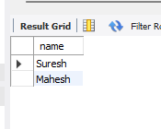

select max(damage_amount) from participated;

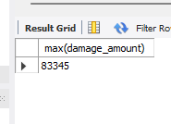

select c.model from car c , accident a , participated pa

where pa.report_num = a.report_num and pa.reg_num = c.reg_num and a.location='basavanagudi';

