3)select m.ename , m.empno

from employee e , employee m

where e.mgrno = m.empno -- we will get the managers list

group by m.ename

having count(*)=(select max(mycount) from (select count(*) mycount from employee group by mgrno)a);

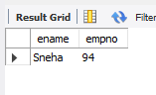

4) select m.ename

from employee m

where m.sal > (select avg(sal) from employee );

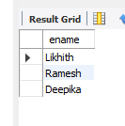

5) select distinct g.ename

from employee e , employee m , employee g , dept d

where m.empno=e.mgrno and m.mgrno = g.empno

group by d.deptno;

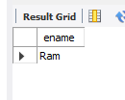

6) select *

from employee e , incentives i

where e.empno = i.empno and 1 = (select count(*) from incentives j where incentive_date like '2019-08-%'and i.incentive_amount < j.incentive_amount ) and incentive_date like '2019-08-%';

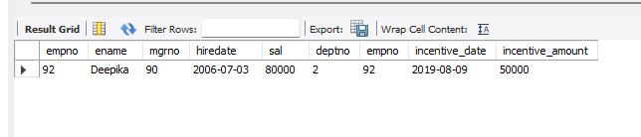

7) select e.ename, e.deptno

from employee e, employee m

where m.empno=e.mgrno and m.deptno = e.deptno;